
Module – ACCA4019
Analysing and Solving Problems
Component 2: Problem Analysis and Solution Development

Prepared by:
Muhsin Aslam
2514783

Contents
Introduction 3
Task 1- 4
Part1: Deconstructing the Problem 4
Part 2: 5
Part 3: 6
Task 2- 7
Part 1: Proposed Solution 7
Part 2: 7
Task 3: Reflect & Justify 9

Analysing and Solving Problems: Optimising Classroom Allocation at a Local College

Introduction
A resourceful classroom allocation is a key component operationally within educational settings, where it can have a significant impact upon student’s learning experience as well as the impact upon students and staff. When resources are not being utilised, this can often lead to challenges being presented such as overcrowding, rooms not being used to their full capacity, conflicts between timetables as well as avoidable movements between classes. Together this can affect the success of both teaching and learning [1].
Within this scenario, these challenges are present, therefore by addressing these inefficiencies is important to ensure that teaching is done smoothly, all avenues of resources are being used which essentially provides a positive learning experience.
The report applies methods such as the MoSCoW prioritisation technique, flowchart-based process modelling and logical problem decomposition to identify requirements, constraints and key variables. By doing so the assignment seeks to provide a solution that optimises classroom usage, minimises movement time and eliminates scheduling conflicts while reflecting on the suitability of the chosen problem-solving approach.

Task 1-

Part1: Deconstructing the Problem
One of the most common challenges in colleges is having successful classroom allocation, which impacts the operational perspective and student learning experience.
To analyse this challenge thoroughly, it can be deconstructed into the following components.
- Capacity & use of classroom: Each classroom within the college will have its full capacity of seating and the number of students varying across the different classes. If room capacity and class size is not the focus when allocating rooms, this will often lead to either overcrowding or underusing room capacity.
- Timetable constraints: The allocation of classes should be organised preventing overlapping for both students and teachers. However, this should be done whilst also bearing in mind staff availability and requirements that differ from subject to subject.
- Movement efficiency: If classroom allocation is done with the focus also being on the distance that students and staff must travel being minimised, this will allow maximum learning time which is more effective.
- Resource allocation: Making sure allocation of classrooms is based on how often it is being used, their capacity and the importance.

Part 2:
By using the MoSCow prioritisation technique, the requirements can be categorised as follows:
1. Must Have Requirements
1.1 Classroom Allocation
- 1.1.1 The system must assign a classroom to every scheduled class
- 1.1.2 Each classroom must only be assigned to one class per time slot
1.2 Capacity Management
- 1.2.1 The system must ensure classroom capacity is equal to or greater than the number of students
- 1.2.2 The system must prevent allocation of rooms that are too small for a class
1.3 Timetable Conflict Prevention
- 1.3.1 The system must ensure no student is scheduled for more than one class at the same time
- 1.3.2 The system must ensure no teacher is scheduled for more than one class at the same time
2. Should Have Requirements
2.1 Movement Efficiency
- 2.1.1 The system should minimise the distance between consecutive classes for students
- 2.1.2 The system should minimise the distance between consecutive classes for staff
2.2 Timetable Considerations
- 2.2.1 The system should consider staff availability when assigning classes
- 2.2.2 The system should consider subject-specific requirements when allocating rooms
2.3 Resource Utilisation
- 2.3.1 The system should reduce underutilisation of large classrooms
- 2.3.2 The system should distribute classes evenly across available rooms
3. Could Have Requirements
3.1 Specialised Room Allocation
- 3.1.1 The system could allocate specific rooms to particular departments
- 3.1.2 The system could prioritise commonly used rooms for frequently scheduled classes
3.2 Equipment Consideration
- 3.2.1 The system could assign classrooms based on required equipment (e.g., computers, labs)
- 3.2.2 The system could flag when required equipment is unavailable
3.3 Alternative Solutions
- 3.3.1 The system could suggest alternative rooms when ideal allocation is not possible
4. Won’t Have Requirements
4.1 Advanced Automation
- 4.1.1 The system will not automatically reschedule classes in real time for last-minute changes
4.2 External Integration
- 4.2.1 The system will not integrate with external systems outside the college
4.3 User Preferences
- 4.3.1 The system will not consider individual student or staff room preferences

Part 3:
Many key variables influence these issues which include:
  - Capacity of the classroom
  - The time slot available
  - How many students are going to be present
  - Distance between each room
  - Correlation between class size and classroom size.
Breaking down the challenges that arise and pinpointing the requirements and constraints, this will allow a more stable foundation to be built upon. Having a stable foundation will enable a more logical and improved classroom allocation solution [2].

Task 2-

Part 1: Proposed Solution
The suggested solution is a combination of systematic problem decomposition, prioritisation and making logical decisions to overcome the issues that have been mentioned previously. The process is an order of multiple steps which is demonstrated in the flowchart.
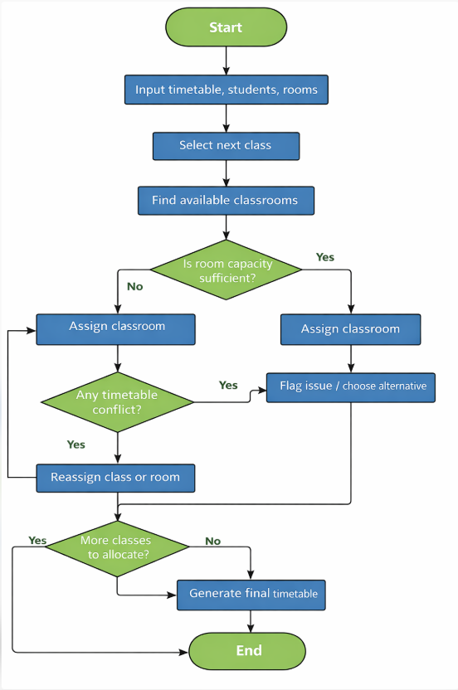

Part 2:
The process begins by establishing the issue and determining what the objective of creating an efficient timetable. This initial step sets this out and ensures that all decisions post this step are in line with what the college would like to happen operationally [3].
This stage involves identifying both sides of constraints, hard and soft. Opposed to these soft constraints which involve how much distance students and staff will have to walk between classes. These are able to be flexible in the instance of conflicts in hard constraints. This difference enables prioritisations to take place [4].
Using this technique, classes are often classified according to their value and inflexibility. By prioritising, this will ensure that allocations that require more importance are allocated first which will prevent conflicts from occurring [5].
Once allocations are done provisionally, Any conflicts that are indicated are required to be adjusted in the next step. By systematically checking will ensure that all allocations are practicable and reliable.
The iterative process echoes thinking systemically which facilitate the solutions to adapt dynamically to constraints and priorities [6].
Once all the conflicts are resolved, this allows for the final timetable to be generated. The timetable will symbolise a balance between operational constraints, good resource utilisation and practical considerations. From this, it will ensure effective room use and an individual experiencing minimal disruption
The process of allocation will be concluded once the generated timetable meets constraints both hard and soft and obeys the prioritisation framework. This means the solution is now ready for implementation [7].

Task 3: Reflect & Justify
The development of the solution for allocation has required the use of problem-solving techniques which have contributed to the clarity, efficiency and practicality of the system proposed. The key techniques that have been utilised are abstract thinking, problem decomposition, iterative refinement and prioritisation.
Abstract thinking was applied by classifying the variables using the terms of classrooms, classes and timetables. By dividing these into variables, this was then altered into a logical general model. Thinking abstract, this enabled recognition of patterns and relationships. One being the correspondence between capacity, size and how travel distances impact efficiency [8].
Iterative refinement was also used where decisions were intended to be iterative and flexible. By including conflict checking and adjustment, this will permit for the solution to be able to modify to constraints dynamically, improving room usage and minimising movement. This technique reflects realistic scheduling processes where sometimes provisional plans will require modification to comply with all constraints [9].
Using the MoSCoW framework, it offered a method to classify classes in line with importance, ensuring that requirements that were essential were facilitated first. This prioritisation significantly reduced the prospect of conflicts and amplified the effective use of critical rooms [10].

The chosen approach is appropriate for several reasons which are:
- Efficiency: The primary concerns are being directly addressed by using logical allocation that takes into consideration capacity which optimises room utilisation and takes away any avoidable movement.
- Conflict minimisation: Candid conflict checking and iterative adjustments prevent the potential overlaps which enable classes to start on time and double booking does not occur.
- Scalability: The abstracted model can acclimatise to changes whether that be in class sizes, availability or timetables which could potentially make it more fitting for larger settings and potential expansions.
- Transparency: The flowchart is clear within each step that supports decision making for administrative staff.

Although, this may have its strengths, but the solution has limitations and assumptions which are:
  - Fixed data assumption: This model holds the assumption that the sizes, capacity and timetables are fixed before the action of allocation. In the event of last-minute changes, this may require for the process to be rerun.
  - Simplified travel times: The distance are anticipated to be linear and unvarying. Where in real time, there may be obstacles or the layouts of the building which could impact the movement time
  - No external integration: This does not instinctively collaborate with wider management systems.
  - Prioritisation Bias: MoSCoW depends on the individual’s judgment which could leave to incorrect prioritisation impacting how effective allocation actually is.
By recognising this limitation, this allows for future instances to be more improved and enabling it to be more real time like and having more details of campus maps which can correlate movement time too.
In conclusion, this reflects that abstract thinking, decomposition, iterative refinement and prioritisation were all very valuable in the development of a logical, efficient and scalable classroom allocation solution. Adopting this, it made sure that the usage of rooms was completed, minimisation of student and staff movement and also a preventative tool of conflicts. By doing this, it also enabled for the process to be transparent and adaptable. Despite there being some presence of assumptions and limitations, this method is strong and appropriate for the college.

References:
[1] R. Vakili, S. Vakili, M. Abbasi, and S. Masoudi, “Overcrowded Classrooms: Challenges, Consequences, and Collaborative Solutions for Educators: A Literature Review,” Med Edu Bull, vol. 5, no. 2, 2024, doi: 10.22034/MEB.2024.492269.1103.
[2] E. Miranda, “MoSCoW Rules: A Quantitative Exposé,” Lecture Notes in Business Information Processing, vol. 445, pp. 19–34, 2022, doi: 10.1007/978-3-031-08169-9_2.
[3] A. Taherdoost and M. Madanchian, “Decision Making: Models, Processes, Techniques,” Cloud Computing and Data Science, vol. 5, no. 1, pp. 1–14, Aug. 2023, doi: 10.37256/ccds.5120233284.
[4] K. Knop, “Using the Theory of Constraints Thinking Process Tools to Solve Critical Problems in the Organization,” Scientific Papers of Silesian University of Technology, Organization and Management Series, no. 197, pp. 305–331, 2024, doi: 10.29119/1641-3466.2024.197.18.
[5] C. Chapman, “MoSCoW Prioritisation Technique for Project Management,” Journal of Business Management, vol. 12, no. 3, pp. 45–53, 2020.
[6] S. Kumar and R. Singh, “Optimisation Algorithms for Educational Resource Allocation,” International Journal of Advanced Computer Science, vol. 11, no. 6, pp. 120–130, 2020.
[7] R. Françozo, A. Paucar-Caceres, and M. C. N. Belderrain, “Combining Value-Focused Thinking and Soft Systems Methodology: A Systemic Framework to Structure the Planning Process at a Special Educational Needs School in Brazil,” Journal of the Operational Research Society, vol. 73, no. 5, pp. 1–20, 2021, doi: 10.1080/01605682.2021.1880298.
[8] M. N. Kholid and N. N. Aisyah, “Classification of Abstract Thinking in Solving Mathematical Problems,” Educational Process International Journal, vol. 16, no. 1, 2025, doi: 10.22521/edupij.2025.16.194.
[9] P. Jackson, “Timetable Scheduling and Resource Optimisation in Universities,” Journal of Scheduling, vol. 22, no. 2, pp. 115–129, 2019.
[10] The Knowledge Academy, “MoSCoW Analysis: A Guide to the Project Prioritisation Method,” 2024. [Online]. Available: https://www.theknowledgeacademy.com/blog/moscow-analysis/ [Accessed: Mar. 23, 2026].

