Gerald C. Kane, Anh Nguyen Phillips, Jonathan Copulsky, and Garth Andrus (2019) How Digital Leadership Is(n’t) Different. Sloan Management Review, MAGAZINE SPRING 2019 ISSUE RESEARCH FEATURE. March 12, 2019. https://sloanreview.mit.edu/article/how-digital-leadership-isnt-different/
Leaders must blend traditional and new skills to effectively guide their organizations into the future.
When describing the new digital reality for organizations, people tend to fall into two camps. Some argue that the future will be more like the past than not, agreeing with the sentiment, “Those who cannot remember the past are condemned to repeat it.”1 Others think the future will be more novel, believing, “No one can possibly know what is about to happen: It is happening, each time, for the first time, for the only time.”2

Either way you look at it, as organizations seek their footing in a turbulent business environment, they require strong leaders at the helm. Senior leaders must not only articulate a vision people can rally around but also create the conditions that enable digital maturity, attracting the best talent and bringing out the best in the talent they attract. The rapid changes associated with digital disruption can be disorienting, so many of us assume the leadership handbook must be completely rewritten for the digital age. Is this true? Or are greater and greater levels of uncertainty causing us to neglect the essentials? Is it possible the leadership challenges of the digital world are more the same than different but we are overly focused on what’s different because we are so alarmed by the threats to the status quo?

There is something to be said for both arguments. Over the past five years, in a joint research project with MIT Sloan Management Review and Deloitte, we have studied how business and leadership are changing as a result of digital disruption. (See “About the Research.”) We have found that while many core leadership skills remain the same, the particular demands of digital disruption call for certain new skills as well. Here, we will explore which are which and what we can learn from organizations that are digitally maturing — that is, those that have been transformed by digital technologies and capabilities that improve processes, engage talent across the organization, and drive new value-generating business models.
What Makes Digital Leadership Different
Leaders face new challenges as a result of digital disruption. The biggest changes respondents cited in our research are the increased pace of doing business, the shift in organizational culture (and the corresponding tensions between “change makers” and employees with a traditional mindset), the need for a flexible and distributed workplace, and greater expectations of productivity. So it stands to reason leaders need to adapt or augment some of their core skills to navigate the digital world. To identify which capabilities matter most in organizations, we asked survey respondents, “What is the most important skill organizational leaders should have to succeed in a digital workplace?” (See “What’s Distinctive About Digital Business and Digital Leadership?”) Taken together, the responses paint a compelling composite picture of what effective leadership looks like in a digital environment. The following traits stand out as most critical.

About the Research
Over the past five years, we have surveyed more than 20,000 business executives, managers, and analysts around the world to understand the challenges and opportunities associated with digital transformation. Each year, we have received between 3,700 and 4,800 responses, capturing insights from individuals in more than 120 countries and 28 industries, from organizations of various sizes. More than two-thirds of the respondents are from outside the U.S. The sample is drawn from a number of sources, including MIT Sloan Management Review readers, Deloitte Dbriefs webcast subscribers, and other interested parties. We have also interviewed more than 140 business executives from a number of industries, thought leaders, and academics to understand the practical issues facing organizations today. Their insights contribute to a richer understanding of the data.
Transformative vision and forward-looking perspective. Providing vision and direction have been long-standing essential components of leadership. But in a digital environment, with the emphasis on future change, they take on new significance.

In our survey, 22% of respondents say the most important leadership skill to possess in a digital organization is a transformative vision, which includes the ability to anticipate markets and trends, make savvy business decisions, and solve tough problems in turbulent times. The second most important is being forward-looking (20%), which includes having clear vision, sound strategy, and foresight. These skill sets are closely related. We interpret the latter as understanding how business trends are evolving because of technology and the former as being able to guide the business in response to those trends. Leaders with a transformative vision are equipped to provide purpose and direction. How is that even possible when you’re facing an uncertain future? John Glaser, senior vice president of population health at Cerner, a health information technology provider, had this to say when he described his approach to us: “Work on things that are likely to be relevant to many possible futures. Tell me a future in which engaging patients to manage their own health is a bad idea, because I don’t see that future at all. So I may not know how it’s going to play out, but under almost any conceivable circumstance, these things will be relevant.”

Digital literacy. Understanding technology is the third most important skill. Such a requirement may seem obvious at a glance, but our survey respondents define it in a particular way. They put a premium on previous experience in a technology leadership role but also say leaders need to have general digital literacy, as opposed to hard-core technical skills like programming or data science. Digital literacy is critical for two reasons. First, it supports the first two leadership skills cited: having transformative vision and being forward-looking. A leader who is not digitally literate will struggle to keep abreast of emerging trends and developments and will fail to grasp how those trends can bring new value or represent a threat to the organization. Second, understanding at a high level how technology does (and does not) work enables leaders to make more informed decisions in an uncertain environment. We observe in our research and consulting work that it is often much easier and more effective to help established business leaders become digitally literate than it is to teach technologists the strategic knowledge they need to lead effectively.

Adaptability. Tied for the third most important capability, a leader must also be change-oriented — that is, open-minded, adaptable, and innovative. Like digital literacy, this skill supports other traits reported as valuable. It helps leaders respond to a fluid environment and change course if the technology and market environments evolve in unanticipated ways. This mindset also enables a digital leader to continually update his or her knowledge stores to account for changes in technology and avoid obsolescence. Leaders can replenish their knowledge stores through formal continuing education, in-house training, cross-generational reverse-mentoring programs, or any of an abundance of online programs.
What Stays the Same
Of course, even though some things change with respect to digital leadership, that doesn’t mean everything does. Indeed, one of the biggest pitfalls is to ignore the fundamentals of good leadership in the face of digital change. We find that leaders often become so focused on the technological aspects that they forget why they are engaged in these efforts in the first place: to improve the way their company does business. So here, we’ll call out a few core skills that remain essential.

Articulating the value change will bring — and investing accordingly. Digital transformation is driven by new technology, but that technology is only as valuable as the new business strategies and practices it enables. Before leaping into any new technology, leaders must be able to clearly articulate why they need to invest in it. Too few executives display this kind of discipline in the midst of all the digital noise.

Making matters worse, leaders also tend to expect projects to go well without giving them proper financial support and resourcing. But not surprisingly, 75% of survey respondents who say their company has made appropriate levels of investment report successful initiatives, while only 34% of those who say their company does not commit sufficient time, energy, and resources report successful outcomes.

Owning the transformation. When executives delegate responsibility for digital business to the technologists, it is a recipe for near-certain failure. For example, we’ve seen technologists flawlessly implement enterprise social media or collaboration platforms without conducting any training or behavioral change initiatives to accompany the launch. The result is often a beautiful technology platform that employees don’t actually use. As with any change effort, top management involvement and support signal prioritization and can help align the rest of the organization behind a digital transformation. It then becomes a cross-enterprise, cross-functional endeavor, which makes it possible to move from simply doing or adopting new technologies to being more digital as an organization. When we asked respondents which part of the organization was most likely to lead an organization’s digital initiatives, the least digitally mature companies tended to situate projects in a functional area, such as IT or marketing. (See “Strategy: Who Leads Digital Progress?”) Digitally maturing companies, however, were nearly twice as likely to situate digital efforts in the CEO’s office.3
Equipping employees to succeed. Another aspect of good leadership that has not changed involves enabling and empowering employees to carry out new initiatives. A strong mandate from the top isn’t enough. If you expect employees to engage in new processes just because your company adopts a new technology, you’re bound to be disappointed. In the context of their existing job responsibilities, employees typically don’t have the time or the know-how to figure out new ways of working on the fly. Leaders must set up employees for success. Among respondents who report their organizations provide them with the resources and opportunities to thrive in a digital environment, 72% say their digital initiatives are successful. However, among respondents who say their company does not provide such opportunities and resources, only 24% report successful digital initiatives. Digital transformation is both a top-down and a bottom-up effort.

Leaders can support employees in many ways — for instance, by providing adequate training, moving employees within the organization to learn other ways of doing things from coworkers, and giving them time and space to adapt so the necessary learning feels doable in the context of their other job responsibilities.
What’s Distinctive About Digital Business and Digital Leadership?
When 3,300 survey respondents completed open-ended questions about how digital business differs from traditional business and what key skill leaders will need to develop, their responses broke down as follows:
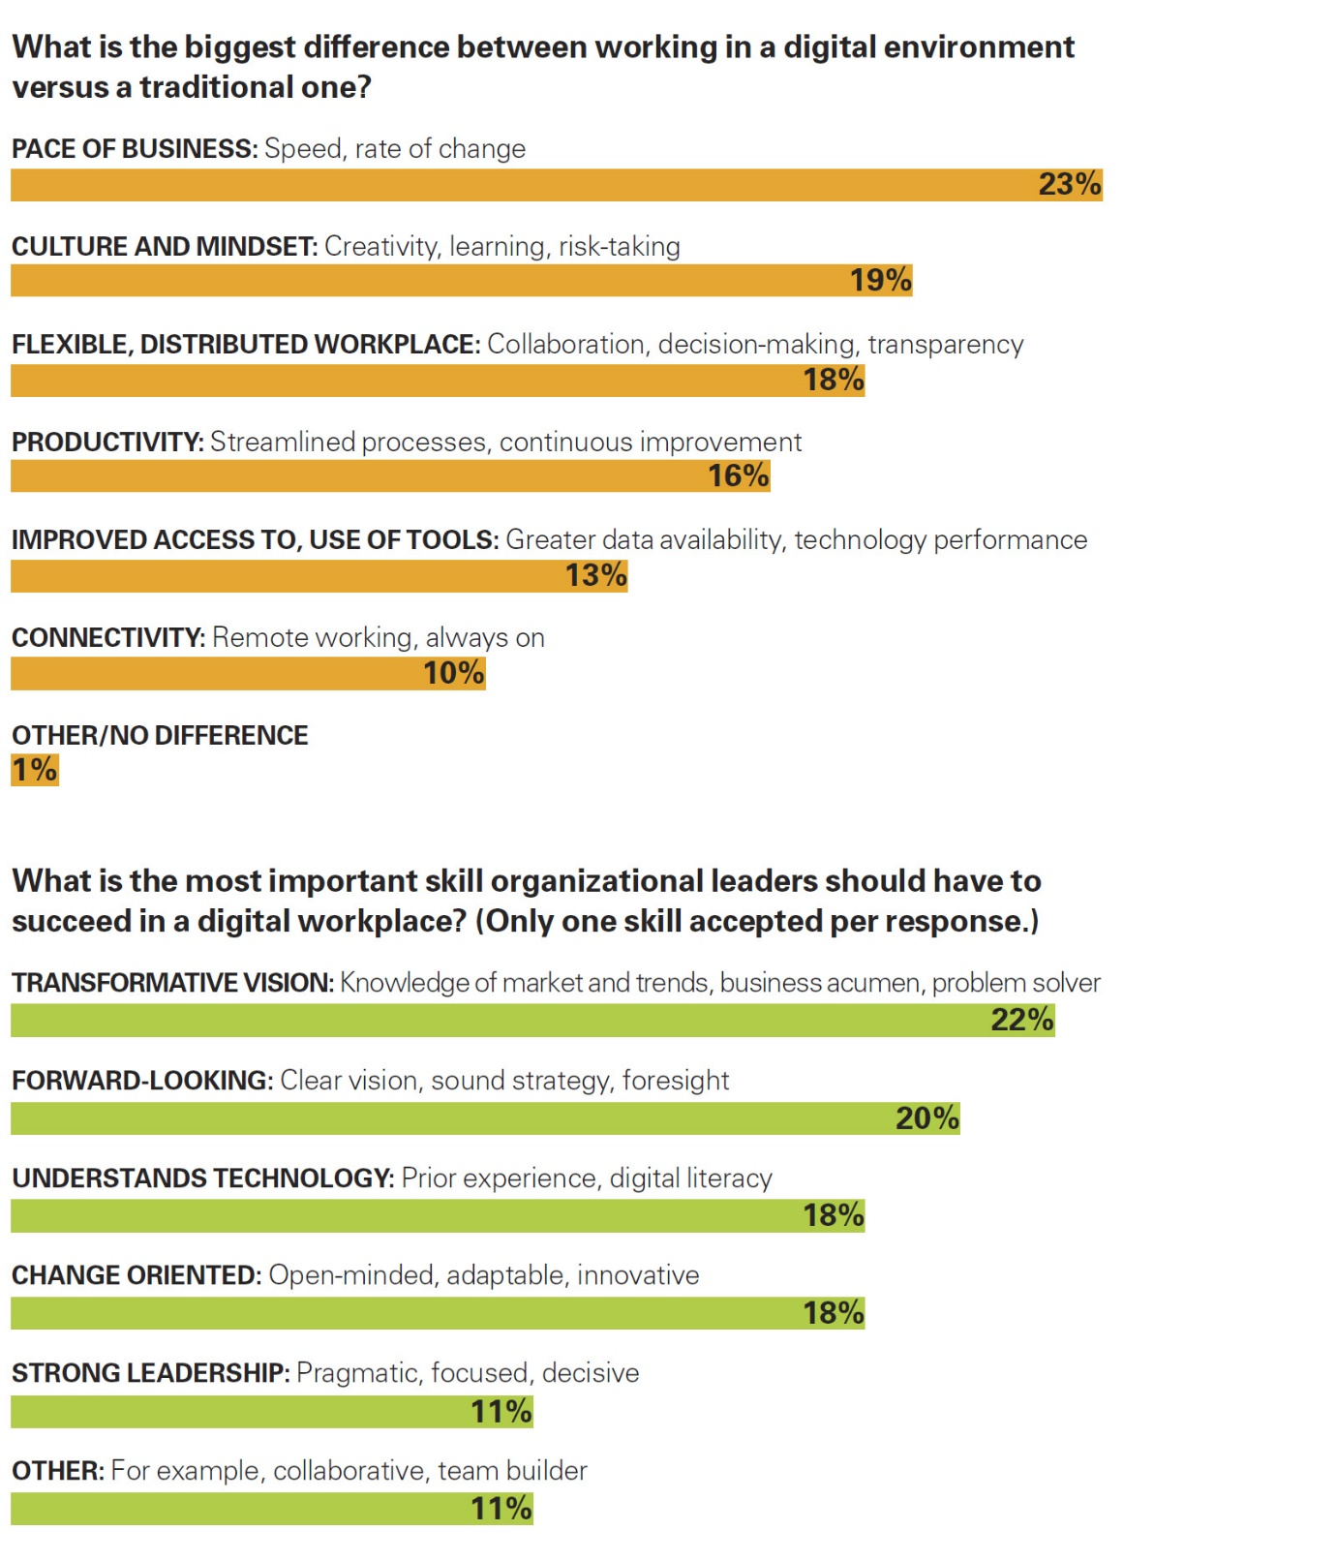
Developing the Right Muscles, Mindsets, and Mettle
In the spirit of leading through others (which is, after all, what senior executives are meant to do), it’s critical to seed the organization with the management talent it needs to pull off and maintain a transformation — and develop and enable the right skills at all levels. To those ends, what can you learn from digitally maturing companies? Here are some lessons we gleaned from our research.

1. Hire digital leaders to get the ball rolling. Many organizations have overlooked digital transformation for so long that they don’t even know where to begin. But they can make so-called anchor hires to catalyze the process. These are outside leaders with deep digital transformation experience who can provide the needed expertise and perspective. For example, to begin driving digital change, John Hancock hired a new chief marketing officer who brought a small team of managers that then developed innovative digital initiatives that were insulated from the bureaucracy of the rest of the organization. Once the digital initiatives began to flourish, the team used the successes to serve as a proof of concept to begin driving change across the organization.

So, what skills do you need to look for in anchor hires? The focus should be on two major areas:

• Having a track record of producing digital products with measurable value.

• Demonstrating the ability to enable and systematize into the organization a new way of thinking and doing.

Bringing these skills in from the outside will support the organization’s transformation, but it is also important to sustain what has been built. For that, you’ll need an entirely different, operational skill set, which you may well find internally.
Strategy: Who Leads Digital Progress?

Respondents in digitally maturing companies say their CEO’s office is primarily heading up transformation efforts. In early-stage companies, it’s often IT.

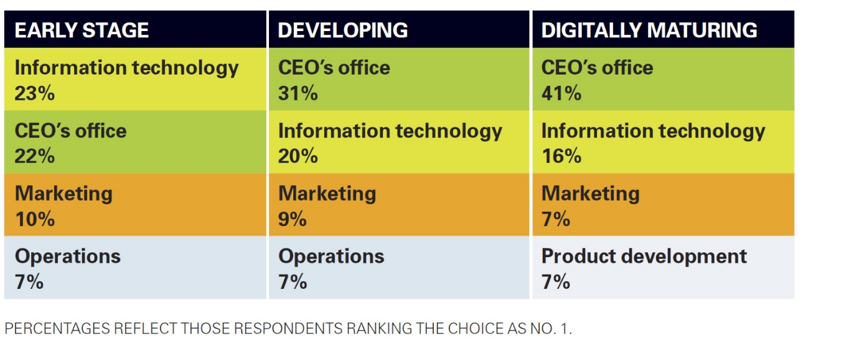

2. Regularly refresh your senior team’s digital literacy. Let’s say your company’s leadership team graduated from college more than five years ago (in most organizations, top leaders have been out of school for much longer than that). The odds are strong that you need to update their digital literacy if you haven’t already been taking steps to do so. Data and analytics, artificial intelligence, blockchain, autonomous vehicles, additive manufacturing, virtual and augmented reality, and other emerging technologies are poised to radically reshape the business environment over the next decade. Certainly, most executives don’t have the time, skill set, or inclination to become sophisticated data scientists or software developers. Nevertheless, virtually all executives are capable of understanding new technologies at a strategic level so that they can make decisions accordingly.

One solution here is simply to have ongoing continuing education sessions with your organization’s leadership. As a part of those sessions, leaders can engage in what many in Silicon Valley call zoom-in/zoom-out strategizing, guided by facilitators with deep digital knowledge. In this process, your executives forecast what your business or industry will look like in 10 years as a result of a particular technology or general digital trends, and then they plot what moves will be necessary in the next 12 to 18 months for your organization to begin preparing for that future. While it is unlikely you will accurately predict the future, this exercise helps you avoid the all-too-common trap of strategizing about the current digital environment instead of the one that will be here by the time your strategies come to fruition.
There’s Never Enough Digital Leadership
Whatever digital leadership consists of, one thing our research clearly shows is that it is very much in demand. When asked whether their organization needs to find new leaders to succeed in the digital age, 68% of respondents agreed that their organization does, indeed, need new leadership to compete. What is more striking is the consistency across digital maturity categories in these responses. As you might expect, 77% of respondents from early-stage companies report needing new leaders, but so do 55% of those from maturing companies.

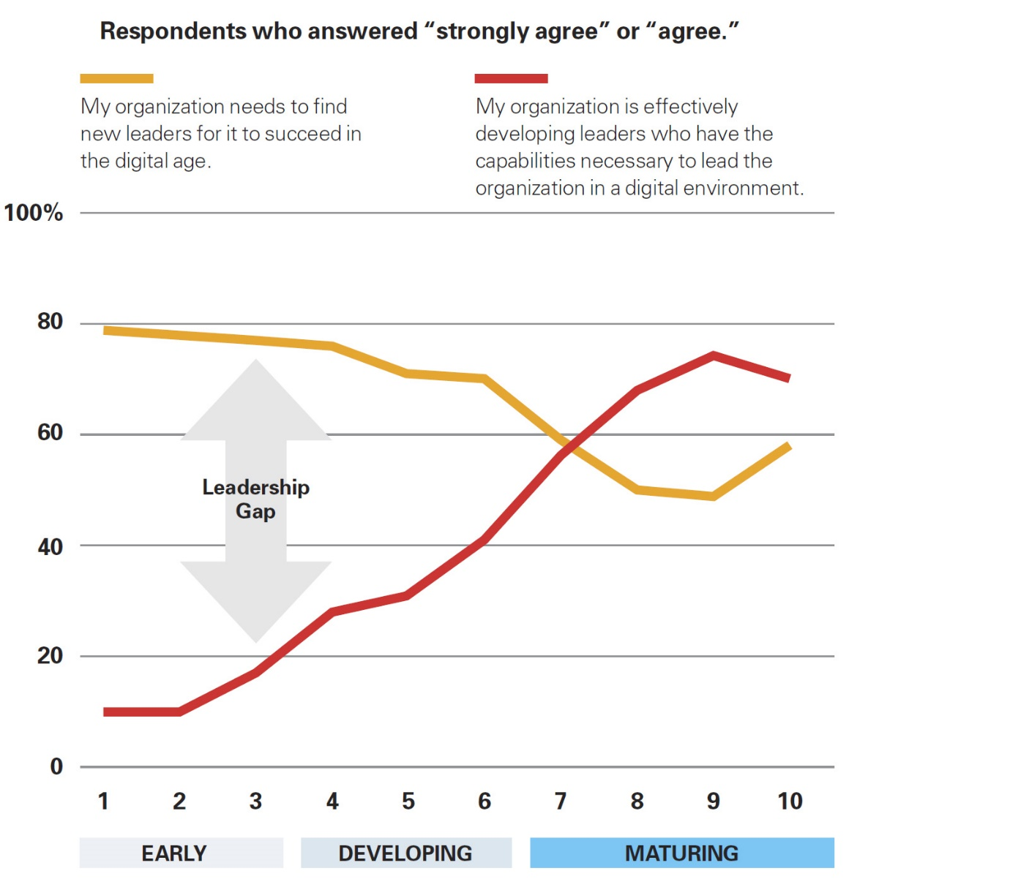

There’s Never Enough Digital Leadership

There just aren’t enough digital leaders who are meeting the challenges most companies face. But here is where digitally maturing companies distinguish themselves from their less mature counterparts: They are doing something to address the problem. When we asked whether organizations are effectively developing the leadership capabilities they need in a digital age, the difference in responses was considerable. While around two-thirds of respondents from maturing companies say that they are doing so, only 33% of developing-stage companies and 13% of early-stage companies say the same.

3. Create an environment where new leaders can step up. Digital business moves too quickly for your managers and employees to wait for marching orders to deal with every situation. Leaders need to clearly communicate strategic objectives so front-line and middle managers can make sound decisions on the ground and have enough time and opportunity to experiment with new ways of leading in a digital environment. One of the most critical skills everyone needs to develop is the ability to lead networks of people and teams, rather than leading via a hierarchy. Traditional leaders who take a waterfall approach to managing communications and decisions — that is, those who favor a linear and sequential approach to organizational leadership — create bottlenecks and chokepoints when speed is needed. In contrast, a network approach facilitates iterative, fast, collaborative conversations and decisions by proliferating many small nodes of communication and decision-making that extend far beyond organizational lines and boxes. If decision rights are clear, enabling, and communicated, senior leaders can enhance the quality and speed of these expanding networks by opening doors, removing barriers, engaging with teams in collaborative work, helping them become more agile, and focusing on innovating day-to-day work.

4. Cultivate a culture of experimentation. Finally, leaders should think like innovators and provide the space for employees to try new things, learn from them, adjust, and scale. Most organizations pay lip service to the concept of failing fast but, in fact, send implicit messages that “failure is not an option.” To avoid conveying mixed signals, you can actively encourage and reward learning that comes with less-than-successful efforts — often called failing forward. As Richard Gingras, vice president of Google News, told us, “It’s really not that important if the experiment succeeds or fails; it’s what they learn from it. Good, bad, or indifferent, it is intelligence that they can lay claim to. Maybe it didn’t work out the way we thought it would, but we learned X, Y, and Z, and we’re not embarrassed by the fact that our initial assumptions were wrong. There are no failures. We tried something, and we learned something.”
So, what kind of leaders do we need for the era of digital disruption? Commanders who study past battles with an eye toward gleaning lessons learned, or intrepid adventurers who believe what is happening now is nothing like what has ever happened before? The answer is a healthy blend of both: leaders who have the core skills cultivated from the insights of the past, but with the agile mindset and digital savvy to allow them to pivot when necessary. In short, we need leaders who can “be the change we seek.”

ABOUT THE AUTHORS
Gerald C. Kane (@profkane) is a professor of information systems at Boston College and the faculty director of the Edmund H. Shea Jr. Center for Entrepreneurship. Anh Nguyen Phillips (@anhphillips) is a researcher and author from Deloitte’s Center for Integrated Research, where she leads research on digital transformation. Jonathan Copulsky (@jcopulsky) teaches marketing at Northwestern University and serves as program director for the Kellogg Executive Education Business Marketing course. Garth Andrus (@garth_ot) is currently a principal and global leader of Digital DNA solutions at Deloitte. They are the authors of the forthcoming MIT Press book The Technology Fallacy: How People Are the Real Key to Digital Transformation (April 2019), from which this article is adapted.

REFERENCES
1. G. Santayana, The Life of Reason: The Phases of Human Progress, Vol. 1: Reason in Common Sense (New York: C. Scribner’s Sons, 1905), 284.

2. J. Baldwin, The Devil Finds Work, sec. 1, The Price of the Ticket (New York: St. Martin’s Press, 1985).

3. G.C. Kane, Is the Right Group Leading Your Digital Initiatives? MIT Sloan Management Review, Aug. 3, 2018.

