Yohan Mendis [2218843]
University of Wales Trinity Saint David |
Critical analysis of philosophies and principles which shapes my research.
LCDB7007 – Research Principles and Philosophy

Executive Summary

The purpose of this report is to analyse the underpinning research philosophies and principles in relation to the chosen subject of the research. The chosen subject area of study for this report is the “critical investigation of reasons underlying retention of students on the widening participation programmes from a customer satisfaction point of view” with a specific focus on University of Wales Trinity Saint David’s (UWTSD) Birmingham campus.
The report explains the choices made in relations to philosophical notions and the research methods which affects the entire design of the study. These choices include constructionism as an ontological notion and interpretivism (constructivism) as an epistemological position. Based on these theoretical choices, the researcher has chosen a qualitative approach and a case study method for this research.
In addition to the above factors, this report also coverers the axiological perspectives and includes a reflexivity statement.

Key words:
Student retention, Widening participation, Customer satisfaction, Ontology, Epistemology, Qualitative research

Table of Contents

Executive Summary i
List of figures iii
List of Tables iii
Abbreviations iv
1. Introduction 1
2. The research topic and background 2
2.1. Summary of key previous research findings 4
2.2. The research gap 8
2.3. Proposed research aim, objectives, and questions 10
3. Research design 12
3.1. Ontological position 12
3.2. Epistemological position 15
3.3. Axiological perspective 17
4. Methodology 20
4.1. Research approach 20
4.2. Research design (Strategy) 23
4.3. Implementation of the research methods 26
5. Reflexivity and Positionality 31
6. Summary and conclusion 33
7. References 35

List of figures

Figure 1. Refined model produced by Tinto (1997) 5
Figure 2. The SERVQUAL model 7
Figure 3. Various dimensions of existing literature 8
Figure 4. Conceptual framework 9
Figure 5. The ontological position assumed by the researcher along the continuum of ontological notions. 14
Figure 6 - Key choices affecting the research design 32

List of Tables

Table 1 - Measures to enhance validity 29
Table 2 - Measures to enhance reliability 29
Table 3 - Summary of the assumptions and choices 34

Abbreviations

BAME – Black Asian Minority Ethnic groups
HE – Higher Education
HEP – Higher Education Provider
HESA – Higher Education Statistics Agency
LGBTQ – Lesbian, Gay, Bisexual, Transgender, Queer
UWTSD - University of Wales Trinity Saint David
WP – Widening Participation

Introduction

Non continuation of students in higher education has been the subject of studies for many years (Burke, 2019; Hindmarch et al., 2020; Nieuwoudt and Pedler, 2021) and is rapidly gaining more attention (Hillman, 2021). A report from Higher Education statistics agency (HESA) has estimated that non-continuation of students costs the higher education sector in the UK over £300 million per year (HESA 2019). Moreover, it is stated that retention levels are higher lower amongst minority student groups including LGBTQ, mature, BAME, and disabled students (Foster, 2022).
It is in this background that this study has been proposed to investigate the student retention in programmes which are specifically aimed at widening participation in higher education within the Birmingham Campus of the University of Wales Trinity Saint David. The purpose of this report is to analyse the underpinning research philosophies and principles in relation to the chosen subject of the research.
The first section of the report explains the significance of the chosen subject of the study. The key discussions in this section will highlight the findings from existing literature, define and specify the research aims and objectives, and attempt to predict the key contributions intended of this study.
Once the context of the research has been laid out, this report will provide a discussion on the key research philosophies and principles which has shaped the design of this research in the next section. This includes the ontological perspective of the research, the epistemological perspective of this research, and the axiological perspective of the research.
The report will then highlight the methodological choices made for this research. This includes discussions on principles underlying the research strategy, choice of research methods, justification of data collection and data analysis methods.
Finally, the report focuses on the reflexivity in carrying out this study as well as possible limitations.

The research topic and background

This section of the report will discuss the context of the chosen research area. The broader focus of the research is on the “student retention” in “higher education” programmes specifically aimed at “widening participation” from “customer satisfaction” perspective. Hence, it is imperative to define the key words for the purpose of this report.

- Student retention
Many authors point out the lack of consensus in defining “Student retention” (Ashby, 2004; Hagedorn, 2005; van Stolk et al., 2007; Hillman, 2021; Nieuwoudt and Pedler, 2021). Some authors draw attention to various terms used interchangeably with student retention. For example, a report published by Department for Children, Education Lifelong Learning and Skills, (2009) of the Welsh Assembly points out that...
“Other frequently cited terms to describe the phenomenon of students choosing to curtail their studies include ‘non-retention’, ‘failing to progress’, ‘non-continuation’ and ‘non-completion’. Morgan (undated) adds ‘departure’, ‘unsuccessful’ and ‘failed’ to this list and points out that Leys (1999) suggested there were “nine definitions associated with drop-out or withdrawal”, while Foster (2000) had identified thirteen possible definitions”.
(Department for Children, Education Lifelong Learning and Skills, 2009. p5)
However, for the purpose of this report, based on the common elements identified by various authors mentioned above, student retention will be defined as the rate of students who have successfully completed the programme they have enrolled.

- Higher education
Higher education (HE) is defined by National Careers Service, (2022) as the qualifications and courses offered post 18 years. UNESCO Institute for Statistics., (2012) refers to this as the “tertiary sector” of education. HE can include a variety of programmes such as diplomas, foundation programmes, bachelor’s degrees and many more. The institutions providing HE is known as Higher Education Providers (HEP) (Hindmarch et al., 2020). This can include both private and government institutions.
According to the HESA, (2022) there were just over two million students enrolled in undergraduate programmes in UK for the 2020/21 academic year. These students are enrolled in a variety of undergraduate programmes and only 156870 students in the came from “low participating neighbourhoods” (the areas which have the lowest participation in higher education) during the 2020/21 academic year (ibid).

- Widening participation
According to Gorard et al., (2019) widening participation (WP) is the mechanism to reduce stratification in HE. They explained that students from less advantaged backgrounds are under-represented in obtaining places for HE programmes. This is partially due access to HE has been largely dependent on prior levels of educational attainment.
WP in HE in England is delivered mainly through;
  - HEPs through WP activities such as alternative entry requirements
  - Approving, monitoring, and disseminating good practices of HEP’s by the Office for Fair Access (OFFA)
  - Through the allocation of funding by the Higher Education Funding Council for England (HEFCE) and the Collaborative Outreach Programme.
(Connell-Smith and Hubble, 2018)

- Customer Satisfaction
Kotler et al. (2018) defines customer satisfaction as “the extent to which a product’s or a service’s perceived performance matches buyer’s expectations”
The research literature highlights many determinants of student satisfaction. The section below will identify some of the aspects which has been highlighted by recent studies.

Summary of key previous research findings

    - Studies on student retention
Having defined the key terms of the research, the attention will now focus on to key findings from existing literature.
Student retention is a well-researched topic which have led to the development of several theories explaining various factors affecting retention (Aljohani, 2016; Burke, 2019). Explained below are some of the key theoretical models which have attempted to explain student retention levels.
Spady, (1971) was one of the early contributors to the study of student retention. The model developed by him, took an intra-disciplinary approach in explaining student retention. Thus, the theory assumes that students are influence by two main systems; The academic systems where success is measured by the academic achievements (grades) and the social systems where the success is measured by personality dispositions, attitudes, and interests etc (Spady, 1971; Webb et al., 2017; Burke, 2019). Therefore, the fundamental argument by Spady is that the poor academic performance coupled with lack of strong social relationships (within and outside the institution) leads to dropouts.
Another prominent contributor to the theories explaining factors affecting student retention is Vincent Tinto. He first published his model in 1975 which was built upon Spady’s model (Tinto, 2006; Aljohani, 2016; Webb et al., 2017; Burke, 2019). Similar to Spady, Tinto also acknowledged the existence of the 2 systems; Academic systems and social systems. His main argument is that students need to build strong relationships and a new community when they start HE, to be successful. Tinto, (1997) has revised this initial model by stressing the connections between academic integration and social integration (Nicoletti, 2019). This model by Tinto has been tested in various contexts which has enhanced its credibility and reliability (Aljohani, 2016)
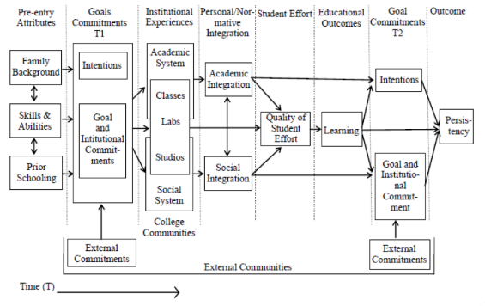
Figure 1. Refined model produced by Tinto (1997, p615)

Bean (1982) offers a different point of view to that of Spady and Tinto. He argues that factors affecting the staff turnover in an organisation directly correlates with the factors causing student dropouts (Bean, 1982; Burke, 2019). In other words many of the factors that cause students to dropout are the same factors that cause employees to leave. Some such factors identified by Bean’s model includes Institutional Satisfaction, value of education, opportunities for further engagement, institutional rules, and regulations.

    - Studies on student retention and widening participation (WP)
As defined above, WP enables HEP’s to reduce stratification or increase diversification of their portfolio of students. This involves providing students from underrepresented groups in the society which include BAME, LGBTQ, mature, and disabled groups. The relationship between student retention in programmes catered towards WP has been well researched. Many authors point out that students from such disadvantaged backgrounds tend to perform less well comparatively and has a high risk of dropout (Mcduff et al., 2018; Thomas, 2020; Reilly et al., 2021).
Mcduff et al., (2018) states that causes for the attainment gap among BAME students are complex and researchers generally agree that entry requirements, socio-economic status, work and family commitments, cultural background etc. Many other researchers have investigated various contextual factors such the educational policies and institutional factors (Thomas, 2020).
However, O’Sullivan et al., (2019) feels that the foundation year of the English universities has not be researched sufficiently. Thus, it would be useful to explore this area further.

    - Studies related to customer satisfaction and student retention
Many authors point out that HE is a provision of a service (Mazzarol, 1998; Ostrom, Bitner and Burkhard, 2011; Guilbault, 2018) thus students are seen as the customers or the recipient of services. A study conducted by Koris and Nokelainen, (2015) has found out that students expected to be treated as customers by HEPs. Therefore, for the purpose of this report students will be considered as the customers in HE.
Customer satisfaction is a well-researched area within the field of Marketing. There are many models developed by various authors which explains the factors affecting customer satisfaction. For example, SERVQUAL model developed by Parasuraman et al (1988) and American Customer Satisfaction Index model developed by Fornell (1996) has been used widely by many scholars in different contexts (Nguyen et al., 2021).
This study would aim to apply the SERVQUAL model in the given context to ascertain the relationship between student satisfaction and retention.
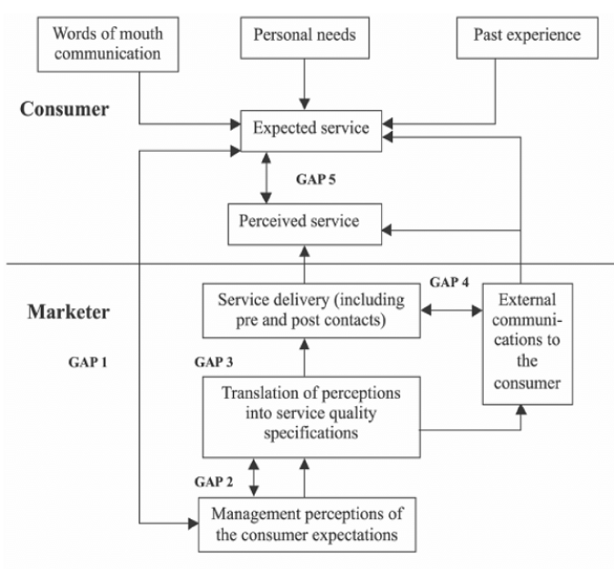
Figure 2. The SERVQUAL model
(Source: Parasuraman, Zeithaml and Berry, 1985; p.44)

Having defined the key concepts together with brief explorations of the key areas of the proposed research in this section, the attention will now be focused on the gap/s intended to be filled by the proposed research.

The research gap

As mentioned at the start of the section, this research will consider student retention from three broad dimensions as illustrated in figure 3 below.
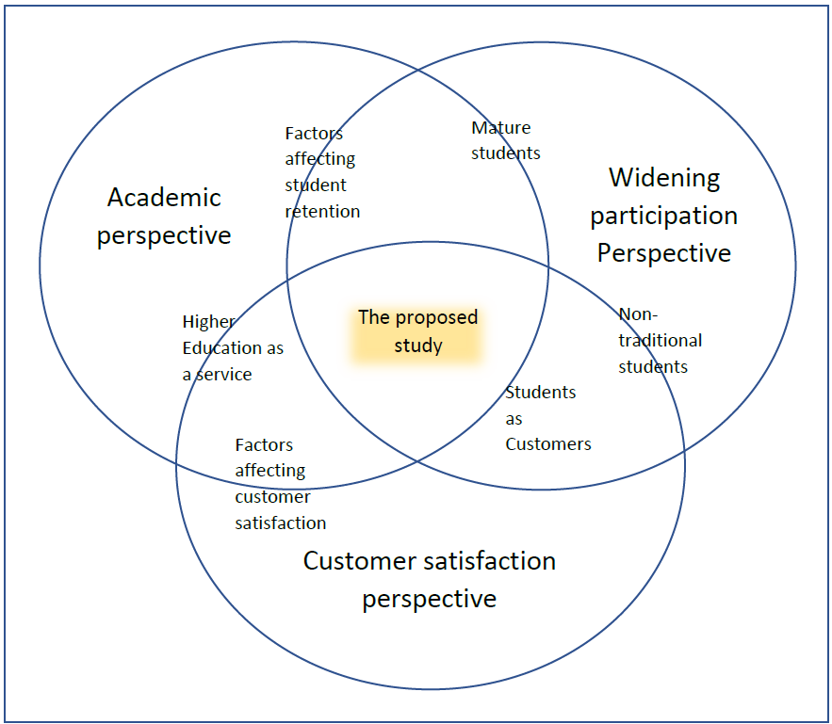
Figure 3. Various dimensions of existing literature

As illustrated in figure 3, the scope of this research is spread across three themes. As noted in the previous section, a wealth of research has been conducted on student retention in HE with well-developed models which are tested in various contexts. Furthermore, there are numerous studies as mentioned above which explains the various factors that affects student satisfaction. These studies have also branched out to explain the positive relationship between student satisfaction and retention. Finally, there is an emerging stream of literature which has focused on WP which also attempts to explore the relationship between student retention and WP.
It is notable that there are mutual connections between any two of the three themes identified above. However, it is difficult to identify the interrelationships between all three of these themes as indicated by the question mark within the intersections of figure 3 above.
This research intends to contribute to reducing this void by fulfilling the aims and objectives stated below.

    - Conceptual framework
As indicated in the section above, this research will attempt to examine the relationship between retention, WP, and customer satisfaction elements. Hence, a conceptual framework has been developed (as illustrated in figure 4 below) by combining the key factors identified by the theoretical models of Tinto and Parasuraman et al.
Key variables identified by Tinto (1997)

Factors related to the institution

Factors related to the student
Key variables identified by SERVEQUAL model
Expected service
Service provided
Satisfaction
Retention

Pre-entry attributes
Institutional experience

Figure 4. Conceptual framework

The conceptual framework identifies the key variables for the study as pre-entry attributes and expected service levels from a student perspective as well as Institutional experience and the quality of service provided from an institutional perspective as factors affecting satisfaction and thereby retention.

Proposed research aim, objectives, and questions

Creswell, (2014) states that when a broad area is the subject of the study, a focus statement should be made which explains the intent/purpose of the research. This statement will then guide in subsequent steps of the research.
Based on the explanations provided above, the broad aim of this research is;
“To critically explore the reasons underlying retention rates of students enrolled on the programmes catering for widening participation in higher education offered at UWTSD Birmingham”.

The following research objectives have been developed to breakdown the above aim and facilitate its achievement.
- To critically analyse the relevant literature in relation to student retention in higher educational institutes and the causes with a particular focus on widening participation and student satisfaction.
- To critically analyse the causes affecting retention of students in programmes aimed at widening participation at UWTSD Birmingham
- To critically Investigate the extent to which Tinto’s model explains the rates of retention for the programmes aimed at widening participation in UWTSD Birmingham
- To make recommendations on how to improve student retention on widening access programmes offered at UWTSD Birmingham.

According to Creswell, (2014) and Johnson and Christensen, (2014) developing research questions is a significant step which helps in narrowing down the research aim and objectives to specific areas which will be studied by the research. These research questions should be closely aligned to the research objectives, cover all aspects of the research aim, and be achievable (realistic) (Doody and Bailey, 2016).
In attempting to achieve the above objectives, this research will seek to answer the following questions.

- What are the factors identified by the literature in relation to student retention?
- How are these factors identified by the literature applied to retention levels of the widening access programmes at UWTSD Birmingham?
- How effective are the intervention mechanisms used by UWTSD Birmingham to improve student retention levels for widening participation programmes?

Summary of the section.
This section started with a discussion of the literature related to the chosen area of study. This enabled the identification of three key themes of literature and the interconnections between them. Once the interconnections were established based on the existing literature, a gap was identified which will be explored by this research. The identification of this gap then led in developing the research aim, objectives, and the questions.
The next section of this report will delve deeper into the aspects related to the design of the research while analysing the underlying principles and philosophies which has shaped the design.

Research design

The design of the research provides a map which guides the researcher through various choices in conducting research (Creswell, 2014. p293). In other words, the research design is the plan on how the research aim and objectives will be achieved. This section of the report will attempt to explain the philosophical principles that underlie the proposed research with appropriate justifications for the choices made.
Such choices are created due to the existence of different ‘paradigms’. A paradigm is defined as “a loose collection of logically related assumptions, concepts, or propositions that orient thinking and research” (Bogdan and Biklin S.K., 1998. p22) or as “the philosophical intent or motivation for undertaking a study” (Cohen and Manion, 1994. p38).
According to Lincoln and Guba, (1985) and Lincoln, Lynham, and Guba, (2018) a research paradigm is made up with ontology, epistemology, methodology, and axiology.
The discussion begins with an evaluation of the ontological position of the researcher.

Ontological position

Kivunja and Kuyini, (2017) defined Ontology as “a branch of philosophy concerned with the assumptions we make in order to believe that something makes sense or is real, or the very nature or essence of the social phenomenon we are investigating”. In other words, ontology explains the assumptions made on reality or the existence of “truth”
Bryman, (2016) states that ontological beliefs are generally discussed as a dichotomy. He identifies ‘objectivism’ and ‘constructionism’ as two conflicting notions within ontology.

    - Objectivism
Objectivism is “an ontological position that asserts that social phenomena and their meanings have an existence that is independent of social actors. It implies that social phenomena and the categories that we use in everyday discourse have an existence that is independent or separate from actors” (Bryman, 2016. p33).
Objectivism thus argues truth or reality (Social phenomena) exist irrespective of human beings (social actors). For example, trees exist in the natural world irrespective of the existence of human beings. Therefore, objectivism strongly advocates the detaching the existence of social phenomena (the truth) from the existence of the social actors (Human beings).
Crotty, (1998) uses the phrase “realism” to denote the ontological notion that realities exist outside the mind. In other words, the truth/reality exists, and it has to be discovered carefully. Therefore, “objective detachment” is important in discovering ‘how things really work’ (ibid).
Thus, for a researcher, it means that the truth exists, and it needs to be uncovered by a careful approach which enables the researcher to be objective (detached) in the process.

    - Constructionism
Constructionism is defined as “an ontological position (often also referred to as constructivism) that asserts that social phenomena and their meanings are continually being accomplished by social actors. It implies that social phenomena and categories are not only produced through social interaction but that they are in a constant state of revision” (Bryman, 2016. p33).
In different words, according to constructionism, multiple realities can exist as the social phenomena (truth or reality) can be interpreted by the social actors in multiple ways. From a researcher’s point of view what this means is that each researcher will present a specific version of their social reality and there is no one that can be accepted as definitive.

This research aims to critically analyse the causes affecting the retention levels among students as explain in section 2.3 above. This would require the researcher to interact with numerous parties such as students, and the staff at UWTSD Birmingham. Considering that the researcher is a member of the staff at UWTSD Birmingham, it is expected to have a higher degree of involvement in the proceedings. The researcher also acknowledges the existence of multiple realities which may vary according to the context. But the researcher does not believe that the proposed research questions should have infinite number of explanations/ interpretations depending on the mindset of various researchers.
Furthermore, the researcher would also like to acknowledge the influence of objectivism on the research through the personality of the researcher. By nature, the researcher favours unbiases and presenting a balanced picture of the phenomena. Therefore, the concept of detaching from the phenomena is appreciated by the researcher. However, the researcher rejects the notion of the existence of ‘universal reality’ as explained by objectivism. In a nutshell the researcher rejects both extremes of the ontological philosophies.
Moon and Blackman, (2014) discusses a spectrum of ontological positions ranging between the above-mentioned extremes. They state that ontological positions will vary according to the degree of confidence of the researcher’s ability to define the nature of reality. In other words, towards the objectivist end of the spectrum, believes firmly the existence of a single reality. As we move towards constructionism, the beliefs become more accommodating of the notion that the nature is reality is not static.
Therefore, for the purpose of this research, the researcher would position his ontological beliefs in the middle of the spectrum as illustrated in the figure 5 below.
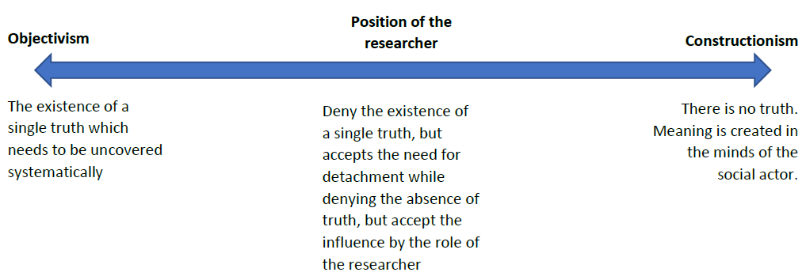
Figure 5. The ontological position assumed by the researcher along the continuum of ontological notions.

Having explained the ontological position of the researcher for this specific study, the attention will now focus on the epistemology.

Epistemological position

Crotty, (1998) states that “Epistemology is concerned with providing a philosophical grounding for deciding what kinds of knowledge are possible and how we can ensure that they are both adequate and legitimate”. In short it is about what we know and how we know it (ibid). Therefore, epistemology is important for researchers as it influences the design of the research in the quest for discovering knowledge in particular social context (Moon and Blackman, 2014; Bryman, 2016; Kivunja and Kuyini, 2017).
Crotty (1998) also stated researchers are confronted with a fundamental question. Which is “is human knowledge something that exists for researchers to identify in an objective way with certainty or is knowledge value laden?”. He goes on to state that the answer for this question would have a significant impact how the research is conducted, and findings will be interpreted. Based on the possible answers which could be provided to the question posed above, Crotty developed a continuum which explains the relationship between the subject and the object. Many other researchers explain various epistemological stances such as positivism, interpretivism etc (Bryman, 2016; Cohen, Manion and Morrison, 2018) However, for the purpose of this report, the continuum explained by Crotty (1998) will be used. Explained below are some of the key points along this continuum.

    - Objectivism
If a researcher strongly believe that reality exists outside of the mind and independent of the researcher, such views or assumptions are regarded as objectivist epistemology (Crotty, 1998). In other words, a researcher with objectivist view would state that reality is consistent and is independent of the perceptions of the researcher. Such researchers would believe that the study of the world should be through objective observations (Moon and Blackman, 2014). This is one end of the continuum as explained by Crotty (1998).
As per this proposal, the researcher does not believe that the reality is fully independent from the perceptions. At least not for the chosen area of study. For example, when collecting data from student participants (subject of the study) related to retention, the responses can vary according to various factors such as the level of how the subject comprehends the question, the state of mind (emotions) of the subject, context such as the time of the day, surrounding etc. In other words, this means that the responses provided by the students will be impacted by many factors. Similarly, the interpretation of these response are also subjected to the comprehension levels of the researcher which can vary depending the levels of knowledge, cultural factors, personal values, attitudes, beliefs etc. Thus, the same response can be subjected to multiple interpretations by different researchers.
Therefore, the notion of Objectivist epistemology is not considered to be suitable for this research by the researcher during the construction of this research.

    - Subjectivism
Subjective epistemology assumes that knowledge is subjected to individual perception of reality (Crotty, 1998; Moon and Blackman, 2014). Therefore, according to subjectivist beliefs reality can be expressed in a range of different ways (Pluralistic) and can be shaped to suit the needs of individuals (Schwandt, 1998). Such beliefs certainly add great value in explaining how an individual’s experience can affect and shape their own experience and perceptions of the world (Cohen, Manion and Morrison, 2018). According to Crotty (1998) subjectivism is at the opposite end of objectivism in the epistemological continuum.
This research proposal favours the notion of subjectivism to a certain extent as it acknowledges the influence of the researcher in the interpretations of the knowledge. For example, the researcher in this context has been involved in WP programmes for a period of over 10 years. Therefore, the researcher possesses insights which may not be available for someone who has not been in the industry or is completely new. Thus, the interpretations made by the researcher could be different to that of someone else. Therefore, subjectivism is seen as a possible stance.
However, a subjectivist approach may result in multiple interpretations regarding the factors affecting retention of the students depending on the nature of the researcher. The researcher does not believe this should be the case. For example, the researcher believes that the knowledge obtained from this study should be applicable at least in similar contexts. Therefore, for the purpose of this report, pure subjectivist epistemology is not considered to be the most appropriate stance.

    - Constructionism
Crotty (1998) explains constructionism as the epistemological viewpoint which considers that human beings construct knowledge as the engage with and interpret the world. In other words, different individuals can construct different meaning of the same phenomenon on different ways. What causes these differences are the cultural, historical, and social aspects of an individual (Crotty, 1998; Creswell, 2014). The key points to note here is the emphasis on the interaction between the subject and the object which leads to the creation of knowledge. This therefore differs from the notion of subjectivism where the subject imposes meaning or interpretations on the object as explained above in section 3.2.2. Therefore, constructionist assumptions of knowledge creation implies that if the human beings are from a similar background / context, the interpretations they make should broadly be similar. Thus, in a nutshell, constructionism appears to occupy the middle ground of the epistemological continuum.
Constructionism as an epistemological stance is felt very appealing for this research. The researcher strongly believes that knowledge can be created with appropriate interactions with the subject (students). Moreover, the acknowledgement of the impact from the background of the researcher is also crucial. This awareness will allow the researcher to take appropriate steps in avoiding any biases which may hinder the interpretation of results. Therefore, the researcher will accept the notion of constructivism in designing the research.

The researcher acknowledges the importance of the epistemological notions not only in conducting this research but also in own conduct / practices. As the researcher feels strongly that knowledge is created collaboratively, steps will be taken where possible to enhance collaboration, to seek feedback, participate in peer reviews, instead of pursuing highly independent learning strategies.
This section discussed various epistemological stances and attempted to explain the epistemological positions taken by the researcher in developing this proposal. Having done this the next section will explain the axiological perspectives which has been taken into consideration in developing this proposal.

Axiological perspective

According to Kivunja and Kuyini (2017) axiology is related to the ethical consideration which needs to be addressed in the process of developing a research proposal. Such ethical aspects may include the value attributed to many parties who are related to the research such as the participants of the research, the data gathered, and the audience (which the results will be presented to) (ibid).
Therefore, axiology implies that the researchers understanding of the right and wrong will have a significant impact on the design, implementation, interpretation, and presentation of the research. Explained below is how the researcher would expect to meet the ethical requirements based on four main areas as identified by Kivunja and Kuyini, (2017).

    - Privacy
This research will be designed to provide the optimum level of privacy by carefully analysing the information needed to make the research meaningful. This would require careful thought of what information is required to be disclosed and what is not.
Moreover, once the information has been collected every possible step will be taken to ensure the information provided remains private. The researcher would respect the privacy of all participants in the process.

    - Accuracy
Accuracy is considered by the researcher as an integral part of the validity of the study. During the research process, steps will be taken to cross check data where applicable. For example, once an interview is done with a participant, the participant can be given a transcript of the interview to verify if the records provided an accurate account of the discussion. The researcher would also take appropriate steps in the processing data to minimise errors. It is of utmost importance to the researcher to avoid any misrepresentation, fabrication or falsification of data. Therefore, steps will be taken to make every step of the research transparent and recorded appropriately.

    - Property
This refers to the ownership of the data. Particularly when there are cost implications associated with collecting data, there can be questions related to the ownership of the data. As this research is conducted within the context of UWTSD where both the subject of study (the researcher) and the object of the study (the students) are integral parts of the university, the data gathered will be considered a property of the university.

    - Accessibility
This refers to who would have access to the data? How would it be stored securely? Etc. As mentioned above, the data gathered for this research will be a property of the university. Therefore, staff members with the appropriate authority will have access to the data. This may include, supervisory staff of the research, management, senior management etc. The data will be stored in the university cloud storage. This is a safe location from a security perspective and will have appropriate access management protocols built in making it safe and convenient
No information related to the research will be stored in any of the private equipment belonging to the researcher.
Appendix one provides further ethical considerations based on the ethical grid produced by Seedhouse (2008).

Summary of the section
This section was mainly focused on the philosophical ‘paradigms’ which is instrumental in shaping the proposed research. In the process, this section explained the ontological, epistemological, and axiological stances favoured by the researcher which has influence the design of the research.
Among the two contrasting ontological positions identified in the literature, the researcher has chosen the middle ground based on the philosophical understanding. Similarly, the researcher has also favoured a middle position on the epistemological continuum. The final section explained the axiological stance of the researcher. Here the key ethical aspects which will need to be taken into consideration when designing the research has been looked into.
Having discussed the key philosophical principles that underpins the design of this research, the next section will explain the influence of these principles on the methodological design of the research.

Methodology

The methodology of a research is often regarded as a blueprint or a road map which is used by the researchers to enable their work to be open to further analysis, critique, replication, or repetition in the future, and/or to adapt and choose the research methods (Given, 2018). In other words, it is the path followed by the researcher to discover the knowledge. Having clearly laid this path will enable evaluations, comparisons, and replication in the future.
It is the research methodology that translates the ontology, epistemology, and axiological perspectives into instructions, methods, and activities that shapes the research (Sarantakos, 2017). Creswell and Creswell (2018) identified three key elements which forms the methodology of the research. Namely, the selection of the research approach, the research designs (strategy), and specific research methods. The sections below will explain these elements in relation to this research.

Research approach

Various authors such as Bryman, (2016); Sarantakos, (2017); Cohen, Manion and Morrison, (2018); Creswell and Creswell, (2018); Denzin and Lincoln, (2018); Given L M, (2018) has identify different approaches to research which captures the broad assumptions underpinned by the philosophical stances. These approaches are named as
- Quantitative research approach
- Qualitative research approach and
- Mixed methods approach
Creswell and Creswell, (2018) states that the above approaches should not be seen as rigid distinct categories or dichotomies. Instead, they should be seen as options along a scale of which the choice would depend on various factors. The following sections will briefly explain these research approaches and with a justification of the chosen approach by the researcher.

    - Quantitative research approach
Quantitative research approach has its roots embedded in objectivist ontological perspective (also known as positivism / scientific method) (Cohen, Manion and Morrison, 2018). This research approach generally involves deriving data from participants, analysing data deductively to test theories (Johnson and Christensen, 2014; Creswell and Creswell, 2018; Denzin and Lincoln, 2018). In other words, quantitative approach to research is guided purely of numerical data and strict statistical rules (Mulisa, 2022). Therefore, quantitative research usually involves testing hypothesis, measuring cause and effect, prediction of variables, removing confounded variables, and lessening researcher bias (Johnson and Christensen, 2014).
As explained in section 3 (research design) above, the ontological and epistemological stances taken by the researcher does not support a purely scientific study. Particularly when the researcher believes that there can be multiple “truths” which would explain the causes behind student retention. Therefore, the research approach used in developing this research will be a lesser degree of quantitative approach.

    - Qualitative research approach
Qualitative research, on the other hand, attempts to explore and understand the meanings assigned to social or human problems by groups or individuals (Creswell and Creswell, 2018). Such qualitative research process would generally involve data which are typically collected from the setting of the participant, analysing such data inductively to arrive at generalised themes, and the researcher making interpretations of the data (ibid).
Mulisa, (2022) states that qualitative research approaches are generally aligned in subjectivist ontological notions and constructivist epistemological notions where the belief is that reality is constructed by the researcher and there can be multiple such realities.
Thus, as explained in the research design (Section 3) a qualitative research approach is in line with ontological and epistemological positions taken by the researcher.

    - Mixed methods approach
As the name suggests, mixed methods approach involves a mixture of the quantitative and qualitative methods. In other words, mixed methods are used to collect quantitative and qualitative data and using distinct research designs based on the philosophical assumptions and theoretical frameworks (Creswell and Creswell, 2018).
Mulisa (2022) states that mixed methods approach is unique due to its ability to help the researcher understand complex phenomena which could be difficult to understand using a single research approach. As explained previously quantitative approaches will enable the researcher to understand a particular phenomenon deeper while qualitative research will enable the researcher to generalise the findings.

For this research, a qualitative approach will be used for the following reasons.
- The objectives of the research are in line with the goals of qualitative research.
Maxwell (2012) identified five different objectives qualitative research can be used for. These revolve around understanding the participants of a study, within a specific context, explore the process, and produce causal explanations.
The overarching aim of this study as explained in section 2.3 is “to critically explore the reasons underlying retention rates of students enrolled on the programmes catering for widening participation in higher education offered at UWTSD Birmingham”. This involves deriving deeper understanding of the participants, within the context of WP and in the geographical location of Birmingham. Thus, qualitative research can be seen as a “good fit” for meeting the aims of this research.

- The need to produce in depth understanding of a social phenomenon.
Creswell (2014) states that qualitative research is useful in attempting to establish a deeper understanding of how various features affect a particular social phenomenon. As this study aims to examine “student retention” and the various factors affecting retention within the context of UWTSD Birmingham, a qualitative study would be suitable.

- Alignment with research philosophy.
As the researcher has chosen a middle ground between objectivism and constructionism ontologically as well as the middle ground of the epistemological spectrum as explained in sections 3.1 and 3.2 above, it is felt that a qualitative approach in research would be most justifiable for this research.

As the researcher has identified a qualitative approach to be most justifiable, the following section will explain the main research strategies which will be used in seeking answers to the research questions. Therefore, the research design (explained in section 4.2 below) will consider various qualitative strategies in the attempt to achieve the research objectives.

Research design (Strategy)

As discussed in the above section a qualitative research methods approach has been justified for this research. Creswell and Poth, (2016) identified 5 different strategies for implementing a qualitative research approach. The following sections explain these strategies and how they will be used in this research.

    - Ethnography
Ethnographic studies are aimed at identifying shared patterns of behaviour, beliefs, and languages among specific cultural groups (Creswell and Poth, 2016). Reeves, Kuper and Hodges (2008) states that ethnographical studies provide a “holistic insights into people's views and actions, as well as the nature (that is, sights, sounds) of the location they inhabit, through the collection of detailed observations and interviews”. They further state that ethnographers are expected to be involved heavily in the “world” they study due to the complex nature of social life.
The aim of this proposed study does not include in depth study within a possible cultural group of students. Instead, this study would focus on the student population on WP programmes at UWTSD Birmingham. Therefore, an ethnographic study is deemed unsuitable for meeting the purpose of this study.

    - Grounded theory
Grounded theory is identified as a qualitative research method which aims to produce a theory which is grounded in data collected and analysed systematically (Creswell and Poth, 2016; Noble and Mitchell, 2016). Hence, grounded theory method is useful for research which is aimed at fulfilling a theoretical void.
As mentioned previously, the purpose of this research is not to develop a new theory related to student retention. On the contrary, this study attempts to extend the application of existing theories to the context of WP within a specific geographic location. Therefore, a grounded theory approach is considered unsuitable for this study.

    - Phenomenology
Phenomenology attempts to explain how people experience and interpret the world / phenomena (Gallagher, 2022). Creswell and Poth, (2016) suggests that phenomenologists should gather data on “what” they experienced and “how” they experienced by encountering a particular phenomenon. Hence the identification of a central “phenomenon” is crucial for a study of this nature.
However, the focus of this research is not how students perceived or experienced retentions or withdrawal. The study would look student retention as a process and would attempt to identify the factors that affect this process with the intention of making suggestions on how to improve the processes to enhance retention within the chosen context. Therefore, a phenomenological approach has not been adopted for this research.

    - Narrative study
Narrative research is considered as a qualitative research method which is aimed at investigating lived experiences usually in the form of a story organised chronologically (Clandinin, 2006; Creswell and Poth, 2016). It requires gathering extensive amounts of detailed information related to one person or two (ibid). Bogdan and Biklin (1998) state that the amount of details needed to produce a complete picture can be a significant challenge in using this method.
Once again, this study does not aim to produce the “life story” of a particular student enrolled on the WP programme. Instead, the study would be investigating the factors affecting retention among students on the WP programmes delivered at UWTSD Birmingham. Therefore, narrative research is considered not to be suitable for this study.

    - Case study
Case study is a research method used to derive in depth understanding of complex phenomena in real-life contexts (Yin, 2014; Crowe et al., 2011). Therefore, a case study is a useful tool to answer “how” and “why” type of research questions which demands an in-depth understanding bounded by a specific context.
A case study approach is considered to be suitable for this research due to the reasons explained below;
- Specific focus on a context
As explained previously, this research focuses specifically on UWTSD’s Birmingham campus. The focus is further narrowed down to studying the retention levels among the students enrolled on the WP programmes. Thus, a case study approach is well suited for this specific context in comparison to the various other qualitative research methods which were explained above.
- The type of research questions
The research questions of this study focus on producing a deeper understanding of “how” various factors affect retention as well as “how” effective are the mechanisms used by UWTSD Birmingham in improving retention within the chosen programmes for this study. As per the definition provided above on case study as a research method, it is well suited for this type of study.

Implementation of the research methods

As explained in section 4.2 above, this research will use a case study strategy in order to achieve the research objectives. This section of the report will explain how these strategies will be implemented. In the process, specific attention will be given to explaining the data collection methods, data analysis techniques chosen for this research, and steps taken to ensure reliability and validity.

    - Data Collection
Data collection methods are the steps followed by a researcher to collect evidence required in relation to the research questions, organise the information, and document the information (Creswell, 2014). Yin (2014) identified six methods which can be used to gather evidence for case study research. Explained below are these six methods with a brief justification for using/not using each method in this study;
Documentation – This includes gathering information from various sources such as published reports, letters, memorandums, or any other documents which can provide the required information.
Documentation will be considered a strong source of evidence in the quest for finding answers for the research questions of this study. Therefore, a data base will be built consisting information mainly available in the format of published reports from internal sources. Reports published by external sources such as the HESA will also be used considering the suitability of the reports to the aim of this study.

Archival records – Archival data can include maps, charts, personal records (such as diaries, logbooks) etc which is mostly of historical significance.
As this study is focused on the factors affecting the process of student retention, the relevance of archival records is not very strong. Thus, archival records will not be considered as a source of evidence for this study.

Interviews – This is one of the most important sources of information in a case study (Tellis, 1997). Interviews can be used to gather opinions on events or facts (open ended), short interviews based on a protocol (focused), or surveys (structured) (ibid).
As explained in section 2.1, there are many factors that affect student retention. Identifying what factors affect students on the chosen programmes can be complicated due to the background nature of students. Hence, this study will use a mixture of interview methods as the primary method of data collection from intended participants such as students and staff. This would enable the collection of accurate information by providing clarifications where necessary to bring out opinions, feelings, and emotions (Denscombe, 2017).

Direct observation – A researcher visiting the site to gather information results in direct observation (Tellis, 1997).
This research does not intend to observe students’ behaviours during the classroom at this stage. Therefore, direct observations are not used at this stage.

Participant observation – Takes place when the researcher participates actively in the event being studied. Such studies are commonly used in the field of anthropology (Tellis, 1997).
This method would not be used in this research as it would not be feasible for the researcher to participate in the journey of a student.

Physical artifacts – this may include any physical evidence gathered during site visits such as notebooks, art works, printouts etc.
As mentioned previously, no site visits are planned at this stage of the study. Therefore, this method of data collection will not be relevant for this study.

As mentioned above, using multiple sources of information such as documents and interviews will enable triangulation (Crowe et al., 2011) which will be explained in section 4.3.3 below.

    - Data Analysis
Being able to make sense and provide coherent interpretations is the focus of data analysis (Crowe et al., 2011). Data will need to be coded and organised which will enable easier retrieval at later stages (ibid). Coding and organising data will help in identifying key themes emerging from the data set as well as from the literature.
Miles, Huberman and Saldaña (2020) identified 4 stages in the process of qualitative data analysis. Explained below are how these stages will be carried out during this research.

Data collection – please refer to section 4.3.1 above on data collection methods.
Data condensations – According to Miles, Huberman and Saldaña (2020),data condensation involves selecting, focusing, simplifying, and transforming data to make data stronger.
Data display – Data display refers to an organised, condensed assembly of information which enable reflections to be made and/or actions to be taken
Drawing and verifying conclusions – Making meaningful interpretations based on the patterns identified during the analysis is considered as drawing conclusions. These conclusions then need to be verified.

To facilitate the above stages of this research, the researcher will use NVivo, a computer-based software for organising and displaying data.

    - Validity and reliability
Validity of a research is defined as “a demonstration that a particular instrument in fact measures what it intends, purports or claims to measure” (Cohen, Manion and Morrison, 2018; p245).
Riege, (2003) identified three broad branches of validity while Creswell and Creswell (2018) explained different methods to enhance validity of case study research. The below table summarises how this research intends to adopt the methods and suggestions made by Riege and Creswells.

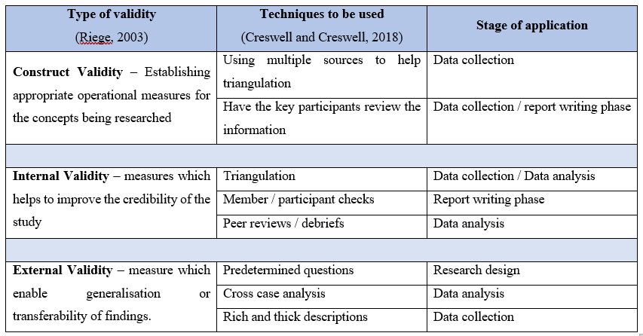
Table 1 - Measures to enhance validity

Reliability of a research indicates that the researcher’s approach is consistent across different researchers and among different projects (Creswell and Creswell, 2018). This implies that replicability and repeatability of results or observations. The table below explains the methods which will be used to enhance the reliability of this study

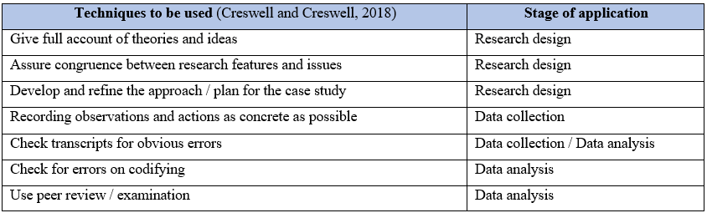
Table 2 - Measures to enhance reliability

Summary of the section
Being one of the largest sections of this report, section 4 covered 3 key areas related to methodology. The section highlighted the research approach adopted for this study which is a “qualitative approach”. This is based on the epistemological position of constructivism.
Secondly the section explained the various research strategies that would be used in this research. Amongst various qualitative research strategies, the researcher has chosen the “case study method” for the purpose of this research.
Finally, the section explained the details related to interviews and document reviews as methods of data collection which will be utilised for this research.

Reflexivity and Positionality

Having considered the key elements related to the design of the research, this section will explain details related to the connections between the researcher and the research.
Reflexivity recognises that the researcher is an integral part of the social world which is being researched (Cohen, Manion and Morrison, 2018). Therefore, it is important that the researcher becomes neutral to maintain objectivity. Therefore, reflexivity suggest that researchers should acknowledge and disclose themselves in the research (ibid). Thus, this section of the report will provide key insights related to the background of the researcher.

- Biographical and personal information
The researcher is a 42-year-old male from an Asian ethnic group currently residing in the UK. The researcher considers the knowledge of Asian cultures would serve as an advantage as a larger proportion of the students enrolled on the widening access programmes are of an Asian origin.
Personally, the researcher highly values the principles of fairness, morality, and self-discipline. Therefore, the researcher feels very strongly about the topic of the research as it is related some of the wider social concerns related to accessing, HE. The researcher feels that this contributes to changing many lives which aligns with the ethos of UWTSD “Transforming education, Transforming lives”
- Employment history
The researcher is currently serving as a Senior Lecturer at UWTSD Birmingham. Prior to the current role, the researcher has held various academic positions over a period of 12 years. For most of this period the researcher has been engaged in programmes aimed at WP in HE. Therefore, the researcher would be starting the study with significant experience related to topic of the research. Although this is view as a positive attribute, the researcher is also aware of potential bias due to previous experiences.
It is in this background that the researcher will be conducting this research in the current place of employment.

- Research setting and the relationship between the researcher and the researched
The relationship between the researcher and the researched is also known as positionality (Cohen, Manion and Morrison, 2018). As mentioned above, the researcher is a staff member of the proposed location of the research. Furthermore, the researcher is actively engaged in managing programmes aimed at WP. This includes various activities from recruiting students for the programme, to managing the delivery of the programme.
Therefore, the researcher would be constantly in contact with various stakeholders who may form part of this research. The researcher is aware of the influence this may have on the research. Thus, appropriate steps will be taken to minimise the potential biases.
Furthermore, as a current employee of the organisation, the researcher is bound by contract of employment. Therefore, the research will be conducted within the parameters set by the institution.
Despite prior knowledge of the participants of the study, all will be provided the same levels of guidance, choice, and access to information. In other words, steps will be taken to treat all participants fairly and equally.

Summary and conclusion

The main aim of this research is “to critically explore the reasons underlying retention rates of students enrolled on the programmes catering for WP in HE offered at UWTSD Birmingham” as explain in section 2.3.
In the process of designing the research to achieve the above aim, this report considered important literature which has been published. Analysing the existing literature, it was noted that a wealth of research publications is available in relation to student retention, issues related to WP, and students as customers. However not much research has been conducted covering all three of these areas. Thus, this was identified as the “research gap” which this research would be contributing to.
This report also examined various philosophical concepts and principles which shaped the design of this study. Figure 6 below illustrates the key choices made by the researcher in designing the research.
Ontological position
Objectivism
Constructionism
Epistemological position
Objectivism
(Positivism)
Constructivism
(Interpretivism)
Research approach
Quantitative
Qualitative
Position chosen by the researcher

Research Methods
Ethnography
Grounded Theory
Phenomenology
Case Study
Narrative

Figure 6 - Key choices affecting the research design

Table 3 below summarises the key paradigmatic elements and the respective assumptions and choices made in designing the research.
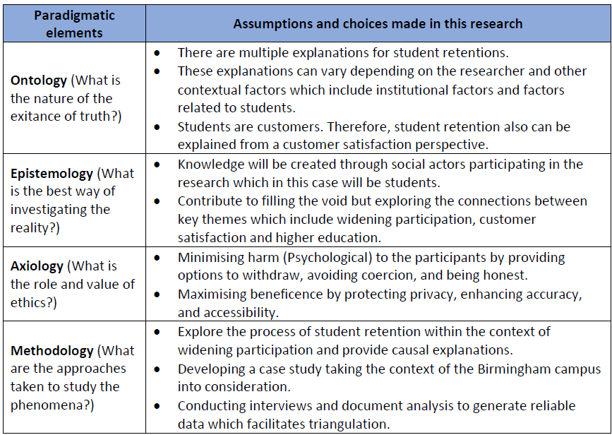
Table 3 - Summary of the assumptions and choices

The key data collections tools proposed for this study would be document review and interviews. Upon collecting the data, the researcher intends to use the NVivo software package to conduct thematic analysis.
Being a qualitative study, the steps followed by the researcher to enhance the validity of the data and the reliability of the methods are very important. Section 4.3.3 highlighted the key steps which would be followed during each of the stages of the research to enhance validity and reliability.
Finally, the report is concluded with a reflexive and positionality statement which explains the influences the researcher as a person may have on this qualitative study. The researcher firmly believes that completing this study as per the plan presented in this report would enable the fulfilment of the research aim whilst contributing to the knowledge in the relevant field.

References

Aljohani, O. (2016) ‘A Comprehensive Review of the Major Studies and Theoretical Models of Student Retention in Higher Education’, Higher Education Studies, 6(2), p. 1. Available at: https://doi.org/10.5539/hes.v6n2p1.
Ashby, A. (2004) ‘Monitoring student retention in the open university: Definition, measurement, interpretation and action’, Open Learning, 19(1), pp. 65–77. Available at: https://doi.org/10.1080/0268051042000177854.
Bean, J.P. (1982) ‘Conceptual models of student attrition: How theory can help the institutional researcher’, New Directions for Institutional Research, 1982(36), pp. 17–33. Available at: https://doi.org/10.1002/IR.37019823604.
Bogdan, R.C. and Biklin S.K. (1998) Qualitative research for education: An introduction to theory and methods. 3rd edn. Boston: Allyn and Bacon.
Bryman, A. (2016) Social research methods. 5th edn. Oxford: Oxford University Press.
Burke, A. (2019) ‘Student Retention Models in Higher Education: A Literature Review’, College and University, 94(2).
Clandinin, D.J. (2006) ‘Narrative inquiry: A methodology for studying lived experience’, Research studies in music education, 27(1), pp. 44–54.
Cohen, L. and Manion, L. (1994) Research methods in education. 4th edn. London: Routledge.
Cohen, L., Manion, L., and Morrison, K. (2018) Research Methods in Education. 8th edn. London: Routledge.
Connell-Smith, A. and Hubble, S. (2018) Widening participation strategy in higher education in England.
Creswell, J.W. (2014) Educational Research: Planning, Conducting, and Evaluating Quantitative and Qualitative Research. 5th edn. New Jersey: Pearson Education.
Creswell, J.W. and Creswell, J.D. (2018) Research design: Qualitative, quantitative, and mixed methods approaches. 5th edn. Thousand Oaks, CA: SAGE Publications.
Creswell, J.W. and Poth, C.N. (2016) Qualitative inquiry and research design: Choosing among five approaches. Sage publications.
Crotty, M. (1998) The Foundations of Social Research: Meaning and perspective in the research process. London: Sage.
Crowe, S. et al. (2011) ‘The case study approach’, BMC Medical Research Methodology, 11, p. 100. Available at: https://doi.org/10.1186/1471-2288-11-100.
Denscombe, M. (2017) EBOOK: The good research guide: For small-scale social research projects. McGraw-Hill Education (UK).
Denzin, N.K. and Lincoln, Y.S. (2018) The Sage handbook of qualitative research. Fifth edition. Los Angeles: Sage.
Department for Children, E.L.L. and S. (2009) Student Withdrawal from Higher Education Yr Adran Plant, Addysg, Dysgu Gydol Oes a Sgiliau Department for Children, Education, Lifelong Learning and Skills. Available at: http://wales.gov.uk/topics/educationandskills/.
Doody, O. and Bailey, M.E. (2016) Setting a research question, aim and objective.
Foster, Jen. (2022) How are UK universities working to improve student retention?, https://www.qs.com/how-are-uk-universities-working-to-improve-student-retention/.
Gallagher, S. (2022) ‘What is phenomenology?’, in Phenomenology. Springer, pp. 1–10.
Given L M (2018) The SAGE Encyclopedia of qualitative research methods. California: Thousand Oaks.
Gorard, S. et al. (2019) ‘Which are the most suitable contextual indicators for use in widening participation to HE?’, Research Papers in Education. Routledge, pp. 99–129. Available at: https://doi.org/10.1080/02671522.2017.1402083.
Guilbault, M. (2018) ‘Students as customers in higher education: The (controversial) debate needs to end’, Journal of Retailing and Consumer Services, 40, pp. 295–298. Available at: https://doi.org/10.1016/j.jretconser.2017.03.006.
Hagedorn, L.S. (2005) How to define retention: A New Look at an Old Problem.
HESA (2022) Higher Education Student Statistics: UK, 2020/21 - Student numbers and characteristics | HESA, HESA. Available at: https://www.hesa.ac.uk/news/25-01-2022/sb262-higher-education-student-statistics/numbers (Accessed: 16 December 2022).
Higher education | National Careers Service (no date). Available at: https://nationalcareers.service.gov.uk/explore-your-education-and-training-choices/higher-education (Accessed: 30 November 2022).
Hillman, N. (2021) A short guide to non-continuation in UK universities.
Hindmarch, Duncan. et al. (2020) A Concise Guide to Lecturing in Higher Education and the Academic Professional Apprenticeship. Critical Publishing.
Johnson, R.B. and Christensen, L. (2014) Educational Research: Quantitative, Qualitative, and Mixed Approaches. 5th edn. California: Sage.
Kivunja, C. and Kuyini, A.B. (2017) ‘Understanding and Applying Research Paradigms in Educational Contexts’, International Journal of Higher Education, 6(5), p. 26. Available at: https://doi.org/10.5430/ijhe.v6n5p26.
Koris, R. and Nokelainen, P. (2015) ‘The student-customer orientation questionnaire (SCOQ): Application of customer metaphor to higher education’, International Journal of Educational Management, 29(1), pp. 115–138. Available at: https://doi.org/10.1108/IJEM-10-2013-0152.
Kotler, P., Armstrong, G. and and Opresnik, M.O. (2018) Principles of marketing. 17th edition. Harlow: Pearson.
Lincoln Y S, Lynham S A and Guba E G (2018) ‘Paradigmatic Controversies, Contradictions, and Emerging Confluences, Revisited’, in Denzin Norman K. and Lincoln Yvonna S. (eds) The SAGE Handbook of Qualitative Research. 5th edn. California: Thousand Oaks, pp. 213–263.
Lincoln, Y.S. and Guba, E.G. (1985) Naturalistic inquiry. Beverly Hills: Sage.
Maxwell, J.A. (2012) Qualitative research design: An interactive approach. Sage publications.
Mazzarol, T. (1998) ‘Critical success factors for international education marketing’, International Journal of Educational Management, 12(4), pp. 163–175. Available at: https://doi.org/10.1108/09513549810220623.
Mcduff, N. et al. (2018) Closing the attainment gap for students from black and minority ethnic backgrounds through institutional change.
Miles, M.B., Huberman, A.M. and Saldaña, J. (2018) Qualitative data analysis: A methods sourcebook. Sage publications.
Moon, K. and Blackman, D. (2014) ‘A Guide to Understanding Social Science Research for Natural Scientists’, Conservation Biology, pp. 1167–1177. Available at: https://doi.org/10.1111/cobi.12326.
Mulisa, F. (2022) ‘When Does a Researcher Choose a Quantitative, Qualitative, or Mixed Research Approach?’, Interchange, 53(1), pp. 113–131. Available at: https://doi.org/10.1007/s10780-021-09447-z.
Nguyen, T.V. et al. (2021) ‘Factors Affecting Customer Satisfaction with The last-mile Delivery Service of The Food and Beverage Industry E-Commerce in Hanoi City’, Journal of Contemporary Issues in Business and Government, 27(5). Available at: https://doi.org/10.47750/cibg.2021.27.05.008.
Nicoletti, M. do C. (2019) ‘Revisiting the Tinto’s Theoretical Dropout Model.’, Higher Education Studies, 9(3), pp. 52–64.
Nieuwoudt, J.E. and Pedler, M.L. (2021) ‘Student Retention in Higher Education: Why Students Choose to Remain at University’, Journal of College Student Retention: Research, Theory and Practice [Preprint]. Available at: https://doi.org/10.1177/1521025120985228.
Noble, H. and Mitchell, G. (2016) ‘What is grounded theory?’, Evidence-based nursing, 19(2), pp. 34–35.
Ostrom, A.L., Bitner, M.J. and Burkhard, K.A. (2011) Leveraging Service Blueprinting to Rethink Higher Education When Students Become ‘Valued Customers,’ Everybody Wins. Available at: www.americanprogress.org.
O’Sullivan, K. et al. (2019) ‘Academic identity, confidence and belonging: The role of contextualised admissions and foundation years in higher education’, British Educational Research Journal, 45(3), pp. 554–575. Available at: https://doi.org/10.1002/berj.3513.
Parasuraman, A., Zeithaml, V.A. and Berry, L.L. (1985) ‘A conceptual model of service quality and its implications for future research’, Journal of marketing, 49(4), pp. 41–50.
Reeves, S., Kuper, A. and Hodges, B.D. (2008) ‘Qualitative research methodologies: ethnography’, Bmj, 337.
Reilly, D. et al. (2021) ‘An investigation into the self-efficacy of year one undergraduate students at a widening participation university’, Teaching in Higher Education [Preprint]. Available at: https://doi.org/10.1080/13562517.2021.2015756.
Riege, A.M. (2003) ‘Validity and reliability tests in case study research: a literature review with “hands‐on” applications for each research phase’, Qualitative market research: An international journal [Preprint].
Sarantakos, S. (2017) Social Research. 5th edn. London: Red Globe.
Schwandt, T. (1998) ‘Constructivist, Interpretivist Approaches to Human Inquiry’, in Denzin N. K. and Lincoln Y. S. (eds). California: Thousand Oaks, pp. 118–137. Available at: https://www.researchgate.net/publication/232477264.
Seedhouse, D. (2008) Ethics: the heart of health care. John Wiley & Sons.
Spady, W.G. (1971) ‘Dropouts from higher education: Toward an empirical model’, Interchange 1971 2:3, 2(3), pp. 38–62. Available at: https://doi.org/10.1007/BF02282469.
van Stolk, C. et al. (2007) Student Retention in Higher Education Courses International Comparison.
Tellis, W. (1997) ‘Application of a case study methodology’, The qualitative report, 3(3), pp. 1–19.
Thomas, L. (2020) ‘Excellent outcomes for all students: A whole system approach to widening participation and student success in England’, Student Success, 11(1), pp. 1–11. Available at: https://doi.org/10.5204/ssj.v11i1.1455.
Tinto, V. (1997) ‘Classrooms as communities: Exploring the educational character of student persistence’, The Journal of higher education, 68(6), pp. 599–623.
Tinto, V. (2006) RESEARCH AND PRACTICE OF STUDENT RETENTION: WHAT NEXT?*, J. COLLEGE STUDENT RETENTION.
UNESCO Institute for Statistics. (2012) International standard classification of education : ISCED 2011. UNESCO Institute for Statistics.
Webb, O. et al. (2017) Enhancing access, retention, attainment and progression in higher education A review of the literature showing demonstrable impact.
Yin, R.K. (2009) Case study research: Design and methods. sage.

