Abstract
Past research has identified Child maltreatment as a risk factor for Non-Suicidal Self-Injury (NSSI) (Liu,et al., 2018). This study used a non-experimental qualitative approach to examine the effect of child abuse and neglect on non-suicidal self-injury (NSSI). The method used to interpret the data was Interpretative Phenomenological Analysis (IPA). A case study was made of an anonymised extract from the online diary; Self-harm and Cutting an Excerpt from my Memoir my Alien-self my Journey Back to Me. The results found four superordinate themes emerging as the underlying motivation for NSSI, these were the Suppression of Emotion, Self-loathing, Emotional Regulation and Control, and Abuse and Neglect. From this research it seems that the effect of child abuse and neglect on non-suicidal self-injury is accumulative and interwoven, the repression of memories/feelings and the self-loathing that is associated with the rape and the subsequent feelings of lack of love and neglect lead the individual to feel the need to use NSSI to control and regulate painful emotions.
Introduction
Non-suicidal self-injury (NSSI) is defined as the deliberate disfigurement or bodily harm without the intention of suicide, for example scratching, cutting, head banging, or self-burning (Power, Smith & Beaudette, 2016).The Children’s Society’s recent Good Childhood Report (2018) looks in detail at childhood subjective wellbeing, this research suggests that one in five 14-year-old girls report Non-suicidal self-injury (NSSI), and girls were twice as likely to self-harm than boys. The report highlighted the importance of family relationships to the overall wellbeing of young people, children who felt valued and loved showed higher levels of resilience to the risk of self-harm (The Children’s Society, 2018). There has been much interest in the underlying causes of NSSI however we do not conclusively know why it occurs. If we look at Liu, Scopelliti, Pittman & Zamora’s (2018) review and meta-analysis on Childhood maltreatment and how it associates with NSSI, it suggests a strong association between sexual abuse and NSSI, and a weaker but relevant association between emotional neglect and NSSI (Liu, et al., 2018). In 2004 Nock and Prinstein’s qualitative research suggests that individuals use NNSI as a form of emotional regulation, so for example the physical pain of NSSI would mask the psychological pain of the sexual abuse and physical neglect (Liu, et al., 2018). Their research looked at the diaries of individuals with NSSI and from this they developed the four-functioning model, this suggests that NSSI is reinforced by four distinct processes (Bentley, Nock & Barlow, 2014). These four reinforcement factors are structured as follows; positive, negative, automatic and social. For example, positive creates a positive stimulus, this could be the feeling of euphoria reported by self -harmers or even just the lack of numbed emotions, negative is the removal of a negative stimuli, for example the removal of a painful emotions by the replaced physical pain as mentioned earlier (Bentley, Nock & Barlow, 2014), Automatic, that is intrapersonal experience or social for interpersonal motives, so for example the automatic positive could be an individual who self-harms to alleviate the numbness of depression and the social positive could be an attempt to show another how distressed they are, a cry for help, love or attention (Bentley, Nock & Barlow, 2014; Power, Smith & Beaudette, 2016). Studies have also shown that there is an association between individuals who regulate their emotions with NSSI and with an individual’s diminished pain perception (Franklin, Aaron, Arthur, Shorkey & Prinstein, 2012). Another study by Victor & Klonsky, (2013) looked at emotional diaries kept by individuals with NSSI and contrasted them with diaries kept by non NSSI sufferers, this showed that individuals with NSSI reported stronger feelings of self-dissatisfaction and were very self-critical, in these cases the NSSI impulse was the result of a desire to punish oneself (Victor & Klonsky, 2013). Interestingly, self-criticism has also been shown to associate with diminished pain perception (Bunderla & Kumperščak, 2015). Emotional regulation and self-criticism seem to be independent motives but neurobiological research into NSSI suggests that they may both be routed in neurochemical differences in brain function common in both situations, for example, reduced levels of endogenous opioids were reported in individuals with NSSI, these are involved in the perception of pain and behaviours associated with addiction so this might explain the link between diminished pain perception and the addictive qualities of NSSI that many sufferers report. Also, individuals with NSSI have reduced cortisol secretions and a hypo responsive HPA-axis in stressful situations, both these associate with many other stress disorders (Bunderla & Kumperščak, 2015).
Most individuals who engage in NSSI stop within a few years but about 20% of individuals continue for more than five years and in some cases it can be a stronger predictor of suicide than previous suicidal history (Bentley, Nock & Barlow, 2014; Liu, et al., 2018). Understanding the causes of NSSI is important for a variety of reasons, as already mentioned it is physically and psychologically damaging to the self-harmer, however, it also indicates a potential for negative self-image, academic difficulties, it causes psychological distress to other family members and has been associated with the contraction of other infectious diseases like HIV and hepatitis (Bentley, Nock & Barlow, 2014). This research may also give us some insight into other self-damaging behaviours like obesity, smoking and drug/ alcohol abuse and is also vital as it may show us ways to development support strategies, interventions and treatments such as the screening for maltreatment history or seeing self-harm as an indication of possible child abuse or a precursor to suicide (Liu, et al., 2018). The purpose of this current study will be to use the anonymised extract from a diary to examine the effect of child abuse and neglect on non-suicidal self-injury.

Method

Design
A non-experimental qualitative approach was used to examine the effect of child abuse and neglect on non-suicidal self-injury (NSSI). The qualitative method used to interpret the data was Interpretative Phenomenological Analysis (IPA). A case study was made of an anonymised extract from a diary published online, named Self-harm and Cutting an Excerpt from my Memoir my Alien-self my Journey Back to Me (see appendix one).

Participants
This case study was empirical but with no specific participant as it was taken from an anonymised extract from a diary that was supplied by the University and published online, it is called Self-harm and Cutting an Excerpt from my Memoir my Alien-self my Journey Back to Me and is available at; http://amandagreenauthor.co.uk/self-harm-and-cutting-an-excerpt-from-my-memoir-my-alien-self-my-journey-back-to-me/ (link to open resource).
Researcher is R. Hemming, available at; 0801667@student.uwtsd.ac.uk

Materials
Three A4 coloured copies of the original article were printed into hard copy (see appendix one). The words were transcribed into an A4 white paper with black Times New Roman font, size 11 word document (see appendix two). A pen was used to make general notes in right margin and identify subordinate themes in the left margin. Another word document was created to colour code the subordinate into superordinate themes (see appendix three).

Procedure
The original diary extract was downloaded and printed into a hard copy (see appendix one),This was then transcribed into a word document and this was read and re-read 5 times, during these readings general notes were made in the right hand margin, these notes were then analysed for subordinate themes and these were noted in the left margin (See appendix two ) The subordinate themes were input into another word document and then organised using a colour code into groups of superordinate themes (see appendix three). This data was subsequently interpreted using Interpretative Phenomenological Analysis (IPA) and input using a computer and Microsoft Word as per results section below.
Ethical Considerations
These included risks to the researcher’s wellbeing as data might have proved upsetting, I could mitigate these risks by using the university counselling services. However, risks in this study are minimal as this is an anonymous unknown source.
Normally the participants would provide written consent to participate and would be debriefed and withdrawal would be offered before submission. The debriefing would provide links to agencies that provides support for those who have experienced abuse or for those engaged in self-harm. However, Written consent will not be obtained and following the study withdrawal will not be offered as the diary extract is written by an unknown source.
Results/Discussion
This section presents the results for the Interpretative Phenomenological Analysis (IPA) used to examine the diary extract titled Self-harm and Cutting an Excerpt from my Memoir my Alien-self my Journey Back to Me. It is particularly looking at the effect of childhood abuse and neglect on non-suicidal self-injury (NSSI).
Summary Table

Superordinate Themes | Subordinate Themes | Quote Keyword | Page/Line Number
Suppressed Emotions | - Repressed memory  - Depression  - Displaced feelings  - Suppressed feeling  - No self-awareness | “as I searched through my diaries”  “therapy for depression”  “as if I were reading the diary of someone else,”  “I had pushed it into a place so deep I couldn’t retrieve it”  “I never questioned why I did it or anything I did” | Page 1; Line 3.  Page 1; Line 3.  Page 1; Line 5.  Page 1; Line 12.  Page 1; Line 16
Self-loathing | - Self-doubt  - Self -loathing  - Self-blame  - Self-destruction  - Displacement activity | “I felt uneasy about myself”  “with her dirty little secrets and self-destructive behaviour”  “I wasn’t a Virgin”  “Not long after that I cut myself”  “He couldn’t hurt me but I could hurt myself” | Page 1; Line 4  Page 1; Line 5-6  Page 1; Line 6  Page 1; Line 8  Page 1; Line 19
Emotional Regulation and Control | - Cutting  - Ritual  - Pain relief  - Elation/Euphoria  - Emotional regulation | ” every time I made another cut I liked the way it felt”  “My little ritual didn’t satisfy me”  “scratching pain, self-inflicted relief, It gave me relief, the enjoyment I was looking for”  “Marvellous”  “I felt dreadful, I grabbed the knife from the bread board and headed for my bedroom” | Page 1; Line 20  Page 1; Line 32  Page 2; Line 42  Page 2; Line 48  Page 2; Line 55
Abuse & Neglect | - Raped  - Unloved  - Cry for help  - Low Self-Esteem  - Vulnerable | “I rediscovered the rape”  “not because I was told I was loved by my parents because I wasn’t”  “When I showed mum, she wasn’t amused and nor was dad”  “I wanted to love my body, it was the one good thing I had that men wanted”  “I came across something I had written, it said please love me” | Page 1; Line 2.  Page 2; Line 74.  Page 2; Line 49.  Page 2; Line 69.  Page 2; Line 73.

Table one shows four superordinate themes emerging as the underlying emotive motivation for NSSI, these are the Suppression of Emotion, Self-loathing, Emotional Regulation and Control, and Abuse and Neglect. Let us start with the abuse and neglect superordinate theme, we see her mention the rape at the start of the text and later in the context of a forgotten or suppressed emotion, “I rediscovered the rape” (P1, L2) and she alludes to feeling unloved and unheard in a few different ways, for example “ not because I was told I was loved by my parents because I wasn’t” (P2,L74) and “I came across something I had written, It said please love me” (P2,L73). Research has indicated that Childhood maltreatment is associated with NSSI, with a strong association between sexual abuse and NSSI, a weaker association between emotional neglect and NSSI (Liu, et al., 2018).). Other studies have shown how NSSI can be an attempt to demonstrate distress in a situation of neglect, it is a cry for help or love and attention (Power, Smith & Beaudette, 2016; Bentley, Nock & Barlow, 2014).
Liu, Scopelliti, Pittman & Zamora, (2018), research suggests that children use NSSI to regulate and control negative feelings and supress negative emotions and thoughts, this we see indicated in the superordinate theme Suppression of Emotion, there are many indications in the original text that suggest this, for example, “as if I were reading the diary of someone else” (P1,L5) or “I had pushed it into a place so deep I couldn’t retrieve it” (P1, L12) these show that the writer has suppressed and displaced her feelings, this seems an example of the removal of a painful emotions by the replaced physical pain as described earlier in the four-functioning model (Bentley, Nock & Barlow, 2014). This model also suggests how NSSI is used by this individual in the Emotional Regulation and Control superordinate theme section that is described in one quotation as “scratching pain, self-inflicted relief, it gave me relief, the enjoyment I was looking for” (P2, L42) shows that she is able to use the NSSI to create feelings that are positive and even “Marvellouse” (P2,L48) and these feelings can become addictive.
The final superordinate theme is self-loathing, as demonstrated by her comment” her with her dirty little secret and self-destructive behaviour” (P1, L5-6). Research has shown that self-criticism is an associated characteristic of individuals who are prone to self-harm (Victor & Klonsky, 2013), the behaviour is seen as a way to punish themselves as we see in “he couldn’t hurt me, but I could hurt me” (P1, L19). From this research it seems that the effect of child abuse and neglect on non-suicidal self-injury is accumulative and interwoven, the repression of memories/feelings and the self-loathing that is associated with the rape and the subsequent feelings of lack of love and neglect led this individual to feel the need to use NSSI to control and regulate these painful emotions.
Whitlock, Prussien & Pietrusza’s (2015) study that asked self-harmers how they managed to stop came up with the three most common answers, many simply grew out of it or felt that they developed emotional resilience to handle their negative feeling, however, 24% said they stopped because they felt loved, this concurs with The Children’s Society, (2018) research that found that family relationships were key, children who felt valued and loved showed higher levels of resilience to the risk of self-harm (The Children’s Society, 2018). This would suggest that family counselling and family interventions were the way forward. The limitations of this study are that it is the study on one anonymous individual therefore it cannot be said to reflect the experiences of the population at large, also some research has suggested that neurochemical differences in brain function common in both the superordinate theme Self-Loathing and the superordinate theme Controle and Regulate of Emotions could be at the rout of the risk for NSSI (Bunderla & Kumperščak, 2015; Franklin, et al, 2012) this topic would benefit from further research that looks at a larger sample of individuals who suffer from NSSI.

Reflexive Account
I found this research very interesting as it allows you to explore the psychological motivation in a subjective way, it enables you to look closely at an individual case and deeply explore their feelings and thoughts and the life events that shape this. I enjoyed the IPA method and I felt it worked well and was pleased to find that my research tied into many other research papers, unfortunately since it was a single extract from an anonymous diary study it cannot be said to generalise to the population and could be categorised as subjective speculation. However, I feel that with a larger sample group the IPA method is a valid way to analyse qualitative data.
There are some aspects of the contemporary research mentioned above (Bunderla & Kumperščak, 2015; Franklin, et al, 2012), that I found very interested and these I feel would be better investigated using quantitative methods.
Conclusion
This study used a non-experimental qualitative approach IPA to examine the effect of child abuse and neglect on non-suicidal self-injury (NSSI). The results found four superordinate themes emerging as the underlying motivation for NSSI, these were the Suppression of Emotion, Self-loathing, Emotional Regulation and Control, and Abuse and Neglect, this results tied in with the majority of research and suggests that the effect of child abuse and neglect on non-suicidal self-injury is accumulative and interwoven, the repression of memories/feelings and the self-loathing that is associated with the rape and the subsequent neglect lead the individual to feel the need to use NSSI to control and regulate painful emotions. This would suggest that family counselling and family interventions are the way forward.
Diagrammatical Representation of Results

Diagrammatical Representation of Results

Reference List
Bentley, K., Nock, M., & Barlow, D. (2014). The Four-Function Model of Nonsuicidal Self-Injury. Clinical Psychological Science, 2(5), 638-656. doi: 10.1177/2167702613514563.
Bunderla, T., & Kumperščak, H. (2015). ALTERED PAIN PERCEPTION IN SELF-INJURIOUS BEHAVIOR AND THE ASSOCIATION OF PSYCHOLOGICAL ELEMENTS WITH PAIN PERCEPTION MEASURES: A SYSTEMATIC REVIEW. Psychiatria Danubina, Vol. 27,(No. 4,), pp 346-354.
Franklin, J., Aaron, R., Arthur, M., Shorkey, S., & Prinstein, M. (2012). Nonsuicidal self-injury and diminished pain perception: the role of emotion dysregulation. Comprehensive Psychiatry, 53(6), 691-700. doi: 10.1016/j.comppsych.2011.11.008.
Liu, R., Scopelliti, K., Pittman, S., & Zamora, A. (2018). Childhood maltreatment and non-suicidal self-injury: a systematic review and meta-analysis. The Lancet Psychiatry, 5(1), 51-64. doi: 10.1016/s2215-0366(17)30469-8
Power, J., Smith, H., & Beaudette, J. (2016). Examining Nock and Prinstein’s four-function model with offenders who self-injure. Personality Disorders: Theory, Research, And Treatment, 7(3), 309-314. doi: 10.1037/per0000177.
The Childrens Society. (2018). The Good Childhood Report (pp. 7-33). London: The Childrens Society. Retrieved from https://www.childrenssociety.org.uk/sites/default/files/the_good_childhood_report_full_2018.pdf [Accessed 02/01/19].
Victor, S., & Klonsky, E. (2013). Daily Emotion in Non-Suicidal Self-Injury. Journal Of Clinical Psychology, 70(4), 364-375. doi: 10.1002/jclp.22037. https://www2.psych.ubc.ca/~klonsky/publications/VictorKlonsky_EmotionNSSI.pdf [Accessed 02/01/19].
Whitlock, J., Prussien, K., & Pietrusza, C. (2015). Predictors of self-injury cessation and subsequent psychological growth: results of a probability sample survey of students in eight universities and colleges. Child And Adolescent Psychiatry And Mental Health, 9(1). doi: 10.1186/s13034-015-0048-5.

Appendix one, The Effect of Child Abuse and Neglect on NSSI – Original online resource

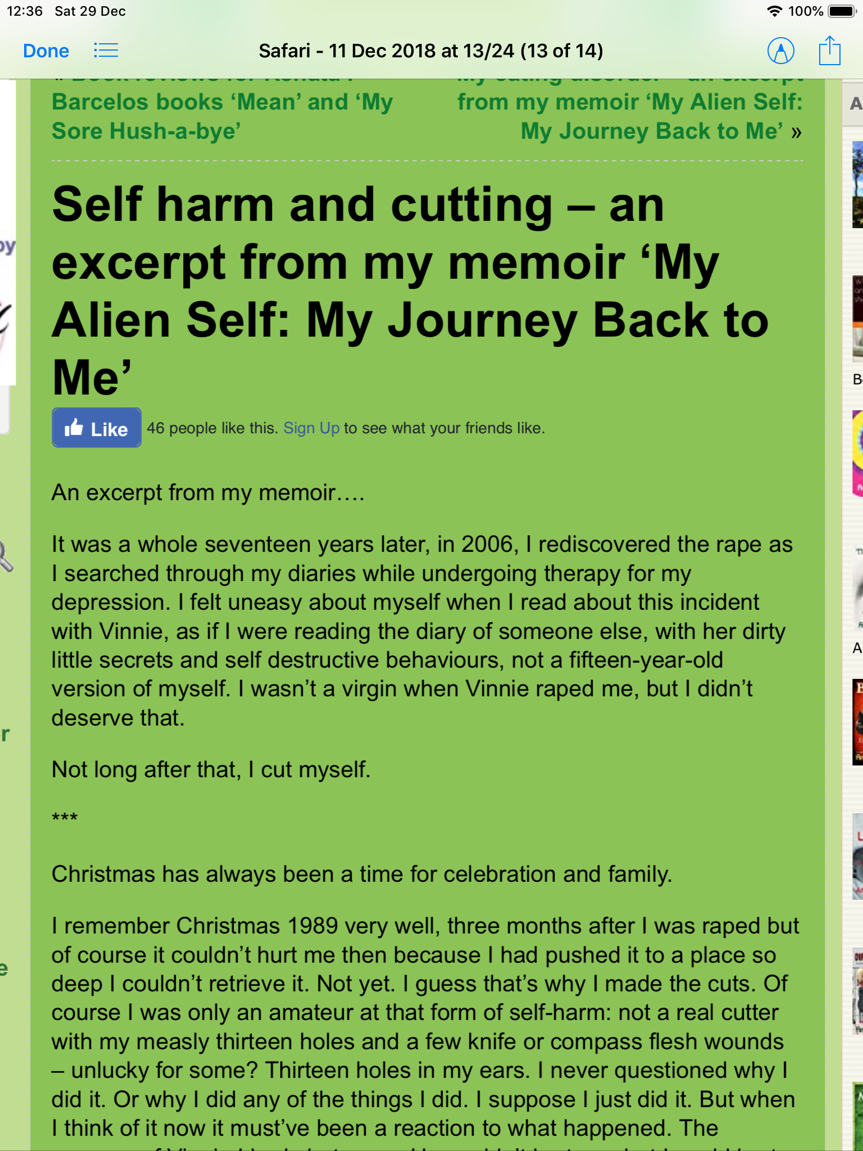

Appendix one continued..., The Effect of Child Abuse and Neglect on NSSI – Original online resource

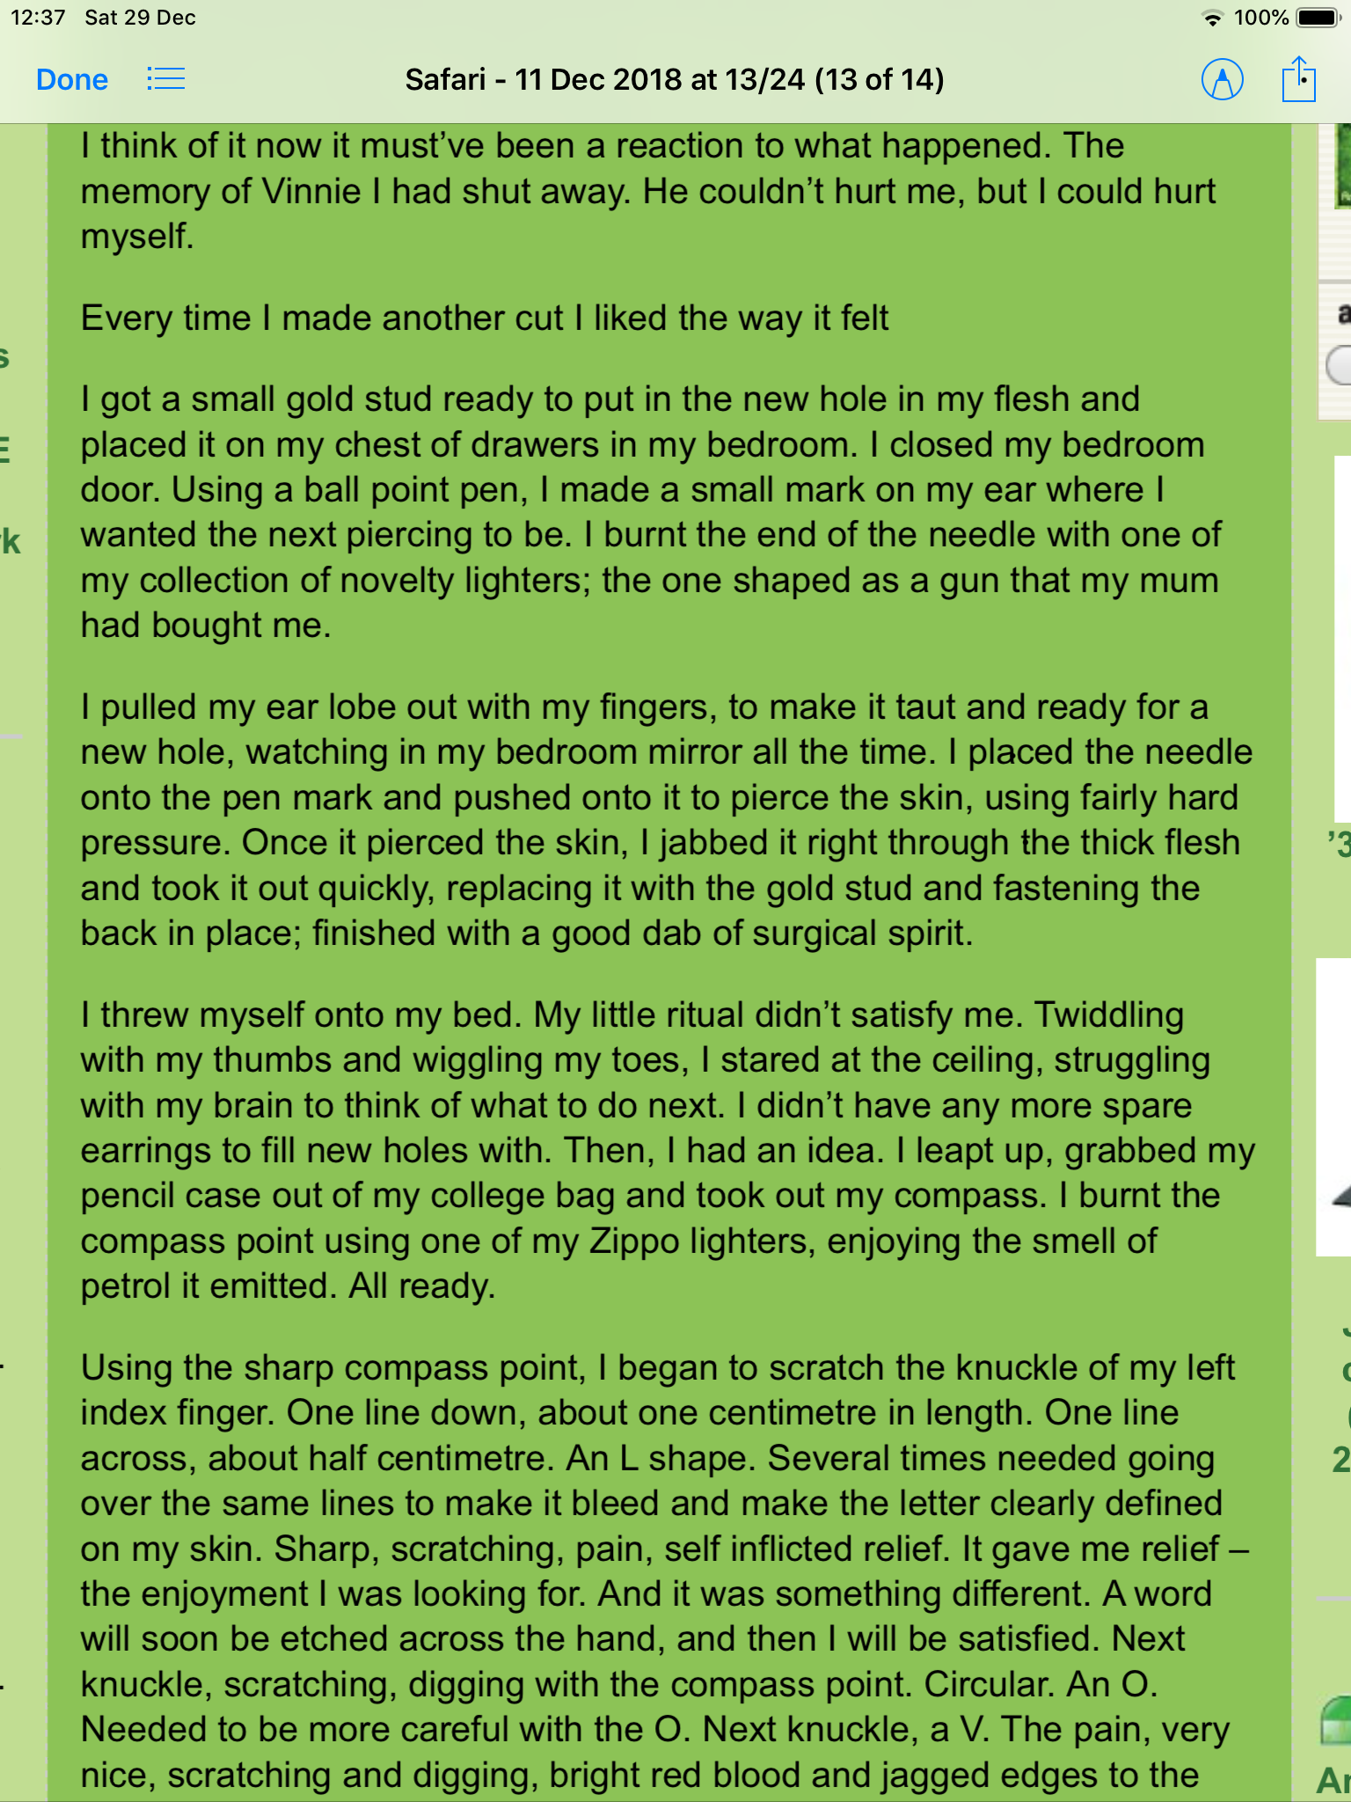

Appendix one continued..., The Effect of Child Abuse and Neglect on NSSI – Original online resource

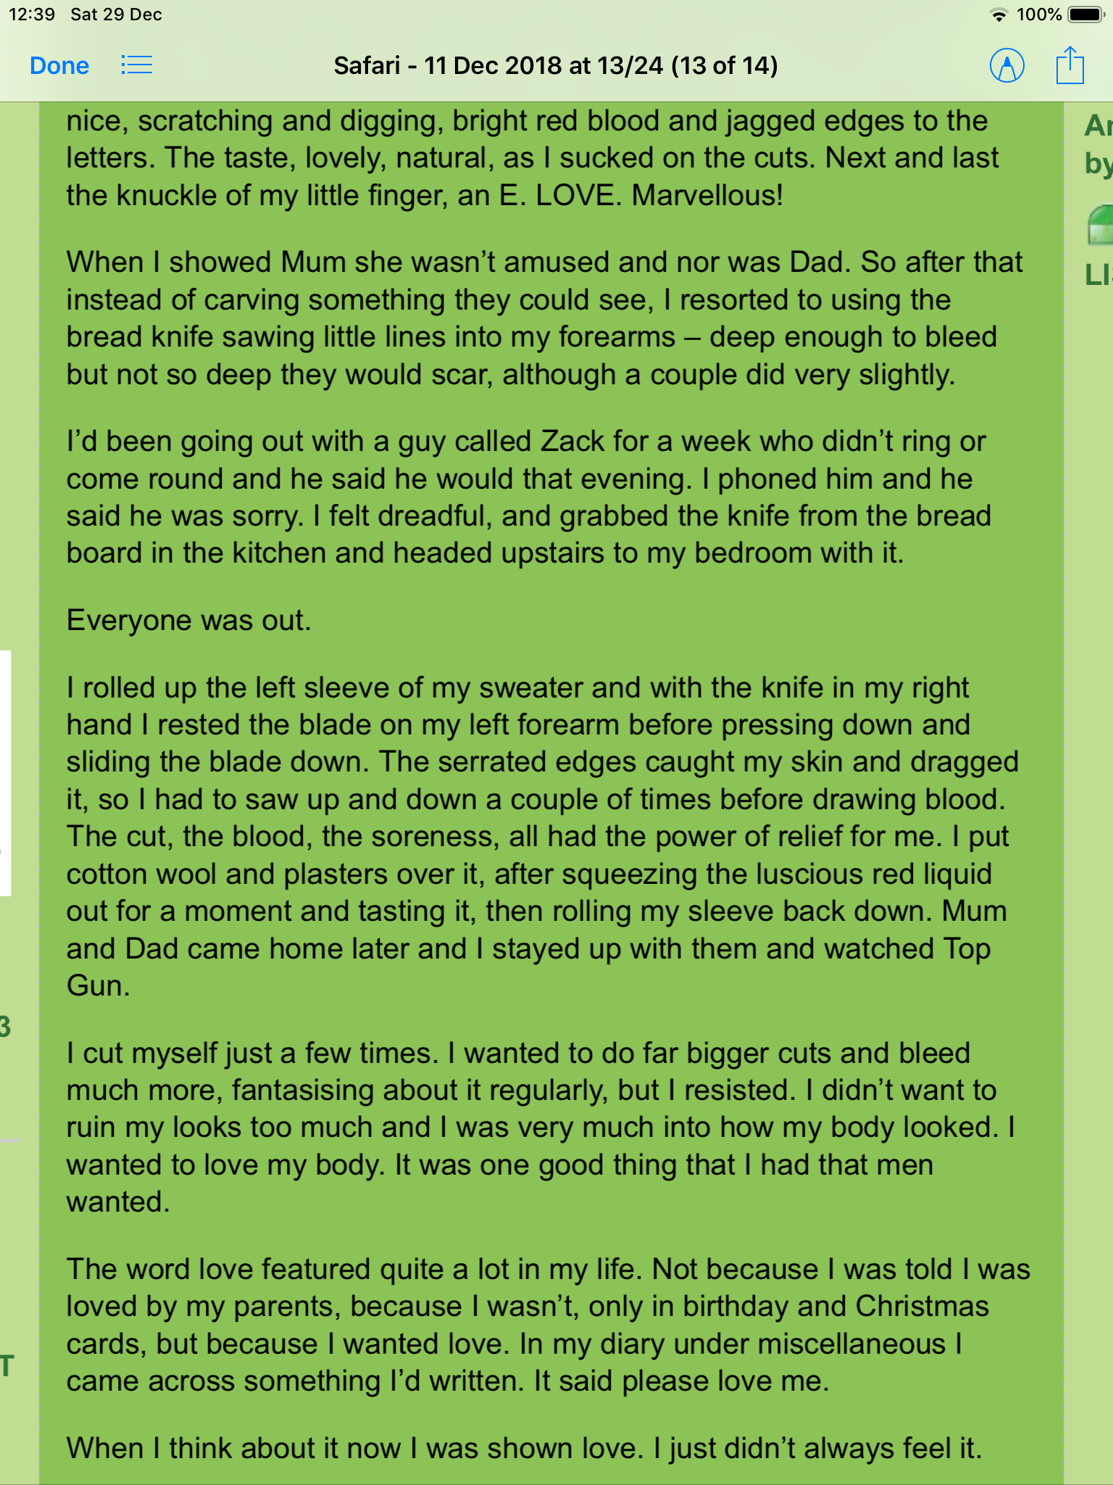

Appendix two, The Effect of Child Abuse and Neglect on NSSI – Transcribed data and analysis.

Appendix two continued..., The Effect of Child Abuse and Neglect on NSSI – Transcribed data and analysis.

Appendix three, The Effect of Child Abuse and Neglect on NSSI - Subordinate Themes
Rape positive feeling
Repressed memory Satisfaction
Depression Addiction
Self-doubt Escalation
Self-loathing Displacement activity
Self-blame Cry for help
Self-destruction Visible cry for help
Not Virgin Analgesic
Anger Suppressed pain
Self -harm Emotional regulation
Cutting Accomplishment
Displaced feelings Elation
Suppressed memories Euphoria
Self-harm Showed Parents
Cutting Hidden behaviour
No self-awareness Stopped to preserve looks
Displacement Dealing with negative emotions
Loathing Pain relief
Shame Looking for love
Controle Un-loveable
Pain low self-worth
Pleasure Vulnerable
Ritual Male admiration
Pleased with result Lack of parental involvement
Negative to positive
Planned
Appendix four, The effect of Child abuse and neglect on NSSI- Ethics form
 PG2/E1 FORM

APPLICATION FOR ETHICAL APPROVAL
In order for research to result in benefit and minimise risk of harm, it must be conducted ethically. A researcher may not be covered by the University’s insurance if ethical approval has not been obtained prior to commencement.
The University follows the OECD Frascati manual definition of research activity: “creative work undertaken on a systematic basis in order to increase the stock of knowledge, including knowledge of man, culture and society, and the use of this stock of knowledge to devise new applications”. As such this covers activities undertaken by members of staff, postgraduate research students, and both taught postgraduate and undergraduate students working on dissertations/projects.
The individual undertaking the research activity is known as the “principal researcher”.
Ethical approval is not required for routine audits, performance reviews, quality assurance studies, testing within normal educational requirements, and literary or artistic criticism.
Please read the notes for guidance before completing ALL sections of the form.
This form must be completed and approved prior to undertaking any research activity. Please see Checklist for details of process for different categories of application.
SECTION A: About You (Principal Researcher)
Full Name: |  |  | Rosie Hemming
Tick all boxes wh | ich apply:
Member of staff: |  | Student: |  | ☒ | Honorary research fellow:
Faculty/School/Centre: |  |  | Psychology
Campus: |  |  | Carmarthen
E-mail address: |  |  | 0801667@student.uwtsd.ac.uk
Contact Telephone Number: |  |  | 07557734231
For students:
Student Number: |  |  | 0801667 |  |  | Undergraduat e |  | ☒
Programme of Study: |  |  | Research methods |  |  | Taught Postgraduate
Director of Studies/Supervisor: |  |  | Dr Stuart Jones |  |  | Research
SECTION B: Approval for Research Activity
Has the research activity received approval in principle?  (please check the Guidance Notes as to the appropriate approval process for different levels of research by different categories of individual) |  | YES | ☒ | NO
 |  |  |  | Date
If Yes, please indicate source of approval (and date where known): | Research Degrees Committee
 | Faculty Research Committee
 | Other (write in)  School ethics board |  | ☒ | 2.12.18
Approval in principle must be obtained from the relevant source prior to seeking ethical approval.
SECTION C: External Ethical Guidance Materials
Please list the core ethical guidance documents that have been referred to during the completion of this form (including any discipline-specific codes of research ethics, and also any specific ethical guidance relating to the proposed methodology). Please tick to confirm that your research proposal adheres to these codes and guidelines.
Code of Ethics and Conduct (2018) | ☒
BPS Code of Human Research Ethics (2nd edition, 2014) | ☒
The General Data Protection Regulation (GDPR) | ☒
SECTION D: External Collaborative Research Activity
Does the research activity involve collaborators outside of the University? |  | YES |  | NO | ☒
If Yes, please provide the name of the external organisation and name and contact details for the main contact person:
Institution
Contact person name
Contact person e-mail address
Where research activity is carried out in collaboration with an external organisation
Does this organisation have its own ethics approval system? | YES |  | NO
If Yes, please attach a copy of any final approval (or interim approval) from the organisation
SECTION E: Details of Research Activity
Indicative title: | The effect of Child abuse and neglect on NSSI
Proposed start date: | 10.12.18 | Proposed end date: | 4.1.19
Purpose of research activity (including aims and objectives)
Outline the purpose, aims and objectives of the research activity, including key research questions. Show briefly how existing research has informed the proposed activity and explain what the research activity will add and how it addresses an area of importance. (Maximum 300 words) Liu RT, Scopelliti KM, Pittman SK, Zamora AS. Childhood maltreatment and non-suicidal self-injury: a systematic review and meta-analysis [published online November 28, 2017]. Lancet Psychiat. doi:10.1016/ S2215-0366(17)30469-8
The purpose of this research is to explore the effects of childhood abuse and neglect on an individuals experience of NSSI. The aim of this study is to better understand the subjective experience of a adolescent who has experienced physical and psychological abuse that has led her to self harm. The purpose of this research is to better understand the psychological processes that underpin this behaviour and to inform future psychological and pharmacological approaches to treatment.
This research follows on from Liu, et al (2017) research that looks at Childhood maltreatment and non-suicidal self-injury: a systematic review and meta-analysis. This research found that childhood physical, emotional abuse and childhood neglect were associated with self harm in adolescents. The research suggested that whilst most self injury stops in approximately two years, about 20% persists for more than 5 years and can be a predictor of suicide in a percentage of adolescents (Liu et al, 2017).
This qualitative research is important because it highlights an individual psychosocial experience of childhood abuse and how this manifests in self destructive impulses. The findings of this study are important as it indicates that screening self harming adolescents may provide psychologist and healthcare professionals with the opportunity to identify abuse and neglect and some insight into timely preventative interventions and appropriate health care for those at risk of suicide. (this box should expand as you type)
Proposed methods
Provide a brief summary of all the methods that may be used in the research activity, making it clear what specific techniques may be used. If methods other than those listed in this section are deemed appropriate later, additional ethical approval for those methods will be needed. (Maximum 600 words)
This qualitative study will look at one adolescents psychosocial experience of NSSI and explore the effects of childhood abuse and neglect on the individuals experience NSSI
This research will look at the diary extract of an anonymous adolescent that has been provided by our lecturer for the purpose of this experiment.
Written consent will not be obtained and following the study withdrawal will not be offered as the diary extract is written by an unknown source.
The diary will be transcribed into a word document for greater accessibility. This will be anonymized, and no identifiable information will be included, i.e.; name. address, DOB, occupation etc.
The diary will be analysed and interpreted using Interpretative Phenomenological Analysis
(IPA)
(this box should expand as you type)
Location of research activity
Identify all locations where research activity will take place.
IPA analysis on Carmarthen campus.
My own home
(this box should expand as you type)
Research activity outside of the UK
If research activity will take place overseas, you are responsible for ensuring that local ethical considerations are complied with and that the relevant permissions are sought. Specify any local guidelines (e.g. from local professional associations/learned societies/ universities) that exist and whether these involve any ethical stipulations beyond those usual in the UK (provide details of any licenses or permissions required). Also specify whether there are any specific ethical issues raised by the local context in which the research activity is taking place, for example, particular cultural sensitivities or vulnerabilities of participants.
N/A
(this box should expand as you type)
SECTION F: Scope of Research Activity
Will the research activity include: | YES | NO
Use of a questionnaire or similar research instrument? |  | ☒
Use of interviews? |  | ☒
Use of diaries? | ☒
Participant observation with their knowledge? |  | ☒
Participant observation without their knowledge? |  | ☒
Use of video or audio recording? |  | ☒
Access to personal or confidential information without the participants’ specific consent? |  | ☒
Administration of any questions, test stimuli, presentation that may be experienced as physically, mentally or emotionally harmful / offensive? |  | ☒
Performance of any acts which may cause embarrassment or affect selfesteem? |  | ☒
Investigation of participants involved in illegal activities? |  | ☒
Use of procedures that involve deception? |  | ☒
Administration of any substance, agent or placebo? |  | ☒
Working with live vertebrate animals? |  | ☒
Other primary data collection methods, please explain in this box Experiment (see above) |  | ☒
If NO to every question, then the research activity is (ethically) low risk and may be exempt from some of the following sections (please refer to Guidance Notes).
If YES to any question, then no research activity should be undertaken until full ethical approval has been obtained. SECTION G: Intended Participants
Who are the intended participants: |  | YES | NO
Students or staff at the University? |  |  | ☒
Adults (over the age of 18 and competent to give consent)? |  |  | ☒
Vulnerable adults? |  |  | ☒
Children under 18? |  |  | ☒
Prisoners? |  |  | ☒
Young offenders? |  |  | ☒
Those who could be considered to have a particularly dependent relationship with the investigator or a gatekeeper? |  |  | ☒
People engaged in illegal activities? |  |  | ☒
Others (please identify): |  |  | ☒
Participant numbers and source
Provide an estimate of the expected number of participants. How will you identify participants and how will they be recruited?
They will the diary writing of one anonymous adolescent female age who’s writing has been provided by the lecturer for the purpose of this assessment this box should expand as you type)
Information for participants: | YES | NO | N/A
Will you describe the main research procedures to participants in advance, so that they are informed about what to expect? |  |  | ☒
Will you tell participants that their participation is voluntary? |  |  | ☒
Will you obtain written consent for participation? |  |  | ☒
Will you explain to participants that refusal to participate in the research will not affect their treatment or education (if relevant)? |  |  | ☒
If the research is observational, will you ask participants for their consent to being observed? |  |  | ☒
Will you tell participants that they may withdraw from the research at any time and for any reason? |  |  | ☒
With questionnaires, will you give participants the option of omitting questions they do not want to answer? |  |  | ☒
Will you tell participants that their data will be treated with full confidentiality and that, if published, it will not be identifiable as theirs? |  |  | ☒
Will you debrief participants at the end of their participation, in a way appropriate to the type of research undertaken? |  |  | ☒
If NO to any of above questions, please give an explanation
Not relevant to research design as this is a university assessment and the diary is an anonymous article.
Information for participants: | YES | NO | N/A
Will participants be paid? |  | ☒
Is specialist electrical or other equipment to be used with participants? |  | ☒
Are there any financial or other interests to the investigator or University arising from this study? |  | ☒
Will the research activity involve deliberately misleading participants in any way, or the partial or full concealment of the specific study aims? |  | ☒
If YES to any question, please provide full details
(this box should expand as you type)
SECTION H: Anticipated Risks
Outline any anticipated risks that may adversely affect any of the participants, the researchers and/or the University, and the steps that will be taken to address them.
If you have completed a full risk assessment (for example as required by a laboratory, or external research collaborator) you may append that to this form.
Full risk assessment completed and appended?
Yes
No ☒
Risks to participants
For example: emotional distress, financial disclosure, physical harm, transfer of personal data, sensitive organizational information
Emotional distress.if the participant was real they could be upset if this research highlights personal problems that relate to home or work life or triggered emotional distress associated with past events. In the debriefing I will provide links to agencies that provides support for those who have experiences abuse or for those engaged in self harm. Personal data may be at risk, but all data will be stored securely, and all data will be anonymized to minimize this risk.
(this box should expand as you type)
If research activity may include sensitive, embarrassing or upsetting topics (e.g. sexual activity, drug use) or issues likely to disclose information requiring further action (e.g. criminal activity), give details of the procedures to deal with these issues, including any support/advice (e.g. helpline numbers) to be offered to participants. Note that where applicable, consent procedures should make it clear that if something potentially or actually illegal is discovered in the course of a project, it may need to be disclosed to the proper authorities
The fictional participant would need to be made aware that any information disclosed that could indicate criminal activity would need to be disclosed to the relevant authorities.
Risks to investigator
For example: personal safety, physical harm, emotional distress, risk of accusation of harm/impropriety, conflict of interest
The risks to the investigator are minimal as the research will be self-selecting and the participant is fictional. Normally the participants would provide written consent to participate and would be debriefed and withdrawal would be offered before submission. In the debriefing I will provide links to agencies that provides support for those who have experiences abuse or for those engaged in self harm.
(this box should expand as you type)
University/institutional risks
For example: adverse publicity, financial loss, data protection
Minimal as I will follow BPS and University guidelines. However, All participants will provide written consent to participate and will be debriefed and withdrawal will be offered before data submission
(this box should expand as you type)
Adverse outcomes
List measures put in place to limit any adverse effects or outcomes of research activity where appropriate. Include any emergency protocols.
I will follow the University’s emergency protocols if need be (as the experiment will take place on the premises).
(this box should expand as you type)
Disclosure and Barring Service
If the research activity involves children or vulnerable adults, a Disclosure and Barring Service (DBS) certificate must be obtained before any contact with such participants. | YES | NO | N/A
Has a DBS certificate been obtained? |  |  | ☒
SECTION I: Feedback, Consent and Confidentiality
Feedback
What feedback will be provided to participants, how will this be done and when?
Debriefing – at end of research before it is submitted
(this box should expand as you type)
Informed consent
Describe the arrangements to inform potential participants, before providing consent, of what is involved in participating. Describe the arrangements for participants to provide full consent before data collection begins. If gaining consent in this way is inappropriate, explain how consent will be obtained and recorded.
Obtained at the beginning of the research
(this box should expand as you type)
Confidentiality / Anonymity
Set out how anonymity of participants and confidentiality will be ensured in any outputs. If anonymity is not being offered, explain why this is the case.
No names/personal information will be attached to the research
SECTION J: Data Protection and Storage
In completing this section refer to the University’s Research Data Management Policy and the extensive resources on the University’s Research Data Management web pages (http:// uwtsd.ac.uk/library/research-data-management/).
 | YES | NO
Does the research activity involve personal data (as defined by the Data Protection Act)?  “personal data” means data which relate to a living individual who can be identified—  - from those data, or  - from those data and other information which is in the possession of, or is likely to come into the possession of, the data controller, and includes any expression of opinion about the individual and any indication of the intentions of the data controller or any other person in respect of the individual. |  | ☒
If YES, provide a description of the data and explain why this data needs to be collected:
(this box should expand as you type)

Does it involve sensitive personal data (as defined by the Data Protection Act)?  “Sensitive personal data” means personal data consisting of information as to –  - the racial or ethnic origin of the data subject,  - his political opinions,  (c ) his religious beliefs or other beliefs of a similar nature,  - whether he is a member of a trade union (within the meaning of the Trade  Union and Labour Relations (Consolidation) Act 1992),  - his physical or mental health or condition,  - his sexual life,  - the commission or alleged commission by him of any offence, or (h) any proceedings for any offence committed or alleged to have been committed by him, the disposal of such proceedings or the sentence of any court in such proceedings. | ☒ | ☒
If YES, provide a description of the data and explain why this data needs to be collected:
The purpose of the research is to explore the effects of menopausal symptoms, both biological and psychological and how these may change and shape one woman’s experience of every day events. This is important as it can shape future psychological interevntions that may improve quality of life and health
Will the research activity involve storing personal data on one of the following? | YES | NO
Manual files (i.e. in paper form)? |  | ☒
University computers? |  | ☒
Private company computers? | ☒
Home or other personal computers? | ☒
Laptop computers/ CDs/ Portable disk-drives/ memory sticks? | ☒
“Cloud” storage or websites? | ☒
Other – specify: | ☒ | ☒
For all stored data, explain the measures in place to ensure data confidentiality, including details of password protection, encryption and anonymization:
There will be a diary journal, this is publicly available online but if this was a real personal document it would be anonymized before it was copied to the research document the originalbut this can be destroyed once it is transcribed and then all data will be online. There is no personal date that will identify an individual
(this box should expand as you type)
Will the research activity involve any of the following activities? | YES | NO
Electronic transfer of data in any form? |  | ☒
Sharing of data with others at the University? |  | ☒
Sharing of data with other organizations? |  | ☒
Export of data outside the European Union or importing of data from outside the UK? |  | ☒
Use of personal addresses, postcodes, faxes, emails or telephone numbers? |  | ☒
Publication of data that might allow identification of individuals? |  | ☒
Use of data management system? |  | ☒
Data archiving? |  | ☒
If YES to any question, please provide full details, explaining how this will be conducted in accordance with the Data Protection Act (and/or any international equivalent):
(this box should expand as you type)
List all who will have access to the data generated by the research activity:
My tutor and I (principal researcher)
(this box should expand as you type)
List who will have control of, and act as custodian(s) for, data generated by the research activity:
The Principal researcher and Director of Studies
(this box should expand as you type)
Give details of data storage arrangements, including where data will be stored, how long for, and in what form. Will data be archived – if so how and if not why not.
Data will be completed using online diary, the data will be sent to my personal PC via email, the the data will be stored on my computer and in the University cloud. All raw data will be analyses using IPA technique. box should expand as you type)
SECTION K: Declaration
The information which I have provided is correct and complete to the best of my knowledge. I have attempted to identify any risks and issues related to the research activity and acknowledge my obligations and the rights of the participants.
In submitting this application I hereby confirm that I undertake to ensure that the above named research activity will meet the University’s Research Ethics and Integrity Code of
Practice
Signature of applicant: R Hemming | Date: 4/12/18
For students:
Director of Studies/Supervisor: | Dr stuart Jones
Signature: | ! 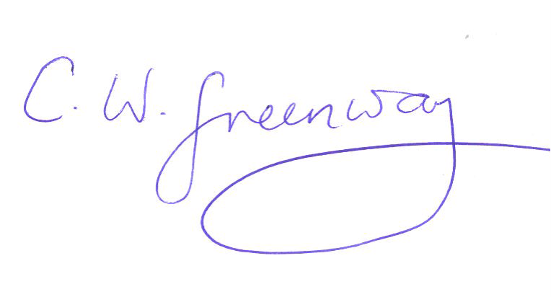
Date: | 4.12.18
For staff:
Head of School/Assistant Dean:
Signature:
Date:
Checklist: Please complete the checklist below to ensure that you have completed the form according to the guidelines and attached any required documentation:
☒ | I have read the guidance notes supplied before completing the form.
☒ | I have completed ALL RELEVANT sections of the form in full.
☒ | I confirm that the research activity has received approval in principle
☒ | I have attached a copy of final/interim approval from external organization (where appropriate)
 | I have attached a full risk assessment (and have NOT completed Section H of this form) (where appropriate)
☒ | I understand that it is my responsibility to ensure that the above-named research activity will meet the University’s Research Ethics and Integrity Code of Practice.
☒ | I understand that before commencing data collection all documents aimed at respondents (including information sheets, consent forms, questionnaires, interview schedules etc.) must be confirmed by the DoS/Supervisor, module tutor or Head of School.
RESEARCH STUDENTS AND STAFF ONLY
All communications relating to this application during its processing must be in writing and emailed to pgresearch@uwtsd.ac.uk , with the title ‘Ethical Approval’ followed by your name.
You will be informed of the outcome of your claim by email; therefore, it is important that you check your University and personal email accounts regularly.
STUDENTS ON UNDERGRADUATE OR TAUGHT MASTERS PROGRAMMES should
submit this form (and receive the outcome) via systems explained to you by the supervisor/ module leader.
This form is available electronically from the Academic Office web pages: http:// www.uwtsd.ac.uk/academic-office/

Application Process
All staff research projects and all research students must submit the Ethical Approval Form to the University Ethics Committee via the Academic Office (pgresearch@uwtsd.ac.uk). Staff research directly in relation to personal study for taught undergraduate or Masters programmers should be submitted via the Faculty procedures explained below.
Taught masters and taught undergraduate research Ethical Approval Forms are considered within Faculties. Faculties will provide details of the specific processes for this. Where the Ethical issues within any single ethical application are of particular concern the Faculty will refer these to the University Ethics Committee. Any student activity that involves the collection of primary data needs to undergo Ethical approval, this includes assignment work as well as dissertations.
Notes for guidance in completion of this form
Section A: About You
Please complete all relevant sections

Section B: Approval for research activity
Research proposals must be approved in principle before applying for Ethical Approval. The proposal approval only becomes final when the ethical approval is received.
The process for proposal approval varies according the individual and programmed of study:
- Research students, by application on form PG1 to the Research Degrees Committee
- Taught students by review of research proposal within Faculties (Faculties provide specific details of these processes)
- Staff, by agreement by the Head of School/Assistant Dean

Section C: External Ethical Guidance materials
Many discipline areas are required to operate with the discipline specific codes of research ethics (for example health, psychology, education etc.), any such codes must be listed, and you must tick to confirm that you have consulted with these.

Section D: External Collaborative Research Activity
Provide details of the external collaborative partners, where appropriate you might want to submit a copy of the external collaboration agreement with the Ethical Approval Form. If the partner requires the research to be subject to its own internal Ethical approval process, then please provide details of that process and a copy of any final (or interim) approvals received from the organization.

Section E: Details of Research Activity
Remember that the individuals reviewing this Ethical Approval Form may not have seen your research proposal, and also may not be experts in the specific area of your research. The information provided should therefore be jargon free and clearly stated.
Indicative Title: please use the same title as used on the research proposal.
Purpose: the Ethical approval process will want to ensure that the methods you propose are adequate and appropriate to address the research aims and objectives. Excessive additional data collection can be seen as unethical.
Proposed Methods: the Ethical approval process seeks to ensure that you understand the methods that are intended, and that the implementation of those methods will be appropriate and without unnecessary impact on respondents. Please be specific.
Location: this needs to mention geographical location and also local situation (for example, within Local Authority Offices in Cardiff, using a private room but close to other individuals). If you are collecting data within an organizational setting then you need to explain the permissions that you have obtained to do this.
Research Activity outside of the UK: please complete this section in detail and note any guidance you have received. Also describe your own familiarity (or not) with the location that you will be utilizing.

Section F: Scope of Research Activity
Please tick ALL of the research activities that might be undertaken. If any additional types of activity are intended, then please add an extra box and describe these.
If you have answered no to all questions in F then sections G and J do not need to be completed. Section H should be considered and may be completed. Signatures are still required in section K.

Section G: Intended Participants
Please tick all categories that might apply.
Numbers & Source: if you are using a series of different methods or research activities please list numbers for each stage/phase. Be clear about how you will find respondents. Will you use intermediaries, and if so how? How will you ensure compliance with your sampling strategy? Information for participants: all participants should be appropriately informed about the research, what is expected of them and what will happen to the information that they provide. The Ethical review process does not ask to see this documentation but requires this to be reviewed and approved by the Director of Studies in the case of research students, the supervisor/module tutor in relation to students on taught programmers and the Head of School/Assistant Dean in relation to staff research.

Section H: Anticipate Risks
All research carries some level of risk. The answers you provide to questions in this section will be reviewed to ensure that you have an appropriate understanding of the type of risks involved and how you can mitigate against these risks. If you have completed a full risk assessment, as required for example for laboratory work, field work, clinical tests, diving operations, or by a collaborative partner, you may append that to this form. In that case, please tick the box indicating this has been provided.
You will not then be required to complete Section H.
Risk to participants Think very carefully about how your actions/questions/discussions might affect the people you are involving as participants. You might identify the risk as small, but it would still be a risk. Many types of question have the potential to make respondents less content with their life / job; you need to recognize and try to ameliorate any such effects
If these are business owners, time with you may reduce profit.
In some locations physical risk is very real to both participants and yourself, please consider this.
Risk to you, the researcher Think about where you will meet people, if there are any dangers involved in the location. If you are meeting people as individuals think about using a public place. In general, do not visit people in their own homes or remote locations. If you are talking to individuals about certain issues think about how their responses might affect you emotionally. What about the risk of collecting insufficient data?
Risk to the University When undertaking your research, you are acting as a member of the University (student or staff). Professionalism is important, so it is important to be well organized and well prepared. Punctuality, clarity etc. are all part of this. What will you do to ensure this? You must ensure you do not harm the good name of the University in any way and do nothing to undermine the reputation of the research it conducts and sponsors. Upholding high standards of conduct and integrity are vital in this regard. You must also conduct the research in such a way to minimize the potential for claims of negligence made against the University, its researchers and any collaborating individual or organization. In this respect you should always comply with ethical, legal and professional frameworks, obligations and standards as required by statutory and regulatory authorities, as well as the university’s Research Integrity and Ethics Code of Practice. Research misconduct in this respect can take many forms, including:
- fabrication: making up results or other outputs (eg, artefacts) and presenting them as if they were real
- falsification: manipulating research processes or changing or omitting data without good cause
- plagiarism: using other people’s material without giving proper credit
- failure to meet ethical, legal and professional obligations: for example, failure to declare competing interests; misrepresentation of involvement or authorship; misrepresentation of interests; breach of confidentiality; lack of informed consent; misuse of personal data; and abuse of research subjects or material
- improper dealing with allegations of misconduct: failing to address possible infringements such as attempts to cover up misconduct and reprisals against whistle-blowers
Adverse Outcomes. Think carefully about the possibilities, and cover here

Section I: Feedback, Consent and Confidentiality
Feedback to participants: outline your approach. Will interview transcripts be shared with respondents to check accuracy? Will summaries of questionnaire analysis be made available to respondents in some way? Will an overview report be provided? How and when?
Informed consent: Draft letter / e-mail / or heading (or footer) section of questionnaire must be approved by DoS/supervisor (if research student), supervisor/module tutor if taught student, or Head of School / Assistant Dean if a member of staff.
Confidentiality/Anonymity. Explain clearly how you will ensure confidentiality and anonymity.

Section J: Data Protection and Storage
Before completing this section, it is necessary to read the University’s Research Data Management information. The questions that follow are designed to ensure compliance with the Data Protection Act as well as established research protocols.
Many research activities will involve electronic transfer of data and use of data management systems in the summarization and analysis of data. You will need to explain these in relation to compliance with the Data Protection Act.
Think carefully about who access to your data will have, this will include supervisors and examiners. Also, that a thesis will be made available via the University library and the British Library system. If you are seeking an access bar for a period of time after completion, then mention it here. If you will provide a copy of your findings, or intend to give a presentation, to a facilitating/ supporting/accessing organization then explain that in this section. But also think about the general principle of data sharing, as explained in the Research Data Management information.
In terms of storage of data please ensure security, and also mitigate against loss of data.

Section K: Declaration
Ensure the appropriate countersignatures have been provided
Look carefully at the checklist and ensure that you comply with and tick all that are relevant to your research.

