Task 2 – Reflective report – My experience at UWTSD

Academic and Employability Skills
BMSW4001

Iunsiya Hussain

2024760

Rebecca Stewart

Table of Content

Title …………………………………. Page 1
Table of Content …………………... Page 2
Introduction ………………………… Pages 3-4
Gibbs Reflective Cycle ……….…... Pages 5-7
Personal Development Plan ………. Pages 8-10
References ……………………….... Page 11

Introduction
In this reflection I will be using the Gibbs reflective cycle to examine my experience of being given the opportunity to have a resit for Academic Skills. I have received feedback from lecturers during my current time at UWTSD and with this feedback I will be creating a personal development plan which is included in this report.

I will be using the Gibbs reflective cycle to write a reflection of this term and what I have learned along the way. Graham Gibbs (1988) adapted the experiential learning cycle to acknowledge the importance of feelings and emotions in learning.
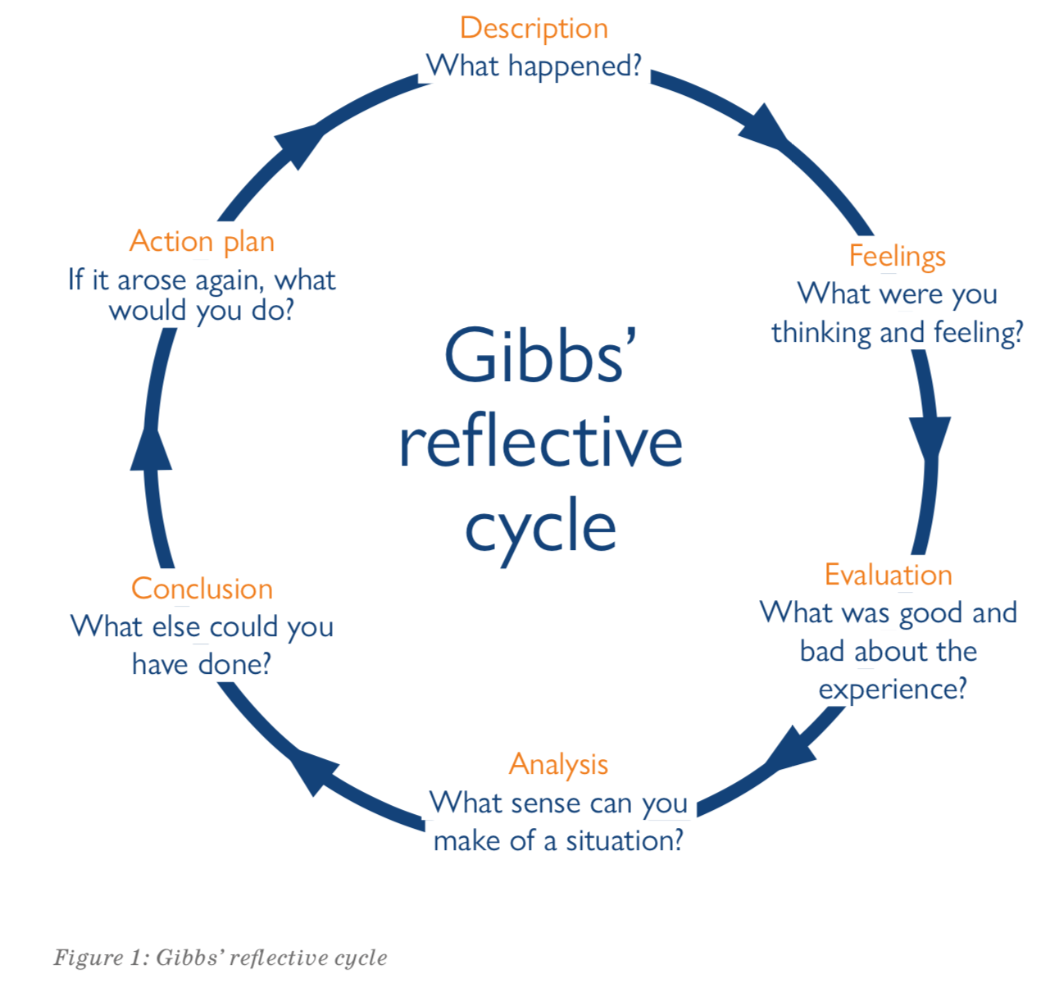
(Source: Sor.org)
Above is the Gibbs reflective cycle broken down, there are six sections to this cycle, and I will be using them within this reflective report regarding my experience of having a resit for Academic Skills.

Description
‘A summary of the event or experience is required for setting the scene and providing context in the first phase of this reflective analysis methodology. In this step, the learning process should also be thoroughly documented, and it is crucial to provide an answer to a specific question regarding the circumstances surrounding the occurrence, its timing, and the participants’. (Adeani, et al., 2020).
I was given the opportunity to resit my Academic Skills module, my resit assignment included methods for increasing employee motivation in any workplace, this is what was produced in the task 1 resit. Discussed were various incentives and how they help employees feel motivated at work. The conclusion included which type of reward system best inspires employees to feel motivated. A positive connection between employees and management will boost employee enthusiasm and productivity. In the resit I divided the work into sections as shown on the assignment brief to make a flow of the report. Firstly, I described about motivation and the importance of motivation for a happy employee and an employer. Then I have described each way to motivate employees. I have supported each method using articles, referencing them using Harvard referencing.

Feelings
I was conscious of the report writing and Harvard referencing prior to this report. At first, I wasn't convinced I was able to complete my resit as I had assignments and group work due for other modules. My peers in my class helped me with completing our group assignment and presentation two weeks before it’s deadline so that I was able to focus on my resit for Academic Skills, this has relieved me of stress. I feel grateful for being given the opportunity to have a resit as if I have done well, I am able to achieve my Level 4 in Skills for The Workplace.

Evaluation
In reflection, the task had both positive and negative aspects. Thanks to this task to discover employee motivation, I had a fantastic opportunity to learn about cooperative setting employee behavior and motivation while working practically in a work situation and concurrently in academics. The good thing aspect about the resit itself is that I have been given another opportunity to receive feedback on my academic writing. I will be able to see which areas I will need to work on in the future The negative experience I have had from this resit is the stress I have been under with having to delegate my other assignments for two other modules alongside this resit and report.
Analysis
I believe that my failure to recognise my abilities was the source of my previous work’s poor performance. I have done this before and found that when I’m working by myself, I prefer to work in fields that highlight my abilities. In truth, this took a lot longer than I anticipated, and I had to rush as well as stress through the rewrite. I got into this scenario, I believe, because I hadn’t prepared how I was going to write and how I would find time to research the best methods to motivate employees. I should have been self-aware, knowing what I could achieve and in what time, this would have prevented me from having to rush my resit assignment. ‘I believe that being aware of potential challenges would be beneficial when making future decisions.’ (Tesh & Kautz, 2017)
Conclusion
Thanks to this experience, I am more conscious of the importance of academic writing skills if comparable situations occur again in the future either in university or in my career. Thanks to the knowledge I gained from this experience, I now have a greater grasp of writing. Prioritising improving relationships between tutors will also help to increase levels of understanding (Rutkowski, et al., 1983). I need to have spoken with the resit tutors immediately soon after reading the assignment brief to ask for advice instead of leaving this till the last minute. This resit had also made me realise how important it is to read more books and journals instead of reading from websites and online sites as this allows me to gain better knowledge about topics as these sources are factual.
Action Plan
Depending on my level of understanding or competence in the matter, I desire to be more engaged in confronting situations head-on in the future. When I believe there could be a risk and there isn’t any information, I handle the tense circumstances and make sure that there is information in the relevant study area. The way I engage with people in different settings will also change in the future, and I’ll be sure to use a variety of communication methods and do my own independent research on their particular needs. I will continue using Gibbs reflective cycle to regularly practice professional reflection (Husebø, et al., 2015). Since I cannot expect the other lecturers that have not taught me previously to understand how I feel if I don’t express my feelings, I must speak with them about any topics I do not completely understand so that I am able to complete my assignments to the best of my abilities. Also need to discuss my feelings with my other fellow students more often because I think I can learn a lot from them. I will be signing up study skills in academic writing in the next term so that I can practice my writing skills, this will help me with my future assignments. Now that I realize it, I need to be more confident in my writing and I think improving my writing skills can help me do that.

Personal Development Plan
I have had six lectures overall during my studying at UWTSD. I have studied five other modules after Academic Skills. During this time, I have received feedback from my tutors, either in class, presentation feedback or assignment feedback. This has made me realise I have academic goals I need to reach during my studying. I have created a personal development plan to visually see my targets and how I can achieve them.
‘A personal development plan, which is also known as a PDP, is an action plan that you can use to identify:
- Your individual goals and what you want to achieve.
- Your strengths and weaknesses.
- The areas you need to improve and develop to meet your goals.
- What you need to do to achieve your goals.
- Anything that could hinder your progress’. (Putter, 2021)
Below is a personal development plan cycle that I have used to understand what I need to put in my personal development plan.
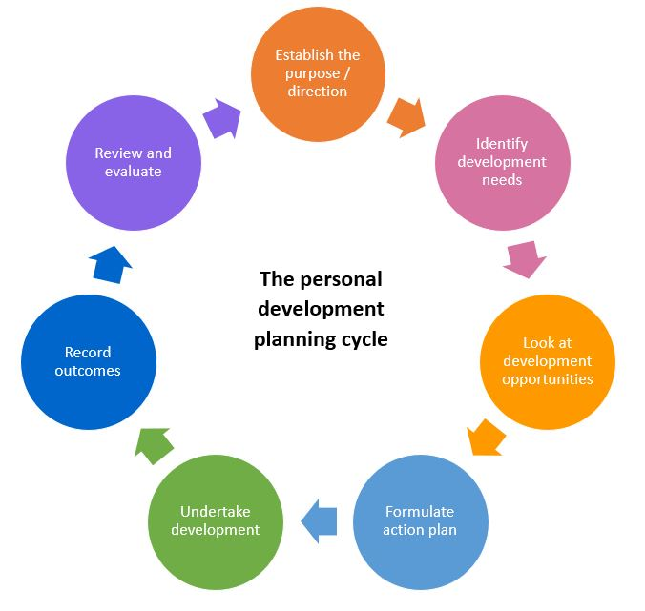

(Source: Lancashire Business View)
The three targets I have set are:
- Correctly using Harvard reference in my academic work
- Becoming more confident in my presenting skills
- Using analytical tools in my work correctly (SWOT and Pestle)
The definition of Harvard referencing is ‘The Harvard style or Harvard referencing is an author-year system that is widely used in academia. The use of Harvard referencing means putting the source citation right after the quote, thus referring directly to the reference list’. (Bruner, 2022). This is used to reference my in-text citation and citations. The analytical tools I have learnt of in my previous modules that I need to improve on are SWOT and Pestle. ‘SWOT & PEST analyses are two methods through which companies plan ahead by conducting research.’ (Pestle analysis contributor, 2016) I also need to work on my presenting skills, individually and as a team.

Personal Target | How will I achieve this? | How will this improve my academic or employability prospects? | How will I know that I have achieved this? | When will I achieve this by?
Being able to Harvard reference correctly in my written assignments and presentations. | I will achieve this by attending study skill sessions for referencing also practicing individually with different resources e.g., articles, books, journals, and images. | This will improve in my academic prospects as the work I provide will be reliable as it will be sourced and referenced correctly. | I will know I have achieved this when I receive positive feedback from my lecturer regarding my referencing on my assignments and presentations. | I am hoping to achieve this within 3 months. This will be enough time to practice Harvard referencing and incorporate in my work.
Becoming more confident in my presentation skills. | I will achieve this by attending study skill sessions for presenting, I will also achieve this by practicing within my group. I will achieve this by ensuring in future presentations I research and learn the topic accurately so that I feel confident whilst presenting. | This will improve my academic prospects as I will receive greater marks for my presentation work. I will feel more confident to work with other members of my class. This can also improve my employability prospect as I will be able to have discussions at work without feeling anxious and share my ideas. | I will I know that I had achieved this when I feel confident in presenting to my lecturer or in part of a group. I will know I have achieved this when I receive good feedback from my group or lecturer regarding my presenting skills. | I will achieve this within the next 6 months. I feel this will take a little longer to achieve as I am quite anxious and will need to work on my presenting skills as much as I can to build my confidence and achieve this target.
Using analytical tools correctly. (SWOT and Pestle) | I will achieve this by attempting to use these tools whenever they are applicable in my assignments. I need to do my own research on both tools extensively so that I know when I can apply them. | This will improve my academic skills as I study CertHE Skills for The Workplace Business these tools are popular as they are used in businesses. I will need to use SWOT and Pestle in future academic work. | I will know I have achieved this when I receive feedback from my lecturer on my future assignments that I have used the tools correctly. | I will achieve this within 3 months as I believe I will need to use these tools frequently in my future modules which will allow me to have a better understanding of them.
Below is my personal development plan for my above targets.

References
Adeani, I., Febriani, R. & Syafryadin, S., 2020. USING GIBBS’REFLECTIVE CYCLE IN MAKING REFLECTIONS OF LITERARY ANALYSIS. Indonesian EFL Journal, Volume 6(2), pp. 139-148.
Bruner, E. (2022) Harvard referencing: Overview &amp; Examples, BachelorPrint. Available at: https://www.bachelorprint.com/harvard-referencing/#:~:text=The%20Harvard%20style%20or%20Harvard%20referencing%20is%20an,quote%2C%20thus%20referring%20directly%20to%20the%20reference%20list. (Accessed: December 1, 2022).
Clinical Simulation in Nursing, pp. 368-375. Tesh, A. & Kautz, D., 2017. Using reflective practice in a leadership course. pp. 117-119.
Contributor, P.E.S.T.L.E. (2022) SWOT vs. Pest, and how to decide which one to use, PESTLE Analysis. Available at: https://pestleanalysis.com/swot-vs-pest-analysis/#:~:text=SWOT%20%26%20PEST%20analyses%20are%20two%20methods%20through,These%20factors%20are%20prime%20determinants%20of%20strategic%20planning. (Accessed: December 1, 2022).
Gibson, C. (2021) Reflection means more than keeping a diary, SoR. Available at: https://www.sor.org/news/students/reflection-means-more-than-keeping-a-diary (Accessed: November 19, 2022).
Husebø, S., & Regan, S. & Nestel, D., 2015. Reflective practice and its role in simulation.
LBVmagazine (2019) Professional Development Planning cycle, Lancashire Business View. Available at: https://www.lancashirebusinessview.co.uk/latest-news-and-features/professional-development-planning-cycle (Accessed: December 1, 2022).
Putter, M. (2021) What is a personal development plan?, CPD Online College. Available at: https://cpdonline.co.uk/knowledge-base/business/what-are-personal-development-plans/#:~:text=A%20personal%20development%20plan%2C%20which%20is%20also%20known,you%20want%20to%20achieve.%20Your%20strengths%20and%20weaknesses. (Accessed: December 1, 2022).

