

University of Wales Trinity Saint David
Prifysgol Cymru Y Drindod Dewi Sant
School of Engineering

Analysis of power generation cycles & application of compression-vapour cycle (ACMA5011)

Aneurin (Nye) Evans
(1907963)
19/01/2022

Contents
1 Part A 1
1.1 a) 1
1.1.1 i) 1
1.1.2 ii) 3
1.2 b) 4
1.3 c) 5
1.4 d) 6
2 Part B 7
2.1 Gas Turbines 7
2.2 Steam Turbines 7
3 Part C 10
Part C 11

Part A

a)
Given values:
$$Air Temperature \left(T_{1}\right)=32℃$$
$$\text{Converting to Kelvin: ℃+273 = 32+273}$$
$$∴T_{1}=305K$$
$$Standard atmospheric pressure \left(P_{1}\right) given as:101325 Pa$$
$$γ_{air}=1.4$$
$$C_{v}=718\frac{J}{kg}.K$$
$$Q_{in}=1650\frac{kJ}{kg}=1650\frac{J}{kg}$$
Compression ratio = 8.5:1
Calculations:

i)
Find T2, T3, T4, P2, P3, P4:
T2:
$$\frac{T_{2}}{T_{1}}{=(\frac{V_{1}}{V_{2}})}^{γ-1}$$
$$T_{2} {=T_{1} (\frac{V_{1}}{V_{2}})}^{γ-1}$$
$$T_{2} {=305 (\frac{1}{8.5})}^{1.4-1}$$
$$T_{2}=717.91K$$

T3:
$$Q= C_{v}∆T$$
$$∴ ∆T= \frac{Q}{C_{v}}$$
$$∆T=\frac{1650000}{718}$$
$$∆T=2298.05K$$
$T_{3}= ∆T$+ $T_{2}$
$$T_{3}=2298.05+717.91$$
$$T_{3}=3015.96K$$
P2:
$$\frac{p_{1}v_{1}}{T_{1}}=\frac{p_{2}v_{2}}{T_{2}}$$
$$p_{2}=\frac{p_{1}v_{1}T_{2}}{T_{1}v_{2}}$$
$$p_{2}=\frac{\left(101325×8⋅5×717.91\right)}{\left(305×1\right)}$$

$$p_{2}=2027230⋅39Pa$$
P3:
$$\frac{p_{2}v_{2}}{T_{2}}=\frac{P_{3}v_{3}}{T_{3}}→(Constant Volume, so v_{2 }\& v_{3} cancel)$$
$$p_{3}=\frac{p_{2}T_{3}}{T_{2}}$$
$$p_{3}=\frac{\left(2.03×{10}^{6}×3015.96\right)}{717⋅91}$$
$$p_{3}=8⋅51×{10}^{6} Pa$$

T4:
$$T_{4}=T_{3}{\left(\frac{v_{3}}{v_{4}}\right)}^{γ-1}$$
$$T_{4}=3015⋅96{\left(\frac{1}{8⋅5}\right)}^{\left(1⋅4-1\right)}$$
$$T_{4}=1281.32K$$
P4:
$$\frac{p_{3}v_{3}}{T_{3}}=\frac{P_{4}v_{4}}{T_{4}}$$
$$p_{4}=\frac{p_{3}v_{3}T_{4}}{T_{3}v_{4}}$$
$$p_{4}= \frac{\left(8⋅51×{10}^{6} ×1 ×1281⋅32\right)}{\left(3015.96 ×8.5\right)}$$
$$p_{4}=425671.12 Pa$$

ii)
Find $r_{c} \& η_{Thermal}$:
$$η_{Thermal}= 1-\frac{T_{4}-T_{1}}{T_{3}-T_{2}}$$
$$η_{Thermal}= 1-\left(\frac{1281⋅96-305}{3015⋅96-717⋅91}\right)$$
$η_{Thermal}$ = 0.58
Using different method to compare and validate both values for $η_{}$:
$$η=1-\frac{1}{r_{v}^{γ-1}}$$
Assuming:
$$r_{v}=\frac{v_{1}}{v_{2}}$$
$$η=\frac{1}{{\left(\frac{8⋅6}{1}\right)}^{\left(1⋅4-1\right)}}$$
$η_{Thermal}$ = 0.58

b)
Given Values:
$$P_{1}=1.05×{10}^{5}p_{a}$$
$$T_{1}=50°C→\left(+273\right)=323K$$
$$γ=1⋅4$$
$$r_{v}=17⋅5:1$$
$$Q_{in}=1400×{{10}^{3}J}/{kg}$$
$$C_{p}={1005J}/{kg}$$
Calculations:
$$r_{c}:$$
$$r_{C}=\frac{Q}{C_{p}T_{1}r_{v}^{γ-1}}+1$$
$$r_{c}=\frac{1400000}{\left(1005×323×{17.5}^{\left(1.4-1\right)}\right)}+1$$
$$r_{C}=2⋅37:1$$
$η_{Cycle}$:
$η_{Cycle}$ = $1-\frac{1}{r_{v}^{γ-1}} \left[\frac{r_{c}^{γ}-1}{γ\left(r_{c}-1\right)}\right]$
$$η_{Cycle}= 1-\left(\frac{1}{17⋅5^{1⋅4-1}}\right) × \left(\frac{\left(2⋅{37}^{1⋅4}-1\right)}{1⋅4\left(2⋅37-1\right)}\right)$$
$$η_{Cycle}=0.83$$

c)
Assumptions:
Mass of air (m) = 1kg
Cp = 1005 J/kg
Cv = 718 J/kg
Calculations:
$$Heat energy supplied:$$
$$Heat energy supplied= mc_{v}\left(T_{3}-T_{2}\right)+mc_{p}\left(T_{4}-T_{3}\right)$$
$$=1×718\left(1097-928\right)+1×1005 \left(1709-1097\right)$$
$$Heat energy supplied=736,402\frac{J}{kg}$$
$$Heat energy rejected:$$
$$Heat energy supplied= mc_{v}\left(T_{5}-T_{1}\right)$$
= $=1 ×718 ×\left(710-323\right)$
$$Heat energy rejected=277,866\frac{J}{kg}$$
$$η:$$
$η=1- \frac{heat rejected}{heat supplied}→ 1-( \frac{277866}{736402}$)
$$η=0.6227 \left(×100\right)$$
= 62.27%

d)
Given Values:
$$T_{1}=725℃$$
$$\dot{m}=3⋅{25kg}/s$$
$$c_{p}={980J}/{kg}$$
Calculations:
W:
$$T_{2}=725×0⋅65$$
$$T_{2}=471⋅25℃$$
$$W=\dot{m}c_{p}\left(T_{1}-T_{2}\right)$$
$W$ = 3.25 x 980 x (725 – 471.25)
$$W=808,193.75 W$$
T1 if W = 800 kW:
$$T_{1}=\frac{w}{\dot{m}c_{p}}+T_{2}$$
$$T_{1}=\left[\frac{800000}{\left(3⋅25×980\right)}\right]+471.25$$
$$T_{1}=722.43 ℃$$

Part B
Although ideal processes are a good way of showing how a system could operate in perfect conditions, it is unfortunately, not realistic. It is impossible, in the real world, for anything to truly achieve 100% efficiency. This can be for a number of different reasons, but is to do with different environmental conditions and other constraints, which add up to reduce overall efficiency. There are however, some things we can do to help make processes a little more efficient, and these, like the constraints, can add up and help a system reach the highest efficiency it can in the real world. Obviously, everyone wants anything to be more efficient, and as efficient as it can be. But nowadays it is more important than ever that we can increase the output of our energy systems and cut down on any type of non-renewable fuels.

Gas Turbines
Some inefficiencies in gas turbines commonly can be attributed to clearance spaces causing leakage, turbulence and friction, amongst others[1]. Therefore, these are areas that can look to be improved. One of these said methods is known as intercooling. This is quiet self-explanatory, the air travelling around the system is cooled. Between one stage of the turbine cycle and the next (however many there are) the air is cooled. This decreases the amount of work done by the compressor, as cooling the air will naturally make the air more dense and therefore easier to compress [2].
Quite the opposite to this is reheating. This process involves further increasing the temperature of gas that has already been partially expanded. The device used is, unsurprisingly, called a reheater [2]. Finally, water injection is another useful method of making a gas turbine more efficient. It is a method that many people, whether they have a background in engineering or not, may well have heard of. Injecting water can increase power output by increasing the total mass flow of the working medium, this process also decreases the level of air [2], which may be useful in turbines found in difficult environments such as underwater, where there is no air, or high above sea level, where the air is much thinner than it is closer to or below sea level. To prevent corrosion though. The water must be pure. It is also worth mentioning that, like intercooling, water injection can be used to decrease the temperature of combustion, and hence greater efficiency [3].

Steam Turbines
Typically, steam turbines are made up of four main components, which are: a compressor, a pump, a boiler and the turbine which generates the electricity. Once again, reheating is a method to improve efficiency. A reheater may be used between a boiler and a heater, this is essentially to ensure that the steam remains steam, and doesn’t start condensing into water (increased dryness fraction) [4], which could cause erosion an is generally not desirable for the turbine. Every time that the steam is reheated, it expands isentropically. This can be highlighted below with a graph.
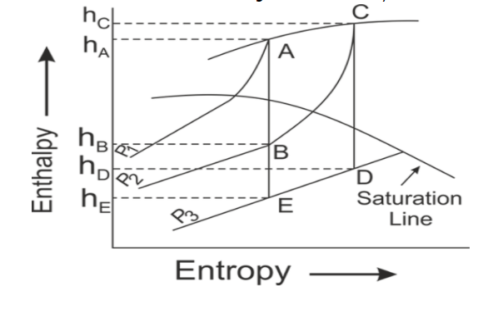
Figure 1 - Diagram showing the reheating process in a steam turbine plant

The point at which the steam is reheated is BC, where the volume is not constant. At point B, the steam is starting to get ‘wet’, so it is reheated as mentioned to prevent unnecessary erosion and generally increase the work done by the turbine.
Another method for improving efficiency could be the binary vapour cycle. Maximum efficiency of any steam engine is given as:
$$η=\frac{T_{1}-T_{2}}{T_{1}}= 1-\frac{T_{2}}{T_{1}}$$
The above equation actually shows that T2 is fixed by the atmospheric conditions of the turbine, so T1 is essentially guaranteed to cause the overall cycle efficiency ($η)$ to increase also. It is important to note that for this, mercury is used. This is done as it can increase the temperature of the plant, without increasing its pressure. Well, its expansion is nominal, as it expands by 0.018% per degree Celsius increase [5].
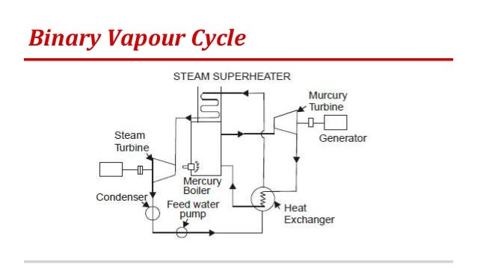
Figure 2 - Diagram of how a Binary Vapour system is integrated into a steam turbine

As the diagram shows, a few mercury related apparatus are required to be integrated into the turbine plant. There is a mercury boiler and a mercury machine. It is basically its own very own little turbine system in itself. Both methods are similar to investing in a funny way, they require a new system or fundamental component to be added, the better the quality, the more efficient the plant will be and get more work done in less time and with less resources.

Part C
The second law of thermodynamics states that any spontaneously occurring processes will always lead to an increase in the universe’s entropy, it will never decrease over time [6]. However, a vapour-compression system, also referred to as a vapour-compression refrigeration system, seems to disobey this law. More specifically, Clausius Statement of the Second Law of thermodynamics states: “It is impossible to construct a device that operates in a cycle and produces no effect other than the transfer of heat from a lower-temperature body to a higher-temperature body” [7]. What a vapour compression system does is like a reverse-operating heat engine. The transfer of heat is from a cold reservoir to a hot reservoir, not the other way around. The medium of this process is a circulating liquid refrigerant, which removes heat from the space by absorbing it, that can be cooled elsewhere, as well as rejecting that heat elsewhere in the system. The four main components of a vapour compression system are not alien to many other types of closed system seen in industry:
- Compressor: Compress the vapour refrigerant to a temperature and pressure to a point it can be condensed more easily [8]
- Condenser: Provides a heat transfer surface, cools refrigerant down via water spray or blowing air
- Expansion valve (aka Throttle valve): Supplies proper quantity of liquid refrigerant to the evaporator
- Evaporator: Provides a surface for heat transfer though which heat can pass from the refrigerant space to the refrigerant (hot to cold)
Of course, other components can be found in this system, but the above four are the main and fundamental ones.

Bibliography

[1] | Computer Aided Chemical Engineering, “Turbine Engineering,” ScienceDirect, 2018.
[2] | Engineering Notes, “Top 6 Methods to Improve the Efficiency of Gas Turbine”.
[3] | Control Automation, “Water Injection Systems in Gas Turbines,” 2009.
[4] | MechanicalTutorial.com, “Calculate Turbine Efficiency - How to Improve Steam Turbine Efficiency”.
[5] | J. Papiewski, “Liquid Mercury's Reaction to Temperature,” 2017.
[6] | Aakash + Byju's, “Second Law of Thermodynamics,” Aakash + Byju's.
[7] | Araner, “The Vapour Compression Refrigeration Cycle, Step by Step”.
[8] | S. Baskiin, “All About Vapour Compression Cycle,” Learn Mechanical.

