Certificate of Higher Education in Skills for the Workplace:

Broadening Horizons/ Changing Live

Student Name: | Saguira Laguiab
Student Number: | 1714252
Module No: | BMSK4003
Module Title: | Digital Skills and Research method
Lecturer: | Mr Balendran Kandasamy

TABLE OF CONTENTS

Page
INTRODUCTION 3
Importance of Adapting to Modern Technology 3
CLOUD STORAGE 4
How Technology can Improve Work Place Efficiently 5
Pros and Cons of Dropbox and OneDrive 6
Exploring social media 7
Marketing via Facebook 7
Creating my own professional online page 9
LITERATURE CITED 11

INTRODUCTION

Earlier study by Boxall (2000) states that it is important to note that technology is not static, but dynamic. Modern office technological gadgets such as smartphones, faster Windows operating systems (e.g., Windows 7 and 8), laptops and tablets are being used by many managers and are helpful in terms of making their work very flexible and easy (Pfano and Beharry 2016). Hritzuk and Jones (2014), state that we live in an era of tablets, phones and computers, and IT has become an enabler for greater convenience. Users can access the most popular types of computer software programs, like word processing programs which help with the writing and editing of letters and reports, and data management programs which help us to work with long lists of data and spread sheets every day on our tablets, smartphones and laptops, thus, making some management tasks easier (Hritzuk and Jones, 2014).
Technology change has been beneficial to both organizations and its employees. The adoption of technology innovations by organizations has exploded over the last few decades with global spending on technology across all industries reaching an estimated $2.6 trillion (Schraeder, 2008). This growth had been in large part to the use of the internet which has increased by over 200% between the years of 2000 and 2007 based on statistics from Internet World Stats (Schraeder, 2008). In general, technology change can bring increased efficiency, improved quality, assist in bringing products to market quicker and expand the skill set of employees’.
Technology can also bring benefits such as improved communication, reduced costs and help foster new innovations. Additional benefits may be seen depending on the specific type of technology that is being implemented. (Agostino and Delaney, 2015)
With organizations moving to things such as telecommuting, technology can increase participation and involvement with remote employees. Technology can expand the potential pool of participants that are working and collaborating together on projects through shared databases, on internal intranets and the internet (Schraeder, 2008). Technology solutions now allow th
e ability to overcome the limitations of remote employees providing the ability for individual participation and input from all over the world regardless of location. This benefit allows for employees to work at times that are more convenient for them but still provides for collaboration and communication across a team. (Agostino and Delaney, 2015)
New technology can also help organizations stay more in touch with their market. Rapid changes in the economic landscape of today’s business environment require action to meet customer expectations. Failure to stay current on customer needs and market changes could result in the loss of any competitive advantage an organization may possess. Additionally, keeping current on the latest technology could allow an organization to seize any possible opportunities that are not being filled by a competitor (Agostino and Delaney, 2015). As stated by Venkatraman and Henderson in 2004, Information Technology should help organizations understand their position in relation to their competitors, learn about customers, monitor relationships with suppliers, and control strategic objectives (Affeldt, 2013). The use of new technology can help make a business more agile and adaptable to the changes going on in their particular market.
The addition of new technology can also benefit an organization by helping to shape its strategic vision as well as helping it to gain a competitive edge on their competition (Norton, 1995). Having a strategic vision will help to focus an entire organization on what they are trying to achieve and what their goal is. Doing so will create a competitive advantage that will lead to increased sales, profits and an increased market share. This benefit (strategic vision) also extends to the staff of an organization by communicating where it is going and how that technology is going to help them achieve the vision. (Agostino and Delaney, 2015)
Cloud Storage
Cloud storage is the lower layer of cloud computing system which supports the service of the other layers above it. In addition, it is an effective way to save and manage heavy data. So it focused even more attentions from some researchers. (Zhang 2008). Therefore, the research of cloud storage will not only follow trends, but also has a high application value. Cloud storage is a distributed file system with complicated architecture. Firstly, it is implemented on top of the cloud computing infrastructure which is based on cheap, virtualized and unreliable physical hardware, Secondly it supports large server scale, and has efficient heavy data storage. For all of these challenge, the key technologies of the system architecture and modules design is Cloud storage (Yan, 2017). As stated by Loomis in 2010, cloud storage is one of the best ways to keep business's important data safe and accessible. Many small and midsize businesses are turning to cloud storage services to keep files and documents backed up and available from any Internet-connected device — even when those files contain sensitive company and client data. (Yan, 2017)

How technology can improve workplace
Mobile technology can be used to increase productivity and profitability. The demand to access business information and applications through mobile technologies such as the smartphone and tablet, and devices running Google Android and Windows 7 Mobile or using RIM Blackberry is surging, as consumer preferences and behaviors spill over into the business workforce. The reason for this is that there is a huge growth of adoption of these technologies around the world and many business managers are looking for ways to effectively position their firms where they can benefit from this trend. (Pfano and Beharry 2016). Mobile technology has introduced a new dimension to advertising and marketing for businesses worldwide (Haghirian et al., 2005). Businesses use mobile technology to advertize to a greater number of users of mobile technology. Customers now see business advertisements on mobile phones through a variety of mobile marketing technologies, including SMS (text) messaging, mobile websites and mobile applications. (Pfano and Beharry 2016).
Managing time and resources, according to Huns (2005), time and other resources are major constraints in the business. Time and management are the boundaries and directly affect the scope of businesses, and the quality of their products and services. Office technologies help to make things possible, given limited time and resources. Technological gadgets are there to help businesses to save time and resources. For example, smartphones and tablets can help managers to save time because they can be used to send and receive emails at any time without having to be in an office at a PC (Schwalbe, 2013). When a business is extending its market globally, it needs technology to help it to save valuable resources. With today’s technology, business managers can communicate with any stakeholder of the business and conclude important deals without travelling across countries to meet stakeholders. According to Matt (2007), today’s global business environment calls for complex, widely distributed technologies to drive a highly mobile workforce.
The pros and cons of two cloud storage applications
One Drive is the product from Microsoft, the user who using Windows8 and above this version will find this function in basic system. They can find out the file path in the browser interface. But any user can download this service from the OneDrive application store. The previous versions users of Mac and Windows8 can download and installed the desktop software. Android, iOS, WP, and Xbox users can also download applications on their platforms to use the OneDrive service. (Weibo 2016.)
Advantage of OneDrive is that can connects to Windows devices directly, because it is built on the computer, tablet and mobile phone equipped with Windows operating system. It is easy to open and edit files on OneDrive on other Microsoft applications. Because OneDrive is closely connect with Office software. OneDrive is a good choice for those people who use Office software frequently. (Weibo 2016.) Disadvantages is if people do not have all the Windows devices OneDrive's appeal is not huge enough. Although other devices have a corresponding application, OneDrive is born for Windows. In order to use OneDrive, people must register a Microsoft account and then you can use Outlook, Xbox Live and other Microsoft services. The need for these services is up to users. Currently OneDrive has a limit of twenty thousand files. Microsoft say that it was solving the restrictions, but the solution time is still unknown. OneDrive is suitable for the people who use Windows computers, tablets and mobile phones, and people have to access files easily from these various devices. (Weibo 2016.)
Dropbox is popular in cloud storage because it is reliable, easy to use and easy to set up. After the file is uploaded to the cloud, people can access it through the Dropbox website, Mac, Windows and Linux desktop applications, or iOS, Android, Blackberry and Kindle Fire mobile applications. (Weibo, 2016.)
The biggest advantage of Dropbox is that all the equipment are very good. Application is simple to use. It has elegant design. Everyone can get started. Desktop applications connect very well with computer file system. Disadvantages is that Dropbox's website design is the most primitive of all cloud storage service applications. Simple and clean, but people cannot choose the file display mode. However, users can get sharing options on the Dropbox website, which almost cover the lack of terrible design. Dropbox is suitable for the people who share their files using a large number of different devices. (Weibo 2016.)

11. EXPLORING SOCIAL MEDIA
Marketing in Facebook
Social network marketing has gained massively in popularity. There are increasing numbers of web-based companies that focus their marketing strategies on social network platform such as Facebook, Twitter,etc. Even if social network marketing is perceived as a huge success, little or nothing is known about how well such social network-based marketing campaign perform.
This is the example of online business that I have known for ages, The FRONTROW International . Most of the FONTROW members explore and advertise their products online via facebook. This where they mostly get their clients and members as you know in this era. Health wellness and beauty is top of the time essential nowadays. Advertising in facebook is created a huge scale in business industry as most people are into social media scale. People whom advertise create a huge amount of income this kind of business without spending to much. To sell products from social media like facebook you have to create commercial pictures with the products and the benefits and information of the products.

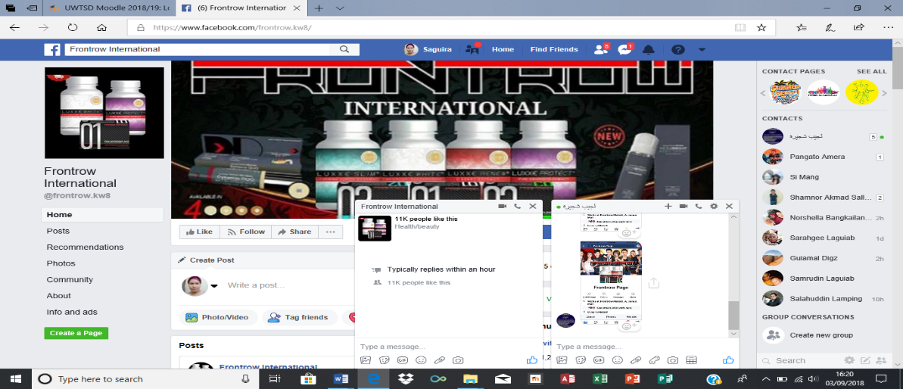

111. CREATING MY OWN PROFESSI0NAL ONLINE PAGE
Facebook account (https://www.facebook.com/saguiralaguiab3)
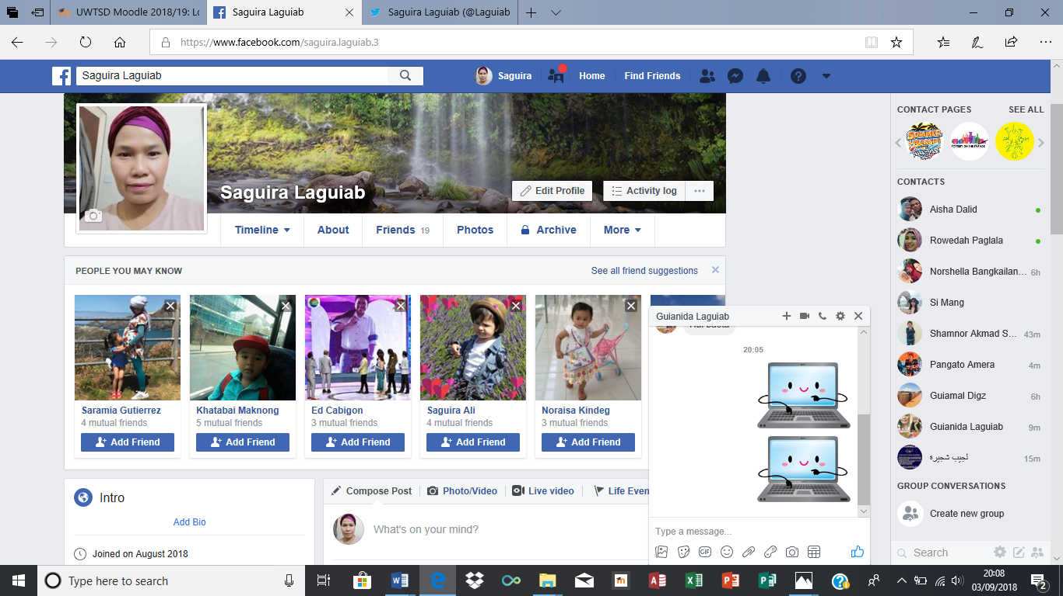

Twitter account ( https://twitter.com/laguiabsaguira)


Linked In( https://www.linkedin.com /in/Saguira-laguiab
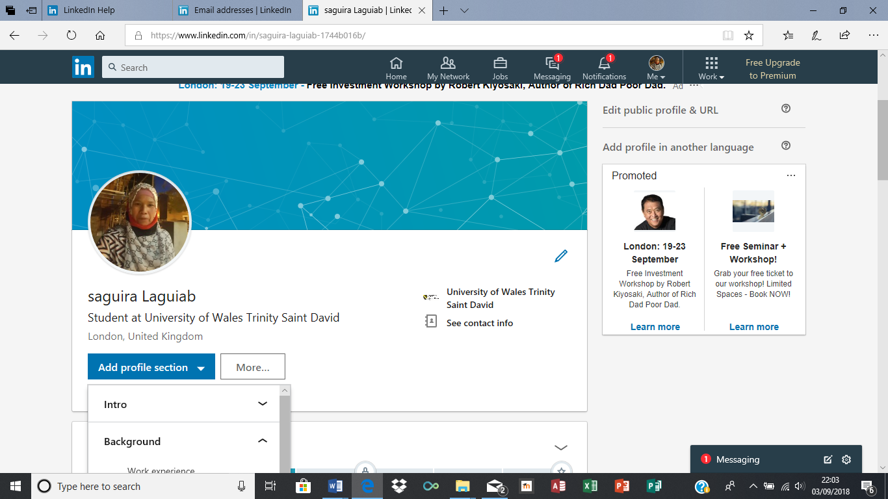

LITERATURE CITED
Affeldt, F. S., & Silva Junior, S. D. d. (2013). Information Architecture Analysis using Business Intelligence Tools Based on the Information Needs of Executives. JISTEM - Journal of Information Systems and Technology Management, 10(2)

Boxall, P. & Purcell, J. (2000). Strategic Human Resource Management: Where Have We Come From and Where Should be Going? International Journal of Management Reviews, 2 (2), pp. 183-203.

Cheng Yan (2017). CLOUD STORAGE SERVICES. Thesis CENTRIA UNIVERSITY OF APPLIED SCIENCES Information Technology

Delaney, Rob and D'Agostino, Robert (2015), "The Challenges of Integrating New Technology into an Organization" .Mathematics and Computer Science Capstones. 25. http://digitalcommons.lasalle.edu/mathcompcapstones/25

Hritzuk, N. & Jones, K. (2014). Multiscreen Marketing: The Seven Things You Need to Know to Reach Your Customers Across TVs, Computers, Tablets, and Mobile Phones. New York: John Wiley & Sons.

Huns, J.T. (2005). Management of Technology, Managing Effectively in Technology-Intensive Organizations. New York: John Wiley & Sons.

Kerzner, H.R. (2013). Project Management: A Systems Approach to Planning, Scheduling, and Controlling. New York: John Wiley & Sons.

Mashau Pfano and Andrisha Beharry (2016). The Effect of Modern Office Technology on Management Performance: Durban Westville. Problems and Perspectives in Management, 14(2-2), 376-384. doi:10.21511/ppm.14(2-2).2016.13

Matt, T. (2007). Streamlining Technology Management to Increase Workplace Productivity, EDS Workplace Services.

Schraeder, M., Swamidass, P. M., & Morrison, R. (2006). Employee Involvement, Attitudes and Reactions to Technology Changes. Journal of Leadership & Organizational Studies, 12(3), 85.

