Feasibility Study for Meeting Spaces Within the LC2 Swansea
P150503
Reagan Cartwright

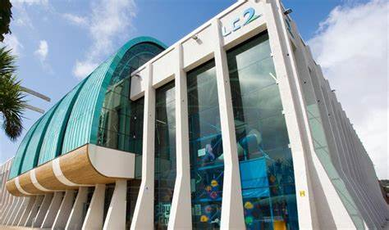

Contents
Project Justification 3
Background 3
Project Aim 3
Project Objectives 3
Initial Ideas 4
Rationale 4
Findings 4
Ethical Considerations and Limitations 5
Scope and Exclusions 5
Constrains and Assumptions 5
Business Case and Approach 5
Potential benefits and outcomes 5
Potential Issues 6
Approach 6
Methodology 6
Quantitative 7
Project Management 7
Quality Project Management 8
Communication Management Strategy 9
Project Time scale 9
Project Plan 9
Project Controls 10
Project Reporting 10
Appendix 11
References 13

Project Justification

Background
The LC Swansea is “home to Wales biggest indoor Waterpark, Swansea's most state-of-the-art gym and they have been awarded “TripAdvisor Traveller's Choice award winner”. The LC also features an indoor surf machine, a four-storey interactive play area, a 30ft indoor climbing wall and a multi-purpose sports and exhibition hall. Also, a two-storey gym” LC website(Online). They also cater for children’s parties and events which shows they do have a lot going on, so I want to see if having more booking for their meeting rooms could be feasible as there are other places that cater for meeting spaces and people do not necessarily see the LC as a meeting space.

Project Aim
The overall aim is to provide an understanding on the feasibility on the meeting room spaces within LC2, people should book and take the LC2 more serious as a business not just a leisure centre as that’s why they lack with bookings for meeting rooms. There will also be questionnaires on via social media to see if people would book the meeting room spaces within the leisure centre other than hotels etc to get. There will be information about hotels packages, National Wales Pool packages and Environment Centre packages and show information about how much they price their rooms.

Project Objectives
The objectives of this proposal are
- Provide an understanding on how feasible the LC2 meeting rooms are.
- Make questionnaires/surveys to get the information I need.
- Outline the problems of having meeting spaces
- I will research via websites to see what other businesses offer within their meeting rooms.
- If meeting room bookings do not work, then suggest more events for e.g. wedding fayres or student events as there is a lot of student housing close by.
- I will be looking into packages which will be sent to me by Lyndsey about how much each meeting room costs, what the capacity of each room is, what is the price per person and what is included in each room.

Initial Ideas
I will be finding out if the spaces within the LC2 Swansea will be feasible for meeting rooms. I will do this by looking into each hotel, places with meeting rooms very closely and see what they have on offer and promotions. I will be conducting secondary research by looking on websites to see what other places offer within their meeting spaces and looking into what LC2 meeting spaces offer and compare. I will also be conducting primary research by visiting the competitors and by possibly contacting them via email or giving them a call to discuss what they have on offer.
After this project is finish, I will be able to get them more bookings within the future and if having more businesses to book their meeting spaces does not go well then, I will offer them a different approach of more bookings for e.g. student events or wedding fayres.

Rationale
The LC2 is based within Swansea and is situated very close to the Marriot and not a far distance from the Dragons Hotel which both cater for meeting room spaces. They have quite a few competitors around Swansea. But the LC do offer a much cheaper rate than the hotels which is very beneficial. They lack in bookings for the meeting rooms they have due to people not seeing them as much of a meeting room venue only a leisure centre. People and their businesses want to book spaces that look sophisticated on the outside of the building and inside, not where people take their children and families.

Findings
When discussing about the project to Lyndsey which is the Marketing Manager via Facebook LC2 page, she was more than happy for me to investigate and see if its feasible to hold meetings within their meeting spaces. She was happy to send the information I need to me over email and will help and communicate with me every step of the way which is very beneficial. I have discussed with her I may need to come in to talk to her when she’s free about the information I got so far and if she wants me to change anything and she was happy to do that.

Ethical Considerations and Limitations
Ethical Considerations and Limitations For both, “the questionnaires and the interviews, consent will be required from the person answering the questions. Also informing the respondents that they will be anonymous is important as it should mean they are more likely to answer honestly.” (Mitchell & Jolley, 2007, p. 288) since there will not be any interviews or with children there will no need to be consent forms given.

Scope and Exclusions
This project intends to help the LC2 with more booking within their meeting spaces and to get more businesses to book with them as people do not necessarily see them as a meeting venue. This project will compare with different places that cater for meeting spaces and give them recommendations and to see if the LC is feasible enough to hold meeting room spaces. If not them possible suggesting to them different events to hold within them for e.g. student events.

Constrains and Assumptions
As a student, time is going to be a huge pressure especially when I am working to a specific deadline. With any project and having a client it can be time consuming due to the client not being free to discuss the project, when creating a questionnaire people may not want to do it due to using up their own time. There may be a problem that the data from the questionnaire as it could be biased. And may not give out the correct information due to people not going booking meeting spaces before. Also, people may not be truthful so in that case it will have to be made clear once created that it will all be anonymous and confidential only to me and LC.

Business Case and Approach

Potential benefits and outcomes
- Increase bookings
- business opportunities
- more recognition
The potential benefits and outcomes will be giving the LC more recognition due to sharing the questionnaire via social media and getting people involved with answering the questions. It will show people that the LC does cater for meeting rooms spaces which will then increase bookings for them.

Potential Issues
- Still no increase in bookings
- Lack of communication
- profit
- Time consuming
There are potential issues when it comes to getting more bookings for the LC, as it could possibly be time consuming as people still may not want to book still possibly having a regular meeting room space or still not potentially seeing them as a meeting room space. There could possibly be a lack of communication as I speak to the marketing manager Lyndsey via social media, she may not answer back due to being busy or might not be able to discuss the project with me on certain days as she could be busy on the days that I’m free. If the project does go in the right direction and is successful, then the LC will see more profit within their business which will be very beneficial as it will give the LC more recognition as customers to take them seriously as a meeting space venue other than a leisure centre.

Approach
To overcome the lack of communication I will make sure I am contacting Lyndsey before hand as she will be busy most of the times due to being the marketing manager of the LC. I will investigate into them holding other events as well as booking businesses within their meeting room spaces as it will still give them the idea of more profit, they do book children’s parties but if they book something different then they will get more customers. It will be time consuming as it is a lot of work to do but I will set myself deadlines for certain tasks to complete.

Methodology
Methodology is very important when carrying out a project. Clough & Nutbrown states “how research questions are expressed, and its effect is a claimed about significance” so when carrying out an investigation for an initial project, there are two types of research strategies, these are qualitative and quantitative research, but I will be focusing on quantitative data.
Defranzo. S states that “Some common methods include focus groups (group discussions), individual interviews, and participation/observations. The sample size is typically small, and respondents are selected to fulfil a given quota.” Which shows It can take some time to get people involved and some people may not have time to answer all the questions or could answer the questions simple, which can lead to inaccurate data that can be undependable.

Quantitative
This sample would be best for the questionnaires as it does focuses on a specific group of people e.g. people that has meetings and uses meeting room spaces or has ever been to the LC2 Swansea. The people who participate in the questionnaire are people 18+ due to people under that age not going to meetings.
Research strategies which will be used:
• Questionnaires
- Observation
This project will mainly focus on using quantitative research to get an in-depth understanding of people’s opinions of LC holding meeting spaces and seeing if people think it will be feasible. I will do this by creating a questionnaire via survey monkey to share over social media for people to answer the questions about the LC and what they think about them holding meeting spaces. I will also be observing hotels that are close by to the LC to see who they have within their meeting rooms and what they have to offer. “Observation is a research method which involves the direct observation of occurrence in someone’s natural setting” (Babbie, 2013). so, observation will be used so that the research can have a precise understanding of what the hotels offer that LC do not and compare them.

Project Management
Fox states “For any organisation to run well there must be a logical approach to planning and controlling, especially the roles of staff within in an organisation allowing matters to run smoothly”
Below show the roles within the LC2
- General manager
- Waterpark manager
- Front of house manager
- Fitness manager
- Core team leader
- Cleaning team leader
- F&B supervisor
- Duty manager
- Swim lesson coordinator
- Marketing and group events executive
- Membership team
- Reception team
- Cleaning team
- Core team
- Lifeguard
- Finance team
- Back of house admin
All of these have a major role within the LC2 to make sure it runs smoothly and their getting people through those doors. Lyndsey is the marketing manager within LC2 and I will only be contacting her throughout this project as she plans and executes events and meetings.

Quality Project Management
A quality management strategy can be defined as “a formal record of an organisations method of managing the quality of its product and services” (Beckford, 2010). Quality project management is used to make sure that the business knows how the project goes. For the client they will have certain exceptions and standards that my research must bind behind. So whatever information is sent to me or I have found out it will be kept private and only shown towards the marketing manager not other parties. Staff names will not be mentioned in the final report, so any recommendations made will be only shown to the marketing manager.

Communication Management Strategy
Communication within this project is very vital because without communications from the LC it will be extremely hard to carry out the research. To make sure the communication always happens within this project on a regular basis there will be three main communications:
- Emails, on a weekly basis if possible
- Discussion over Facebook (LC2 Facebook page) as Lyndsey runs the page.
- In person meetings, when the marketing manager is free
- Phone calls if any urgent information is required if there the marketing manager isn’t free for a meeting or if no one is getting my emails.

Project Time scale
Below is a Gantt chart which shows the project time scale from start to finish.

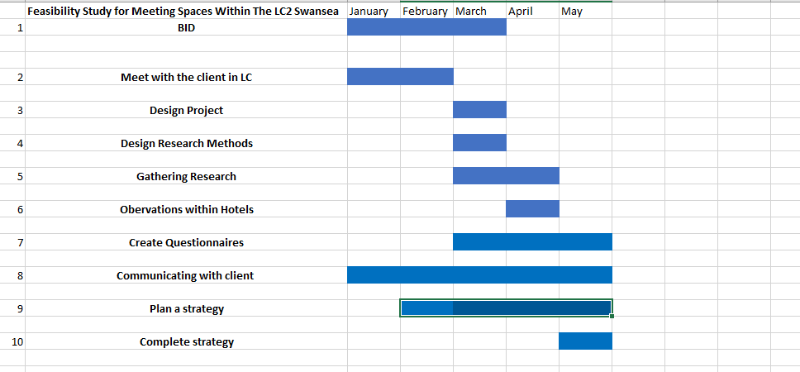

Project Plan
The plan within this project will stretch between presenting the BID in February 2019 to mid-May 2019 when the full report will be completed. So firstly, research and be carried out on the LC to have more of an understanding of the structure of the leisure centre and to find the relevant information I need to carry out this project. From planning this project, I will be looking into depth their meeting rooms and comparing them with hotels and other meeting space venues by observing them and comparing. I will also create questionnaires via Survey Monkey, it will be uploaded on social media as it will get people involved. It will all be anonymous so the marketing manager or me will not see what people answered, the questions will be very brief and simple, but it will show peoples opinions if they think the LC is feasible for meeting room spaces. Once this has happened, an analysis and summary will be carried out by comparing the hotels to the LC and seeing if the LC is feasible. If not, there are other suggestions within the recommendations for the LC as hosting student events as there is a great number of students within Swansea, or possibly using the spaces for wedding fayres etc. Finally, there will be a report given on improvements and recommendations which will benefit the LC and Lyndsey who is the marketing manager.

Project Controls
Within each stage of the project there will be different approaches which will help identify the projects progress and see if there any problems along the way. These approaches should help prevent any failure to the project through boundaries, reporting and communicating. As the project is following a certain time scale clearly there could be errors if research cannot be collected by a certain date or if meetings are rescheduled, in the case of this I will make sure I complete certain parts of the report by a certain day to give myself time as meetings or communication to the client.

Project Reporting

Preceding to this document there was a meeting with my client dating back to 26th February to discuss my project with them and to see if there are any problems within the LC2 and discuss to see if we can overcome them. From this, a plan was made of how research was going to be carried out and possible ways to use the meeting room spaces if they still not being used as much after the project. Over the time of this project I will be setting up more meetings over the Easter holidays to discuss what I got so far and to see if they want to make any changes.

Appendix
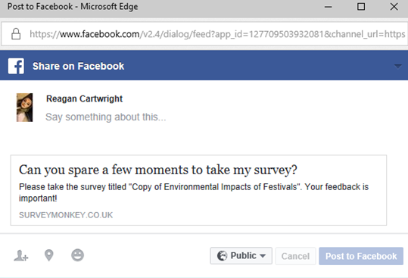
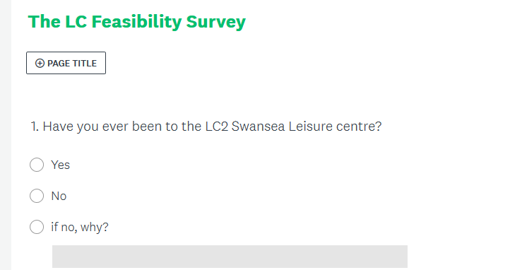
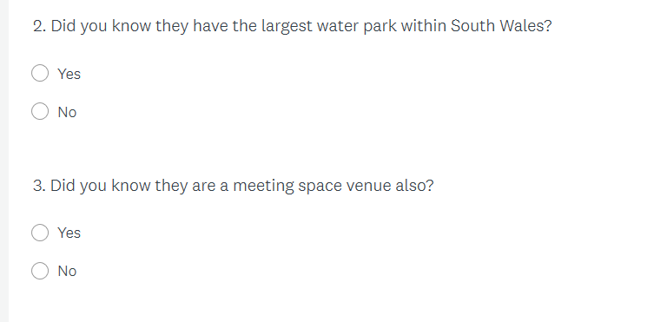
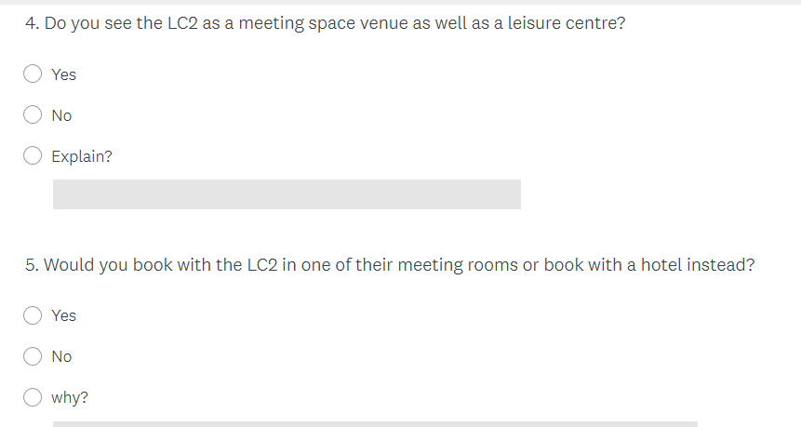
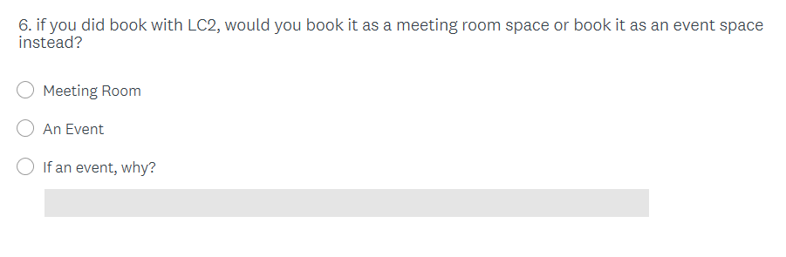
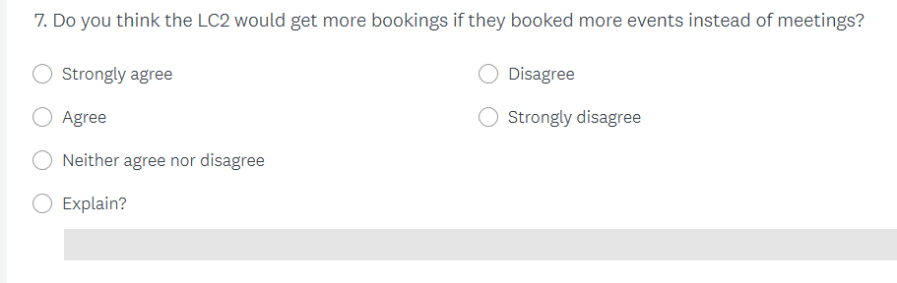

References
Anon. (2018). Swansea's premier leisure complex. Available: http://www.thelcswansea.com/. Last accessed 24/03/19.
Babbie, E. (2013). The Basics of Social Research. USA: Cengage Learning.
Beckford, J. (2010). A Critical Introduction, Third Edition . London : Routledge.
Clough, p., & Nutbrown.C. (2013). The Students guide to methodology. London: Sage.
Fox , W. M. (2009). The Management Process: An Integrated Functional Approach. London : IAP .
Rubin. A & Babbie. E (2010). Essential Research Methods for Social Work. Belmont: Cengage Learning.
Saunders, M., Lewis, P., & Thornhill, A. (2009) Understanding research philosophies and approaches. In M. Saunders, P. Lewis, & A. Thornhill, Research methods for business students (p. 106-135). England. Pearson
Susan Defranzo. (2011). What’s the difference between qualitative and quantitative research? Available: https://www.snapsurveys.com/blog/qualitative-vs-quantitative-research/. Last accessed 24/03/19
Wild, J. & Diggines. C (2009). Marketing Research. Cape Town: Juta and Company ltd.

