Effective Team Working and Communication
Lecturer : Akash Puranik
Student : Chirnoaga Florin 2129812
Table of Contents
Introduction 2
Development of an effective team 2
Roles of the team in team development 3
Benefits of teamwork 4
Barriers to teamwork 6
Conclusion 7
References 8

Introduction
Teamwork has been considered an important part of any organization. Similarly, in the case of Amazon teamwork will be required to deal with the expansion of the business in the desired areas. In the absence of good teamwork, the company's efforts to expand and grow its business will be hampered. In this report, various aspect of teamwork has been taken up. The role that the team members should play in the creation of an effective team has been discussed. The benefits that the company can get from teamwork have been talked about. The barriers that the company can face while undertaking teamwork have been identified as well. Lastly, a conclusion has been provided, to sum up, all the important points.

Development of an effective team
Team building will serve as the base for an effective team. The ideas of every team member must be considered. Each and every opinion of the team members will prove to be valuable in the growth of the company. This is because the ideas that will be put forward by the team members will be unique and can guide the team and help in the better creation of the team. It should be kept in mind that no idea should be considered useless (Berkeley, 2022). The next step that can be taken up for the creation of an effective team is the outlining of the purpose. If the team members are well versed with the aims and objectives that are set by the company, it will enable them to act towards a common goal and help them identify the strengths and skills that they possess to carry out the work. The creation of respect and building of trust is important in effective team building. The nurturing of the environment that deals with the team building should be adopted. In this context, the feelings that are unspoken should not be overlooked. The leader of the team should be able to communicate with the team members and everyone's opinion will be considered. The creation of trust by allowing the members to let know all the happenings of the organization should be practiced. Transparency should be maintained by the leaders as this can create a balance between the employees and the employers. If the level of trust is strong then the team will be better at navigating the risks and the problems together. The 7C's and the forming, norming, storming, and performing model can be used in the creation of effective teamwork.
Conflict can be seen as a part of teamwork. The leaders should maintain a harmonizing influence which will enable the team members to work in peace. For achieving this good communication techniques should be adopted. Clarity in communication should be maintained (Forbes, 2017). Good communication will help in encourage the trust and cooperation of the employees. The working of the team members should be supervised as it will give the leaders the idea of the compatibility of the employees with each other. The leaders should encourage the team members to share information that will enable the understanding of the contribution of the members regarding the problems. The contribution of each member should be acknowledged and they should be praised. This will allow the motivation of the employees and will encourage them to undertake much more work. The delegation of the problem-solving tasks should be given to the team members which will facilitate the working of communication within the team (Page, 2022). The updating of the progress of the team should be made known to them and the leaders should remain open to any form of suggestion and feedback that is given by the team members.
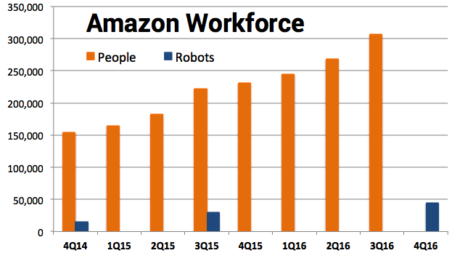
Graph: Amazon Workforce
Source: (Page, 2022)

Roles of the team in team development
An effective team is always the reason for a company's growth. If every person in teamwork equally and give their importance in team work then that team could be called an effective team. In a team, the individuals have different role to play. The leader of the team means the head of the team. Leaders should always provide instructions to the team. A good leader always needs to motivate the member of the team. The leader has to be team building skills, and the capability to manage the situation. Team leaders clarify the goals, fix the goal, and provide direction. The team leader needs to ensure effective and smooth operations of the team. Leaders should serve as a mediator between the quality council and the team. He needs to implement the changes according to the needs of the team. In a team, the role of the creative director is to provide creative energy for the success of the team. Employees sometimes need someone who can think out of the box and can give new and unique ideas, so, a creative director always should provide these things to the team. The team creative director needs to insist everyone maintains progressive energy (Gander, Gaitzsch, and Ruch, 2020). The responsibility of a facilitator is to help the team to understand their objectives and help to achieve their goals. The facilitator needs to always motivate the people for the development and communication at work.
The facilitator always supports the leader during the initial stages for the team for facilitating the situation. Coach needs provide one to one support to the team members after their training. He needs to work as the resource of the team. During the training, if anyone faces any problem then the team coach supports that member. The hardworking members of a team always are a benefit for a team (Sanyal and Hisam, 2022). An effective team member always needs to participate in team meetings and whatever is assigned to them does that work. Sometimes members participate in meetings via webinar platforms and also physically. Members should regularly communicate with their team. Team members should respect the contribution of others. If the members listen to their leader carefully and ask questions it will helps in the solving of the conflicts. For personal growth, employee needs to develop new skills and make use of the new technique and tools. The role of the Team recorder is should document the main ideas of the team. He needs to provide the documents for the team and needs to review them during the meeting. In a team, shaper needs to face the challenges, and shapers have to think positively to shape their challenges. In a team, everyone has to be their own roles and responsibilities.

Benefits of teamwork
The benefits of teamwork always give advantages to a team and the company. Teamwork increase and improve productivity. The team always motivates the members to achieve the company's goals. It helps in better communication. Through teamwork, the company increases innovation. Teamwork always gives place to the open-minded employees that help in the growth of the company. Teamwork enhances flexibility. At the time working together, everyone knows about their roles and responsibilities which enhance the flexibility of the team (Schmutz, Meier and Manser, 2019). If a team faces challenges in their work then they can use unique of ideas. To overcome the situation teammates also help each other and they find out multiple solutions to their problem. It improves the service level. Teamwork always provides updated and improved customer service for the company. Good teamwork always decreases the workload and the stress level. The customer always loves the quick and experienced service from the company and teamwork is the main key to quick service of a company. Through effective teamwork company always meet its deadline at the right time.
Teamwork does more work in less time. Teamwork provides conflict resolution skills to the members of the team. In high performing team always be confident at the time of taking a risk. It also maximizes the involvement of many members in a work. The outcome of teamwork is always better than any individual work. Teamwork always protects the company from risk, and it helps individuals to take the risk (Shuffler, Diazgranados, Maynard, and Salas, 2018). It also helps to improve the office relationship. Members help each other in team work and adopt each other's adaptability. Share ideas mean better ideas which increase the growth of a team. Teamwork also identifies the mistake of an individual, which helps that person in the growth of his or her personal life. Teamwork also increases the energy level of individuals. In teamwork, there is no place for lack of communication. It promotes unity and diverse thinking. Without teamwork, a company cannot achieve its goals.

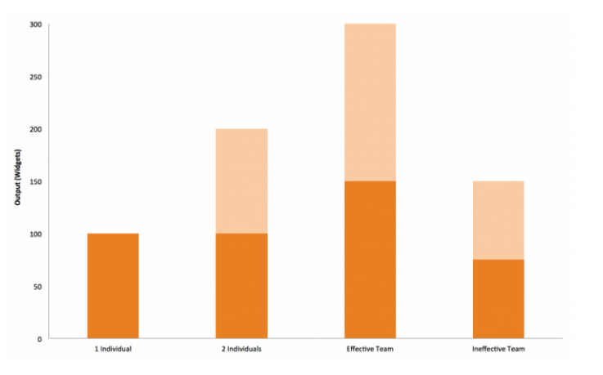
Graph: Effectiveness of team work
Source: (Shuffler, Diazgranados, Maynard, and Salas, 2018)

Barriers to teamwork
The barrier that can be seen in the case study is that the team-building qualities that are possessed by Tom are inefficient and lacking. In the absence of strong leadership, the team will not be formed and it will have a negative impact on the organization. Thus it can be considered that the most common barrier to teamwork is bad leadership (Bestpractice, 2021). This can lead to the ruining of the company's bottom line. In the absence of good leadership quality, the conflict that can be seen among the team members will not be solved. The lack of decision-making capacity of the leaders may throw the employees and the team members off guard without any direction and this can result in demotivation and discourage the workers from taking part in any activities (Zajac et al., 2021). The ineffective team management on the part of the leaders can lead to the downfall of the team. Secondly, poor communication can also impact and act as a barrier to effective team work (Morrison-Smith and Ruiz, 2020). In the absence of good communication, the processing of the information that is required for the running of the organization will be lost. The team members will not feel confident and comfortable without good communication efforts. The delegation of the task will not be done if good communication skills are not present (Root, 2022). Resolving the conflicts will not be possible in the absence of strong verbal as well as non-verbal methods. The lack of communication will debar them from having the information that they require for the smooth running of the organization. This can be seen in the case of Tom.
Another aspect that can hinder the growth of the team is the poor planning of the goals. Identification of the goals that are long-term will enable the team members to understand the required focus that is required for the tasks that are at hand (Weller, Boyd, and Cumin, 2022). The long-term goals can be divided among the team members so that they can focus on the important tasks that are needed to be solved. In the absence of clear goals, the team members cannot estimate the time and chart their progress (Petit, 2022). Along with that, they cannot plan for emergencies in the future and they will be bound to fail in their endeavors. The undertaking of the planning and the procedures that can help the employees to undertake different works will be hindered. With the absence of planning in the team, the utilization of the skills and techniques of the employees will be wasted as seen in the case of Amazon. Another issue that can be seen is the problem of commitment on the part of the employees. In the absence of commitment, the performance of the team will be declining (Salih and Draucker, 2019). This will not promote the productivity of the team. The team goals will not be shared by the team members and the working of the team will be affected.

Conclusion
It can be concluded that Tom has been facing some issues in gathering the correct team members that will help in the expansion of the company. The development of an effective team needs the best leadership as well as good communication techniques that will encourage the team members to take up the work. The lack of effective teamwork may lead to a low outcome for the company. The benefits that teamwork provides are the increased revenue and productivity of the employees as well as the company. The barriers that are present in the company should be removed so that good teamwork can be established.

References
Berkeley, 2022. Steps to Building an Effective Team | People & Culture. [online] Hr.berkeley.edu. Available at: <https://hr.berkeley.edu/hr-network/central-guide-managing-hr/managing-hr/interaction/team-building/steps> [Accessed 27 September 2022].
Bestpractice, 2021. The Impact of Bad Leadership on an Organisation. [online] Best Practice. Available at: <https://bestpractice.biz/the-impact-of-bad-leadership-on-an-organisation/#:~:text=Bad%20leadership%20in%20business%20leads,cycle%20of%20poor%20staff%20retention.> [Accessed 27 September 2022].
Forbes, 2017. Five Ways To Build An Effective Team. [online] Forbes. Available at: <https://www.forbes.com/sites/theyec/2013/06/07/five-ways-to-build-an-effective-team/> [Accessed 27 September 2022].
Gander, F., Gaitzsch, I. and Ruch, W., 2020. The Relationships of Team Role- and Character Strengths-Balance With Individual and Team-Level Satisfaction and Performance. Frontiers in Psychology, 11.
Morrison-Smith, S. and Ruiz, J., 2020. Challenges and barriers in virtual teams: a literature review. SN Applied Sciences, 2(6), pp.223-228.
Page, M., 2022. Building an effective team | Michael Page. [online] Michael Page. Available at: <https://www.michaelpage.ae/advice/management-advice/development-and-retention/building-effective-team> [Accessed 27 September 2022].
Petit, P., 2022. Overcoming Common Barriers to Collaboration, Part 1 :: UXmatters. [online] Uxmatters.com. Available at: <https://www.uxmatters.com/mt/archives/2017/10/overcoming-common-barriers-to-collaboration-part-1.php> [Accessed 27 September 2022].
Root, G., 2022. Biggest Barriers to Teamwork. [online] Small Business - Chron.com. Available at: <https://smallbusiness.chron.com/biggest-barriers-teamwork-11451.html> [Accessed 27 September 2022].
Salih, Z. and Draucker, C., 2019. Facilitators of and barriers to successful teamwork during resuscitations in a neonatal intensive care unit. Journal of Perinatology, 39(7), pp.974-982.
Sanyal, S. and Hisam, M., 2022. The Impact of Teamwork on Work Performance of Employees: A Study of Faculty Members in Dhofar University. The Impact of Teamwork on Work Performance of Employees: A Study of Faculty Members in Dhofar University, 20(3), pp.15 - 18.
Schmutz, J., Meier, L. and Manser, T., 2019. How effective is teamwork really? The relationship between teamwork and performance in healthcare teams: a systematic review and meta-analysis. BMJ Open, 9(9), p.e028280.
Shuffler, M., Diazgranados, D., Maynard, M. and Salas, E., 2018. Developing, Sustaining, and Maximizing Team Effectiveness: An Integrative, Dynamic Perspective of Team Development Interventions. Academy of Management Annals, 12(2), pp.688-724.
Weller, J., Boyd, M. and Cumin, D., 2022. Teams, tribes and patient safety: overcoming barriers to effective teamwork in healthcare.
Zajac, S., Woods, A., Tannenbaum, S., Salas, E. and Holladay, C., 2021. Overcoming Challenges to Teamwork in Healthcare: A Team Effectiveness Framework and Evidence-Based Guidance. Frontiers in Communication, 6(3), pp.112-115.

