Teacher : Mary March

Professional Career Develepment , Term 3

Tiganuc ioan Cosmin : Student id 1817442
University of Wales Trinity Saint David

Table of Contents
INTRODUCTION 3
LO1 UNDERSTAND THE SKILLS AND KNOWLEDGE NEEDED FOR WORKING EFFECTIVELY 5
LO2 UNDERSTANDING OF PERSONAL STRENGTHS 10
LO3 EMPLOYMENT GOALS PERSONAL AND PROFESSIONAL DEVELOPMENT PLAN 14
CONCLUSION 17
REFERENCES 18

INTRODUCTION
Personal reflection and career development plan are very important for the person as it allows an individual to plan before the execution. This enables an individual to improve its performances by working on skills and abilities. It also improves the knowledge of an individual required in school or workplace (Argyropoulou and Kaliris, 2018).
This personal reflection and career development plan assignment is related to the personal and professional career development of an individual in an organization. Personal reflection allows an individual to focus on owns skills and abilities. One can easily identify its strength and weakness by reflecting on the self (Argyropoulou and Kaliris, 2018). By personal reflection, one can improve its habits and weakness. It includes the development of different strategies required for working on one's weakness. It ensures success in career.
The report will help to introduce the strategies required for personal and career development. As planning is very important for any execution. Thus career development planning is also important. As it allows to eliminate the risk factors that an individual can face. Planning is a set of method required for proper execution. In the career development plan assignment, the main focus is on the steps that are essential for career development (Bhardwaj et al., 2019).
The report will include different strategies and approaches required for the career development of a career counsellor. The assignment is beneficial to learn self-management skills which are very basic and essential for career development planning. The report includes different benefits of personal and career development planning. In this assignment, an individual can understand the importance of gaining confidence and competences as effective employees and how to achieve it. Furthermore, the report will successfully apply self SWOT analysis to understand the requirements in career development planning (Bhardwaj et al., 2019).
This will allow an individual to understand the strength and other weak areas. Furthermore, the report will include the employment goals required to develop a personal action plan. A career development plan involves the feedbacks which allows and individual to improve the performances (Bushardt et al., 2018). For career development planning, an individual must know all the fields. It allows an individual to choose the right path. Thus career counsellor is the best field that can anyone go for. Career counsellor understands the problems and thoughts of the people and gives the right advice to the right people. In career development, effective communication skills play a vital role in shaping a career. It allows an individual to learn and teach (Bushardt et al., 2018).
The main aim of the module is to develop and understand personal and career development planning. And to gain confidence and competencies as an effective employee. The assignment is made to understand the different methods of planning required for personal and career development (Chen et al., 2019).
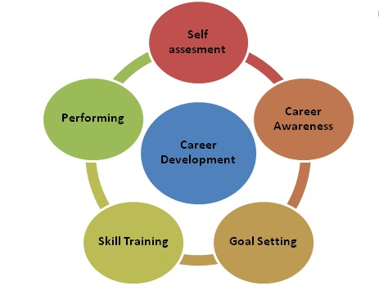
Figure- career development
Source- (Yu et al., 2016)

LO1 UNDERSTAND THE SKILLS AND KNOWLEDGE NEEDED FOR WORKING EFFECTIVELY
The personal reflection includes the various strategies which are required to set the goals for the career development plan. This includes the methods of self-management and self-learning to gain lifelong experiences. This report will further discuss the different ways of improving personal and professional life experiences. The report will explain the benefits of the career development plan (Chen et al., 2019).
HOW TO DEVELOP SKILLS AND KNOWLEDGE FOR WORKING EFFICIENTLY
I referred to a module which includes various strategies which are beneficial to improve the skills and knowledge for working efficiently. Working on skills and knowledge allows me to work efficiently. As we all surrounded by knowledgeable people. So my first approach is to motivate myself to work on my weakness. The module includes various ways of improving skills and knowledge (Bhardwaj et al., 2019).
- Attending Conferences And Seminars
There are several conferences and seminars that I can attend to gain knowledge of various fields. This helps me in my career development of Career counsellor. It also ensures me to give the right advice to the students. The conferences and seminars are hosted by highly qualified and experienced people (Chen et al., 2019). This improves my knowledge related to my career and also allows me to take the right decision. The people who host the seminars and conferences belong to different cultures and different educational backgrounds. By interacting with them, I can easily understand my weakness and strength. This allows me to improve my skills and knowledge required for working effectively and efficient (Cohen et al., 2018).
I have attended various seminars and conferences to improve my knowledge and skills required for mu profession and career development planning to work efficiently and actively. Attending seminars and conferences allows me to exchange my knowledge and perception for the required career development plan (Chen et al., 2019).
- Attending Colleges And Classes
Attending colleges and classes adds values in the life of people to improve their knowledge and skills. I have uses one of this method to improve my knowledge. The professors are highly qualified and experienced and belong to different educational backgrounds. I always would like to interact with them and upgrade my knowledge related to my career development. I have attended most classes of my PHD holder master classes. This helps me exchange my knowledge and thoughts which enables me to identify the required skills and resources to eliminate the risk factors (Cohen et al., 2018).
My professors have shared various articles and lectures which are beneficial to improve my knowledge related to the chosen profession. The articles include knowledge related to subjects that enables me to gain knowledge. It also includes the subject of sociology which is beneficial to know the perspectives of the people (Cohen et al., 2018). As this skill is most important in the career of the Career counsellor. The articles are written by the various authors which include various methods to understand the perspectives of an individual. I have referred various articles of authors which includes several models and theories to identify the perspectives and thoughts of the people. it has added a value in my life and improves my knowledge and skills (Hilton et al., 2016).
- Surfing the Internet
Internet is available all over the world. Surfing the internet is the most common method to gain knowledge. As it allows an individual to gather and collect knowledge in one place. There are many highly qualified and experienced people who do not work in any education centre but provides knowledge on the online platform. They also share information and their valuable experiences on the internet.
I have referred this to improve my skills and knowledge. I have collected information from various sources includes downloading of PDFs from the official sites and gain the knowledge. It allows me to learn self-management and time management. Surfing the internet improves my analytical skills in research. It also helps me develop various strategies which are required to face future challenges (Hughes et al., 2019). Strategies made by the authors help me to understand various opportunities in the career development of Career counsellor.
This methods of collecting information enable me to work efficiently on my skills.
SKILLS AND KNOWLEDGE DEVELOPED BY THIS METHODS
I have chosen a career development plan for career counsellors. From the research and reading of various modules, I understood the role of a career counsellor. The main aim on which the career counsellor works is to provide efficient results by understanding the feelings and thoughts of an individual related to the career. I have referred various modules and reports to understand the skills and knowledge that are required to become a good career counsellor and to work efficiently (Lipshits et al., 2017).
Career counsellor focuses on individual thoughts and feelings which is beneficial to understand the perspectives to achieve the career goals. By learning the module I have identified the various skills and knowledge which are required to work efficiently. Career counsellor must know the different field which plays a crucial role in this field. The module includes various lectures which include the various benefits of gaining the knowledge of different fields (Mazzotti et al, 2018). This allows a career counsellor to give the right advice to the right person in the right place. The modules also include various skills and abilities which are very beneficial to work efficiently (Ragan, 2018). For becoming a good career counsellor the skills and knowledge required are listed below
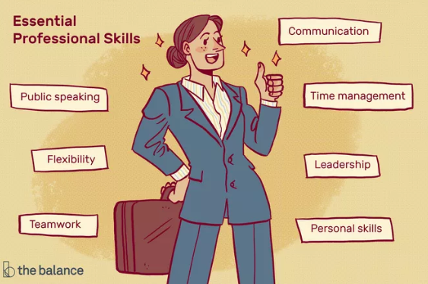
Figure- skills for career development
Sources- (Yu et al., 2016)
- Communication Skills
This module helps me to understand the importance of effective communication skills. It also includes various methods which allow me to improve my communication skills. The module focused on the different key points which help me to improve my interaction method. The module also focused on the listening skills which makes a speaker a good listener.
Career counsellor must have abilities to listen and ask a question related to the career. The thoughts of the career counsellor must be clear. This allows him to communicate and understand the perspectives of students. Knowledge plays here a crucial role. Career counsellor must have the knowledge this allows him to answer correctly and solve the problems of the students. Learning of this module helps me to improve my various weakness and allows me to identify my strength to serve people and provide the right information about the career (Ragan, 2018).
- Problem Solving Approaches
By learning this module helps to strategies various approaches which has a great impact on the problem-solving approaches. The module various methods to understand the perspectives of students which allows me to understand the point where the students are going wrong. By understanding this, I could be able to analyze the logical ideas which help me to determine their weakness and strength. This will add value to my working method. Many times students suffer from depression because of selecting the wrong career (Bhardwaj et al., 2019).
The module also has various methods for dealing with those students. It allows me the judge and provides the best solution for dealing with their problems. Recognizing the student's nature also plays an important role in it. This helps to understand the behaviour of students and provides a good experience of dealing with those students. The problem-solving methods must be unique which allows a career counsellor to work efficiently (Argyropoulou and Kaliris, 2018).
Career counsellor must have various ideas to generate new techniques for improving knowledge and dealing with students. Furthermore, the module includes the ideas to think effective, original, unusual and creative to solve the problems. This will allow me to understand various distractions that a student went through (Bhardwaj et al., 2019).
- TIME MANAGEMENT
Again time management plays a vital role in becoming of a career counsellor. The module allows me to learn different methods of proper time management. This also me to give preference to the important work (Ragan, 2018). Proper management allows managing people, time and resources. By managing time one can save time and utilize to improve its knowledge. This method is beneficial for the generative new creative ideas for dealing with the people. Career counsellor must have the power to motivate others for a better career.
- Work With The People
The module helped me to understand the different methods to understand the behaviour of the people. Career counsellor must be aware of other's reactions. A career counsellor can gain experience while dealing with other people. These experiences are beneficial to learn and teach many new techniques for problem-solving approaches. This experiences also provides ways to solve the various misunderstanding and misconceptions of the students related to their career and provides them with the right path (Ragan, 2018). This also improves the problem of communication gap.
The module focuses on the different skills which are required to develop in an individual to become good. The module helps me to focus on the various strategies that can be affected by the behaviour of people, students or colleagues in the office. Despite this, it is also very important to maintain a relationship with colleagues. This helps me to maintain my reputation in the workforce (Ragan, 2018).
This module shows the importance of effective communication skills. This skill is beneficial for me to take lectures and seminars related to career problem-solving approaches. It also emphasis on listening skills. This allows me to gain knowledge and to hear the questions and problems of the students. Developing good listening power will ensure me to think positively and creatively to solve the problems.

LO2 UNDERSTANDING OF PERSONAL STRENGTHS
Strength is a way of motivation for an individual. Strength of a person allows him to work efficiently. It also enables a person to improve its skills and knowledge. An individual can get various opportunities in its personal life by understanding the strength and weakness in the existing environment (Reid et al., 2016). This encourages a person to work efficiently. This minimises the risk factors in the working process. Strength also enables a person to work over the weakness and improve its skills and knowledge related to the professional finding of strength allows and individual to understand the competitors and new entrains in the existing environment. Understanding of strength helps to develop various strategies required to overcome the weakness (Reid et al., 2016). Understanding of strength and weakness allows an individual for personal development. Career counsellor mostly spends their time with clients. It is required for them to develop their personality and convincing power. They must be professional to maintain their relationships. Reading of various articles allows me to identify my strength which is beneficial in my profession of a Career counsellor. Personal reflection allows me to mention all my strength here. Strength of a person provides a positive image and reputation in front of clients. It also provides a confident way of speaking in from the clients and students (Reid et al., 2016).
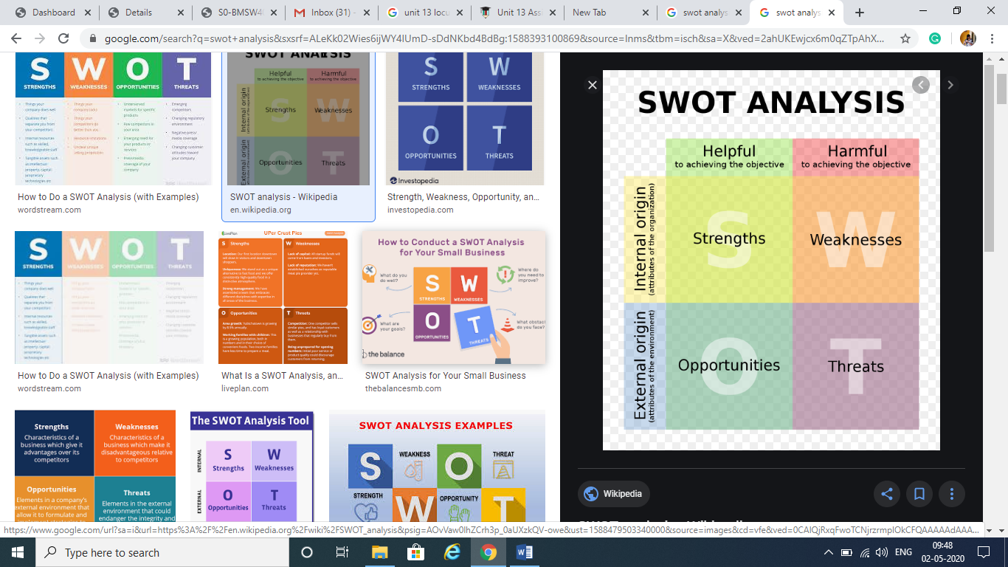
Figure- swot analysis for career development plan
Source- (Reid et al., 2016)
- Listening skills
Listening skill is the most important and essential skill which maintains the relationship between clients and Career counsellor. Listening habits gives importance to the clients and make them feel comfortable and important. My strength of listening will allow students to speak freely and clear their doubts related to career. Good listening power allows Career counsellor to understand the perspectives of students and to identify their problems. It will beneficial for me to improve my therapeutic relationship with the people. Being a Career counsellor, I understood that giving importance to the students allows them to feel special and they can share their problems and thoughts without any hesitation (Rubens et al., 2018).
- Communication skills
My strength is my effective communication skills. This allows me to explore myself in front of people. This is also beneficial for me to represent my view related to the problem. Effective communication also allows me to motivate those students who are dealing with depression related to my career (Whittenburg et al., 2019). As the biggest responsibility of the Career counsellor is to understand and evaluate the records of the clients by conducting interviews and questions. So communication skills play an important role in knowing the views of the clients. This process is nothing without communication skills. Effective communication skills will help to gain the trust of the clients and allows them to take my advice seriously. Effective communication also helps me to present my view to the people. It also allows me to give the right advice to the right clients and beneficial for exchanging the information.
- Trustworthiness and creative
Trust is the basic element for every person required in any career. Career counsellor more deals with the clients a student’s so it is very important to know the feelings of the students. By understanding various lectures, I have understood that is the responsibility of a Career counsellor to make students comfortable in front of them and allows them to speak openly. A career counsellor can gain the trust of the client by providing them with good and proper information related to the career. This makes the trust of a client for the Career counsellor. Career counsellor must have knowledge related to the career (Whittenburg et al., 2019). The way of presenting the information must be creative this allows customers to attract towards the Career counsellor. Knowledge-based skills and transferable skills play a very important role here and have become my biggest strength in terms of a Career counsellor. This skill allows me to share the information with the clients in a more attractive and creative way. This helps clients to understand my perspectives and advice seriously.
- Enthusiasm and patience
I am enthusiastic in working which gives me the motivation to work efficiently and allows me to attend more clients and serve for their problems. Career counsellor must have a uniqueness in providing the solutions for the problems. I am flexible, friendly, hardworking, expressive, formal and punctual. This quality makes me enthusiastic. It is also very important for having patience in the life of Career counsellor. Patience helps me to provide best and perfect solutions to clients. I do not hurry in speaking, I wait, watch, analyses the condition and then speak.
Understanding strengths also allows me to evaluate and analyze my weakness related to my career. There are a few areas where I need to work to improve my skills and ability to work. They are listed below.
Career counsellor must have solutions that help the student to reach their goals. Many times due to behaviours of clients, I am unable to judge their views and behaviour. This leads me to provide the wrong information this affects me the most. The other problem that I face most of the time is I do not get the time to improve my strengths and talents due to my busy schedules. This also affects me in my career. I need to update according to the generation to get advancement on the career. I just need to improve myself and know better about the weakness (Whittenburg et al., 2019).
Many times I am unable to evaluate the behaviour of clients. This reduces m self-confidence which affects me the most. I required to refer more articles which helps to understand the sociology of the clients.
My biggest weakness is my mental ability. I feel frustrated with my busy schedules. Frustration do not me to concentrate on the problems of clients. This affects my reputation in front of them. My frustration always dominates my other capability of being flexible and understanding. This reduces my tolerance for power. Many times because of the behaviour of clients I feel various problems in providing them solutions for their problems. I need to improve my adaptability power (Yu et al., 2016).
By overcoming all my weakness, I can be a good Career counsellor and serve more people and provide the right path.

LO3 EMPLOYMENT GOALS PERSONAL AND PROFESSIONAL DEVELOPMENT PLAN
Setting goals is a helpful way to build a career (Taylor and Savickas, 2016). it helps to set the objectives and creating a path to reach the goal. It allows an individual to set the target. This allows an individual to decide how and when to apply the time and resources. Without setting goals it is very difficult to determine the job, promotion and other milestones. To achieve employment goals it is important to set the smart goals. The smart goals for any career must be carefully planned (Yu et al., 2016).
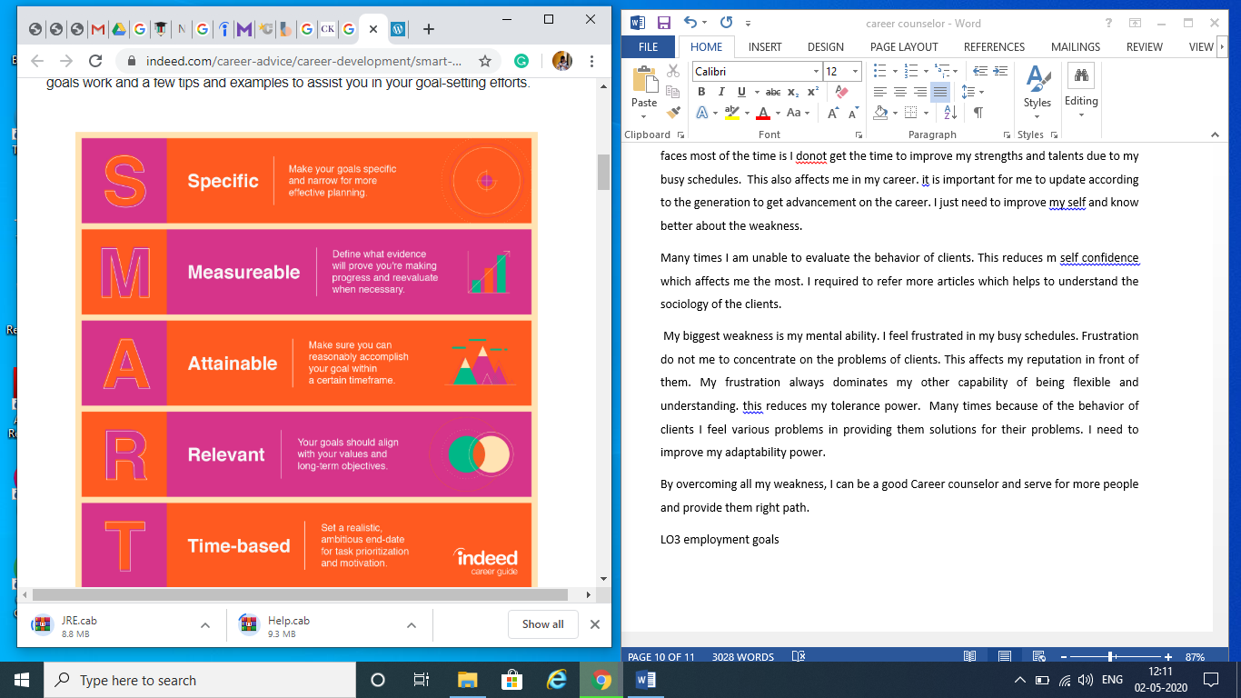
Figure- Employment goals for a career counsellor
Source- (Yu et al., 2016)
- Specific goals
As the main working of the counsellor depends on the behaviour of the clients. So it has a specific goal to advise the clients. So it is important for a career counsellor to focus on their problems (Savickas, 2016). This allows me to understand all the required methods to solve the issues.
- Measurable
This method focus on the evidence that is collected by an individual this helps to measure the value and also motivates to work more. The method evaluates the number of goals achieved by an individual. This method helps to measure my milestones and motivates me to gain more opportunities. This method also allows me to give a reward.
- Achievable
This is the task that is achievable and can be completed. This keeps an individual to be focused a motivated towards the work. The more number of tasks accomplishes by an individual the more number of goals (Savickas, 2016).
- Relevant
This goal helps an individual to evaluate the planned goals are decide which are relevant and which are not. This helps an individual to give priority to the important work. Many times I engaged with the work and cannot determine the important work. This strategy will help me to identify the work as required.
- Time-Based
This method is based on the time required for specific work. For example, there are many clients which a career counsellor needs to focus more and they are time-consuming. This method provides the realistic time frame for an individual which allows setting the work according to their time demands (Taylor and Savickas, 2016).
Time management plays a key role here. This allows an individual to do not get disturb all the time work. I use the same method for solving the problems.
PERSONAL AND PROFESSIONAL DEVELOPMENT PLAN
Current skills | Time management | Communication | Working with people | Professional knowledge
Skills to work on | Managing time for improving knowledge and skills | Want to learn the professional way of communication. | Try to collaborate with people to understand their perspectives. | Need to develop a formal way of communication in the profession.
Improvement activity | To serve more students and clients and advise them. Time-based allocation of the clients. | Live participation in a video call and audio call. This helps to gain the experience of dealing with the people. | Try to keep my relations better with the team members and clients. | Try to attend classes and participates in the various activities. This will improve my professional knowledge.
Time frame | 3 months | 2 months | 1 month | 3 months
Action plan | I will develop various strategies which help me to manage time for attending more clients and to learn various things and improve my skills. | I will try to attend more clients and communicate with them to solve their problems related to their career. | Try to attend meetings in the workplace. This helps me to improve my working abilities with people and employees. | Using presentation to express my views more clearly. This will improve my professional knowledge

CONCLUSION
Learning is the main role in life. It is very essential for individual life. One can learn things from its academic to its professional life. Without education, nobody can achieve real milestones of life. The modules me to focus on personal reflection. This is beneficial for me to understand the skills and knowledge required to achieve the milestones in professional career development. Setting the goal and planning for achieving the goal is very important. The reflection focused on the personal development skill that is required for professional development also. As an individual need to be more focused on the skills and knowledge required in career development. This allows an individual to work more efficiently. Knowledge-based skills help an individual to solve the problems without taking more time. Personal reflection and career development plan are very important for the person as it allows an individual to plan before the execution. This enables an individual to improve its performances by working on skills and abilities. It also improves the knowledge of an individual required in school or workplace.
The reflection report focused more on the strategies that are beneficial to improve the skills and knowledge of an individual. Furthermore, the reflection includes the strength of an individual. One can identify its strength and weakness to work efficiently in the workplace. The report reflects the various opportunities that are achievable for an individual. This encourages a person to work efficiently. This minimises the risk factors in the working process. Strength also enables a person to work over the weakness and improve its skills and knowledge related to the professional finding of strength allows and individual to understand the competitors and new entrains in the existing environment. The last part includes the personal development plan action and the smart employability goals for career counsellor profession.

REFERENCES
- Argyropoulou, K. and Kaliris, A., 2018. From career decision-making to career decision-management: New trends and prospects for career counselling. Advances in Social Sciences Research Journal, 5(10).
- Bhardwaj, P., Hahs-Vaughn, D.L., Hernandez, F.E. and Scott, J.B., 2019. Career Development Strategies for Mid-Career Faculty. In Mid-Career Faculty (pp. 143-177). Brill Sense.
- Bushardt, S.C., Young, M. and Beal, B.D., 2018. Understanding Work Passion: An Important Element for Career Success and Improved Quality of Life. Journal of Organizational Psychology, 18(2).
- Chen, C.P. and Javid-Yazdi, M., 2019. Career counselling strategies to enhance the vocational wellness of journalists. Australian Journal of Career Development, 28(1), pp.31-38.
- Cohen-Scali, V., Rossier, J. and Nota, L., 2018. New perspectives on career counseling and guidance in Europe. Springer.
- Hilton, T.M.L., Brant, J. and Vess, L., 2016. CAREER COUNSELING GROUP SUPERVISION: A New Approach in Master's Level Counseling Programs. Career Planning and Adult Development Journal, 32(1), p.141.
- Hughes, R., Kinder, A. and Cooper, C.L., 2019. Personal and Professional Development. In The Wellbeing Workout (pp. 255-259). Palgrave Macmillan, Cham.
- Lipshits-Braziler, Y., Tatar, M. and Gati, I., 2017. The effectiveness of strategies for coping with career indecision: Young adults’ and career counselors’ perceptions. Journal of Career Development, 44(5), pp.453-468.
- Mazzotti, V.L., Rowe, D.A., Simonsen, M., Boaz, B. and VanAvery, C., 2018. Steps for implementing a state-level professional development plan for secondary transition. Career Development and Transition for Exceptional Individuals, 41(1), pp.56-62.
- Ragan, D.D., 2018. A Structured Course for Personal and Professional Development. Honors in Practice, 14, pp.43-57.
- Reid, H., Bimrose, J. and Brown, A., 2016. Prompting reflection and learning in career construction counseling. Journal of Vocational Behavior, 97, pp.51-59.
- Riggs, D.E., 2017. Professional and personal growth. Journal of Environmental Health, 79(8), p.6.
- Rubens, A., Schoenfeld, G.A., Schaffer, B.S. and Leah, J.S., 2018. Self-awareness and leadership: Developing an individual strategic professional development plan in an MBA leadership course. The International Journal of Management Education, 16(1), pp.1-13.
- Savickas, M.L., 2016. Reflection and reflexivity during life-design interventions: Comments on career construction counseling. Journal of Vocational Behavior, 97, pp.84-89.
- Taylor, J.M. and Savickas, S., 2016. Narrative career counseling: My career story and pictorial narratives. Journal of Vocational Behavior, 97, pp.68-77.
- Whittenburg, H.N., Sims, K.A., Wehman, P. and Walther-Thomas, C., 2019. Strategies for Developing Work Experiences for Youth With Intellectual and Developmental Disabilities. Career Development and Transition for Exceptional Individuals, 42(4), pp.259-264.
- Yu, Y.A.N.G. and Peng, J.I.A., 2016. Research and Reflection on Career Development of University Counselors: Based on Investigation into Counselor Faculty at Shandong University, Weihai in Its Thirty years History. Journal of Shandong Youth University of Political Science, (2), p.19.

