Hotel standars, reputation management, building and retaining customer loyalty

Cornel Stoica
Hoapitality and Guest Service Management
BMIH4003
Muhammad Cassamo

Executive Summary
This report provides a detailed explanation of Hotel standards, reputation management, as well as customer loyalty toward their brands. It has been discussed that management of Hotel reputation is regarding influencing and monitoring how the hotels are perceived online. Further, challenges faced by the businesses, and recommendations to overcome those challenges have also been discussed briefly.

Table of Contents
Introduction 3
Goals of the standards of the Brand consistency and the standards of the different hotels of the UK. 3
Effective Management of the reputation of the Hotels and the Importance of effective management of Guest Reviews as well as the impact of negative reviews. 5
Ways and purpose of building and retaining customer loyalty 6
Recommendations for Hotels regarding market trends and the challenges faced by certain businesses. 7
Conclusion 8
Recommendations 9
References 10

Introduction
Hotel standards can be demonstrated as operational standards such as advertising, staffing, and the amenities suggested to the guests and the physical standards such as condition, utility, and quality of the Leased personal property and Fixtures. Management of Hotel reputation is regarding influencing and monitoring how the hotels are perceived online. It includes engaging and posting on Social Media, tracking review sites, and optimizing the sites for search. Customer loyalty is fundamentally when an individual provides repeat business to an organization or a brand. Although when the policies are strict or prices are high, the loyal customers will stand with their preferred option.

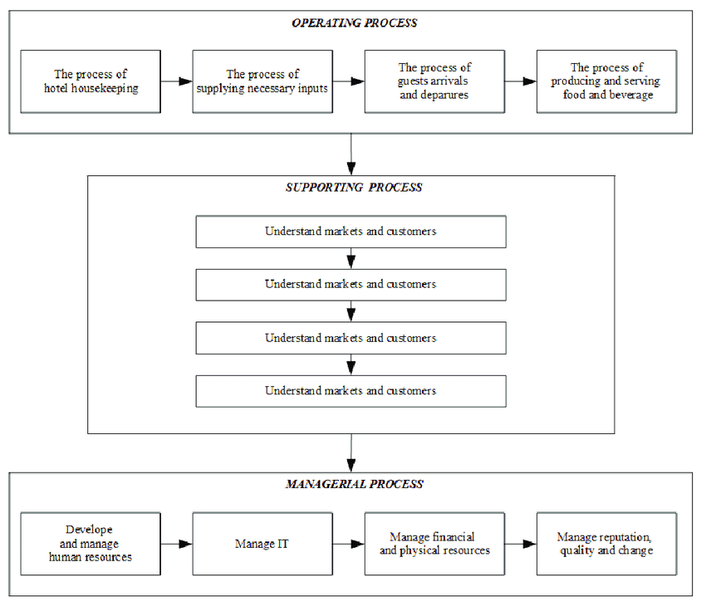
Figure1: Hotel standards
(Source: Reidhead, 2020)

“Goals of the standards of the Brand consistency and the standards of the different hotels of the UK”
Brand standards are the guidelines that represent how the graphic elements of the Brand should be utilized and set the language in which the Hotels communicate with their customers (Reidhead, 2020). They define the elements like the usage of logos, photography, typography, and color palette. The main purpose of the Brand consistency standards is to maintain consistency and provide a clear and concise understanding of the Brand. Effective brands are very consistent and the standards of the brand keep the identity of the Brand recognizable and consistent (Liu, et al. 2020). Therefore, consumers will perceive the Brand as professional and trustworthy. Everyone within an organization can use the Brand consistency standards for getting a grasp on the values of an organization. The guidelines of the brand can be considered a useful asset for a new employee as it helps in learning how the Hotels communicate with the customers.

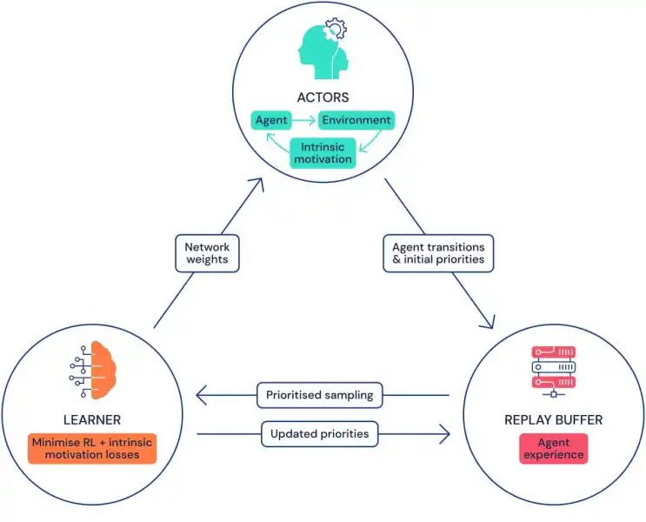
Figure 2: Goals of the Brand consistency standards
(Source: Choi and Choi, 2021)
However, as it has been identified, there is no such standard that applies to every hotel and is recognized universally. Some of the basic guidelines are widely accepted around the world but not the Brand consistency standards. Therefore, there is no such universal standard or worldwide law (Choi, and Choi, 2021). The Perth Station Hotel in the UK is decorated with simple standards with a large-sized double bed or a twin single bed. All the rooms of the Hotel are suitable for both business visitors as well as tourists, as the train station is just beside the hotel and the coach station as well (Wong, and Kim, 2020). The usage of car parking is mandatory for the guests of the hotel. However, the standards of the New Country Hotel in the UK have some different standards it provides the customers with a wide range of luxurious environment-friendly accessories like some biodegradable additives for helping the guests to feel comfortable keeping in mind that they are experiencing an eco-friendly and sustainable stay.

“Effective Management of the reputation of the Hotels and the Importance of effective management of Guest Reviews as well as the impact of negative reviews”
The Hotels can manage their reputation effectively by staying active on the social media platform. It is the only platform to represent the visual image of the brand and provide the brand with a voice or a tone while directly connecting with the followers. Social Media can also help build relationships with potential guests and planners (El-Said, 2020). Optimizing the business for search engines is also an essential part of hotel reputation management. A high ranking in the search engine means that the website is getting more popular and found more likely. According to most of the research, 93% of online experiences start with search engines. Review management is important for hotel businesses for the collection, distribution, and analysis of new reviews (Reyes-Menendez, et al. 2019). However, review management is also important for changing the online positioning of businesses.

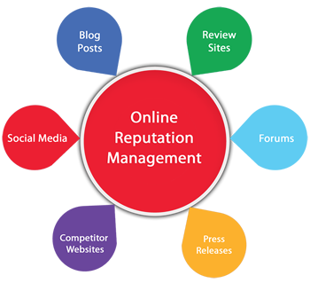
Figure 3: Hotel Reputation Management
(Source: Reyes-Menendez, et al. 2019)
There are two reasons for rating a hotel: the very satisfied guests want to share their better experiences and raise the reputation of the hotel publicly and the guests who are disappointed want to release their frustration with the reputation of the hotel. Developing a review management plan can easily be incorporated into the routine duties (Anagnostopoulou, et al. 2019). However, marketing acts as an essential part of review management since it acts as both negative and positive multipliers. The guests' reviews are very important for any establishment of services. Although the management of the guest's reviews might seem abstract to some, it is difficult to understand the outcomes in both financial and brand terms for the hotel. It has been estimated that the risk of an establishment losing 22% of the bookings is just because of the negative reviews (Wen, et al. 2021). However, this figure significantly increases when various negative reviews are posted around several portals which therefore results in a 70% decline in potential guests for a hotel.

Ways and purpose of building and retaining customer loyalty
Hotels that want to build the loyalty of the customer or increase the retention of guests should focus mainly on the improvement of the hotel services, guest experiences, and guest perception (Juanamasta, et al. 2019). Here are some of how hotels can improve the loyalty of the customer:
- Exceeding the expectations of the guests.
- Providing excellent services to the customers.
- Responding to the feedback and reviews of the guest constructively.
- Making commitments for improvement regularly.
- Developing better relationships with regular travelers.
- Understanding the needs of the guests from the hotel.
- Providing personalized experiences to the guests.

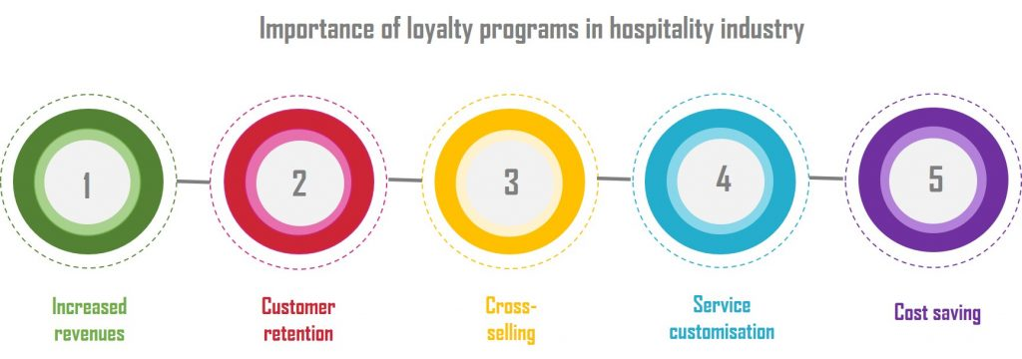
Figure 4: Customer loyalty
(Source: Omoregie, et al. 2019)
A loyalty program is also an essential tool for the chain hotels for boosting the loyalty of customers by providing a collaboration of hard benefits creating a separation of direct financial costs such as complimentary stay and the soft benefits reflecting the sense of the customer of a unique status such as late check outs to the customers who make purchases frequently (Omoregie, et al. 2019). The loyalty program helps the hotels in retaining a huge number of customers who possess a huge level of repeated purchases of loyalty. The loyalty programs produce diverse impacts in influencing the intentions, attitudes, and behavior of the customers which represents that it significantly influences the satisfaction of the customer (Alshurideh, et al. 2020). Most of the organizations analyzed that loyalty seems to be a competitive advantage for them as the loyal customers present an average of 20% of the entire base of their customers, and the same loyal customers account for 80% of the entire revenue. Increasing customer retention even by 5% leads to an increase in the results of the economy to 55% from 25%. These figures reveal that loyal customers prefer the hotels in every situation as compared to other customers (Dewnarain, et al. 2019). Loyalty and retention of customers positively influence the profitability as well as the turnover of the organizations.

“Recommendations for Hotels regarding market trends and the challenges faced by certain businesses”
According to experts in organizations and industries, the new and innovative trends in the hospitality industry will reshape the manner the hotels in treating their guests completely (Lee, et al. 2020). Nowadays, in the world of advanced technology, guests are getting accustomed to those advanced facilities and therefore, they are expecting the same in the hotel industry. The growth in digital channels is becoming more difficult for hotels to provide fast responses to the inquiries of guests across all the channels which can result in a loss of revenue. So, a hotel chatbot is considered one of the latest technologies which are being used for improving experiences (Reyes-Menendez, et al. 2019). At present, the hospitality industry is mostly utilizing chatbots which have the capability of engaging with the visitors of websites in real-time which can therefore help in increasing direct bookings. In this way, hotels can focus on the trends of the market and provide personalized experiences to the guests. Some of the obstacles faced by the business include Cash flow, growing revenues, staff turnover, over-dependence on few customers, and competing on price always. A consequence of the lack of development of leadership is a lack of planning of business in most SMEs. Every business sector has its set of challenges and demands. Some of them are as follows:
- Meeting the requirements of the customer.
- Preserving a better reputation.
- Retaining employees.
- Maintaining quality relationships with the customers.
- Finding an efficient brand.
- Marketing within a drenched marketplace.
Every business strives in maintaining top quality relationships with the base of their customer to keep the employees satisfied and happy and keep the brands relevant as well (Köseoglu, et al. 2021). Overcoming and facing the obstacles which arise is all that sets a better business apart from its competitors.

Conclusion
In this report, Hotel standards, reputation management, as well as customer loyalty toward their brands have been discussed. Further, the purpose of the brand consistency standards and how the hotels can manage their reputation effectively have also been mentioned. It has been discussed how guest reviews impact the reputation of the brand and along with that, the negative reviews decrease the number of guests in the hotels. How hotels can retain as well as build the loyalty of the customer and the objectives of building and retaining customer loyalty have also been mentioned. Further, recommendations have been provided to the hotels regarding the trends of the market.

Recommendations
It is very simple to respond to the good reviews but for a better reputation of the hotel as well as the brands it is essential to respond to the bad review as well. A positive perception of the brand of the hotel is paramount for influencing sales and therefore maximizing the revenue of the business. The usage of the templates helps in automating the procedure of management of the reviews and the reputation online. However, it is essential to ensure to customize the reviews and feedback to every review of the individual. The use of the templates with several recommended responses will not only help in setting the tone but will also guarantee for following of a protocol.

References
Alshurideh, M., Gasaymeh, A., Ahmed, G., Alzoubi, H. and Kurd, B., 2020. Loyalty program effectiveness: Theoretical reviews and practical proofs. Uncertain Supply Chain Management, 8(3), pp.599-612.
Anagnostopoulou, S.C., Buhalis, D., Kountouri, I.L., Manousakis, E.G. and Tsekrekos, A.E., 2019. The impact of online reputation on hotel profitability. International Journal of Contemporary Hospitality Management, 32(1), pp.20-39.
Choi, M. and Choi, Y., 2021. Employee perceptions of hotel CSR activities during the COVID-19 pandemic. International Journal of Contemporary Hospitality Management, 33(10), pp.3355-3378.
Dewnarain, S., Ramkissoon, H. and Mavondo, F., 2019. Social customer relationship management: An integrated conceptual framework. Journal of Hospitality Marketing & Management, 28(2), pp.172-188.
El-Said, O.A., 2020. Impact of online reviews on hotel booking intention: The moderating role of brand image, star category, and price. Tourism Management Perspectives, 33, p.100604.
Juanamasta, I.G., Wati, N.M.N., Hendrawati, E., Wahyuni, W., Pramudianti, M., Wisnujati, N.S., Setiawati, A.P., Susetyorini, S., Elan, U., Rusdiyanto, R. and Astanto, D., 2019. The role of customer service through customer relationship management (CRM) is to increase customer loyalty and a good image. International Journal of Scientific and Technology Research, 8(10), pp.2004-2007.
Köseoglu, M.A., Mehraliyev, F., Altin, M. and Okumus, F., 2021. Competitor intelligence and analysis (CIA) model and online reviews: integrating big data text mining with network analysis for strategic analysis. Tourism Review, 76(3), pp.529-552.
Lee, M., Cai, Y., DeFranco, A. and Lee, J., 2020. Exploring influential factors affecting guest satisfaction: Big data and business analytics in consumer-generated reviews. Journal of Hospitality and Tourism Technology, 11(1), pp.137-153.
Liu, A.X., Hsu, C.H. and Fan, D.X., 2020. From brand identity to brand equity: a multilevel analysis of the organization–employee bidirectional effects in upscale hotels. International Journal of Contemporary Hospitality Management, 32(7), pp.2285-2304.
Omoregie, O.K., Addae, J.A., Coffie, S., Ampong, G.O.A. and Ofori, K.S., 2019. Factors influencing consumer loyalty: evidence from the Ghanaian retail banking industry. International Journal of Bank Marketing.
Reidhead, C., 2020. Impact of organizational culture on employee satisfaction: A case of Hilton hotel, United Kingdom. Journal of Economics and Business, 3(1).
Reyes-Menendez, A., Saura, J.R. and Filipe, F., 2019. The importance of behavioral data to identify online fake reviews for tourism businesses: A systematic review. PeerJ Computer Science, 5, p.e219.
Reyes-Menendez, A., Saura, J.R. and Martinez-Navalon, J.G., 2019. The impact of e-WOM on hotel management reputation: exploring TripAdvisor review credibility with the ELM model. Ieee Access, 7, pp.68868-68877.
Wen, J., Lin, Z., Liu, X., Xiao, S.H. and Li, Y., 2021. The interaction effects of online reviews, brand, and price on consumer hotel booking decision making. Journal of Travel Research, 60(4), pp.846-859.
Wong, A.K.F. and Kim, S.S., 2020. Development and validation of standard hotel corporate social responsibility (CSR) scale from the employee perspective. International Journal of Hospitality Management, 87, p.102507.

