Module Title: International Meetings Management for the Hotel Industry
Module Code: BMIH6007

Student Name: Nicolae Masca
Student ID: 2126875

Lecturer: Jemma Smith

Slide 2
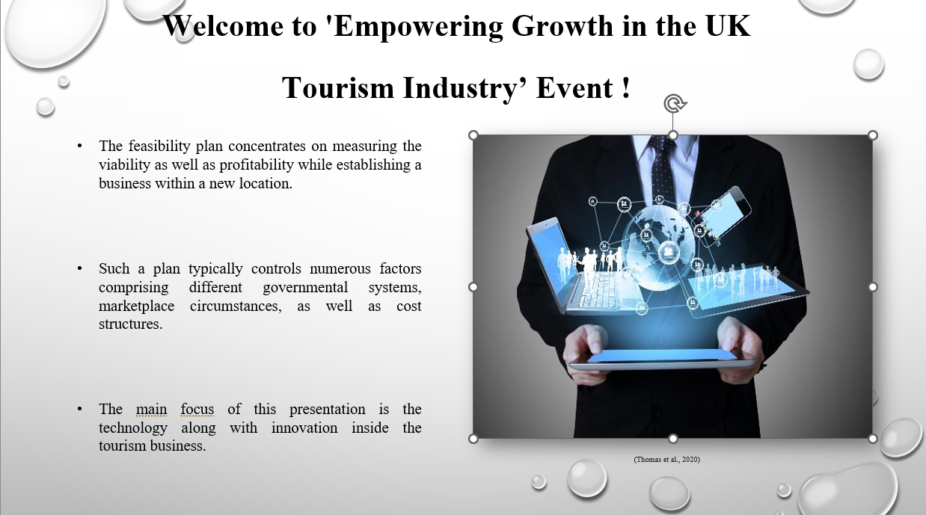
Welcome to 'Empowering Growth in the UK Tourism Industry’ Event!
- The feasibility plan concentrates on measuring the viability as well as profitability while establishing a business within a new location.
- Such a plan typically controls numerous factors comprising different governmental systems, marketplace circumstances, as well as cost structures.
- The main focus of this presentation is the technology along with innovation inside the tourism business.

Slide 3
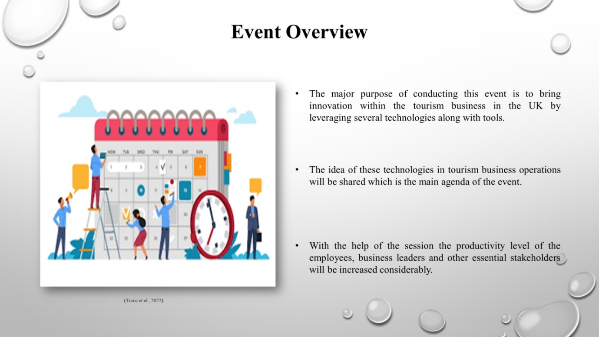
Event Overview
- The major purpose of conducting this event is to bring innovation within the tourism business in the UK by leveraging several technologies along with tools.
- The idea of these technologies in tourism business operations will be shared which is the main agenda of the event.
- With the help of the session the productivity level of the employees, business leaders and other essential stakeholders will be increased considerably.

Slide 4
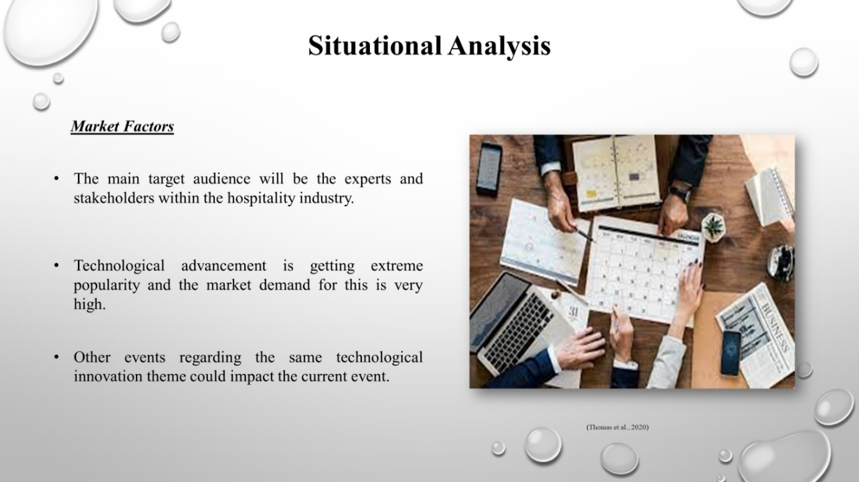
Market Factors
- The main target audience will be the experts and stakeholders within the hospitality industry
- Technological advancement is getting extreme popularity and the market demand for this is very high.
- Other events regarding the same technological innovation theme could impact the current event.

Slide 5
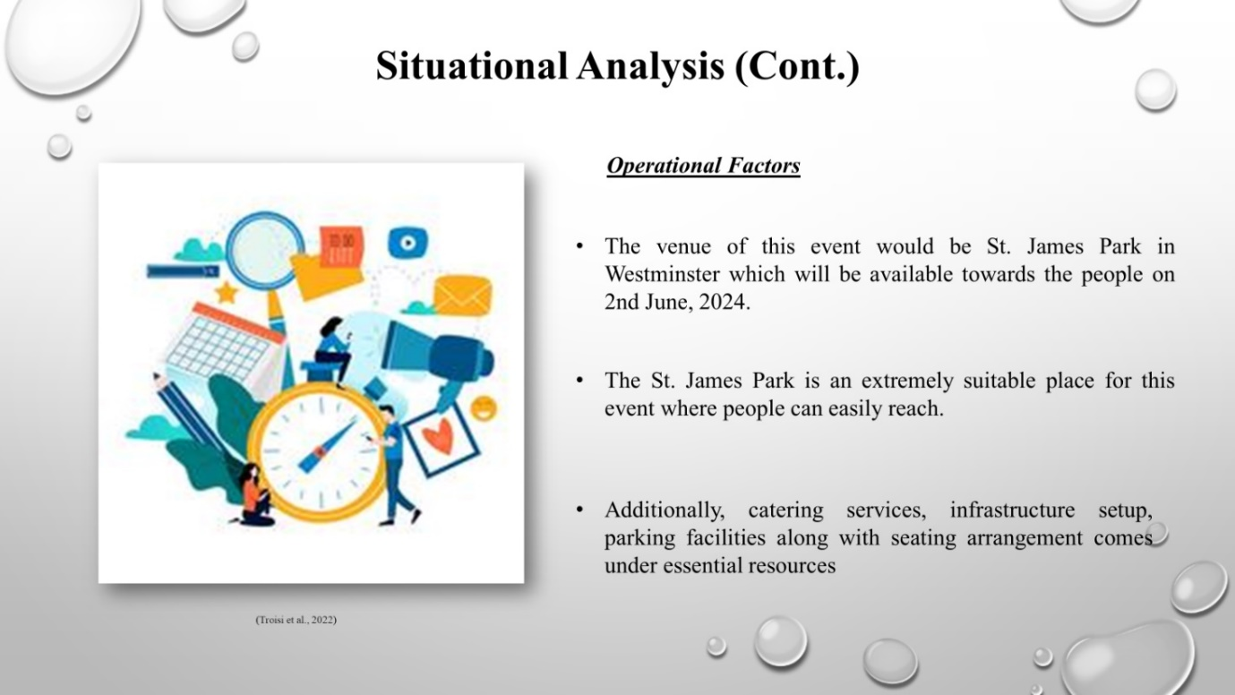

Operational Factors
- The venue of this event would be St. James Park in Westminster which will be available towards the people on 2nd June 2024.
- The St. James Park is an extremely suitable place for this event where people can easily reach.
- Additionally, catering services, infrastructure setup, parking facilities along with seating arrangement comes under essential resources.

Slide 6
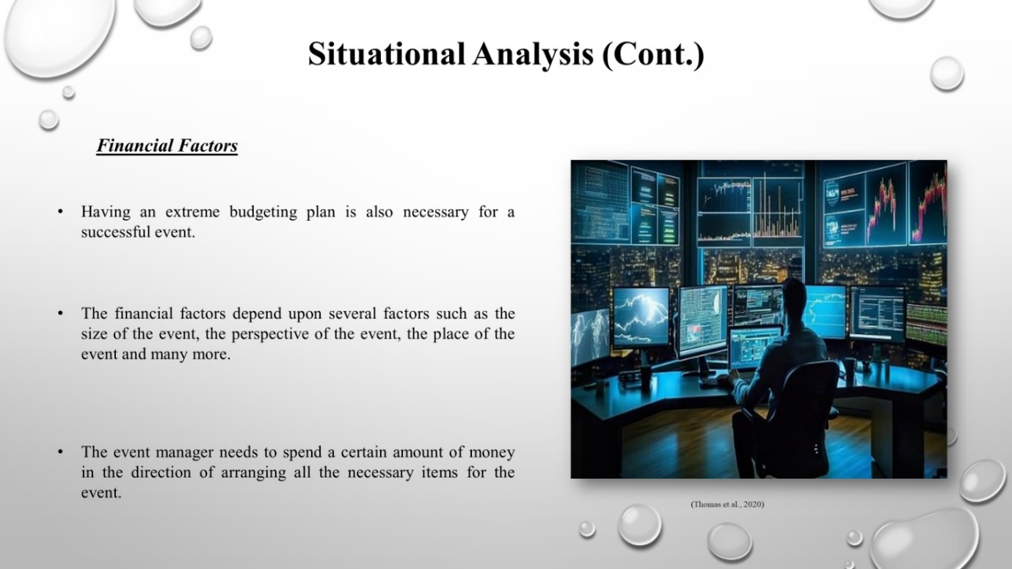
Financial Factors
- Having an extreme budgeting plan is also necessary for a successful event.
- The financial factors depend upon several factors such as the size of the event, the perspective of the event, the place of the event and many more.
- The event manager needs to spend a certain amount of money in the direction of arranging all the necessary items for the event.

Slide 7
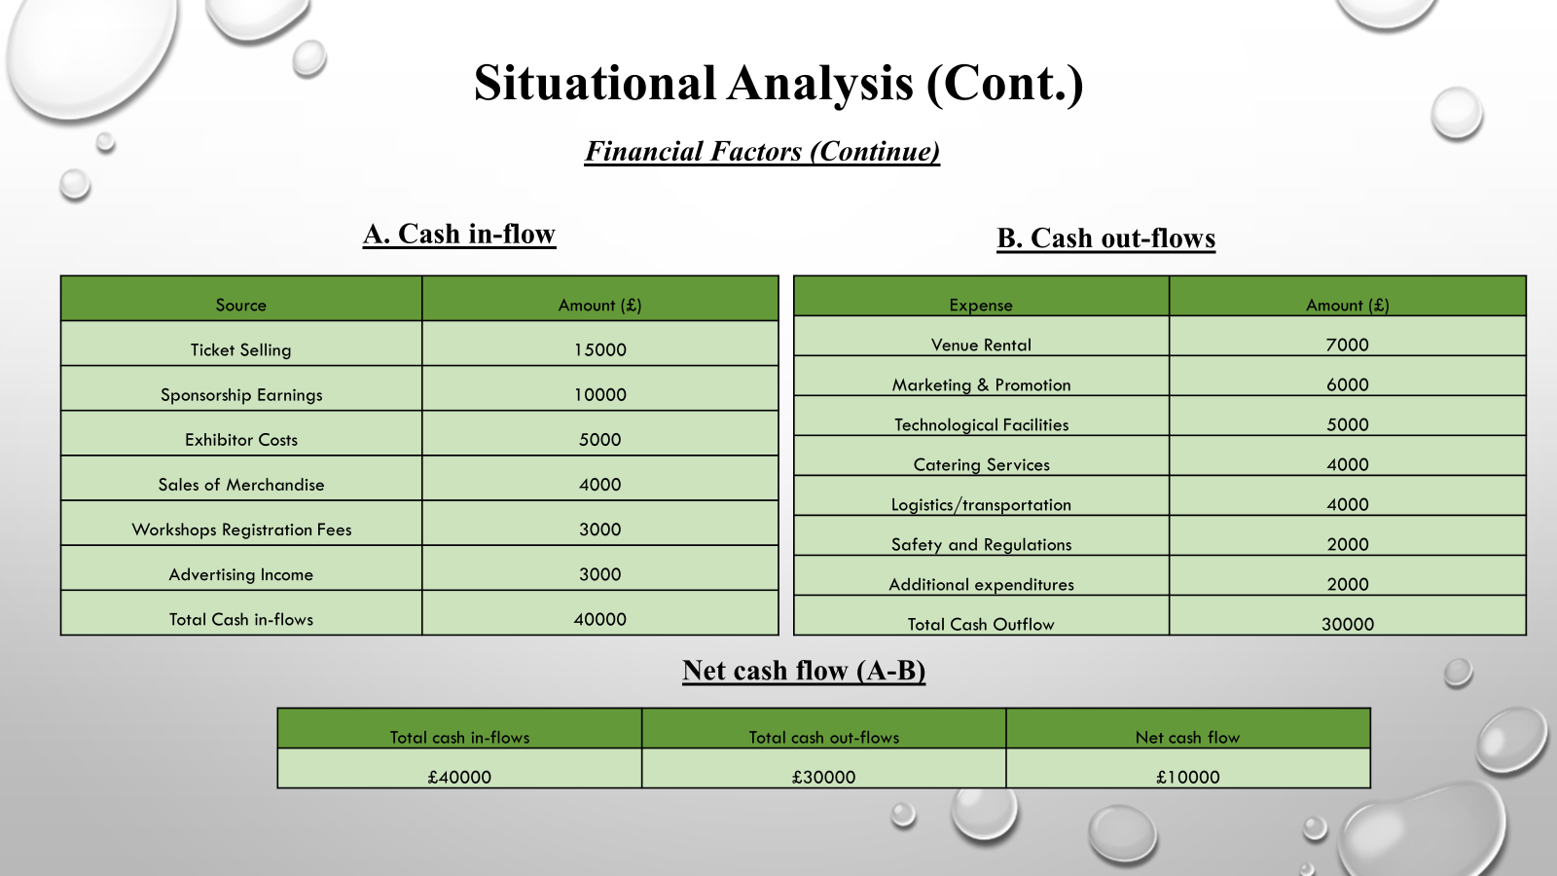
Financial Factors (Continue)
The total income earned during the event has been expected to be around £40,000, that is a substantial profit margin. Ultimately, after reviewing all of the expenditures, it has been determined that an aggregate of £30000 must be allocated for the necessary expenditures of the specific tourism event. The estimate indicates that the event would create around £10000 in revenue that may be utilized to support future business growth.

Slide 8
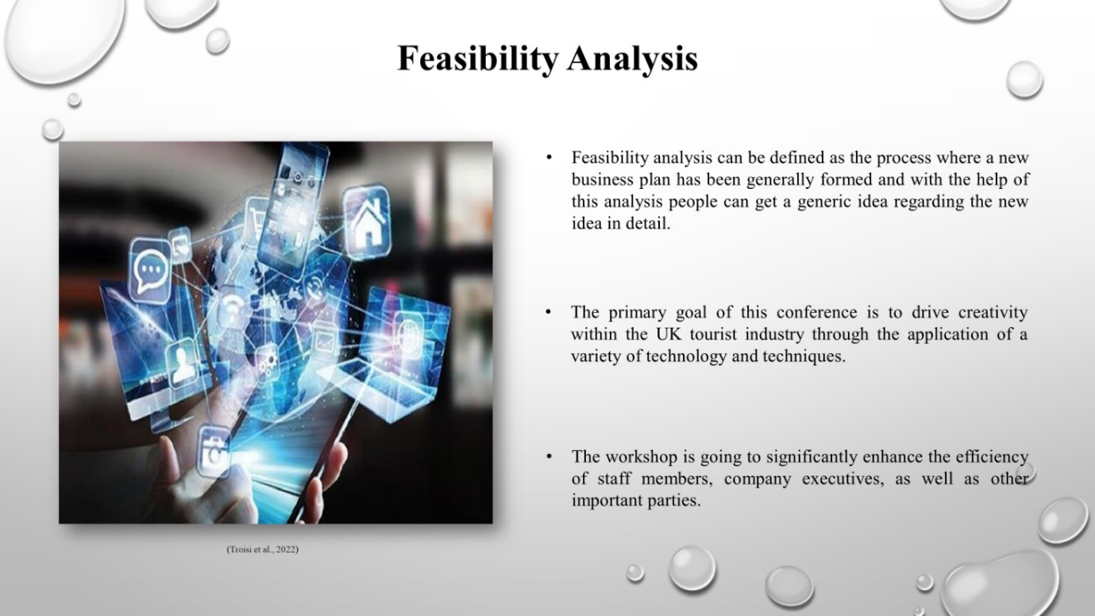
Feasibility Analysis
- Feasibility analysis can be defined as the process where a new business plan has been generally formed and with the help of this analysis people can get a generic idea regarding the new idea in detail.
- The primary goal of this conference is to drive creativity within the UK tourist industry through the application of a variety of technology and techniques.
- The workshop is going to significantly enhance the efficiency of staff members, company executives, as well as other important parties.

Slide 9
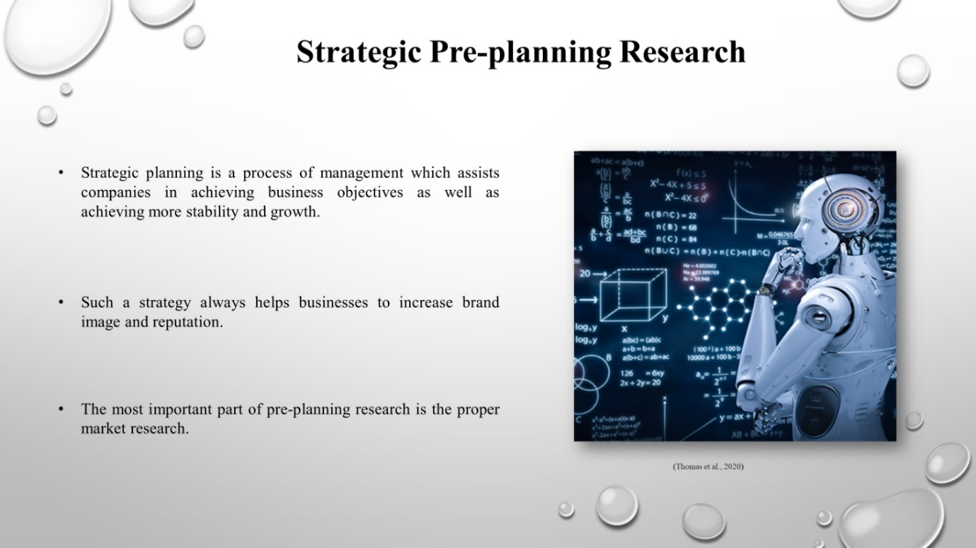
Strategic Pre-planning Research
- Strategic planning is a process of management which assists companies in achieving business objectives as well as achieving more stability and growth.
- Such a strategy always helps businesses to increase brand image and reputation.
- The most important part of pre-planning research is the proper market research.

Slide 10
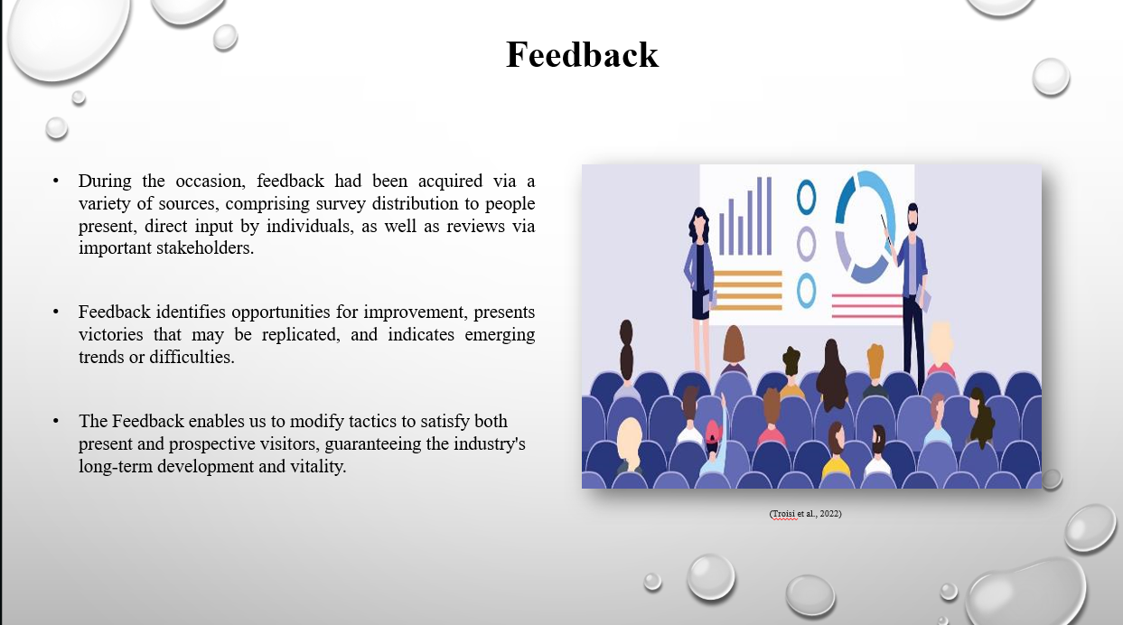

Feedback
- During the occasion, feedback had been acquired via a variety of sources, comprising survey distribution to people present, direct input by individuals, as well as reviews via important stakeholders.
- Feedback identifies opportunities for improvement, presents victories that may be replicated, and indicates emerging trends or difficulties.
- The Feedback enables us to modify tactics to satisfy both present and prospective visitors, guaranteeing the industry's long-term development and vitality.

Slide 11
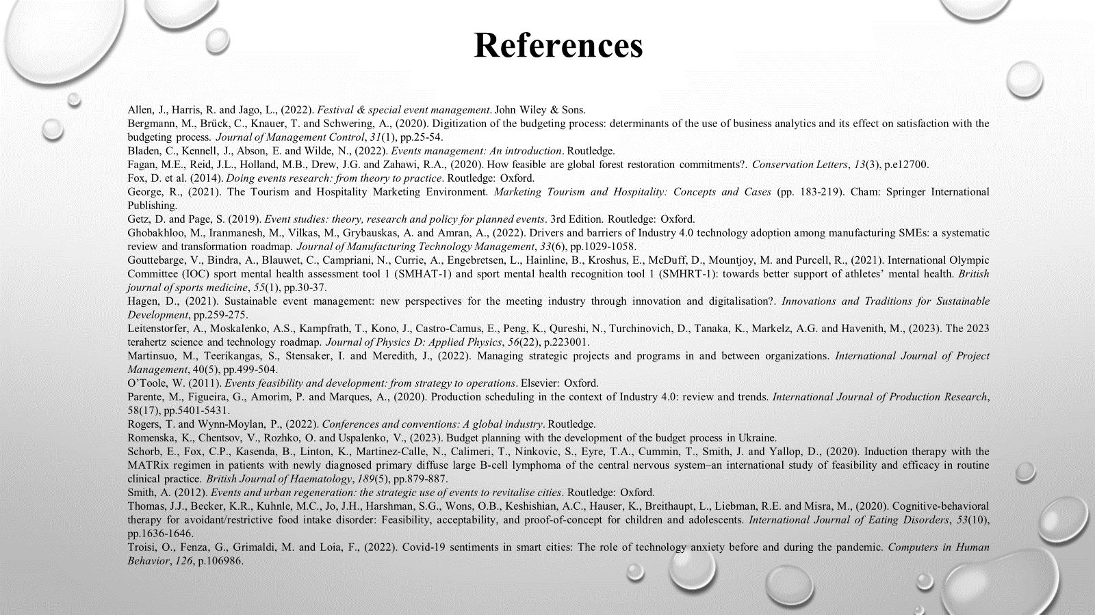

References
Allen, J., Harris, R. and Jago, L., (2022). Festival & special event management. John Wiley & Sons.
Bergmann, M., Brück, C., Knauer, T. and Schwering, A., (2020). Digitization of the budgeting process: determinants of the use of business analytics and its effect on satisfaction with the budgeting process. Journal of Management Control, 31(1), pp.25-54.
Bladen, C., Kennell, J., Abson, E. and Wilde, N., (2022). Events management: An introduction. Routledge.
Fagan, M.E., Reid, J.L., Holland, M.B., Drew, J.G. and Zahawi, R.A., (2020). How feasible are global forest restoration commitments?. Conservation Letters, 13(3), p.e12700.
Fox, D. et al. (2014). Doing events research: from theory to practice. Routledge: Oxford.
George, R., (2021). The Tourism and Hospitality Marketing Environment. Marketing Tourism and Hospitality: Concepts and Cases (pp. 183-219). Cham: Springer International Publishing.
Getz, D. and Page, S. (2019). Event studies: theory, research and policy for planned events. 3rd Edition. Routledge: Oxford.
Ghobakhloo, M., Iranmanesh, M., Vilkas, M., Grybauskas, A. and Amran, A., (2022). Drivers and barriers of Industry 4.0 technology adoption among manufacturing SMEs: a systematic review and transformation roadmap. Journal of Manufacturing Technology Management, 33(6), pp.1029-1058.
Gouttebarge, V., Bindra, A., Blauwet, C., Campriani, N., Currie, A., Engebretsen, L., Hainline, B., Kroshus, E., McDuff, D., Mountjoy, M. and Purcell, R., (2021). International Olympic Committee (IOC) sport mental health assessment tool 1 (SMHAT-1) and sport mental health recognition tool 1 (SMHRT-1): towards better support of athletes’ mental health. British journal of sports medicine, 55(1), pp.30-37.
Hagen, D., (2021). Sustainable event management: new perspectives for the meeting industry through innovation and digitalisation?. Innovations and Traditions for Sustainable Development, pp.259-275.
Leitenstorfer, A., Moskalenko, A.S., Kampfrath, T., Kono, J., Castro-Camus, E., Peng, K., Qureshi, N., Turchinovich, D., Tanaka, K., Markelz, A.G. and Havenith, M., (2023). The 2023 terahertz science and technology roadmap. Journal of Physics D: Applied Physics, 56(22), p.223001.
Martinsuo, M., Teerikangas, S., Stensaker, I. and Meredith, J., (2022). Managing strategic projects and programs in and between organizations. International Journal of Project Management, 40(5), pp.499-504.
O’Toole, W. (2011). Events feasibility and development: from strategy to operations. Elsevier: Oxford.
Parente, M., Figueira, G., Amorim, P. and Marques, A., (2020). Production scheduling in the context of Industry 4.0: review and trends. International Journal of Production Research, 58(17), pp.5401-5431.
Rogers, T. and Wynn-Moylan, P., (2022). Conferences and conventions: A global industry. Routledge.
Romenska, K., Chentsov, V., Rozhko, O. and Uspalenko, V., (2023). Budget planning with the development of the budget process in Ukraine.
Schorb, E., Fox, C.P., Kasenda, B., Linton, K., Martinez‐Calle, N., Calimeri, T., Ninkovic, S., Eyre, T.A., Cummin, T., Smith, J. and Yallop, D., (2020). Induction therapy with the MATRix regimen in patients with newly diagnosed primary diffuse large B‐cell lymphoma of the central nervous system–an international study of feasibility and efficacy in routine clinical practice. British Journal of Haematology, 189(5), pp.879-887.
Smith, A. (2012). Events and urban regeneration: the strategic use of events to revitalise cities. Routledge: Oxford.
Thomas, J.J., Becker, K.R., Kuhnle, M.C., Jo, J.H., Harshman, S.G., Wons, O.B., Keshishian, A.C., Hauser, K., Breithaupt, L., Liebman, R.E. and Misra, M., (2020). Cognitive‐behavioral therapy for avoidant/restrictive food intake disorder: Feasibility, acceptability, and proof‐of‐concept for children and adolescents. International Journal of Eating Disorders, 53(10), pp.1636-1646.
Troisi, O., Fenza, G., Grimaldi, M. and Loia, F., (2022). Covid-19 sentiments in smart cities: The role of technology anxiety before and during the pandemic. Computers in Human Behavior, 126, p.106986.

