The First 1000 Days
Cerian Gwen Roberts
2107087
ECEY4005
Word Count 2745
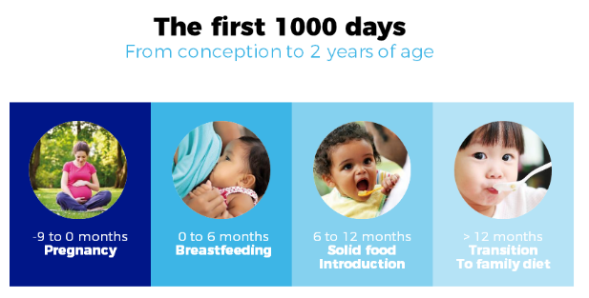
Introduction:
(Source: Danone Nutricia Research, 2022)
This sway document will be discussing the first 1000 days of a child’s life from conception to 2 years old. This is a critical phase during which the foundations of a child’s development are laid. According to Piaget (1896-1980) (McLeod, 2020), during the first month of life, basic reflexes are modified by experience, meaning a baby will keep moving their cheeks to find the teat of a bottle and within a few weeks the baby’s movements will be less random and more deliberate (McLeod, 2020). The first 1000 days of a child being born can improve the child or children’s health, development and life chances and make society more open minded and more thriving. It also is a critical time for development, however, some babies are at their most vulnerable at this time (HM Government, 2021). Some babies are diagnosed with an illness, some have a developmental need that will develop later on in life. Babies do not have the skills to speak for themselves, therefore their carers or parents must speak on their behalf (HM Government, 2021). If a mother has a healthy pregnancy, it sets up the child to have a healthy life. A few examples of a healthy pregnancy could be:
- Eat well, this is a healthy balanced diet
- See a midwife as soon as you find out, to have good advice
- Keep well hydrated, more water means to prevent constipation and tiredness and because you will be producing extra blood
- Take a supplement of folic acid and vitamin D
- Cut out alcohol, as this is a risk of harm to your baby, and it can damage baby’s development
- Rest a lot as there are high levels of pregnancy hormones circulating in your body.
(Thomas, 2021).
The government wishes children to receive the best start in life, as it is an important period for brain development, impacting a child’s social and emotional flexibility later in life (HM Government, 2021). Erikson (2022) states ‘in the social jungle of human existence, there is no feeling of being alive without a sense of identity. The Government sets demanding goals to reduce negative childhood experiences, improve the child’s readiness for school and reduce infant fatality and child poverty.

High-quality local services for children, parents and families should be set up on the consecutive six assumption of:
- Proportionate universalism, this means so that services are available to all but targeted into the scale of level needed
- Prevention and early intervention
- Community partnerships
- A focus on meeting the needs of marginalised groups
- Bigger integration and better multi-agency working
- Evidence-based provision (House of Commons 2019).
In the first 1000 days of life of a child, the local service area should develop jointly with the local NHS bodies, the community and voluntary service, a clear and enthusiastic plan to improve support for children, parents and families. Whereby, the Government should publish a holistic workforce plan for service covering the first 1000 days.
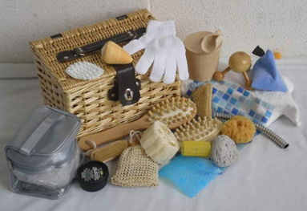
Holistic Play:
(Source: Wandsworth Preschool, 2021)
Holistic play approaches are crucial to a child’s development, learning to recognise the connectedness of mind, body, and spirit and is important when planning and assessing the needs of the child (Scottish Social Services Council, 2022). For example, it assesses the child individually and understands what they have achieved and what they have not achieved. An example of an assessment for a child could be, that the child can pick up building blocks and put them on top of each other, however the child cannot insert the blocks together. The childcare setting can plan an activity around this to help the child develop their skills. (Scottish Social Services Council, 2022).
Erikson (1902 - 1994) believes that people at every stage experience a conflict which acts as a turning point during their development (First Discoverers, 2021). The Welsh Government (2016, p.24) points out:
that children should have a range of experiences, including freely chosen, unstructured and self-directed play, that contribute to their emotional, physical, social, intellectual, language and creative development, and that they are given opportunities to be active, indoors and out, as well as time to relax.
(Welsh Government, 2016, p24)
According to Raise Learning (2012), holistic approach pays attention to six different developments, which are:
- Physical
- Personal
- Social
- Emotional
- Spiritual wellbeing
- Cognitive
(Raise Learning, 2012).

Physical development:
(Source: First Cry Parenting, 2018)
There are two different physical developments. One is physical growth, and the other physical development (White, 2008, cited in Brodie, 2018). Physical growth is the process of getting bigger determined by genetics and physical development and is the use of the body and skills, for example, muscle coordination to move a baby’s head. White (2008, cited in Brodie, 2018) states that, ‘through playful movement and physical activity the child can explore who they are, how the world works and how they fit into it.’ Prime areas in Early Years Foundation Stage (EYFS) supports learning in all other areas. Before birth the baby is measured for length and size to estimate the growth rates and when the baby is born, it is measured again and recorded onto the predetermined centile chart. They are then compared to other babies’ averages (White, 2008, cited in Brodie, 2018).
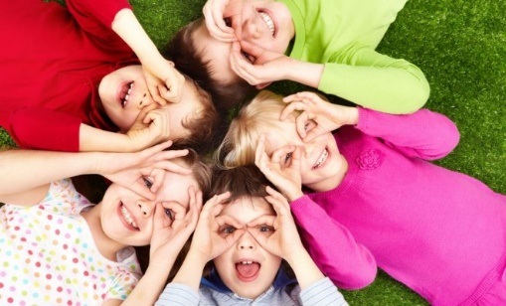
Personal, Social and Emotional Development:
(Source: First discovers, 2021)
Personal, Social and Emotional Development are the three prime areas of the Early Years Foundation Stage and are essential in supporting other areas of learning and development. Gray and Macblain (2012) claim ‘the closer the circle to the centre, the greater the influence on the child’s life and development’.
Personal development is making the child’s personality more obvious with a combination of temperament, self-esteem, and self-confidence.
Social development is associated with older children however, there is more research showing that even babies can socialise. Nevertheless, when children’s social skills develop, they will push boundaries and test behaviours.
Emotional Development is rooted in attachment, and it manages children’s feelings and emotions. Part of a baby’s emotional development is resilience and self-regulation (Gray and Macblain, 2012).

Spiritual Wellbeing:
(Source: GNRC, 2017)
Spiritual wellbeing is the ability to experience and combine meaning and purpose such as, music, literature, and nature (Roberts, 2016). Spiritual wellbeing is often a misunderstood concept, and it is about wholeness and inner life and the relationship with the wider world. Roberts (2016) believes that ‘spirituality is not about religion. Rather it is an acknowledgement of our spiritual essence by exploring our desire for purpose, meaning and an interconnection with others.’
Cognitive Development:
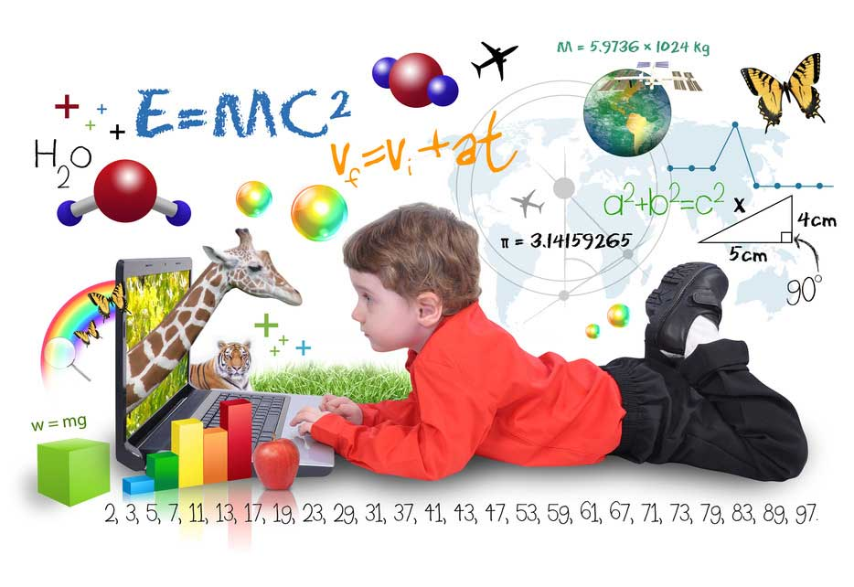
(Source: Bacctraining, 2019)
Cognitive development is the development of intelligence or of mental abilities and it is holistic by its nature. According to Oakley (2004), Piaget was the first to note that children’s thinking was different from adult thinking and that at different ages children’s thinking was different. However, Bruce (2011, cited in Colwell, 2015) states that ‘children learn best when they are given appropriate responsibility, allowed to make errors, decisions and choices, and respected as autonomous and complete learners.’

Storytelling and reading
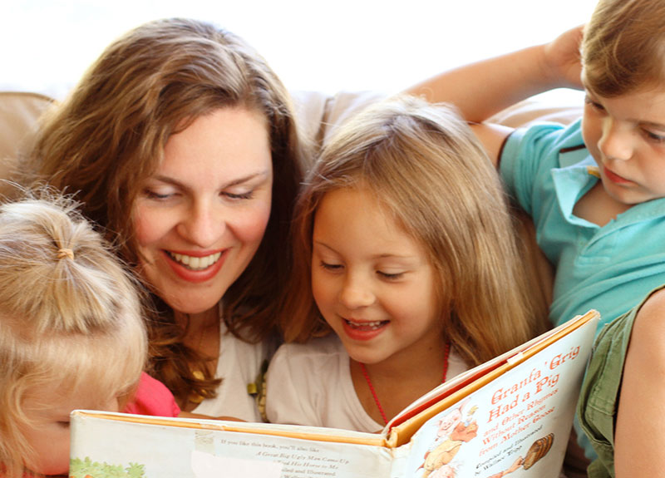
(Source: Wondered hub, n.d)
Storytelling and reading is very important for babies and young children because it promotes brain development (Raising Children, 2006-2022). Also, babies and young children like to enjoy books, songs, and stories. When the conception of the baby has been made and the baby is growing, this is a way of getting the baby to getting to know the person’s voice. Reading and sharing helps the child develop in many ways, according to Raising Children (2006-2022) these are important points to note:
- Help the child get to know sounds
- Help develops the child’s brain
- Help the child learn about the world, and their culture
- Help the child learn new or frightening events
Also Raising Children (2006-2022) stated that ‘parents can start reading aloud to baby as early as you like – the earlier the better. The baby will love being held in arms, listening to the voice.’ Patel (2018) believes that ‘story telling is the oldest form of teaching’ Young Academics (2022) also believes this.
Music
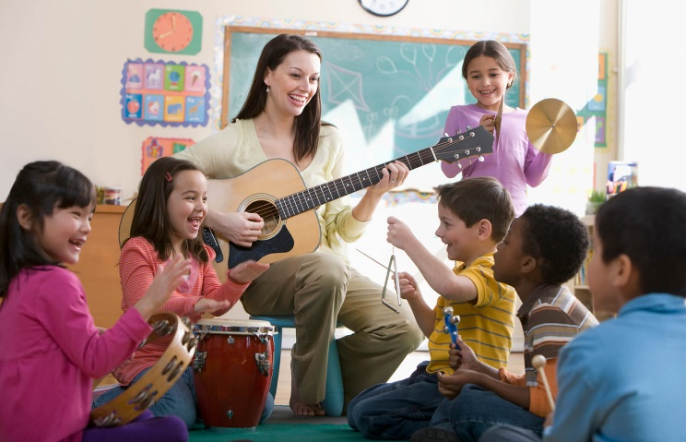
(Source: Love to Know, 2022)
Steinhoff (2016) states that music plays a very important part in the culture. Also, Cambridge Montessori (2019) states that there are ten reasons why music is important, and the ten reasons are:

- Music expands communication and imagination
- It boosts IQ
- It cultivates patience in children
- Music increases child’s sensory development
- It makes them happy
- It improves their literacy
- Emotional development
- Improves coordination
- Improves listening skills
- It’s a mood lifter (Cambridge Montessori, 2019).
When children are approximately seven months and sitting up, they can start grasping different objects, a way of creating different but simple musical instruments is an empty bottle filled with rice for a shaker and different sized pot for drums (Steinhoff, 2016).
Treasure Baskets
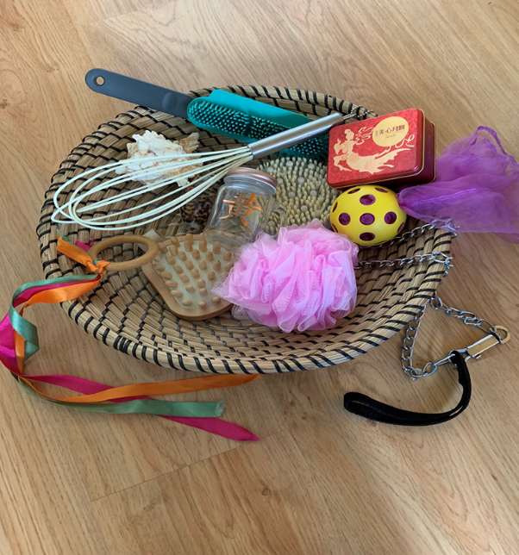
(Source: Early Impact, 2022)
A treasure basket is a basket of natural and household objects and babies use their five senses along with their co-ordination of eye and hand in playing with the objects. The treasure basket is used when the child can sit up, for example, by themselves or with support from an adult or by having some equipment such as pillows around them. According to Williams (2022) there are sixteen benefits of using treasure baskets with babies, these are:

- Curiosity
- Decision making
- Practice sitting
- Gross motor
- Experimenting
- Independence
- Begin understanding mathematical properties of objects
- Total involvement
- Begin to choose what they like and dislike
- Learning through feel
- Develop concentration
- They are multisensory
- Simple to facilitate and resource
- Develop their eyesight
- Brain development
- Introduction to loosen part play (Williams, 2022).
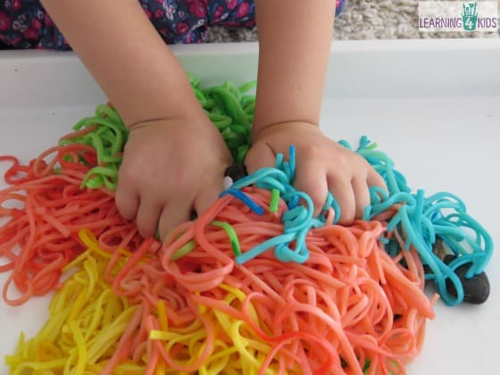
Sensory play
(Source: Learning 4 kids, 2015)
Sensory play encourages discovery and independent thinking (Amelia, 2018). From birth, the child is exploring their senses and processing new information. The child begins to make sense of the world as they grow, to the new textures, materials, and resources. Amelia (2018) explains that there are many ways in which sensory play can benefit a child’s development and learning, such as:
- Brain development
- Language development
- Fine and gross motor skills
- Problem solving skills
- Cognitive growth
- Social interaction
- Awareness
- Comforting
- Adaptability (Amelia, 2018).
According to Goodstart (2018) an example of sensory activities for a baby is watching the bubbles float and feeling them land on their body or scrunching paper tissues and hearing the noise, The Montessori NoteBook (2022) explains sensory experiences begin as soon as a child is born. Also, by participating in sensory activities, children can consciously obtain clear information that helps them classify their surroundings (The Montessori NoteBook, 2022).
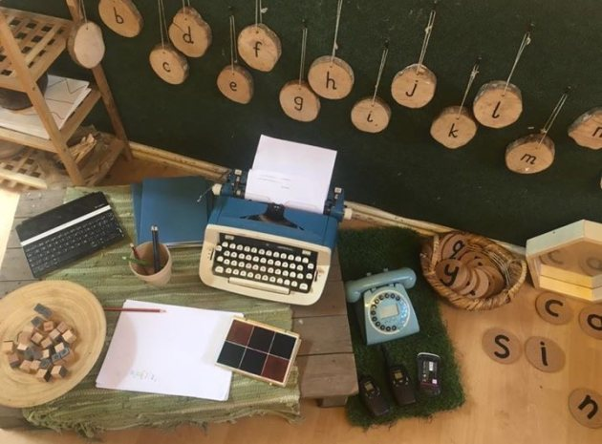
Enabling Environment:
(Source: Teach early years, 2022)
According to Roy (2015) the environment should be welcoming and interesting. Also, the learning environment is the mix of spaces and context in which a young child grows and learns. Effective learning environments encourages learning through play, an example of this could be a nature table with branches, sticks, leaves and some dolls or figures. This develops a child’s way of thinking and how to create play from the table (Roy, 2015). Early Years Matters (2022) agrees with this as it states that enabling environments encourage babies and young children to play because they feel relaxed, comfortable and ‘at home’ in them. When children feel secure in the environment then they will be able to explore and find out about the place.
The Welsh Government (2021, p.25) states:
that it is essential that the setting considers not only the physical spaces but also the emotional climate that support children to thrive. The setting should allow the child to express themselves physically, creatively and imaginatively, and safely follow their interests, independently or with others. The setting should have access to a range of open-ended resources, including digital media, to enhance learning in developmentally appropriate ways. Within the environment there should be flexibility and variety of different learnings, such as risk, challenge, and support the child to develop confidence, independence and resilience.
(Welsh Government, 2021, p.25).
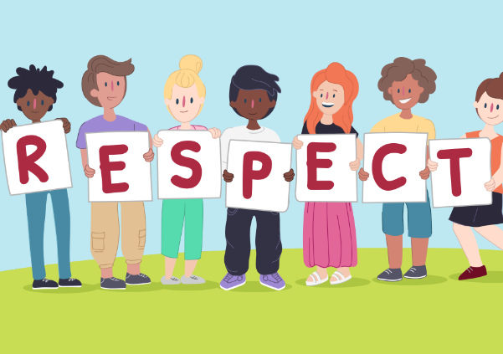
Respectful Care:
(Source: Kids helpline, 2022)
Stonehouse (2010) points out that children’s right to privacy is an important issue to consider in childcare. Pikler (1902 – 1984) (Marlen, 2022) believed that parents and caregivers need to take the time to make nappy changing, feeding, bathing, and dressing, an unhurried and pleasant quality time, with the baby being an active partner (Marlen, 2022).
When toileting a child, it should be treated with respect encouraging the child to be independent whilst using the toilet. It is essential that childcare workers have a policy and procedure regarding toilet training. In Meithrinfa Twts Tywi Nursery (n.d.), the child or children always have access to the toilet facilities and if the child needs assistance, then the assistance is given when needed. CBAC WJEC (2019a) states that nappies should be changed regularly to prevent infection. Meithrinfa Twts Tywi Nursery (n.d.) states that a new disposable apron and pair of gloves is used for each nappy change and practitioners always wash their hands after.
Purdy (2020) believes that rest time is important. Rest time does not have to be a chaotic time and childcare workers cannot expect all children to sleep. According to Queensland Government (n.d), when arranging sleep, rest, and relaxation practices for babies and toddlers, consider the five principles of S.L.E.E.P. which are:
- S for Sleep Need, this is to consider when opportunities for sleep, rest, and relaxation are provided, and ways to identify and respond to each child’s need.
- L for Learning and growth, this is to support children’s learning and physical growth by being responsive to children’s sleep cues.
- E for Environments, this is to provide sleep environment that are safe, predictable, and supportive of children’s sleep, rest and relaxation.
- E for Expectations, this is to ensure that expectations for children’s sleep are realistic.
- P for Partnerships, this is to build partnerships with families to ensure regularity and consistency.
(Queensland Government, n.d).
Meithrinfa Twts Tywi Nursery (n.d.) states that babies or young child are placed on their backs, where they can adopt whatever position if they want to sleep or not. Also, if they child is under six months or a new baby that has started, during the first couple of weeks when the baby is sleeping the baby will be checked every five minutes.
Inclusive:
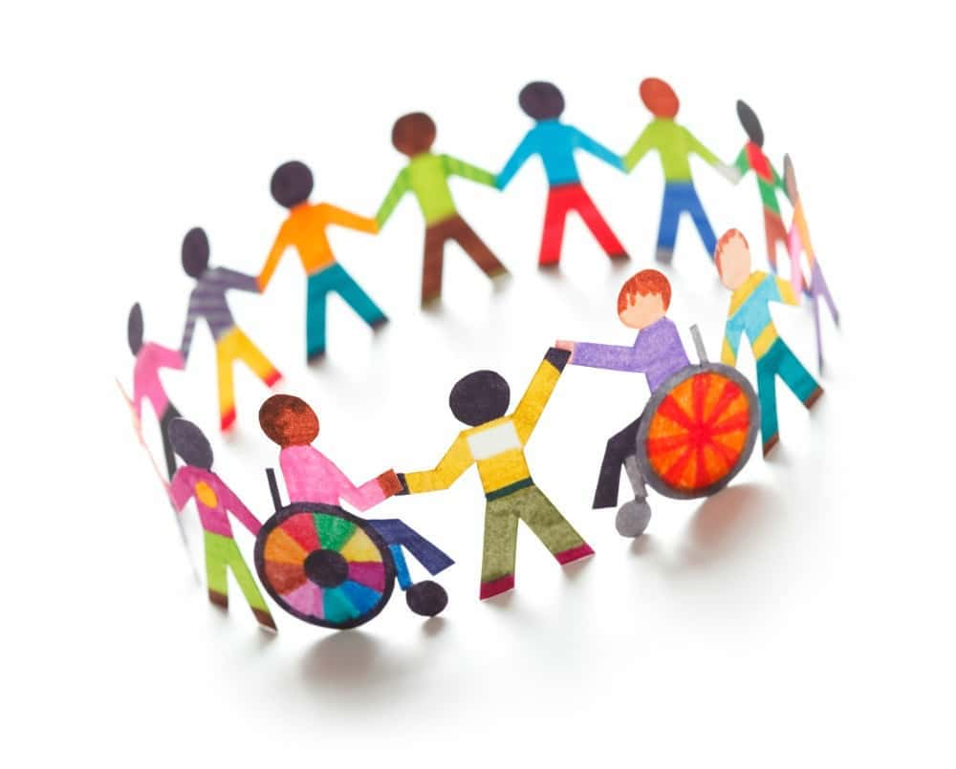
(Source: Film daily, 2020)
Rodgers and Wilmot (2011) state the Early Learning Goals (QCA, 2000) in England defines children should:
- Understand that people have different needs, and they should be treated with respect
- Understand that others need to treat their needs with respect
- Begin to know about their own cultures and the beliefs of others
There are many answers for inclusion and the Early Childhood Forum (n.d.) clarifies inclusion as ‘a process of identifying, understanding and breaking down barriers to participation and belonging.’ Childcare settings need to develop their ethos, policies, and procedures. Meithrinfa Twts Tywi Nursery (n.d.) does this by operating an inclusive admissions policy and procedure ensuring that the nursery reflects and meets the needs of the local community.
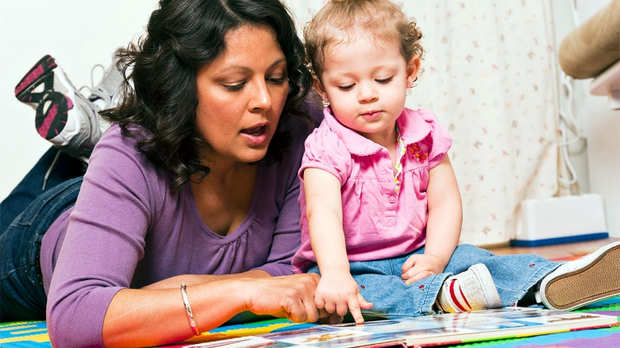
Professional Relationships:
(Source: Raising children, 2020)
According to CBAC WJEC (2019b) developing effective relationships allows everybody to work together successfully. Also, time is needed to communicate effectively with workers and families. Some of the points workers should consider are:
- Listen carefully
- Be aware of confidentiality
- Respect ideas of others
- Take and show interest and empathy (CBAC WJEC, 2019b).
Rodgers and Wilmot (2011) claim that parents and carers are central to their children’s lives and parents need to feel included. This is part of the role of early years professionals to ensure diverse needs are met.

Conclusion:
(Source: Paperpile, 2022)
To conclude, this scrapbook explains the first 1000 days from conception of the baby to when they are 2 years old, and as Piaget (1896 – 1980) identified during the first month of life, basic reflexes are modified by experience. The first 1000 days are a critical time for development, there are six different developments and the government’s aim for the child is to have the best start. The conception of the first 1000 days is also a crucial part of the child’s life as well as the six developments, as then the parent, carers, or the setting the child attends can see how the child develops and if he or she is on the right track. Sensory play, music, storytelling, reading and treasure baskets are central to a child’s growth, as this is critical to many of their developments along their lives. Respectful care is one of the main areas of many points to consider as Stonehouse (2010) stated that children’s right to privacy is important.

Referencing:
Amelia. (2018) The Importance of Sensory Play for Early Years. Available at: https://www.earlyyearsresources.co.uk/blog/2018/02/sensory-play-importance/#respond (Accessed: 18 January 2022).
Aspiring Beginnings. (1997) What sit the Pikler theory?. Available at: https://www.aspiringbeginnings.co.nz/what-is-the-pikler-theory/#:~:text=Pikler%20believed%20that%20parents%20and,baby%20being%20an%20active%20partner. (Accessed: 16 January 2022).
Bacctraining. (2019) 2nd Stage of Piaget’s Cognitive Development. Available at: https://www.bacttraining.com/2nd-stage-of-piagets-cognitive-development/ (Accessed: 22 January 2022).
Brodie, K. (2018) The holistic care and development of children from birth to three : an essential guide for students and practitioners. Abingdon, Oxon: Routledge, Taylor & Francis Group.
Cambridge Montessori. (2018) 10 Reasons why music is IMPORTANT for early childhood development. Available at: https://cambridgemontessoriglobal.org/10-reasons-why-music-is-important-for-early-childhood-development/ (Accessed: 15 January 2022).
CBAC WJEC. (2019a) Health, Well-being, Learning and Development. Available at: http://resource.download.wjec.co.uk.s3-eu-west-1.amazonaws.com/vtc/2018-19/hsc18-19_3-2/_multi-lang/unit06/01-how-to-support-children-with-their-physical-care.html (Accessed: 18 January 2022).
CBAC WJEC. (2019b) Professional Practice as a childcare worker. Available at: http://resource.download.wjec.co.uk.s3-eu-west-1.amazonaws.com/vtc/2018-19/hsc18-19_3-3/_multi-lang/unit02/03-developing-good-relationships-working-in-ways-that-build-trust.html (Accessed: 19 January 2022).
Colwell, J. (2015) Reflective Teaching in Early Education. London: Bloomsbury Publishing.
Danone Nutricia Research. (2022) A journey through the first 1000 days. Available at: https://www.nutriciaresearch.com/nutrition-for-life/early-life-nutrition/a-journey-through-the-first-1000-days/ (Accessed: 22 January 2022).
Early Childhood Forum. (n.d.) Breaking down barriers. Available at: http://earlychildhoodforum.org/docs/ecf_inclusion_leaflet.pdf (Accessed: 10 January 2022).
Early Impact Learning. (2022) What is A Treasure Baskets? The Essential Guide. Available at: https://earlyimpactlearning.com/what-is-a-treasure-basket/ (Accessed: 22 January 2022).
Early Years Matters. (2022) Enabling Environments. Available at: https://www.earlyyearsmatters.co.uk/our-services/school-and-nursery-improvement-partner/enabling-environments/#:~:text=Enabling%20environments%20encourage%20babies%20and,%2C%20touch%2C%20manoeuvre%20or%20manipulate. (Accessed: 22 January 2022).
Erikson. E.H. (2022) Quotes. Available at: https://quotefancy.com/erik-h-erikson-quotes (Accessed: 10 January 2022).
Film daily. (2020) Inclusive education: Everything you need to know. Available at: https://filmdaily.co/craft/inclusive-education/ (Accessed: 22 January 2022).
First Cry Parenting. (2018) Physical Development in Early Childhood. Available at: https://parenting.firstcry.com/articles/physical-development-in-early-childhood/ (Accessed: 22 January 2022).
First Discoverers. (2021) Child Development Theories: Erik Erikson. Available at: https://www.firstdiscoverers.co.uk/erik-erikson-childcare-development-theories/ (Accessed: 16 January 2022).
First Discovers. (2021) Children’s Personal, Social and Emotional Development 0 Online Childcare summit. Available at: https://www.firstdiscoverers.co.uk/online-childcare-summit-social-emotional-wellbeing/ (Accessed: 22 January 2022).
GNRC. (2017) Nurturing Spirituality and Ending Violence in Child Upbringing. Available at: https://gnrc.net/en/blog/3825-nurturing-spirituality-and-ending-violence-in-child-upbringing (Accessed: 22 January 2022).
Goodstart. (2018) Why teaching children empathy is more important than ever. Available at: https://www.goodstart.org.au/news-and-advice/february-2018/why-teaching-children-empathy-is-important (Accessed: 16 January 2022).
Gray, C. and Macblain, S. (2012) Learning theories in childhood. London: SAGE.
HM Government. (2021) The Best Start for Life. Available at: https://assets.publishing.service.gov.uk/government/uploads/system/uploads/attachment_data/file/973112/The_best_start_for_life_a_vision_for_the_1_001_critical_days.pdf (Accessed: 16 January 2022).
House of Commons. (2019) First 1000 days of life. Available at: https://publications.parliament.uk/pa/cm201719/cmselect/cmhealth/1496/1496.pdf (Accessed: 10 January 2022).
Kids Helpline. (2022) All about Respect. Available at: https://kidshelpline.com.au/teens/issues/all-about-respect (Accessed: 22 January 2022).
Learning 4 Kids. (2015) Bucket of Colourful Spaghetti worms sensory play. Available at: https://www.learning4kids.net/2015/07/14/bucket-of-colourful-spaghetti-worms-sensory-play/ (Accessed: 22 January 2022).
Love to Know. (2022) 12 Musical Activities for kids to explore. Available at: https://kids.lovetoknow.com/kids-activities/12-musical-activities-kids-explore (Accessed: 22 January 2022).
Marlen, D. (2022) The Pikler Approach: Part 1. Available at: 2022).https://www.teachearlyyears.com/under-2s/view/the-pikler-approach-part-1(Accessed: 12 January).
McLeod, S. (2020) Piaget’s Stages of Cognitive Development. Available at: https://www.simplypsychology.org/piaget.html . (Accessed: 16 January 2022).
Meithrinfa Twts Tywi Nursery (n.d.) Quality Child Care. Available at: https://www.twtstywi.co.uk/en/quality-child-care (Accessed: 10 January 2022).
Montessori NoteBook. (2022) 10 ways we can show respect to our child. Available at: https://www.themontessorinotebook.com/10-ways-we-can-show-respect-to-our-child/ (Accessed: 12 January 2022).
Oakey, L. (2004) Cognitive Development. London: Routledge.
Paperpile. (2022) How to write an excellent thesis conclusion. Available at: https://paperpile.com/g/thesis-conclusion/ (Accessed: 22 January 2022).
Patel, Y. (2018) Importance of storytelling in Child Development. Available at: https://medium.com/@yash.hsquare/importance-of-storytelling-in-child-development-b63593921a33 (Accessed: 12 January 2022).
Purdy, J. (2020) Rest time is Important. Available at: https://www.jackrabbitcare.com/blog/rest-time-is-important/ (Accessed: 19 January 2022).
Queensland Government. (n.d) Meeting children’s sleep, rest, and relaxation needs. Available at: https://earlychildhood.qld.gov.au/aboutUs/Documents/factsheet-meeting-childrens-needs.pdf (Accessed 22 January 2022).
Raising Children. (2006 - 2022) Reading and storytelling with babies and children. Available at: https://raisingchildren.net.au/babies/play-learning/literacy-reading-stories/reading-storytelling (Accessed: 12 January 2022).
Raising children. (2020) Relationships and Child development. Available at: https://raisingchildren.net.au/newborns/development/understanding-development/relationships-development (Accessed: 22 January 2022).
Raise Learning. (2012) Exploring Holistic Approaches for Early Childhood Educators. Available at: https://www.raiselearning.com.au/blogs/news/5818384-exploring-holistic-approaches-for-early-childhood-educators#:~:text=When%20early%20childhood%20educators%20take,as%20cognitive%20aspects%20of%20learning.&text=An%20integrated%2C%20holistic%20approach%20to,connections%20to%20the%20natural%20world. (Accessed: 12 January 2022).
Roberts, K. (2016) Spiritual Well Being Definiton. Available at: https://insights.vitalworklife.com/blog/2016/01/04/wheel-of-well-being-spiritual-dimension-definition (Accessed: 12 January 2022).
Rodgers, A. and Wilmot, E. (2011) Inclusion and Diversity in the Early Years. Available at: http://fplreflib.findlay.co.uk/books/1/FilesSamples/126197819072412_00000000732.pdf (Accessed: 19 January 2022).
Roy, C. (2015) The Importance of Early Learning Environments. Available at: https://naturalpod.com/the-importance-of-early-learning-environments/ (Accessed: 16 January 2022).
Scottish Social Services Council. (2022) Holistic view of child development and learning. Available at: https://learn.sssc.uk.com/apps/development/chapter-3/index.html (Accessed: 15 January 2022).
Steinhoff, A. (2016) The Importance of Music in Early Child Development. Available at: https://novakdjokovicfoundation.org/importance-music-early-childhood-development/ (Accessed: 15 January 2022).
Stonehouse, A. (2010) A matter of respect: Recognising young children’s right to privacy. Available at: http://www.rainbow-nursery.info/wp-content/uploads/2016/09/Recognising_chns_right_to_privacy_Sept10.pdf (Accessed: 18 January 2022).
Teach Early Years. (2022) 3 Ideas to Improve Your Learning Environment. Available at: https://www.teachearlyyears.com/enabling-environments/view/3-ideas-to-improve-your-learning-environment (Accessed: 22 January 2022).
The Montessori Notebook. (2022) 10 Ways we can show respect to our child. Available at: https://www.themontessorinotebook.com/10-ways-we-can-show-respect-to-our-child/ (Accessed: 19 January 2022).
The Wandsworth Preschool. (2021) Launch of Virtual Heuristic Play. Available at: https://wandsworthpreschool.co.uk/launch-of-virtual-heuristic-play/ (Accessed: 22 January 2022).
Thomas, C. (2021) 10 steps to a healthy pregnancy. Available at: https://www.babycentre.co.uk/a536361/10-steps-to-a-healthy-pregnancy (Accessed: 10 January 2022).
Welsh Government. (2016) National Minimum Standards for Regulated Childcare for children up to the age of 12 years. Available at: https://gov.wales/sites/default/files/publications/2019-06/national-minimum-standards-for-regulated-childcare.pdf (Accessed: 22 January 2022).
Welsh Government. (2021) A curriculum for funded non-maintained nursery settings. Available at: https://gov.wales/sites/default/files/consultations/2021-05/curriculum-funded-non-maintained-settings-consultation-doc.pdf. (Accessed: 22 January 2022).
Williams, M. (2022) 16 Benefits of Using Treasure Basket with Babies. Available at: https://earlyimpactlearning.com/16-benefits-of-using-treasure-baskets-with-babies/ (Accessed: 18 January 2022).
Wondered. (n.d) Benefits of storytelling to children. Available at: https://wonderedhub.com/benefits-of-storytelling-to-children/ (Accessed: 22 January 2022).
Young Academics. (2022) How Does Storytelling in Early Childhood Education Help Your Child’s Development. Available at: https://www.youngacademics.com.au/blog/how-does-storytelling-in-early-childhood-education-help-your-childs-development/ (Accessed: 12 January 2022).

