VIOREL DINU S.N.1905713

PROBLEM SOLVING AND DECISION MAKING

Table of Contents

Task 2: Report 3
Introduction 3
Problem and its scope and impact 3
Analysing information 7
Alternative solutions to the problem 7
Evaluating different solutions using a decision making technique 8
Plan to implement the identified solution 9
Communicating the plan with stakeholders 10
Monitoring and review technique 11
References 13

Task 2: Report

Introduction
With the advancement in technology, changes in problem solving and decision making processes are also noticed across companies in different parts of the world. Having effective problem solving skills usually help individuals to analyse problems, determine its severity thereby identifying effective solutions to it. In different organizations, training has been involved in order to enhance the problem solving skills within the employees. This allows employees to work efficiently thereby determining unforeseen issues with effective alternative solutions to it.
In this report, the researcher will carry out a deep analysis of a serious problem that has headed high across different UK companies that is the issue of Gender discrimination at the workplace. The scopes and the impact of this problem will be analysed in the concerned report. Moreover, an alternative solution that will work effectively and efficiently will be proposed. Using a decision-making technique, a range of solutions will be provided that will be applicable. A plan will be developed through the help of which the identified solution will be implemented in order to get rid of the identified problem. Steps to communicate and discuss the plan with the stakeholders of the company will be determined. Monitor and review techniques will be implemented to determine whether the implemented solution is a success or not.

Problem and its scope and impact
Gender discrimination in the workplace is not a new thing. In the majority of the countries, women face gender discrimination at the higher levels. Gender discrimination is not only faced by women but often by single fathers in different companies worldwide. Recently, in a survey, it has been found that over 8.2 million employees within the UK have felt that they have been discriminated against on the grounds of gender.
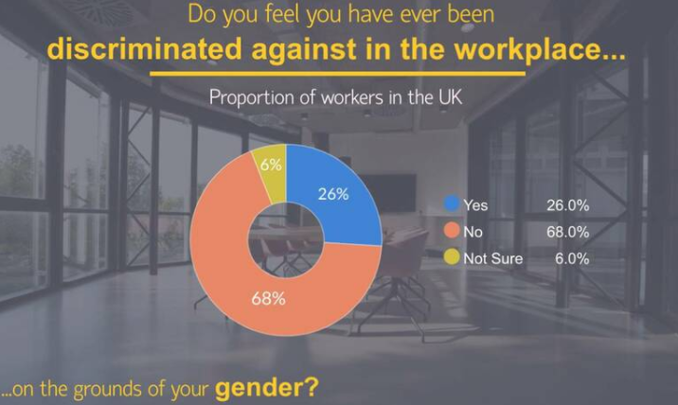
Figure 1: Proportion of workers in the UK who faced gender discrimination
(Source: Rosling, 2019)
On asking the employee about the type of gender decimation they are facing, 32.4% claimed that workers of opposite gender had gotten away with more. On the other hand, 28.7% claimed that they have been overlooked for promotions whereas 26.5% of the respondents were of the opinion that they were not taken seriously at work. 23.4% respondents claimed that they have been unfairly dismissed on gender grounds. While 17.7% felt that, they have been made redundant because of on gender.
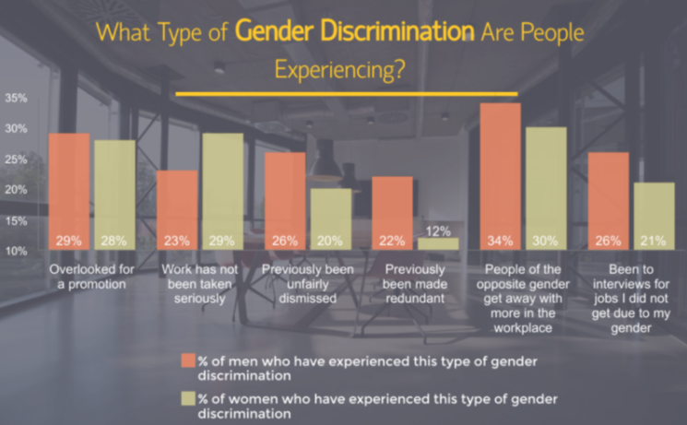
Figure 2: Proportion showing types of discrimination
(Source: Rosling, 2019)
When we talk about gender discrimination or gender pay gap related problems at the workplace, the majority of the conversation revolves around women. However, interestingly, it has been found that men too have felt such discrimination in terms of gender at the workplace environment.
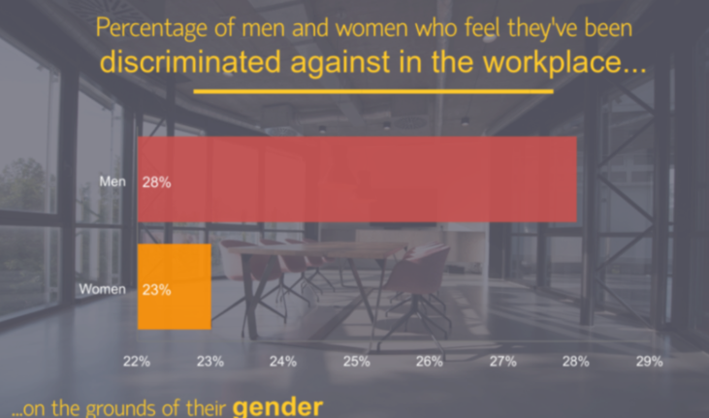
Figure 3: Percentage of men and women who felt discriminated at the workplace
(Source: Rosling, 2019)
In a survey, it has been found that male employees claimed that the type of gender discrimination varies from one to another.
In this context, it needs to be mentioned that there are various organizations across the UK that have continued gender discrimination even in this 21st century. According to the latest figures, six out of ten UK news media companies have noticed an increase in the gender pay gap in the last year. Telegraph Media Group (TMG), one of the most celebrated media houses of the UK, revealed about the gender pay gap related discrimination. Two years ago, this famous media group was caught conducting gender discrimination within the company. However, when women employees came in forefront the issue created big news across the UK and other countries (Butler, 2018).
It should be added here that the scope of such issues are far flung. In fact, the impact of the discrimination not only influenced the employees but the organization as well. The impact was noticed in the organizational performance of TMG. In fact, women backed out at that situation and the reputation of the company was hampered to great extent.

Analysing information
In the case of Telegraph Media Group, it has been found that women were paid 35% less than that of men on average. This was considered as the biggest gender pay gap within any UK media-publishing house. In fact, it was also disclosed that nearly three quarters of the highest paid staff of the company belong to the small section whereas women only get a percent of 26.9. However, on the other side of the pay scale, it was identified that women make nearly 61.6% of the bottom quartile (Butler, 2018). As a result, the performance of the organization severely dropped down a year ago. Not only this, the issue also hampered the working couture and environment of the company thereby leaving behind others problems as well. In fact, the bottom line of the company was affected due to such gender pay gap discrimination.

Alternative solutions to the problem
The issue of Gender discrimination based on pay scale within TMG was surprising. Sánchez-Monedero et al., (2020) commented that the regulations within the country are not tough enough, as a result, such types of discriminations are still valid and exist across varied organizations; hence, proper actions need to be taken. There are laws related to gender pay gap; however, organizations tend to avoid those and carry out such discrimination at full swing. Hence, proper laws need to be made and must be adhered by the organization to reduce gender pay gap issues. On the other hand, Begeny and Ryan (2018) commented that employers must look into adopting a five-year strategy to determine the way by which they can put an end to the issues of gender pay gap.
Apart from this, there are other alternative solutions as well that can help in ending the gender pay gap issue within the workplace for example, claiming salary transparency. With the salary transparency, women would get to know about the pay gap and develop a negotiation strategy based on the same. On the other hand, Hess (2019) claimed that raising the minimum wage within an organization could help in diminishing the problem of gender pay gap. Apart from these solutions, another crucial alternative solution to end the issues of gender pay gap is cultivating negotiation skills. As a woman, it is necessary to witness a price hike and if the organisation is failing to do so, building a negotiation can help a lot. Thus, it can be said that there exist a number of alternative solutions to gender pay gap issues that can be adopted in order to put an end to such malpractices.

Evaluating different solutions using a decision making technique
Gender bias or gender discrimination at workplace has become quite common (Heilman and Caleo, 2018). To date, several authors and business analysts have come forward with different solutions to put an end to such types of malpractices within a workplace. Even though there are organisations, who have taken up the initiative toned thigh gap but there exists some organisation where these kinds of wrongdoings are clearly visible in today’s time. In the above section, several alternative solutions have been identified that TMG thought of adopting in order to overcome such issues. However, in order to adopt the appropriate one, the manager considered the Analytic hierarchy process. Mu and Pereyra-Rojas (2017) commented that the Analytic hierarchy process is a widely used technique for making decisions in a complex environment. In this process or technique, a number of criteria or valuables are being considered in order to determine a correct solution to an identified issue.
Goal: To diminish the issue of gender pay gap in TMG
Improving organizational performance
Improving working culture
Promoting women safety
Cultivating negotiation skills
Raising the minimum wage
Initiating proper laws
Adopting five-year strategy
Claiming salary transparency

Figure 4: Analytic hierarchy process
(Source: created by author)
From the above figure, it can be noticed that the main purpose of the management team of the company was to diminish the gender pay gap so that a healthy working environment can be cultivated and women can be prioritised at the same time. The three main criteria of the media group were to bring about improvement in the organizational performance, working culture and promote women safety. The five different solutions that were taken into consideration were calculated. The results showed that claiming salary transparency is the ideal solution to reduce the issue of gender pay gap.
Khuzwayo (2016) commented that various business organizations across the UK have always focused on remaining transparent to their employees regarding pay scale so that no bias is formed thereby treating all the employees equally. Thus, it can be said this alternative solution is the ideal one. On the contrary, it can be said that often cultivating effective negotiation with these employers does not mortgage gender inequality issues. Moreover, it has also been identified that there are UK laws that strictly prohibit employers to carry out such malpractices; even after that organisations tends to carry out the same illegal practices. This has been the reason for which the management team of TMG avoided such alternative solutions to mitigate the problem of gap in the pay scale.

Plan to implement the identified solution
After a great discussion and the implementation of the Analytic hierarchy process, it was decided that the company would consider claiming salary transparency to diminish the gender inequality or the inequality in the pay structure of the company. It was identified that the media group was responsible for resting such inequalities towards the women as they were offered 35% less salary than what they offered to the employees (Butler, 2018). The plan:
- Determining the organizational readiness:
In the first stage, the manager identified whether the company and the other staff are ready to implement the solution. In fact, the doctor was sure that there would be no pitfalls to this solution.
- Developing team and schedule:
In the second stage, the company decided that this planning would include the stakeholders and the managers of the company as changes to the policies would have to be made. However, later, employees were also included in the decision making process to see if they were readily accepting the identified solution or not.
- Collecting current data:
In this stage, the employee’s dissatisfaction rate was identified. A market analysis of the ways by which other competitors have promoted gender equality was identified.
- Reviewing the collected data:
The data that were collected was reviewed to see if there was any loophole.
At the end of it, the company after taking a grant from the stakeholder (except staff) made changes into the company policy thereby removing the barrier and coming out transparent to the existing staff. In the current time, the media house tries to discuss the salary structure with the newly hired employees to avoid any negative consequences. Moreover, after that, the director of the company decided to pay both men and women staff equally and remain transparent to the employees. This brought about drastic changes in the company and the skill set of the staff and employees. Over the years, Telegraph Media House has successfully entertained their employees and readers side by side.

Communicating the plan with stakeholders
In the above section, the plan to reduce or diminish the discrimination regarding gender pay gap has been developed. However, it was necessary for the management team of TMG to communicate the plan with their stakeholders to generate their reactions on it. Kaur and Lodhia (2018) opined that stakeholders play an integral role within an organization; hence they form a major part of any decision making process.
Description | Type | Target audiences | Delivery method | Responsible
Discussion of the plan | Mandatory | Sponsor  Steering committee  Employees | Face to face meetings | Manager of the company
Granting permission | Mandatory | Sponsor  Steering committee | Face to face meetings  Over the calls | Project manager
Status reports | Mandatory | Managers  Sponsor  Steering committee | Paper-statuts  Report- emailed to the audience | Project manager
Table 1: Communication plan
(Source: created by author)
From the above table it can be analysed, that at first a meeting was held to discuss the plan with the target audiences like the sponsor, steering committees. In fact, the employees were also involved in order to remain transparent. After discussing the plan, it was identified that the target audiences are in favour and if any modifications are required. Shortly after, the target audiences to execute and implement the identified plan of claiming salary transparency granted the permission. In fact, it was found that the employees also favoured such an intuitive in order to end the gender discrimination that the company was conducting at that moment. Thus, in a way already succeeded; however, the success was actually evaluated through proper monitoring and reviewing of the plan.

Monitoring and review technique
The last step to any project or planning implementation is to monitor and review its growth and success. Kasamska and Tsvetkova (218) commented that if any organization fails to monitor and review their plan effectively, it might bring negative consequences largely. In the context of Telegraph Media Group, the project manager and the manager of the company ensured that the activities were based within the parameters of the identified goal. Moreover, they also made sure that the actions of the planning were spontaneous and consistent with that of the company's mission, values and vision. In order to monitor and review the planning, the manager of the company along it when the project manager was acquainted with the task of generating feedback from the employee. From the feedback, it was found that the company was successful in claiming salary transparency with their employees and the other stakeholders. The company decided to change the company policy and changes were made where it was mentioned that all the employees are equal in the eye of the company as well as law. Moreover, the improvement in the organizational performance, employees’ performance and increasing employee retention also proved the success of the plan. In fact, the effective implementation of the plan, increase the productivity, profitability as well as the reputation of the Telegraph Media Group worldwide.
Conclusion
To conclude, it can be said that promoting gender inequality is illegal to great extent. In the modern time, women are ruling in various fields like sport, education, science and others. There are various organisations where the hierarchy is of female origin. In fact, some female entrepreneurs are there who are successfully running businesses all over the globe. Thus, looking down upon women or men at this point of time is not justifiable. Giving maternity leave to women, not to single fathers, is also discrimination. Hence, everyone should have the opportunity to represent his or her organization and uses for it. Telegraph is a well-circulated newspaper and its media house is well-known one. One can never expect such type of gender pay gap discrimination within such a well known organization as all the employees have equally qualified to get their position in that company. After the incident of bias in the gender pay gap in Telegraph, the company brought about caribou changes so that these mistakes are not repeated. The media house has promoted gender equality and one of the safest companies for women to work in the UK.

References
Begeny, C.T. and Ryan, M., 2018. Gender discrimination in the veterinary profession: a brief report of the BVA Employers’ Study 2018.
Butler, S. 2018. The UK companies reporting the biggest gender pay gaps. The Guardian. [Online]. Available at: https://www.theguardian.com/society/2018/apr/05/the-uk-companies-reporting-the-biggest-gender-pay-gaps [Accessed on: 07th December 2020]
Heilman, M.E. and Caleo, S., 2018. Gender discrimination in the workplace.
Hess, A. 2019. 8 steps economists say could help close the gender pay gap. The CNBC. [Online]. Available at: https://www.cnbc.com/2019/05/09/8-steps-economists-say-could-help-close-the-gender-pay-gap.html [Accessed on: 07th December 2020]
Kasamska, R. and Tsvetkova, R., 2018. Monitoring, evaluation, and quality assurance in project management. VUZF Review, (1), pp.100-109.
Kaur, A. and Lodhia, S., 2018. Stakeholder engagement in sustainability accounting and reporting. Accounting, Auditing & Accountability Journal.
Khuzwayo, Z., 2016. Separate space: An approach to addressing gender inequality in the workplace. Journal of International Women's Studies, 17(4), pp.91-101.
Mu, E. and Pereyra-Rojas, M., 2017. Understanding the analytic hierarchy process. In Practical decision making (pp. 7-22). Springer, Cham.
Rosling, L. 2019. Women To Feel Discriminated At Work On The Grounds Of Gender. [Online]. Available at: https://smeloans.co.uk/blog/gender-discrimination-in-the-workplace/ [Accessed on: 07th December 2020]
Sánchez-Monedero, J., Dencik, L. and Edwards, L., 2020, January. What does it mean to'solve'the problem of discrimination in hiring? social, technical and legal perspectives from the UK on automated hiring systems. In Proceedings of the 2020 Conference on Fairness, Accountability, and Transparency (pp. 458-468).

