Andreea Lilea (2126939) Word count: 1099 words

Module Lead: Giulia Chifari

Managing Projects in the Organisation
(Blogs)
(BMSW5009_SWAN)

BLOG 1 – Understanding My Contribution Through Belbin Team Roles
For our project, my team organised an event called Promoting Romanian Desserts and Culture. The project aimed to introduce Romanian culture through traditional desserts while raising money for charity. The event took place at UWTSD and successfully raised approximately £80 for EYST (Swansea) Wales.
Our team consisted of five members. Ionut Ungureanu acted as the Project Coordinator, Mariana Danescu was responsible for poster and banner design, Silvia Mita managed flyer distribution, Andreea Porumbel organised the purchase of Romanian desserts, and my role was Event Setup and Donation Collection.
One project management tool that helped me understand teamwork was Belbin’s Team Role Theory. According to Belbin (2010), effective teams are formed by people with different strengths and responsibilities. During the project, I communicated with university staff, completed documentation, organised allergen information and contacted charity organisations. Based on these responsibilities, I believe I mainly worked as a Coordinator because I was involved in communication and organisation.
The Belbin model was useful because it helped identify the contribution of each team member. However, I noticed that people frequently completed tasks outside their assigned roles. This suggests that flexibility is important in real projects. Effective communication and cooperation are also key factors in project success (Lock, 2020).
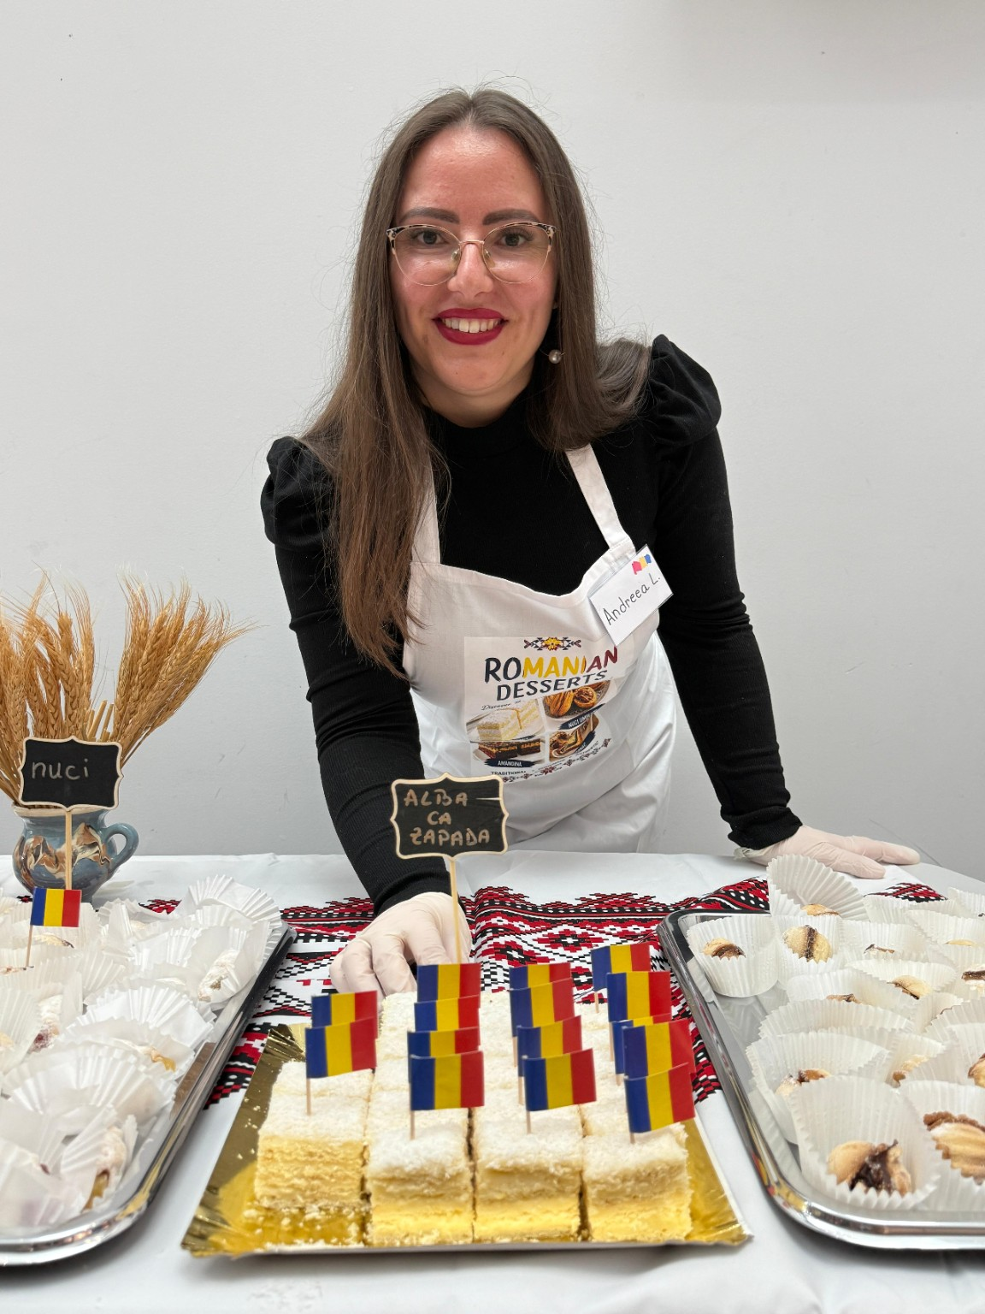
Figure 1. My participation in the Promoting Romanian Desserts and Culture charity event.

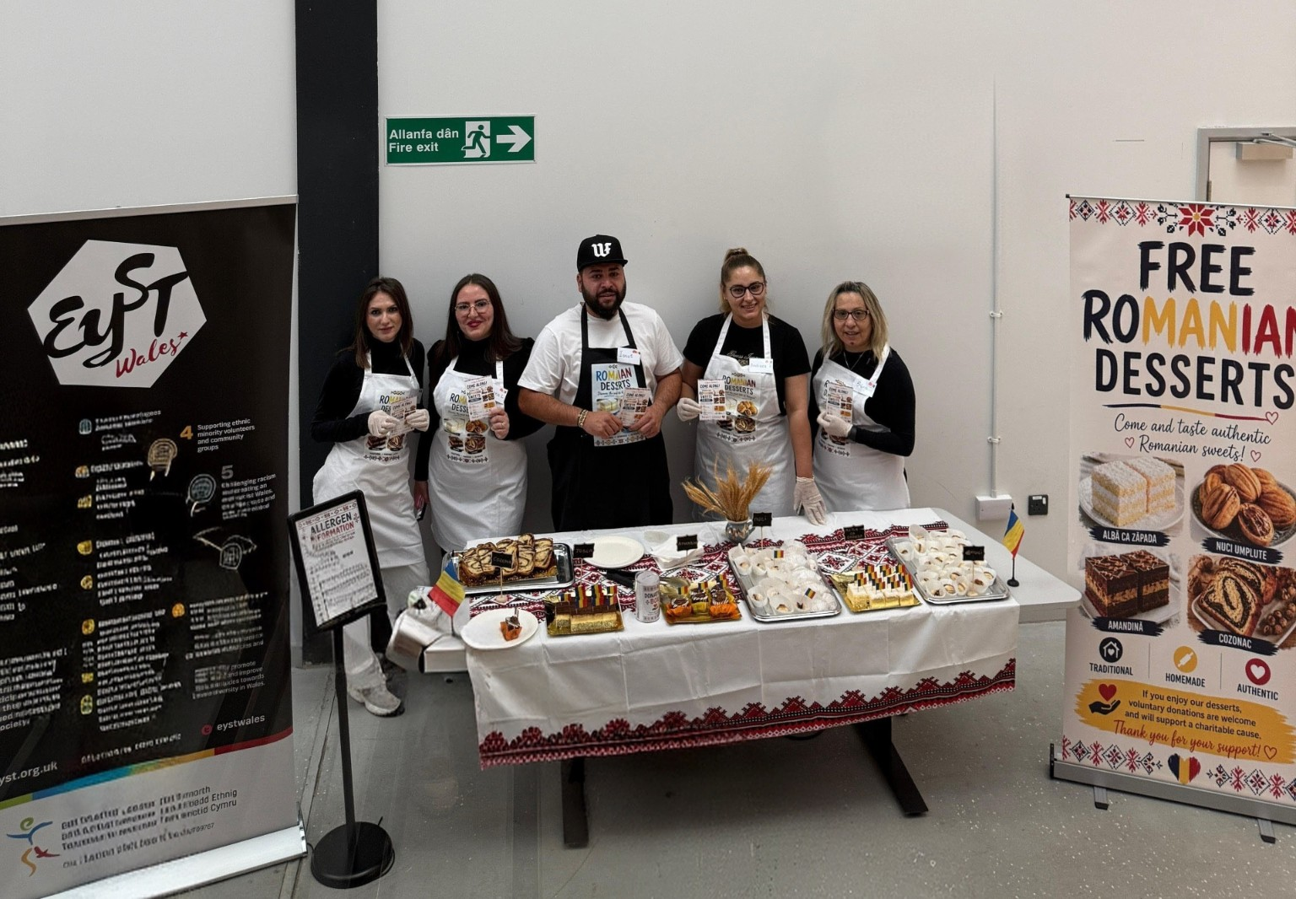
Figure 2. Project team during the Promoting Romanian Desserts and Culture event.

BLOG 2 – PROJECT SCOPE, OBJECTIVES AND THE IRON TRIANGLE
At the start of the project, it was important to define the scope and objectives. The project aimed to promote Romanian culture through traditional desserts while raising money for charity. Defining the project scope helped the team understand what activities were included and what needed to be achieved. According to Maylor (2010), a clearly defined scope helps prevent confusion and keeps a project focused on its objectives.
The project scope included obtaining university approval, creating promotional materials, distributing flyers, purchasing desserts, organising the event and collecting donations for EYST Swansea. A clear scope helped the team allocate responsibilities.
The project also followed the principles of the Iron Triangle, which focuses on balancing time, cost and quality (Kerzner, 2022). Time was important because the event had to be completed before the scheduled date of 15 June. Cost was a significant factor because the project was self-funded by the team members, who paid for the desserts, banners and aprons themselves. Quality was maintained by obtaining university approval, completing the required documentation and displaying allergen information for visitors.
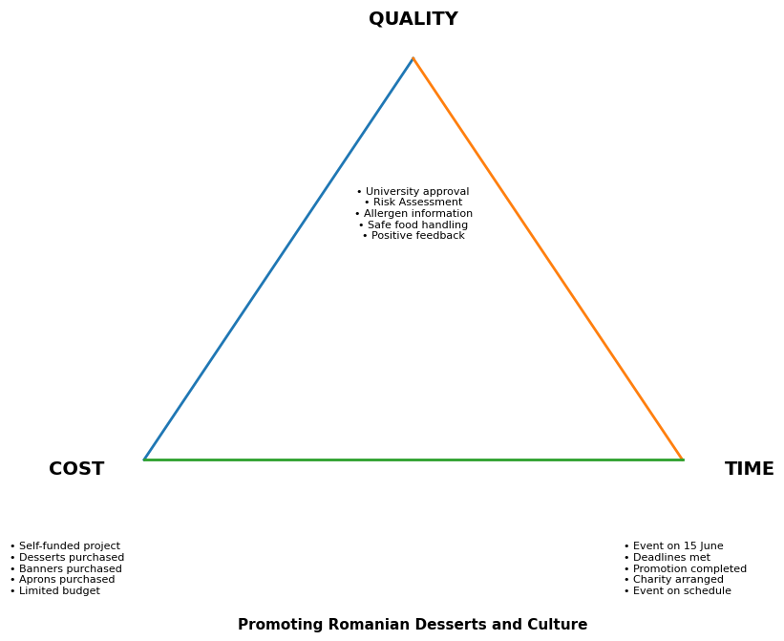
Figure 3. The Iron Triangle applied to the project.
In my opinion, the Iron Triangle was a useful project management tool because it highlighted the challenges of balancing limited resources while still delivering a successful event. The team successfully maintained quality standards despite working with a limited self-funded budget.
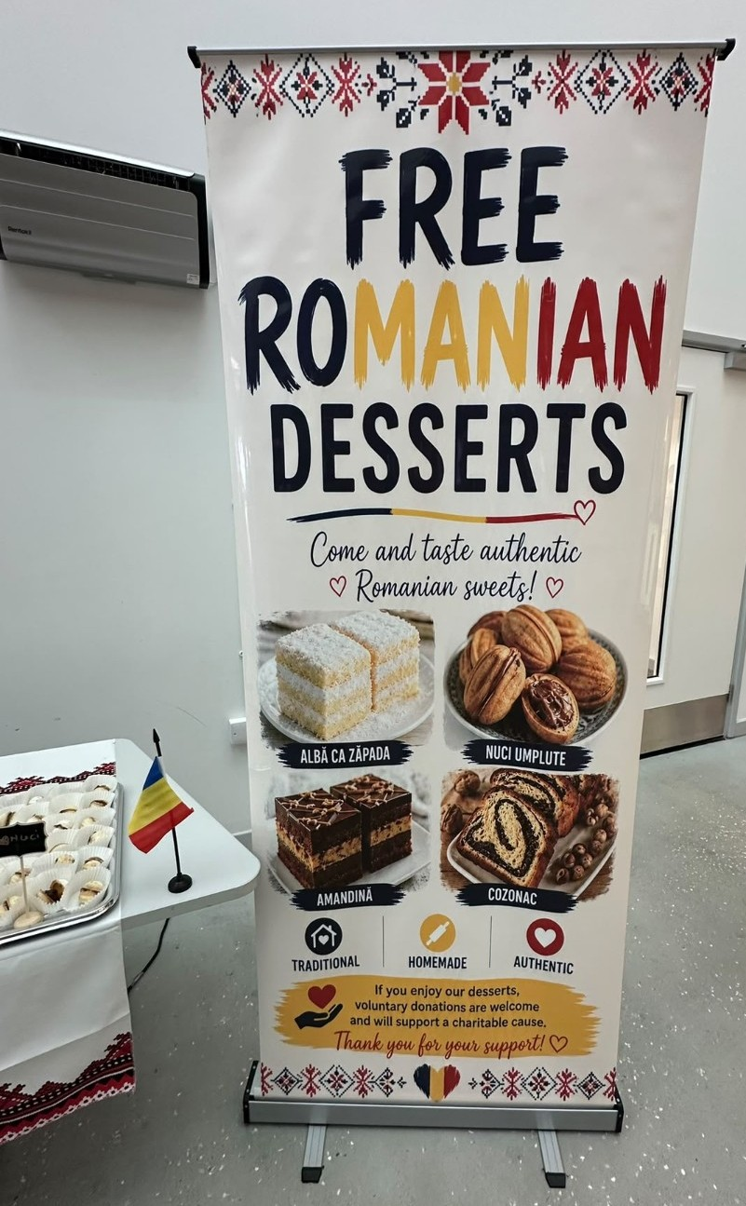
Figure 4. Promotional banner used during the event.
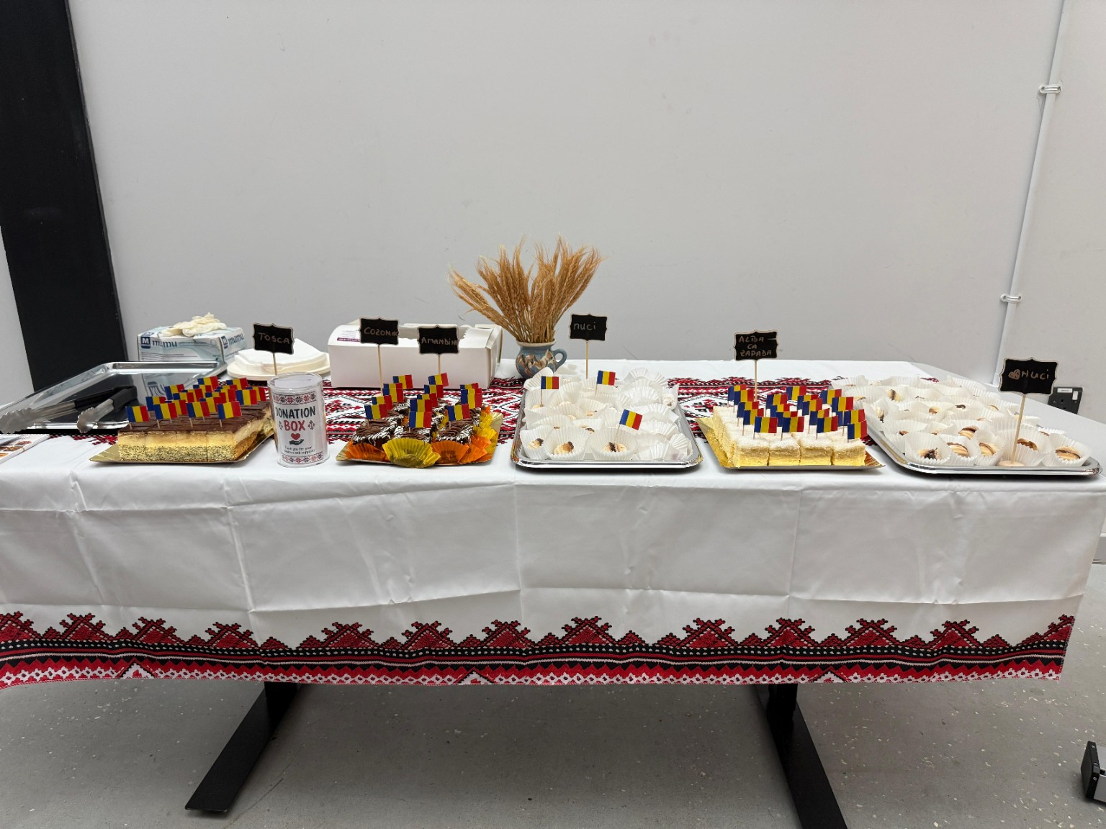
Figure 5. Romanian desserts stand.

BLOG 3 – STAKEHOLDER ANALYSIS AND COMMUNICATION MANAGEMENT
Stakeholder analysis was an important project management tool during this project. Stakeholders are individuals or organisations that can influence a project or be affected by its outcomes (Bourne, 2015). Identifying stakeholders helped the team prioritise communication. (Freeman, 2010).
The main stakeholders were UWTSD, EYST Wales, the dessert supplier, students, staff, the project tutor and the project team. The university was a key stakeholder because approval was required for the event. EYST Wales was important because the organisation received the donations raised during the event. The project team was also a stakeholder because members invested their own time and money to support the event.
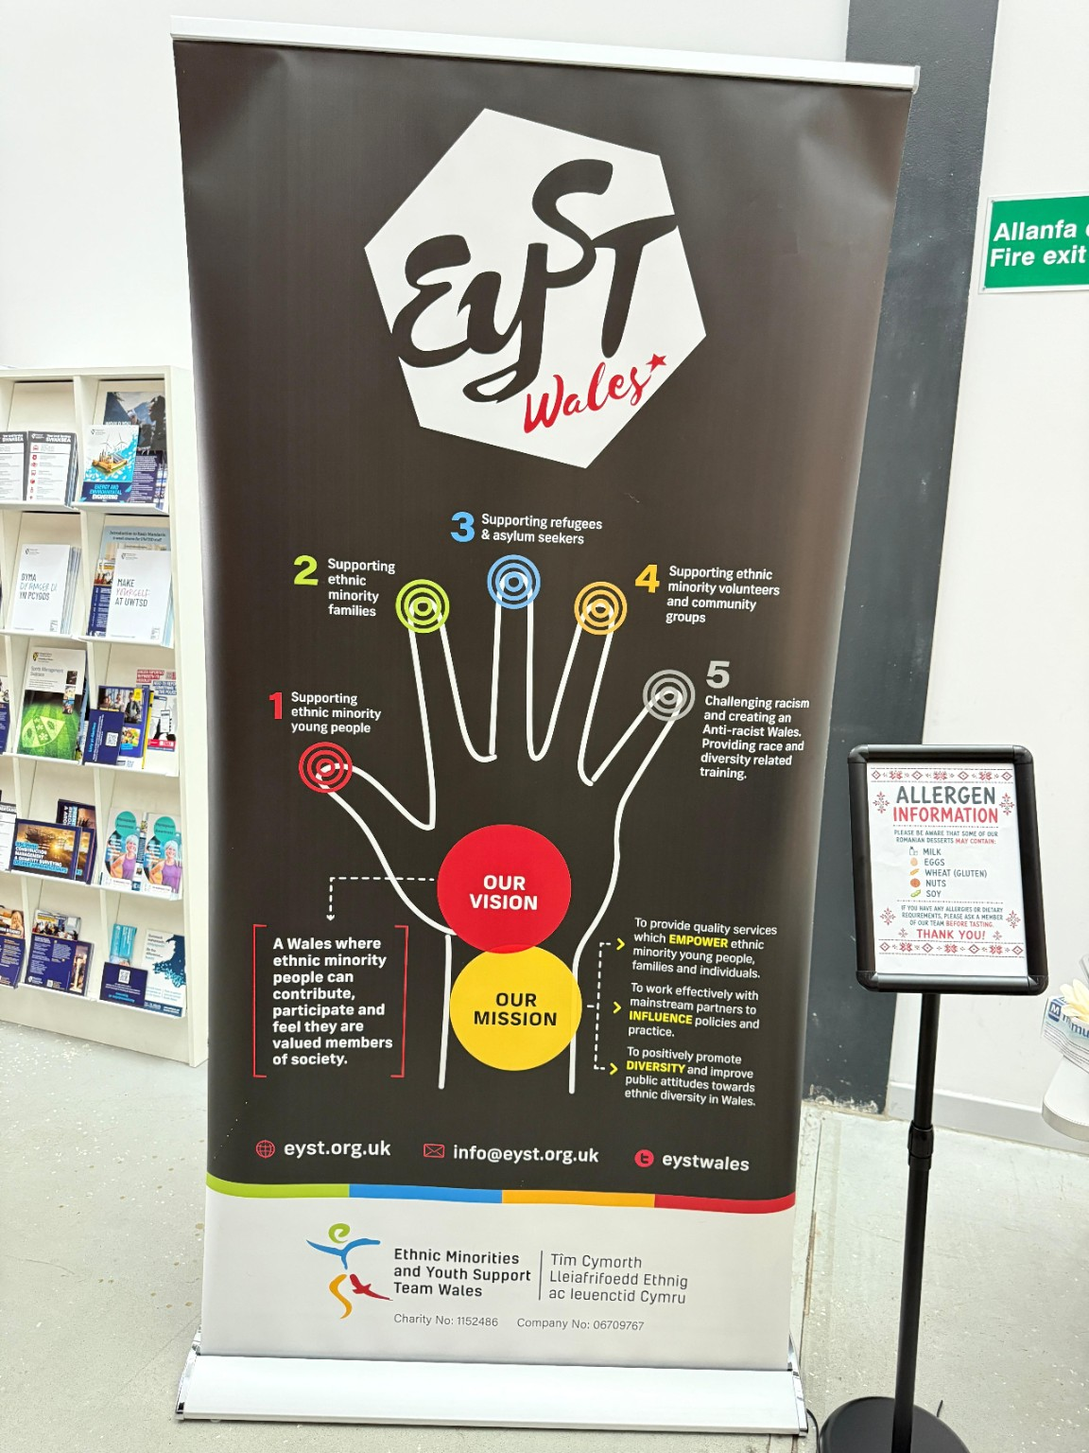
Figure 6. EYST Wales charity banner displayed during the event.
Communication management was essential throughout the project. I communicated with university staff regarding approval, risk assessments and allergen requirements. I also contacted the dessert supplier and EYST Wales to ensure that all arrangements were completed successfully. Effective communication helps build positive stakeholder relationships and contributes to project success (Turner, 2014).
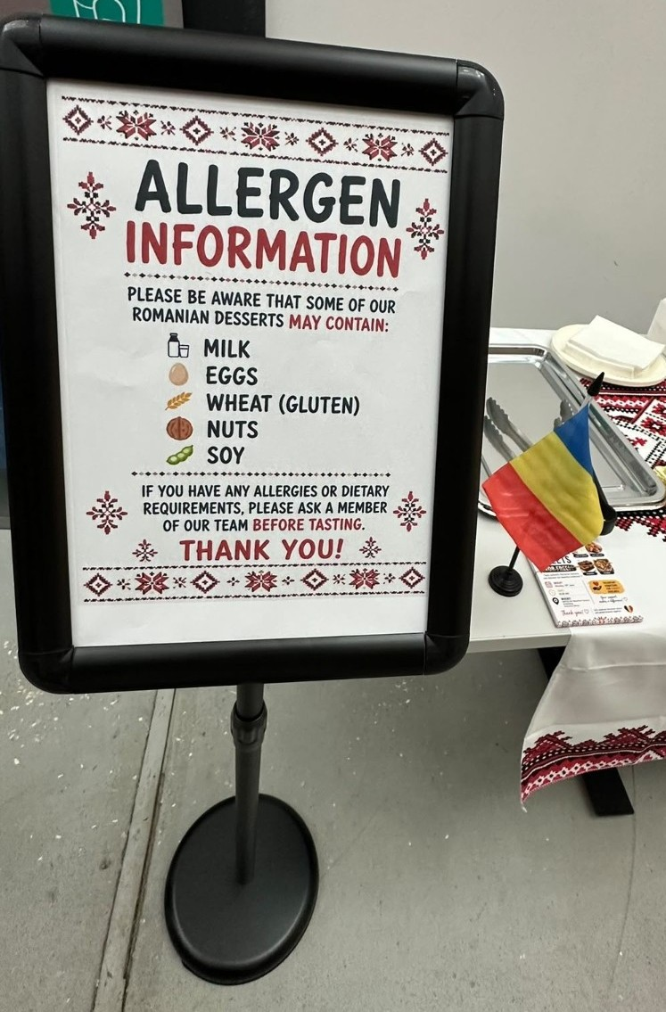
Figure 7. Allergen information displayed for visitors.
Overall, stakeholder analysis helped improve communication and supported the successful delivery of the event.

Figure 8. Positive participants' feedback collected during the event

BLOG 4 – WORK BREAKDOWN STRUCTURE (WBS) AND GANTT CHART
Planning is an important part of project management because it helps teams organise activities and meet deadlines. During our project, two useful planning tools were the Work Breakdown Structure (WBS) and the Gantt Chart.
The WBS helped divide the project into smaller and more manageable tasks. Activities such as obtaining university approval, creating promotional materials, contacting EYST Wales, ordering desserts and event preparation were organised into separate sections. According to Nicholas and Steyn (2020), breaking a project into smaller tasks helps improve organisation and control.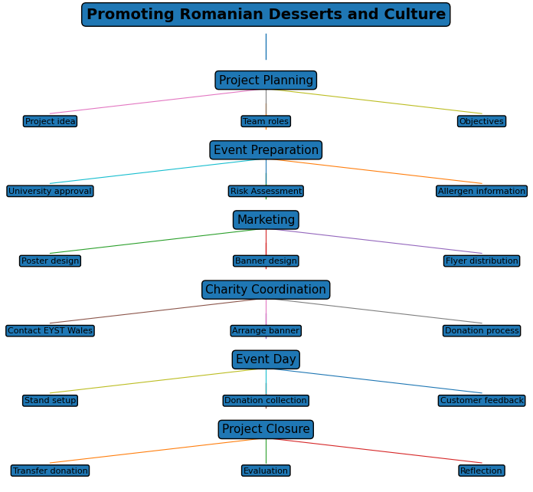
Figure 9. Work Breakdown Structure for the project.
The Gantt Chart was also useful because it provided a visual overview of the project schedule. However, the Gantt Chart could not predict unexpected delays when searching for a charity partner. It helped the team monitor progress and ensure that tasks were completed within the planned timeframe. Promotional activities were completed before the event, while dessert ordering was scheduled closer to the event date. Meredith, Mantel and Shafer (2021) suggest that Gantt Charts are effective tools for tracking project activities and deadlines.
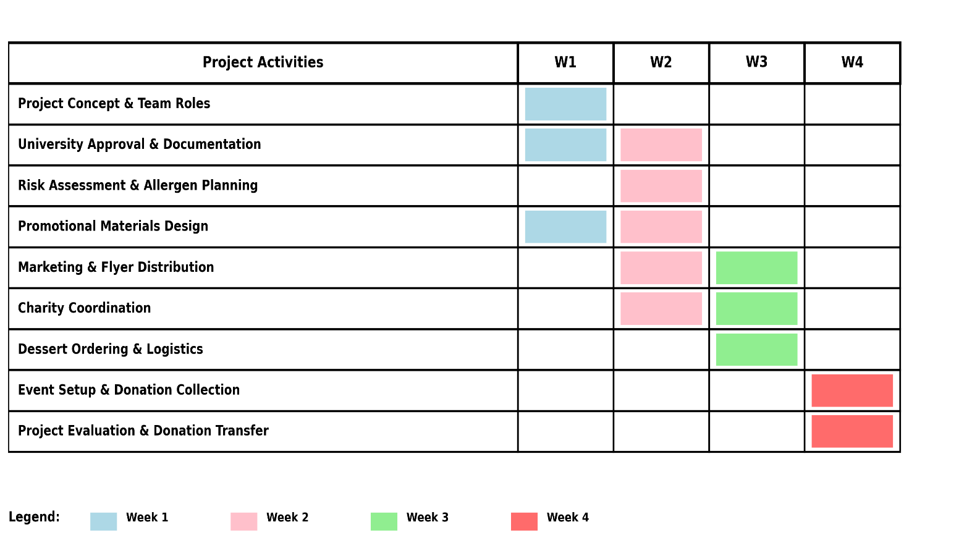
Figure 10. Gantt Chart showing the project schedule and key activities.
Overall, both tools improved project planning and coordination. Although some activities, such as finding a suitable charity partner, took longer than expected, the project remained on schedule and was successfully completed.

BLOG 5 – SELF-EVALUATION AND PERSONAL DEVELOPMENT
This project helped me develop my communication, organisation and problem-solving skills. My responsibilities included obtaining university approval, completing documentation, communicating with stakeholders and collecting donations during the event.
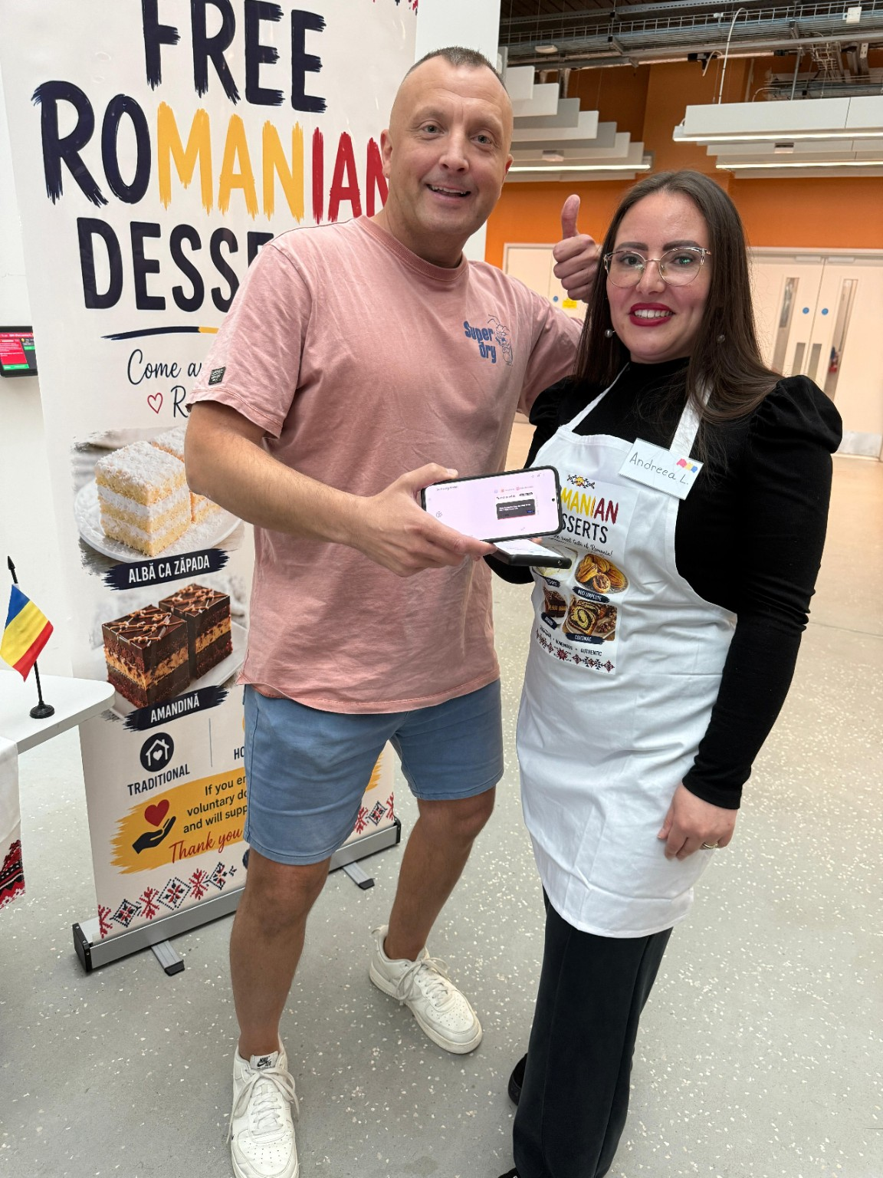
Figure 11. Donation collection using a mobile POS system.
One challenge I faced was finding a suitable charity partner. Initially, I contacted the university, but they were unable to recommend a charity. I then contacted a local organisation that stopped responding to emails. As a result, I had to find an alternative solution and successfully arranged a partnership with EYST Wales shortly before the event. This experience showed the importance of flexibility and contingency planning in project management (PMI, 2021).
I believe my strengths were communication and organisation. Through this project, I realised the importance of risk management and stakeholder planning, which are areas I would like to develop further. Continuous learning is important for effective project management and professional development (Kerzner, 2022).
As part of my personal development plan, I intend to develop my understanding of project management tools and gain more experience managing projects. Overall, this project increased my confidence and provided valuable experience.

REFERENCES
Belbin, R.M. (2010) Team Roles at Work. 2nd ed. Oxford: Butterworth-Heinemann.
Bourne, L. (2015) Stakeholder Relationship Management: A Maturity Model for Organisational Implementation. Farnham: Gower.
Freeman, R.E. (2010) Strategic Management: A Stakeholder Approach. Cambridge: Cambridge University Press.
Kerzner, H. (2022) Project Management: A Systems Approach to Planning, Scheduling and Controlling. 13th ed. Hoboken, NJ: Wiley.
Lock, D. (2020) Project Management. 11th ed. London: Routledge.
Maylor, H. (2010) Project Management. 4th ed. Harlow: Pearson Education.
Meredith, J.R., Mantel, S.J. and Shafer, S.M. (2021) Project Management: A Managerial Approach. 10th ed. Hoboken, NJ: Wiley.
Nicholas, J.M. and Steyn, H. (2020) Project Management for Engineering, Business and Technology. 6th ed. New York: Routledge.
PMI (2021) A Guide to the Project Management Body of Knowledge (PMBOK® Guide). 7th ed. Newtown Square, PA: Project Management Institute.
Turner, J.R. (2014) Handbook of Project-Based Management: Leading Strategic Change in Organizations. 4th ed. New York: McGraw-Hill Education.

