Student Number 2060263261
Word Count- 2300

#Portfolio for ECEY4012.

Contents:

Part 1- Study Timetable
Part 2- AI activity
Part 3- Poster and reference list
Part 4 – Link to oral presentation also shared with lecture team

AI acknowledgement
I acknowledge the use of Microsoft 365 Copilot on 21 September 2026 to explore study techniques for time management. I used the prompts:
- “Suggest study techniques that could help a university student manage their study time alongside work. Explain briefly how each technique is used.”
- “Explain how Pomodoro cycles and visual timers can support time management during independent study. Give practical examples.”
- “What questions should I investigate when researching how Pomodoro cycles and visual timers support time management?”
I acknowledge the use of Grammarly on 23 September 2026 to check the spelling, punctuation, and grammar of my own writing. I pasted my draft into Grammarly and reviewed its suggested corrections. I did not use Grammarly to re-word my work.

Study Timetable
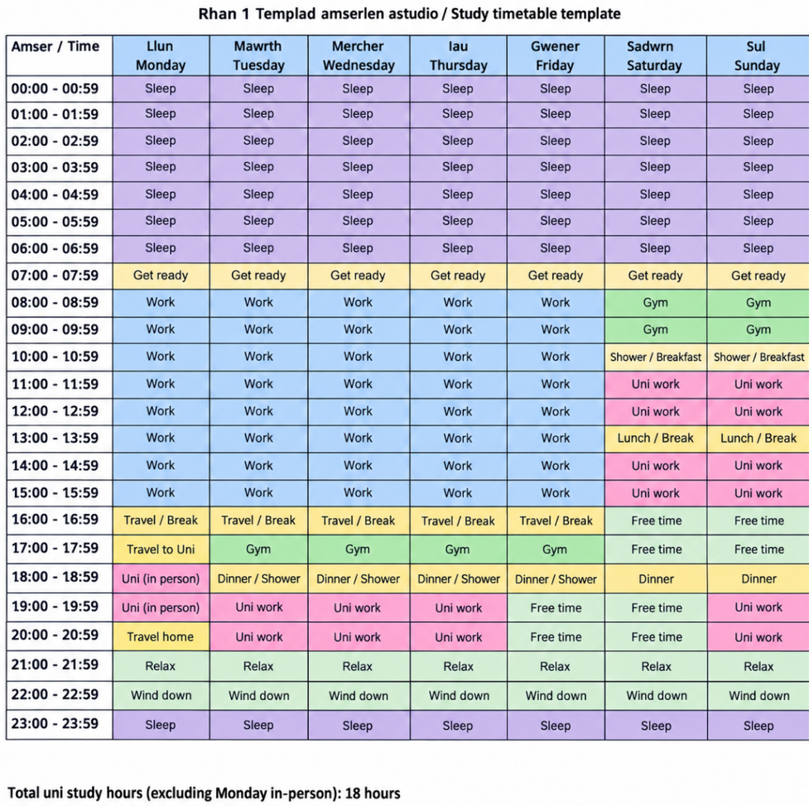

Part 2 – Using AI

1. Initial prompt about study techniques
Prompt to Copilot:
“Give me study techniques to support someone who needs support with time management”

2. Original output from Copilot
• Time blocking — Divide the day into coloured blocks (study, break, lunch, free time). This helps them see where their time goes and reduces decision fatigue.
• Pomodoro cycles — 20 minutes work + 5 minutes break. Great for learners who avoid starting tasks because it feels “too big”.
• Visual timers — Sand timers, countdown clocks, or apps that show time disappearing. Perfect for learners who don’t feel the passage of time.
• Daily anchor points — Fixed moments (breakfast, lunch, after school) that act as “reset points” so the day doesn’t drift.

3. Refined prompt
Prompt to Copilot:
“Explain to me in more detail about Pomodoro cycles and Visual Timers”
Copilot response:
Pomodoro Cycles for adults
What Pomodoro actually does for you
• It stops the “I’ll start in a minute” spiral.
• It gives you a clear start and end, which reduces anxiety.
• It prevents you from over-focusing on one task and burning out.
• It helps you estimate time better — crucial for assignments and deadlines.
• It creates a rhythm that makes studying feel lighter and more predictable.
How to use Pomodoro as an adult
• Pick one task only. Your brain works better when it knows exactly what to do and for how long.
• Set a timer for 20–25 minutes. This is long enough to do meaningful work, but short enough to avoid overwhelm.
• Work until the timer rings. No pressure to finish the whole task — focus.
• Take a 5-minute break. Move, breathe, grab water. Don’t open social media.
• Repeat 3–4 cycles. Then take a longer break (15–30 minutes).
Why Pomodoro works especially well for adults with busy lives
• You can fit a cycle into any gap — before work, after dinner, during a quiet moment.
• It helps you avoid the “I need a whole hour to start” mindset.
• It gives structure when your day is unpredictable.
• It’s brilliant for essay writing, reading, planning, and admin tasks.
Visual Timers for adults
Why visual timers help adults
• They stop you from accidentally spending too long on one task.
• They make time feel real, not abstract.
• They help you transition — “When the red disappears, I stop.”
• They reduce guilt because you can see you’ve genuinely worked for a set period.
• They help you avoid perfectionism by giving you a boundary.
How to use visual timers for your own study
- Set the timer where you can see it on your desk, next to your laptop, or on your
- Choose a time that matches your energy: Low energy: 10–15 minutes; Medium energy: 20 minutes; High energy: 25–30 minutes.
- Watch the time shrink. This keeps your brain engaged and reduces drifting.
- Stop when the timer ends. This prevents overworking and keeps your study sustainable.
When visual timers are especially useful for adults
• When you’re tired after work
• When you’re juggling multiple responsibilities
• When you need to avoid hyperfocus
• When you’re trying to build a consistent study routine

4. Prompt to identify sources
Prompt to Copilot:
“For the Pomodoro technique and the Visual Timer Aid, provide me with 5 online sources that support these techniques”
Copilot response:
Here are 5 credible online research sources you can use for a project on the Pomodoro technique and visual timers for studying. I’ve combined both techniques, so you have evidence covering each one.
- Pomodoro technique – university students. Smits, Wenzel & de Bruin (2025), Investigating the Effectiveness of Self-Regulated, Pomodoro, and Flowtime Break-Taking Techniques Among Students. Studied 94 university students and compared Pomodoro-style breaks with other break strategies during a 2-hour study session.
- Pomodoro technique – actual learning. Göksu, Wiradhany & de Bruin (2026), When to Take a Break: Comparing Effects of Systematic Short (Pomodoro) and Self-Regulated Breaks on Subjective Experience and Actual Learning. Compared structured Pomodoro-style breaks with self-regulated breaks among 176 university students, measuring learning, mood and fatigue.
- Pomodoro technique – review of educational research. Assessing the efficacy of the Pomodoro technique in enhancing anatomy lesson retention during study sessions: a scoping review (2025). Reviews 32 studies/reports examining the Pomodoro technique in educational and cognitive contexts, including attention, focus, time management, and learning.
- Visual timers – student performance. Vallier et al. (2025), Time on Their Side: How Visual Timers Affect Anticipatory Anxiety, Performance, and On-Task Behaviour in Elementary Math Assessments. Tested 44 children aged 7–9 with and without a visible Time-Timer. The visual timer reduced anticipatory anxiety, although the researchers found no significant difference in maths performance.
- Timers and academic performance. Increasing academic performance by using a timer as antecedent stimulus: A study of four cases (1976). Examined the use of a timer with four first-grade students during maths and reading tasks. The researchers found increased maths performance when they introduced the timer.
Source validation
I checked source details before using them in my academic writing. For example, Copilot listed the visual-timer study as “Vallier et al. (2025)”, but the published article names Hallez and Vallier as its two authors. This showed why I needed to check Copilot’s suggestions against the published sources.

5. Academic writing on two chosen study techniques
Pomodoro cycles and visual timers are two techniques that can help learners manage study time. Pomodoro cycles break a task into planned work periods and short breaks. A visual timer displays the time remaining in a work period. Together, they provide a clear starting point, make a large task feel more manageable, and show when a break is approaching.
Pomodoro cycles may be useful when a learner finds it difficult to begin an assignment or works for too long without a break. Assigning a specific task to each work period, such as reading an article or drafting a paragraph, gives the period purpose. In a study of university students, Biwer et al. (2023) compared planned breaks with breaks students chose for themselves. Students using planned breaks reported less fatigue and distraction, although the groups did not differ in task completion. This suggests that structured breaks may improve the study experience, but it would be inaccurate to claim they automatically improve academic results.
A visual timer can support this structure by showing how much of a study period remains. For someone who loses track of time, this may make the plan easier to follow. Hallez and Vallier (2025) studied children completing timed mathematics assessments. With a visual timer, the children showed lower anxiety before the task, and fewer inattentive behaviours, but their mathematics performance did not significantly improve. As this research involved children in an assessment rather than university students studying independently, its findings cannot be applied directly to every study setting.
These techniques therefore offer practical ways to organise time, rather than guarantees of better marks. A learner could choose one small task, set a work period and use a visual timer to follow it. They could then review whether the period length helped them concentrate and adjust it to suit the task.

6. Reflection on use of AI
I used AI to explore study techniques for someone who needs support with time management. My initial prompt was broad. I asked Copilot for study techniques for this purpose. It suggested several options, including time blocking, Pomodoro cycles, visual timers and daily anchor points. This was a useful starting point because it gave me ideas to explore, but the short descriptions did not provide enough detail to decide which techniques were most suitable.
I then refined my prompt and asked Copilot to explain Pomodoro cycles and visual timers in more detail. The more focused question produced an easier-to-use answer. It helped me think about how a learner might set a work period, take a break and see how much time remains. This showed me that response quality depends partly on how clearly I explain what I need. Asking a broad question helped me identify options; asking a narrower one helped me examine two of them.
However, I could not treat the AI response as academic evidence on its own. Its explanations sounded confident, but a plausible explanation does not prove that a technique works. I needed to check research before making claims in my academic writing. For example, research on planned breaks suggests possible benefits for fatigue and distraction, but it did not find a difference in task completion. Research on visual timers found benefits in a study with children, which does not necessarily mean the same results would occur for an adult university student. Checking those details helped me write more cautiously.
AI was most helpful when I used it to generate ideas and questions for further research. It also helped me understand unfamiliar terms in simpler language. Its main limitation was that a general answer could leave out important details, such as who took part in a study and what the researchers actually measured. If I had copied its suggestions without checking them, I might have overstated the techniques’ benefits.
This process has changed how I would use AI for future university work. I would begin with a specific question, refine it if the answer was too general, and then check any factual claims against sources I can identify and read. I would keep a record of my prompts and use the research to support my own conclusions. This would let AI support my learning while I remain responsible for what I submit.

Reference List
Biwer, F., Wiradhany, W., Oude Egbrink, M.G.A. and de Bruin, A.B.H. (2023) ‘Understanding effort regulation: Comparing “Pomodoro” breaks and self-regulated breaks’, British Journal of Educational Psychology, 93(S2), pp. 353–367. Available at: https://doi.org/10.1111/bjep.12593 (Accessed: 27 September 2026).
Göksu, A., Wiradhany, W. and de Bruin, A.B.H. (2026) ‘When to take a break: Comparing effects of systematic short (Pomodoro) and self-regulated breaks on subjective experience and actual learning’, Behavioural Sciences, 16(7), article 1158. Available at: https://doi.org/10.3390/bs16071158 (Accessed: 27 September 2026).
Hallez, Q. and Vallier, V. (2025) ‘Time on their side: How visual timers affect anticipatory anxiety, performance, and on-task behaviour in elementary math assessments’, European Journal of Investigation in Health, Psychology and Education, 15(12), article 243. Available at: https://doi.org/10.3390/ejihpe15120243 (Accessed: 27 September 2026).
Ogut, E. (2025) ‘Assessing the efficacy of the Pomodoro technique in enhancing anatomy lesson retention during study sessions: A scoping review’, BMC Medical Education, 25, article 1440. Available at: https://doi.org/10.1186/s12909-025-08001-0 (Accessed: 27 September 2026).
Smits, E.J.C., Wenzel, N. and de Bruin, A.B.H. (2025) ‘Investigating the effectiveness of self-regulated, Pomodoro, and Flowtime break-taking techniques among students’, Behavioural Sciences, 15(7), article 861. Available at: https://doi.org/10.3390/bs15070861 (Accessed: 27 September 2026).

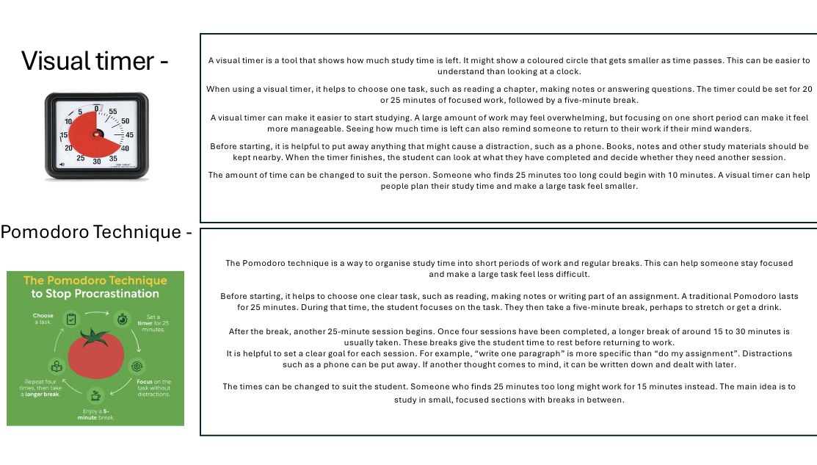
Part 3 – Poster and Reference List Slide

Reference list
- University of Washington (no date) ‘Improving time awareness’. Available at: https://www.washington.edu/drs/improving-time-awareness/ (Accessed: 25 September 2026).
- University of Sheffield (no date) ‘How to revise effectively’. Available at: https://sheffield.ac.uk/study-skills/assessment/revision-exams/effective (Accessed: 25 September 2026).

Part 4 – Link to Oral Presentation

Link for poster presentation
https://uowtsd-my.sharepoint.com/:v:/g/personal/2602173_student_uwtsd_ac_uk/IQD_pJjxQkMhQpm3nSaSN-s9ATTb4f-k5NP4vOUFIzXsu70?e=eVMevj

