Amna Hussain - ID number 2319523
Module – change makers: building your personal brand for sustainable employment.
Lecturer – Raheela Shaikh (BMHP5015)
Introduction.
The role of a registered nurse in the UK health and social care system is examined in this report, with an emphasis on the employability skills necessary to be successful in this line of work. In addition to supporting patients' physical and emotional needs, nurses are essential in providing safe, compassionate, and evidence-based care. They collaborate with multidisciplinary teams. They are in charge of evaluating patients, treating them, keeping an eye on their health, and encouraging wellbeing. I am especially motivated to pursue a career in nursing because I enjoy helping people, having a positive influence, and helping to provide high-quality patient care. In order to fulfil this role, this report will analyse the skills that are required, assess my present skills, and provide a clear development plan.
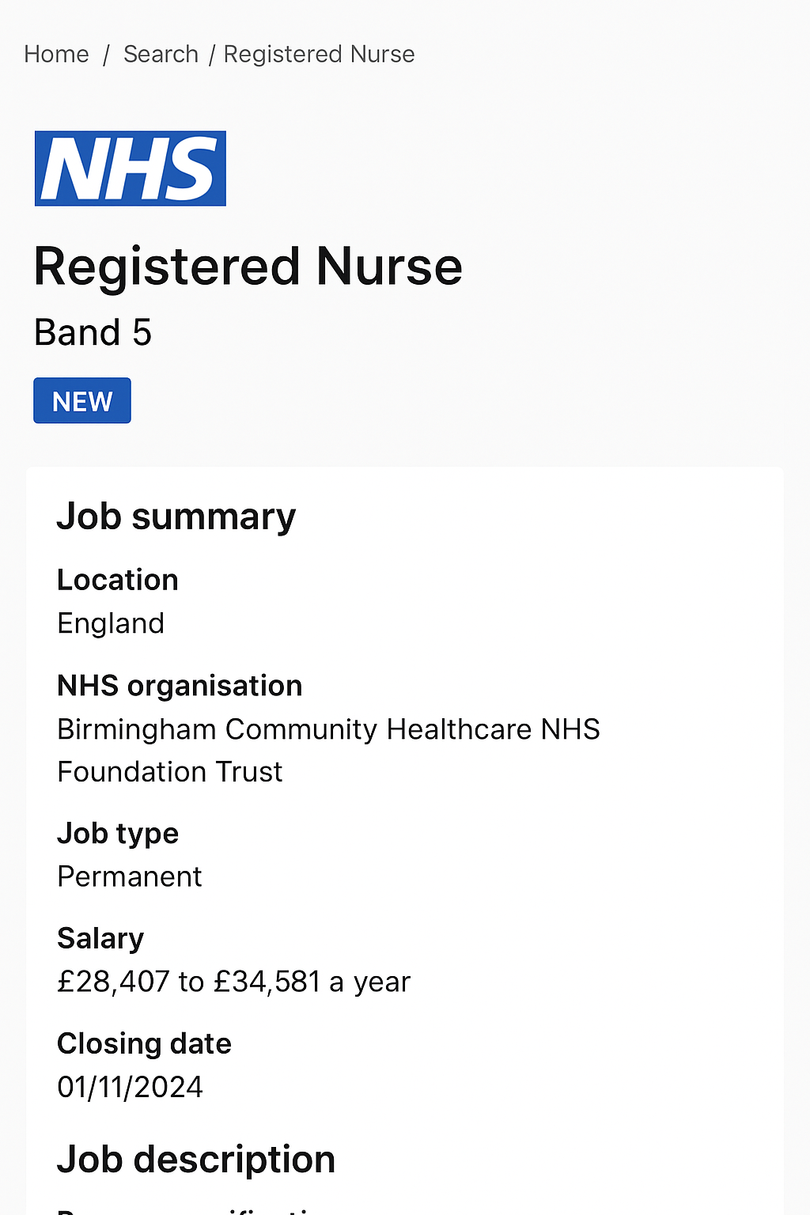
Job advertisements -
https://beta.jobs.nhs.uk/candidate/jobadvert/C9435-24-0727?utm_source=chatgpt.com

Job role employability skill.
A number of fundamental employability skills that are necessary for safe and efficient practice are regularly highlighted in the job description and person specification for registered nurses. In order for nurses to effectively communicate with patients, families, and multidisciplinary teams, communication skills are essential. In addition to promoting correct recordkeeping and lowering the possibility of error, effective communication also improves patient outcomes (Bach & Ellis, 2015).

Since nurses collaborate with physicians, allied health professionals, and support workers, teamwork is another essential ability. In hectic clinical settings, good teamwork guarantees coordinated care delivery, fosters efficiency, and improves patient safety (West & Lyubovnikova, 2013).

Critical thinking and problem-solving abilities are essential for patient evaluation, clinical information interpretation, and prompt decision-making. In order to prioritise care based on clinical need, nurses must react quickly to changing situations. This skill directly supports risk mitigation, patient survival, and sound clinical judgement (Benner, 2001).

Given the heavy workload and conflicting demands that are common in healthcare settings, time management is crucial. Medication administration, examinations, paperwork, and emotional support must all be balanced by nurses. Reduced stress, increased productivity, and better care delivery are all results of effective time management (Killackey-Jones, 2017).

Lastly, technical and clinical abilities are essential. These include using electronic health records, administering medications safely, and following clinical protocols. These abilities guarantee that nurses can safely operate medical equipment, deliver evidence-based care, and adhere to professional standards established by regulatory organisations like the Nursing and Midwifery Council (NMC, 2018).

When taken as a whole, these employability skills help registered nurses carry out their duties with professionalism, competence, and compassion. They facilitate efficient teamwork, improve patient safety, and support the general operation of healthcare services.

Evaluate your own skills.

Self-Evaluation
I have a variety of talents that closely match the demands of a professional care role thanks to my education and experience in health and social care. I've finished courses in Human Anatomy, Infection Prevention and Control, Safeguarding, and Communication in Health and Social Care. I also have certifications in manual handling, basic life support (BLS), and first aid. My hands-on experience includes volunteering in a community care setting, where I helped senior citizens with everyday tasks, kept an eye on their well-being, and encouraged social interaction. Additionally, I finished a brief placement in a residential care facility, where I gained practical experience in adhering to care plans, helping with mobility, and upholding dignity and confidentiality.

Advantages
Communication is one of my best abilities. I frequently dealt with service users who had dementia or communication difficulties during my volunteer placement. I made people feel understood and supported by employing emotional awareness, straightforward communication, and active listening. I also exhibit excellent collaboration. For instance, I collaborated with nurses, care assistants, and physiotherapists in my care home placement, rapidly adjusting to orders and fostering a supportive team environment.

My sensitivity and person-centred attitude are two more important strengths. I constantly strive to comprehend the particular requirements and preferences of every person. This kind of thinking enables me to provide compassionate care and foster trust. My time management abilities are also strong; juggling schoolwork, a part-time job, and volunteer work has taught me how to set priorities.

My ability to establish rapport fast without sacrificing professionalism is my unique selling proposition. This enables me to collaborate with coworkers and provide a supportive environment for service users. This trait, in my opinion, would contribute warmth, dependability, and stability to the position.

Potential Improvements
Despite my fundamental knowledge, I am aware that I need to improve my clinical skills, especially in areas like managing complex medical conditions, advanced risk assessment, and pharmaceutical handling. Additionally, I want to become more self-assured when working under pressure, particularly in hectic clinical environments. Increasing my practical experience will enable me to close these gaps.

Who May Assist?
Supervisors and mentors during clinical assignments can offer direction, criticism, and chances to exercise critical skills in order to further grow. Senior nurses and healthcare trainers can help me become more proficient in technical activities and decision-making. My confidence and competence can also be increased by enrolling in further credentials or attending professional workshops.

Create an action plan and timeline.

I have developed a systematic action plan outlining the measures I will take over the next five years in order to successfully acquire the knowledge and expertise necessary for a professional career in health and social care. The goals of this strategy are to increase my clinical competency, improve my teamwork and communication abilities, and obtain more practical experience.

Short-Term Objectives: 0–12 months
My top goal for the upcoming year is to lay a solid foundation. I intend to finish other quick training programs including Advanced First Aid, Safeguarding Level 2, and the Care Certificate. These will strengthen my comprehension of safety procedures and fundamental care requirements. In order to boost my confidence when assisting service users, I will also look for regular volunteer work in a nearby assisted living facility or community health group. In addition, I'll improve my communication abilities by attending workshops or finishing online courses on professional boundaries, active listening, and productive teamwork.

Medium-Term Objectives (one to three years)
By enrolling in a recognised health and social care qualification program or advancing into a nursing degree program, I hope to expand my clinical expertise over the next three years. In order to obtain practical experience in areas like drug administration, record-keeping, care planning, and emergency response, I intend to participate in structured placements in hospital or community settings during this time. In order to improve my practice, I also plan to go to professional development events, observe seasoned nurses, and solicit feedback. Another goal will be to strengthen critical-thinking and problem-solving abilities through mentorship and reflective practice.

Long-Term Objectives (three to five years)
I want to be completely capable and self-assured in a therapeutic setting within five years. My long-term objectives include finding a paid job in a health or social care setting, preferably as a newly trained nurse (after training is finished), assistant practitioner, or healthcare assistant. I intend to seek additional professional development, such as specific training in wound care, mental health, or dementia care. I'll also strive to develop my leadership abilities so that I can take on duties like coaching younger employees or helping to enhance services.

Every year, my action plan will be evaluated to assess my progress and make adjustments for any changes in my personal situation or professional goals.

Building your personal brand.

Developing a strong personal brand is crucial for advancing in the health and social care industry because it enables professionals and employers to recognise your beliefs, abilities, and dedication to providing high-quality care. Finding the traits you want to be recognised for, such as empathy, professionalism, dependability, and a person-centred approach, is the first step in developing a distinctive personal brand. Your identity as a committed care professional is strengthened when you consistently exhibit these qualities in your interactions, education, and placements.

The way you present yourself professionally is greatly influenced by digital tools. You can highlight your credentials, certifications, volunteer work, and career aspirations by creating or upgrading a LinkedIn profile. Employers can see that you are knowledgeable and involved if you share posts about your learning process, reflections on placements, or insights from pertinent articles. You can further display your accomplishments, education, and any case studies or projects you've finished with a straightforward personal website or portfolio.

You can develop a professional brand that represents your commitment and long-term goals in the health and social care sector by regularly posting pertinent information and interacting with others.

Promoting your professional identity.

Building a solid professional identity in the health and social care industry requires effectively articulating your abilities and experiences. Customising your resume and cover letter for every job application is one of the most crucial tactics. Employers can more easily identify how you fulfil their person requirements if you highlight pertinent credentials, training certifications, placements, and real-world experience. Using action verbs like "supported," "assessed," or "collaborated" shows that you were actively involved in prior responsibilities. Your application is strengthened even more by providing succinct, precise examples, such as helping with personal care or implementing safeguarding protocols.

It's also essential to keep up a solid internet presence. A current LinkedIn page can serve as an online resume, showcasing your accomplishments, credentials, volunteer activity, and professional objectives. You can demonstrate your commitment to learning and growth by sharing articles, posting reflections on training sessions, or participating in professional debates. Additionally, LinkedIn provides beneficial networking opportunities with recruiters, employers, and other healthcare professionals.

By showcasing courses, case study summaries, or proof of Continuing Professional Development (CPD), a basic personal website or digital portfolio can further strengthen your professional brand. When combined, these tactics show prospective employers your professionalism, skill, and commitment to providing high-quality treatment.

Building a network for successful employment.

In the field of health and social care, networking is essential to professional advancement. Building solid relationships can lead to career possibilities, mentorship, and further education because the field places a high value on teamwork, communication, and shared professional standards. Through networking, prospective professionals can learn about existing procedures, comprehend company expectations, and stay up to date on changes in training, policy, and care standards. Additionally, it fosters self-assurance and a feeling of inclusion in the larger professional group (Skills for Care, 2021).

Building a successful professional network can be done in a number of ways. Experienced nurses, senior care providers, instructors, placement supervisors, and clinical educators are examples of potential mentors who can provide direction, criticism, and expert counsel. Access to training, events, and peer support can be obtained by joining professional associations like the Royal College of Nursing (RCN), Nursing and Midwifery Council (NMC) forums, or Skills for Care networks. Students and early-career professionals can meet employers and industry experts at regional workshops, conferences, and career fairs organised by numerous associations.

Making important contacts can also be facilitated by participating in online webinars, university networking events, and local health lectures. You may increase your exposure and reputation in the health and social care community by participating in LinkedIn groups and making contributions to professional discussions.

Conclusion.

In summary, this report has outlined the fundamental demands of the selected health and social care position and looked at how my present abilities, credentials, and experiences meet these needs. Key employability skills including communication, teamwork, problem-solving, time management, and technical competence are essential for providing safe, person-centred care, as the job study showed. Through my self-evaluation, I was able to pinpoint my strengths—such as empathy, good communication, and a strong dedication to learning—as well as my areas for growth, which included acquiring more practical experience and advanced clinical abilities.

The action plan outlined specific short-, medium-, and long-term actions to improve my competency, such as finishing more training, looking for structured assignments, and pursuing continuing professional development. The methods described for developing my professional and personal brand also underlined the significance of keeping an up-to-date resume, an active web presence, and an interesting portfolio. It has also been demonstrated that developing a solid professional network through groups, industry events, and mentors is crucial for future employment prospects.

In the end, I'm still very driven and dedicated to having a prosperous career in health and social care. I am committed to ongoing development, offering sympathetic assistance, and making a constructive impact on people's and communities' well-being.

Reference

Bach, S., & Ellis, P. (2015). Communication Skills for Nursing Practice.

Benner, P. (2001). From Novice to Expert: Excellence and Power in Clinical Nursing Practice.

Health Education England (2021). Care Certificate Standards.

Killackey-Jones, B. (2017). Time management strategies for nurses.

Nursing and Midwifery Council (NMC). (2018). The Code: Professional Standards of Practice and Behaviour for Nurses.

Nursing and Midwifery Council (2018). The Code: Professional Standards of Practice and Behaviour for Nurses.

Nursing and Midwifery Council (2018). Professionalism and Social Media Guidance.

NHS Careers (2021). Creating Effective Job Applications in Health and Social Care.

Skills for Care (2020). Developing Your Professional Identity.

Values-Based Job Description and Person Specification

West, M., & Lyubovnikova, J. (2013). Teamwork in healthcare.

