Student: Gary Mclean
Student Number:1909400
BMSW4003
Digital Skills and Research
University WTSD London
Lecturer Modak Koushik

Contents
Introduction--------------------------------------------------------------------------------------------------3
Literature Review-------------------------------------------------------------------------------------------- 4
Rationale ----------------------------------------------------------------------------------- -------------------5
Methodology--------------------------------------------------------------------------------------------------5
Findings--------------------------------------------------------------------------------------------------------6
Analysis--------------------------------------------------------------------------------------------------10
Discussion------------------------------------------------------------------------------------------------12
References --------------------------------------------------------------------------------------------------14
Appendix A--------------------------------------------------------------------------------------------------16
Appendix B --------------------------------------------------------------------------------------------------17

Introduction
This research seeks to uncover the positive impact Moodle or Virtual Learning Environment (VLE) has on the students at the University of Wales Trinity Saint David Campus, London (UWTSD) 2019-2020 semester learning. After selecting the topic, I decided on an appropriate approach to get the best perspective. This research relies on primary and secondary sources and the data collected from the twenty questionnaires, which will be plotted into graphs. This study focuses on questions 1,2,4,5 and 8 results, which will be analyzed. The author will alternate between the term VLE and Moodle.
As a theoretical framework, I will operationally define the following key terms: the term virtual learning environment is defined as a social space design for educational interaction, which turns places into space (Dillenbourg, P. et al., 2002). Also, traditional learning is defined as, “a process of learning that takes place under the supervision of a teacher in a physical learning environment when using physical tools of learning and direct synchronous communication” Targamadzė and Petrauskienė, (2010) p.171. Moreover, a classroom is defined as a place where classes meet Miamwebster.com, (2020) Mejia, H., (2017) points out that the Merriam-Webster dictionary defines experience as: “the act or process of directly perceiving events or reality” p.13. Marcus, A., (2002) describes the user interface as a location, task, human, oriented interactive communication device, or system whose meaning is not static, n.p. I will provide a summary of a literature review and a rationale for conducting this study. Also, discuss the research methodology, findings, and provide an analysis of the results. I end with my assertion regarding the findings and recommendations. See Appendix A for a copy of the research questionnaire, and Appendix B illustrates the research findings.

Literature Review
The sources used for the study uncovering reports demonstrate that the term VLE definition is not static means the term can change meaning over time (Dillenbourg, P. et al., 2002). Their research will benefit this study because it illustrates how culture influences the meaning things are associated with. Furthermore, the research titled Research and Evaluation in Education and Psychology: Integrating Diversity with Quantitative, Qualitative, and Mixed Methods by Martins, D. (2009) discusses the logics of conducting research and evaluates the different research methods. Her writing is beneficial to this research because the source provides variable information about different approaches to inquiry. Marcus, A. (2002) article titled Fast forward: Dare we define user-interface design? Interactions. Vol 9, (5) discusses the ongoing process of developing a mature model of an interactive system, which provides technical information about virtual learning platforms.
Oliver, P., (2003) book titled The Students' Guide to Research Ethics. provides guide students to follow when conducting research, which involves theoretical perspectives and research ethics. Oliver’s work is essential to this research because it allows for valid information about research ethics. “The Merriam-Webster Dictionary, 2020” and the “Oxford Dictionary, 2020” were selected to provide definitions for key terms. Targamadzė, A., and Petrauskienė, D. research titled Influence of Technologies on Quality of Distance Learning, (2010) discuss how technology influences learning. Their work is equally valuable to this research of (Dillenbourg, P. et al.,2002)) study titled Virtual Learning Environments. 3rd Hellenic Conference” Information & Communication Technologies in Education which illustrates how traditional, virtual, distance and e-learning are used and that their meanings are fluid. The research relies on these theorists, and upon a critical examination of these sources, it became clear that these sources explain and logically connected ideas that explain the application used to analyses research data.

Rationale
Moodle is defined as a blended learning platform that is used in schools’ universities and workplace, and it incorporates distance learning, e-learning and students viewing their lectures online (Moodle, 2020). Within post-secondary educational institutions, Moodle (VLE) is crucial towards the education and success of the students at the UWTSD Campus London. The relationship between the impact (VLE) has on the grades of students is that VLE serves as an incentive for students to be active participants in their learning. VLE allows students and instructors to communicate with the whole class list, and this serves as a function to help students succeed in all their classes.
I was curious if Moodle (VLE) is easy to use and if it promotes positive virtual classroom experience for students. I observed that regarding my virtual learning experience Moodle was the only tool available to communicate with teachers and students quickly. I wanted to explore the User Interface of Moodle and its correlation between students' success. Moodle (VLE) is an integral user interface at the UWTSD, London Campus.

Methodology
The term methodology is procedures used to inquire about a topic Martins, D., (2009). This research utilises primary and secondary sources. Primary sources are first-hand evidence or original findings from a research Martins, D., (2009)—for example, the result of the questionnaire. A secondary source is not first-hand information or in other words, information that was created later by someone Martins, D., 2009 and Oliver, P., 2003. Based on the research question and critical concepts the following databases were searched: UWTSD library catalogues, Scholar Portal Journals, ERIC (Educational Resources Information Centre); Information & Communication Technologies in education Archives, Google Scholar, Moodle.com, Merriam-Webster dictionary online and The Oxford Dictionary online. I narrowed my search using keywords, and the advanced bar to filter search scholarly peer-reviewed articles published within the past five years. However, some articles beyond five years provided valuable research to use for this study.
There were inclusion criteria for the study such as English language articles, reviews about virtual learning, and online learning. Some exclusion criteria were articles pre-dated 2015 and articles or studies on traditional learning environments. I brainstormed ideas, organised a plan for questionnaires and its weekly distributions. I create a working copy of the questionnaire (see Appendix A). I conduct the surveys by emailing them to various students that attend the UWTSD Campus, London during the 2020 term. Twenty (20) copies of this survey were distributed to the students during the 2019-2020 semester. A thesis-perspective connection was made of both the independent and dependent variables to measure. The dependent variable is the variable the researcher is interested in measuring Martins, D. (2009). The independent variable does not cause any change in the dependent variable-VLE Martins, D., (2009).

Findings, Analysis and Discussions
Social Science research is bound to ethical rules and must follow accepted research procedure and protocol. Such as no physical, psychological, or social harm is done to the participants—also, anonymity, where necessary, the confidentiality of personal data. Moreover, appropriate debriefing or post-study follow up Oliver, P., (2003). The participants of this study were in no harm and were debriefed before completing the questionnaires, and their information is kept confidential.
The Positive Impact of Moodle or VLE on Students’ Success Questionnaire

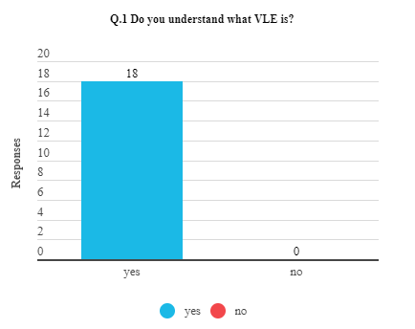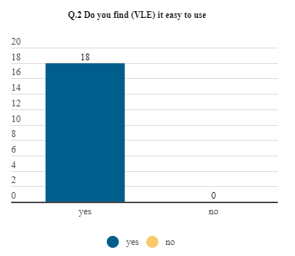
Data is defined as information used to learn about people or something Martins, D., (2009). Question 1 data suggests that out of eighteen participated in the survey, zero students answered not knowing what VLE is, and eighteen 18 students replied yes to knowing about VLE. For question two, all eight respondents find VLE easy to use, so that means all the students who participated in the study find VLE easy to use.
For question four, the respondents were asked if they find traditional learning TLE better than virtual learning VLE. Respondents are participants of a study Martins, D., (2009).
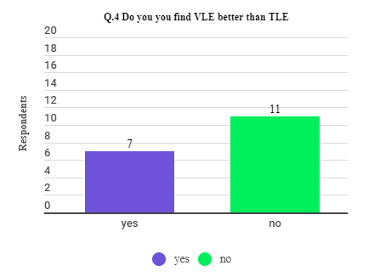
Eleven participants answered no to questions and seven students answered yes to finding TLE better than VLE.
Question five (5) consists of multi-variants answers. The participants were asked to give their opinions on how they would make the VLE platform perform better.
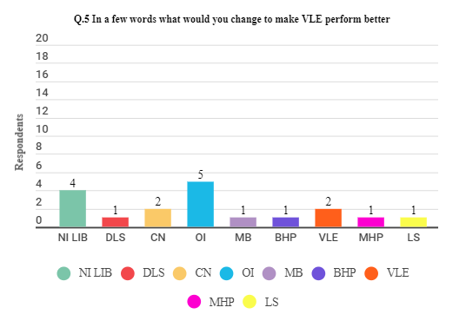
For question five (5) four, 4 respondents think the library contents need improvement. Out of the sample of 90% of people who took the survey, 1person thinks the platform needs integration of different learning styles. Two 2 of the 18 people who were surveyed believe that the VLE platform does not need improvement. Also, 5 of the 18 students believe that Moodle needs an overall improvement. 1 of 18 respondents’ belief that more books are required for all the courses. Out of the 18 students who answered question 5, 1 respondent believes that the VLE platform needs a better way of issuing homework. 2 respondents think there should be more information about virtual learning. 1respondent thinks more homework platforms are required. One the respondent did not answer the question (5) five.
Question 8 consists of multi-variants answers. The respondents were asked to rate their
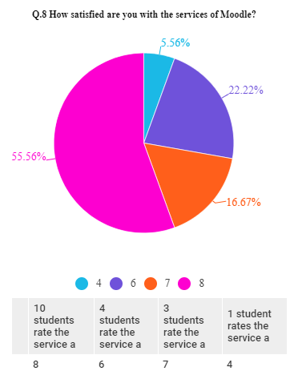
satisfaction with VLE services from a scale of 1-10. Where 10 means very satisfied.
For question 8 eight, where the respondents must rate how satisfied they were with Moodle’s service, from a scale from 1-to-10. Whereas 10 means the participants are delighted with VLE services. From the sample of eighteen (18) students who answered the questionnaire ten students voted 8, four students rated the service as a 6; Three students rated the service a 7 and one student rated the service as a 4. The term student is defined as a learner of the scholar, especially if the person goes to schools (Merriamwebster.com, 2020).

Analysis
The data suggest that out of the sample of twenty students who were surveyed 18 or 90% of the students answered the questions. 100% of the students answered yes to questions one (1) and two (2). Which indicates that students are familiar with VLE and have no problems using the VLE platform. 90% of the students who took the survey, 7 or 39% answered yes to question four (4)—these respondents’ belief VLE is better than the traditional learning environment TLE. However, 11or 61% answered no to ask 4. They believe that TLE is better than VLE. For question five (5) four 4 or 22 % of respondents think the library contents need improvement. Out of the sample of 90% of people who took the survey 1person or 6% of the respondents believe the platform needs integration of different learning styles. Two (2) or 11% of the 18 people who were surveyed think that the VLE platform does not need improvement. Also, 5 or 29% of the 18 students believe that Moodle needs an overall improvement. 1 or 6% of18 respondents’ belief that more books are required for all the courses. Out of the 18 students who answered question 5, 1 or 6% believe that the VLE platform needs a better way for issuing homework. 2 or 11% of the respondents think there should be more information about virtual learning. 1or 6% of the respondents believe more homework platforms are needed. 1 or 6% of the respondent did not answer the question (5) five.
For question 8 eight, where the respondents must rate how satisfied they were with Moodle’s service, from a scale from 1-to-10. Whereas 10 means the participants are very satisfied with VLE services. From the sample of eighteen (18) students who answered the questionnaire ten students or 56% of the students vote 8, four students or 22% rate the service as a 6, Three students or 17% of the participants rate the service a 7 and one student or 6% rate the service as a 4. Out of those twenty 20 respondents, there were two non-respondents. The study demonstrates multiple variants of what students would do to improve the VLE platform. For instance, question five (5) four (4) respondents would like to see improvement in the school library content. One respondent would like integration of content tailored towards students with different learning disabilities. Two respondents are satisfied with Moodle (VLE) and contend that it does not need any improvements. Whereas five respondents think the VLE platform needs an overall improvement. One respondent proposes that there should be more books available on the platform for students. Another respondent suggests that modifications should be made on how professors issue homework. Also, another respondent wants to see more homework portals. One respondent requires more information regarding virtual learning. Lastly, one respondent would like to see fewer course evaluations.

Discussion
The research findings for questions 1,2,4, 5, and 8 suggest out of the 18 people who participated in the study 100% of the students know what V LE and are comfortable using the platform. Moreover, 61% of students who participated in the research prefer TLE over VLE. However, 56% of the respondents are very satisfied with VLE compared to 6% of the students who are not happy with VLE. The limitation of this research is the sample size is small, which makes the research results unable to generalise to the population of the student at the UWTSD, London 2020 school term. Therefore, through the functions of the content availability, communication, and accessibility of Moodle (VLE), these factors have a positive impact on the grades of students.
The research data indicates that out of the 90% of the students who participated in the survey, a100% are aware of Moodle (VLE) and are comfortable with its usability. Besides, the study illustrates that the students are satisfied with the VLE services. Moreover, the study demonstrates that 61% of the respondents prefer the traditional learning environment TLE when contrasted with 39% who preferred VLE. The research suggested that students who participated in the survey consider the (VLE) platform interface accessible and user friendly, which integrates social and collaborative tools to make it easy for students to learn. Moodle (VLE) is a requirement that all faculty staff and students use to enhance the learning environment of the 2020 semester at UWTSD Campus, London. Moodle (VLE) is an integral part of their educational platform, which is designed to make it easier for students to learn at anytime and anywhere students have internet access. However, the study suggests when it comes to TLE and VLE, students strongly prefer the traditional learning environment (TLE). Nonetheless, VLE is an option that challenges the status quo that considers learning to be done in a specific way.
Further research can be done to determine if there is something else besides Moodle (VLE) that is vital to students’ success that is a part of the UWTSD Campus, London institutions. Also, more research needs to be done to determine if Moodle (VLE) incorporates the assurance for students living with visual or other learning disabilities in its learning platform. Moreover, further research could be carried out to determine if VLE promotes negative class attendance by students.

References
Dillenbourg, P., Schneider, D., Synteta, P. (2002). Virtual Learning Environments. 3rd Hellenic Conference” Information & Communication Technologies in Education. Rhodes, Greece. pp.3- 18. ffhal-00190701f. [Retrieved] from //telearn.archives-ouvertes.fr/hal-00190701/document (Accessed May 01, 2020)
Donna M. Mertens, D., (2009). Research and Evaluation in Education and Psychology: Integrating Diversity with Quantitative, Qualitative, and Mixed Methods
Publisher: SAGE Publications, Inc, Thousand Oaks, California. USA [Print]
Marcus, A., (2002). Fast forward: Dare we define user-interface design? Interactions. Vol 9, (5). Pp.19-24. (Accessed May 01, 2020). From://dl.acm.org/doi/fullHtml/10.1145/566981.566992.
Mejia, H., (2017). Emplant-Designing for a human experience in the transhumanist era. (accessed May 1, 2020) Retrieved from://umu.diva-portal.org/ Web.
Merriamwebster.com, (2020). Better (accessed May,01, 2020). [Retrieved] from https://www.merriam-webster.com/dictionary/better
Merriam, Webster.com (2020) Student. [Retrieved] from //Merriamwebster.com/dictionary/students. (Accessed May 1, 2020). Web.
Merriam, Webster.com (2020). Use. Retrieved from://www.merriam-webster.com/dictionary/use. (Accessed May 1, 2020) web.
Moodle, (2020). Empowering Educators to Improve the world. [Retrieved] from: https://moodle.com/about/

Oliver, P., (2003). The Students' Guide to Research Ethics. Open University Press
McGraw-Hill Education. Philadelphia, PA, USA. [Print]
Oxford dictionary, (2020). Perform (accessed May 01, 2020). [Retrieved] from//oxfordlearnersdictionaries.com/ Web.
Schaefer, R. T. & Haaland, B. (2011). Sociology: A brief introduction (4th Canadian Edition. Toronto, ON McGraw-Hill Ryerson.
Targamadzė, A., and Petrauskienė, D. (2010). Influence of Technologies on Quality of Distance Learning. Software Engineering Department, Kaunas University of Technology Student str. 50, LT-51368 Kaunas, Lithuania. Retrieved//scholar.google.com/ning/ (accessed May 01,2020). web

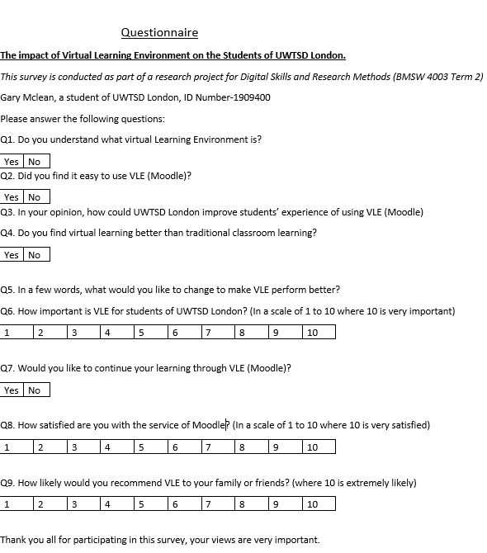
Appendix A is a copy of the questions the respondents were asked about VLE.

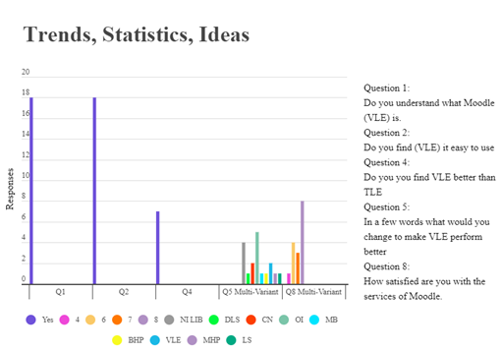
Appendix B is a copy of the research findings.

