With
I
02-03-2018
Course: Web Development

PROGRAMMING
Tim Bashford & Michael Dacey
Rabea Benkadi [1110890]

WHAT IS A VARIABLE AND WHY ARE THEY IMPORTANT TO WRITING PROGRAMS?

When it comes to programming, Variables are necessary and very important when it comes to writing programs. A Variable is a name that is given to a blank and an unidentified value depending on what the value’s information represents. This will allow, once the variable has been named, to be referred to when it has been allocated to a storage area. What also must be considered when naming a Variable is what type it is. Variable also have the ability to store one or more values. A particular scenario of when this can be used is in a program that does some sort of calculation. Instead of the programmer repeating the same values various times through their program code, the Variable will offer support by storing the result of the calculation that is made. There are various types that can be used, the main and most common types are:

- Int
- String
- Bool
- Double

The purpose of declaring type when naming a Variable is, depending on the type that is declared, it will determine the memory size and length of values that can be stored to the Variable. Meaning, if a program requests certain information and the wrong type of information is entered or the wrong amount, there will be an error because by declaring type, it prepares the compiler of the possible errors that need to be identified and will restrict the type of information that can be entered.

Variables offer flexibility to programmers when coding because they allow programmers to process different set of data within the same program by using Variables to represent the individual data instead of having to enter data into the program. When the program is executed, the Variable that were used will be changed into real data allowing.

Therefore, to conclude, Variables are very important because gives a large amount of flexibility to programmers due to the fact that they are able to hold one or more values, prevent code from getting cluttered because no repetitiveness is needed, allow you to store and represent data.

WHY IS FOR-LOOP ALSO REFERRED TO AS A COUNTING-LOOP?

In programming, Loop statement can be used to repeatedly run a block of code once its conditions have been checked. What distinguishes the For-Loop from other available looping statements is that it allows the programmer to be able to specify the exact number of times the loop is executed.

CODE SCREENSHOTS

EXCERISE 1
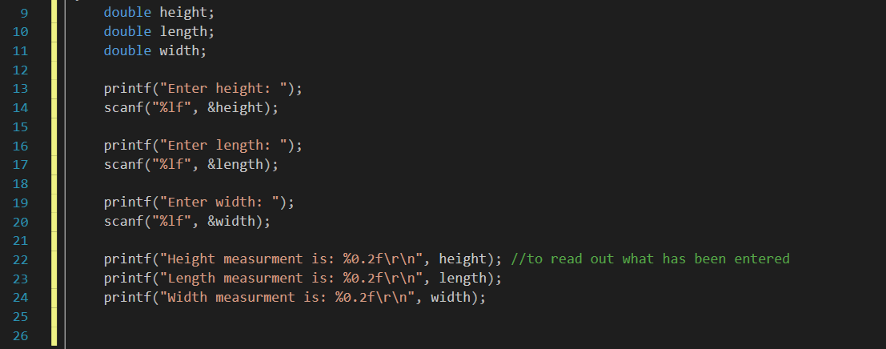
EXCERISE 2
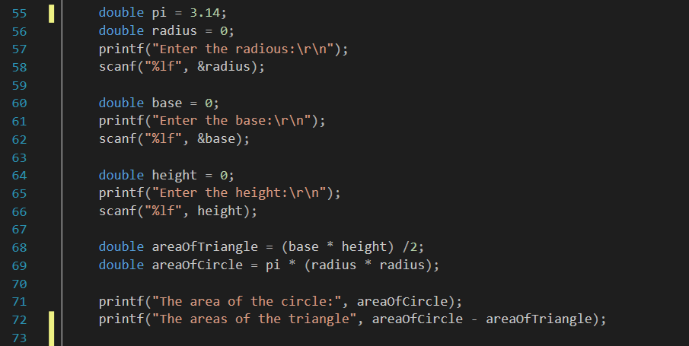

EXCERISE 3


