student name: vladislav scarevnea
STUDENT NUMBER: 2125439
lecturer name: balendran kandasemy
module name: problem solving and decision making
module code: bmsw4004
Report for Problem Solving and Decision Making

Contents
Introduction 4
The Workplace Problem 4
Information analysis 5
Root Cause Analysis (RCA) 5
Application of Situational Analysis Models 6
PESTLE Analysis 6
Range of Alternative Solutions 7
Alternative Solutions Evaluation 8
Solution Implementation 8
Stakeholders Communication Plan 9
Monitoring and Review Techniques 10
Conclusion 10
References 12
Appendices 14
Appendix 1. Role-play Discussion 14
Appendix 2. Class Activities 15

Introduction
Problem solving skills have always been very important throughout the years. They always were the tool that moved humans to progress and adapt. Therefore, we could evolve up to this point where humans are at the top of the food chain. Essentially, problem solving means one’s ability to determine complex problems, analyse them, and come up with solutions effective in the solving of these problems, it also comprises the implementation of solutions with further analysis and strategic planning (Kaplan, 2022). Nowadays it is extremely important for managers to have good problem-solving skills, as companies become bigger and bigger, so do the problems that come up.

The Workplace Problem
The problem that this report will be solving is the problem of unsatisfied employees at Meta Office in Canary Wharf. This office 55 full-time and 30 part-time workers. Meta Platforms Inc. is an American multinational technology conglomerate, their mission is to bring people closer together, grow businesses and find communities (Meta, 2023). To find out the level of job dissatisfaction within this office, discussions between the management consultant and the non-managerial staff have taken place. The scope of the complex problem is this particular office and its employees.
If this problem is not solved the office risks the following actual and potential impact: less productivity as a result of unmotivated staff; increase turnover, as most employees will quit if they are unhappy for a long time; conflicts between managerial and non-managerial staff; disengagement; negative impact on the reputation of the business, decrease in employees’ loyalty, and decrease of morale.

Information analysis

Root Cause Analysis (RCA)
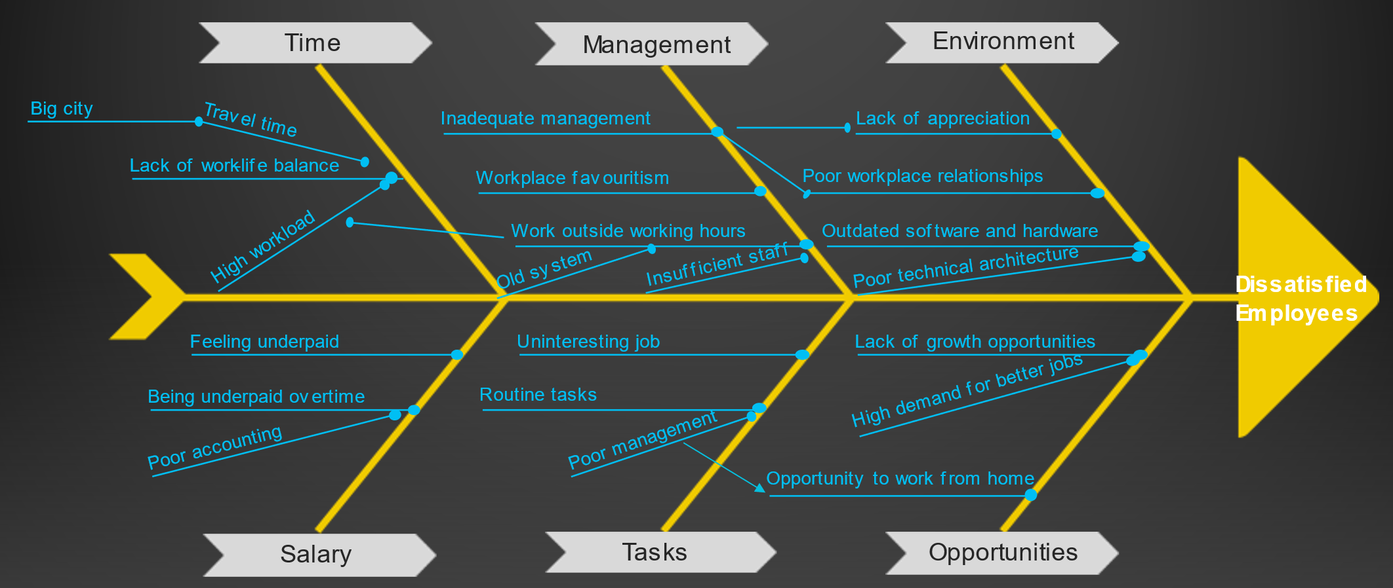
In order to find and list all the possible causes of job dissatisfaction within this Meta office, a fishbone diagram has been used with answers collected from employees. In the diagram above, all the possible causes have been categorized in 6 main sections, to be able to monitor which ones cause most of the problem. In the Time section, we can see that lack of work-life balance is the real cause, since London is a big megapolis, travel time is one possible root cause, contributing to lack of work-life balance. Another possible cause is high workload, caused by the amount of additional work the staff is required to produce, for which the possible root causes are an old system and insufficient staff. Other possible causes identified are inadequate management, workplace favouritism which fall under Management section. In the Environment section other possible causes including lack of appreciation and poor workplace relationships have inadequate management as a possible root cause. Another possible cause in this section is outdated software and hardware, which is caused by another possible root cause - poor technical architecture. Salary is another section that causes staff to feel unhappy, where they feel underpaid for the work they do, and because they are asked to work overtime, they are being underpaid for the overtime work they do which might be caused by poor accounting. Other sections, Tasks and Opportunities include possible causes like uninteresting job, which is caused by routine tasks, lack of growth opportunities caused by high demand for better jobs, and the opportunity to work from home, which is the trend of years 2020-2022.
Having collected data, from non-managerial staff withing Meta office in Canary Wharf, a conclusion of what are the real causes and their actual root causes has been drawn. Therefore, workload outside working hours is a real cause contributing to about 20% of unsatisfied employees within the office, the actual root cause for it being insufficient staff. Another real cause that affects 40% of the unsatisfied employees is lack of work-life balance caused by travel time which is its actual root cause. The third real cause affecting 25% of the unhappy staff is the outdated software and hardware caused by poor technical architecture, being its actual root cause.

Application of Situational Analysis Models
For the purpose of identifying solutions to the root causes of job dissatisfaction within Meta office in Canary Wharf, a PESTLE analysis combined with SWOT analysis will be used. PESTLE Analysis is a tool for analysing external factors (Political, Economic, Sociocultural, Technological, Legal, and Environmental) to help guide you towards strategic decision-making for the benefit of an organisation (CIPD, 2021).

PESTLE Analysis
Political
The political stability index in the U.K. is much higher than the average around the world (The Global Economy, 2021). This means an excellent opportunity for Meta Platforms Inc. to show their diversity in the U.K.
Economic
The cost of living in the U.K. has increased significantly compared to last year. Therefor people are forced to cut the costs to make ends meet. As a result, there is a significant reduction in people’s disposable incomes that keeps going down (Boyle, 2022). For Meta this would mean a significant decrease in the growth of UK Market. The UK unemployment rate is low, compared to the average value (Watson, 2022). For Meta this would mean the opportunity to hire more staff that is trained to operate in the field.
Sociocultural
Internet shopping is more and more popular in the UK, taking more than 30% of the market nowadays, which shows constant growth from previous years (Trade, 2022). Meta can use this to grow and use small retailers as part of their services.
Technological
Following covid-19 pandemic, many businesses had to move their system so that the people were able to work remotely. This facilitated the development of many technological tools that made working and managing staff remotely much easier. As Meta is on of the big technological leaders this would mean that such implementation is more than possible in the context of this company. Moreover, because technology has advanced so much, there are time saving tools that can be easily implemented into Meta if the issue was brought up to managers.
Legal
The patent act of 1977, in the UK has allowed companies to protect their copyright, and the products or services they provide (Intellectual Property Office, 2021). In the context of meta this means the opportunity to better protect its newly launched products or services without having to worry about intellectual property theft.
Environmental
The UK Environment Act shows a new framework for the protection of the environment against water wastage, clean energy, energy wastage, air pollution etc (ClientEarth, 2022). For Meta this would mean an opportunity to acquire a good reputation, following this framework for the better of the planet. On the other hand, this would also mean a restriction in the company’s procedures that might lead to the need of adaptation and consequences that might come with that. Moreover, this would also mean a restriction in the products or services that Meta can come up with.

Range of Alternative Solutions
Having analysed the real causes, the actual root causes as well as applying situational analysis models, three solutions have been developed to solve most of the problem of unsatisfied employees at Meta office in Canary Wharf. These solutions are as follows:
- Solution 1: Hire more qualified staff.
- Solution 2: Organisation of remote work opportunity with paid overtime hours.
- Solution 3: Implement new, time-efficient, up-to-date software and hardware tools.

Alternative Solutions Evaluation
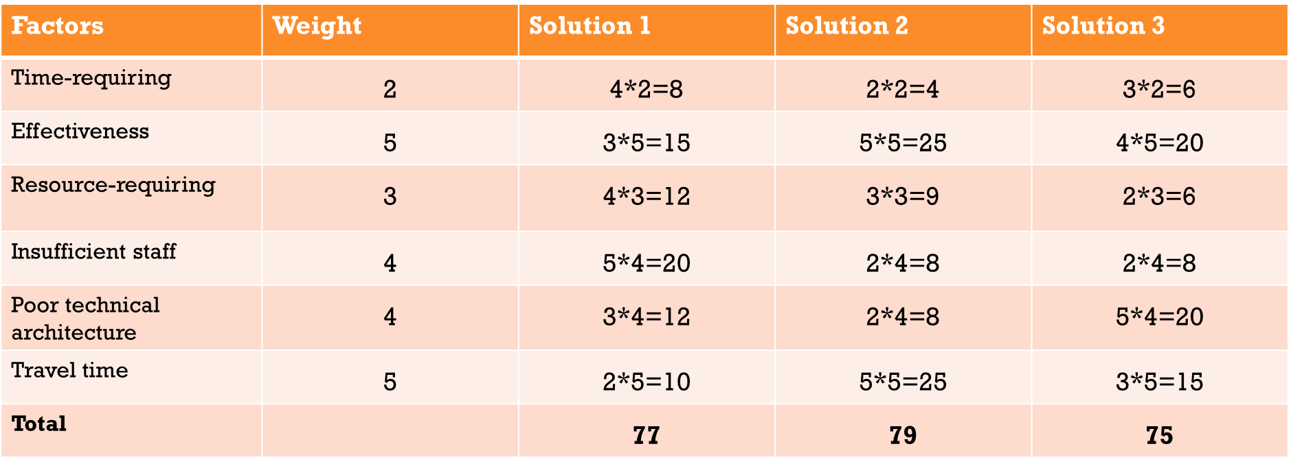
Having performed a decision-making matrix to evaluate which solution solves to problem of unsatisfied employees in correlation with the needs of the organisation, a conclusion that Solution 2 is the best, having scored the most points in the decision-making matrix. The decision to choose Solution 2 is, also, the right one because it solves the root-cause of travel time, the best way. As travel time, represents the root-cause of 40% of unsatisfied employees, it is the best solution unanimously.

Solution Implementation
To ensure that the solution is implemented correctly, and within the required time, a Gannt Chart is the tools that will be used. Because it is extremely important to follow the deadlines, the following Gannt Chart will help divide responsibilities among managerial and non-managerial staff.
The set of tasks that will be applied into the Gannt Chart is as follows:
- Task 1: Establish clear communication of the upcoming change
- Task 2: List acceptable reasons to work remotely
- Task 3: Implement tools for online cooperation
- Task 4: Create healthy remote communicating environments for employees
- Task 5: Determine the jobs that work remotely
- Task 6: Identify times of availability
- Task 7: Test remote work
- Task 8: Solve the remaining issues
- Task 9: Finish implementation
Subsequently, these tasks were introduced into the Gannt Chart below:
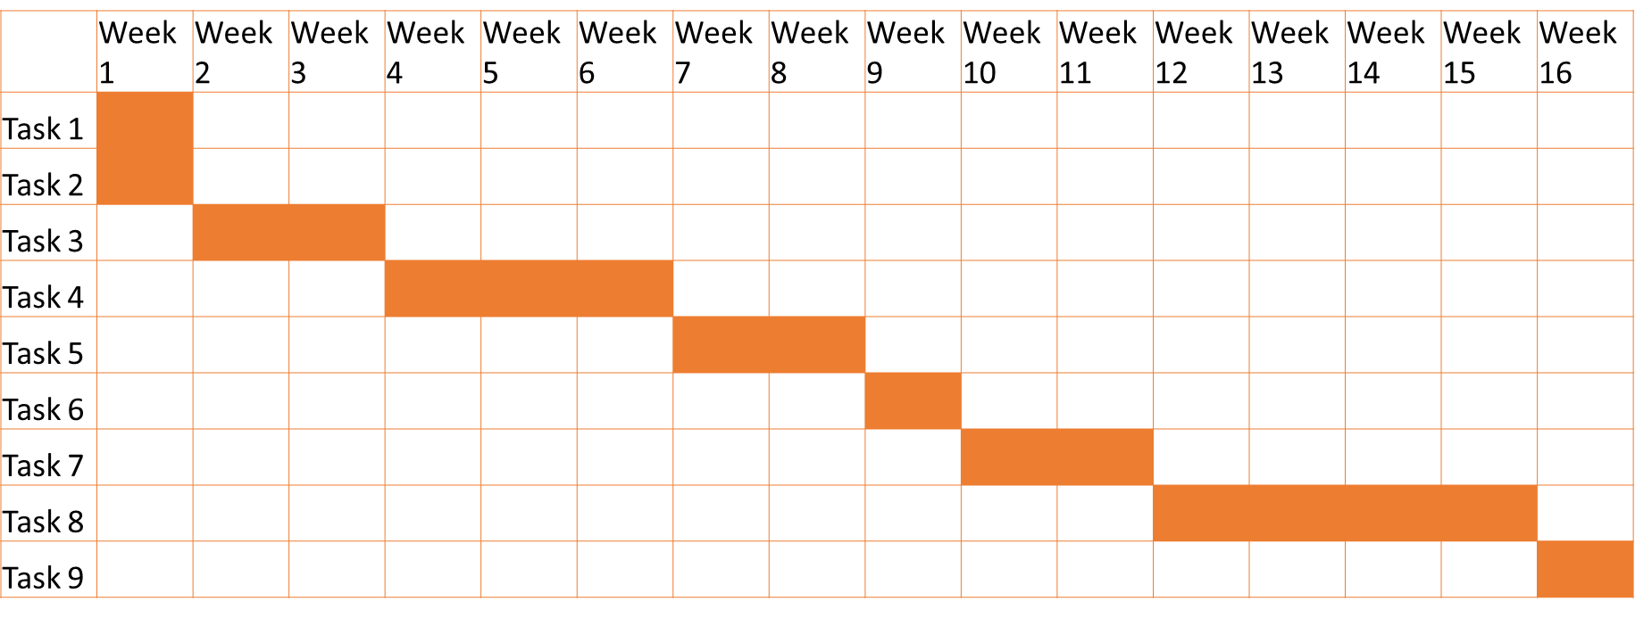
It can be seen in the Gannt Chart above that the implementation plan will take 16 weeks to fully unravel. Some tasks will take longer than others, for example task 8 will take four weeks, whereas task 1 and 2 will be completed in the same week.

Stakeholders Communication Plan
Stakeholders are either individuals, groups, or organizations affected by the outcome of a project or a change in the company. It is important to involve the stakeholders in the decisions you are trying to apply, because with any decision there is a chance of failing, therefore, it is important that the stakeholders know of the upcoming change so that they can prepare for the consequences if the outcome is negative (Landau, 2022).
Power
- CEO of the company  - Directors of other Meta offices  - Senior Managers of other Meta offices | - Director of the office  - Senior Managers  - Junior Managers
- Local residents  - Customers  - Local businesses | - Non-managerial staff  - Property owners  - Service providers
Interest

Communication Plan with Stakeholders
Stakeholder | Power/Interest | Key interest & issues | Communication Vehicle | Frequency
Director of the office | High/High | Company productivity | Face-to-face meeting | Weekly
Senior managers | High/High | Company productivity | Face-to-face meeting | Weekly
Junior Managers | High/High | Company productivity | Face-to-face meeting | Weekly
Non-managerial staff | Low/High | Improve work-life balance | Daily briefing and email | Daily
Property owners | Low/High | To find other tenants | Phone call | Once
Service Providers | Low/High | To keep customers | Phone call | Once
CEO of the company | High/Low | Overall Productivity of the company | Email | Monthly
Directors of other Meta offices | High/Low | Overall Productivity of the company | Email | Monthly
Senior managers of other meta offices | High/Low | Overall Productivity of the company | Email | Monthly
Local residents | Low/Low | New tenants | Media | Once
Customers | Low/Low | Quality of products/services | Media | Once
Local businesses | Low/Low | New neighbours | Media | Once

Monitoring and Review Techniques
To monitor the progression of the implementation plan we can use the Gannt Chart above. Therefore, by using it we can once again see at what stage of the project we are, what is remaining to be completed, and if the milestones are achieved in time.

Conclusion
To summarise everything stated above, I must say that decision-making is a complex process that is extremely important for the prosperity of any company. In this report one such project of problem solving in a company has been introduced. To be able to make major decisions, many macro and micro factors must be analysed to ensure successful implementation of decisions. These factors include but are not limited to the actual and potential impact, information analysis, range of alternative solutions, solution implementation etc. Moreover, it is very important to keep stakeholders updated on any decisions that are going on in the company. Thus, ensuring everyone is prepared for the consequences and aware of this change.

References
Boyle, M. Disposable income in the UK. [Online]. Available at: https://www.finder.com/uk/disposable-income-around-the-uk#:~:text=The%20average%20British%20adult%20has,at%20%C2%A3688%20a%20month. (Accessed: 03 January 2023).
CIPD (2021) PESTLE analysis. [Online]. Available at: https://www.cipd.co.uk/knowledge/strategy/organisational-development/pestle-analysis-factsheet#gref (Accessed: 03 January 2023).
ClientEarth (2022) The UK Environment Act - what's happening now? [Online] Available at: https://www.clientearth.org/latest/latest-updates/news/why-the-uk-environment-bill-matters/#:~:text=The%20Environment%20Act%2C%20which%20became,intended%20to%20fill%20the%20gap. (Accessed: 03 January 2023).
Intellectual Property Office (2021) The Patent Act 1977. [Online] Available at: https://www.gov.uk/government/publications/the-patents-act-1977 (Accessed: 03 January 2023).
Kaplan, Z. (2022) What Are Problem-Solving Skills? Definition and Examples. [Online]. Available at: https://www.theforage.com/blog/skills/problem-solving-skills (Accessed: 02 January 2023).
Landau, P. (2022) What Is a Stakeholder? Definitions, Types & Examples. [Online]. Available at: https://www.projectmanager.com/blog/what-is-a-stakeholder#:~:text=A%20stakeholder%20is%20either%20an,organization%20that's%20sponsoring%20the%20project. (Accessed: 03 January 2022).
Meta (2023) About us. [Online]. Available at: https://about.meta.com/ (Accessed: 03 January 2023).
The Global Economy (2021) United Kingdom: Political stability. [Online] Available at: https://www.theglobaleconomy.com/United-Kingdom/wb_political_stability/#:~:text=Political%20stability%20index%20(%2D2.5%20weak%3B%202.5%20strong)&text=The%20latest%20value%20from%202021,to%20compare%20trends%20over%20time. (Accessed 03 January 2023).
Trade (2022) Assessment of Current Buyer Behavior in Market. [Online]. Available at: https://www.trade.gov/country-commercial-guides/united-kingdom-ecommerce#:~:text=82%25%20of%20the%20UK%20population,Mobile%20phone%20connections%3A%2067.61M (Accessed: 03 January 2023)
Watson, B. (2022) Employment in the UK: November 2022. [Online] Available at: https://www.ons.gov.uk/employmentandlabourmarket/peopleinwork/employmentandemployeetypes/bulletins/employmentintheuk/november2022#:~:text=The%20UK%20unemployment%20rate%20was,points%20below%20pre%2Dpandemic%20levels. (Accessed: 03 January 2023).

Appendices

Appendix 1. Role-play Discussion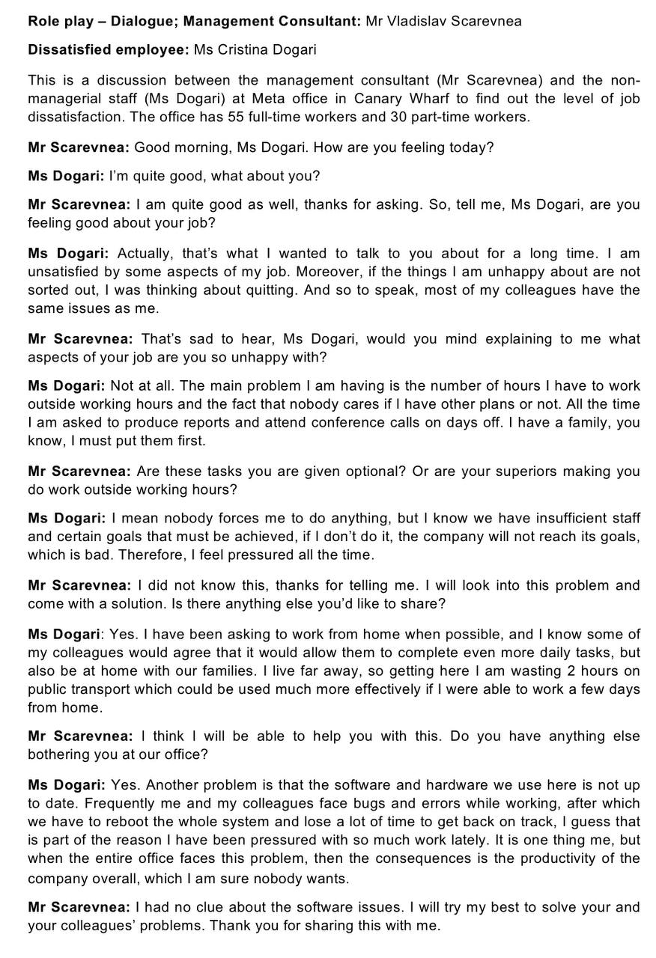

Appendix 2. Class Activities


