Personal Development for Employment
Student Name:Ayesha Azad
Student ID:1706296

Table of Contents
Introduction 3
Concept of personal development 4
Strategy of personal development 4
Personal Development Cycle 4
Criteria of self development as employee 5
Vark Learning Style personal development questionnaire: 5
Explanation of Vark Learning Style 9
SWOT Analysis 9
Steps of Improvements 10
Conclusion 12
References 13

Introduction
Each and every person has different personality according to their way of thinking. But the development of personality or self-evaluation is very much needed for every sectors of our life. When any one wants to start his job life or any corporate life they have to improve their personal characteristics. As a student everyone is determined to start their career. Today’s civilized world gives more opportunity to start our career. But this competitive world gives more challenge to get any standard job. Because the owner of the company wants to recruit skill full and standard personality full employee in his company and for that reason he developed his personal skills also. A skill full owner and the employee make the organization more successful. So, it’s my duty to improve myself for any employment. It will also be benefited when I start a business and recruit any employment. In this entire report here discussed about the stately of the personal development and learning style of Vark. The SWOT analysis of my personal development, how to improve self-confidence to take any actions in any situations and lastly the route of improve of my lacking will be discussed in this report.

Concept of personal development
Personal development indicates the enhancement of own consciousness, increasing the thinking power, establishment of essential human development. Personal development for employment declares the preparation to join in any employment and developed each and every criterion which each essential for employment such as communication skill, thinking power, enhancing unique ideas etc. It is a procedure of identify own skills and also find out which skills need to be improved. There are several advantages of personal development procedures. It is a method of realize the circumstances situation of individual skills and performance (Anseel, Lievens and Schollaert, 2010).

Strategy of personal development

Personal Development Cycle
To make prepare for any employment following a personal development cycle is gives more idea and confidence to move forward. The personal development cycle is given below:
Establish reason: Firstly, personal development we have to select in which purpose or reason we make our self-developed. In the case of employment, we have to think about the organizational goal and the responsibility of mine. We also can gain help from our managers or trainers of the institute(Austin, Marini and Desroches, 2015).
Identify need of expansion: It is depending on the responsibility and roles in the organization after assuring from the managers. Needs of developments is requires if we want to apply for new employment or in the job sector if we want to promote our position. In the need of switching to the new better job or also for self-developments it is essential to develop our self (Baker, and Sinkula, 2013).
Identify learning style: For developing our self in the sector of employment there are many sectors we can learn from here. For entering into the career and also in the employment we educated our self with additional degree. In any education we can obtain different learning outcomes. Before entering in a job sector and after we can motivate and enriching our self by participates any training session(Beck, Livenand Bear, 2016).
Documentation outcome: If we remember or record our outcomes we can improve that sector if we want to give better performance. Also, this system encourages us and giving us strengths to give more input for getting the better output (Beguine and Rapardel, 2011).
Reviewing: If we regularly reviewing our personal development process and the entire activities, it will make sure that what we become skilled and what we done. It will also give us idea that our activities will help us to reach our goals relevant to employment (Boud, Keogh and Walker, 2015).

Criteria of self-development as employee
In the employment sector there are many sectors in which an employee can developed him. It is depending on the time session and also the planning and budget. The following sectors will help an employee for his personal development.
Official Learning:An employee is firstly gathering a minimum educational qualification then in the requirement of the working place we can gather additional for our job sectors. As an employee to develop our self we can attend different conference, training (Bradshaw and Hawk, 2016).
Task Based: According to the task of the job, I can enrich myself by attending different projects, doing assignments, research related to the task. In that case I can also improve my communication process.
Self-initiatives: To make the work easy and if we want to develop in the sector of job beside academic knowledge and official training we can read different journal, industrial website, and task related topic for self-establishment and also for the employment (Brown, 2013).
Practiced activities: The essential learning point from the educational site, administration site if we are not emphasizing that and also are not practice that we cannot do that better. If we practice and teach that things to others we can memorize that and applies that in our working and personal life.

Vark Learning Style personal development questionnaire:
Choose the answer which you think it can represent your personal characteristics.
(Read the options very carefully then give tick)

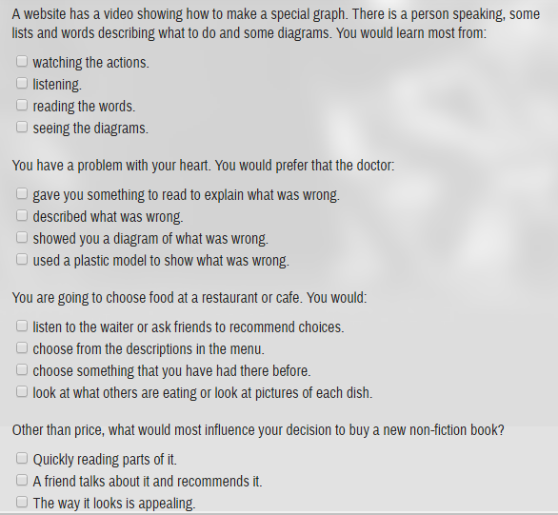
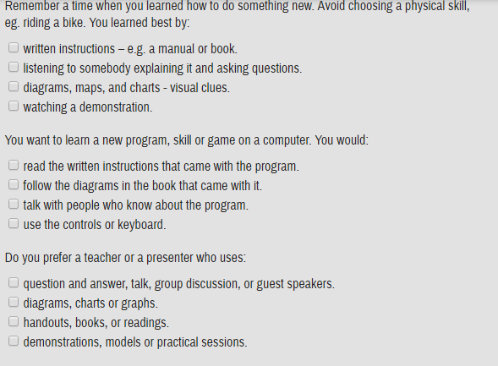

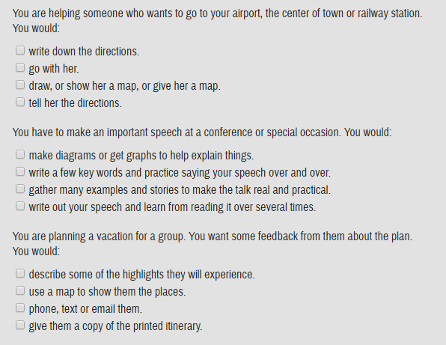Now describe the numbers of A’s, B’s and C’s you selected.
A’s = B’s = C’s =
Choosing the tick A’s are maximum describe Watching style.
Choosing the tick B’s are maximum describe Listening style.
Choosing the tick C’s are maximum describe Observing style.
Many of the people find themselves that are using all of this three-learning style that listening, watching and observing. The stages are shortly stated below:
When I identified my learning style which is comfortable for me then I evaluate my skill of my development easily and also can do better. I prefer watching style and, in my perception, it gives more idea then others.

Explanation of Vark Learning Style
The learning style of Vark is explained the four modalities which is used in the gathering information. Fleming and Mills described these four modalities in the year of 1992 which is applicable for those who are wanting to develop their personality in the sectors of employment and others. The four modalities are described below:
Illustration: The illustration learning style indicates the information of specific charts, table, diagram of different topics etc. It must not be including some of power point presentation, content of some videos etc. It must be more than simple words that would be obliging to individuals who encompass a Read/write partiality.
Listening: The process of listening can be varying. We can learn when someone gives any speech or when we attend any conference or any program of motivational speech we can learn from there (Cree, 2010).
Reading or writing way: We can also learn by reading any article or gathering information from dictionaries, notes, quotes, different types of websites such as goggle, Wikipedia, twitter etc. There is rarely an acoustic channel or an arrangement that uses illustration symbols.
Kinesthetic: Kinesthetic modality refers to the acquiring experiences and performs. A familiarity may appeal to other modalities; the key point is that community who prefer this method is associated with reality.

SWOT Analysis
The majority of personal development in the business organization as an employee is generally look upon the employability ability within their workers which are announcementusually, collaboration, ability of problem solving etc. My individual SWOT analysis is described below:
Strength:I have the ability to communicate and interact with persons and can gather necessary information from the people which I need. And I can also lead the group and can satisfy the needs of the members of the team by doing the job accurately. I can apply different ideas and also can take decisions and giving actions in any situation.
Weakness: The main weakness of mine is that my working experiences are poor. For any job the organization hires an experienced person who has much confidence in the job sectors. In the time of working sometimes I lose my concentration that is another big weakness of mine. My analytical skill is poor I need more time to understand any problem.
Opportunity:If I have the ability to make the task easy and also made it easier to other it is benefited for me and also others. I want to build up my skill of my presentation for the sector of job filed and also in other segment of the life.
Threat: I have to be additional anxious about the tasks and try to overcome all the circumstances which I faces in my work. Learning new expertise is not trouble-free to accomplish.In this modern world the number of graduates is increasing day by day, so it is very difficult for anyone to find any job, so it is one kind of threat for me. I maintain a food chart for my health issue it is also threat for me in my job sector.

Steps of Improvements
After analyzing my SWOT, I found some of the sectors that I need to develop. So, as a result, I prepare a structure to make myself more developed. This will be helping me to gain knowledge of some criteria to my personal development. The steps of improvements are given below:
Statement: As per I say before that my communication skill is quite good but, in some purpose, I have to updated it more. I will try to complete the courses that contain foreign languages. If I know the foreign language it will be easy for me in the multinational employment sectors. There I can made myself demonstrate by dealing with the foreigner clients in own country job if I can speak in foreign language. By using this I can also increase my personal development and also can apply for employment in many reputed organization (Cottrell, 2010).
Initiative and enterprise:As I have not gathered much working experience so it difficult for me to compete in this competitive job market. For doing any job in any reputed I have to take some initiative step to over some this. Beside my corporate job I obtain some freelancing experience and also experience in online marketing I can apply many of jobs in these sectors. I also can add initiative ideas and thinking level in my working place it will be easy for me to acquire more experience than before (Beck, Livne and Bear, 2016).
Problem solving:I have already functional for a route which helps me to improve the skill of solve the problem in any situation. Awell-known organization which helps an employee by learns them different criteria of personal improvement for developing the opportunity of occupation.For the very begging of any one in the employment sectors he must increase his personal skill to acquire any profession by know some strategy of the acting and the overcome the situation by resolve the certain problem.
Judgmentautonomously: Judgment any situation independently can add additional learning point in the case of personal development. Every internal relation must be prohibited in the time of solving any problem or decision taking. Personal development can be obtained by judgment any situation autonomously(Anseel, Lievens and Schollaert, 2010).

Conclusion
In this developed country we have also be made our personal development very crucially for making our self-more enriched for any employment. For getting any desirable employment is dream for all. But everyone cannot get chance in their demanded job. If I and everyone want, try to make we appropriate by learning different skillful strategies. In the following report I try to discuss some criteria of skill of learning as employee. In doing a work we also face some barriers in this report also discuss the way of overcomingthis barrier and become improve the self-assessment. If once we developed our self, we can employ our self in any well-known organization.

References
- Anseel, F., Lievens, F. and Schollaert, E. (2010), “Reﬂection as a strategy to enhance taskPerformance after feedback”, Organizational Behavior and Human Decision Processes, Vol. 110, pp. 23-35.
- Austin, Z., Marini, A. and Desroches, B. (2015), “Use of a learning portfolio for continuousProfessional development: a study of pharmacists in Ontario (Canada)”, PharmacyEducation, Vol. 5, pp. 175-81.
- Baker, W.E. and Sinkula, J.M. (2013), “The synergistic effect of market orientation and learningOrientation on organizational performance”, Journal of the Academy of Marketing Science, Vol. 27, pp. 411-27.
- Beck, R.J., Livne, N.L. and Bear, S.L. (2016), “Teachers’ self-assessment of the effects of formativeand summative electronic portfolios on professional development”, European Journal ofTeacher Education, Vol. 28, pp. 221-44.
- Beguin, P. and Rapardel, P. (2011), “Designing for instrument-mediated activity”, ScandinavianJournal of Information Systems, Vol. 12, pp. 173-90.
- Boud, D., Keogh, R. and Walker, D. (Eds) (2015), Reﬂection: Turning Experience into Learning,Kogan Page, London.
- Bradshaw, L.K. and Hawk, P.P. (2016), “Portfolios for the continuing licensure of beginningteachers: their development and assessment”, paper presented at the Annual Meeting ofthe National Staff Development Council, December 10, (2016), Vancouver, Canada.
- Brown, R. (2013), Portfolio Development and Proﬁling for Nurses, 2nd ed., Quay Publications, Lancaster.
- Cree, V. (2010). Sociology for social workers and probation officers. 2nd Ed. New York, NY: Taylor & Francis.
- Cottrell, S. (2010). Skills for success. Basingstoke: Palgrave Macmillan.

