Name: Ross Van Den Eeckhaute-Jones
Student P Number: P151366
Module Title: Internet Security
Module Code: M5X01045
Assignment Title: Synthesize a solution to a potential real life scenario
Module Lecturer: Dr Carlene Campbell
Date: 10/12/2017
Synthesising a solution to a potential real life scenario

Ross Van Den Eeckhaute-Jones
University of Wales Trinity St. David
Swansea, Wales
Rvandeneeckhaute-jones.151366@student.uwtsd.ac.uk

Abstract— This report will provide a solution to the problems that arise while setting up a BYOD/BYOT network. To accomplish this task, the use of data flow diagrams, security policies, device management policies and the use of a suitable Mobile Device Management software will be utilized.
Keywords—BYOD, BYOT, MDM, SECURITY, UWTSD

INTRODUCTION
This report will provide Golding-Harvest Ltd with an in-depth comprehensive framework for a BYOT/BYOD network. The framework will cover every aspect of the network including a user policy, device management policy and a security policy.

A data flow diagram will be used to show the architecture of the network including the flow of information from different types of users that will be using the network. The network will accommodate both staff and customers with varying levels of access to information stored on the company’s network.

A fully functioning network will be designed in Cisco Packet Tracer to visualize the layout of the network. Varying levels of security will be implemented across the network to allow different levels of employees to access what they require for their jobs, as well as basic level access to the network for customers.

After reviewing the needs of the company’s network, a suitable Mobile Device Management software will be selected to manage devices on the network. It is important that this software allows for the wide range of devices that could be present on the network including operating system versions, accessibility issues and practicality.

The advantages and disadvantages of a BYOT/BYOD network will be analysed

TABLE OF CONTENTS

Section | Page Number
Introduction | 2
List of Figures and Tables | 3
Research | 4
Advantages and disadvantages | 5
Implementation – Data flow Diagram | 6
Implementation – Packet Tracer Design | 7
User Policy | 8
Device Management Policy | 8-9
Security Policy | 9
Mobile Device Management Software | 9-11
Conclusion | 11
References | 12

LIST OF FIGURES AND TABLES

1.
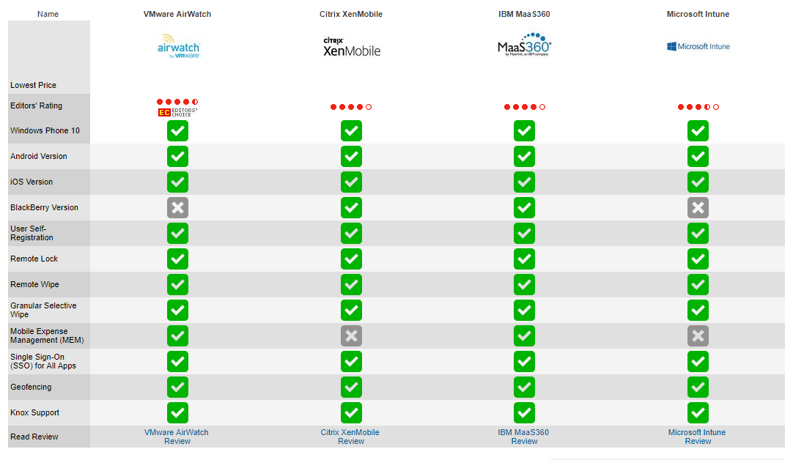
Comparison of Mobile Device Management systems by uk.pcmag.com [1]

RESEARCH

A BYOD system allows for a business to convert a large amount of its network infrastructure into wireless functionality. [1,15,16]

BYOD creates an environment where the majority of devices using the network are owned by the employee/client themselves. [2] This means that the users should be more comfortable and understanding of the devices used, resulting in higher productivity, and in effect, less tickets submitted to IT support on device failures/advice.

To be able to design and implement a BYOD system for Golding-Harvest Ltd, it would be wise to take a look at the current systems already functioning, and how they are secured and protected against inside and outside threats to the network. It is apparent that the most efficient way of maintaining the integrity of the network while implementing a BYOD system, is to make use of Mobile Device Management software. [2,3,4]

Mobile Device Management software allows the IT department to remotely configure user access groups which contain varying levels of user restrictions. MDM can allow a select group of employees/users to only access required data on the network. [2,3]

Being able to remotely control the activities available to users on the network is a big increase to the security of the network and its data. Some MDM software also allows locational tracking and identification for devices which can add another layer of security. [5] Using location technology such as GPS or RFID tagging, devices can be tracked should they be lost or stolen. If the device is irretrievable it is sometimes possible to remotely wipe the device to reduce the chance of important data ending up in the wrong hands. [5]

There are many MDM software providers in the market, including software from some of the biggest companies in the IT world such as Microsoft, IBM, cisco and many more. [1]

Different MDM software varies in the level of support they offer to certain devices, for example almost all top MDM providers support iOS, android and windows as they are the most common devices used currently. Whereas a company seeking MDM software to support Blackberry devices will be limited in the options they have. [1, 17-24]

Each MDM software provider usually offers a few different versions of their MDM software, which increase in price as the levels of security are increased. Depending on the type of business, it may be cost effective to implement a higher level of security at a higher cost to protect your company’s data. [1, 17-24]

An example of this tiered pricing could be VMware AirWatch, where the base version costs $4.33 per device per month and offers the basic Mobile device management and custom app catalogue. Whereas the 3rd option (out of 4) offers the base package as well as VMware Boxer, Identity management, VMware Content Locker Standard, a VMware browser and VMware PIV-d Manager at an increased price of $6.33 per device per month. [20,21]

Ease of setup can also play a huge part in what MDM software is suitable for your company. A company with a user base of 20-50 may be ok with manually entering data to register every user’s device to the system, whereas a larger company with potentially 1000s of users, this is just not a viable option. Some MDM software allows the use of QR code scanning for quick, streamlined user registration which can be easily carried out by the user without relying on IT staff. [15,16]

Due to the different packages offering different levels of functionality, security, ease of setup and support to different operating systems of devices, it is important to analyse the needs of your company and make a cost-effective decision as to which package from which provider would be the most suitable for your company network. [17-24]

Advantages of BYOD/BYOT [3,7,8-10]

- Increased productivity due to smooth device connection and the use of familiar devices
- Allows more freedom and flexibility in choice of devices used
- Reduced costs as personal devices are used, and usually more looked after than company supplied devices.
- Remote monitoring of devices through suitable Mobile Device Management software
- Increased security functionality with use of MDM software
- Less need for costly infrastructure as wireless capability is increased
- Less wires in the workplace which reduces potential safety hazards
- MDM Software moves the line of responsibility from network users to company liability due to access control lists/groups

While there appear to be more disadvantages than advantages, the strength of the advantages are much stronger due to there being workarounds for many of the disadvantages displayed above.

Disadvantages of BYOD/BYOT [3,7,8-10]

- Poses increased security risks/threats that have to be acknowledged and dealt with
- While relying mostly on wireless technology, dead zones may arise in certain areas and will have to be dealt with
- Wireless devices are usually small and easy to lose, damage or steal than desktop hardware
- Incompatibilities between different devices operating systems and MDM software
- Potential increased load on IT Support due to device failures
- Company has to choose whether to cover the cost of device repair/replacement or leave it to the device owner
- Required MDM software can be expensive and may need retraining of staff to be able to use the new software
- Device users may feel over restricted due to strict usage policies
- Mobile devices lack the level of antivirus/antimalware capabilities that desktop computers have access to
- Requires multiple STRONG enforced policies and training of users to ensure smooth and secure performance of the BYOD system

IMPLEMENTATION

Data Flow Diagram

This data flow diagram shows the process of a device entering the companies network. Showing both new and old devices paths into joining the network, and showing how lost or stolen devices are dealt with.
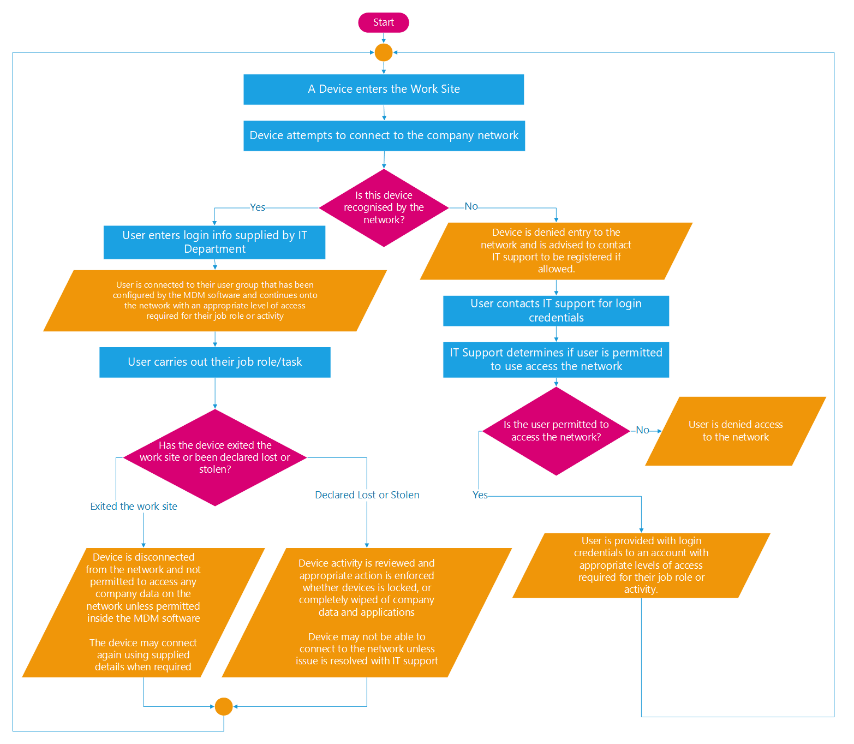

Packet Tracer

Proposed network layout designed in Cisco Packet Tracer. The network layout demonstrates the onsite office including separate customer and employee wireless networks, as well as the firewall to protect the company’s data.

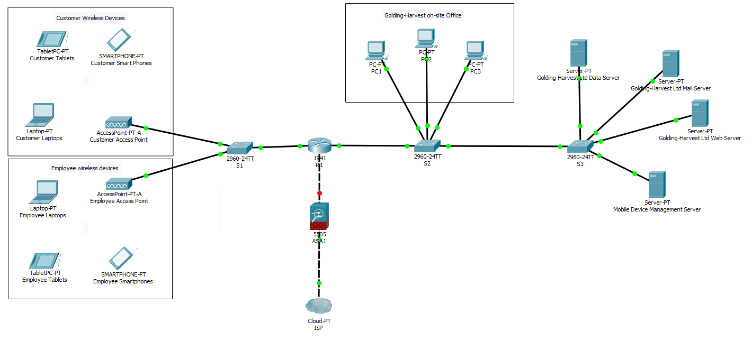
USER POLICY [2-4, 11]

The company has a ZERO TOLERANCE policy towards the following:

- The presence of alcohol or drugs (both consumed and in possession)
- The use of devices while in control of a vehicle or any machinery on site
- Harassment to any other user on the network
- Any activity performed in an attempt to hide actions carried out on the network
- Unauthorised access to any part of the network
- The storage of information/data that could put the company and/or its users at risk
- Transporting illicit material across the network.

Acceptable Use

- Every BYOD/BYOT device shall only be operated by the device owner. (This rule will serve to add another layer to the protection of user’s data, and to reduce the risks of impersonation. It will also aim to provide the Network Engineers with more accurate data logs
- Each device using the company network during work hours shall only be used for activities required of the users assigned work.
- Usage of the network during non-work hours (break times, before and after shifts start and end) will be less restricted to allow some measure of personal use for example social media, reading, games, phone calls in non-restricted areas. However, activities that undermine the integrity of the network will still be restricted.
- Device camera, video and microphone capabilities must be disabled during work hours unless the user is granted use due to job role requirements.
- Applications will be blocked during work hours aside from a list of applications required for certain job roles in the company.
- Access to certain websites will be blocked on the company network due to not being of any use to any user on the network, and being a potential threat to the security of the network and the data of the users.

DEVICE MANAGEMENT POLICY
[2-4,6-9,11]

Supported Devices/ Device Security

- Any modern smartphone (Apple, Android and windows) is permitted to use the network providing the latest updates have been installed and the software has not been modified in any way (NO jailbroken/rooted devices as they are unstable) from the standard configuration. Any device not using the latest update can be updated to the latest version by IT Support.
- Devices must use the company supplied antivirus software that is compatible with the device.
- An IT Support team will be on site to assist with any device related problems.
- Devices must be installed with tracking software that will be operational during work hours. Should a device be lost, IT Support can manually activate the tracking software to attempt to retrieve/track the lost device. (This will reduce the amount of lost devices, while also providing valuable information should a device be stolen.
- Devices must always communicate with available servers to access information, and only certain job roles will be able to store data on devices. Devices that are permitted to store data/information must be equipped with a remote wiping capability. (less data being stored locally on devices means a lower chance of confidential, important data being compromised)

- In the event of a lost device, if the device is not recovered through the use of tracking software, it will be wiped 24hrs from the initial lost device report. Devices will also be wiped at the end of an employee’s contract.

- Every user will be given a level of access suitable for the job role they are required to perform. This will limit app usage, data access and device capabilities while on the company network.
- Devices must auto-lock requiring re-entry of password if the device is idle for more than 5 minutes.

Costs

- The company will provide devices for certain job roles when absolutely necessary (usually when a job role requires the use of certain programs to perform).
- Devices damaged during work will be covered by company insurance, and reviewed on a case by case basis by IT Support to first ensure the device is not repairable.

Risk Analysis and disclaimers

- Due to some devices requiring storage of personal/confidential data, it is the user’s responsibility to keep backups in the even that a device must be wiped.
- Damaged, lost or stolen devices must be reported to IT Support immediately so that the best course of action may be taken to maintain integrity of the network.
- The company may revoke access to the network for any device at any time, in an effort to protect the integrity of the network.

SECURITY POLICY [7,11-14]

- Every device on the network must be protected by a suitable password that includes: Minimum 8 characters including upper and lower-case letters, 1 number and 1 symbol. Passwords will have to be changed every 3 months (no repeating passwords in last 10 used) to increase security.
- 5 failed password attempts will result in a locked device, which can only be unlocked by contacting IT Support.
- Company applications and data will not be usable unless connected and authorised by the company network. Exceptions will be made for employees who are permitted to work from home, and will make use of a VPN to connect safely to the company network.
- Before connecting a device to the company network, the user must be made aware of all policies concerning use of the network and appropriate handling of data stored on the network. This means being knowledgeable of current data protection laws

MOBILE DEVICE MANAGEMENT

A suitable Mobile Device Management software must allow the IT Department to easily and reliably control and restrict a range of available Mobile OS systems. The main OS systems used by mobile devices currently are Apple iOS, Android, and Windows. [1,15,16]

Mobile Device Management software allows IT Support to easily make changes to the access levels of user groups. Through the use of an MDM client, any changes made to the user profile or groups will synchronise to all connected devices. The updates will either take place live in a hotfix if the situation requires urgent action, or during a scheduled update period, usually during out of work or low traffic work hours. [1,15,16]

As seen in Figure 1, a comparison was carried out by uk.pcmag.com which shows the leading Media Device Management systems used today in businesses around the world. The top 4 including VMware airwatch, citrix XenMobile, IBM MaaS360 and Microsoft intune all support devices which use Apple, Android and Windows. [1,15-20]

All the above Mobile Device Management systems allow user self-registration, which reduces the workload on the IT department. New users can register themselves by simply entering login credentials given to them from the IT Department, which will usually follow company standards such as an employee number that is already assigned. [1, 15-20]

The above MDM systems also allow IT Engineers to Remote lock devices, which can stop malicious actions in their tracks. Devices can also be remote wiped should the situation demand it. Remote wiping devices can give peace of mind that data is not lost should it go missing or be stolen. [1, 15-20]

Geofencing is a technology that allows the device to be tracked using GPS or RFID technology. The MDM software can effectively create a virtual boundary around the company’s work sites. [1,5,17-20]
This positional data allows the network engineers to restrict usage of the device or company applications in areas deemed to be non-work related. [5]

Due to the nature of a BYOD/BYOT system, easy intuitive device setup is key as there may be multiple new devices entering the network every day. While many new devices will be entering the network, it is important to be able to quickly go through the process of removing a device from the network for situations such as employees being terminated, replacing old devices and removing broken devices to keep the network secure. [15,16]

Quick access to control features and finding specific devices on the network is a MUST to be able to swiftly deal with any problems that arise on the network. [1,15,16]
VMware AirWatch is the market leader of Mobile Device Management Systems. [1]
While the base version of VMware AirWatch costs $4.33 per device per month, the $6.33 per device per month version offers Identity management and increased functionality. VMware AirWatch makes use of QR code scanning on all devices apart from Windows devices. QR scanning allows quick input of information for ease of configuration on new devices. [20,21]

Microsoft Intune lacks a device location service for all devices but IOS, [25] so would not be suitable for this company due to the BYOD nature of the network involving multiple new devices entering the network from across the whole work site. It is of high importance that location services are available to ensure the company’s data is only to be accessed on site. [17,22]

While Citrix XenMobile is a strong competitor in the MDM field, the cost is over 10 times that of a similar performing software at a huge $61(£45.55) per device. [19,21,23]
Using Citrix XenMobile with back-end systems other than those from Citrix can result in incompatibilities across the device management system. It is not wise to restrict the companies network back-end system to that of one vendor. This would result in extra costs of installation, as well as retraining of staff to ensure they are comfortable and confident using the new equipment/software. [19,23]

IBM MaaS360 is very comparable to VMware AirWatch in performance, however its support for Windows devices is considerably lower than that of VMware AirWatch. IBM MaaS360 utilises QR codes for ease of configuration which speeds up new user registration massively. [18,24]

While each MDM provider has multiple levels of security/controls among different versions of the software, the cost selected below reflects the most suitable version of MDM to protect the potential billions worth of intellectual property and important data in the company. The cost (At time of research, 09/12/2017) of similar competing MDM software options is shown below: [1,17-24]

MDM Software | Cost Per Device Per Month |  | Source
VMware AirWatch | $6.33 | £4.73 | [21]
Microsoft Intune | $17.41 | £13 | [22]
Citrix XenMobile | $61 | £45.55 | [23]
IBM MaaS360 | $9 | £6.71 | [24]
(Costs accurate at time of research: 09/12/2017)

Due to the downsides of the other 3 top MDM options, the MDM software VMware AirWatch will be the preferred MDM solution for the company. VMware AirWatch offers the best control/security package for the company along with a very competitive price considering similar alternatives.

CONCLUSION

Considering the information gained during the research of BYOD setups and the various Mobile Device Management software available, it’s clear that VMware AirWatch is the best fit for Golding-Harvest Ltd. The strong device support over multiple OS platforms that are regularly used along with the quick and easy setup ensures that smooth transition into a full, secure BYOD system is possible. This version of VMware AirWatch will provide the most suitable security controls to protect the billions worth of intellectual property that is owned by the company.

The geofencing capabilities will ensure that the devices are only restricted while on site and have access to company data through the network, while devices will be able to function as normal without access to important company data in the comfort of the device owners home. This is an important aspect of MDM as after all, the devices are owned by the users, so they will not want to feel their personal devices have restricted performance while not at work.

The above Data Flow Diagram demonstrates the process of a device entering the company network. It shows the process of a current user accessing the network, as well as a new user going through the registration process with the IT Department. The handling of a lost or stolen device is also shown in the data flow diagram.

The supplied Cisco Packet-Tracer network demonstrates the functionality and security of the proposed network design. The customers and employees are setup on separate VLANs so that traffic can be identified and sent to the correct destinations, as well as restricted from certain areas of the network.

REFERENCES

[1] [1] “The Best Mobile Device Management (MDM) Solutions of 2017; Dropbox (for Business).” [Online]. Available: http://uk.pcmag.com/cloud-services/76018/guide/the-best-mobile-device-management-mdm-solutions-of-2017. [Accessed: 08-Dec-2017].

[2] P. Stąpór, D. Laskowski, W. Akademia, and T. I. J. Dąbrowskiego, “BRING YOUR OWN DEVICE -PROVIDING RELIABLE MODEL OF DATA ACCESS BRING YOUR OWN DEVICE -NIEZAWODNY MODEL DOSTĘPU DO DANYCH,” J. KONBiN, vol. 39, 2016.

[3] C. Rose, “BYOD: An Examination Of Bring Your Own Device In Business,” Rev. Bus. Inf. Syst. –
[4] B. Morrow, “BYOD security challenges: control and protect your most sensitive data,” Netw. Secur., vol. 2012, no. 12, pp. 5–8, Dec. 2012.Second Quart., vol. [1] “BYOD (Bring Your Own Device) - ProQuest.” [Online]. Available: https://search-proquest-com.ezproxy.uwtsd.ac.uk/docview/1196914876?accountid=130472&rfr_id=info%3Axri%2Fsid%3Aprimo. [Accessed: 09-Dec-2017].
[5] “What Is ‘Geofencing’?” [Online]. Available: https://www.howtogeek.com/221077/htg-explains-what-geofencing-is-and-why-you-should-be-using-it/. [Accessed: 09-Dec-2017].
[6] “BYOD - ProQuest.” [Online]. Available: https://search-proquest-com.ezproxy.uwtsd.ac.uk/docview/1504427999?accountid=130472&rfr_id=info%3Axri%2Fsid%3Aprimo. [Accessed: 10-Dec-2017].
[7] “BYOD Considerations - ProQuest.” [Online]. Available: https://search-proquest-com.ezproxy.uwtsd.ac.uk/docview/1557049510. [Accessed: 06-Dec-2017].
[8] “Building a Better BYOD Strategy - ProQuest.” [Online]. Available: https://search-proquest-com.ezproxy.uwtsd.ac.uk/docview/1564767033/fulltext/B31BED58163740E7PQ/1?accountid=130472. [Accessed: 10-Dec-2017].
[9] “BYOD (Bring Your Own Device) - ProQuest.” [Online]. Available: https://search-proquest-com.ezproxy.uwtsd.ac.uk/docview/1196914876?accountid=130472&rfr_id=info%3Axri%2Fsid%3Aprimo. [Accessed: 10-Dec-2017].17, no. 2, 2013.
[10] “BYOD: The Pros and Cons for End Users and the Business - ProQuest.” [Online]. Available: https://search-proquest-com.ezproxy.uwtsd.ac.uk/docview/1368616703/fulltext/D24D5641AA984244PQ/1?accountid=130472. [Accessed: 09-Dec-2017].

[11] B. Tokuyoshi, “The security implications of BYOD,” Netw. Secur., vol. 2013, no. 4, pp. 12–13, Apr. 2013.
[12] “BYOD Guidance: Executive Summary - GOV.UK.” [Online]. Available: https://www.gov.uk/government/publications/byod-guidance-executive-summary/byod-guidance-executive-summary. [Accessed: 10-Dec-2017].

[13] “Mobile Security - ProQuest.” [Online]. Available: https://search-proquest-com.ezproxy.uwtsd.ac.uk/docview/1014209476/. [Accessed: 06-Dec-2017].

[14] “Cyber security for smart mobile devices - ProQuest.” [Online]. Available: https://search-proquest-com.ezproxy.uwtsd.ac.uk/docview/1550434714?accountid=130472&rfr_id=info%3Axri%2Fsid%3Aprimo. [Accessed: 06-Dec-2017].

[15] “The best MDM solutions for November 2017 | TechRadar.” [Online]. Available: http://www.techradar.com/news/software/business-software/7-mobile-device-management-solutions-you-need-to-know-1252969. [Accessed: 09-Dec-2017].
[16] “The Best Mobile Device Management (MDM) Solutions of 2017; Dropbox (for Business).” [Online]. Available: http://uk.pcmag.com/cloud-services/76018/guide/the-best-mobile-device-management-mdm-solutions-of-2017. [Accessed: 08-Dec-2017].

[17] “Microsoft Intune; Microsoft Azure.” [Online]. Available: http://uk.pcmag.com/microsoft-intune/76023/review/microsoft-intune. [Accessed: 09-Dec-2017].
[18] “IBM MaaS360; Cloud Services.” [Online]. Available: http://uk.pcmag.com/ibm-maas360/76020/review/ibm-maas360. [Accessed: 09-Dec-2017].
[19] “Citrix XenMobile; Cloud Services.” [Online]. Available: http://uk.pcmag.com/citrix-xenmobile/76021/review/citrix-xenmobile. [Accessed: 09-Dec-2017].
[20] “VMware AirWatch; Cloud Services.” [Online]. Available: http://uk.pcmag.com/vmware-airwatch/76019/review/vmware-airwatch. [Accessed: 09-Dec-2017].

[21] “Pricing | AirWatch.” [Online]. Available: https://www.air-watch.com/pricing/. [Accessed: 09-Dec-2017].
[22] “Microsoft Intune Pricing | Microsoft.” [Online]. Available: https://www.microsoft.com/en-gb/cloud-platform/microsoft-intune-pricing. [Accessed: 09-Dec-2017].
[23] “Citrix Online Store - Checkout.” [Online]. Available: https://store.citrix.com/store?Action=DisplayPage&Locale=en_US&SiteID=citrix&id=QuickBuyCartPage. [Accessed: 09-Dec-2017].

[24] “IBM MaaS360 with Watson - Unified Endpoint Management (UEM) | IBM.” [Online]. Available: https://www.ibm.com/security/mobile/maas360. [Accessed: 09-Dec-2017].

[25] “Locate lost iOS devices with Intune | Microsoft Docs.” [Online]. Available: https://docs.microsoft.com/en-us/intune/device-locate. [Accessed: 09-Dec-2017].

marking criteria and Student FEEDBACK

This section details the assessment criteria. The extent to which these are demonstrated by you determines your mark. The marks available for each criterion are shown. Lecturers will use the space provided to comment on the achievement of the task(s), including those areas in which you have performed well and areas that would benefit from development/improvement.

Common Assessment Criteria Applied (Assignment 1) | Marks available | Marks  awarded
1. Research-informed Literature
Extent of research and/or own reading, selection of credible sources, application of appropriate referencing conventions.
Range of research informed literature. Referencing consistently applied. (Grade mark: 66.67%) | 15 | 10
2. Knowledge and Understanding of Subject
Extent of knowledge and understanding of concepts and underlying principles associated with the discipline.
Exhibit very good understanding of the field of study. (Grade mark: 70.00%) | 15 | 10.5
3. Analysis
Analysis, evaluation and synthesis; logic, argument and judgement; analytical reflection; organisation of ideas and evidence
Your introduction lacks referencing but good start. You have discussed and completed all the relevant aspect of the assignment. However some areas could be discussed more and cross-referenced with literature and implementation diagram. (Grade mark: 70.00%) | 40 | 28
4. Practical Application and Deployment
Deployment of methods, materials, tools and techniques; application of concepts; formulation of innovative and creative solutions to solve problems.
The implementation shows a basic knowledge of the enterprise network topology. The switches and routers have been configured with the basic security to prevent unauthorised access. With no IP addresses being configured a ping test cannot be performed across the network. The firewall sits on the outside of the network and should ideally be placed just after the router. (Grade mark: 65.00%) | 20 | 13
5. Skills for Professional Practice
Attributes in professional practice: individual and collaborative working; deployment of appropriate media; presentation and organisation.
Can communicate in a suitable manner but some sentences could be restructure. Be consistent with your formatting. (Grade mark: 65.00%) | 10 | 6.5

Assignment Mark (Assessment marks are subject to ratification at the Exam Board. These comments and marks are to give feedback on module work and are for guidance only until they are confirmed. ) | Late Submission Penalties (tick if appropriate) |  | 68%
 | Up to four weeks late |  | 68%
 | First Attempt? |  | 68%

