The Global Business Environment

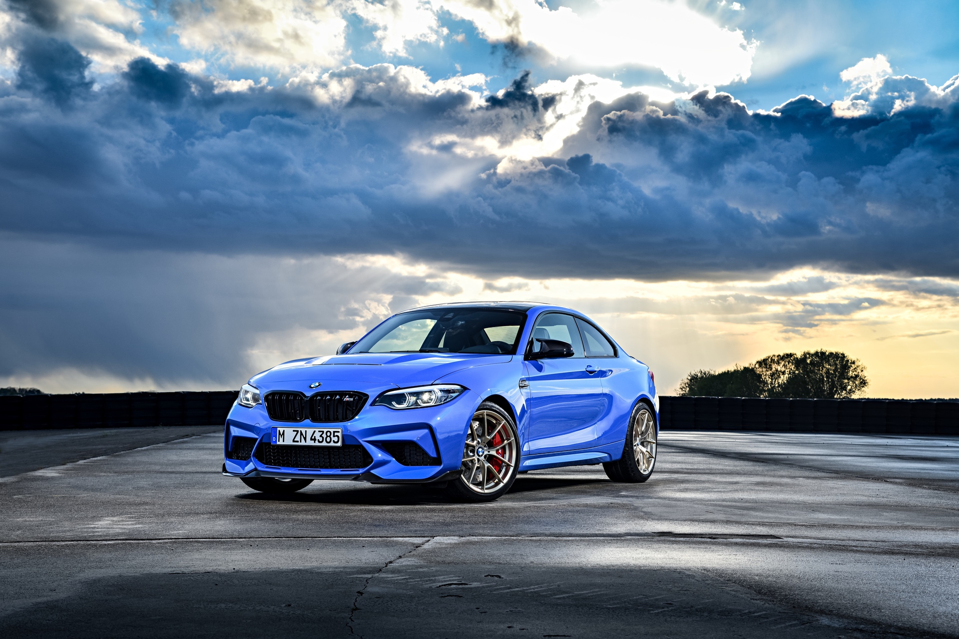
MODULE CODE: LCBB4005

STUDENT NAME: ELENA ALINA GRIGORAS
STUDENT ID: 2112864

LECTURER NAME: MR. NADEEM MIRZA
University of Wales Trinity Saint David
Assessment 1

Table of Contents

Introduction 3
1. “Analysing the challenges of BMW’s internal business environment” 4
2. “Analysing the challenges of BMW’s external business environment” 6
3. “Deriving porter's five forces” 8
4. “Assessing Value Chain and BMW’s competitive advantages concerning their core values on sustainability” 9
Recommendation 10
Conclusion 11
References 12

Introduction

BMW is a German automobile, motorcycle, and appliance manufacturer that was founded in 1916 and has been in continuous operation since 1969. BMW is a multinational company that manufactures luxury automobiles. They are the world's 12th largest brands that produce expensive motor vehicles. The company manufactures and sells a wide range of high-end active automobiles and motorcycles. It also owns and manufactures miniature products and is the parent company of Rolls-Royce automobiles. BMW has subsidiaries in 41 countries and more than 3000 dealerships and local importers in more than 100 countries. BMW is a forward-thinking company that generated 53.2abillion euros in sales in 2008 by selling 1.2amillion automobiles and 101,000 motorcycles. It employs more than 100,000apeople worldwide. BMW has a Rolls Royce aircraft engine business in addition to automobiles and motorcycles. BMW is also a major financial services provider and has a significant market position in the motorcycle business. Automobiles accounted for 78% of revenue in 2000, followed by vehicle financing leasing (18%), motorbikes (3%), and other (1%). The BMW group's three brands – BMW, TINY, and Rolls-Royce Motor Cars – are all represented in the UK, which is the third largest market and second largest manufacturing base in the world.
The report will discuss and will drive PESTLE to grab out challenges they are facing within their external environment. This will drive SWOT to take out the challenges they are facing within their internal environment.

1.“Analysing the challenges of BMW’s internal business environment”

These segments will be derived through SWOT analysis to assess the challenges they are reflecting within BMW’s internal business environment. SWOT functions as strengths, weaknesses, opportunities and threats (Zhikang, 2017). This helps companies to analyse out best strategy to sustain its successful for the future and its current position.

Strength | Weaknesses
- Strong global reach  - High performance R&D team  - High appearance in advertising  - Skilled workforce | - Market size is limited  - Rise in debt  - Decrease market share  - Generation of electric cars
Opportunities | Threats
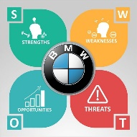  - Cheaper price structure  - Rise in affluence  - Newer models  - Expand in new markets | - Covid-19  - Rise in petroleum prices  - High competition  - Rise regulation in cars

Analysis,
Strengths
- Strong global reach - Within all of the strongest automobile manufacturers and widest known automobile brands, BMW is one of the expensive automobile brands that is likely to grab its position and are subjected to established within different parts of the world with a high profit and premium cost structure which represents as a precious status that reflects as an strong identity. They are also profound in their spreader variety of aircraft engines and motorcycles (Aspiany et al., 2019).
- High performance R&D team - Their R&D department is precisely known for its technological flow as they have been the masters of perfection and have always stepped off as a winner within from the premium segment, as they basically reflect and target customer who are passionate to drive its auto vehicles which are highly modified and seeks to have high tech features which grab its demand out in the respective industry.
- High appearance in advertising - BMW are conserved to have strong connections within both high successive and strong engaging celebrities which helps them to promote their models.
- Skilled workforce - They have been working out with 2,00,000 above employees and staff that are professional and are subjected to be experts in their own committed roles.

Weaknesses
- Market size is limited - BMW are subjected to supply products that can only be traded within developed nations and to the individual who always reflects to purchase premium products, these can be acquired by middle class people and lower than that. This is their toughest challenge.
- Rise in debt - The debt has been subjected to a rise within the amount of more than 60 million Euros which can leave out their R&D team to get misbalanced to spend more funds within their R&D team (Uhunamure and Shale, 2021).
- Decrease market share - They are majorly dependent upon their production of cars, as they could have lost out their demands if their competitors seek to introduce new unique models which can retain their organisational potential customers.
- Generation of electric cars - They have to proceed up their production of electric cars which will be more demandable within the coming future.

Opportunities
- Cheaper price structure - The company had to change its strategic pricing structure as they only target the premium segment of individuals, but they have to open up to the middle class and the classes who can't afford them. This can be an emerging move for BMW. To make its appearance stretch up wider.
- Rise in affluence - As these times majority of individuals are changing up their lifestyles and are surfacing through luxurious and premium brands and its products, which is a productive and growing opportunity that can reflect them out to rise up its revenues and sales.
- Newer models - They are innovating more new models that are highly preferred by the customers over the world. These could be a successive point for BMW.
- Expand in new markets - To connect within more qualified and stable brands over the world within their automobile industry can help them to standardize their image and reputation within the respective industry.

Threats
- Covid-19 - Majority of the targeted individuals back stepped from their choice and have changed their way of purchasing as pandemic has totally changed the way these individuals used to process remarks towards their premium automobiles.
- Rise in petroleum prices - As most individuals are acquiring or purchasing electric vehicles, as the price of petroleum has been seen to be raised, therefore they soon need to adapt or innovate electric vehicles for better convenience (Pandyaswargo et al., 2021).
- High competition - They have been facing tough competition within their competitors to function out more attractive and advanced feature loaded vehicles within the market which has totally triggered them. Ex, Audi or Mercedes Benz etc.
- Rise regulation in cars - As BMW has been seen to be influenced by the regulation released by the government, as they have committed to decrease carbon footprints. These somewhere have been detected to hit their revenues and their sales structure.

2. “Analysing the challenges of BMW’s external business environment”

This segment will be analysed through PESTLE analysis, as these stands for political, economic, social, technological, legal and environmental factors. It basically allows companies to gain a macro image of industry (Walsh, Bhagavatheeswaran and Roma, 2019).

Political factors - Brexit has impacted BMW supply and trading mark. As they have been reflected to invest low double digit million euro to stand back more precisely within Brexit. The chief of BMW conveyed that getting separated from the EU could cost their productions and suppliers up to 12billion euro unless the “cross border trade” reflects to remain unbearable and tariff free. The chief of BMW reflected that they are processing out just-in -time manufacturing systems, therefore they will be tight within their administrative functioning (Iacovidou and Zorpas, 2022). BMW says they have loosed high progressive sales and revenues through the No-deal Brexit deal by increasing prices upon the cars that are imported to the UK.
Economic factors - Impact of covid-19 has impacted BMW widely. Within the pandemic their respective shares fell up by 4%, it has been detected to be a great loss to them. BMW EBIT official margin for cars have slumped to minus 11% from the 7% in the second quarter last year, as the time its operating income or profit arrived within an amount of 2.7bilion Euros. It produced about 5,00,000 cars within the second quarter, low 30% from the early year (Guan, 2021). BMW chiefs have reflected on looking over the second sixth period with high efficiency and strong optimism and proceed to aim for an EBIT margin between 0% and 4% for their automotive segment within the period of 2020. The impact of decreasing profitability of the manufacturers of BMW to get success within grossing up more sales and revenues and to subjectively meet up EU emission targets within 2020.
Social factors - BMW aims for price oriented and premium individuals, as they have to equally function upon different markets to acquire position, as they have to be aware of different cultures with different lifestyles and they are implied to launch up and renovate their existing strategies to trade within different countries and to not stuck for a small segment of clients (Dardary et al., 2020). This has seen to be a social challenge. They are a multinational automobile company that needs to look out for the definite needs and demands of the customers reflecting both the political and economic environment of the country.
Technological factors - Within the technology they have not reflected to commence any negative impacts, as through technology they are specifically standing out here within the industry. They have enabled automatic car parking as these help out function with laser scanners that scans each and every area across the vehicle and to initiate an accurate image of the surrounding (Iacovidou and Zorpas, 2022). They are profound of precise urban parking system solutions, these incurs advanced and intelligent solutions, these effectively decreases up the volume of traffic reflecting upon for a specific space to park in. Technology is their strength and with the innovations within their BMW 330e has been imputed with power train electrification within the major premium segment.
Legal factors - The laws and respective regulations could be a challenge for BMW and has impacted their business operations. As majority of government subject to reduce air pollution so they detect out to make automobile brands to function up their cars on road lesser. As the sale of BMW vehicles and automobiles are being exported into the international market, they are subjected to laws that commit their specific safety and quality. And these pollution laws have grown stricter and when they transit to export their vehicles overseas that they are ordered to pass more strict emission controls. As they once have seen to reflect loose airbags that have commenced to show several faults within that they have questioned to put passengers and clients with safety, therefore governments have enabled strict laws that will be completely focused upon the safety of passengers. These are the challenges they are facing externally.
Environmental factors - The following environmental factors bring out challenges to BMW and within this automobile industry. BMW has been committed to have in depth insights within the impact driven by the environment to their products. As their single production of their respective vehicles’ accounts for 0, 25 tons of C02, that is equivalent to 13% of the CO2 budget of a single person (Deepak, Sharma and Kumar, 2022).

3.“Deriving porter's five forces”

This segment will be driven out by Porter's five forces that help marketers and the respective business managers to deeply analyse the power of balance of marketing within several organizations and within the global level.
- Threat to new entrants (medium) - As the competitors are growing BMW had to invest more upon their employees, production house and to invest more upon the designers to progress up its sustainability within in front of these new entrants. As these new entrants are reflecting to function more new innovations that can make them to behind (Jae-Woong Byun, 2014).
- Power of competitors (high) - The competitors like Audi, Mercedes Benz are one of their biggest rivals who are equally stronger when it comes to producing high premium cars and successive clientele within the industry. These are triggering them to make more new modifications and produce something different then what their competitors are already serving out in the industry.
- Powers of suppliers (high)- As the suppliers influences effectively but in terms of BMW, their cost of suppliers stabilizes impact upon their profits structure that is driven out by the organization. Their manufacturers demand stronger because each and every part of their vehicles is made within the company with high quality appearance provided through the suppliers.
- Power of buyers - They conserve a premium segment of customers and clients and through marketing and advertising they are reflected to target these customers from different established production houses that stabilize within countries. Quality attracts and an advanced image of them brings up more customers towards their product. Proper customer base can make a business to outlook wider and grab successive presence for a longer period of time.
- Threat to substitutes -The value it possesses to its international customer are a strong reflection of their brands and threat that can commence from them is the emissions from fuels and the impactful, environmental hazards their respective cars are causing. Majority of customers are thereby reflected encourage moving upon public transport in UK.

4.“Assessing Value Chain and BMW’s competitive advantages concerning their core values on sustainability”

Value chain analysis is an analytical tool for finding commercial operations that could add value and provide a competitive edge to a company. The essence of value chain analysis is depicted in Figure 1.
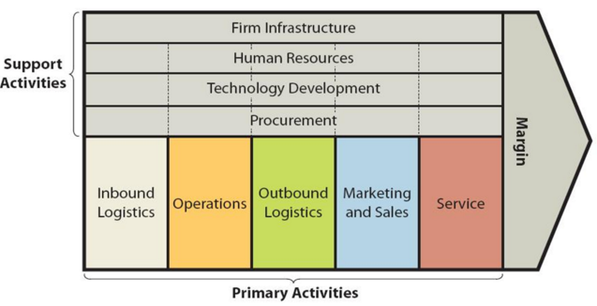
Fig.1 BMW value chain analysis
BMW has more than 14,000 suppliers that are located internationally and they add value within its logistic activities through decreasing the cost of the transportation and are detected to make out more quality materials through sources (Liu and Liu, 2021b).
The consistent process to enhance their research and development with more new additions to technologies are its core and key to the subjective competitive advantage of BMW (Chen, Zhang and Wu, 2018). These reflect to be reliable, superior to client service support.

Recommendation

The company is hereby recommended that they had to focus more upon targeting every segment of customers to get complete support and long sustainable hold within the market. They had to reflect more on producing electric vehicles which will serve a great competition towards its competitors.

Conclusion

This report has discussed the challenges BMW is facing within the internal and external business environment. The internal analysis has been derived through PESTLE and internal analysis has been functioned through SWOT. This report also discussed the competitive edge through Porter's five forces. Also, referred to their value chain and its competitive advantage reflecting upon their key values on sustainability.

References

1. Aspiany, Anggoro, S., Purwanti, F. and Gunawan, B.I. (2019). Evaluating Ecotourism Development in Bontang: Water Quality, Compatibility, and Carrying Capacity. IOP Conference Series: Earth and Environmental Science, 370, p.012049.
2. Deepak, A., Sharma, V. and Kumar, D. (2022). Life cycle assessment of biomedical waste management for reduced environmental impacts. Journal of Cleaner Production, p.131376.
3. Walsh, K., Bhagavatheeswaran, L. and Roma, E. (2019). E-learning in healthcare professional education: an analysis of political, economic, social, technological, legal and environmental (PESTLE) factors. MedEdPublish, 8(2).
4. Iacovidou, E. and Zorpas, A.A. (2022). Exploratory research on the adoption of composting for the management of biowaste in the Mediterranean island of Cyprus. Cleaner and Circular Bioeconomy, 1, p.100007.
5. Chen, J., Zhang, R. and Wu, D. (2018). Equipment Maintenance Business Model Innovation for Sustainable Competitive Advantage in the Digitalization Context: Connotation, Types, and Measuring. Sustainability, 10(11), p.3970.
6. Liu, Y. and Liu, Y.L. (2021). A critical analysis of how BMW designs a collaborative and value-adding supply chain. International Journal of Business Performance and Supply Chain Modelling, 12(4), p.414.
7. Electric Car Brand Positioning in the Automotive Industry: Recommendations for Sustainable and Innovative Marketing Strategies. (2019). Journal of Strategic Innovation and Sustainability, 14(1).
8. Dardary, O., Daaif, J., Tridane, M. and Belaaouad, S. (2020). DISTANCE LEARNING IN THE AGE OF COVID – 19: BETWEEN PERSPECTIVE AND REALITY. International Journal of Engineering Applied Sciences and Technology, 5(6), pp.12–18.
9. Pandyaswargo, A.H., Wibowo, A.D., Maghfiroh, M.F.N., Rezqita, A. and Onoda, H. (2021). The Emerging Electric Vehicle and Battery Industry in Indonesia: Actions around the Nickel Ore Export Ban and a SWOT Analysis. Batteries, 7(4), p.80.
10. Guan, T. (2021). A Brief Analysis and Suggestions on the Current Situation of New Energy Vehicles in China. Finance and Market, 6(1), p.103.
11. Zhikang, L. (2017). Research on Development Strategy of Automobile Reverse Logistics Based on SWOT Analysis. Procedia Engineering, 174, pp.324–330.
12. Electric Car Brand Positioning in the Automotive Industry: Recommendations for Sustainable and Innovative Marketing Strategies. Journal of Strategic Innovation & Sustainability, 14(1).
13. Uhunamure, S.E. and Shale, K., 2021. A SWOT analysis approach for a sustainable transition to renewable energy in South Africa. Sustainability, 13(7), p.3933.
14. Jae-Woong Byun (2014). Successful Global Brand of the BMW: Porter’s 5 Forces Analysis. Journal of Distribution and Management Research, 17(5), pp.77–87.

