

Student Name: Asaduzzaman Tutul
Student ID: 2435434
Lecturer: Dr Laila Maazouz
Programme: Master of Business Administration
Module: Marketing Management
Module Code: LCMB7024
Word: 2548
Date of Submission: 17th December 2025

Table of Contents
Introduction 1
Element 1: Segmentation, Targeting, Differentiation, and Positioning (STDP) Analysis for a New Brand Concept of Tesla 2
1.1 Introduction: Company and New Brand Concept 2
1.2: Market Attractiveness and Trends 2
1.3: STDP Analysis 3
Element 2: Marketing Mix (4Ps) for Haven-X 6
Element 4: Reflection 10
Conclusion 12
References 13
Element 3: Appendix 15

Contents of Figures
Figure 1: Market Size Growth (2024-2034) 3
Figure 2: Marketing Mix 4Ps 6
Figure 3: HAVEN-X Product 7

Introduction
The entire portfolio serves as a strategic growth and advertising plan for Haven-X, a new brand that Tesla, Inc., plans to create. Haven-X is a new brand that aims at disrupting the housing market worldwide by providing sustainable and AI-driven modular houses. The idea would use Tesla's strengths of vertical integration, factory automation, and the clean energy sphere to provide net-zero energy living spaces at a cost. The primary target market is determined by the Segmentation, Targeting, Differentiation, and Positioning (STDP) analysis as 'Eco-Tech Pragmatists' – middle-income consumers who are interested in both innovations and sustainability. The following 4Ps Marketing Mix describes a Direct-to-Consumer (D2C) model of sales and zero-cost publicity focus, which makes the brand competitively priced and aligned with Tesla's reputation for disruptive, sustainable innovation.

Element 1: Segmentation, Targeting, Differentiation, and Positioning (STDP) Analysis for a New Brand Concept of Tesla

1.1 Introduction: Company and New Brand Concept
Tesla, Inc. is a well-known company worldwide, not only as a car manufacturer but also as a company specialising in clean energy and technology with the goal of ensuring that the world goes green (Tesla, Inc., 2024). Its main competitive advantage is its vertical integration, advanced battery technology, and its ability to produce in large volumes and automated manufacturing through its Gigafactories, allowing it to substantially lower its costs and product differentiation (The Strategy Institute, 2025).
The proposed new brand, Haven-X, offers a modular housing solution that is both sustainable and AI-based. The Haven-X homes are prefabricated self-sustaining housing units with a full Tesla Powerwall and Solar set up, high-order smart-home automation control, and a developed AI energy management system. The idea directs the use of Tesla's well-established energy and automation foundations to provide a technologically advanced and net-zero living room at a level affordable to a broad range of individuals.

1.2: Market Attractiveness and Trends
Haven-X is in a strategically placed position to take advantage of three key trends in world markets:
- Affordability Crisis & Housing Demand: The high cost of housing and population density are fuelling the demand for flexible and cost-efficient housing units such as Accessory Dwelling Units (ADUs), and the ADU market in the world is projected to grow at a CAGR of more than 10% by 2025 (Wise Guy Reports, 2025). Modular construction as used by Haven-X features prefabricated components, which are built in factories, and has a maximum time-saving of 50% and much reduced and more predictable costs compared to site-built homes.
- Sustainability Requirement: Customers are making more environmentally friendly decisions. A PwC survey (2024) revealed that more than 80% of the consumers would be prepared to pay a higher price to obtain goods that are sustainably produced or sourced (PwC, 2024). Haven-X directly focusses on achieving a net-zero carbon footprint through its home designs, which cater to the increasing demand for energy efficiency and cost-effective construction in housing (Semarak International Journal of Design, Built Environment and Sustainability, 2025).
- Technology-Driven Living: The need to have smart home technologies is growing, and more than half of the new ADUs of North America have smart features (Wise Guy Reports, 2025). Haven-X is a sleek, centralised AI-controlled home experience that guarantees the highest level of power efficiency, safety, and climate control and will attract a high-tech consumer demographic.
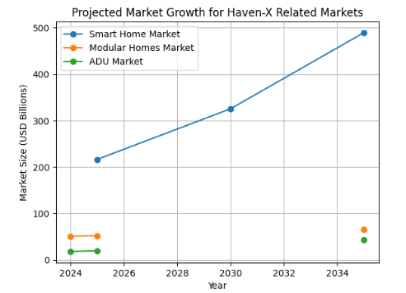
Figure 1: Market Size Growth (2024-2034)
Source: marketgrowthreports

1.3: STDP Analysis
Segmentation and Targeting
Segmentation
Haven-X categorises the market based on the mixture of the following factors, which are in line with the contemporary, value-orientated consumers:
Segment Dimension | Segment Description | Relevance to Haven-X
Demographic | Middle-Income Millennials/Gen Z & Early Retirees (50+). University-educated individuals or families seeking financial flexibility. | Targets those who are debt-averse and value long-term financial freedom over large, traditional mortgages.
Geographic | Urban/Secondary Cities with High Costs & Favourable ADU Legislation. North America (e.g., California) and densely populated European regions. | Focuses on markets where land-use policies support smaller, infill housing and where the cost saving is most pronounced (Wise Guy Reports, 2025).
Psychographic | Eco-Conscious Minimalists & Tech-Savvy Early Adopters. Value efficiency, innovation, self-sufficiency, and ethical consumption. | Appeals to those who view a home not just as shelter, but as an integrated lifestyle system that aligns with their values (The4 Shopify Theme, 2025).
Behavioural | High Brand Loyalty & Users of Renewable Energy/Smart Systems. Consumers who already own Tesla products (EVs, Powerwalls) or actively seek out innovative, high-tech, and sustainable brands. | Focuses on existing brand advocates and those who seek the holistic integration of Tesla's energy ecosystem (Wondershare EdrawMind, 2024).
Table 1: Segmentation Dimension
Eco-Tech Pragmatist: The Target Audience
The main target audience will be the Eco-Tech Pragmatist: people in the middle-income bracket, most of whom are Millennials (30-45 years old) or Gen Z, and are highly cost-effective, environmentally friendly, and technologically conscious.
This consumer considers the house a source of financial stability and a manifestation of his or her values towards the environment. They do not have to be high-income (Tesla is initially targeting the middle-income mass market), but they are middle-income buyers interested in the maximum value possible, which Haven-X promises with no utility bills and long operating efficiency, overcoming the upfront premium on sustainable construction (PwC, 2024). They have brands that are true to innovation and functional sustainability.
Differentiation and Positioning
Differentiation (How is Haven-X different?)
Haven-X stands out from the standard construction and other modular competitors on three primary dimensions:
- Full Vertical Integration & Cost-Efficiency: Compared to competitors who use traditional construction supply chains, Haven-X uses the Tesla Gigafactory manufacturing, based on robots, to create homes on a scale and speed never seen before, while reducing the cost-of-goods-sold (COGS) by almost unachievable competitors (The Strategy Institute, 2025).
- Native Clean Energy Ecosystem: The native compulsory implementation of Tesla Solar and Powerwall into the building construction is differentiated. This guarantees a well-constructed, completely independent, Net-Zero Energy Home right out of the factory, a major point of distinction over modular competitors, with solar commonly being a bolt-on option.
- AI and Software Focus: The home is a product on a platform, which is controlled by a combined Tesla AI system to control energy routing, security, and maintenance diagnostics. This can be updated in real-time as a software-controlled solution, which enables over-the-air (OTA) updates and remote diagnostics, transforming the household into a dynamic and efficient device, a fundamental Tesla strategy (The4 Shopify Theme, 2025).
Positioning (What is Haven-X?)
The positioning that Haven-X is desired to be is the fully automated, net-zero home that makes sustainable living affordable.
Positioning Statement:
The sustainable modular home that will rebrand the meaning of shelter to the middle-income sector, tech-savvy consumers, and early retirees in search of financial and environmental security is Haven-X, a modular home that is Tesla-shaped (and Tesla-enabled) as a way of providing net-zero and self-sufficient living at the price of the mass market.
This stance is in direct opposition to the traditional housing market, which costs high and contributes to environmental pollution, positioning Haven-X as not only clean energy but also affordable and disruptive innovation to the overall mission and brand equity of Tesla (Tesla, Inc., 2024).

Element 2: Marketing Mix (4Ps) for Haven-X
Haven-X Marketing Mix: Tesla's sustainable and automated modular housing brand, Haven-X, is developed on the basis of the company's already existing model of disruption, vertical integration, and digital-first customer interaction. As Haven-X is a product-based product, the 4ps framework (Product, Price, Place, and Promotion) is employed to adjust marketing efforts to the main brand strategy of Affordable, Sustainable, and Automated Living.
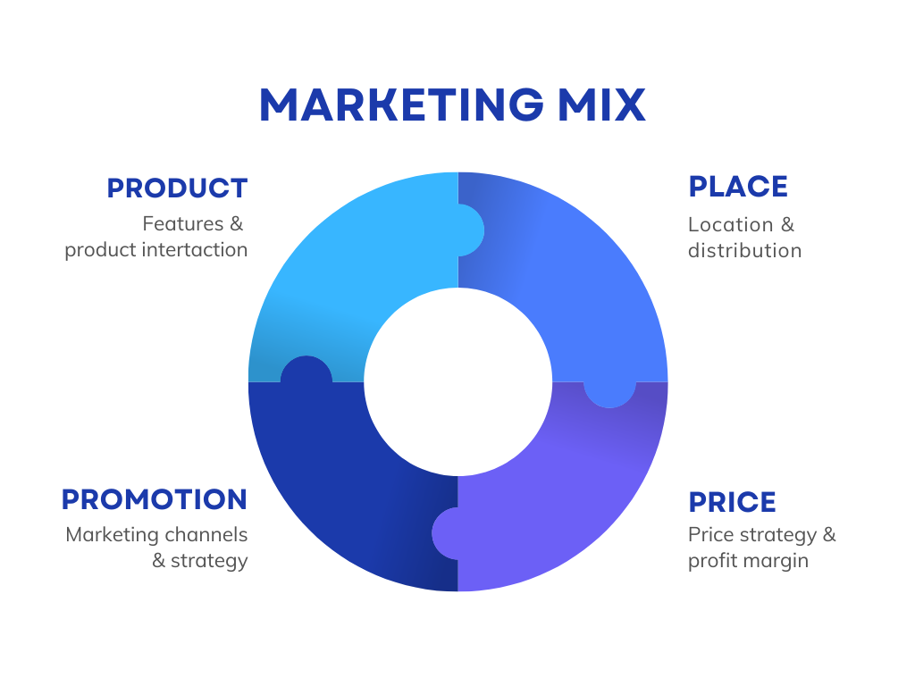
Figure 2: Marketing Mix 4Ps
Source: business
1. Product: The Home, Software-Defined Home
The Haven-X product is not just a building; it is a software-defined ecosystem, offering the Tesla energy and AI platform to be expanded to the residential environment.
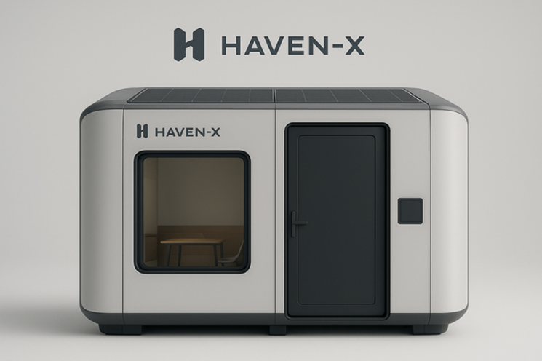
Figure 3: HAVEN-X Product
Product Strategy and Alignment:
- Core Product: Prefabricated, exceptionally strong modular residential houses, including Accessory Unit to larger family units. They are designed to be quick to install and very resistant to the weather, which fits the theme of Tesla, which is safety and a strong emphasis on engineering (Tesla, Inc., 2024).
- Native Integration: Tesla Solar and Powerwall energy storage systems are built in every unit to ensure Net-Zero Energy (NZE) functionality (Wise Guy Reports, 2025). This is what distinguishes Haven-X from competitors who sell solar/storage as an optional and expensive add-on.
- Automation and AI: Homes have an operating system that is run by a central AI that manages climate, security, routing of energy and diagnostic inspection. This is a software-first solution that enables Over-the-Air (OTA) updates on new features and enhanced efficiency, keeping the value and modernity of the home intact, which is a strategy that is central to Tesla in the automotive department (The4 Shopify Theme, 2025).
- Personalisation: The production is automated, but the product is modularly customised through an online configurator, and the target audience (Eco-Tech Pragmatists) has the opportunity to choose the product layouts and finishes that would match their spare, minimalist, efficient lifestyle.
2. Price: Mass-Market Affordability Value-Based
Pricing Haven-X will be aimed at providing a high-tech, premium product at an affordable mass-market price, which Tesla has shifted to affordability after originally serving the high-end market (Model S/X) (Scribd, 2023).
Pricing Strategy and Alignment:
- Price Leadership through Automation: Tesla has vertical integration and an automated factory that directly allows it to provide a price to the mass market. Research of modular construction reveals that automation can save almost 40% of time and more than 69% of labour per unit, leading to massive cost savings which are passed to the consumer (Frontiers, 2025).
- Value-Based Pricing: The initial cost of purchasing may be a bit more than the normal low-quality building, but the price is set as a long-term investment. Its marketing focus is the total cost of ownership (TCO), which includes the fact that the utility bills are virtually absent, and the cost of maintenance is also very low in terms of a factory-built house that is controlled by the artificial intelligence (NewswireJet, 2025).
- Fixed and Open Pricing: Haven-X will also adopt the no-haggle, fixed pricing through its online platform like that of its vehicle sales. This is transparent and complies with a simplified Tesla customer experience which is streamlined (Investopedia, 2025).
3. Place: Experiential Hubs, Direct-to-Consumer (D2C)
The Place strategy embraces the groundbreaking approach of Direct-to-Consumer (D2C) used in Tesla by not utilising the traditional channels of friction and middlemen in the real estate and construction business, staying in control of the sale process, brand experience, and the bottom line (Investopedia, 2025).

Place Strategy and Alignment:
- Digital Sales Platform: The main sales channel will be the Tesla web/app, where customers design, finance, and order their Haven-X unit all online. This is a digital-first strategy that appeals to the younger generation that is technologically minded.
- Regional Hub Centres: These hubs, situated strategically in high-density urban centres and secondary cities, have three main functions in common with Tesla showrooms:
  - Experience: Customers can physically tour and experience the environment of a Virtual Reality (VR) centre where they can physically walk through their designed home.
  - Consultation: Open financing, allowance and solar/energy consultation.
  - Service: The regional centre of the installation coordination and after-sales technical support (Investopedia, 2025).
- Installation Network: Tesla will create a network of certified logistics and construction partners who would help with the laying of foundations and final-mile assembly of the model, so the high quality defined by the factory should be continued on-site.
4. Promotion: Zero-Cost Publicity and Digital Stories
Expanding upon the tradition of the Tesla brand: a zero-cost publicity scheme based on the excellence of the products, viral marketing, and the internet presence of its founder (Blankboard Studio, 2025), Haven-X will remain.
Promotion Strategy and Alignment:
- Zero-Cost Publicity: The importance of the promotion is on earned media and word of mouth by:
  - High-Impact Launch Events: Introducing the first all-in-one, off-grid home, generating the viral news.
  - Founder Influence: Take advantage of the social media presence of Elon Musk to create mass and free publicity (ResearchGate, 2025).
  - Referral Program: Adoption of a high-value referral program that will reward the early adopters (Behavioural Segment) to become the brand evangelists.
- Digital Storytelling: Promotion targets informative and interactive digital content, rather than the old-fashioned advertisements:
  - VR/3D Configurators: This feature will enable the customer to plan and physically locate the home on his or her property through augmented reality (AR).
  - Performance Metrics: Providing actual data on energy conservation, NZE performance, and long-term TCO to attract the Pragmatist part of the target consumer.
The Haven-X marketing mix is a strategic combination of the Tesla strengths, which position the brand to take over the high-tech, affordable, sustainable housing industry.

Element 3: Presentation
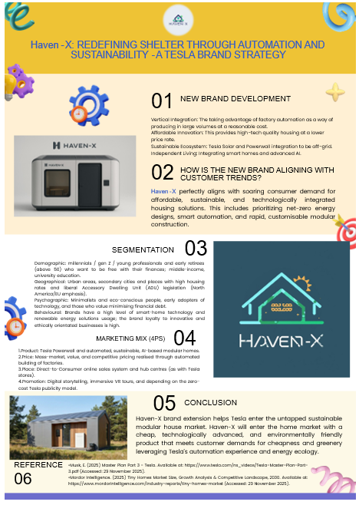

Element 4: Reflection
The entire experience of creating the Haven-X brand concept and the associated marketing mix was priceless in terms of strategic alignment and market disruption. The inherent issue was being able to transfer the high-tech, disruptive Tesla parent company image to the low-innovation, traditional modular houses. The implementation of the 4Ps theory (Product, Price, Place, Promotion) was essential to put order on this new idea. I learnt a major lesson about defining the Product as not timber and steel but as a software-defined and vertically integrated energy ecosystem. This process required that all future Ps – notably the free Promotion and the TCO-driven Price – had to strengthen this technological core, such that they caused a close fit to the wider brand image of affordable, automated and sustainable living.
The key element of the marketing pitch that I trained and practiced was strategic synthesis. I was forced to compress the lengthy and convoluted arguments of hundreds of words, such as why the Direct-to-Consumer (Place) model was essential to brand control and price transparency, into succinct and impactful arguments. This assignment also helped hone my prioritising skills in that I must always follow the Brand Mission first and then show how the 4Ps fulfil the mission. The pitch experience particularly emphasised the role of articulation and clarity in explaining why spending on traditional advertising (promotion) is not needed when product innovation and a powerful founder's persona result in all the earned media required.
To further improve on my approach in future undertakings, I would have to critically consider two areas. To begin with, the concept of price strategy was sound, but I would include a more elaborate quantitative analysis of costs and a financial model to reinstate the argument of return on investment (ROI) for the customer. My proposal would shift the debate from the conceptual to the financial benefit that is provable. Second, to enhance pitch execution, I should invest more time in anticipating and addressing critical objections, particularly regarding the scalability of the service, installation logistics, and the creation of more engaging visual representations of the AI integration into the physical product. The data-driven proactive approach will not only lead to innovative strategies but also ones that can be defended.

Conclusion:
The Haven-X brand is a strategic and timely expansion of Tesla into the market of sustainable modular houses. Haven-X can really be considered a disruptive solution by merging Tesla's experience in factory automation, clean energy, and AI. The brand is well placed to cater to the needs of the Eco-Tech Pragmatist consumer globally and meet their needs in terms of low-cost, net-zero living. The move to diversify Tesla through Haven-X will succeed and revolutionise the residential market, which strengthens the company's mission to hasten sustainable energy implementation.

References
PwC. (2024) Consumers willing to pay 9.7% sustainability premium, even as cost-of-living and inflationary concerns weigh: PwC 2024 Voice of the Consumer Survey. [Online]. Available at: https://www.pwc.com/gx/en/news-room/press-releases/2024/pwc-2024-voice-of-consumer-survey.html (Accessed: 3 December 2025).
Semarak International Journal of Design, Built Environment and Sustainability. (2025) Sustainable Affordable Housing: Global Trends, Policy Gaps, and Game Changing Practice. [Online]. Available at: https://www.researchgate.net/publication/390572807_Sustainable_Affordable_Housing_Global_Trends_Policy_Gaps_and_Game_Changing_Practice (Accessed: 3 December 2025).
The4 Shopify Theme. (2025) Tesla's Marketing Strategy: How They Sell Without Really Selling. [Online]. Available at: https://the4.co/ecommerce/tesla-marketing-strategy/ (Accessed: 3 December 2025).
The Strategy Institute. (2025) Inside Tesla's Blueprint: Strategy, Sustainability, and Competitive Edge. [Online]. Available at: https://www.thestrategyinstitute.org/insights/inside-teslas-blueprint-strategy-sustainability-and-competitive-edge (Accessed: 3 December 2025).
Wise Guy Reports. (2025) Accessory Dwelling Unit (Adu) Market Research Report 2035. [Online]. Available at: https://www.wiseguyreports.com/reports/accessory-dwelling-unit-adu-market (Accessed: 3 December 2025).
Wondershare EdrawMind. (2024) Tesla Segmentation, Targeting, and Positioning. [Online]. Available at: https://edrawmind.wondershare.com/strategy-planning/tesla-segmentation-targeting-and-positioning.html (Accessed: 3 December 2025).
Blankboard Studio. (2025) Tesla's Marketing Strategy: How They Built a $1T Brand with $0 Ads. [Online]. Available at: https://www.blankboard.studio/originals/blog/tesla-marketing-strategy-case-study (Accessed: 3 December 2025).
Frontiers. (2025) Cost-Benefit Analysis of Automating Modular Construction Manufacturing for Affordable Housing. [Online]. Available at: https://www.frontiersin.org/journals/built-environment/articles/10.3389/fbuil.2025.1713686/abstract (Accessed: 3 December 2025).
Investopedia. (2025) What Makes Tesla's Business Model Different?. [Online]. Available at: https://www.investopedia.com/articles/active-trading/072115/what-makes-teslas-business-model-different.asp (Accessed: 3 December 2025).
NewswireJet. (2025) Tesla Pricing Strategy: How Dynamic Pricing is Reshaping the EV Market. [Online]. Available at: https://newswirejet.com/tesla-pricing-strategy/ (Accessed: 3 December 2025).
ResearchGate. (2025) A Study of Tesla's International Marketing Strategy Based on the STEPPS Model. [Online]. Available at: https://www.researchgate.net/publication/381563897_A_Study_of_Tesla's_International_Marketing_Strategy_Based_on_the_STEPPS_Model (Accessed: 3 December 2025).
Scribd. (2023) Strategy.: Tesla's Pricing Strategy. [Online]. Available at: https://www.scribd.com/document/547994108/Pricing (Accessed: 3 December 2025).
Tesla, Inc. (2024) About. [Online]. Available at: https://www.tesla.com/about (Accessed: 3 December 2025).

