Name: Peace Akporugo Aghedo 2247004
Moodle Code: BMHP5014
Moodle Name: Change makers: Creating and value creation

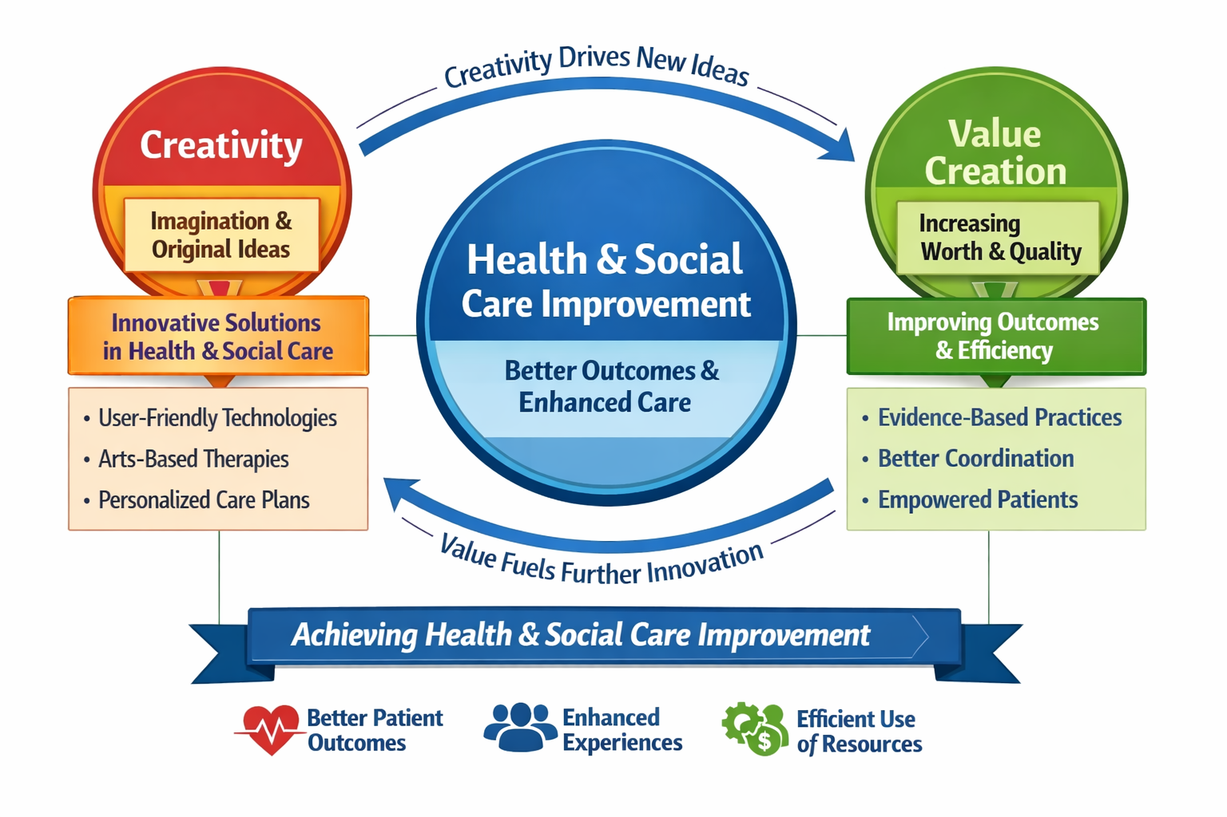

Here is a concept map that I created and outlines the relationship between creativity, value creation, and health and social carer improvement:
Central Theme: health and social care improvement
- Creativity:
Definition: the use of imagination or original ideas to create something.
- Application in health and social care: developing innovative solutions, new service delivery models, and novel approaches to address complex challenges.
- Examples: designing user-friendly technologies for remote monitoring, implementing arts-based therapies, or creating personalised care plans.
Value creation:
- Definition: the process of increasing the worth, merit, or quality of something.
- Application in health and social care: improving patient outcomes, enhancing service user experiences, reducing costs, and increasing efficiency.
- Examples: implementing evidence-based practices, improving communication and coordination among healthcare providers, or empowering patients to manage their own health.
Interaction:
- Creativity drives value creation by generating new ideas and approach that can improve health and social care services.
- Value creation is turn, fuels further creavity by demonstrating the impact of innovative solutions and inspiring new ideas.
- The goal is to achieve health and social care improvement, which encompasses better patient outcomes, enhanced services user experiences, and more efficient and effective use of resources.
- In a health and social care context, creativity, value creation, and improvement are interconnected. Creavity is the spark that ignites innovation, value creation is the process of translating innovative ideas into tangible benefits, and improvement is the goal of enhancing the well-being of individuals and communities. By fostering creavity, promoting value creation, and striving for continuous improvement, health and social care, improve patient outcomes, and create a more sustainable and equitable healthcare system.

Task 2:

A map that shows how creavity, value creation, and health and social care improvement all link up:
Central idea: health and social care improvement:
Creavity:
Definition
Coming up with new and original ideas.
In health and social care:
Leads to innovate solutions for patient care.
Helps in designing better services.
Encourages problem-solving from different angles.
Value creation:
Definition:
Making services more effective and beneficial for patients and staff.

In health and social care:
Boots patients' satisfaction and health results.
Making services more efficient, saving time and resources.
Improves staff morale and productivity.

Introduction in health and social care:
Creating fuels value creation by inspiring new approaches.
Value creation enhances health and social care imrpovement by making services better.
Health and social care improvement motivates more creativity by showing what works and what needs changing.
In health and social care, being creative means finding new ways to help patients and make services better. This leads to creating more value, like happier patients and more value, like happier patients and more efficient services. When health and social care improve, it encourages more creavity to keep making things even better.

Task 3:
Description:
During the convergent/divergent paperclip thinking class activity, the task was to generate as many uses for a paperclip as possible withing a set time frame. The initial phase involved individual brainstorming (divergent thinking), followed by a group discussion to consolidate and refine ideas (convergent thinking).
Feelings
Initially, i felt a mix of excitement and pressure. The open-ended nature of the task was both liberating and dounting. As ideas started flowing, i become more comfortable and engaged. The group discussion was particularly stimulating, as it allowed for the cross-pollination of ideas and the refinement of initial thoughts.
Analysis
The activity highlighted the importance of both divergent and convergent thinking in problem- solving. divergent thinking allows for the convergent thinking enables the selection and implementation of the most promising solutions.
Conclusion
- The convergent/divergent paperclip thinking class activity was a valuable learning experience that provided insights into the problem-solving process
Action plan
In the future, inwill consciously apply both divergent and convergent thinking strategies in problem-solving situations.
This will involve dedicating time for brainstorming and idea generation, as well as for evaluating and selecting the most viable options.
Task 3:
Here is a concise case study analysis of an innovative project:
Case study: The ‘’ Hospital at Home’’ initiative, implemented by several NHS trust, represents a significant shift in healthcare delivery, leveraging creativity to enhance patient care and create value. This model allows patients with specific acute conditions to receive hospital-level care in their own homes, rather than being admitted to a traditional setting.
Creativity in action:
The creavity of this iniative lies in its reimaging of the traditional care model. Instead of confining patients to a hospital bed, healthcare professionals use technology and coordinated home visits to deliver personalized care. Remote monitoring devices, such as wearable sensors, track vital signs and transmit data to a central monitoring hub. This enables early detection of any deterioration in the patient’s condition allowing for timely intervention.
Value creation:
The ‘’Hospital at Home’’ model creates value for patients in several ways. Firstly, it enhances the patient experience by providing care in comfortable and familiar environment. This can reduce anxiety and stress, loading to improved outcomes. Secondly, it promotes patient autonomy and independence, as individuals are actively involved in their own care. Thirdly, it reduces the risk of hospital-acquired infections, which can be a significant concern for vulnerable patients.
Challenges and considerations:
Despite its many benefits, the ‘’Hospital at Home’’ model also faces challenges. Ensuring patients safety and providng adequate support in the home environment requires careful planning and coordination. Additionally, not all patients are suitable for this type of care.
Conclusion:
The ‘’Hospital at Home’’ initiative demonstrates how creavity can drive positive change in healthcare. By reimaging the traditional care model and leveraging technology, this imitative enhances patient care, promotes autonomy, and creates value for both patients and the healthcare system, as healthcare continues to evolve, such innovative approaches will play on increasingly important will delivering high-quality, patientient-centered.
Task 4:
Issue: Mental Health Stigma
Mental health stigma remains a significant issue in health and social care, affecting individuals’ willingness to seek help, their social inclusion, and overall well-being-stigma can manifest in various forms, including public stigma (negative attitudes held by the public), self-stigma (internalized negative beliefs), and structural stigma (systemic policies and practices that disadvantage people with mental health conditions).
Sources 1: Fictional Author and Journal ‘’The Roots of Stigma: A Sociological Analysis’’
This study explores the sociological factors contributing to mental health stigma. The authors argue that stigma arises from combination of factors, including lack of awareness, fear of the unknown, and societal norms that pyritize physical health over mental health. They found that negative portrayals of mental illness in the media and popular culture reinforce stereotypes and contribute to public stigma. Additionally, the research highlights the role of labelling theory, where individuals diagnosed with mental health conditions are labelled as ‘’deviant’’ or ‘’different,’’ leading to social exclusion and discrimination. The study emphasizes that addressing stigma requires a multifaceted approach, including public education campaigns, promoting positive representations of mental illness, and challenging discriminatory practices in healthcare and employment.
This article investigates the impact of self-stigma on help-seeking behaviour among individuals with mental health conditions. The authors found that individuals who internalize negative beliefs abpit themselves due to their mental illness are less likely to seek professional help. Self stigma can lead to feelings of shame, embarrasment, and fear of judgment, which act as barriers to accessing mental health services. The study also revealed that self-stigma is associated with lower self-esteem, reduces social support, and increased risk of deicide that interventions aimed at reducing self-stigma, such as cognitive behavioural therapy and peer support groups, can improve help-seeking behaviour and promote recovery.

Task 5:
PODCAST

https://www.rev.com/app/file/NjljMjkzM2RlODc3NzY1MWQwZTM0MWVkeTZiZFM3QkVaT0Fp

