How climate change has affected business.
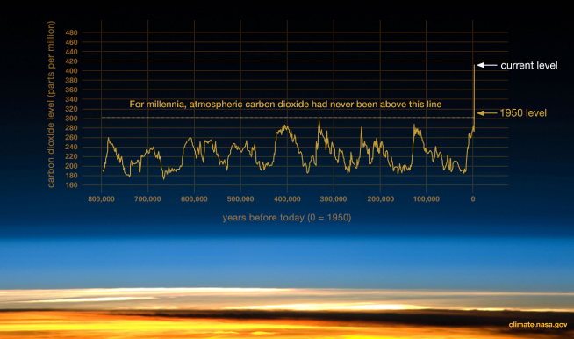
Climate change is one of the main challenges that humanity faces in the 21st century and beyond. At the forefront of these challenges is businesses, largely down to the fact that they play the biggest role in deciding what fate our planet faces. In 2015 the Paris agreement was created whereby 195 countries across the world signed an agreement to reduce the rate at which global temperatures are rising. The agreement was to prevent global temperatures rising 2 degrees Celsius above pre-industrial levels and if this was able to be achieved then the target is to prevent global temperatures rising 1.5 degrees above pre-industrial global temperatures (European Union, n.d). To achieve this goal, businesses across the world will have to follow the initiatives set out in the Paris agreement. The effects of climate change will be devastating for everyone, climate change causes temperatures to rise, which alone brings along huge effects to our planet. The rise of temperatures will lead to more droughts, increasing sea levels which leads to more flooding since 1880 sea levels have risen 8 feet and by 2100 it is estimated that sea levels will rise by a further 1-8 feet due to the melting ice caps and the expansion of water as the planet gets warmer (NASA, 2020). Climate change will also lead to changes in precipitation patterns as well as more droughts and also an increase in natural disasters which can have enormous effects on humanity. All of these effects will negatively affect businesses, for example, droughts will affect the efficiency at which crops can be harvested and natural disasters can lead to the destruction of infrastructure and loss of life which will also negatively affect businesses (NASA, 2020). Although climate change may cause crops to be destroyed in some parts of the world some crops may benefit from climate change due to more rain and hotter summers. For example, In West Virginia, they are seeing cooler summers, warmer winters, and more wet weather. This has resulted in changes in their agriculture as they used to know it. Hay and corn yields have increased, however, at a much slower rate, 23% lower than the national average, however, winter crops such as winter wheat and soybeans have increased at a faster rate due to these climate changes, they have increased 15 % faster than the national average. (West Virginia University 2019). These figures show that there may be some benefits to climate change, however, do they out way the negatives? Image from https://climate.nasa.gov/evidence/
If climate change continues to occur at the rate at which it is now it will have huge effects all over the world. The effects of climate change will lead to damaged economies, make resources scarcer which in turn will make the running of a business more costly which will minimise profit margins (Mainwaring, 2018). With all of these negatives’ effects on businesses, it is down to every individual business to take it upon themselves to help make a change. An initiative that has allowed influential businesses to come together to help make a change and make the commitment of using 100% renewable electricity is the RE100 initiative, the RE100 is an initiative that was created by The Climate Group and is in partnership with CPD. At the time of writing this article, 268 businesses have joined and supported the initiative to achieve zero carbon grids across the globe (RE100 Climate Change Group, 2020). The initiative is worldwide and is found in 140 different markets all over the world. Currently, the 268 businesses that support the initiative are producing enough energy to supply renewable power for an average-sized country. Due to the reach that the initiative has more and more influential businesses are supporting RE100, which highlights one of the changes businesses have had to make due to climate change. All figures in this section were collected from the RE100 website.
In recent years the amount of fossil fuels has been increasing year on year and in 2018 the amount of carbon dioxide emissions being emitted hit a record high and thus businesses have had to change how they produce and source their energy (National Geographic, 2018). Using renewable energy can be one of the key factors in tackling climate change, the use of renewable energy can help reduce the number of greenhouse gasses that are being released into the atmosphere, which scientists believe is the main culprits of our changing climate (Terrapass, n.d). Not only does renewable energy reduces the number of harmful gases that are being released into the atmosphere they can end up being more cost-effective, more for some businesses than others, but this is also because some business has greater access to the sources required into order to produce renewable energy (Terrapass, n.d). There are 6 different sources of renewable energy, these are wind, sun, water, biomass, ocean, and geothermal.
As with anything, there are positives and negatives to using renewable energy which all need to be considered by businesses. The role of the business is to determine whether the positives out way the negatives. Some positives of renewable energy include: it cannot run out like fossil fuels, another positive is the fact that once the infrastructure is in place it requires very little maintenance which can be cost-saving compared to other sources of energy. One of the main positives that businesses will look at is the cost-effectiveness of renewable energy. Once the infrastructure needed for renewable energy I in place there is very little cost involved in running and maintaining the source of power in comparison to the cost of continuing to use fossil fuels. On the other hand, the cost of the initial instalment of renewable energy sources is one of the main reasons why businesses have not yet leaped to use renewable energy because they simply cannot afford it (Reigler, 2020). Some of the other negatives include the fact that although they can be relied upon in the long term due to the unlimited supply, their reliability in the short term could be questioned because, for example, it is not always windy, thus solar panels then become redundant in these instances, the same can be said for wind energy, it will not always be windy. This point ties into the next negative regarding renewable energy, many businesses may not be able to have access to renewable energy because they may not have the right climate to take advantage of the elements around them. For example, if a business is located in a climate where there very little sunlight then solar energy would not be suitable, another example is that if a business is located in the middle of a densely populated city then they will not have the space available to them to implement these sources of energy. The good thing with renewable energy is the fact that there are numerous different options available so that most businesses will be able to utilise renewable energy sources.
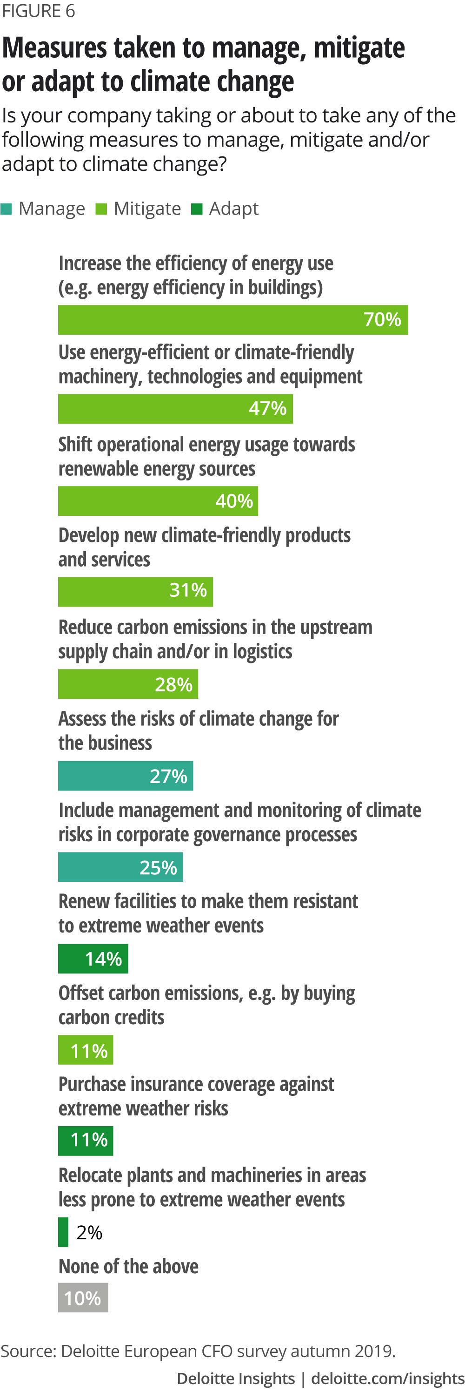
The increase in natural disasters has a drastic effect on the supply chain as more droughts and flooding can make it more difficult to obtain the resources that they need to manufacture the products they need. Natural disasters have a huge negative effect on raw materials. Natural disasters have a huge effect on an individual countries economy as well as the global economy, these disasters range from flooding to wildfires and hurricanes, each of these disasters has huge economic effects, these disasters can cost countries billions and billions of pounds with the costliest disaster in recent times causing a staggering $350 billion (Amadeo, 2020), this was the 9.0 magnitude earthquake that hit Japan in 2011 which then caused a tsunami. These natural disasters can cause grave uncertainty for businesses as the supply chain can be greatly affected by these disasters. Due to climate change businesses will have to have contingency plans in place so that if the worse was to happen and they were unable to get hold of the supplies they require then they would have a plan in place to overcome this hurdle, for example, have alternative suppliers for materials or improve infrastructure so that these disasters do not cause as much damage to their supply chain. Due to the increased regularity of these disasters, the global supply chain is becoming more and more affected due to loss of revenues, interruption in the production of goods, and also costs being increased due to high demand. The global supply chain contributes to $20 trillion worth of goods annually (Woetzel et. al. 2020). It is predicted that by 2040 the probability of a hurricane of significant intensity disrupting the semiconductor supply chain will grow by two to four times (Woetzel et. al. 2020). After a natural disaster, suppliers could experience losses of up to 200% of annual profits and lose up to 35% of their annual revenues. The three main factors that contribute to these losses are the physical damaged that is caused by these disasters, the reduced sales due to the interruption in production or due to the supplier's inability to ship their goods, and finally, due to the increased costs after a disaster, such as market prices may increase and also logistics costs may also increase. Each of these factors contributes to the overall losses that a supplier may face after a natural disaster. An example of where these losses occurred was during the severe flooding that occurred in Thailand in 2011, this affected more than 14,500 businesses and the estimated losses ranged between $15 and $20 billion (Wei & Chase 2018). Image from https://www2.deloitte.com/us/en/insights/topics/strategy/impact-and-opportunities-of-climate-change-on-business.html
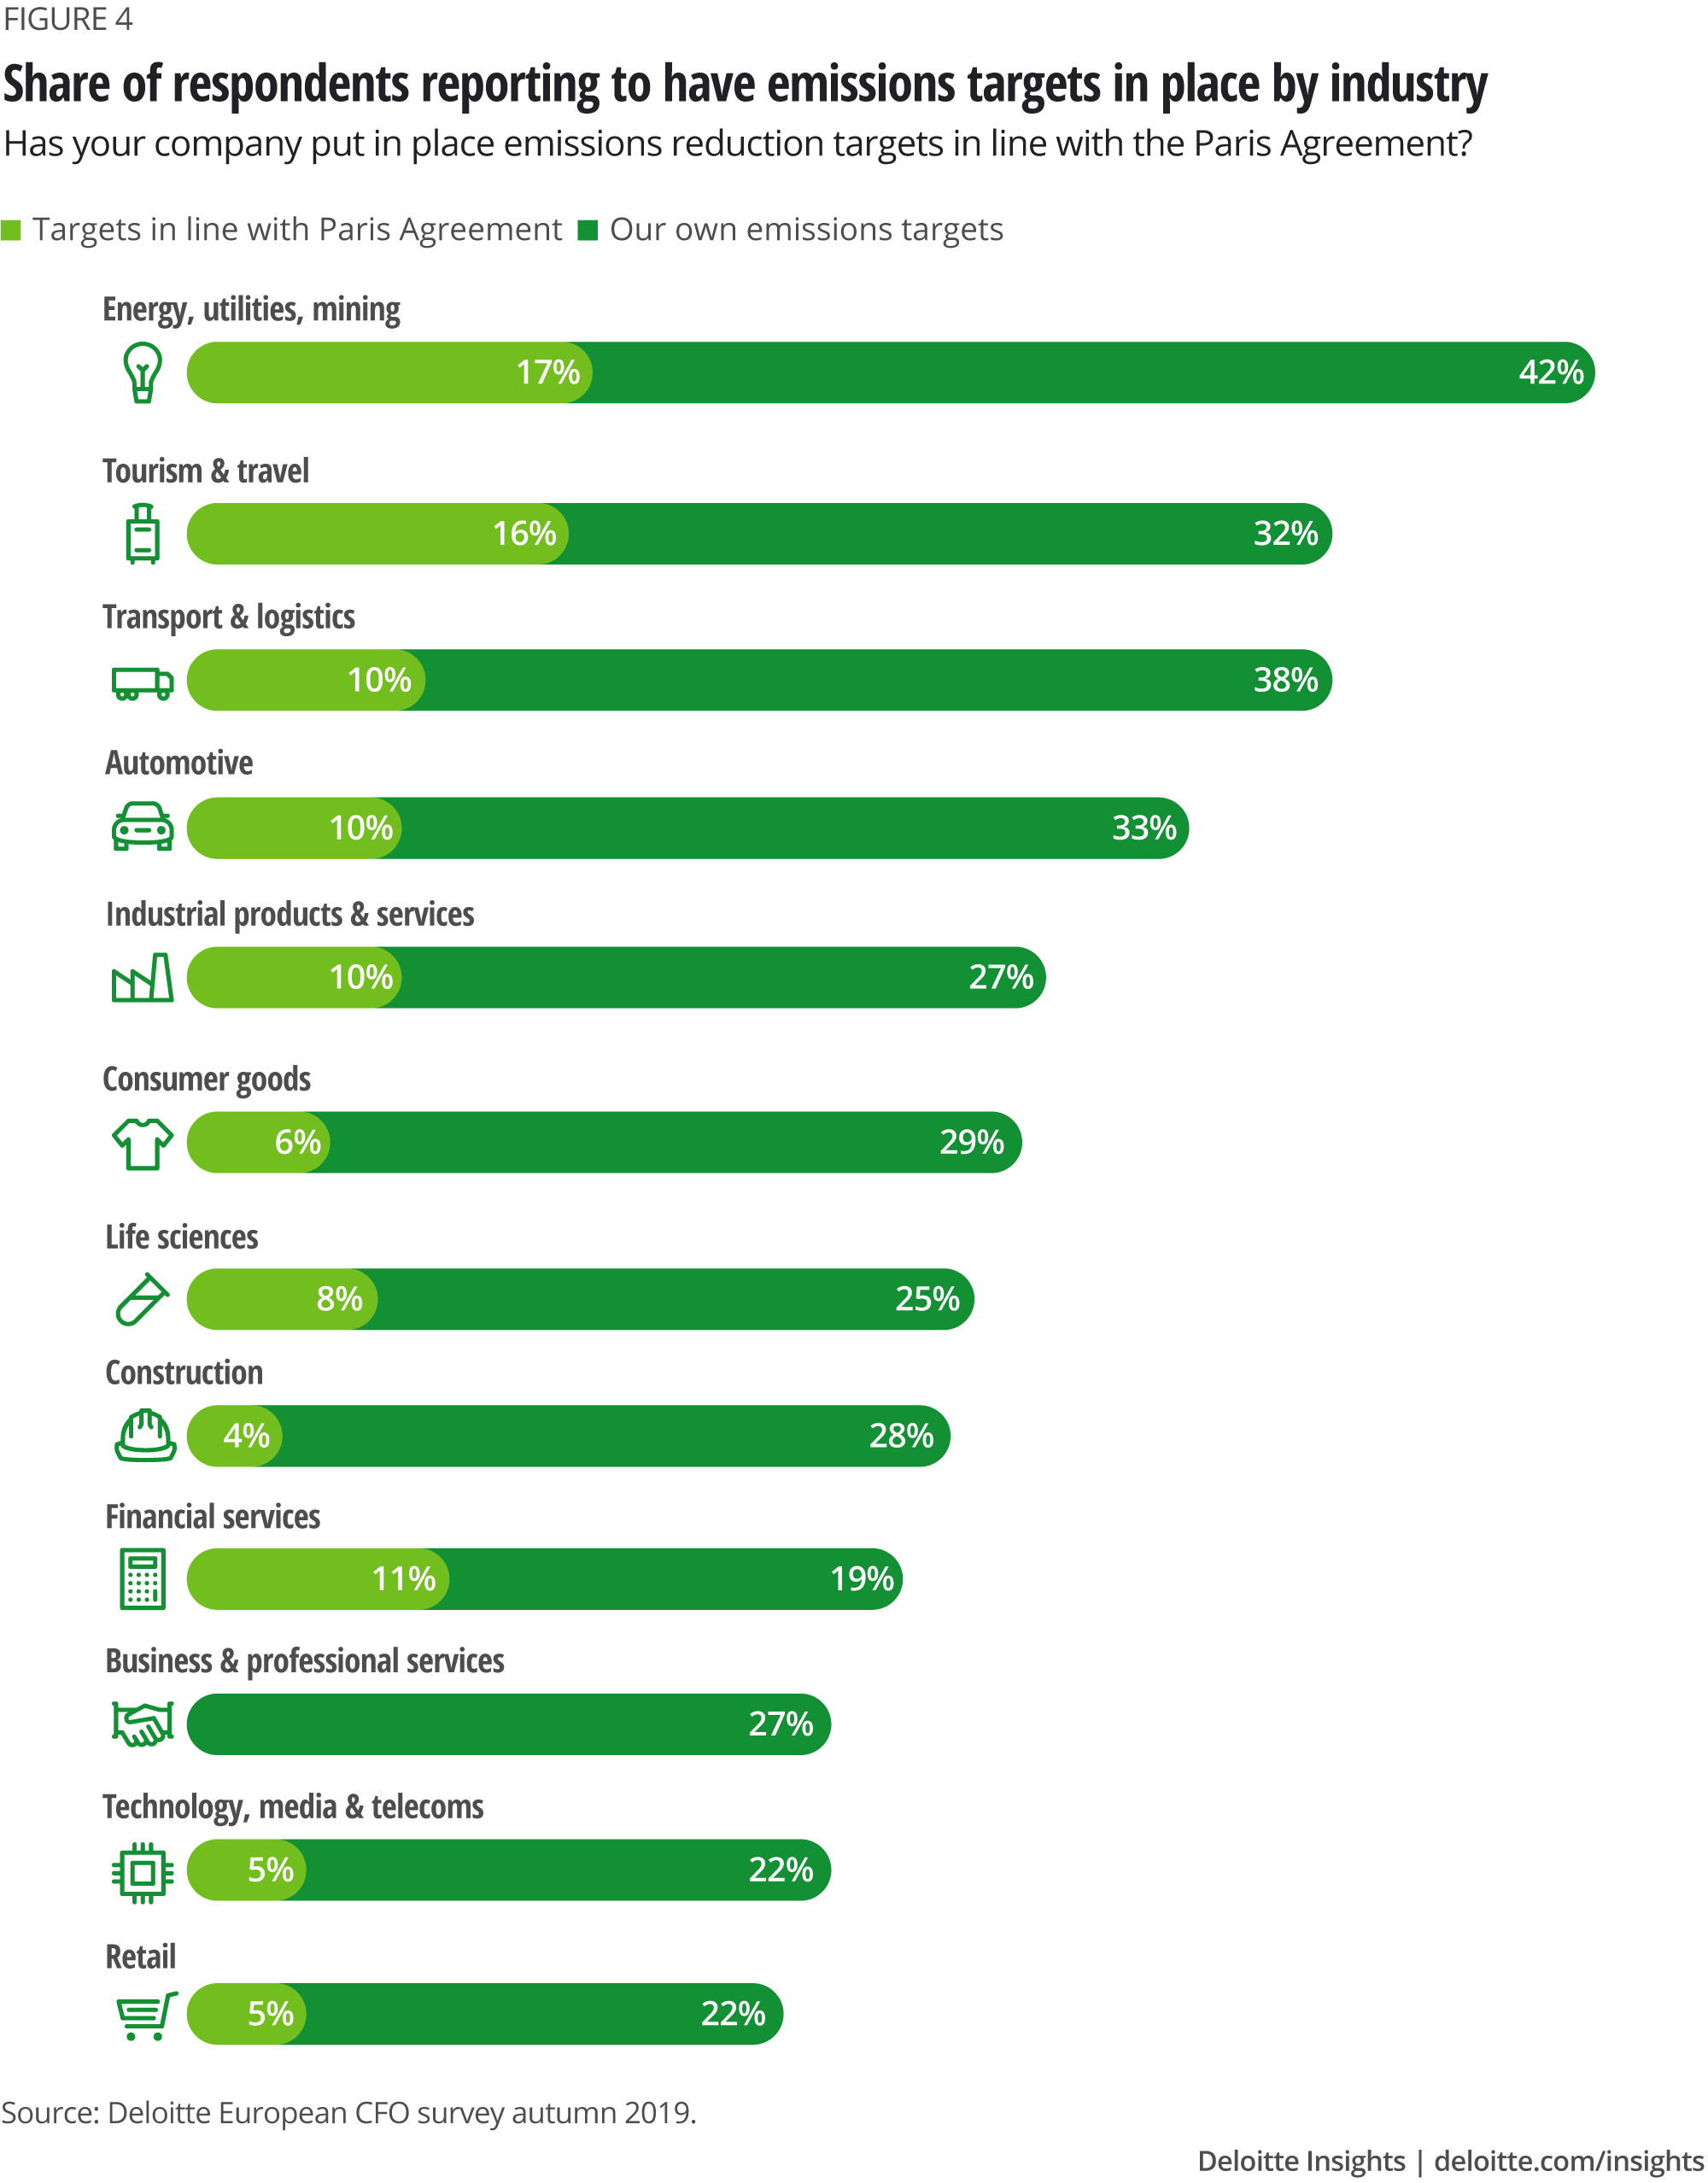
Another effect that climate change has had on the supply chain is that businesses may be forced or may decide voluntarily to change suppliers to meet the targets set by their country of residence in reducing emissions. By changing suppliers’ businesses could be more likely to meet these targets set by their respective governments and thus save on emission-related taxes and will also boost their overall brand image could help them to make more sales. Businesses could change their suppliers to be located closer to the factories where their products are subsequently made as this will reduce the amount of traveling that would be required to do which in turn would reduce the number of emissions being released into the atmosphere. Businesses could also change to suppliers that are generally more environmentally friendly, for example, use more renewable energy sources and transport goods using electric powered vehicles rather than more traditional petrol- or diesel-powered vehicles. An example of where a business has threatened to change suppliers due to environmental reasons is Volkswagen, in 2019 Volkswagen told its 40,000 suppliers to cut their emission or risk losing their businesses (The economist 2019). Image from https://www2.deloitte.com/us/en/insights/topics/strategy/impact-and-opportunities-of-climate-change-on-business.html
Another area in which climate change is affecting business is in the packing of their materials, waste packaging is playing a huge role in our changing climate. To be sustainable a company must be conscious of their packaging as packaging is one of the main contributors to climate change in today's society. To be considered sustainable a business must have policies in place to ensure that they can meet the targets set by their respective governments in line with the Paris agreement. As of November 2020, CO2 emissions from the packaging was responsible for 1.1 global tonnes of CO2 per year, which is more than both the aviation and shipping industries (Henriksen 2020). If this issue is not tackled by business, then packaging materials are estimated to contribute to 32% of the world's entire CO2 emissions by 2050 (Henriksen 2020). This issue stems through the entire supply chain and thus everyone must come together to come up with the most sustainable and effective solutions possible. to reduce packaging waste there are several different things that a business can do, some options include use custom packaging that helps to reduce the overall footprint of the item and thus takes up less space whilst in transit which means more can be transported at a time, this reduces the number of trips needed to be made which reduces the amount of CO2 emissions released by transport vehicles. An example of this method being used today is Apple, they have stopped shipping earphones and chargers with their phones so that they can reduce the footprint of their boxes and thus transport more items at a time which reduces CO2 emissions as the number of journeys by transport vehicles is reduced. Multiple other methods can be used to tackle the packing waste pandemic that we are currently going through. Another change business have made in recent years is changing the materials that are being used within their packaging so that they can be reused rather than being put to waste. Some examples of businesses making changes to their packing due to our changing climate are Calvin Klein and ASOS. Calvin Klein has ambitious sustainability goals, one of these goals is to ensure that 100% of its packaging is sustainably and ethically sourced (Gomes, 2019). According to Calvin Klein's corporate sustainability report in 2018, it was stated that 74% of their packaging was now recyclable and has managed to save 200 tonnes of plastic waste simply by reducing the thickness of their bags (Gomes, 2019). As of 2018 ASOS used 25% of recycled materials for their bags, like Calvin Klein they also reduced the thickness of their bags which allowed them to save 583 tonnes of plastic annually (Gomes, 2019). Large businesses like these have had to make these changes due to climate change as they can have a huge effect on our climate's future and also because of the targets they are required to meet in accordance with the Paris agreement.
Conclusion
To conclude, climate change has had numerous effects on businesses both directly and indirectly in many more negative ways than positive. Climate change has forced businesses to make numerous changes, from how they make decisions, the materials they use in their products as well as their packaging, and what suppliers they use. All of these changes have had to be made due to the targets set by each business’s country of residence in line with the Paris Agreement 2016. Another contributing factor for these decisions is because public perception is also a huge factor as to how successful a business is, although businesses may lose money in the short term due to these changes in the long term they are likely to benefit due to the long term value of things such as renewable energy has as well as their public perception driving up sales. Climate change will always affect the way that businesses operate it is just down to them if they decide to embrace that change and thrive for years to come. Businesses must be vigilant when it comes to climate change as it is always changing. If we are to get a hold of climate change and save our planet businesses play a huge part in determining how well, we will do.
Bibliography
Coppola, D., Krick, T. and Blohmke, D., 2019. Feeling The Heat?. [online] Deloitte Insights. Available at: <https://www2.deloitte.com/us/en/insights/topics/strategy/impact-and-opportunities-of-climate-change-on-business.html> [Accessed 18 November 2020].
The Economist. 2020. The Great Disrupter. [online] Available at: <https://www.economist.com/special-report/2020/09/17/the-great-disrupter> [Accessed 18 November 2020].
Mainwaring, S., 2018. Why And How Business Must Tackle Climate Change Now. [online] Forbes. Available at: <https://www.forbes.com/sites/simonmainwaring/2018/10/25/why-and-how-business-must-tackle-climate-change-now/?sh=56ee0fc44712> [Accessed 12 November 2020].
RE100. 2020. RE100 Members | RE100. [online] Available at: <https://www.there100.org/re100-members> [Accessed 19 November 2020].
Jackson, R., 2020. The Effects Of Climate Change. [online] Climate Change: Vital Signs of the Planet. Available at: <https://climate.nasa.gov/effects/> [Accessed 19 November 2020].
Recycle-more.co.uk. n.d. Recycle More | Recycling Facts. [online] Available at: <https://www.recycle-more.co.uk/household/recycling-facts#:~:text=Waste%20facts%201%20Around%2030%20million%20tonnes%20of,been%20safely%20consumed.%20%28source%3A%20WRAP%29%20More%20items...%20> [Accessed 19 November 2020].
Maganello, K., 2019. How Will Climate Change Impact The Supply Chain?. [online] Thomasnet.com. Available at: <https://www.thomasnet.com/insights/how-does-climate-change-impact-the-supply-chain/> [Accessed 18 November 2020].
Bennett, M., 2019. Why More Than Half Of UK Businesses Are Planning To Increase Spend On Sustainability. [online] The Telegraph. Available at: <https://www.telegraph.co.uk/business/ready-and-enabled/sustainability/increasing-spend/> [Accessed 19 November 2020].
Amadeo, K., 2020. Natural Disasters Are A Bigger Threat Than Terrorism. [online] The Balance. Available at: <https://www.thebalance.com/cost-of-natural-disasters-3306214> [Accessed 19 November 2020].
Woetzel,J., Pinner,D., Samandari,H., Engel,H., Krishnan,M., Kampel,C., & Graabak,J . 2020. Could Climate Become The Weak Link In Your Supply Chain?. [online] Available at: <https://www.mckinsey.com/business-functions/sustainability/our-insights/could-climate-become-the-weak-link-in-your-supply-chain#> [Accessed 19 November 2020].
Wei, D., 2018. Climate And Supply Chain | Reports | BSR. [online] Bsr.org. Available at: <https://www.bsr.org/en/our-insights/report-view/climate-change-and-supply-chain-the-business-case-for-action> [Accessed 19 November 2020].
The Economist. 2019. Climate Change And The Threat To Companies. [online] Available at: <https://www.economist.com/leaders/2019/02/21/climate-change-and-the-threat-to-companies> [Accessed 19 November 2020].
Henriksen, A., 2020. Why Cross-Industry Collaboration On Packaging Is Crucial To Tackle Climate Change. [online] The Grocer. Available at: <https://www.thegrocer.co.uk/environment/why-cross-industry-collaboration-on-packaging-is-crucial-to-tackle-climate-change/649983.article> [Accessed 19 November 2020].
Nunez, C., 2019. Renewable Energy, Explained. [online] Nationalgeographic.com. Available at: <https://www.nationalgeographic.com/environment/energy/reference/renewable-energy/> [Accessed 18 November 2020].
Wright, C and Nyberg, D. (2017). An inconvenient truth: How organisations translate climate change into business as usual. 60(5), p1633-1661.
Nasa 2020, accessed 15th November 2020 <https://climate.nasa.gov/evidence/ >
Deloitte 2019, accessed 17th November 2020 <https://www2.deloitte.com/us/en/insights/topics/strategy/impact-and-opportunities-of-climate-change-on-business.html>

