DS 1 Template

My Screenshots/Photos
- Please add 4–6 screenshots or photos of your digital life.
- You can use your phone or laptop.
- For each screenshot, write one or two sentences explaining what it shows.

Screenshot/Photo 1
[Insert Photo/Screenshot below]
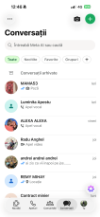
I am using whatsapp to keep in touch with my family and friends.

Screenshot/Photo 2
[Insert Photo/Screenshot below]
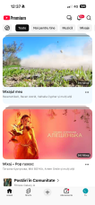
When I want to listen to music, find some tutorials or reviews about something, I am using the “Youtube” app.

Screenshot/Photo 3
[Insert Photo/Screenshot below]
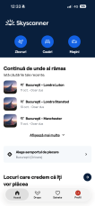
If I have to travel abroad, through the “skyscaner” app I can find and book the flight tickets.

Screenshot/Photo 4
[Insert Photo/Screenshot below]
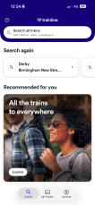
In order to get to the airport we need a way of transport. For this I am using the “trailine” app because is very reliable.

Screenshot/Photo 5
[Insert Photo/Screenshot below]
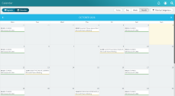
For me to remember all the important dates it is very easy to use the “outlook calendar” app.

Screenshot/Photo 6
[Insert Photo/Screenshot below]
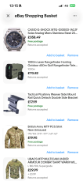
When I need one item that I can not find in nearby shop, I am using the “ebay” app to purchase it.

My Short Reflection
- Write 5–8 simple sentences about your digital life.
- You can use the sentence starters below if helpful.
I use digital tools to make my life easier and to save time.
I want and need to improve using the “excel” “word” and “powerpoint” apps because I have to use them at my workplace and I know just the basics of them.
I often use the social media apps such as “whatsapp” “facebook” and others but I also use the banking apps and online shopping.
I hope this module will help me improve using most of the important digital tool in order to succeed in my job and get a higher position.
Digital skills are very important for me because they help me with my job and be side of that they are required in most of the jobs now
What I feel nervous about, is using the apps that I have to improve.

Sentence starters
- I use digital tools to …
- I feel confident when I …
- I want to improve …
- I often use these tools: …
- I sometimes feel nervous about …
- I hope this module will help me …
- Digital skills are important for me because …
You can write more if you want.

Submission Checklist
Before you submit, please check:
​​​ ☒ I added 4–6 screenshots
☒ I wrote short sentences for each screenshot
☒ I wrote my short reflection
☒ My work is my own
☒ My file opens correctly
​​☒ My file opens correctly

