

Programme: Master of Business Administration
Module: Strategic Management
Module Code: LCMB7003

BP’s UK Offshore Wind: Strategic Choices and Capital Discipline

Student’s Name: Bogdan Pacuraru
Student ID: 2245496

Table of Contents
Introduction 3
Part A: Planning Map 3
A1. Strategic Issue 3
A2. Strategic Analysis 6
A2.1 Macro-Environment Analysis 6
A2.2 Industry and Competitive Environment 8
A2.3 Internal Resources and Capabilities 11
A2.4 Strategic-Group (Competitor Analysis) 12
A2.5 Partnership and Dynamic-Capability Analysis 14
A2.6 Integrated Strategic Diagnosis 15
A3. Strategic Recommendations 16
A3.1 Strategic Options 17
A3.2 Recommended Strategic Direction 17
A3.3 Alternative and Trade-Off 18
A3.4 Implementation 18
A3.5 Risk and Mitigation 19
Part B: Reflective Account 20
Conclusion 22
References 23

Introduction
This report critically assesses British Petroleum public limited company’s (BP plc) strategic position in the offshore-wind market of the United Kingdom (UK), in particular the Morgan, Mona and Morven projects, as Hitt et al. (2024) directed. It looks at the impact of increasing project costs, shifts in policy conditions and partner departure on the strategic decisions and funding prioritisation of BP. The report utilises PESTEL, Porter’s Five Forces, VRIO, strategic-group and dynamic-capability analysis to consider external pressures, competitive dynamics and internal capabilities prior to considering strategic options and recommending a commercially disciplined response optimising valuable transition opportunities.

Part A: Planning Map

A1. Strategic Issue
BP plc is a long-established global energy company but this report focuses strategically on the offshore-wind portfolio of the United Kingdom (UK), which consists of the Morgan project, the Mona project and the Morven project, all three of which are located in the Irish Sea and the North Sea (BP p.l.c., 2025). As part of these projects, the combined potential generating capacity is 5.9GW, which is around 6 million UK homes (morvenoffshorewind.com, n.d.). These projects will therefore play a significant role in BP’s transition plans for the UK and the country’s offshore wind goals.
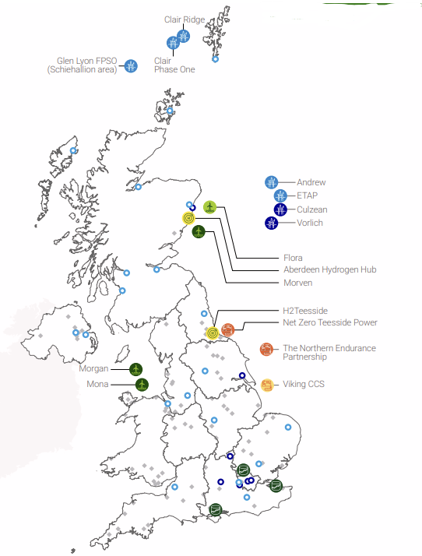
Figure 1: BP’s UK Business Footprint and Offshore-Wind Projects
(Source: BP p.l.c., 2025)
The strategic question explored is the management of BP’s UK portfolio of offshore wind that can be developed, when partner exits, the project economics worsens and the policy framework changes, without being detrimental to the capital returns and leaving BP unable to transition in the long term. This is a timely topic given BP’s transition-related investments are expected to fall to $1.5-2.0 billion per year by 2027 as part of a strategy shift to capital discipline and higher return opportunities to 2025 (Palmer, 2025). The question is not only one of whether offshore wind aids decarbonisation but whether specific projects continue to be both strategically and financially viable in BP’s modified capital priorities.
The problem has increasingly become more pronounced since EnBW revoked its withdrawal rights from Morgan and Mona in January 2026 together with the €1.2 billion impairment (EnBW Energie Baden-Württemberg AG, 2026). Rising supply chain expenses, decreased electricity prices and increased interest rates, implementation risk and the projects’ lack of government support through the latest Contract for Difference (CfD) auction were the challenges that EnBW identified. JERA Nex bp later would comment about other possibilities. This shift in the strategic environment has material consequences as BP has to decide whether to go ahead with the projects, restructure or make other partners or cut down on exposure projects whose commercial assumptions have become less robust.
However, external conditions are not entirely negative. The policy in the UK has also changed to make investments in offshore wind more effective. The government extended the life of new CfD contracts to 20 years and launched the Clean Industry Bonus to incentivise developers to invest in sustainable supply chains, as Crown (2025) reported. These measures offer the opportunity to boost project economics but do not resolve uncertainty relating to costs, financing, electricity prices, delivery and future auction results.
The decision also comes as BP formed JERA Nex bp, a 50:50 partnership deal with India’s NTPL, also completed in August 2025 (JERA Nex Ltd, 2026). The new business brings together some 1GW of installed power, a development pipeline of some 7.5GW and 4.5GW under secured leases, alongside a clear goal of disciplined portfolio prioritisation, value optimisation and bringing in external funding and competitive finance, as JERA Co., Inc (2025) stated. Hence, BP is in an intermediate position between no investment and total exit, selective investment, based on the more capital-efficient model of partnership.
The problem is, therefore, not a simple one, because it is difficult both in itself and due to its interconnections. First, a lot of uncertainty and fast changes of environmental conditions including project economics, financing, supply chains and governmental support, as per Hayes (2022). Second, it presents a sustainability, commercial performance challenge furthering investment in offshore wind can help the UK decarbonise, provide energy security and contribute to BP’s longer-term transition and investment expertise but over-investment in offshore wind may result in an acceptable return on investment mismatch with shareholder expectations (Johnson and Scholes, 2023). On the other hand, over-reserve might cost the company strategic options and capabilities in a potentially critical energy market.
As such, there is no best response. BP needs to take a measured approach between the need for immediate controls on spending and the need for long term competitiveness and satisfaction of shareholders (Grant, 2021). The tension serves as the foundation for a subsequent external, industry and internal strategic analysis and an evaluation of alternative strategic responses.

A2. Strategic Analysis

A2.1 Macro-Environment Analysis
Factor | Key External Development | Strategic Implication for BP
Political | UK policy supports offshore wind through the Clean Power 2030 agenda and CfD reforms including longer 20-year contracts. | Creates stronger policy legitimacy and revenue visibility but support remains conditional on affordability and competitive allocation.
Economic | High interest rates, inflation, electricity-price uncertainty and supply-chain cost pressures have weakened project economics. | Increases investment risk and strengthens the case for strict capital-return thresholds and risk-sharing.
Social | Offshore wind supports energy security, employment, regional development and decarbonisation expectations. | Strengthens stakeholder support but BP must demonstrate tangible economic and social value.
Technological | Advances in turbines, foundations, grid integration and floating wind can improve future project competitiveness. | Creates opportunities for efficiency and innovation but requires specialist capabilities and continued investment.
Environmental | Offshore wind contributes to emissions reduction and energy-transition objectives while marine biodiversity impacts require management. | Supports BP’s transition legitimacy but increases environmental assessment and mitigation requirements.
Legal | CfD eligibility, planning, consenting, environmental requirements and contractual obligations shape project development. | Regulatory compliance is essential and can affect development timing, costs and investment decisions.
Table 1: PESTEL Analysis of BP’s UK Offshore-Wind Environment
(Source: Created by Author)
The PESTEL analysis shows that BP’s UK offshore wind portfolio is situated in an enabling but challenging macro-environment. The UK government’s Clean Power 2030 strategy further reinforces offshore wind’s strategic position and the reforms to CfD policy confirms policy support (Crown, 2025). Allocation Round 7 contains 20-year CfD contracts for offshore wind as well as measures to bolster investment confidence and supply-chain resilience (Gaborieau, 2026). Nevertheless, support is based on the commercial viability and value for the consumer of individual projects so the commercial risk at the project level cannot be transferred to the policy level.
Offshore wind is capital intensive and sensitive to financing costs, movements in electricity prices and inflation and supply chain pressures (Đukan et al., 2023). These conditions impact project revenue and the opportunity cost of investing BP capital in lower-carbon projects compared to higher-reward projects. BP cannot therefore take policy ambition as equal to economic attractiveness.
Socially, benefits of offshore wind include expectations of energy security, jobs, regional development and decarbonisation (González et al., 2025). However, developers need to set expectations on the local economic gain, environmental impact and cost to consumers. This puts pressure on BP to prove its value to society along with financial discipline.
Technologically, innovation in turbines, foundations, grid-integration and floating wind can enhance LTC competitiveness but also adds complexity in the execution process and capital needed (Eltohamy et al., 2026). Offshore wind is strategically legitimate and supports emissions reduction and energy-transition goals but projects are still subject to the needs of marine ecosystems and biodiversity.
Planning, consenting, CfD eligibility and contractual requirements result in planning and development dependency. The government’s announcement to allow some fixed bottoms to apply for CfDs under the umbrella of potential planning consent could help to make development more flexible, provided that they comply with the regulations.

A2.2 Industry and Competitive Environment
Porter’s Five Forces suggests that despite the positive policy support and long-term demand, the UK offshore-wind industry presents a moderate short-term opportunity for profitability due to high capital investment, competitive pressures and supply-chain challenges. This is especially relevant to BP as the projects at Morgan and the one at Mona have shown that competitive auction conditions can manifest itself at the project level as an economic risk.
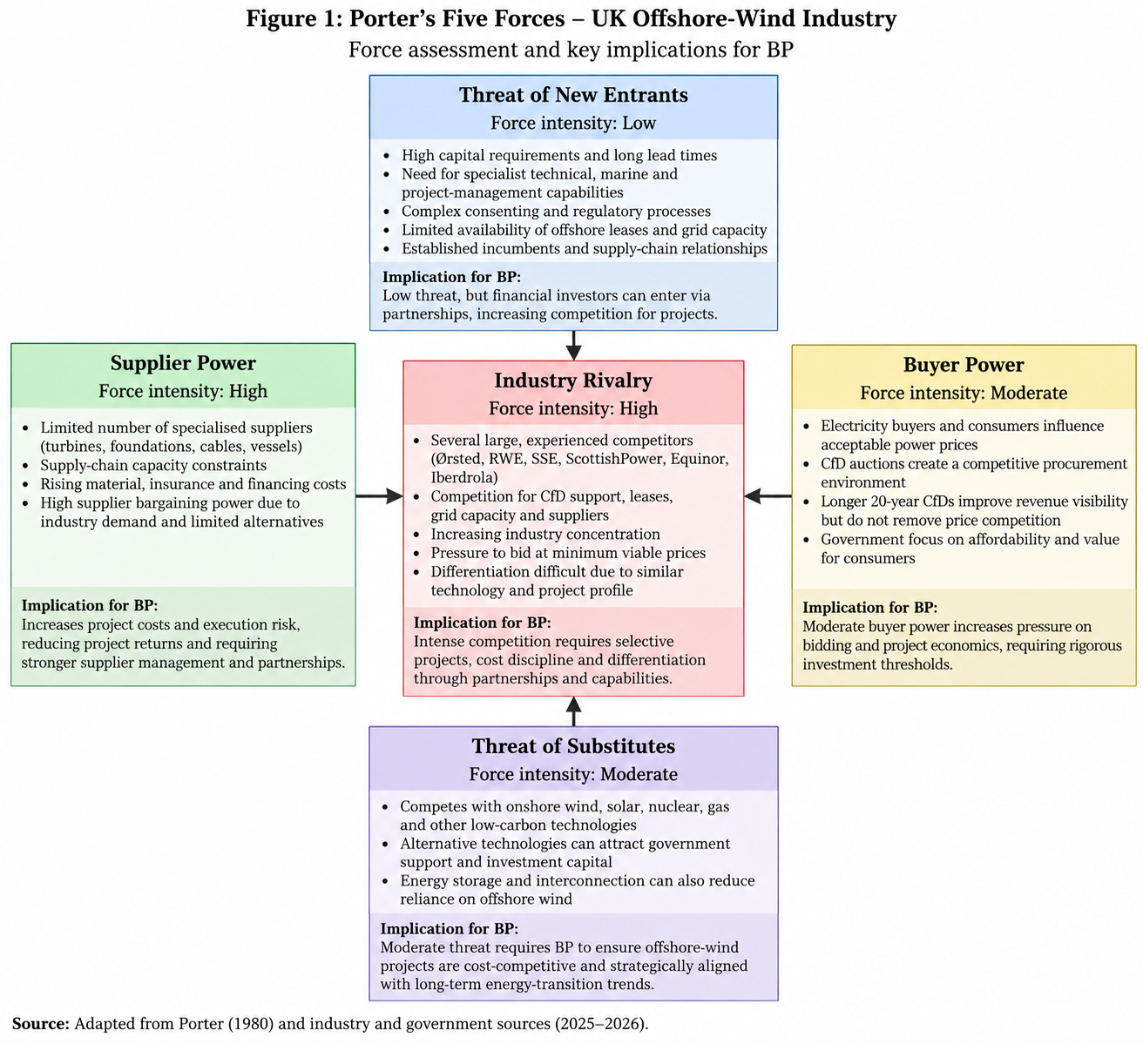
Figure 2: Porter’s Five Forces Analysis of the UK Offshore-Wind Industry and Implications for BP
(Source: Created by Author)
Competition is keen. There are a number of well-financed, experienced developers in the UK market such as Ørsted, RWE, SSE Renewables, ScottishPower Renewables, Equinor and Iberdrola. Inclusively, the concentration of developers is likely to grow with RWE and SSE Renewables likely to play a big part in the development of the industry through 2030 (Mordor Intelligence, 2026). Competition, therefore, is not only for projects but also for leases, CfD support, grid capacity, suppliers and investment opportunities. The problem here is that the competitors with more existing strong UK offshore-wind positions could have more experience and economies of scale, which makes BP’s task that much more difficult.
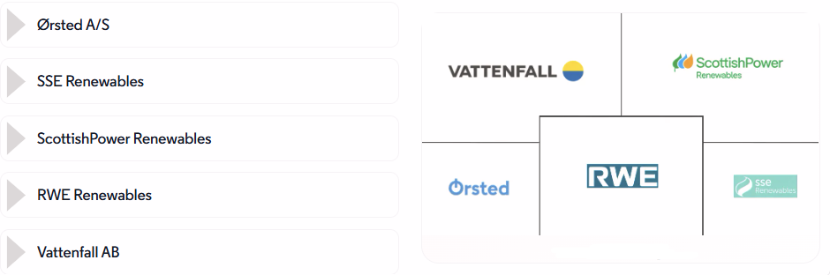
Figure 3: Top 5 UK Wind Energy Companies
(Source: Mordor Intelligence, 2026)
Power of the suppliers is relatively high. There is a need for specialised turbines and foundations, subsea cables, vessels and engineering expertise for offshore-wind projects and limited capacity for the supply chain. Recent industry evidence includes continued availability challenges in the supply chain and increased costs of materials, insurance and financing (Crown , 2025). This limits developers’ capacity to take on the expense spike without compromising project returns. EnBW’s exit from Morgan and Mona only adds to this structural flaw primarily due to rising supply-chain costs as well as higher interest rates and implementation risks (EnBW Energie Baden-Württemberg AG, 2026).
Buyer power is medium but has strategic importance. Acceptable power prices are effectively determined by the electricity buyer and consumer and the CfD mechanism establishes a very competitive path to guaranteed collections. AR7 has introduced 20-year inflation-indexed CfDs but when there is competition, developers bid to the minimum viable price (Gaborieau, 2026). Therefore, it is not certain that those who win an auction will necessarily achieve better returns.
There is medium risk of substitutes. Offshore wind competes with onshore wind, solar, nuclear and various other low carbon technologies for the support of the government, grid capacity and investment capital. Offshore wind would still have the benefits of scale and of resources, which makes it strategically relevant in the long term (Afridi et al., 2024).
The threat of new entrants is relatively low. There are significant barriers due to high capital costs, specialist skills, agreed complexity, supply experiences and connections to offshore leaseholds. Nonetheless, financial investors do not have to come up with their own projects; rather they can come in on a partnership basis as was the case with RWE’s 50% partnership on its Norfolk projects with KKR, for example (Steitz, 2026).

A2.3 Internal Resources and Capabilities
A VRIO (Value, Rare, Inimitable, Organised) analysis implies that BP has substantial resources and capabilities that apply to UK offshore wind but not investing in full scale is not a foregone conclusion. BP’s biggest asset is that it has a lot of money, an energy-industry background, a project-development ability and a network of partners.
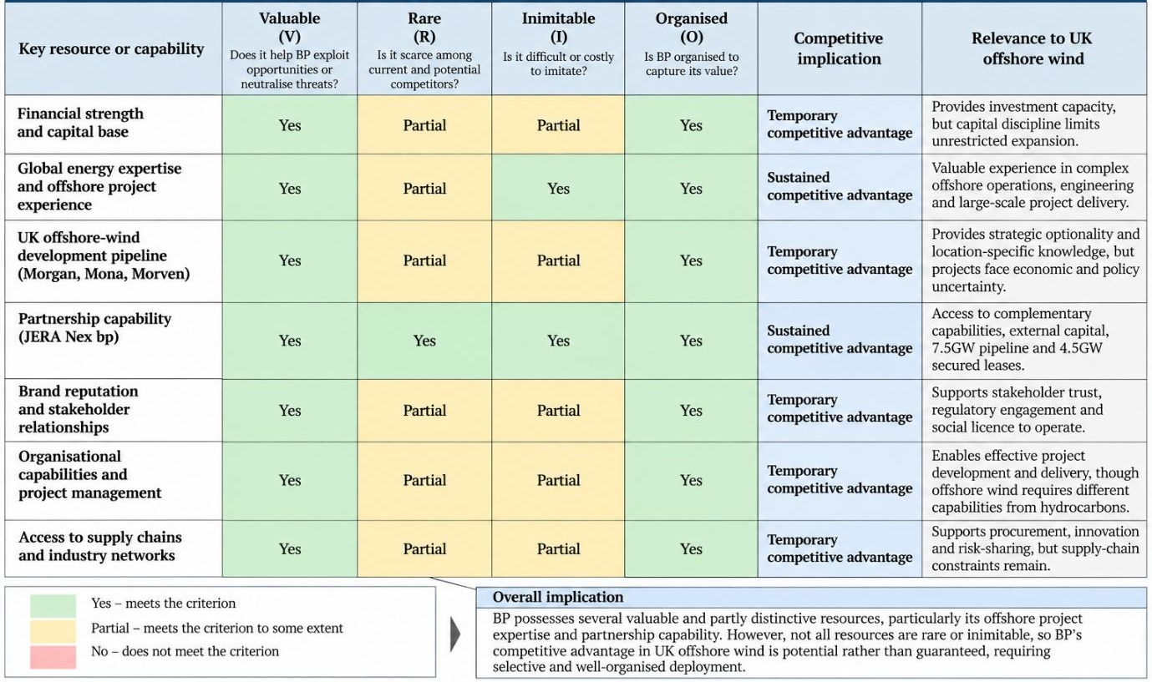
Figure 4: VRIO Analysis of BP’s Key Resources and Capabilities in UK Offshore Wind
(Source: Created by Author)
Despite BP’s financial and organisational resources, these resources are increasingly limited by its capital-allocation reset. The company has clearly moved from fewer, lower-value opportunities to more, higher-value opportunities and a more capital-light approach for low-carbon businesses. Financial capacity is useful but can also lead to an opportunity cost issue because offshore wind is vying for money with BP’s more lucrative ventures, as per Henry (2025).
It is more challenging to imitate its technical and project-management skills. BP has extensive expertise in energy infrastructure, offshore operations, engineering, procurement and development of large projects (Li, Trencher and Asuka, 2022). Its activities in the UK offshore-wind sector have also resulted in location-specific knowledge, supplied through a series of surveys and consenting exercises, community engagement and the development of the Morgan, Mona and Morven projects. These are the skills that constitute the ability to manage technically complex offshore projects but offshore wind is very different from BP’s hydrocarbon background.
BP’s most significant potential VRIO advantage is that it has both the skills and the resources to partner with outside firms. Besides, with the launch of JERA Nex bp, complementary investment strategies, knowledge, connections and buying power are combined. The 50:50 operation has about 1GW of installed capacity and a 7.5GW development pipeline and 4.5GW of secured leases with the model specifically focusing on projects based on value and access to external capital (JERA Nex Ltd, 2026). This partnership capability could be useful and hard to source rapidly organisationally through BP’s existing partnerships.
However, BP’s resources also show strategic vulnerabilities. Its lower carbon portfolio has faced transition volatility and its new approach to capital discipline has lessened its appetite for transition projects with unpredictable returns. Furthermore, with the withdrawal of EnBW from Morgan and Mona while established partnerships may not guarantee projects against adverse economics.

A2.4 Strategic-Group (Competitor Analysis)
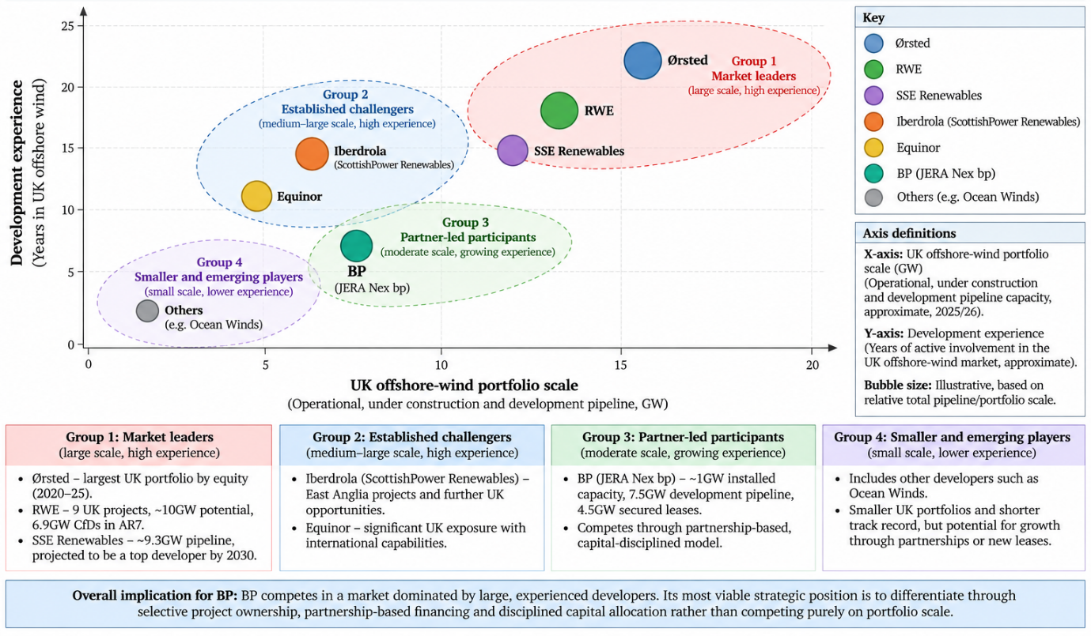
Figure 5: Strategic-Group Analysis of Key Competitors in the UK Offshore-Wind Industry
(Source: Created by Author)
The strategic-group analysis provides BP with a positioning of its competitors based on the size of the offshore-wind portfolio, development experience, capital commitment and partnership capability. This is more useful than looking at all providers as being in the same position as the following reasons:
The top strategic group consists of RWE, SSE Renewables and Ørsted, who have large wind-portfolios in the UK offshore market and have developed capacities. Ørsted is likely to lead the development market in terms of equity size in 2020-25 with the UK’s RWE and SSE expected to be the two largest developers by 2030 (powermag.com, 2025). RWE has strong competitive momentum with its portfolio of projects in the UK including 9 with around 10GW of potential capacity and a new CfD award of 6.9GW over 20 years (finansdanmark.dk, 2025). This is the case compared to BP’s impacted portfolio which is more stagnant.
The second group consists of companies such as Iberdrola or ScottishPower Renewables and Equinor, who have core international expertise and exposure in the UK but different approaches to their portfolios. Iberdrola, for instance, has projects for East Anglia in the construction phase, not to mention other development prospects in the UK but it has a strategy of not spreading its offshore-wind investments out (Iberdrola, 2026). The same applies to Equinor, which has a solid understanding of offshore energy developed into a comprehensive international energy portfolio.
BP is in a unique position, given the evolution of its business model and increased embrace of partnership-based, capital-disciplined participation rather than relying solely on ownership scale as a competitive advantage. Its JERA Nex bp structure offers them complementary capacity and capital, which could further limit BP’s exposure to the incident. This is similar to the growing partnerships in the industry as RWE, for instance, has been working with KKR on the project Norfolk Vanguard as well as collaborating with Masdar and SSE on projects in the UK (Steitz, 2026).
However, the comparison does show an important strategic weakness for BP, the competitors with secured CfDs and bigger near-term pipelines can boast of stronger market positions and larger economies of scale. On the other hand, if BP can facilitate risk sharing without compromising access to valuable strategic projects, its capability will prove to be an asset, according to David (2022). UK’s AR7 results prove that there is still good potential for offshore wind but competition for projects of interest is high.

A2.5 Partnership and Dynamic-Capability Analysis
To respond to the UK's offshore wind challenge, the UK oil major must analyse its strategic partnerships and dynamic capabilities, through which it can engage in a capital-intensive market without having to shoulder the entire capital and operational risk. BP already has its sights on a model of offshore-wind powered by partnerships (Heubeck, 2023). Its annual report for 2024 indicated that the firm had shifted its offshore-wind model to work with partners and external financing to develop a more capital-light and enhance equity returns. With the UK projects Morgan, Mona and Morven where BP has partnered with EnBW, this is a strategy that is particularly applicable (Cozzolino and Verona, 2024).
At a business-level strategy level, partnerships are a type of business-level differentiation. BP brings its offshore engineering and project-development and energy-market expertise, to team up with partners' financial resources, technical expertise and local capabilities. This will save BP from having to invest on its own in a market that is also very appealing for growth. This new, 50:50 offshore wind joint ventures, JERA Nex bp, is another example of this trend toward linking up complementary strengths and reducing investment risk (Herath and Harrington, 2023).
The relationship can also be viewed according to the dynamic capabilities theory, specifically sense-making, seizing and transforming capabilities. But before the company can make its decision, it will have to respond to changes in the economics of offshore wind, such as inflation, supply chain issues, finance costs and the shifting contours of UK energy policy. This is important because BP has previously seen just how it can impact costs; in its annual report, it noted that supply-chain inflation was present for offshore wind and that projects need to be prioritized based on returns and feasibility. BP can then pursue opportunities by strategically advancing projects that have a greater risk adjusted return through partnerships and external financing (Hong et al., 2024). Lastly, BP will need to adjust its portfolio, capital allocation and partnership arrangement continually as market conditions evolve.
Thus there is no need to have BP go for offshore wind with a volume maximisation strategy. Rather a focused partnership model should be used, with projects that have a good strategic fit retained, with risks of development, construction and financing shared. This would enable BP to maintain its ability and strategic optionality in UK offshore wind, while continuing to focus on capital discipline.

A2.6 Integrated Strategic Diagnosis
The strategic diagnosis suggests that the central question for BP is whether or not to enter into UK offshore wind – not how.The strategic diagnosis is that the question for BP is not whether to enter into the UK offshore wind, but how to enter in a way that protects capital returns. Offshore wind is still strategically important as the UK government is still putting the effort into supporting large-scale offshore development and energy security (Malleret et al., 2024). The Morgan project was given development consent in 2025, and is part of the UK's plans to achieve 50GW of offshore wind by 2030. However the economics of offshore wind has become more difficult since the time of inflation, supply chain difficulties and increased financing costs.
The resource based view implies that BP has valuable project development, engineering, energy trading and stakeholder management skills or abilities that can help it participate in this market. However, these resources cannot ensure that there is no risk of unlimited capital (Hansen et al., 2024). The better strategic option, then, is to bring together the unique strengths of BP, and then look to external sources of investment and partners with complementary skills.
This diagnosis implies that a differentiation and a strategy based on strategic alliances should be pursued, not a general strategy of expansion. BP should hold UK offshore wind assets which offer good risk-reward tradeoffs, learning and long-term asset values (Bastos Sathler et al., 2025). This is reflective of its trend towards capital-light platforms and partnerships; BP reports that transition businesses are becoming more capital-light and cost efficient.
In sum, the strategic option is to be selective about commitments, rather than withdraw, or aggressively expand. BP should partner with others to share capital and risk; set high investment thresholds; and have the ability to scale up, restructure, and/or divest projects as market conditions change (Santhakumar et al., 2023). This way it's able to align its UK stance on energy transition with its focus on profitability, cash generation and capital discipline.

A3. Strategic Recommendations
Analysis suggests BP needs to keep a picky stance on UK offshore wind, but only via a partnership-driven, capital disciplined approach as it can be considered to be better than expansion or retreat. The recommendation is significant as offshore-wind economics have come under strain in the recent past, and BP has recently been undergoing a broader reset of its strategy to boost returns and reduce financial risk. The Morgan and Mona projects had not obtained support in the latest UK Contracts for Difference (CfD) auction, so EnBW exited the two in January 2026, on the grounds of increased costs for supplies, decreased electricity prices, increased interest rates and implementation risks.

A3.1 Strategic Options
BP has three overarching strategic choices to make. In aggressive expansion, BP will spend heavily on UK offshore wind and unearth opportunities such as Morgan, Mona and scale them up. This would help to maintain BP's role in the UK's energy transition and enable the company to benefit from future growth (Malleret et al., 2024; Martinez and Iglesias, 2024). It would, however, put BP at the exact same risks that have degraded the economics of offshore wind – high CAPEX, inflation, financing costs, supply chain and uncertain auction results.
Option 2 is a complete or substantial exit from UK offshore wind. This would be the most immediate capital protection as well as management focus and would follow BP's overall trend of increased return on investment. However, withdrawal would result in the loss of project-development capabilities, partnerships, and market knowledge and future strategic options in a sector that remains supported by UK energy policy (Hansen et al., 2024). The UK remains the leading market for CfDs as the key mechanism for supporting new low carbon generation and the allocation round 7 offered £900m for fixed-bottom offshore wind.
Selective partnership-led participation (option 3) is the preferred option. BP should have some exposure to projects, but not be the only capital supplier that has a long-term sound economic case. This option is similar to the dynamic-capability analysis due to the opportunity for BP to detect shifts in market conditions, capture good opportunities and adjust their portfolio as project economics decline.

A3.2 Recommended Strategic Direction
The policy for BP should be a capital light partnership with investment gates. Projects should move forward if they show acceptable risk adjusted returns, revenue support that is credible (based on likely revenue streams), and partner commitment that is adequate (based on the expected partnership). BP should therefore focus on projects that are at a high level of development maturity, have grid connections, are supply chain feasible, and are able to benefit from the competitive CfD support (Cozzolino and Verona, 2024).
Partnerships MUST continue to be a key element of this approach. The potential for complementing capabilities and securing competitive financing is illustrated by BP's 50:50 offshore-wind partnership with JERA (Malleret et al., 2024). The partnership should be established to share development and construction risks and give BP strategic control and access to offshore-wind skills.
In the case of Morgan and Mona, BP should be waiting to make further large capital investments until they have been independent evaluated for their economic worth. With EnBW's recent decision to NOT exercise the Agreement for Lease for Morgan, we need to be mindful and cautious. BP should create clear investment gates based on CfD outcome, project costs, financing requirements, partners' involvement and expected returns.

A3.3 Alternative and Trade-Off
The next best alternative is a full pullout from UK offshore wind. This would offer more near-term capital discipline and limit BP's risk in an industry facing high costs and financing strain. It would also help BP focus its resources on companies where it's anticipating better returns (Santhakumar et al., 2023).
This other choice is however very expensive in opportunity costs. Withdrawal may have negative effects on BP's relationship, renewables capabilities and relations with governments, investors and industrial partners. It may also limit BP's gains if offshore-wind economics improve through technological advances and/or decreasing financing costs or increasing government support.
Selective participation is thus a conscious compromise: BP will take risks with a limited amount of capital to maintain strategic optionality but not with unlimited capital risk. This is more in line with the strategic flexibility than both extremes (Sørheim and Linnerud, 2024). The UK government's offshore-wind policy also remains a source of potentially more consistent income through CfDs, such as the 20-year contracts in place with the most recent policy.

A3.4 Implementation
The investment should be managed in accordance with a stage-gate investment process. First, BP should carry out a standalone commercial assessment of each offshore-wind project in the UK, including capital spending, expected return, supply-chain commitments, grid connection, financing assumptions and revenue certainty (Heubeck, 2023). In projects where the financial thresholds are not met, halt, renegotiate or exit projects.
Second, BP needs to improve partner governance. For each major project, there should be well-defined responsibilities for capital provision, construction risks, procurement, technology and project delivery and exit rights. This is particularly important following EnBW's withdrawal from Morgan and Mona.
Third, BP should establish a specific senior investment committee for offshore wind – with a sample mix of finance, engineering, procurement, commercial and regulatory skills. Those in charge should reward discipline in capital deployment not just the ability to grow (Herath and Harrington, 2023). Therefore, the measures of performance should include risk adjusted return, capital employed, cost variance, project milestones and commitments of partners' funding.
Lastly, BP needs to learn from each project. Learning from procurement, financing, participation in auctions and partnership management should be shared across the portfolio, thus bolstering BP's dynamic capabilities instead of considering each project as an individual investment opportunity.

A3.5 Risk and Mitigation
The major risk is economic risk, including additional rises in construction and financing expenses. To reduce this, BP needs to make conservative financial assumptions, contingency allowances and staged capital commitments. The second risk is policy & revenue risk, as government support and auction results are a key component of project viability (Hong et al., 2024). BP should not be making final investment decisions if the revenues are not adequately visible.
The third risk is partner risk as shown by EnBW's exit. BP's partnership due diligence, contractual funding commitments and well-defined exit strategies need to be tighter (Martinez and Iglesias, 2024). The fourth risk is strategic inconsistency—investing in a high amount of offshore wind could compete with BP's current focus on capital discipline (Bastos Sathler et al., 2025). This should be managed via board investment limits and on-going portfolio reviews.

Part B: Reflective Account
My strategic thinking was influenced by the necessity to separate BP's strategic involvement with UK offshore wind from the more short-term issue of the continued capitalization. I will start it off by saying that I have deliberately posed the question as to how BP should balance the participation in UK offshore-wind with capital discipline, rather than whether BP should remain in renewable energy, overall. Narrow framing was important here because a sustainability or corporate-strategy conversation could make the financial and strategic dilemma being faced by the organisation lost in the mix. As a consultant, I agree with this approach since it links the market factors to a threshold decision – expand, pull back, or make selective moves.
The resource based view (RBV) and dynamic capability theory and strategic partnership concepts were chosen as the resources because they referred to various aspects of the decision. The RBV approach prompted me to reflect on the possible capabilities of BP that make it worth staying involved, such as its project-development and engineering capabilities, and its energy market capabilities. Dynamic-capability theory focused my thinking on the question: Can BP detect shifts in market conditions, be able to capitalize on market opportunities, and reconfigure its portfolio when assumptions are changing? This was significant because offshore wind is an investment, technology and operation intensive initiative. However I saw through the idea of trying to apply these theories mechanically and came to the conclusion that BP should go on investing because it has some valuable resources. As a result, I placed greater emphasis on the capital discipline and risk-adjusted return, which acknowledged the practical aspects of making strategic decisions.
The confidence I had in the recommendation was also based on my evidence base. I used BP's corporate and annual report disclosures as my primary sources and information from the UK government on offshore-wind policy and Contracts for Difference, as well as recent evidence on the evolving economics of offshore wind. The sources were suitable as they could provide direct evidence regarding BP's strategic priorities and the regulatory environment. But the inherent drawback to corporate disclosures is that the information is given to the investors by the management who may highlight the most advantageous possible interpretation of the information. The information provided by government sources is more reliable with regard to policy and regulatory information, but is less likely to be able to determine if an individual project will ultimately yield a satisfactory return. Therefore, I did not take the evidence as the basis for a specific prediction of project profitability in the future, but instead relied on it as enough to make a directional recommendation.
However a number of assumptions lie behind my recommendation. I believed the offshore wind market in the UK was going to be a strategically significant area and that BP would be able to find credible parties and that if they could work on a more selective basis they would be able to get to some reasonable economics depending on the way they structured the capital exposure. I also assumed that BP's strategic abilities are not only useful for a single project, but they are useful for the company's entire operation. Should financing costs stay structurally elevated, supply-chain inflation continue to trend upwards, or government support fail to keep up, my advice would be to further cut back on the portfolio. But if the offshore-wind price drops significantly or the chances of making a return improve, BP could make a logical move to boost its investment. I therefore view the recommendation as 'till further notice', rather than 'forever'.
Schon's reflection-on-action got me to understand that professional judgement is not just about using pre-existing models. In particular, a textbook strategic-growth approach might favour investment in a market with long-term growth potential. However, in BP's case, strategic attractiveness needs to be taken into account along with capital intensity, execution risk and shareholder expectations. A feature of the exercise is also the question of double-loop learning: I take the liberty of challenging not only projects that BP should support but the notion that BP must have a significant amount of capital risk if it wants to participate in the market.
However, I know that this analysis is limited. I was not able to access BP's internal hurdle rates or partner negotiations at the project level, nor were I able to access BP's confidential project-level financial models. If the overall message from senior stakeholders was substantially different with regard to project returns, financing, or regulatory support, then I would reconsider my recommendation. I would stand up for the idea of picking and choosing projects, prioritized by the capital they require, but still be open to shuffling the projects themselves. So, my professional opinion will not be that BP shouldn't do anything because it must be done, but rather that BP should be investing when the evidence points to value creation, and it should be ceasing investments when the economics no longer make sense.

Conclusion
The approach for BP to continue to participate in the UK offshore wind sector should be through capital-light partnerships, investment gates and through disciplined risk-sharing. This is a method that helps achieve a balance between capital return and transition capability over the long-term. As economics and policy conditions continue to evolve, continued portfolio review will enable BP to scale or restructure or exit projects as they see fit.

References
Afridi, S.K., Koondhar, M.A., Jamali, M.I., Alaas, Z.M., Alsharif, M.H., Kim, M.K., Mahariq, I., Touti, E., Aoudia, M. and Ahmed, M.M.R., (2024). Winds of progress: An in-depth exploration of offshore, floating, and onshore wind turbines as cornerstones for sustainable energy generation and environmental stewardship. Ieee Access, 12, pp.66147-66166.
Bastos Sathler, K.P., Yeter, B. and Kolios, A., (2025). Impact of operational losses on the levelized costs of energy and in the economic viability of offshore wind power projects. Energy Sources, Part B: Economics, Planning, and Policy, 20(1), p.2437181.
BP p.l.c., (2025). bp in the UK Our impact on the UK economy in 2024. [Online] Available at: https://www.bp.com/content/dam/bp/country-sites/en_gb/united-kingdom/home/reports/bp-uk-eir-2024.pdf [Accessed on 10th September 2026]
Chen, Y.S., Hu, C.Y., Li, C.Y., Lin, J.B. and Shih, Y.C., (2025). Marine spatial planning for offshore wind firms: a comparison of global existing policies and data for energy system storage. Sustainability, 17(13), p.5884.
Cozzolino, A. and Verona, G., (2024). Decision tree for adaptation after radical changes: linking dynamic capabilities, ambidexterity, and strategic alliances. Journal of Management and Governance, 28(3), pp.745-769.
Crown, (2025). Clean Power 2030 Action Plan: A new era of clean electricity – main report. [Online] Available at: https://www.gov.uk/government/publications/clean-power-2030-action-plan/clean-power-2030-action-plan-a-new-era-of-clean-electricity-main-report [Accessed on 10th September 2026]
Crown, (2025). Consultation outcome Further reforms to the CfD scheme for AR7: government response to policy proposals (published July 2025 - accessible webpage). [Online] Available at: https://www.gov.uk/government/consultations/further-reforms-to-the-contracts-for-difference-scheme-for-allocation-round-7/outcome/further-reforms-to-the-cfd-scheme-for-ar7-government-response-to-policy-proposals-published-july-2025-accessible-webpage [Accessed on 10th September 2026]
D’Adamo, I., Di Leo, S., Gastaldi, M. and Ozturk, I., (2025). Exploring the economic feasibility of offshore wind energy for sustainable development. Energy Reports, 14, pp.3093-3104.
David, F. R., (2022) Strategic Management: A Competitive Advantage Approach, Concepts and Cases, Global Edition, 17th edition, Pearson
Đukan, M., Gumber, A., Egli, F. and Steffen, B., (2023). The role of policies in reducing the cost of capital for offshore wind. Iscience, 26(6).
Eltohamy, M.S., Aldawsari, M.S., Raouf, A., Youssef, H., Ahmed, I., Alsenani, T.R., Kim, Y.S. and Ahmed, M.M.R., (2026). Enhancing electric grid flexibility for the integration of variable renewable energy: Challenges, innovations, and future directions. IEEE Access.
EnBW Energie Baden-Württemberg AG, (2026). EnBW will not continue offshore wind projects Mona and Morgan in the UK. [Online] Available at: https://www.enbw.com/investors/news-and-publications/enbw-will-not-continue-offshore-wind-projects-mona-and-morgan.html [Accessed on 10th September 2026]
finansdanmark.dk, (2025). Analysis of barriers to increased financing and investment in the green transition Background report. [Online] Available at: https://finansdanmark.dk/media/4iyihqeb/climatepartnership_report_2025_en.pdf [Accessed on 10th September 2026]
Gaborieau, M., (2026). The offshore wind supply chain impact of UK Allocation Round 7. [Online] Available at: https://www.spinergie.com/blog/the-offshore-wind-supply-chain-impact-of-uk-allocation-round-7 [Accessed on 10th September 2026]
González, M.O., Jones, D., Santiso, A.M., Akbari, N., Melo, D.C., Nogueira, L.P. and Vasconcelos, R.M., (2025). Offshore wind and energy transition: lessons learned, progress, and trends. Annual Review of Environment and Resources, 50.
Grant, R. M., (2021) Contemporary Strategy Analysis, 11th edition, Wiley
Hansen, T.A., Wilson, E.J., Fitts, J.P., Jansen, M., Beiter, P., Steffen, B., Xu, B., Guillet, J., Münster, M. and Kitzing, L., (2024). Five grand challenges of offshore wind financing in the United States. Energy Research & Social Science, 107, p.103329.
Hayes, J., (2022) The Theory and Practice of Change Management, Bloomsbury Publishing
Henry, A. E., (2025) Understanding Strategic Management, 5th edition, Oxford University Press
Herath, D.B. and Harrington, S., (2023). Saying yes to mess: disorganization as an antecedent to dynamic capabilities. Review of Managerial Science, 17(5), pp.1539-1558.
Heubeck, T., (2023). Looking back to look forward: a systematic review of and research agenda for dynamic managerial capabilities. Management Review Quarterly, pp.1-45.
Hitt, M. A., Ireland, R. D., Hoskisson, R. E., Harrison, J. S., (2024), Strategic Management Concepts & Cases Competitiveness & Globalization, 14th edition, Cengage.
Hong, S., McMorland, J., Zhang, H., Collu, M. and Halse, K.H., (2024). Floating offshore wind farm installation, challenges and opportunities: A comprehensive survey. Ocean Engineering, 304, p.117793.
Iberdrola, (2026). Iberdrola completes installation of the 95 foundations for its East Anglia THREE windfarm. [Online] Available at: https://www.iberdrola.com/press-room/news/detail/iberdrola-completes-installation-95-foundations-east-anglia-three-windfarm [Accessed on 10th September 2026]
JERA Co., Inc., (2025). JERA and bp launch offshore wind joint venture JERA Nex bp. [Online] Available at: https://www.jera.co.jp/en/news/information/20250804_2227 [Accessed on 10th September 2026]
JERA Nex Ltd, (2026). bp and JERA joining forces to create top-tier global offshore wind joint venture. [Online] Available at: https://jeranex.com/bp-and-jera-create-top-tier-global-offshore-wind-joint-venture/ [Accessed on 10th September 2026]
Johnson, G. and Scholes, K., (2023) Exploring Strategy, 13th edition, Harlow: FT Prentice Hall.
Kurpiela, S. and Teuteberg, F., (2024). Linking business analytics affordances to corporate strategic planning and decision making outcomes. Information Systems and e-Business Management, 22(1), pp.33-60.
Li, M., Trencher, G. and Asuka, J., (2022). The clean energy claims of BP, Chevron, ExxonMobil and Shell: A mismatch between discourse, actions and investments. PloS one, 17(2), p.e0263596.
Malleret, S., Jansen, M., Laido, A.S. and Kitzing, L., (2024). Profitability dynamics of offshore wind from auction to investment decision. Renewable and Sustainable Energy Reviews, 199, p.114450.
Martinez, A. and Iglesias, G., (2024). Levelized cost of energy to evaluate the economic viability of floating offshore wind in the European Atlantic and Mediterranean. e-Prime-Advances in Electrical Engineering, Electronics and Energy, 8, p.100562.
Mordor Intelligence, (2026). United Kingdom Wind Energy Companies: Leaders, Top & Emerging Players and Strategic Moves. [Online] Available at: https://www.mordorintelligence.com/industry-reports/united-kingdom-wind-energy-market/companies [Accessed on 10th September 2026]
morvenoffshorewind.com, (n.d.). Morven Offshore Wind Farm Offshore and onshore infrastructure in England. [Online] Available at: https://www.morvenoffshorewind.com/wp-content/uploads/2025/09/BP-ENBW_Morven_Brochure_Print_FINAL.pdf [Accessed on 10th September 2026]
Noble, D.R., Olsson, S., Grattan, K. and Jeffrey, H., (2026). An Analysis of Market Subsidy Costs for Utility-Scale Renewable Energy Generation in the UK. Energies, 19(12), p.2916.
Palmer, D, I., (2025). BP Resets To Oil, Backslides On Renewables: What Can We Learn Here. [Online] Available at: https://www.forbes.com/sites/ianpalmer/2025/03/11/bp-resets-to-oil-backslides-on-renewables-what-can-we-learn-here/ [Accessed on 10th September 2026]
powermag.com, (2025). Renewables 2020 Analysis and forecast to 2025. [Online] Available at: https://www.powermag.com/wp-content/uploads/2020/11/renewables_2020-pdf.pdf [Accessed on 10th September 2026]
Rubio-Domingo, G. and Linares, P., (2021). The future investment costs of offshore wind: An estimation based on auction results. Renewable and Sustainable Energy Reviews, 148, p.111324.
Santarromana, R., Abdulla, A., Mendonca, J., Morgan, M.G., Russo, M. and Haakonsen, R., (2024). Assessing the costs and benefits of dynamically positioned floating wind turbines to enable expanded deployment. Energy Conversion and Management, 306, p.118301.
Santhakumar, S., Heuberger-Austin, C., Meerman, H. and Faaij, A., (2023). Technological learning potential of offshore wind technology and underlying cost drivers. Sustainable energy technologies and assessments, 60, p.103545.
Sørheim, H. and Linnerud, K., (2024). Hybrid offshore wind projects. Social desirability vs. incentives to invest. Energy, 312, p.133612.
Steitz, C., (2026). RWE, KKR to partner on $15 billion British offshore wind projects. [Online] Available at: https://www.reuters.com/sustainability/climate-energy/rwe-sells-50-stake-british-norfolk-offshore-wind-projects-kkr-2026-01-14/ [Accessed on 10th September 2026]

