IMPLEMENTING A ZERO TRUST SECURITY FRAMEWORK FOR VIGILANT TRUST & ASSET MANAGEMENT (VTAM)
Table of Contents
Introduction 3
Identification of Modern Threats 3
Modern Security Policies: The Zero Trust Framework 4
Zero Trust Principles 4
Application of Zero Trust at VTAM 4
Framework Alignment 5
Technical Mitigation Measures 6
Proactive Monitoring and Incident Response 6
Continuous Monitoring 7
Incident Response Workflow 7
Integration with Zero Trust 8
Continuous Training and Awareness 8
Awareness Training Program 8
Communication Strategy 9
Continuous Improvement 9
Conclusion and Recommendations 9
References 10

Introduction
In the digital world today financial organisations, such as Vigilant Trust & Asset Management (VTAM) are dealing with more and more cyber threats both internally as well as externally. No longer can a conventional perimeter-based approach to security be considered effective in light of the emergence of phishing, ransomware-as-a-service (RaaS), and supply chain attacks. The following report suggests the use of the modern cybersecurity strategy that is focused on the Zero Trust architecture with reference to the NIST Cybersecurity Framework (CSF) principles and the Security Information and Event Management (SIEM) tools. The aim is to enhance the cyber resilience of VTAM, by implementing a proactive, layered system of defence that constantly provides verification of trust and minimises the attack surface.

Identification of Modern Threats
The financial services industry is one of the most susceptible to criminal activities by cybercriminals as a result of its sensitive and valuable data. Vigilant Trust & Asset Management (VTAM) is a medium-sized financial organisation, which has a sensitive threat environment, with external and internal parties taking advantage of the human, technical, and organisational vulnerabilities to achieve their objective. Such threats in the modern world are becoming more complex, computerised, and less likely to be detected, prompting VTAM and need to enhance its defences through an adoptive and multi-faceted security system.
VTAM has several high-impact cyber risks to which it is exposed externally. Phishing and vishing when assailants pretend to be the representatives of a trusted party, like an executive, or a client or a financial collaborator, in order to scam employees to provide confidential information or into permitting a fraudulent transaction, is one of the most widespread [1]. The Cybersecurity and Infrastructure Security Agency (CISA, 2024) indicates that phishing has remained the main method used by breachers of data in the industry. Ransomware-as-a-Service (RaaS) is one more rising issue in the context of which organised cyber groups rent ransomware toolkits to affiliates and share profits. Such attacks can be used to abuse poor email filters, old-fashioned systems, and ineffective back-up policies and they tend to cause system lockdowns, disruption of operations as well as reputational damage. Another serious threat is supply chains attack because, the cybercriminals can exploit third parties or software vendors and breach VTAM indirectly by using the updates or services integrations made by different parties -the approach used by hackers of SolarWinds. Also, cloud mis-configurations have become a significant threat as more financial institutions move to the hybrid environments. Lack of control on policies of gaining cloud access, or unencrypted storage buckets may make available large quantities of sensitive financial information to unauthorised persons.
There are also insider threats that are very dangerous internally. Leakage of data and violation of compliance can be caused by discontented employees, negligent behaviours or unintentionally breaking the policy laws.

Modern Security Policies: The Zero Trust Framework
Traditional perimeter-based security approach is no longer effective in a dynamic digital world where threats may be initiated by both external and internal sources of an organization [11]. To this end, Vigilant Trust and Asset Management are going to implement the Zero Trust security structure, which essentially is based on the premise of never trust and always verify. This model enhances the strong cyber resiliency of VTAM by introducing sustained cheques and balances, stringent access control, and active surveillance on all digital assets and systems.

Zero Trust Principles
The Zero Trust model assumes three main principles which are aimed to minimise the possibility of unauthorised access and data breach. First is Verify Explicitly that involving authentication of all access requests by strong identity verification and contextual verification such as device status and user behaviour [2]. Second, Least Privilege Access, where the users and the devices are only allowed permissions that they need to accomplish their work, is actually the best solution to minimising damage in an event of compromise. Lastly, Assume Breach, in which all activity is constantly monitored to detect anomalies where the assumption is that there is a potential intrusion already existing in the network. All these principles will improve the capacity of VTAM in identifying, preventing and responding to cyber incidents effectively.

Application of Zero Trust at VTAM
VTAM will consider Identity and Access Management (IAM), Multi-Factor Authentication (MFA), micro-segmentation integrated into its IT environment to operate this model. IAM solutions will take care of identity of users and provide access controls in accordance with job description and risk undertaken. MFA will add another authentication step, a mobile token or a biometric authentication, which will greatly decrease the number of credential-based attacks. Network segmentation will split the internal infrastructure of VTAM into secured areas to ensure that a lateral internal system attacker cannot move across it [3]. Moreover, Data Encryption, with AES-256 encryption of the data both at rest and transit, and Data Loss Prevention (DLP) tools will facilitate Data Confidentiality and Integrity. Lastly, user behaviour will be monitored on a continuous basis using Security Information and Event Management (SIEM) solutions that will record and process user behaviour, thus providing early notice of anomaly.
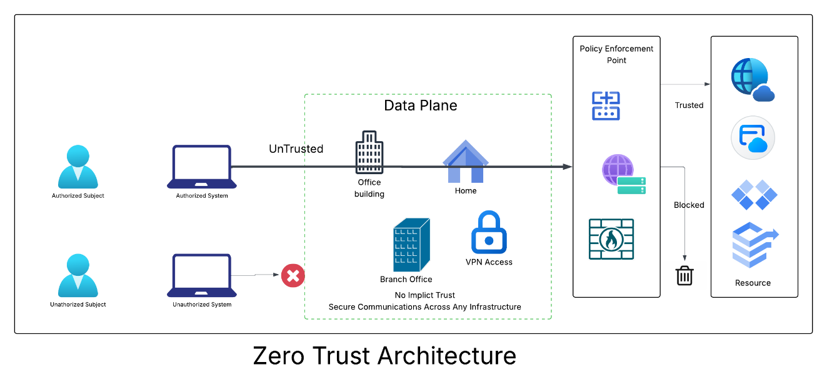
Figure 1: Zero Trust Architecture for VTAM
(Source: Obtained from Lucidchart)

Framework Alignment
Zero Trust policies are in direct correlation with the NIST Cybersecurity Framework (2020) that comprises five main functions. In Identity, VTAM will map important assets and compare the risk involved. Protect entails introduction of Zero Trust implementation controls like IAM, MFA, and encryption [10]. Detect defines the application of SIEM tools in the practice of continuous anomaly detection. Respond involves automatic incident response procedures which were activated by SOAR systems, and Recover provides business continuity by taking precise data backups and by resilience. All these policies will make up a comprehensive and responsive security stance of VTAM.

Technical Mitigation Measures
In order to implement its Zero Trust strategy, VTAM will integrate a number of technical mitigation controls, which will offer multi-layered security against advanced cyber threats. Such steps have the higher effect of proactive prevention and quick detection and automated response to improve the defence posture of the company.
The initial tier is by executing Multi-Factor Authentication (MFA) in which granted access to users is more than one factor, like a password and a mobile confirmation code. This greatly minimises risk of phishing or brute force attack on an account [4]. The posterior Security Information and Event Management (SIEM) tools, which include Splunk or IBM QRadar, will then be utilised to gather and examine the log data amongst many systems comprising servers, endpoints, and firewalls. These tools can be used to detect suspicious activity in real time using correlation rules, and machine learning, to aid in the early detection of threats.
Endpoint Detection and Response (EDR) solutions will be constantly built to track endpoints regarding malicious behaviour. The EDR system has the ability to automatically isolate in case of an attack of ransomware or malware in order to prevent lateral movement. There will be encryption and Backup mechanism to defend the integrity and availability of the data. VTAM can guarantee a rapid recovery after a ransomware attack; this can be achieved by encrypting valuable information with AES-256 standards and having a secure offsite backup.
Network Access Control (NAC) will help guarantee access of only authorised and legitimate devices to the network of VTAM. The combination of NAC and IAM with SIEM systems will allow the organisation to have centralised visibility and control, minimising the risks of having unauthorised or unmanaged devices [5]. Moreover, Patch Management Automation tools, including Microsoft Intune or ManageEngine, will be applied to automatically implement the update and patches to ensure that the known vulnerabilities cannot be exploited.

Proactive Monitoring and Incident Response
An effective cybersecurity plan should cover not only prevention, but also constant monitoring and response to incident. Vigilant Trust & Asset Management (VTAM) appreciates the importance of prompt notification and immediate response to mitigating the effects of any possible breach. VTAM will provide proactive monitoring, and automated management of incidents in real-time by deploying the most advanced Security Information and Event Management (SIEM) systems with obtained Security Orchestration, Automation, and Response (SOAR).

Continuous Monitoring
SGVTAM will consolidate the gathering of log information of varied origins through SIEM including firewalls, servers, databases, cloud as a service, and endpoints. These logs will undergo normalisation and correlation to recognise patterns which would indicate suspicious or unauthorised activity. Machine learning and rule-based analytics in SIEM will create warning signals in case anomalies are detected so that the security team can follow suit. Additional integration to the SOAR tools allows speeding up response efficiency by automating repetitive processes, including blocking malicious IPs or isolating infected devices, and reducing human error and response time. The adherence to regulations in the financial sector is also maintained due to the continuous monitoring that allows seeing the activities of the users and the processes in the system in real-time.

Incident Response Workflow
Unpreparedness will involve the Incident Response Plan (IRP) based on the NIST 800-61 lifecycle, which will make the response to security incidents organised and consistent. During the Preparation phase, employees are going to be trained on a regular basis and provided with the equipment to recognise and report on the threats. The SIEM will consist of: Detection and Analysis due to which the incidents will be identified and classified by their seriousness, and alerts will be sent to the security team [7]. Containment, Eradication, and Recovery phases entail the isolation of affected system, removal of malicious code and restoring normal business operations on clean backup. Lastly, the Post-Incident Review guarantees a steady rise of performance through examining the root cause of the incident and enhancing security controls and playbooks.
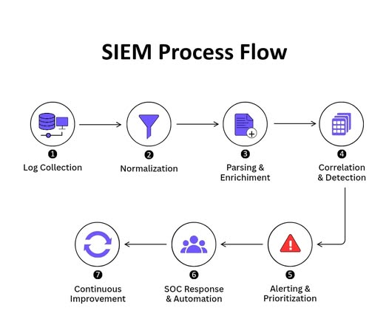
Figure 2: SIEM Process flow of VTAM

Integration with Zero Trust
The SIEM and SOAR frameworks are a direct reference to the principle of the Zero Trust model that presupposes the Assumed breach, as they help you have the situational awareness in real time and ensure verification on the basis of the zero trust. This integration will make sure to monitor, analyse and verify dynamically all user actions, data flows and interactions of systems with other systems so to maintain a consistent protection of the system against changing cyber threats.

Continuous Training and Awareness
Although cybersecurity is founded on advanced tools, human awareness to cybersecurity is the strongest defence. VTAM will thus develop a training and awareness programme of never ending nature to create a culture of security consciousness throughout the organisation.

Awareness Training Program
Cyber exercises will be conducted quarterly to mimic phishing and vishing attacks so that employees can be able to identify and appropriately react to offline attacks efficiently [8]. To supplement these exercises, interactive e-learning modules will also address such vital issues as password protection, data management and incident reporting. Additional incentives will be added through gamified leaderboards, that is, an award to those departments or individuals who can show a track record of security compliance and watchfulness.

Communication Strategy
A regular flow of information by means of monthly security newsletters and real time dashboards about ongoing threats and best practise will help strengthen the awareness. The Human Resources will work with IT to guarantee training attendance and tracking of compliance and involve cybersecurity competence in personnel performance assessments.

Continuous Improvement
These awareness cycles will be followed by a feedback collection and analysis. Experience will determine improvements to the future training content and shall make the future training material in line with the up and coming threats. The progress and the cultural improvement will be evaluated as key performance indicators, including fewer phishing clicks and higher incident reporting.

Conclusion and Recommendations
The current report is an entire cybersecurity plan of Vigilant Trust & Asset Management (VTAM), which is based on the principles of a Zero Trust network and supplemented with proactive and active monitoring and staff awareness initiatives [9]. The implementation of Zero Trust in an age when phishing, ransomware, and insider threats are getting more sophisticated every day ensures that each user and device is in a state of constant authentication, authorisation, and monitoring.
VTAM has the opportunity to effectively add together risks, regulatory compliance, and operational integrity by applying the recommended technical options, such as MFA, SIEM, EDR, and encryption. Resilience will also be improved by the implementation of a 24/7 monitoring, which will be equally backed by an automated incident response workflow.

References
Phiayura, P. and Teerakanok, S., 2023. A comprehensive framework for migrating to zero trust architecture. Ieee Access, 11, pp.19487-19511.
Fernandez, E.B. and Brazhuk, A., 2024. A critical analysis of Zero Trust Architecture (ZTA). Computer Standards & Interfaces, 89, p.103832.
Ahmadi, S., 2024. Zero trust architecture in cloud networks: Application, challenges and future opportunities. Ahmadi, S.(2024). Zero Trust Architecture in Cloud Networks: Application, Challenges and Future Opportunities. Journal of Engineering Research and Reports, 26(2), pp.215-228.
Edo, O.C., Tenebe, T., Etu, E.E., Ayuwu, A., Emakhu, J. and Adebiyi, S., 2022. Zero trust architecture: Trend and Impacton information security. International Journal of Emerging Technology and Advanced Engineering, 12(7), p.140.
Alevizos, L., Ta, V.T. and Hashem Eiza, M., 2022. Augmenting zero trust architecture to endpoints using blockchain: A state‐of‐the‐art review. Security and privacy, 5(1), p.e191.
Kodakandla, N., 2024. Securing cloud-native infrastructure with Zero Trust Architecture. Journal of Current Science and Research Review, 2(02), pp.18-28.
Ike, C.C., Ige, A.B., Oladosu, S.A., Adepoju, P.A., Amoo, O.O. and Afolabi, A.I., 2021. Redefining zero trust architecture in cloud networks: A conceptual shift towards granular, dynamic access control and policy enforcement. Magna Scientia Advanced Research and Reviews, 2(1), pp.074-086.
Ramezanpour, K. and Jagannath, J., 2022. Intelligent zero trust architecture for 5G/6G networks: Principles, challenges, and the role of machine learning in the context of O-RAN. Computer Networks, 217, p.109358.
Cao, Y., Pokhrel, S.R., Zhu, Y., Doss, R. and Li, G., 2024. Automation and orchestration of zero trust architecture: Potential solutions and challenges. Machine Intelligence Research, 21(2), pp.294-317.
Paul, E.M., Mmaduekwe, U., Kessie, J.D. and Dolapo, M., 2024. Zero trust architecture and AI: A synergistic approach to next-generation cybersecurity frameworks. International Journal of Science and Research Archive, 13(2), pp.4159-4169.

