LEO RICHARDS
REHAN JOSEPH
SKYLER SCHENKE
Network Programmability
ACCB5029
Assignment
20 January 2026

Contents
Introduction 3
Team Formation 3
Team Member Roles 3
Communication Tools Used 4
Objectives 4
Planning 4
GANTT CHART 7
Resources 7
Implementation 8
Future Enhancements 9
Team Contribution 9
Conclusion 10

Network Automation Project

Introduction
As modern networks continue to grow in scale and complexity, the limitations of manual configuration have become increasingly evident. Traditional command-line configuration is slow, repetitive, and prone to human error, especially when managing multiple devices or applying consistent changes across an infrastructure. Network automation has emerged as a powerful solution to these challenges, enabling engineers to deploy configurations rapidly, maintain consistency, and reduce operational risk[1].
For this project, our team selected Option 1: Network Automation, focusing specifically on automating configuration tasks on physical Cisco routers and switches using Ansible. The project required us to design a small but functional network, plan and develop automation playbooks, test the solution on real hardware, and evaluate the overall effectiveness of our approach. This report presents a detailed overview of our teamwork, planning, implementation, testing, and outcomes.

Team Formation
Our team consisted of three members, each bringing different strengths and areas of interest to the project.

Team Member Roles
Each team member was assigned a clear role to ensure equal participation and smooth workflow.
- Rehan Joseph - Network Engineer:
Responsible for designing the network topology, setting up physical routers and switches, and verifying baseline configurations.
- Skyler Schenke - Automation Engineer:
Developed Ansible playbooks, inventory files, and ensured automation tasks worked correctly on physical devices.
- Leo Richards - DevOps & Documentation Lead:
Managed the GitHub repository, handled version control, testing, documentation, and assisted with troubleshooting.
Although these roles were clearly defined, the project was highly collaborative. We frequently worked together during lab sessions, shared ideas during troubleshooting, and supported one another when tasks became challenging. Communication played a crucial role in maintaining this collaboration. Discord served as our primary communication platform, allowing us to exchange messages daily, coordinate tasks, and hold voice calls when real-time discussion was needed. In addition to online communication, we met in person during scheduled lab sessions, where we configured physical devices, tested automation scripts, and verified results directly on the hardware. This combination of online and in-person collaboration ensured that the project progressed smoothly and that all team members remained engaged.

Communication Tools Used
The team used Discord and WhatsApp for communication throughout the project.
- Discord was used for team discussions, voice calls, screen sharing, and working together on Ansible configurations.
- WhatsApp was used for quick messages, updates, and arranging meeting times.
These tools helped the team stay connected and work efficiently.

Objectives
The main objectives of this project were:
- Design a simple and functional network topology
- Automate router and switch configurations using Ansible
- Reduce manual configuration time and errors
- Use GitHub for version control and teamwork
- Test, evaluate, and improve the automation solution

Planning
At the start of the project, the team discussed several possible directions and carefully reviewed the requirements of both available options. After evaluating our skills, learning objectives, and available resources, we collectively agreed to pursue Option 1: Network Automation. This option aligned closely with our academic focus on networking and provided a practical opportunity to work with tools that are widely used in real-world network engineering environments. Automating network configurations also allowed us to explore how modern networks are managed efficiently and consistently[2].
As part of the planning phase, we researched multiple automation approaches before selecting the most appropriate tool for the project. We considered Ansible, Python-based automation scripts, and Cisco DNA Center, evaluating each option based on ease of use, compatibility with physical Cisco devices, learning curve, and suitability for the project scope. After careful consideration, Ansible was selected as the primary automation tool.
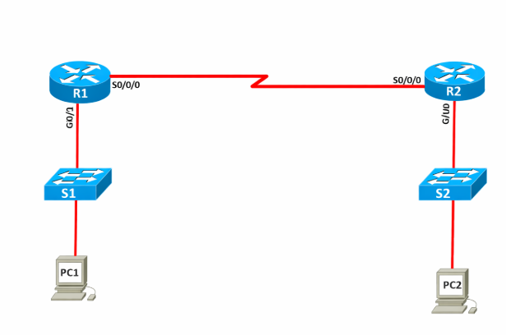
Ansible was chosen because of its agentless architecture, which allows it to connect to network devices using SSH without requiring any additional software to be installed on routers or switches. This made implementation straightforward and reduced unnecessary complexity. In addition, Ansible uses human-readable YAML configuration files, making the automation logic easy to understand, review, and maintain. This was particularly beneficial for teamwork, as all members could easily follow and contribute to the playbooks. Ansible also provides strong native support for Cisco IOS devices through dedicated modules, ensuring reliable and efficient configuration of routers and switches[3][5]. Compared to Python scripts, which require more custom coding and error handling, Ansible offered a cleaner and more structured approach. Cisco DNA Center, while powerful, was considered beyond the scope of this small-scale academic project.
Topology
With the automation tool selected, we moved on to designing a network topology that was simple, realistic, and suitable for demonstrating automation. The final topology consisted of two Cisco routers (R1 and R2) and two Cisco Layer 2 switches (S1 and S2), with end devices connected through access ports. The routers were interconnected using a serial point-to-point link, simulating a wide area network (WAN) connection. Each router also connected to a local switch via a GigabitEthernet interface, providing access to separate LAN segments. This design allowed us to demonstrate both inter-router communication and switch-level configuration while keeping the network easy to manage and troubleshoot.

Addressing and routing were planned to ensure consistency and clarity across the network. A dual-stack IPv4 and IPv6 addressing scheme was implemented to reflect modern enterprise environments. The router-to-router link used the 10.0.0.0/30 IPv4 network and the 2001:DB8:1::/64 IPv6 network. Router R1 served the 192.168.1.0/24 and 2001:DB8:10::/64 networks, while Router R2 provided gateway services for the 192.168.2.0/24 and 2001:DB8:20::/64 networks. Management IP addresses and default gateways were also configured on the switches to allow secure remote access via SSH.
From an automation perspective, the Ansible design was planned carefully to support scalability and reusability. Devices were grouped logically in the Ansible inventory file, separating routers and switches into different host groups. Variables were used extensively to define interface names, IP addresses, subnet masks, IPv6 prefixes, and default gateways. This prevented hard-coded values and allowed configurations to be applied dynamically, making the playbooks easier to maintain and expand in the future.
We identified a set of core configurations that reflect common enterprise networking tasks. These included assigning IP addresses to router interfaces, enabling IPv4 routing using RIP version 2, configuring static IPv6 routes, setting switch default gateways, applying port security on access interfaces, and deploying consistent MOTD banners across all devices. Automating these tasks demonstrated how configuration management can be performed faster, more accurately, and with greater consistency than manual command-line configuration.
Clear objectives were defined during the planning stage to guide the implementation. These objectives included designing a functional and logically addressed network topology, automating essential router and switch configurations using Ansible, implementing IPv4 and IPv6 connectivity, and using GitHub for version control and team collaboration. To manage the project timeline effectively, a three-week Gantt chart was created. The first week focused on team formation and planning, the second week on physical device setup and baseline configuration, and the final week on Ansible playbook development, testing, troubleshooting, and documentation.
Overall, this structured planning phase ensured that the technical implementation aligned closely with the project goals and provided a strong foundation for a successful network automation solution.

GANTT CHART
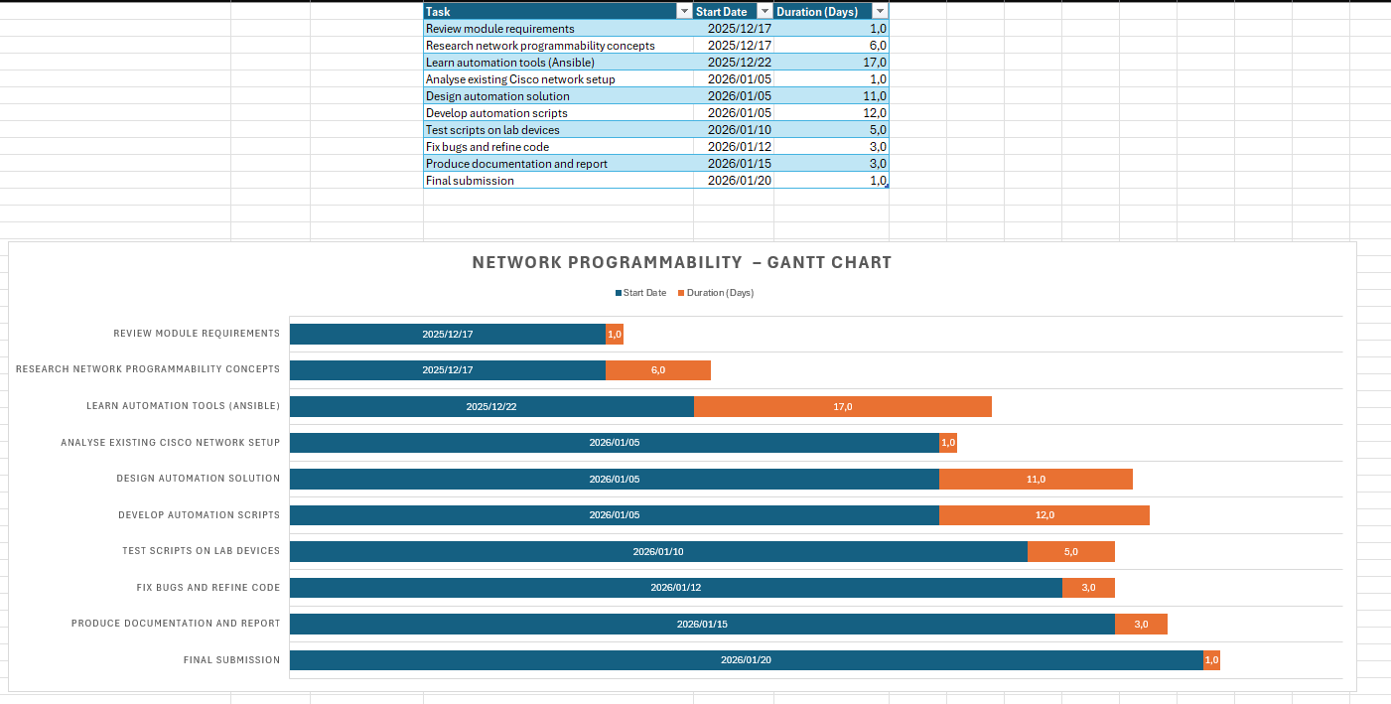

Resources
GitHub played a central role in our workflow throughout the project. We created a private repository that was shared with the lecturer, ensuring that all project files were securely stored and accessible to the team. The repository contained our Ansible playbooks, inventory files, configuration backups, and documentation. Using GitHub allowed us to track changes, avoid conflicts, and maintain a clear history of our progress. Each update to a playbook or configuration file was committed with descriptive messages, making it easy to review changes and revert if necessary. This approach mirrored real-world DevOps practices and reinforced the importance of version control in collaborative technical projects.
GitHub Repository Link: Network-Automation/playbooks/switch_config.yml at main · schenkeskyler-cyber/Network-Automation

Implementation
The implementation phase began with preparing the physical devices. We configured SSH access on both the router and switch to ensure that Ansible could connect securely. Once connectivity was confirmed, we installed Ansible on the management PC and created an inventory file containing the IP addresses of the devices. This inventory file served as the foundation for all automation tasks, allowing Ansible to identify and authenticate with each device.
We developed a series of Ansible playbooks to automate the planned network configurations. The main playbooks were one for all router configurations and one for all switch configurations, which centralized the core settings for each device type. The router playbook handled tasks such as assigning IP addresses, enabling routing protocols, and configuring static routes, while the switch playbook managed VLAN creation, port assignments, and port security. In addition to these main playbooks, we created smaller, task-specific playbooks to handle individual configuration updates as needed. All playbooks were written in YAML and used Cisco-specific modules to apply configurations directly to the devices. After running each playbook from the management PC, we verified the results using IOS commands such as show run, show ip interface brief, and show ip route. This process allowed us to refine our automation, ensure consistency, and reduce manual errors across the network.
Testing played a crucial role in the implementation process. Each playbook was executed multiple times to ensure that it applied the intended configurations consistently across all devices. Any errors or misconfigurations were identified and corrected through iterative testing, which ensured that the playbooks were reliable and produced the desired outcomes before being committed to GitHub. Although we did not implement a full CI/CD pipeline, we followed CI/CD principles by requiring that all changes be tested before being committed to GitHub. This ensured that the repository always contained working, reliable playbooks. While a full CI/CD pipeline was not implemented due to the limited scope and physical-lab constraints of the project, CI/CD principles were applied through repeatable testing of all playbooks, controlled versioning in GitHub, and validation of changes before committing to the main branch.
The final implementation successfully demonstrated the value of automation. Configurations that would normally require several minutes of manual CLI work were applied automatically within seconds. The risk of human error was significantly reduced, and the playbooks could be reused or adapted for future tasks. The demonstration confirmed that automation not only improves efficiency but also enhances consistency and reliability in network management. Detailed troubleshooting steps, Ansible execution outputs, and configuration verification screenshots are documented in the project GitHub repository within the Troubleshooting.docx file, providing timestamped evidence of successful playbook execution and CLI-based validation across all devices.

Future Enhancements
The team recognises that while effective for small environments, this approach has scalability and rollback limitations that would require additional tooling in larger enterprise networks, motivating the following future enhancements:
- Automated Configuration Backups:
Ansible playbooks could be extended to automatically take regular backups of router and switch configurations and store them securely in a central repository.
- Network Expansion and Scalability:
Additional routers and switches could be added to the topology, allowing the automation solution to manage larger and more complex networks.
- Python-Based Validation and Pre-Checks:
Python scripts could be integrated to validate configurations before deployment, helping to identify errors or conflicts before changes are applied to devices.
- Full CI/CD Integration with GitHub Actions:
GitHub Actions could be used to automatically test Ansible playbooks whenever changes are pushed to the repository, ensuring safe and consistent deployments[4].
- Network Monitoring and Alerting:
Monitoring tools could be introduced to track device performance, interface status, and uptime, with alerts sent to administrators when issues are detected.

Team Contribution
Each team member actively contributed to the successful completion of the project. Participation was rated on a scale of 1 to 5, where 1 represents very low contribution and 5 represents excellent contribution.
Team Member | Contribution Rating
Rehan Joseph | 5
Skyler Schenke | 5
Leo Richards | 5

All team members worked collaboratively, completed their assigned tasks on time, and supported each other throughout the project.

Conclusion
This project provided a valuable opportunity to explore the practical benefits of network automation using Ansible and physical Cisco devices. Through careful planning, effective teamwork, and consistent testing, we developed a functional automation solution that reduced configuration time, improved accuracy, and demonstrated the power of modern automation tools. Working with real hardware offered insights that cannot be replicated in virtual environments, and the use of GitHub reinforced the importance of version control in collaborative technical work. Overall, the project met all objectives and highlighted how automation enhances speed, consistency, and reliability in network management. It also strengthened our understanding of network programmability and prepared us for real-world engineering environments where automation is increasingly essential.

References
[1] Sheldon, "Why Is CLI Being Phased Out?" Accessed: Jan 19, 2026. Available at: https://www.fs.com/blog/why-is-cli-being-phased-out-30094.html.
[2] Unknown, "What Is Network Automation?" Accessed: Jan 16, 2026. Available at: https://www.cisco.com/c/en_uk/solutions/automation/network-automation.html.
[3] "Introduction to Ansible," -07-01 2021, Accessed: Jan 16, 2026. Available at: https://www.geeksforgeeks.org/devops/introduction-to-ansible-and-its-architecture-components/.
[4] L. Berton, "Ansible By Example - Expert Ansible Tutorials & Resources," -01-01 2024, Accessed: Jan 17, 2026. Available at: https://www.ansiblepilot.com/.
[5] Cisco, “Network Automation with Ansible,” Cisco DevNet, 2023. Available: https://developer.cisco.com/automation/

