

Programme: Certificate of Higher Education Skills for the Workplace (Health & Social Care)
Module: Introduction to Health and Social Care (LCHS4003)
Name: Daniel Ciprian Iancu
Student ID: 2530100
Lecturer’s Name: Muhammad Aliyu
Assignment Title: Component 1: Portfolio – Two Tasks
Table of Contents
Task 1: Poster 3
Introduction 3
Explanation of the chosen healthcare service 3
A brief history of the service 4
Present-day functioning of the service 4
Two challenges faced by the service 4
Conclusion 5
Task 2: An Essay 6
References 8

Task 1: Poster

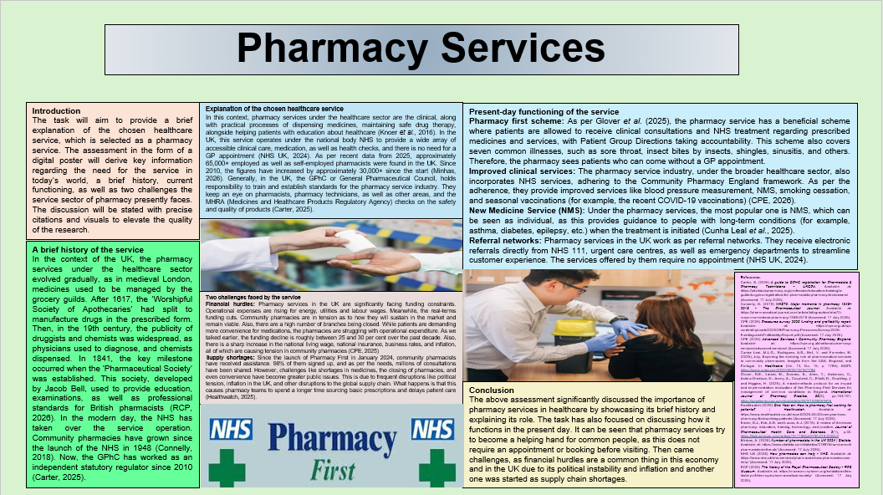Introduction
The task will aim to provide a brief explanation of the chosen healthcare service, which is selected as a pharmacy service. The assessment in the form of a digital poster will derive key information regarding the need for the service in today’s world, a brief history, current functioning, as well as two challenges the service sector of pharmacy presently faces. The discussion will be stated with precise citations and visuals to elevate the quality of the research.

Explanation of the chosen healthcare service
In this context, pharmacy services under the healthcare sector are the clinical, along with practical processes of dispensing medicines, maintaining safe drug therapy, alongside helping patients with education about healthcare (Knoer et al., 2016). In the UK, this service operates under the national body NHS to provide a wide array of accessible clinical care, medication, as well as health checks, and there is no need for a GP appointment (NHS UK, 2024). As per recent data from 2025, approximately 65,000+ employed as well as self-employed pharmacists were found in the UK. Since 2010, the figures have increased by approximately 30,000+ since the start (Minhas, 2026). Generally, in the UK, the GPhC or General Pharmaceutical Council, holds responsibility to train and establish standards for the pharmacy service industry. They keep an eye on pharmacists, pharmacy technicians, as well as other areas, and the MHRA (Medicines and Healthcare Products Regulatory Agency) checks on the safety and quality of products (Carter, 2025).

A brief history of the service
In the context of the UK, the pharmacy services under the healthcare sector evolved gradually, as in medieval London, medicines used to be managed by the grocery guilds. After 1617, the ‘Worshipful Society of Apothecaries’ had split to manufacture drugs in the prescribed form. Then, in the 19th century, the publicity of druggists and chemists was widespread, as physicians used to diagnose, and chemists dispensed. In 1841, the key milestone occurred when the ‘Pharmaceutical Society’ was established. This society, developed by Jacob Bell, used to provide education, examinations, as well as professional standards for British pharmacists (RCP, 2026). In the modern day, the NHS has taken over the service operation. Community pharmacies have grown since the launch of the NHS in 1948 (Connelly, 2018). Now, the GPhC has worked as an independent statutory regulator since 2010 (Carter, 2025).

Present-day functioning of the service
Pharmacy first scheme: As per Glover et al. (2025), the pharmacy service has a beneficial scheme where patients are allowed to receive clinical consultations and NHS treatment regarding prescribed medicines and services, with Patient Group Directions taking accountability. This scheme also covers seven common illnesses, such as sore throat, insect bites by insects, shingles, sinusitis, and others. Therefore, the pharmacy sees patients who can come without a GP appointment.
Improved clinical services: The pharmacy service industry, under the broader healthcare sector, also incorporates NHS services, adhering to the Community Pharmacy England framework. As per the adherence, they provide improved services like blood pressure measurement, NMS, smoking cessation, and seasonal vaccinations (for example, the recent COVID-19 vaccinations) (CPE, 2026).
New Medicine Service (NMS): Under the pharmacy services, the most popular one is NMS, which can be seen as individual, as this provides guidance to people with long-term conditions (for example, asthma, diabetes, epilepsy, etc.) when the treatment is initiated (Cunha Leal et al., 2025).
Referral networks: Pharmacy services in the UK work as per referral networks. They receive electronic referrals directly from NHS 111, urgent care centres, as well as emergency departments to streamline customer experience. The services offered by them require no appointment (NHS UK, 2024).

Two challenges faced by the service
Financial hurdles: Pharmacy services in the UK are significantly facing funding constraints. Operational expenses are rising for energy, utilities and labour wages. Meanwhile, the real-terms funding cuts. Community pharmacies are in tension as to how they will sustain in the market and remain viable. Also, there are a high number of branches being closed. While patients are demanding more convenience for medications, the pharmacies are struggling with operational expenditure. As we talked earlier, the funding decline is roughly between 25 and 30 per cent over the past decade. Also, there is a sharp increase in the national living wage, national insurance, business rates, and inflation, all of which are causing tension in community pharmacies (CPE, 2025)
Supply shortages: Since the launch of Pharmacy First in January 2024, community pharmacists have received assistance. 98% of them signed up, and as per the needs, millions of consultations have been shared. However, challenges like shortages in medicines, the closing of pharmacies, and even convenience have become greater public issues. This is due to frequent disruptions like political tension, inflation in the UK, and other disruptions to the global supply chain. What happens is that this causes pharmacy teams to spend a longer time sourcing basic prescriptions and delays patient care (Healthwatch, 2025).

Conclusion
The above assessment significantly discussed the importance of pharmacy services in healthcare by showcasing its brief history and explaining its role. The task has also focused on discussing how it functions in the present day. It can be seen that pharmacy services try to become a helping hand for common people, as this does not require an appointment or booking before visiting. Then came challenges, as financial hurdles are a common thing in this economy and in the UK due to its political instability and inflation and another one was started as supply chain shortages.

Task 2: An Essay
Introduction
The essay will focus on describing a relevant social care service, for which the assignment in the form of an essay will prioritise the case of community mental health services. In recent days, people are being diagnosed with mental health issues, and this has been reported to the mental health community care. This essay will investigate the origin and explore the history. A critical evaluation of how the service functions today will also be presented. Therefore, the significance of it and its quality regarding the service users will also be mentioned.
Main Body
While investigating the origin and exploration of the history of community mental health services in the UK, as per Turner et al. (2015), it is well to state that throughout the 19th as well as 20th centuries, mental health patients used to end up at an asylum in the UK. Those were remote institutions. Creek and Lougher (2011) opined that the origin of modern community services regarding mental health started with the Mental Treatment Act (1930), which allowed patients to have voluntary care. This act was a turning point, as it elevated the need for outpatient clinics. Again, in the words of Turner et al. (2015), the NHS came into being, and since 1948, psychiatry has been closely linked to general medicine, and it has assisted in reducing social stigma and fear of reaching out to doctors regarding the mental health issues of people.
While describing critically how community mental health services function today, it is necessary to mention the positive sides, as this includes MHTs, which stand for Multidisciplinary Teams. The teams work closely, including psychiatrists, CPNs, social workers, occupational therapists and others. The service also looks for holistic support as the modern-day model connects medical treatments with non-clinical needs. The cost is also budget-friendly as the system gets general taxation funding via the NHS (Parliament UK, 2025). On the other hand, due to heavy demand, this causes long waits for patients. Also, the service explores the staff shortage issue, which leads patients to face unexpected long waits. Also, patients need to meet the symptoms as stated by the community guidance or NHS to access support, since then they can not get support. As of a survey of 12,319 mental health patients, 20% reported they waited too long, while 5% did not even receive the medication due to the complex system process (CQC, 2025).
Talking about the significance of the service in improving the quality of life, it is well to mention that before the amendment, mental health used to be a social stigma, or in some communities, it was strictly prohibited to discuss the issue with other people. People were placed in isolation and, in some cases, in large evacuated spaces. In modern-day society, with the significant policies and frameworks, people or service users get autonomy and empowerment. Patients do not have to go to hospital settings and can continue their daily tasks, where these community-based service providers send occupational therapists or psychiatrists to engage with users. They may support employment, housing, as well as social work.
Conclusion
The essay here denotes several key pieces of information on community mental health services, as this has been a key trend in recent days in the social care sector. Mental health issues are not meant to be ignored, and this essay tried to depict the key essentials like its history, evolution, positive and negative ways related to its functioning, importance to service users, etc. The essay focused on how the community-based services treat patients with greater autonomy and encouragement in their daily lives, rather than isolating them and confining them in a cage.

References
Carter, S. (2025) A guide to GPHC registration for Pharmacists & Pharmacy Technicians - UKCPA. Available at: https://ukclinicalpharmacy.org/profession/education-training/a-guide-to-gphc-registration-for-pharmacists-pharmacy-technicians/ (Accessed: 17 July 2026).
Connelly, D. (2018) NHS70: Major moments in pharmacy 1948–2018 - The Pharmaceutical Journal. Available at: https://pharmaceutical-journal.com/article/infographics/nhs70-major-moments-in-pharmacy-1948-2018 (Accessed: 17 July 2026).
CPE (2025) Pressures survey 2025 funding and profitability report. Available at: https://cpe.org.uk/wp-content/uploads/2025/08/Pharmacy-Pressures-Survey-2025-Funding-and-Profitability-Report.pdf (Accessed: 17 July 2026).
CPE (2026) Advanced Services - Community Pharmacy England. Available at: https://cpe.org.uk/national-pharmacy-services/advanced-services/ (Accessed: 17 July 2026).
CQC (2025) Community Mental Health Survey 2025 - Care Quality Commission. Available at: https://www.cqc.org.uk/publications/surveys/community-mental-health-survey (Accessed: 17 July 2026).
Creek, J. and Lougher, L. (2011). Occupational therapy and mental health. Elsevier Health Sciences.
Cunha Leal, M.L.G., Rodrigues, A.R., Bell, V. and Forrester, M. (2025, July. Exploring the evolving role of pharmaceutical services in community pharmacies: Insights from the USA, England, and Portugal. In Healthcare (Vol. 13, No. 15, p. 1786). MDPI. https://www.mdpi.com/2227-9032/13/15/1786
Glover, R.E., Lalani, M., Sonnex, K., Allen, T., Anderson, C., Ashiru-Oredope, D., Avery, A., Coupland, C., Elliott, R., Goulding, J. and Higgins, H. (2025). A mixed-methods protocol for an impact and implementation evaluation of the Pharmacy First Services for management of common conditions in England. International Journal of Pharmacy Practice, 33(2), pp.152-161. https://academic.oup.com/ijpp/article/33/2/152/8052904
Healthwatch (2025) One Year on: How is pharmacy first working for patients? | Healthwatch. Available at: https://www.healthwatch.co.uk/report/2025-06-30/one-year-how-pharmacy-first-working-patients (Accessed: 17 July 2026).
Knoer, S.J., Eck, A.R. and Lucas, A.J. (2016). A review of American pharmacy: education, training, technology, and practice. Journal of Pharmaceutical Health Care and Sciences, 2(1), p.32. https://link.springer.com/article/10.1186/s40780-016-0066-3
Minhas, A. (2026) Number of pharmacists in the UK 2024 | Statista. Available at: https://www.statista.com/statistics/318874/numbers-of-pharmacists-in-the-uk/ (Accessed: 17 July 2026).
NHS UK (2024) How pharmacies can help - NHS. Available at: https://www.nhs.uk/nhs-services/pharmacies/how-pharmacies-can-help/ (Accessed: 17 July 2026).
Parliament UK (2025) Community Mental Health Services - Parliament UK. Available at: https://publications.parliament.uk/pa/cm5901/cmselect/cmhealth/566/report.html (Accessed: 17 July 2026).
RCP (2026) The history of the Royal Pharmaceutical Society - RPS Museum. Available at: https://museum.rcpharm.org/exhibitions/the-history-of-the-royal-pharmaceutical-society/ (Accessed: 17 July 2026).
Turner, J., Hayward, R., Angel, K., Fulford, B., Hall, J., Millard, C. and Thomson, M. (2015). The history of mental health services in modern England: practitioner memories and the direction of future research. Medical History, 59(4), pp.599-624. https://www.cambridge.org/core/journals/medical-history/article/history-of-mental-health-services-in-modern-england-practitioner-memories-and-the-direction-of-future-research/FD23F0CF400A8F79AFE5E30056FA0311

