
Environmental Analysis & Marketing plan for samcosport


May 18, 2018
Charlotte Hinder (P145048)
University of Wales Trinity Saint David

Contents
Contents 1
Executive Summary 3
1.0. Introduction 4
2.0. Main Findings 5
2.1. Situation Analysis 5
2.1.1. MACRO Analysis 5
2.1.2. MICRO Analysis 5
2.1.3. Internal Analysis 6
2.2. Mission/Vision Statement & Objectives 7
2.2.1. Mission Statement 7
2.2.2. Vision Statement 8
2.2.3. Objectives 8
2.3. Segmentation/Targeting/Positioning 8
2.3.1. Segmentation 8
2.3.2. Targeting 9
2.3.3. Positioning 9
2.4. Strategy 10
2.5. Marketing Mix 10
2.5.1. Product 10
2.5.2. Price 10
2.5.3. Place 10
2.5.4. Promotion 11
2.5.5. People 11
2.5.6. Processes 12
2.5.7. Physical Evidence 12
2.6. Resources 12
2.6.1. Budgets 12
2.6.2. Manpower 12
2.6.3. Equipment 12
2.6.4. Timings/Scheduling 13
2.7. Evaluation & Control 13
3.0. Conclusion 15
Bibliography 17
Appendices 19

Executive Summary
This report executes an environmental analysis on Samco Sport followed by a marketing plan.
All the information in the report will be under clear headings stating the information it contains.
After conducting the environmental analysis it found that, Samco Sport had more Strengths and opportunities than it did weaknesses and threats.
Samco Sport have a strong mission and vision statement.
Clear objectives were set:
- To start selling products into 4 more countries by 2022
- Reduce the time it takes for retailers to get their products down to 5 weeks instead of 6 weeks by May 2019
- Sponsor more events- specifically local events and events that are new by May 2019
- Conduct market research over a 6-month period starting June 2018 to identify areas that are available to market into.
Segments were identified, and the car market was chosen. Targeting was differentiated, and they have a high position over their competitors.
The marketing mix showed that:
- Packaging would have to change
- A premium price could be charged
- The product goes to a distributor then the consumer
- There are opportunities to go to trade shows to promote products
- Opportunities to do contests on social media
- Can choose which distributors to use
- Can set their own policies
- There are multiple factories available for them to use
A growth strategy was chosen, to continue developing products.
There was a limited budget and a database would have to be created to monitor social media activity.
They have most of the staff needed available to them so only need to hire agents when they are needed.
All the information found in this report was from online sources, books, reports and journal articles. They were referenced clearly and with a bibliography at the end.

Introduction
This report will contain an environmental analysis for SamcoSport, followed by a marketing plan.
The environmental analysis will contain:
- A MACRO Analysis using the framework PEST
- A MICRO Analysis which includes Market, Customer, Competition, Supplier, Intermediaries and Other Stakeholders
- An Internal Analysis
The marketing plan will include:
- Mission/Vision Statement
- Objectives
- Segmentation, Targeting and Positioning
- Strategy
- Marketing Mix
- Resources
- Evaluation & Control
SamcoSport are a company who make silicone hoses to go on an engine of a vehicle, their 2 most popular sectors are cars and bikes (Samco Sport, 2018). (Sport, 2018).
Their product range spans over multiple segments of the market and each product is specially made to withstand the pressure it may come under while being used (Samco Sport, 2013). (Sport, 2013).

Main Findings

Situation Analysis

MACRO Analysis
The MACRO analysis will be created using the model PEST, this stands for Political, Economic, Social and Technological (Jobber & Ellis-Chadwick, 2013).

Political
There is an uncertainty surrounding Brexit that will affect Samco Sport, this is down to the fact they sell a lot of their products into Europe (Worstall, 2017).
The political influence of hybrid vehicles will impact the products Samco Sport has to create and supply.
There are different tax and duties in the countries they sell their products into so Samco Sport must be aware of these before sending products to that country.
They must be aware of the laws on employment, for example you now must pay for someone to have a pension if they are working for you (gov.uk, 2018). This could also include things like their contracts as well as minimum wage changing.
As most of their business is outside of the UK there will be export laws that will have to be met, for example there are low regulatory barriers to export into America (gov.uk, 2016).

Economic
As Samco Sport sell a lot of their products outside the UK, exchange rates would affect them in terms of the profit they make (Samco Sport, 2018). They would have to decide whether to sell the products to the businesses in the currency of the country they are sending it to or whether to keep it the same as it is in the UK and work out what it would be in their currency.
The economy could also affect the places they buy their materials from, it could result in the materials being cheaper from a country outside of the UK.

Social
Younger audiences are living at home with their parents which could result in them having the money to buy product for their cars (Bulman, 2017).
Peoples attitudes towards driving older cars is changing so people are buying second hand cars at a reduced price and then buying products to ‘accessorise’ it (Knies, 2017).

Technological
There is new development in technology which is changing the way certain parts of the making process is conducted. There is an option of using a 3D printer to print the tool which the silicone hose will be made over, it opens the ability to change the finished outcome if the specifications are wrong.

MICRO Analysis
The MICRO analysis is made up of 6 parts, these are:
- Market
- Customer
- Competition
- Supplier
- Intermediaries
- Other Stakeholders
These will all be looked at individually.

Market
The market is starting to increase due to the economy slowing becoming better (Jackson, et al., 2017). Also, there are businesses that focus on specific car manufacturers that are becoming more popular.

Customer
As Samco Sport does not sell directly to the customer, they must find businesses who will do that for them.
It would be beneficial to sell products to businesses that already sell products to do with cars and businesses who have knowledge of the product.
As there are other companies who produce the same products they might try to take your employees.

Competition
There is competition from companies who sell straight to the customer which allows them to understand what the customer wants more (JS Performance, 2018). (Performance, 2018).
There are also companies that sell the same products but make a hose kit that Samco Sport does not which could result in a customer buying their product from them (SFS Performance, 2018). (Performance, 2018).

Supplier
Prices of the materials could differ if there are any changes in exchange rates or if laws change in certain countries, this could then affect the price of the finished products.

Intermediaries
Samco Sport deal with retailers, some of them specialise in certain car manufacturers, so they have an interest to keep with Samco Sport if they do a wide range of products for that car.

Other Stakeholders
It would be in the interest of the employees to be skilled and know how to do their jobs, as long as they get the job right they will not have any problems.

Internal Analysis
The internal analysis will be produced using a SWOT analysis, this is made up of Strengths, Weaknesses, Opportunities and Threats (McDonald, 2002).

Strengths
- Well known in the industry.
- Offer a lifetime guarantee.
- Have got good relationships with existing businesses.
- Sponsor a variety of events over different segments of the market.
- Promote their products by going to trade events/shows.
- They have skilled workers who know how to make silicone hoses specifically.
- Large variety of products available, with new products being developed.
- Well known for their keyring samples- some people try to collect all the colours that are available.

Weaknesses
- Don’t sell straight to customers.
- Not the only company selling products.
- Can take a long time to produce products.
- Can be expensive for certain products.
- Don’t carry some products needed to complete a job.

Opportunities
- To sponsor more high-profile events.
- Create new products with more cars being made.
- Local events offer opportunity to sponsor (Aberaman Motorcycle Club, 2018).
- There are opportunities to go into other sectors, for example buses as well as industrial products.

Threats
- Competitors could produce a product that is being sought after.
- Laws could change due to Brexit and could affect how business is conducted.
- Competitors could sponsor high profile events due to them having a higher budget which gets them more advertising.

Mission/Vision Statement & Objectives

Mission Statement
A mission statement is ‘a broadly defined, enduring statement of purpose that distinguishes a business from others of its type’ (Ackoff, 1987).
Samco Sport’s mission statement will have to show what they do as well as offering the reader clear understanding of what the company is doing.
The mission statement for Samco Sport is:
‘Making hoses that support and add to a vehicle for its lifetime’.
The statement is short, so it is easier for the reader to read as well as easier to understand. As it will be easier to understand it should have a better impact than a statement that is considerably longer.

Vision Statement
A vision statement is your goal and where you hope to see the business in the future (Gabriel & Farmer, 2009).
Samco Sport’s vision statement will look ahead for 2020
The vision statement for Samco Sport is:
‘To reach new markets with the intention of improving people’s experiences in their vehicles’.

Objectives
An objective is the goals or targets set by a business (Pearson, 2010).
The objectives that have been set for Samco Sport are:
- To start selling products into 4 more countries by 2022
- Reduce the time it takes for retailers to get their products down to 5 weeks instead of 6 weeks by May 2019
- Sponsor more events- specifically local events and events that are new by May 2019
- Conduct market research over a 6-month period starting June 2018 to identify areas that are available to market into.

Segmentation/Targeting/Positioning

Segmentation
Market segmentation is the process of dividing the population of possible customers into distinct groups (Lovelock & Wirtz, 2011).
The Segments that have been identified in the chart below are:
- Cars
- Bikes
- Lorries/Vans
- Buses
- Trains
- Industrial

A marketing mix will be created using one of these segments, the segment that has been chosen is cars.

Targeting
Targeting will be differentiated for the different areas of the car market, some of these include:
- Formula 1
- Sports Cars
- Old Cars
- Race Cars
- Road Cars
For each of these different areas there are different types of people who would buy them, so this affects the marketing of those areas.

Positioning
Samco Sport is known for their silicone hoses and uses images a lot. Their position in terms of their competitors is high quality and medium price, this is a good place for them to be as some of their competitors have medium quality and high price. Consumers are more likely to buy a product that is high quality and is not too expensive.
They say they are the number one company for silicone hoses in the UK, which shows their position above everyone else as well as stating they have a lifetime guarantee which people are interested in, this puts them above other companies that do not do the same thing.

Strategy
Samco Sport should implement a growth strategy. This strategy could be organic where they slowly grow, and it is much safer. As they are already doing well in the industry they do not need to change the strategies they are currently using only add new ones.
The organic strategy would be to continue new product development, which will slowly reach parts of the market that they currently are not in.

Marketing Mix
This is a marketing mix for Samco Sport regarding the car industry.
The marketing mix contains the following 7P’s:
- Product
- Price
- Place
- Promotion
- People
- Processes
- Physical Evidence
(CIM, 2015).

Product
The packaging of the products would have to be suited towards the car industry, this would have to change in each marketing mix due to them being in different segments.
The lifetime guarantee would have to continue and made easier to access.
New product developments would have to be continued in line with newer cars being made.

Price
As Samco Sport are one of the top companies that sell silicone hoses in the UK, they can charge a more premium price as it’s a premium product.
Pricing would differ in the different countries they supply into due to exchange rates and taxes.

Place
The product goes from the manufacturer to a distributor. The distributor then sells the product onto the consumer.
Distribution will be selective, the retailers will only be able to order products that are being bought/asked for.

Promotion

Personal Selling
- Going to trade shows and events to promote the products opens the opportunity to see what impact Samco Sport is having on the market and consumers.
- Trial samples in the form of keyrings, thin pieces of hose about 5 cm long in all the colour range so people can see if they like the colour before they buy it.
- Gives Samco Sport the opportunity to discover customers suggestions about new product development.

Advertising
- Can put adverts in car magazines, can be in generic magazines as well as magazines that are specific to certain manufacturers.
- Can sponsor events that have big followings to get the brand out and known.
- Can sponsor certain people that could be beneficial due to them having a lot of fans.
- Can create videos that will be played to the promotion videos event organisers create.
- Have a good social media advertising presence to target younger audiences that find companies online.

Sales Promotion
- Contests can be created through social media with a wide variety of prizes on offer.
- A contest could be created every 3-4 months where the winner gets to go to the factory and watch their hose/s being made.

Public Relations
- Visiting the distributors that buy the products to show that there is interest in what they are doing and would then change the way they sell the products.
- Going to trade shows and other events allows the organisation to evaluate the market as well as allowing consumers to ask specific questions able the product and allows the opportunity to recommend distributors to buy the product from.

Direct Marketing
- Have a good online presence on social media, so it gives the opportunity for consumers to ask questions and for them to be answered quicker and easier.
- Send newsletters to consumers, businesses and distributors who sign up to a mailing list online to keep them updated on what has been happening each month.

People
You can choose which distributors to use which gives Samco Sport control, if they do not like the way a distributor is acting or treating consumers they can decide to stop selling products to them.
Employees can be hired who have knowledge in specific areas of the market, for example if there was a trade show specifically for Ford cars then hiring someone who knows a lot about Ford cars would be beneficial.

Processes
Policies can be set by Samco Sport that the company and the distributors must follow, for example the lifetime guarantee must be upheld by the distributors as it’s a policy Samco Sport have created.

Physical Evidence
There are more factories and facilities throughout the UK which are available for Samco Sport to manufacture in, some of them are already being used for specific items and some are being used to make general products.

Resources

Budgets
Samco Sport have a set budget for the year when it comes to marketing, this includes the buying of leaflets that are used when going to tradeshows as well as the costs of the shows themselves.
As they don’t sell their products direct, they do most of their promotion which is why Samco Sport has a budget for marketing.
Their budget is £20,000 for the year. This will include any travel costs that occur when events happen as well as the cost of the event.

Manpower
Most of the work Samco Sport carries out they do themselves, there is only one person currently working on Marketing in the company so that means that sometimes there will need to be agencies used when working on a topic that person has no knowledge how to do.
Although only one person does marketing some of the other employees help with certain areas if they can, if there is a social media post that has certain knowledge of a car and someone knows this they will then help creating this post.
There is a company structure in the appendices under the heading appendix 1 that shows how there is only one person currently carrying out the role of marketing (Samco Sport,2015).
When going to trade shows there is sometimes a need to hire a photographer who will take photos throughout the day which can then be used on any promotion activities.

Equipment
Samco Sport would need to invest in a database that collects data from social media accounts to see what posts are getting more responses and to generally see if it is making an impact.
There is equipment already like cameras and a lighting booth which are used when taking photos of the hoses to put on social media and the website.

Timings/Scheduling
Most of the marketing happens in the summer months as that is when the trade shows begin, this means through out the rest of the year there is a lot of social media advertising, so the cost is not too much, and it doesn’t take a lot of time.
In the appendices under the heading appendix 2 there is a Gantt chart showing marketing activities through a year.
Also, in the appendices under the heading appendix 3 there will be a schedule Gantt chart which will show who will work which shows throughout the year. For each show there will be a heading with the month and then the colours of the employees working it.

Evaluation & Control
To understand how well the business is doing performance review could be completed, this would look and compare how the business is doing this year compared to last year and will generate a statistic showing how much more it is doing or how much less it is doing.
To help keep the objectives and targets relevant a feedforward action can be employed which allows the organisation to change the objective and targets straight away down to there being constant feedback.
To understand how well the marketing is doing and evaluation can be conducted, some of the things to address could be:
- Sales Volume- whether sales have increased since advertising it
- Market share- has market share increases while marketing has taken place
- Whether the marketing has had an impact on the business
This can be done in all the promotional elements.
For advertising, some of those things could be:
- People’s attitudes towards the products and whether they have changed- either become better or have got worse
- The number of enquires that have been received- have they increased, decreased or stayed the same
- What impact it has had on the business
Sales promotion would be:
- The response rates- how long it takes someone to get in touch after giving them information
- The impact it is having on the business
Public relations would be:
- Collect how many press cuttings there are to evaluate whether it is worth doing them with the cost
- The impact it is having on business
Direct marketing would be:
- How fast people respond to social media posts
- How many people respond to social media posts
- How good is the feedback from social media posts- is it negative or positive
- How many people ask relevant questions that could be answered quickly and easily
- The impact it has on the business
Samco Sport could evaluate how satisfied the customers are with the product and ask them to identify if there is anything they would change or improve. This could also be done with staff regarding their satisfaction with their working conditions etc.
Reviews can be carried out to identify what areas of the business are doing well and what areas are not, this could help Samco Sport to improve those areas.
Reports can be created in the different departments of the business that outline budgets and profits as well as targets they want to set and the amount of sales that took place. These could be created yearly so they can go on to be compared to the reports done the year before to see if the business is performing well.
Meetings can be set up every 3 months with managers inside the company in a board room that no one can disturb them in. They will talk about the budgets that need to be set and if they are being treated properly and not being spent all at once, as well as discussing sales volume to help understand if everyone is doing their job right and doing the most they can possibly do.

Conclusion
In conclusion, the environmental analysis shows that Samco Sport have more strengths and opportunities than weaknesses and threats.
Brexit will affect Samco Sport due to the uncertainty and that they sell into other countries.
Laws changing will affect Samco Sport.
Exchange rates will affect Samco Sport as most of their business is done outside of the UK.
People living situations have changed so they now have more money to buy things like upgrades for their cars.
3D printing is starting to change how things are made.
There is a strong mission and vision statement that highlights what Samco Sport does as well as what they want to achieve.
There are clear objectives for Samco Sport to work towards and good opportunities.
The segments that were identified were all different in a range of different areas. The car segment was chosen to do the rest of the marketing plan on.
There will be differentiated targeting to target the different areas of the car market.
Samco Sport have a high position in the market as they offer high quality and medium pricing.
Their strategy will be to grow slowly and continue developing products.
The marketing mix showed that the packaging for the products would have to change to suit the car market as well as the lifetime guarantee having to continue and made easier to access.
They can charge a premium price for a premium product.
Samco Sport does not sell directly so the products must go through a distributor.
Going to trade shows and promoting the products will shows what impact Samco Sport have in the market.
Adverts in car magazine can gain more recognition.
A contest to be created that allows the winner to watch their hose being made.
Having a good online presence gives the opportunity to answer consumers questions quicker.
The distributors can be chosen by Samco Sport so there is an opportunity to get rid of distributors if they do not like the way they work.
The lifetime guarantee is a policy that should be upheld.
There are opportunities to use other factories to produce products.
There is a set budget that is available to use each year.
Samco Sport do not hire too many agency workers as they have the staff inside the business.
A database would have to be started to monitor social media activity.
A performance review would be completed to understand how the business is doing and how well its doing compared to other years.
Reviews can be completed on each of the promotional elements to understand if they are successful and identify areas they are not successful in.

Bibliography
Ackoff, R., 1987. Mission Statements. Planning Review, 15(4), pp. 30-2.
Bulman, M., 2017. Number of young adults living with parents reaches record high. [Online]
Available at: https://www.independent.co.uk/news/uk/home-news/young-adults-live-parents-at-home-property-buy-homeowners-housing-market-a8043891.html
[Accessed 17 May 2018].
CIM, 2015. Marketing and the 7Ps, Berkshire: The Chartered Institude of Marketing.
Club, A. M., 2018. Aberdare Park Road Race. [Online]
Available at: http://www.aberdare-park-road-races.co.uk/news.html
[Accessed 16 May 2018].
Gabriel, J. G. & Farmer, P. C., 2009. HOW TO HELP YOUR SCHOOL THRIVE WITHOUT BREAKING THE BANK. 1st ed. Alexandria: Association for Supervision & Curriculum Development.
gov.uk, 2016. Exporting to the USA. [Online]
Available at: https://www.gov.uk/guidance/exporting-to-the-usa
[Accessed 15 May 2018].
gov.uk, 2018. Workplace pensions- what your employer can and can't do. [Online]
Available at: https://www.gov.uk/employers-workplace-pensions-rules
[Accessed 16 May 2018].
Jackson, G., Tetlow, G., Bernard, S. & Pearson, T., 2017. The UK economy at a glance. [Online]
Available at: https://ig.ft.com/sites/numbers/economies/uk
[Accessed 15 May 2018].
Jobber, D. & Ellis-Chadwick, F., 2013. Principles and Practice of Marketing. 7th ed. Berkshire: McGraw-Hill Higher Education.
Knies, B., 2017. Business Insider. [Online]
Available at: http://www.businessinsider.com/postpone-buying-a-new-car-2017-8?IR=T
[Accessed 16 May 2018].
Lovelock, C. & Wirtz, J., 2011. Services Marketing: People, Technology, Strategy, New Jersey: Prentice Hall.
McDonald, M., 2002. Marketing Plans: how to prepare them, how to use them. 5th ed. Oxford: Butterworth-Heinemann.
Pearson, 2010. Business Objectives. s.l.:Pearson School.
Performance, J., 2018. Car Hose Kits. [Online]
Available at: http://www.jsperformance.co.uk/silicone-hose-kits/car-silicone-hose-kits/alfa-romeo-silicone-hose-kits/alfa-romeo-gtv-coolant-hose-kit-96-98-hoses
[Accessed 17 May 2018].
Performance, S., 2018. Car Kits. [Online]
Available at: http://www.sfsperformance.co.uk/carkits.asp
[Accessed 17 May 2018].
Sport, S., 2013. Hygienci & Sterile Silicone Hose, s.l.: Silflex Ltd.
Sport, S., 2015. Company Structure, s.l.: Samco Sport.
Sport, S., 2018. Distributors. [Online]
Available at: http://samcosport.com/buy/
[Accessed 16 May 2018].
Sport, S., 2018. SamcoSport. [Online]
Available at: http://samcosport.com/
[Accessed 16 May 2018].
Worstall, T., 2017. Brexit Effects- UK Manufacturing Output And Exports Up As Pound Falls. [Online]
Available at: https://www.forbes.com/sites/timworstall/2017/06/05/brexit-effects-uk-manufacturing-output-and-exports-up-as-pound-falls/#156bc70430ab
[Accessed 16 May 2018].

Appendices
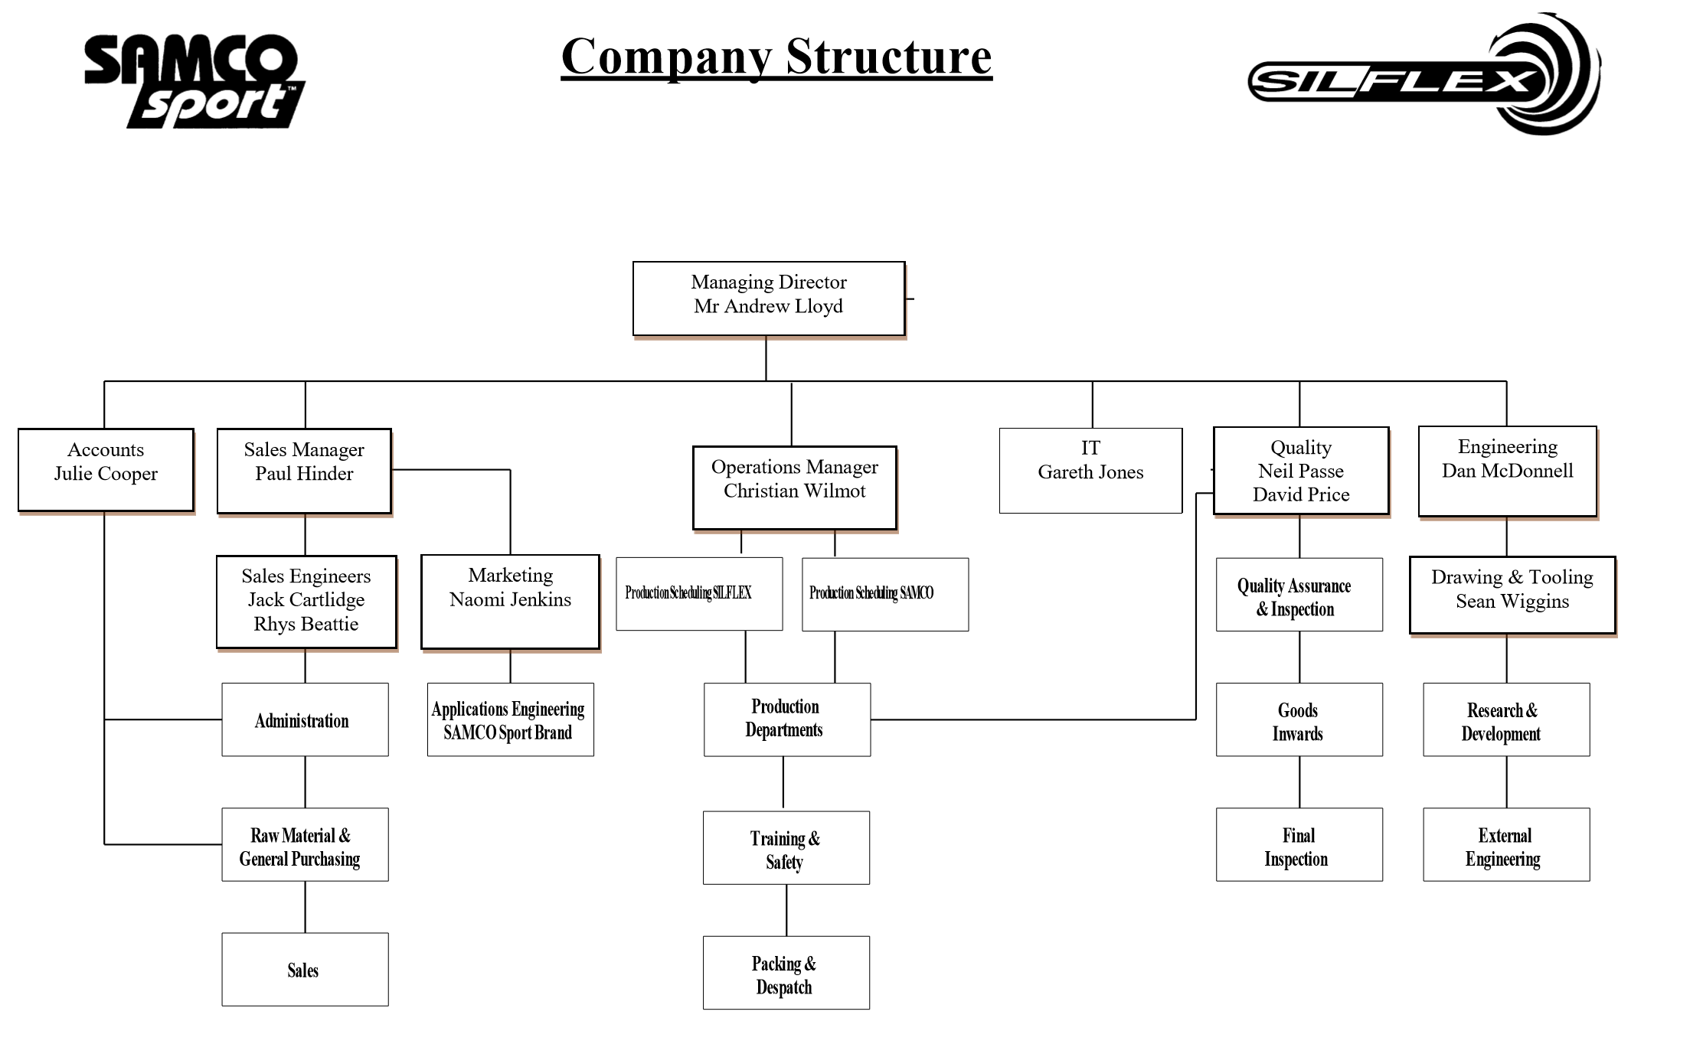
Appendix 1- Company Structure

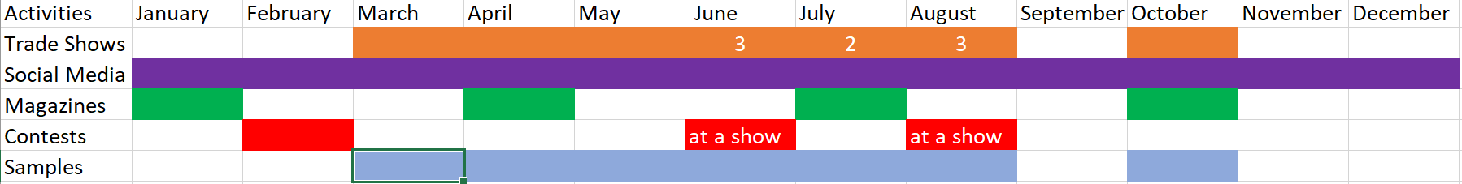
Appendix 2-Marketing Gantt chart

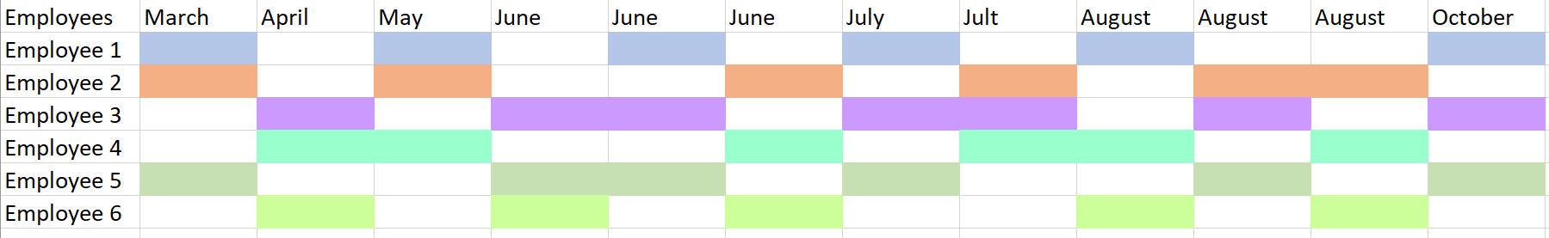
Appendix 3- Employee Schedule

