DS 1 Template Irina Grindei

My Screenshots/Photos
- Please add 4–6 screenshots or photos of your digital life.
- You can use your phone or laptop.
- For each screenshot, write one or two sentences explaining what it shows.

Screenshot/Photo 1
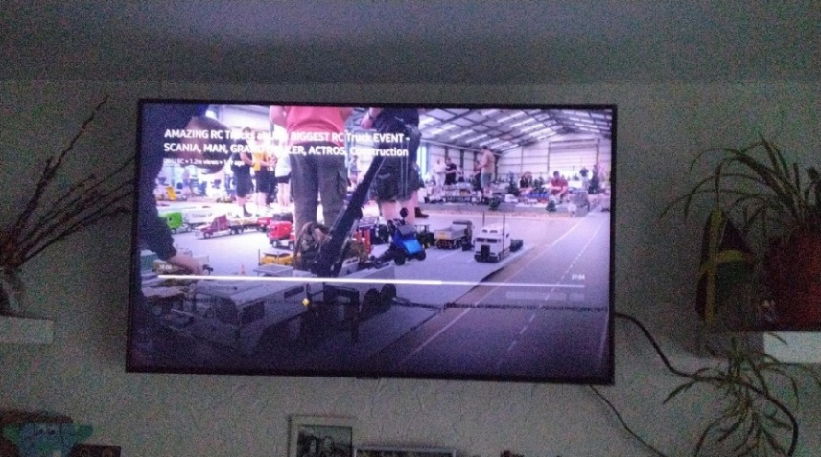
This Photo shows a TV. It helps me watch different videos, movies and especially news. After busy day television helps me to relax.

Screenshot/Photo 2
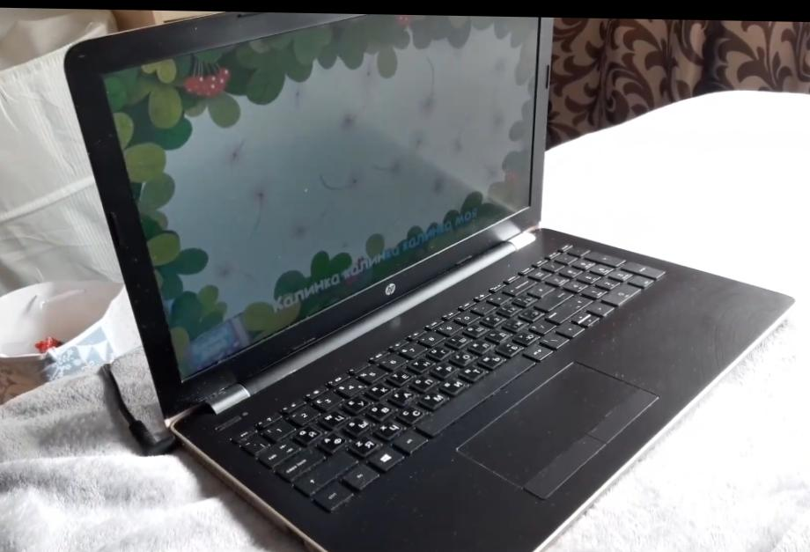
On this Photo illustrated laptop. Thanks for this device, I can do a lot thinks, for example I can work with different programs, such as Word and PowerPoint. I can also use web browser to search any information. This device is very helpful for my study.

Screenshot/Photo 3
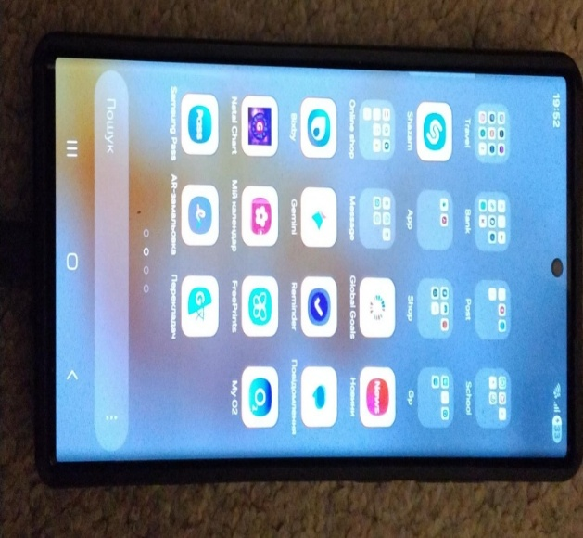
This photo shows an important digital tool in my life. It is mobile phone. With many apps I work every day. This device helps make my life easier. I can keep in touch with my family. Use social media, search for information, take photos, videos. Some apps help me make shop online, for example Amazon, eBay.

Screenshot/Photo 4
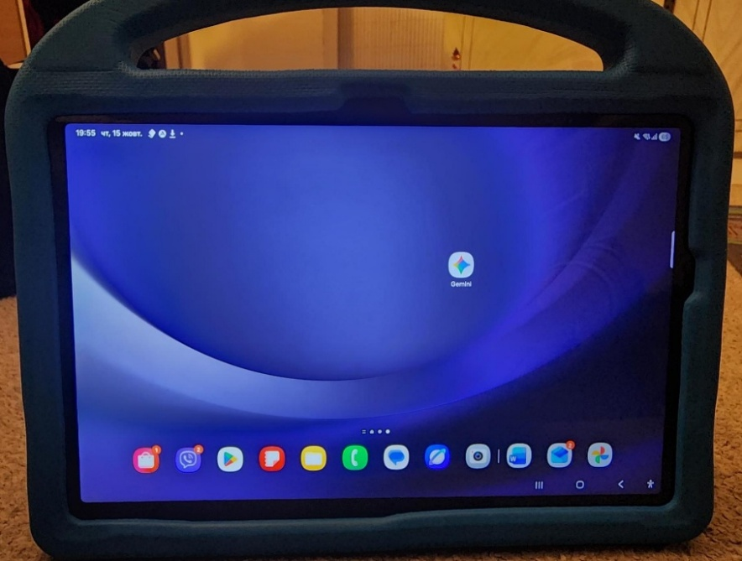

Photo number 4 shows a digital tool, a tablet. This screen is a bit bigger than mobile phone, what helps to read texts, watch video much better. So it is easier to use for reading and learning.

Screenshot/Photo 5
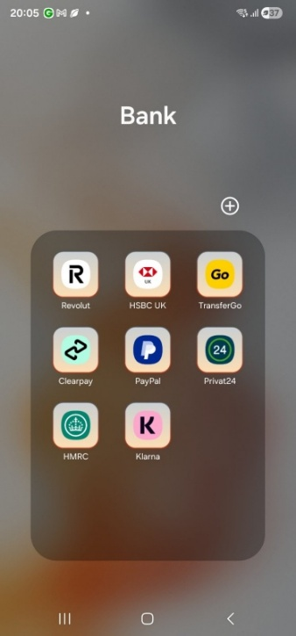
On the Screenshot 5 shows banking and payment app on my phone. I use these apps to pay for shopping, send money and check my bank account. Some apps are very helpful when I travel abroad on holiday. Nowadays, they are very important in modern life.

Screenshot/Photo 6
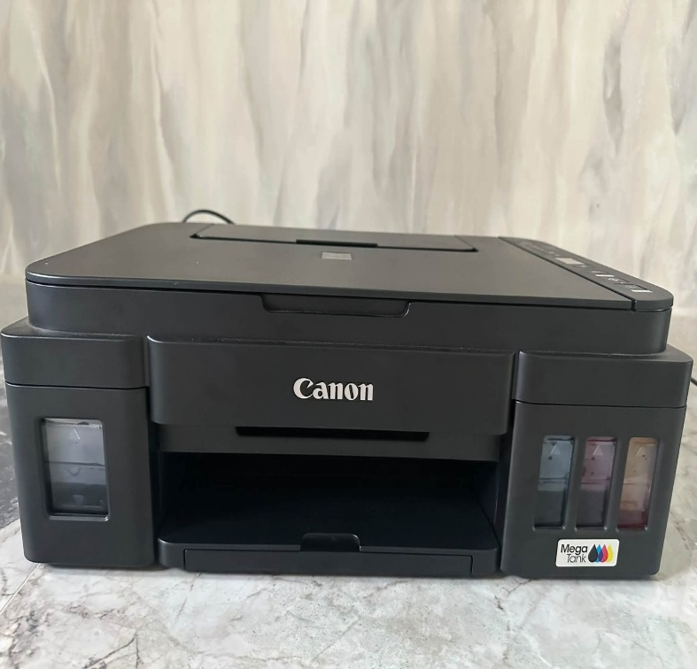
Photo number 6 shows printer and scanner. I use them to print documents, photos and scan important papers. These digital tools help me save time. They are useful for my everyday life.

My Short Reflection
- Write 5–8 simple sentences about your digital life.
- You can use the sentence starters below if helpful.
I use digital tools every day in my life. I use my mobile phone to speak with other people. Send and receive information. Organise my shopping, check the bank account. I often use these tools: WhatsApp, Outlook, Facebook.
I feel confident using my tablet for searching information, use different programs.
I want to improve my computer skills, especially using Word and creating documents for my studies.
I sometimes feel nervous about new digital tools, new programs but I’m very enthusiastic to learn and create something new.
I hope this module will help me to get strong knowledge, develop new digital skills and improve my own.
Digital skills are important for me because it is foundation for my future business, since modern world is impossible without digital life.

Sentence starters
- I use digital tools to …
- I feel confident when I …
- I want to improve …
- I often use these tools: …
- I sometimes feel nervous about …
- I hope this module will help me …
- Digital skills are important for me because …
You can write more if you want.

Submission Checklist
Before you submit, please check:
​​​ ☐ I added 4–6 screenshots
☐ I wrote short sentences for each screenshot
☐ I wrote my short reflection
☐ My work is my own
☐ My file opens correctly
​​☐ My file opens correctly

