Title Page
Module title: Introduction to Health and Social Care
Name: Noreen Rizwan
Student number: 2419138
Module code: LCHS4003
Assignment title: Component 1 Portfolio (Poster + Essay)
Tutor name: Dr Helen Parsons

Task 2: Essay on Ambulance Services
Ambulance services in the United Kingdom have undergone significant transformation since their origins in the late nineteenth century. Historically, emergency transport was informal and inconsistent. As the London Ambulance Service notes, in the 1890s “police, firefighters and even taxi drivers” transported patients using wheeled stretchers known as litters (London Ambulance Service NHS Trust, n.d.) A formal ambulance service emerged shortly before the twentieth century, initially using horse-drawn vehicles before the introduction of petrol-powered ambulances in 1904. The establishment of the National Health Service in 1948 marked a major shift, as ambulance provision became a statutory requirement for all who needed it. By 1965, London had consolidated nine separate services into a single, unified ambulance service, reflecting growing recognition of the importance of coordination emergency care. Newton (2012) highlights that early ambulance staff were regarded primarily as “drivers” with limited clinical capacity, but national reports in the 1960s and the influence of pioneers in resuscitation helped shift the service towards more advanced pre-hospital care. This historical development laid the foundation for the modern paramedic profession and the increasingly clinical role of ambulance services today.
In the present day, ambulance services operate within a highly pressured and rapidly evolving healthcare environment. Demand has increased and the nature of incidents has changed, with a higher proportion now classified as life-threatening or requiring urgent intervention (Alarilla et al, 2022). Although the workforce has grown, capacity has been reduced by risking sickness absence and significant delays in hospital handovers. Alarilla et al (2022) emphasise that longer handover times mean ambulance crews spend extended periods waiting outside hospital rather than responding to new calls, placing further strain on response times. To address these challenges, NHS England introduced the Ambulance Response Programme (ARP) in 2017, following extensive clinical trials. The ARP aimed to ensure that the ‘sickest patients get the fastest response’ and that all patients receive the right response first time (NHS, England, 2017). It introduced clearer triage categories and national frameworks for healthcare professional requests and inter-facility transfers, supporting fair access and consistent definitions of acuity. More recently, government reforms have committed to expanding urgent treatment centres, increasing community-based care and deploying nearly 500 new ambulances by 2026 to improve patient flow and reduce waiting times (Department of Health and Social Care, 2025). These developments reflect a system attempting to modernize while managing rising demand and operational pressures.
Ambulance services play a crucial role in enhancing the quality of life of service users, not only through emergency intervention but also through communication, reassurance and continuity of care. Evidence from patient-experience studies shows that individuals value clear communication, feeling safe and receiving appropriate information while waiting for and receiving ambulance care. For example, patients experiencing acute chest pain reported that contact with the telephone operator was crucial and being told that the ambulance was on the way “reassured them” and reduced fear while waiting alone (Garcia-Alfranca et al, 2018). Patients also described feeling safer when they knew they would receive professional help and that the ambulance was well-equipped. These emotional and psychological benefits demonstrate that ambulance services contribute to wellbeing beyond clinical intervention. This highlights that ambulance services enhance quality of life not only by responding to emergencies but also by providing emotional support, reducing anxiety and ensuring that individuals feel informed and cared for during critical moments. As reforms continue to expand community-based and paramedic-led care, the potential for ambulance services to further enhance wellbeing and independence continues to grow.
Reference list (for both tasks):
ABPI (2025) Modernising UK homecare will boost neighbourhood health services and save money, says ABPI. Available at: https://www.abpi.org.uk/media/news/2025/july/modernising-uk-homecare-will-boost-neighbourhood-health-services-and-save-money-says-abpi/ (Accessed: 22 February 2026).
Alarilla, A., Stafford, M., Coughlan, E., Keith, J. and Tallack, C. (2022) Why have ambulance waiting times been getting worse? The Health Foundation. Available at: https://www.health.org.uk/reports-and-analysis/analysis/why-have-ambulance-waiting-times-been-getting-worse (Accessed: 18 February 2026).
Bennett, L., Bloor, K., Birks, Y., Dale, V., Hall, P., Jefferson, L. and Murray, R. (2017) Understanding domiciliary care in England: Research report. York: University of York. Available at: https://www.york.ac.uk/media/healthsciences/images/research/prepare/UnderstandingDomiciliaryCareInEngland.pdf(Accessed: 22 February 2026).
Bottery, S. (2018) Home care in England: Views from commissioners and providers. London: The King's Fund. Available at: https://www.kingsfund.org.uk/insight-and-analysis/reports/home-care-england (Accessed: 22 February 2026).
Care UK (n.d.) What are live-in and domiciliary care? Available at: https://www.careuk.com/help-advice/what-are-live-in-and-domiciliary-care (Accessed: 22 February 2026).
Department of Health and Social Care, NHS England and Streeting, W. (2025) New ambulances and faster emergency care for patients next winter. Available at: https://www.gov.uk/government/news/new-ambulances-and-faster-emergency-care-for-patients-next-winter (Accessed: 18 February 2026).
García Alfranca, F., Puig, A., Galup, C., Aguado, H., Cerdá, I., Guilabert, M., Pérez Jover, V., Carrillo, I. and Mira, J.J. (2018) ‘Patient satisfaction with pre hospital emergency services: A qualitative study comparing professionals’ and patients’ views’, International Journal of Environmental Research and Public Health, 15(2), 233. Available at: https://www.mdpi.com/1660-4601/15/2/233 (Accessed: 20 February 2026).
Gloucestershire County Council (2024) What does the demographic shift mean for domiciliary care? Available at: https://www.gloucestershire.gov.uk/health-and-social-care/gloucestershire-market-position-statement-mps-2024/home-based-markets/what-does-the-demographic-shift-mean-for-domiciliary-care/ (Accessed: 22 February 2026).
Hall, P., Jefferson, L., Dale, V., Bennett, L., Birks, Y., Bloor, K. and Murray, R. (2017) Understanding domiciliary care in England: Research report. York: University of York. Available at: https://www.york.ac.uk/media/healthsciences/images/research/prepare/UnderstandingDomiciliaryCareInEngland.pdf(Accessed: 22 February 2026).
House of Commons Library (2024) The UK's changing population. Available at: https://commonslibrary.parliament.uk/the-uks-changing-population/ (Accessed: 22 February 2026).
London Ambulance Service NHS Trust (n.d.) Our history – a timeline. Available at: https://www.londonambulance.nhs.uk/about-us/our-history/our-history-a-timeline/ (Accessed: 20 February 2026).
NHS (n.d.) Help at home from a paid carer. Available at: https://www.nhs.uk/social-care-and-support/care-services-equipment-and-care-homes/homecare/ (Accessed: 22 February 2026).
NHS England (2017) Ambulance Response Programme. Available at: https://www.england.nhs.uk/urgent-emergency-care/arp/ (Accessed: 18 February 2026).
Newton, A. (2012) ‘The ambulance service: the past, present and future’, Journal of Paramedic Practice. Available at: https://www.paramedicpractice.com/content/features/the-ambulance-service-the-past-present-and-future (Accessed: 18 February 2026).
Office for National Statistics (2023) Incorporating data on crimes experienced by care home residents into crime statistics. Available at: https://www.ons.gov.uk/peoplepopulationandcommunity/crimeandjustice/articles/incorporatingdataoncrimesexperiencedbycarehomeresidentsintocrimestatistics/2023-12-01 (Accessed: 22 February 2026).
The Domiciliary Care Agencies Regulations 2002 (SI 2002/3214) (2002) London: HMSO. Available at: https://www.legislation.gov.uk/uksi/2002/3214/made (Accessed: 22 February 2026).
Warwick Business School (2024) Why the UK care home sector is in deep trouble. Available at: https://www.wbs.ac.uk/news/uk-care-home-sector-in-trouble/ (Accessed: 22 February 2026).

Task 1: Poster on Domiciliary Care Services in the Community
What is domiciliary care?
Domiciliary care, also known as home care provides personal care and practical support to individuals in their own homes. Having a paid carer visit can make a huge difference, especially if you have difficulty with mobility, helping you stay independently at home (NHS, n.d.). This service enables elderly individuals and those with disabilities or chronic illnesses to maintain independence and quality of life in familiar settings.
Currently around 640,000 people currently receive homecare across the UK (ABPI,2025), with an estimated 249 million hours provided annually (Bottery, 2018). Homecare is flexible in timing it can range from an hour weekly to several hours daily or night-time care (NHS, n.d). Costs range as some pay for services privately while others are eligible for council contributions (NHS, n.d.). Care can be temporary during illness recovery or long-term, including live-in arrangements (NHS, n.d.).


Challenges:
- Workforce crisis: The vacancy rate in adult social care for 2022-23 was 9.9%, representing 152,000 unfilled care vacancies (Warwick Business School, 2024).
Contributing factors:
- Low pay: providers received below the UKHCA recommended 16.70 pounds, forcing unsustainable operations (Allen et al, 2017). Staff turnover reached 48% in some providers.
- Insecure contracts: zero-hour contracts provide no guaranteed income or sick pay (Hall et al, 2017).

- Funding pressures: After 16 billion pounds funding reductions since 2010, councils reduced provider rates (Bottery, 2018). In low-supply areas, authorities paid higher rates for coverage, but in urban areas, rates dropped to unsustainable levels (Bottery, 2018).
- Impacts: shortages cause missed visits, rushed appointments and burnout.
- 15-minute visits: providers called these ‘not viable’ for dignified care. (Hall et al, 2017).
- This can also lead to neglect of clients. As research found 26% of staff witnessed clients waiting for care (Office for National Statistics, 2023).

Brief history:
1990 NHS & Community Care Act: This legislation shifted focus from institutional care to community-based services, establishing local authorities’ responsibility to assess needs and commission appropriate care packages.
2002 Domiciliary Care Agencies Regulations: This established the first comprehensive regulatory framework for domiciliary care agencies in England (The Domiciliary Care Agencies Regulations, 2002). This legislation defined domiciliary care workers and mandated registration with the National Care Standards Commission (later CQC), setting out requirements for staff qualifications and safeguarding (The Domiciliary Care Agencies Regulations, 2002).
2014 Care Act: Reformed adult social care law in England, emphasizing wellbeing, prevention and individual choice in care delivery methods including domiciliary care.
The current functioning: The market is fragile, with over a third of local authorities reporting providers handing back contracts, with major providers withdrawing from publicly funded markets (Bottery, 2018). Lack of available home care significantly contributes to delayed hospital discharge (Bottery, 2018).
The demographic context: in 2022, 12.7 million people aged 65+ (19% of population) lived in the UK, projected to reach 22.1 million (27%) by 2072, up from 7.5 million (13%) in 1972 (House of Commons Library, 2024). This indicates the significance of domiciliary care in the future.

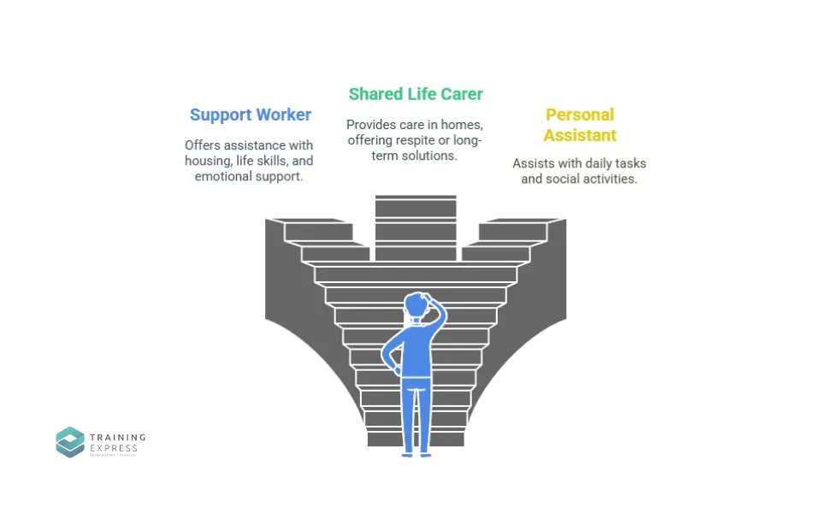
Conclusion:
Without reform addressing workforce and funding, the care sector cannot meet growing demand from an aging population. Thus, risking service collapse and compromising vulnerable individuals’ safety and dignity.

The Services provided:
- Personal care (washing, dressing, toileting, eating assistance)
- Practical support (meal preparation, housework, shopping)
- Healthcare support ( medication prompting, health monitoring)
- Social engagement (companionship, community access)

