Module Name: International Meetings Management for the Hotel Industry
Module Code: BMIH6007

Event Theme: Equality, Diversity and Inclusion within Industry
World Festive Food Festival
Student Name: Khalilur Rahman
Student ID: 2211971
Lecturer Name: Kathryn Flynn

Declaration
I confirm that I have not used any AI tools in the research and creation of this assignment. I confirm that I have not presented any AI-generated materials as my own work. I confirm I have copies of my drafts, notes, and other resources I used, which I may be asked to provide in evidence.

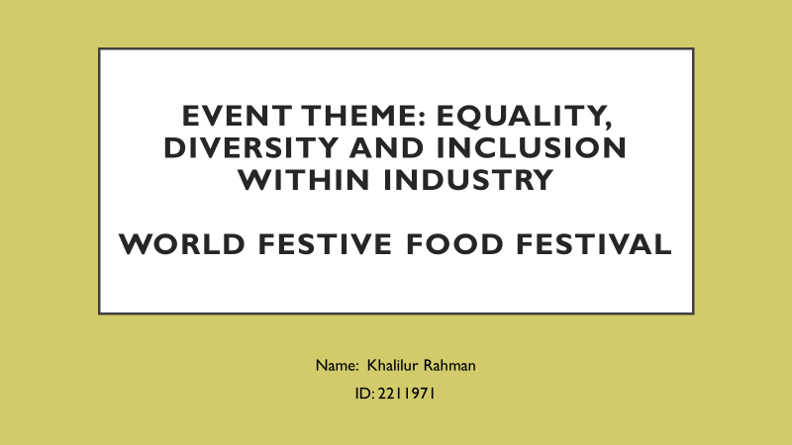

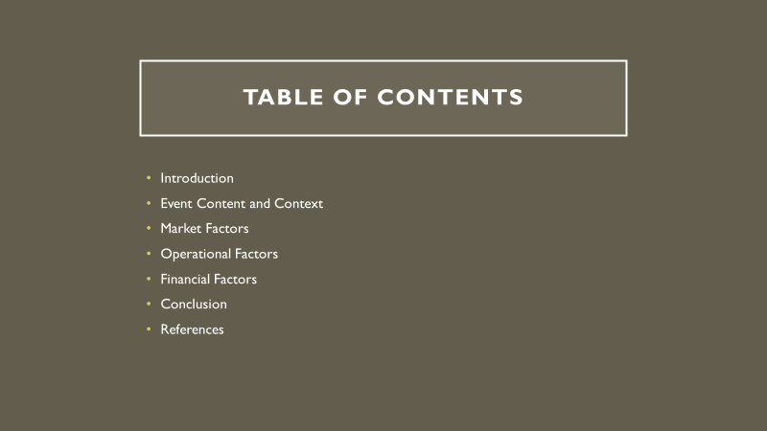

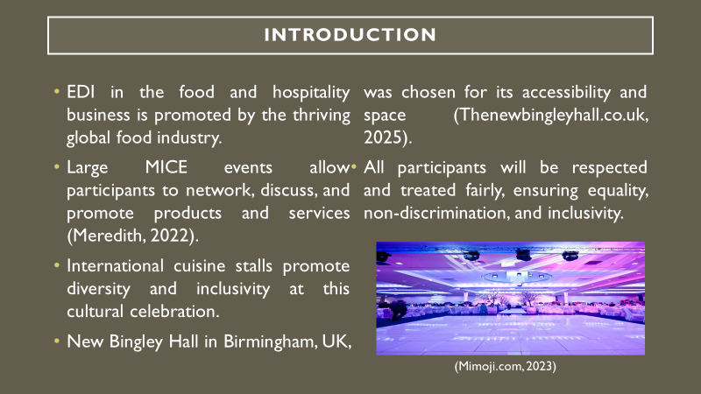

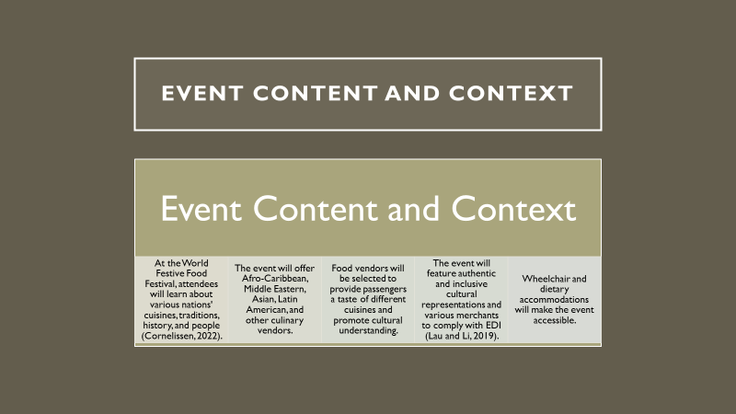

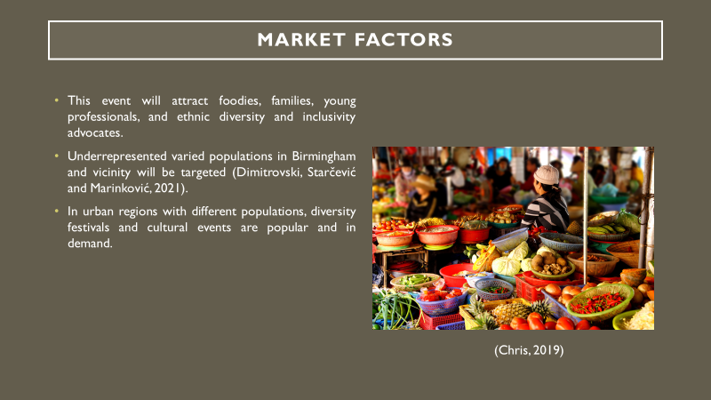

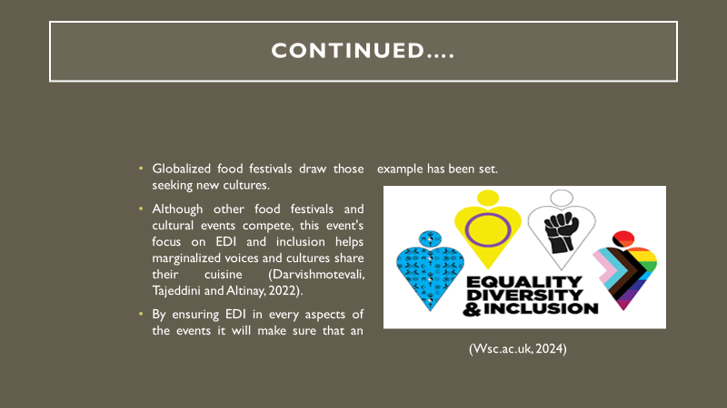

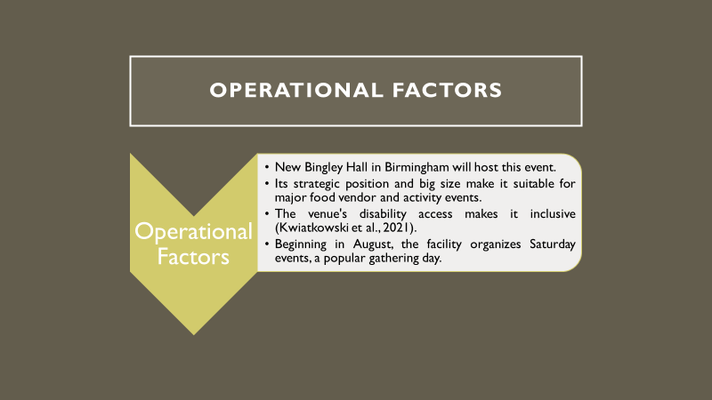

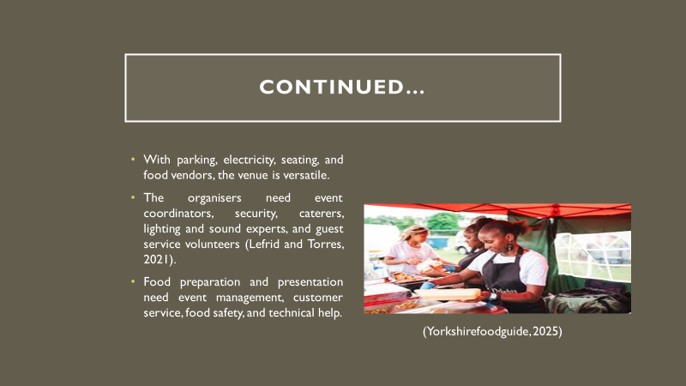

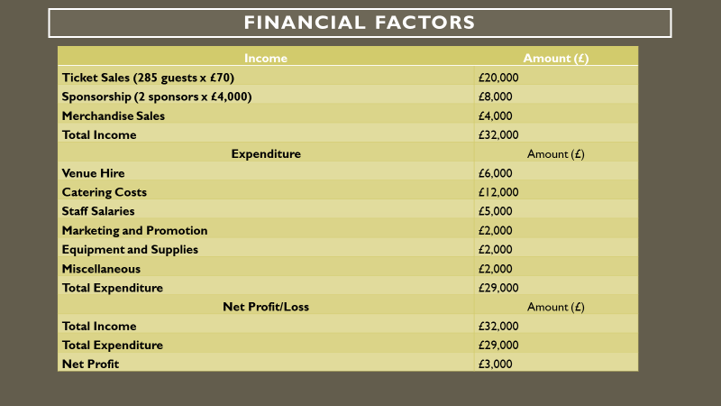

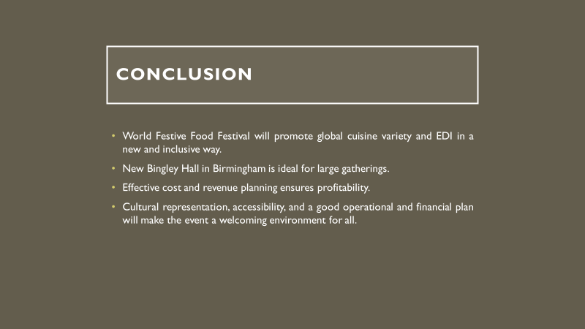

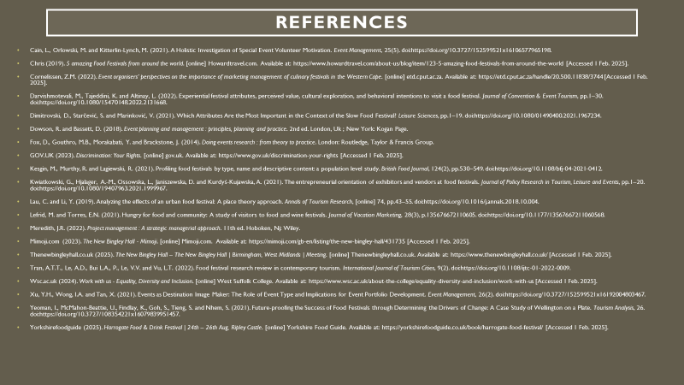

References:

- Cain, L., Orlowski, M. and Kitterlin-Lynch, M. (2021). A Holistic Investigation of Special Event Volunteer Motivation. Event Management, 25(5). doi:https://doi.org/10.3727/152599521x16106577965198.
- Chris (2019). 5 amazing Food Festivals from around the world. [online] Howardtravel.com. Available at: https://www.howardtravel.com/about-us/blog/item/123-5-amazing-food-festivals-from-around-the-world [Accessed 1 Feb. 2025].
- Cornelissen, Z.M. (2022). Event organisers’ perspectives on the importance of marketing management of culinary festivals in the Western Cape. [online] etd.cput.ac.za. Available at: https://etd.cput.ac.za/handle/20.500.11838/3744 [Accessed 1 Feb. 2025].
- Darvishmotevali, M., Tajeddini, K. and Altinay, L. (2022). Experiential festival attributes, perceived value, cultural exploration, and behavioral intentions to visit a food festival. Journal of Convention & Event Tourism, pp.1–30. doi:https://doi.org/10.1080/15470148.2022.2131668.
- Dimitrovski, D., Starčević, S. and Marinković, V. (2021). Which Attributes Are the Most Important in the Context of the Slow Food Festival? Leisure Sciences, pp.1–19. doi:https://doi.org/10.1080/01490400.2021.1967234.
- Dowson, R. and Bassett, D. (2018). Event planning and management : principles, planning and practice. 2nd ed. London, Uk ; New York: Kogan Page.
- Fox, D., Gouthro, M.B., Morakabati, Y. and Brackstone, J. (2014). Doing events research : from theory to practice. London: Routledge, Taylor & Francis Group.
- GOV.UK (2023). Discrimination: Your Rights. [online] gov.uk. Available at: https://www.gov.uk/discrimination-your-rights [Accessed 1 Feb. 2025].
- Kesgin, M., Murthy, R. and Lagiewski, R. (2021). Profiling food festivals by type, name and descriptive content: a population level study. British Food Journal, 124(2), pp.530–549. doi:https://doi.org/10.1108/bfj-04-2021-0412.
- Kwiatkowski, G., Hjalager, A.-M., Ossowska, L., Janiszewska, D. and Kurdyś-Kujawska, A. (2021). The entrepreneurial orientation of exhibitors and vendors at food festivals. Journal of Policy Research in Tourism, Leisure and Events, pp.1–20. doi:https://doi.org/10.1080/19407963.2021.1999967.
- Lau, C. and Li, Y. (2019). Analyzing the effects of an urban food festival: A place theory approach. Annals of Tourism Research, [online] 74, pp.43–55. doi:https://doi.org/10.1016/j.annals.2018.10.004.
- Lefrid, M. and Torres, E.N. (2021). Hungry for food and community: A study of visitors to food and wine festivals. Journal of Vacation Marketing, 28(3), p.135676672110605. doi:https://doi.org/10.1177/13567667211060568.
- Meredith, J.R. (2022). Project management : A strategic managerial approach. 11th ed. Hoboken, Nj: Wiley.
- Mimoji.com (2023). The New Bingley Hall - Mimoji. [online] Mimoji.com. Available at: https://mimoji.com/gb-en/listing/the-new-bingley-hall/431735 [Accessed 1 Feb. 2025].
- Thenewbingleyhall.co.uk (2025). The New Bingley Hall – The New Bingley Hall | Birmingham, West Midlands | Meeting. [online] Thenewbingleyhall.co.uk. Available at: https://www.thenewbingleyhall.co.uk/ [Accessed 1 Feb. 2025].
- Tran, A.T.T., Le, A.D., Bui L.A., P., Le, V.V. and Vu, L.T. (2022). Food festival research review in contemporary tourism. International Journal of Tourism Cities, 9(2). doi:https://doi.org/10.1108/ijtc-01-2022-0009.
- Wsc.ac.uk (2024). Work with us - Equality, Diversity and Inclusion. [online] West Suffolk College. Available at: https://www.wsc.ac.uk/about-the-college/equality-diversity-and-inclusion/work-with-us [Accessed 1 Feb. 2025].
- Xu, Y.H., Wong, I.A. and Tan, X. (2021). Events as Destination Image Maker: The Role of Event Type and Implications for Event Portfolio Development. Event Management, 26(2). doi:https://doi.org/10.3727/152599521x16192004803467.
- Yeoman, I., McMahon-Beattie, U., Findlay, K., Goh, S., Tieng, S. and Nhem, S. (2021). Future-proofing the Success of Food Festivals through Determining the Drivers of Change: A Case Study of Wellington on a Plate. Tourism Analysis, 26. doi:https://doi.org/10.3727/108354221x16079839951457.
- Yorkshirefoodguide (2025). Harrogate Food & Drink Festival | 23th – 25th Aug, Ripley Castle. [online] Yorkshire Food Guide. Available at: https://yorkshirefoodguide.co.uk/book/harrogate-food-festival/ [Accessed 1 Feb. 2025].

