Managing Project in the Organisation

Student Name: Mossammat Asma Akther
Student ID: 1604773
Module Code: BMSK5004

Table of Contents
LO1: Provide a critical assessment of the usefulness of project management tools and techniques 3
How projects are carried out in the workplace 3
Criteria to assess project management approaches 6
Project management tools and using in the Morrisons 7
LO2: Plan the implementation of a project within the workplace 10
Project objectives and critical success factors 11
Project scope 12
Identify the risk and constraints that affect the project 12
Assumptions made about the project 16
Project organisation structure and roles and responsibilities 16
Project control mechanisms 18
Project stakeholder and their involvement 18
LO3: Critically evaluate ability to manage a project 23
Own ability to plan and implement a project 23
Self-development plan to improve managing project using SMART objectives 25
Conclusion 27
References 28

Introduction
Project is very common issue for the company which is received by the management of the company to achieve various organizational purposes. Project is a process which is uniquely conducted for one time achievement that meet certain company objectives with limited cost, resources and time. Each and every project has specific time limit and well planned coordination every task, have fixed time to start program and finish every task meeting all the requirements of the company. Project management is the system that make plan, organize, lead, implement, monitor and control the activities to fill the targets of the company. Morrison’s is a popular supermarket company operates its business from 1899. The company successfully operates its operation and now it has more than 450 retail store in UK. This report discussed about project, project scope, project management tools and techniques, project sponsors and other related issues.

LO1: Provide a critical assessment of the usefulness of project management tools and techniques

How projects are carried out in the workplace
In a project there have limited time, specific resources, and cost so there have small opportunity to change the activities of the project. So the management need to select a suitable project management method and techniques for proper management of the project. Basically a successful project fulfil all the requirements of the project and use the available resources properly. Manager of the company need to choose dynamic, well accepted and well planned project management method to make the project successful. For the project controlling environment the company Morrisons take a well-accepted and dynamic project management named PRINCE2. This project management method has developed in UK and successfully used in various company like Morrisons. PRINCE2 is well accepted and popular project management method which is very much flexible and supportive for managing the activities of the project. Using this method managers can easily complete the project very effectively and efficiently.
Principles of PRINCE2 methodology
For managing the project the method PRINCE2 has seven principle that are given below:
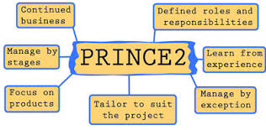
Figure: Principles of PRINCE2
Source: (Eimagine.com)
Justify the business continuously: This principle ensure the justification of project activities continuously to the end of the project (Boyle, 2003). This method make sure the progress and outcomes of the project. It analyse the project life cycle of the company Morrisons according to the target of the company and expectation of the shareholders.
Learn from experience: Past information and knowledge has significant value to finish the project perfectly and successfully. Knowledge and experience from previous project help the managers to solve same type’s problems. For example, if any manager of Morrisons face any problem that has examined previous project then he can solve it within very short time.
Specific roles and responsibilities: There are many people involved in a project. There need some groups and team to complete the project. Every team and groups has different roles and responsibilities. The managers of the company make specify the roles and responsibilities of every member of the project.
Manage by stages: If the manager want to manage the project properly they need to divide the whole project work different part. This make the project more specific and specific every work of the members. It is very much productive in complex and large project.
Manage by exception: Manage by exception is a principle where the team members get the opportunity to coordinate some specific activities (Fox, 2008). They have the authority to manage the activities that are recognized by the project manager to them. The managers are the responsible and in charge of maintaining all activities and budget.
Emphasis on products: Outcomes of project determined by the product of the project. So the project managers should focus on good quality product which is specified and required by the company.
Tailor to harmonize to specific environment: A core principle of this methodology is that it is not a rigid method. Each project is unique and have different activities from other project so the environment of each project is specific and separate. The flexible characteristics of this method provide the project manager to use past experience within specific areas.
The benefits of PRINCE2 methodology for Morrisons
The project management methodology PRINCE2 is very much popular and widely used in UK. The UK government develop the methodology which provide various benefits to the company. This methodology is well accepted and trustworthy to the project managers (Ralph, 2007). This method generates some useful common techniques which can be used in all types’ projects. Moreover, this methodology open explicit recognition that make the project members understandable their requirements and responsibilities in the project. This method design the communication process for the project activities, make authority for project activity and create accountability which make the members punctual and empower the managers to make the project successful meeting all requirements.
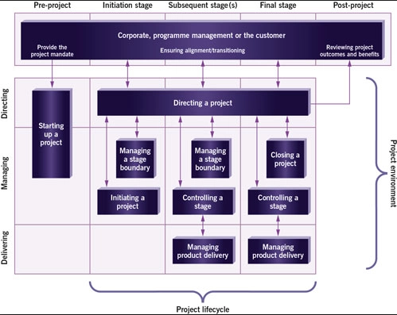
Figure: PRINCE2 project management methodology (Axelos.com)

Criteria to assess project management approaches
Criteria | Assess the approaches of project management
Easily understandable | Simplicity of management approaches is the determination of effectiveness of project management. There have many people involved in a project so there should have simple and easily understandable approaches. In a vague management approaches it is not possible to achieve the target of the company. For example, the approaches and techniques of PRINCE2 is very clear and easily understandable by the stakeholders of the project.
Match with the requirements | Each and every project has planning and implementation ways within some specific scope or project boundary. Managers of the project have to select such area that meet the requirements of project. Every project has some specific requirements and the project is limited by resources, time and cost so the project managers need to choose an effective approach that can defined project requirement perfectly and match with the project area. According to this requirement Morrisons project manager can choose PRINCE2.
Adjust to the organizational culture | Organizational culture is the combination of some principles, common believes, customs, life style that influence the behaviour of the company and employees. Organizational culture has influence to the result of the project because when the employees of the company are not used to practice organizational culture, the project activities will interrupted and lastly may fail. So the managers of Morrisons should choose approaches which will match with the company culture.
Others accessibility | Others accessibility is an important issue for an effective project management approach. Accessibility of the approach determine the effectiveness which ensure to the all stakeholders of the project. To establish the project quality and effectiveness the approach must reach to the all stakeholders of the project. For example, the PRINCE2 approach has the flexibility and accessibility that can ensure the success of the project. So the managers of Morrisons can choose PRINCE2 approach for its project.

Project management tools and using in the Morrisons
Different project management tools are for making the project properly complete within the available resources. Different project management tools are discussed below:
Work breakdown structure: Work breakdown structure is very effective and popular project management tools used by most of the project manager (Dennis, 2014). This is the tool to divide the whole project into different small part in a hierarchical style where all the parts are involved in the project.

This WBS approach is suitable for the company Morrisons for better monitoring and controlling the project at the time of project implementation. WBS maintain the risk management, schedule the whole program, manage operation documents etc.

When the project is large and different types task it is tough to maintain all the task for the project managers. Using WBS techniques managers can determine separate task based on task importance.

Schedule: To complete the project properly there need clear specification of starting time and ending time of every task so that manager can finish the project within the estimated time (Lester, 2013).

Scheduling help the project team members providing the knowledge of task time management so that they can complete the job within the time limit. Time frame bound them to do the job within the fixed time and properly.

Scheduling techniques is not flexible for the project implementation because one task time limit affects the other task of the project. So all the members of the Morrisons project need to follow the task schedule and rescheduling is so much tough to the project managers.

Gantt chart: It is popular project management tool that is widely used by the project managers. Gantt chart is the management tool which is graphically show the performed activities comparing to the time spend (Jupp, 2013). It is the visual presentation of project activity monitoring and tracking the progress of the project.

Gantt chart provide facility to the managers to develop the project activities against the time management of the company. This chart show the milestone of the project performance so the managers can determine the project progress and performance of the members.

The disadvantage of Gantt chart is it require special knowledge for the preparation of a Gantt chart. The company Morrisons need to analyse the project and appoint an experienced project manager.

Stakeholder analysis: Stakeholders are the group of people or may individuals who have interest to the project (Weightman, 2018). It is very much significant and considering elements of project. Stakeholder’s analysis determine the power and level of interest of different stakeholders of a project.

The main objective of stakeholder’s analysis is it help the mangers to make more concern about important stakeholders and less concern to the lower interested stakeholders. Managers of Morrisons give importance who have more power and interest to the project.

Analysing all the stakeholders’ power and interest is very much difficult. This technique is time spending and perfectly determining the interest is complicating and also meeting the needs timely not possible all time.

Critical path analysis: Critical path management analysis is widely used by the project manager for proper management of a project. CPM is the technique that identify the complexity or critical path of a project which affects the result of the project (Khanna, 2015). The managers of the company Morrisons use CPM technique for making list of project task, set the duration of every task.

The advantages of CPM tool that it helps the managers to deal very carefully every task of the project. So the managers can finish the project task properly and timely.

The main disadvantage of CPM technique is it requires reliable data for determining the path. And also it is very complex for a big project.

Project risk management: There have risk in every project. It may certain risk or uncertain. Whatever the risk managers need to identify and address in the planning stage of the project (Grando and Belvedere, 2017). It is very significant tool for the project management.

Project management risk technique help the managers to identify the inherent risk related to the project. This risk management determine the level of risk that is less serious, serious and more serious. This tool provide the ways to minimise risk and complete the project effectively.

There need experienced managers to determine the probable risk of the project. Otherwise managers cannot identify the inherent risk of the project.

LO2: Plan the implementation of a project within the workplace
Introduction
Project is very common issue for the company which is received by the management of the company to achieve various organizational purposes. To achieve different organizational purposes the company need to initiate and implement various projects (Eden and Fran, 2013). To complete a project there have some fixed resources, time limit and cost restriction. So the managers need to develop a dynamic and suitable project plan and execution the taken pan maintaining the standard quality of project. The company managers take a decision to open a store in Cardiff to expand the business and increase the sales percentage of the company. The managers of Morrisons take a plan and execution ways to open a new store using the method PID (PRINCE2).

Project objectives and critical success factors
Project objectives: Every project has some purposes. The project of the company Morrisons has also some objectives to achieve and that are discussed below:
- For increasing the competencies of Morrisons it will open a new store in Cardiff.
- Increase the sales percentage of the company.
- Increase the business operation to capture market share.
- Develop the product quality.
- Increase the customer’s loyalty and acceptance of the company.
- Increase the brand value for better competition.
- The project will take 10 month to complete.
Success factors from the project: Management of the company expects some positive outcomes from the project that are discussed below:
- The sales percentage of the company will increase which make the company profitable. When the company open the new store many customers make transaction with the store that will increase the sales as well as increase the revenue of the company.
- This plan increase the competition in supermarket sector in Cardiff. There have many stores in the supermarket sector and all have strategy to be the first category service provider. So the managers develop effective strategy and at the end of the project the company Morrisons will be able to capture the target market.
- The company want to increase the brand value when the company complete the project. The company have the capacity to provide best quality product to its customers by which the company can increase the customer’s attention and brand reputation.

Project scope
Project scope denotes the activities that are related to the project development and processes which complete the project (Lowson, 2002). It is the process that engaged to specify the project task, monitor and control the whole project activities.
The management of the company take decision to expand its operation and revenue of the company. So the company take a project to open new store in Cardiff. The key driver of the project is project plan, project data, different documents, PM techniques, resources, money, stakeholders and time limit to finish the project.

Identify the risk and constraints that affect the project
Every project has some risk that may certain risk or uncertain. Risk denotes the situation that has direct impact to the project operation. Risk is related to the project operation so the managers of the company need to develop suitable plan to reduce the defined or inherent risk of the project.

Risk breakdown structure for the project of Morrisons
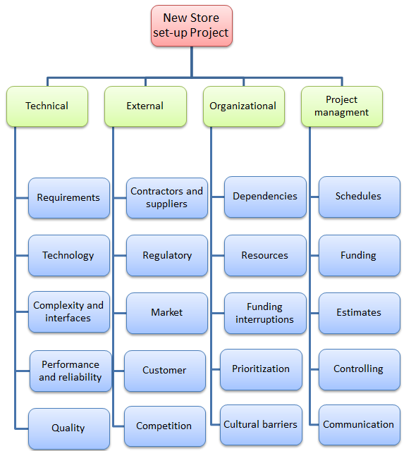

Identification of risks for the project of Morrisons
Risk  NO | RBS category | Risk event | Influence the project objectives | Opportunity or threat?
1 | External | When the supplier not deliver required materials timely | Product quality, scope | Threat
2 | Technical | It takes time to adjust with the Gantt chart techniques, schedule | Scope, time | Threat
3 | Organizational responsibility | There need to distribute the materials and required fund to finish the project task | Product quality, scope | Threat
4 | Project  management | Achieve new knowledge of developing systems | Scope | Opportunity

Risk register
Risk ID | 1 | 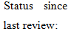 |  |  |  | Date of review: | 22-08-2018
Responsibility: | Project Manager
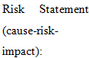 | The project demands sufficient suppliers for continuous supply of required materials (Chary, 2007). So the company manage three responsive supplier from different countries to deliver required materials. If there have any delays for any reason the project have to face huge problems.
Risk Rank |  |  | Time |  | Cost |  |  | Scope
High: (red)
Medium: (yellow)
Low: (green)
Risk ID Number: | 2 |  |  |  |  | Date of review: | 25-09-2018
Responsibility: | Project IT Consultant
 | The project need to use different management tools such as Gantt chart, schedule etc. If the project fail to proper use of tools or any task don’t finish within the time line the managers need to recheck the tools and if needed they can redevelop.
Risk Rank |  |  | Time |  | Cost |  |  | Scope
High: (red)
Medium: (yellow)
Low: (green)

Risk ID Number: | 3 |  |  |  |  | Date of review: | 03-10-2018
Responsibility: | Project Sponsor
 | To finish the project properly there need smooth flow of money (Leseure, 2010). So sponsor need to make available of money for the project. They should not delay release required money.
Risk Rank |  |  | Time |  | Cost |  |  | Scope
High: (red)
Medium: (yellow)
Low: (green)

Risk ID Number: | 4 |  |  | Satisfactory |  | Date of review: | 22-08-2018
Responsibility: | Project Manager
 | Opening the new project provide new experience to the stakeholders of the project which help them in future project.
Risk Rank |  |  | Time |  | Cost |  |  | Scope
High: (red)
Medium: (yellow)
Low: (green)

Assumptions made about the project
Assumptions are important for the project that make clear the known and vague issues of the project by which the managers can develop the plan considering these assumptions.
The known assumptions for the project:
- Making project budget very clearly in project scope.
- The time limit for the project with probable expansion.
- Risk of the project are clarified.
- The information of project resources, time, and cost are well defined.
The unclear (unknown) assumptions for the project:
- The outside risk of the project cannot identified clearly. For example, any accident at working hour of worker cannot be determined in advance.
- At running time of the project the project sponsor may change project requirement that cannot be say in advance.

Project organisation structure and roles and responsibilities
Project organizational structure denotes the hierarchy of authority and responsibility of the project. The company Morrisons organizational structure is given below:
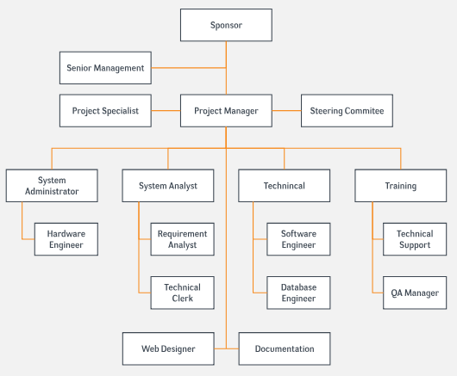
Figure: Project organisation structure
Source (Ecza.com)
Project sponsor: The sponsor of Morrisons project is Morrisons Company. The main responsibility of the sponsor is making financing and govern the whole project.
Senior management: The higher level management of the company is the senior management of the project. Developing project plan, monitoring the progress and controlling are the main responsibility of the senior management.
Project specialist: The specialist of the project consult the managers and hep to develop effective project plan.
Project manager: The managers of the project are very significant part of the project because they are responsible for making plan, implementing, monitoring, and controlling the inter project.
Steering committee: This committee important body that govern the project activity related to the organizational operation.
System analysis: System analysis is for checking the taken techniques and tools and systems for the project.
System administration: This activity is for the hardware engineering required for the project.

Project control mechanisms
Project control management is significant matter for the new project. Opening a new store of the company Morrisons and to set up this project controlling is important for implementing the project plan. There have different control management such as materials control, product quality control, budget control, human resources control etc. The project managers of the company is the responsible for all control management.

Project stakeholder and their involvement
In this project has both internal and external stakeholders.
Internal stakeholders: In this project the internal stakeholders are managers, group members, team members, top level management, and sponsors (Napolion, 2014).
External stakeholders: In this project the external stakeholders are materials suppliers, different financial institutions, shareholders and customers.

Stakeholder matrix
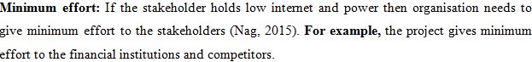
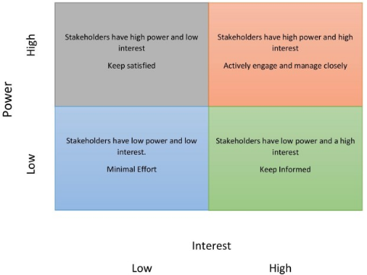
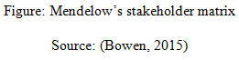
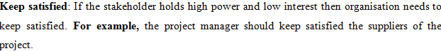
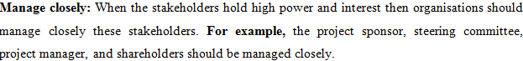
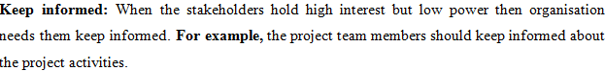

Project planning and milestones
Works breakdown structure of the project
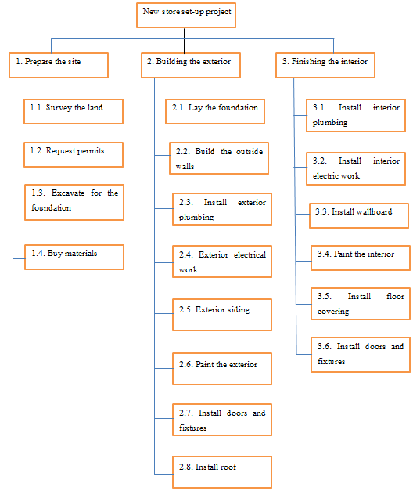
Figure: WBS for Morrison’s project
Source: (Author)
Schedule of the project
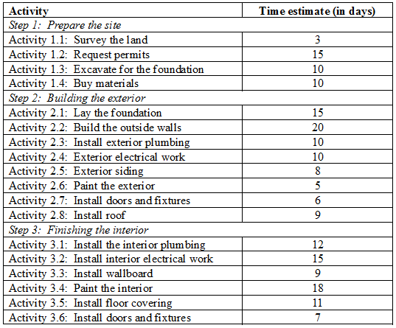
Gantt chart of the project
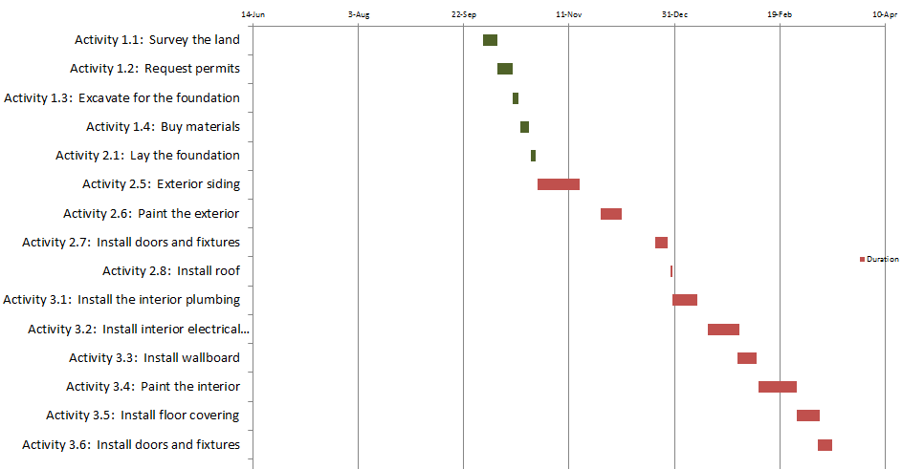
Figure: Gantt chart for Morrison’s project
Source: (Author)
Project budget estimation
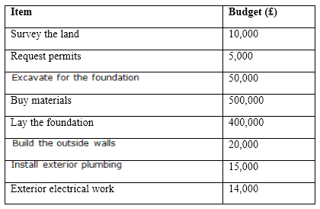
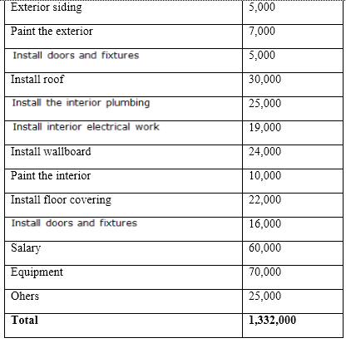

LO3: Critically evaluate ability to manage a project

Own ability to plan and implement a project
Managing the project is very tough and challenging task for the managers of the company. For managing the project the managers need some special qualification, experiences and talent. To make the project successful the project manager must have some significant qualification that the managers can apply to the project. For the positive result of the project there need to identify the strength and weakness so that the manager can recover the weakness of the company and increase the strength. I have to be professional to manage the weakness and strength of the company so that I can use all the resources of the company to make the project successful.
Own strengths
My own strength is making a project plan and implement that.
Capacity to take responsibility: Taking responsibility is a core ability for a project manager. The project manager is the main responsible for making project plan, execution, and monitor and control the whole operation of the project (Ginsburg and Purnomo, 2014). The result of the project fully depends on the effective application of the project plan which is fully depend on the project manager. Analysing the feedback collected from the workers and colleagues of the company I believe that I have the capacity to take responsibility to make a plan and implement that maintaining all the requirements.
Trust and integrity: The project manager have many vital responsibility to perform. So the project manager should have the quality of trust and integrity so that the involved members can get motivation from the project manager (Taormina, 2011). This quality is my core strength by which I can manage and coordinate the project members to perform the project task perfectly.
High commitment: Every project manager is committed to complete the all task of the project within time limit properly (Walton and Deming, 2008). Committed to the project task is important for the project manager. So the managers need to maintain the project task finish with available resources with time limit according to the project plan. I have strong personality to maintain commitment for complete the project task.
Strong leadership: Leadership is the core feature of a project manager (Bolger, DeMent and Pozzo, 2011). The project manager need to train up team members make them used to the culture of the company. The manager need to shape the members behaviour to make the project success. The feedback from the workers of the company I have the super leadership quality to make a project successful.
Decision making ability: Decision making capacity is must for a project manager. During the project operation the project manager need to take many decision to make the project perfectly done. Any wrong decision do hamper the project operation. From feedback of colleagues’ information and past experience I have the quality to take decision considering the situation.
Adjust with change: Change is very common matter in a project. A project manager face different types of complex functions, many challenges, and many internal or external pressure that have direct impact to the project operation. So the manager should have the adaptability quality with any changes of the project. I feel that I have the quality to adjust with any changes during the project operation.
Own Weaknesses
Although I have many capacity to maintain a project I have some limitations also that are discussed below:
Lack of communication skill: Communication skill is very much important for project manager to proper maintenance of a project. From the workplace information I came to know that I have lacking to maintain proper communication. Sometimes I feel hesitate to communicate with the people but I take it a serious issue and take plan to solve this problem.
Lack of self-motivation: Motivation is important part of project work. To make the members confident there need strong motivation but I have lack of self-motivation. Though I can prepare effective project plan, I feel insecurity of success of the project.
Lack of IT skill: Now it is digital world so IT skill is important for every types of project management. Although is significant I have weakness in IT skill. To maintain different tools and techniques like Gantt chart, different schedule there need IT skill. So I need to increase my IT skill as soon as possible.

Self-development plan to improve managing project using SMART objectives
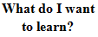 | 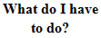 | 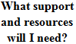 | 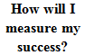 | 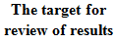
IT skill | Taking training and coaching from experts. | Watching different videos from YouTube, participate in IT training center, practice at home using relevant software like MS word, MS excel. | If I can prepare Gantt chart, different schedule, critical path, WBS, MS power point etc. | 3 months
Communication skill | Attend different communication skill development program, participate in coaching, and interact with new people. | I can take consult from my university teachers, gather knowledge from different books, journals etc. | I have self-confidence to communicate any new people, and deliver any information easily. | 6 months
Decision making skill | Attending in decision making development program, professional skill development program. | Join in skill development training session, gather knowledge from books and journals, solve different case study. | Ability to take decision in different situation and compare with the result and feel confident to take decision. | 1 year.

Conclusion
Managing a project perfectly is a challenging task for the project manager of the company. They have to solve various problem of the company. There have limited resources and time limitation to complete the project. So to make a project successful the managers have to solve many complex task. The manager take help from many management tools and techniques to make the project task easy. Manager make project plan, implement with available resources, and monitor the whole activity, control according to the plan to achieve company specific goals and objectives.

References
Bolger, W., DeMent, S. and Pozzo, J. (2011). Group legal service plans. New York, N.Y.: Law & Business.
Walton, M. and Deming, W. (2008). The Deming management method. New York: Perigee Books.
Taormina, T. (2011). Foreseeable risk. Tucson, Ariz.: Lawyers & Judges Pub. Co.
Ginsburg, D. and Purnomo, B. (2014). OpenGL ES 3.0 programming guide. Upper
Napoléon, H. (2014). Les lois du succ es 3. Performance.
Leseure, M. (2010). Key concepts in operation management. London: SAGE Publication.
Chary, S. N. (2007). Production and operation management. New Delhi: McGraw-Hill publishing company.
Lowson, H. R. (2002). Strategic operation management. London: Routledge.
Eden, C. and Fran, A. (2013). The journey of strategic management. London: SAGE Publications.

Grando, A and Belvedere, V. (2017). Sustainable operation and supply chain management. London: Jhon Wiley & son’s ltd.
Khanna, R. B. (2015). Production and operation management. New Delhi: PHI privet limited.
Weightman, J., (2018). Organisational Assessments. 13th ed. London: Pearson.
Jupp, J., (2013). Management Studies. 12th ed. Tokyo: McGraw-Hill Tokyo.
Lester, A. (2013). Project management, planning and control. 6th edition. Oxford: Butterworth-Heinemann.
Dennis, M. (2014). The essentials of project management. Burlington: Ashgate Publishing
Ralph L. K. (2007), effective communication for project management, 4th ed, Auerbach publications
Fox, W. (2008), A guide to Project management, 7th ed, cape town: Juta and company ltd.
Boyle, G. (2003), Design Project Management, 7th ed, London: Ashgate.

