Business Plan for
Furry Friends Café
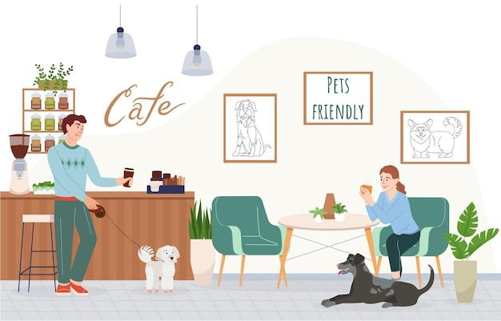

GROUP MEMBERS:
Student Name | Student No.
Viorica Stavinschi | 2243598
Daniela Livia Isar | 2242723
Rezwana Laboni | 2242894
Alina Cristina Ionita | 2246123
Eduardo Polanko Adoka | 2132108
Dated: 18.11.2024

BUSINESS PLAN

Module Name: Entrepreneurship
Module Code: BMIH5001
Lecturer Name: Christopher Wilkins
Word Count: 2164 words

AI Declaration
I certify that I have applied the application named as Grammarly (https://www.grammarly.com/) on 10th November 2024 to make reduction in the emerging errors based on spelling and grammar. Grammarly helps the document to reduce the grammatical and spelling errors by highlighting the word or a sentence. Therefore, I used the way to make necessary changes by applying Grammarly in my work. I also certify that I have not used any kind of AI tools for the completion of the assignment. It is all my research and is my own work. I also confirm that I have saved all the drafts, related notes, and resources for the collection of data and provided appropriate references in the last of my work.

CONTENTS
 |  |  | PAGE
1. | Executive Summary |  | 4
2. | The Business Idea |  | 5
3. | The Team |  | 5
4. | Market Research |  | 7
5. | Marketing Plan |  | 8
6. | Key Resources |  | 10
7. | Finances & Start-Up Support |  | 10
APPENDICES:
Appendix A |  |  | SWOT Analysis
Appendix B |  |  | PEST Analysis
Appendix C  Appendix D |  |  | Copy of Pitch Supporting Material  Customer profiles / Competitor's profiles

- EXECUTIVE SUMMARY
The report introduces a new business, Furry Friends Café, a pet-friendly coffee shop. Will be a unique café that allows all people to come for a relaxing stay with their pets. The café offers a wide range of coffee, desserts and snacks for people along with treats for their pets, an inviting space to relax with their furry. Created for pet owners and lovers, Furry Friends Cafe will provide a comfortable environment where pets are welcome and catered to with a menu tailored to them. The mission of the cafe is to foster, create a unique, welcoming and enjoyable experience for pet owners and their pets, fostering a community of pet lovers while enjoying a coffee and having a rest in a quite reading corner.

2. THE BUSINESS IDEA (Viorica Stavinschi)
2.1 The Product/Service
Business name: Furry Friends Cafe
Location: Ground Floor Bar & Basement, 274 Latimer Road, London W10 6QW (Knight Commercial London, 2024)
Furry Friends Cafe will be in the pet-cafe industry. The innovation allows all pet lovers to get a cosy environment and enjoy a wider range of coffee, desserts, and a variety of pet treats with their pets. The cafe offers a relaxing space as a reading corner that offers a range of books on the shelves. Additionally, it also offers specialised pet drinks and ice cream to make the humans and animals satisfied with the services and environment.
Furry Friends Cafe aims to offer a blend of joy with pet companionship in the cafe setting. The significant features offer a welcoming atmosphere for all the pets and their owners with a wider menu of human-friendly beverages and different types of desserts and some valuable pet treats. The value proposition allows a community hub for promoting the relaxation and social interaction for the pet lovers using different treats and activities (Wirtz, 2020).
2.2 SWOT Analysis Summary (Viorica Stavinschi)
The SWOT analysis for a new business of Furry Friends Cafe defines that the services stand out with the provision of the unique offering based on the pet-friendly cafe and catering the pets and their owners at the same time. The strengths are associated with the provision of innovative concepts and a larger variety of menu, whereas; the weaknesses identify the reliance on local trends of pet ownership using initial financial burdens (Vaska et al., 2021). Opportunities applied to the growth are abundant ones that are particularly considering the partnerships and expansion in the services; however, the business should make appropriate navigation for the competitive pressures and emerging economic challenges to make a success.

3. THE TEAM
3.1 Key Personnel
Name: Viorica Stavinschi
Company Position: Founder and CEO of Furry Friends Cafe
Salary: £38,850 (Indeed UK, 2024)
Skills and Experience: Experience of business management of 3 years. I develop stronger skills in the management of operations, marketing activities, and customer service.
Role and Responsibilities: The significant responsibilities in the business of Furry Friends Café will be based on overseeing daily operations, management of the finances, and development of the strategic marketing plans for attracting and retaining the customers.

Name and Company Position: Head of development Rezwana Laboni (Salary £28,000)
Skills and Experience: I have significant expertise in baking and have previously developed seasonal menus and generated new food products.
Education & Certifications: - Food safety & Hygiene certificate (High speed training, 2023)
Health & Social Care Diploma (L2&3)
Role and Responsibilities: The responsibilities will be based on defining menu, training staff for beverage preparation, and ensuring higher quality of service standards.

Name: Daniela Livia Isar
Company Position: Marketing Manager
Salary: Salary 29.000£
Skills and Experience:
Stronger background in digital marketing and community development for a business.
Role and Responsibilities: Development of the marketing campaigns and organisation of the community events to foster the partnership and enhance the visibility in the industry (Priyono et al., 2020).

Name: Alina Cristina Ionita
Company Position: Operations Manager.
Salary 29.000£
Skills and experience: Achieved over 6 years of experience, maintained an accident-free work environment, expertise in streamlining production, budgeting and financial management, quality and cost control, problem-solving, risk assessment and supply chain.
Role and Responsibilities: Using a Just-In-Time supply chain strategy to reduce inventory risks, maintain an emergency fund, review legal requirements, schedule routine inspections.

Name and Company Position: Pet care specialist. (Salary 23.000£)
Skills and Experience: Experience in animal behaviour and care services.
Role and Responsibilities: Combination of expertise and business management, marketing, operation, and creation of unique experience (Kraus et al., 2022).

3.2 Skills Gaps & Key Partners (Rezwana Laboni)
3.2.1 Additional Staff Requirements:
Pet Care Attendant: The role fills the gap in providing knowledge of pet care with customer experiences.
Marketing Representatives: Focuses on development of marketing strategies. The role addresses lack of marketing expertise in the business.
Customer Representatives: Handles customers’ inquiries and the role will enhance the relations with customers (Keiningham et al., 2022).
3.2.2 Training and Development:
Customer Services Training: It allows recognition of communication skills and customer interactions. It is estimated as £1,500 every month for providing training to the staff (Haider and Tehseen, 2022).
3.2.3 Outsourced Support / Key Partners:
Local Pet Trainers: Allows collaboration with ongoing workshops. The estimate is 2,300 Great British Pounds sterling monthly.
Marketing Agency: The role is to make effective promotional campaigns and estimated as 3,050 GBP monthly.
Event Management Services: Engages people with events and promotions. The estimation will be £5,000 monthly.

4. MARKET RESEARCH (Eduardo Polanko Adoka)
4.1 Market Information, Trends and External Factors
The market for Furry Friends Café will offer a significant growth that increases the ownership and consumer demand to manage social experiences. Pet ownership seems increasingly aligned with the global trend based on the pet-centric businesses in the world (Guldmann and Huulgaard, 2020). The pet industry in the UK is increasing by 7.8% annually till 2025 that identifies the stronger market potential for the new business.
A PEST analysis reveals different external factors impact on the business (Gregori and Holzmann 2020). Political factors allow regulations based on health and safety standards for managing services. Economic factors define the increase in the disposable income within the urban populations. Social trends allow the growing preference for managing pet-friendly environments and community development, and Technological advancements allow several opportunities to outreach to the target audience. The trends will address the external challenges using strategic planning for Furry Friends Café in a new market.
4.2 Customer Profiles (Eduardo Polanko Adoka)
1.Dog Lover Daniel
Gender: All; men more often than not
Ages: 25-35
Professional Occupations: Pupils of Master’s Degrees or higher; workers in the financial technology sectoral industry, and dog-walkers
Salary or Annual Incomes: £20,000 to £60,000
Preferences and Likes: Puppies, walking dogs
Dislikes: Unfit and unhealthy lifestyles
Habitual Tendencies: Eating organic snacks at cafes
Behaviours and Attitudes: Prioritising time with pet dogs
They are single or in relationships, with lesser income and busy lifestyles.
Dog-lovers have contributed to the fact that the pet population of the UK, in the year 2024, is made up of more than 13 million canines (Statista, 2024). They value pet-friendly places on the weekends. They share experiences on social media for the success of brand visibility.
2.Cat-Loving Catherine (Refer to Appendix D).
3. Foodie Frank (Refer to Appendix D).

4.3 Competitor Profiles (Eduardo Polanko Adoka)
Java Whiskers Cat Café
The comfortable cafe in the small town of Marylebone offers services to the pet cats at a special ‘lounge’ only for kittens, with a larger menu of coffee and pastries for humans. The strengths are stronger brand recognition and a loyal customer base (Java Whiskers, 2024). The weaknesses are having limited appeal to different pets since they do not cater to those who may prefer dogs and puppies, birds, or other animals, even the exotic ones.
Competition Strategy: The new business will offer a cosy reading site for all the demographic. The USP will offer quality food for both pets and owners (Felin et al., 2020).
Competition Strategy: A business will manage a broader audience with a variety of menu options. The USP will offer an environment that enhances the community for all the pet lovers.

5. MARKETING PLAN – Daniela Livia Isar
5.1 Price
Furry Friends Cafe will provide a value-based pricing strategy using perceived quality and experience to be defined. For example, the prices of coffee will be £2.50-£3, whereas the pe treats will be from £1 to £5.00 on the services. It reflects on the high-quality products like ingredients and unique services (Burström et al., 2021; Ferasso et al., 2020). The pricing offers a sense of premium quality with an affordable process of target customers. It is compared to competitors such as The Dog House Café that offers less charges.
5.2 Product
The products of Furry Friends Cafe will provide a warm, definite atmosphere, and stronger decor with comfortable seating for the people. Packaging will also be provided to feature eco-friendly options and considering the café's branding. The products are packed in colourful and using pet-themed graphics for encouraging the unique concept.
5.3 Placement
Products and services will be offered offline. The physical café will provide a pet-friendly region for the local pet owners (Breier et al., 2021).
5.4 Promotion
The new business will be based on different types of promotional techniques for the attraction of customers. The initial step is considering the use of social media platforms (Bocken and Geradts, 2020; Bican and Brem, 2020). It will allow learning of different services by the customers using online resources. The email marketing will also help to manage customers and collect their feedback after taking services and enjoy the meals and desserts in the café.

6. KEY RESOURCES – Alina Cristina Ionita
6.1 Premises
Furry Friends Cafe will need a physical space for almost 1618 sq. ft. to make a perfect accommodation for the café area, a relaxing reading corner, and space for all the pet activities. The main seating area is likely to span 800 square feet while the remaining 400 square feet is meant to accommodate the small animals. The location will offer pet-friendly features to different sizes and breeds of cats and dogs while attracting foot traffic from different pet-owners. The estimated rent will range approximately 45,000£ annually. The business will be located in Ground Floor Bar & Basement, 274 Latimer Road, London W10 6QW (Knight Commercial London, 2024).

6.2 Equipment
Coffee Machines will be needed for high-quality machines and grinders that will be estimated to almost £5,000. The tools and technologies are potentially going to be purchased from the supplier Logic Vending Limited. The medium-sized private limited company is located in Ware, the UK (Logic Vending LTD., 2024). The low costs of the brand have made it a household name amongst the coffee shop and cafe owners of Great Britain and the Republic of Ireland, which is why even its espresso machines will be purchased.
The furniture purchases would be made from Furniture Village since it provides extremely high-quality seats, sofas, armchairs, tables, ottoman stools, and even other furniture elements as well. It has been named the largest independent retailer of furniture, the offices of which are based and headquartered in the UK (furniturevillage.co.uk., 2024).
The kitchen equipment will need cutlery, crockery, sinks, refrigerators and freezers, drip coffee-makers, ovens, blenders, along with others with an overall estimated total cost of £9,000. That will be supplied to this new business by Alliance Online. The digital-only firm caters kitchenware products and raw materials to the hospitality industrial sector of the UK (Alliance Online, 2024).
6.3 Key Suppliers
Coffee beans suppliers will be the local roasters offering higher quality coffee beans that will be estimated cost per kg: £ 25. That will be bought from Small Batch Coffee Roasters. Its wholesale coffee beans are the most sought-after supplies (Small Batch Coffee Roasters, 2024). Hence, those speciality items are going to be purchased by Furry Friends in bulk.
The pet treats supplier must be the provider specialised in organic pet services and estimated cost per item will be £5. It is an online store (PetShop.co.uk, 2024). Therefore.
The supplier for the raw ingredients which are required to make the bakery goods and other cooked dishes will provide the materials for the fresh pastries and coffee-flavoured desserts in the shape of small animals, for which the estimated cost per item is £10. These will be obtained from Andrew Ingredients. The company sells wholesale raw bakery goods at very low costs (Andrew Ingredients, 2024). The Just-In-Time supply chain management method will be incorporated in this context to attain the products at a rapid speed without delays.

7. FINANCES AND START-UP SUPPORT – Alina Cristina Ionita
EXPENDITURE | Year 1
EXPENDITURE | £
Company Registration | 71
Rent/Rates | 45,000
Staff Wages | 147,850
Telephone (mobile) | 370
Broadband | 600
Utilities | 9000
Marketing and materials | 1,500
Insurance | 1070
Capital Expenditure and Equipment | 11.000
Training & Development | 400
Accounting/Legal | 350
Outside Services | 200
Stock/Materials Purchases | 3000
Bank Charges | 150
Office Consumables | 600
Loans Repayments | 1,500
Total Expenditure | 221,811
INCOME | Year 1
INCOME | £
Sales of coffees | 103,000
Sales of Pets treats | 14,000
Sales and services | 35,000
Capital Introduced | 25,000
Funding | 7,000
Loans/Borrowing | 25,000
Total Income | 209.000
YEAR ONE PROFIT/LOSS | £
Total Income | 209.000
Total Expenditure | 218.811
Profit/Loss | 12.811

7.1 Financial Summary
It is estimated that almost 221.811 will be needed as total expenditure for the start-up of the business named as Furry Friends Café. There are different services and products included in the expenditures that are essential for a successful business. It is also estimated that the total income will be gained as £209.000 that offers a loss of £12.811 for a business on an annual basis. Despite this anticipated loss in the first year, the business is dedicated to maintaining high quality and services, safe environment, continuous improvement as loyalty programs, optimising efficiency to reduce costs, achieving long term success and profitability over the years.

APPENDICES
Appendix A – SWOT Analysis (Viorica Stavinschi)
Strengths | Weaknesses
Introduction of the unique concept.  Pet-friendly environment.  Customer Loyalty.  Enhancing customer experience.  Cosy environment with books.  Relaxing community engagement. | Difficulties in initial finances.  Space and layout constraints.  Limited marketing experiences.  Limited costumer base
Opportunities | Threats
Growing trends in the services.  Greater customer base.  Potential partnership management.  Social media appeal. | Intense competition in the market.  Economic downturns and instability.  Emerging regulatory challenges.

Appendix B – PEST Analysis – Daniela Livia Isar
Factors | Analysis
Political | Political factors encompass government regulations and policies that can impact the café industry, especially those related to food safety, health regulations, and animal welfare. The use of local health codes with licensing requirements impact on the operating system of a food establishment.
Economic | Economic factors allow economic environment, management of consumer spending power, and disposable level of income. The growing economic trends offer willingness to invest in pet-related services and related products.
Social | Social factors impact on the changing consumer attitudes and behaviours for pets and social management. The growing trend of pet humanisation to know about family members that are leading towards the increase in the demand for pet-friendly places.
Technological | Technological factors allow advancements for the business operations and defining customer engagement. The increase in social media platforms offers different channels for marketing of new business and building an effective community of pet lovers.

Appendix C – Copy of Pitch Supporting Material
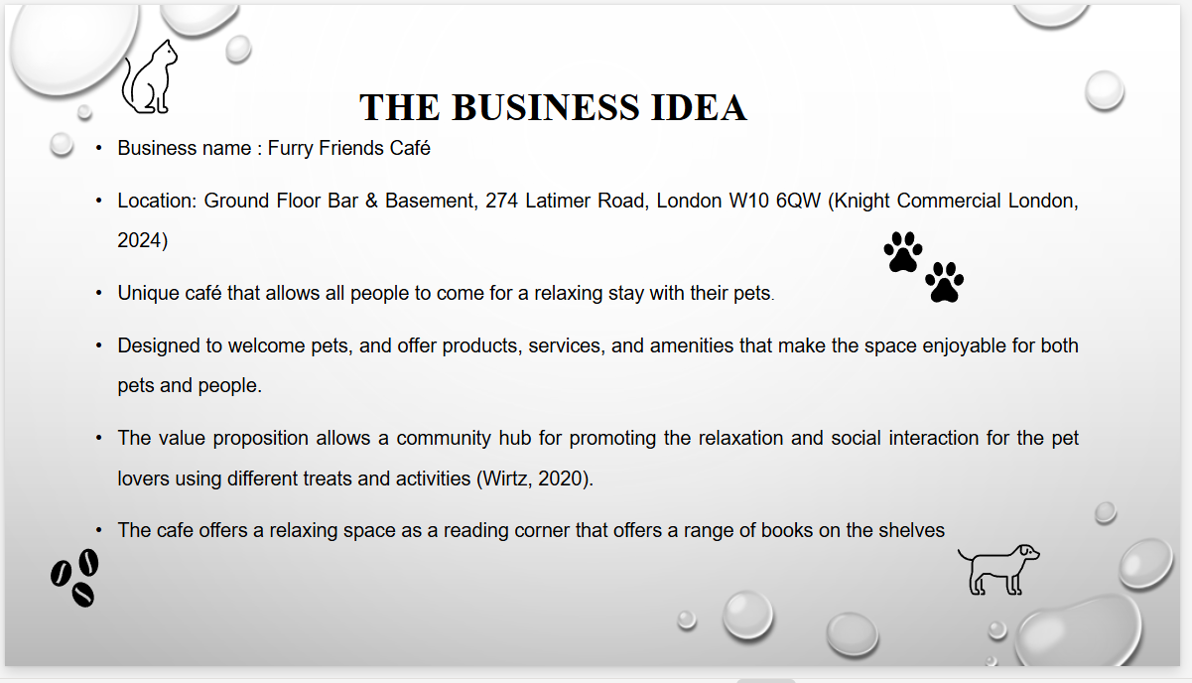

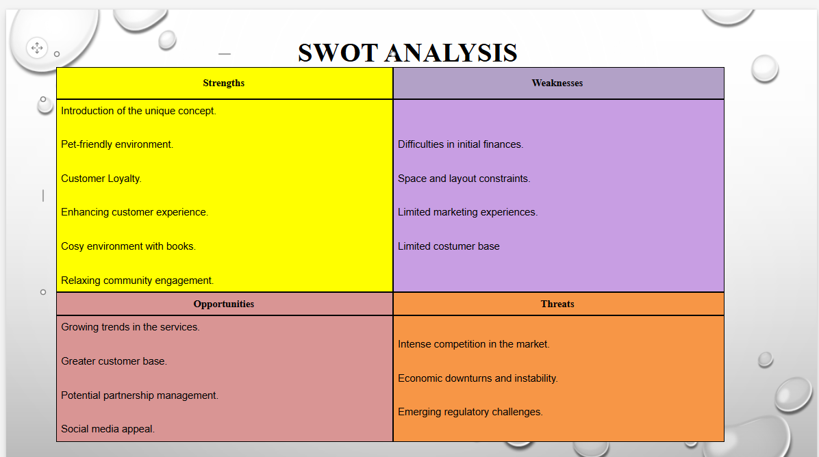
Appendix D – Customer profiles / Competitor's profiles.
Foodie Frank
Gender: All-inclusive
Age: 15 to 40 years old
Profession or Occupation: School students, collegegoers, and corporate office-workers
Salary and Annual Incomes: Minor teenagers will have no income; Adults will have salaries anywhere from £1,000 to £55,000, as self-employed freelancers, part-time interns and apprentices, or placement-holders.
Likes and Preferences: Consumption of large meals, including tea-time snacks such as coffee, cookies, and different types of cake.
Dislikes: They do not enjoy eating only the same flavours of baked products.
Habits and Tendencies: Visiting quaint cafes in close communities
Behavioural Attitudes: Liking to visit new places similar to eateries with pets.
These individuals are likely to be one of the largest demographics of the target consumer market of the Furry Friends Cafe. The most common visitors of cafes in the UK include those who are between 18 and 24 years of age (Statista, 2024).

Cat-Loving Catherine
Gender: Inclusive; a slightly higher demographic of women and girls
Age: 18 to 55 years
Professional Occupation: University students, owners of boutiques, and other skilled white-collar jobholders like Chief Executive Officers
Salary and Annual Incomes: £20,000 to £60,000
Likes and Preferences: Cats; healthy foodstuffs
Dislikes: Posh eateries; trainers who breed crosses of animals and sell them in the place of rescuing critters in need
Habits and Tendencies: Caring for rescue animals, going to quaint cafes and English cottages
Behavioural Attitudes: They are generally compassionate towards people and animals.
They are basically pet owners who manage animals as family members offering different ages and backgrounds. The profile needs higher quality pet products with a relaxing environment for them and their pets (Geissdoerfer et al., 2020).
Parents consider family-friendly activities with their pets.
They prefer spending quality time in the places for all children and pets (Gil-Gomez et al., 2020). The group values a safer environment for kids and pets using convenient outings.

Competitors profiles.
Dog and Scone Café
The cafe is garden-themed and offers commodities like grooming services with café experience. The strengths allow convenience for all the pet owners seeking grooming services (Dog and Scone.com, 2024). Its own official online website is even made up of a section which is dedicated solely to the introduction of each of their dogs. The weaknesses seem in the lack of cosy atmosphere with dedicated café services (Ciampi et al., 2021; Di Vaio et al., 2020). However, traditional British delights in the form of tea cakes are sold, while the visitors pet the resident canines; nonetheless, this turns its other circumstances out to be more posh, prim, and proper, which may not attract each and every individual.
Competition Strategy: The new business will offer a relaxing café environment for the customers to enjoy coffee and desserts with pets.
The USP will offer a quiet reading corner where the competitors focus solely on other services.
Lady Dinah’s Cat Emporium
It focuses on cats with a vibrant environment for the cat lovers. The strengths are offering unique concepts for the cat enthusiasts and making definite interaction with cats. The weaknesses are making a very niche market segment (Donner et al., 2020). It has an immensely high number of loyal customers as it was the first ever cat cafe to have been situated at Bethnal Green, in the urban metropolitan city of London within the United Kingdom. The cosy eatery with a “magical aura” also houses rescue cats, appealing to the sensitive, empathetic, and compassionate nature of its targeted segment of customers, who can adopt them if they wish for it (Lady Dinah’s Cat Emporium, 2024). On the other hand, other consumers may be geared more towards purebred animals who are more expensive to purchase.

REFERENCE LIST
Alliance Online, (2024). Alliance Online. Available at: Catering & Kitchen Equipment Suppliers UK | Alliance Online (Accessed: 09 November 2024).
Andrew Ingredients, (2024). wholesale bakery products. Available at: Andrew Ingredients | wholesale bakery products (Accessed: 09 November 2024).
Bican, P.M. and Brem, A.,( 2020). Digital business model, digital transformation, digital entrepreneurship: Is there a sustainable “digital”?. Sustainability, 12(13), p.5239.
Bocken, N.M. and Geradts, T.H., (2020). Barriers and drivers to sustainable business model innovation: Organization design and dynamic capabilities. Long range planning, 53(4), p.101950.
Breier, M., Kallmuenzer, A., Clauss, T., Gast, J., Kraus, S. and Tiberius, V.,( 2021). The role of business model innovation in the hospitality industry during the COVID-19 crisis. International Journal of Hospitality Management, 92, p.102723.
Burström, T., Parida, V., Lahti, T. and Wincent, J., (2021). AI-enabled business-model innovation and transformation in industrial ecosystems: A framework, model and outline for further research. Journal of Business Research, 127, pp.85-95.
Ciampi, F., Demi, S., Magrini, A., Marzi, G. and Papa, A., (2021). Exploring the impact of big data analytics capabilities on business model innovation: The mediating role of entrepreneurial orientation. Journal of Business Research, 123, pp.1-13.
Di Vaio, A., Boccia, F., Landriani, L. and Palladino, R., (2020). Artificial intelligence in the agri-food system: Rethinking sustainable business models in the COVID-19 scenario. Sustainability, 12(12), p.4851.
Dog and Scone, (2024). Dog and Scone Cafe. Available at: Dog and Scone Cafe (Accessed: 09 November 2024).
Donner, M., Gohier, R. and de Vries, H., (2020). A new circular business model typology for creating value from agro-waste. Science of the Total Environment, 716, p.137065.
Indeed UK, (2024) CEO Office Manager. Available at: CEO Work, jobs in London (with Salaries) | Indeed.com United Kingdom (Accessed: 8 November 2024)

Felin, T., Gambardella, A., Stern, S. and Zenger, T., (2020). Lean startup and the business model: Experimentation revisited. Long Range Planning, 53(4), p.101889.
Ferasso, M., Beliaeva, T., Kraus, S., Clauss, T. and Ribeiro‐Soriano, D., (2020). Circular economy business models: The state of research and avenues ahead. Business strategy and the environment, 29(8), pp.3006-3024.
Furniturevillage.co.uk., (2024). The UK’s Largest Independent Furniture Retailer - Furniture Village. Available at: The UK's Largest Independent Furniture Retailer - Furniture Village (Accessed: 09 November 2024).
Geissdoerfer, M., Pieroni, M.P., Pigosso, D.C. and Soufani, K., (2020). Circular business models: A review. Journal of cleaner production, 277, p.123741.
Gil-Gomez, H., Guerola-Navarro, V., Oltra-Badenes, R. and Lozano-Quilis, J.A., 2020. Customer relationship management: digital transformation and sustainable business model innovation. Economic research-Ekonomskaistraživanja, 33(1), pp.2733-2750.
Gregori, P. and Holzmann, P., 2020. Digital sustainable entrepreneurship: A business model perspective on embedding digital technologies for social and environmental value creation. Journal of Cleaner Production, 272, p.122817.
Guldmann, E. and Huulgaard, R.D., (2020). Barriers to circular business model innovation: A multiple-case study. Journal of cleaner production, 243, p.118160.
Haider, S.A. and Tehseen, S., (2022). Role of decision intelligence in strategic business planning. Decision intelligence analytics and the implementation of strategic business management, pp.125-133.
Java Whiskers, (2024). Java Whiskers - Experience Europe’s Finest Cat Cafe. Available at: Java Whiskers Cat Café - Experience London's Finest Rescue Cat Cafés (Accessed: 09 November 2024).
Keiningham, T., Aksoy, L., Bruce, H.L., Cadet, F., Clennell, N., Hodgkinson, I.R. and Kearney, T., (2020). Customer experience driven business model innovation. Journal of Business Research, 116, pp.431-440.
Knight Commercial London Limited, (2024). Ground Floor Bar & Basement, 274 Latimer Road, London W10 6QW. Available at: Leisure facility to lease in Ground Floor Bar & Basement, 274 Latimer Road, London W10 6QW, W10 (Accessed: 28 October 2024)

Kraus, S., Kanbach, D.K., Krysta, P.M., Steinhoff, M.M. and Tomini, N., (2022). Facebook and the creation of the metaverse: radical business model innovation or incremental transformation?. International Journal of Entrepreneurial Behavior & Research, 28(9), pp.52-77.
Lady Dinah’s Cat Emporium, (2024). Lady Dinah’s Cat Emporium. Available at: London Cat Café - Lady Dinah's Cat Emporium (Accessed: 09 November 2024).
Logic Vending LTD., (2024). Logic Vending. Available at: Commercial Coffee Machines Lease Rent or Buy - Logic Vending (Accessed: 09 November 2024).
PetShop.co.uk, (2024). Welcome to PetShop.co.uk | Online Pet Shop. Available at: Welcome to PetShop.co.uk | Free UK Delivery | Online Pet Shop (Accessed: 09 November 2024).
Priyono, A., Moin, A. and Putri, V.N.A.O., 2020. Identifying digital transformation paths in the business model of SMEs during the COVID-19 pandemic. Journal of Open Innovation: Technology, Market, and Complexity, 6(4), p.104
Small Batch Coffee Roasters, (2024). Small Batch Coffee Roasters - Speciality Coffee. Available at: Small Batch Coffee Roasters - Speciality Coffee (Accessed: 09 November 2024).
Statista, (2024). Cafe visitation frequency Great Britain 2024. Available at: Cafe visitation frequency Great Britain 2024 | Statista (Accessed: 09 November 2024).
Statista, (2024). Leading pets in the UK 2018, by pet population | Statista. Available at: Pet population in the UK 2024 | Statista (Accessed: 09 November 2024).
Vaska, S., Massaro, M., Bagarotto, E.M. and Dal Mas, F., (2021). The digital transformation of business model innovation: A structured literature review. Frontiers in Psychology, 11, p.539363.
Wirtz, B.W., (2020). Business model management: design-process-instruments. Springer Nature.

