Industry 4.0 Technology

What is Industry 4.0?

There is a significant transformation regarding the way we manufacture commodities due to the digitisation of manufacturing. “From the first industrial revolution (mechanisation through water and steam power) to the mass production and assembly lines using electricity in the second, the fourth industrial revolution will take what was started in the third with the adoption of computers and automation then enhances it with smart and autonomous systems fuelled by data and machine learning” (Marr, 2018).
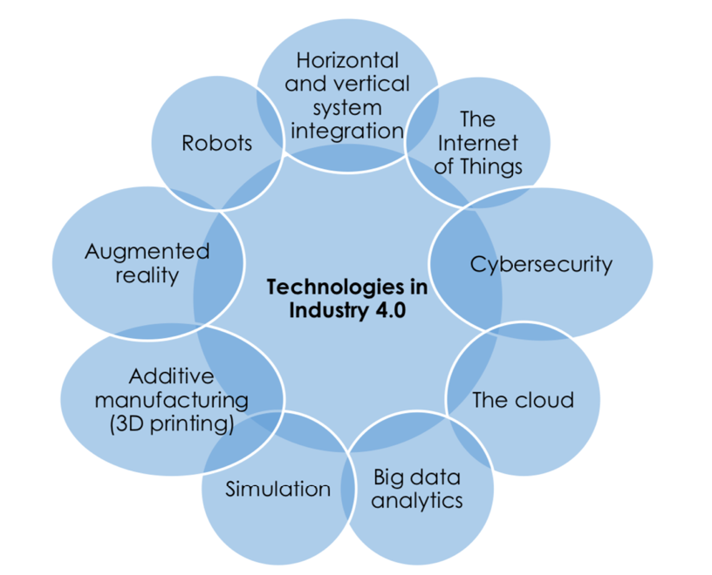

Figure 1.0
(Bahrin, et al., 2016)

There are a number of technologies that are adopted and adapted in Industry 4.0 as shown in figure 1.0. As mention above, the radical change is surrounding creating a digital twin or using computational methods to aid manufacture. Each individual technology can play a large part in recreating production lines and organisations globally. For example, including robotics to production lines can improve productivity and will pay back in under two years. There is an argument that robots are unable to see defects and issues instantly during production. This can be combatted by using collaborative robotics. A collaborative robot is specifically designed for direst interaction with a humans within a defined collaborative workspace. A collaborative workspace is a safeguarded space where the robot and a human can perform tasks simultaneously during automatic operation (Beaupre, n.d.). The use of cobots can be adopted to interact with operators to get ‘the best of both worlds’ when it comes to production. The cobots can aid with handling large products and significantly reduce scores when completing risk assessments while opening up numerous avenues for innovative manufacturing. The collaborative robots can work in close proximity to operators by using a vast amount of sensors for safety and initiating a mode for the robot to move at a safe speed (Matthews, 2018).

The opportunity to create a digital representation of equipment or production lines is something many factory floors should take. Using software such as Siemens Process Simulate can provide important feedback when designing new and adapting existing production lines. Main issues or bottle necks in the new lines can be managed accordingly and be can be dramatically reduced. The software is also able to give you accurate output timings to ensure you are reaching the run at rates for the equipment and production line. The digital representation of equipment can also be useful when completing factory acceptance tests. The machine can be interrogated to see if there are any flaws or safety issues with the machine. This can reduce lead times on modifications that might be needed before it arrives on the factory floor. Just like the introduction of cobots, the simulation software could lead to finding new and innovative ways to produce the products. You can trial new equipment on the market in the software to see if there is a benefit to the production line before purchasing typically expensive equipment. Since many managerial decisions are data driven, using simulation software is a suitable tool to use during the discussions. The data can be manipulated into a format to show overall costs, pay back and throughput increase. With Industry 4.0 being data driven, it is paramount that decisions are made using accurate data that has been collected in reputable way. (Mallej, et al., 2015)

Marelli (MLUK)

As mentioned above there are two key technologies that can be adopted at Marelli. These technologies are the use of robotics and creation of a digital simulation of production lines. This engineering report will go into detail in how Marelli Llanelli can use the technologies involving robotics/cobots from Industry 4.0. Marelli have a global standard of using Yaskawa robots and that will be considered in this report.

With the introduction to a whole new product for the plant, this brings new challenges that may have not been seen before. With volumes hitting 400 per hour in peak production, any seconds that can be saved by increasing productivity will be explored. The new products range from 300mm to 1500mm long and can be difficult to handle due to how flexible the products are especially when they have left the furnace. A key characteristic from customer is that the products maintain a 2mm flatness over the length of the product. With how delicate the product is there can be value added by introducing a cobot to manoeuvre the product in the correct orientation to place onto the coating plant. There are two places in the production line where the product changes from the horizontal to vertical orientation and the other position in the line is where it returns back to horizontal. During the prototype build there has been significant fall out due to flatness. Some days of production would be producing 100% fallout and a secondary operation was introduced. In the changing of orientationof the products, there are opportunities to introduce small pick and place cobots to assist the operator. Another area where cobots can be used is at the packaging station. The current boxes used for transporting the products to customer have been rejected by health and safety after an ergonomic assessment. The Marelli logistic team have designed returnable packaging that will house five products before it is placed into the large Gefco box shown in figure 2.0. Due to the size and weight of the returnable packaging two operators are needed. This still creates issues due to the amount that they will need to bend and how many times per hour they will be repeating the action.

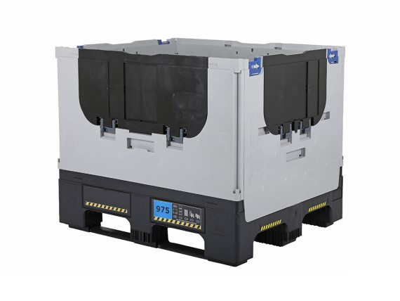
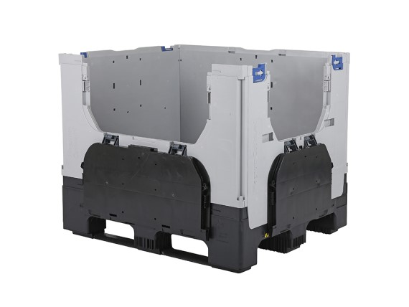

Figure 2.0

There will be two operators working in the packaging cell and there is an opportunity to remove one operator while improving the ease of packing with the collaborative robot. The Yaskawa Cobot HC10 is sufficient to complete the packaging tasks. It is a good introduction to cobots due to its easy to use programming pendent (Yaskawa, 2019). The Yaskawa cobot is extremely safe and does not need safety fences set up as it equipped with sensors to detect when external force exceeds the limitations. These values can be set in advance. The arm is also designed in a shape that prevents people’s hands from being trapped or pinched which will improve the flexibilities for production equipment. The HC10 was selected over the HC20 due to size constraints in the cell and the 10kg lift is more than enough to cope with the lift requirements.
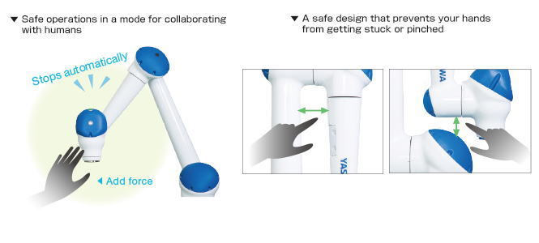
Figure 3.0

Figure 4.0

If the packaging cell removed one operator the payback period would be for the collaborative robot would be just over 18 months. Due to the saving of the operator’s yearly salary there can be adequate savings.

Figure 5.0

Even further saving can be made if the removal of two operators is achieved. This is real possibility as the production line in operator heavy. The test machine operator would have another operation and place the component into the returnable packaging before the cobot can place it into the Gefco box.

The proposed production line is extremely manual. This shows that if the introduction of cobots can make a considerable difference improving production efficiency and making substantial savings. There are many issues that can occur when trying to introduce robots to the plant floor. It is very difficult to get the backing from the operators and there can be tensions between operators and engineers that may reduce throughput (Crowe, 2018). When new robotic systems are implemented, a new level of expertise is required from employees. Many will have to be trained on how to operate in this new environment, while other employees will have to be hired that have the proper certifications, education, and robotic experience. Convincing plant managers and health and safety officers that robotics do not need to be contained is another area that needs to be addressed. Robots introduce many new safety hazards into the workplace and there are strict regulations, as well as stiff penalties, surrounding robotic safety. Manufacturers have to prepare for this before the robots are installed to ensure compliance and create a safe environment for workers (Robotics Online Marketing Team, 2018).

Bibliography
Alejandro , F. G., Dalengare, L. S. & Ayala, N. F., 2019. Industry 4.0 technologies: Implementation patterns in manufacturing companies. International Journal of Production Economics, Volume 210, pp. 15-26.
Bahrin, M. A. K., Othman, M. F., Azli, N. & Talib, M., 2016. INDUSTRY 4.0: A REVIEW ON INDUSTRIAL AUTOMATION AND ROBOTICINDUSTRY 4.0: A REVIEW ON INDUSTRIAL AUTOMATION AND ROBOTICINDUSTRY 4.0: A REVIEW ON INDUSTRIAL AUTOMATION AND ROBOTIC. Jurnal Teknologi.
Beaupre, M., n.d.. Collaborative Robot Technology and Applications. [Online]
Available at: https://www.robotics.org/userAssets/riaUploads/file/4-KUKA_Beaupre.pdf
[Accessed 2020].
Crowe, S., 2018. 10 Biggest Challenges in Robotics. [Online]
Available at: https://www.therobotreport.com/10-biggest-challenges-in-robotics/
[Accessed 2 February 2020].
Mallej, W., Nayebi, M., Johann, T. & Ruhe, G., 2015. Towards Data-Driven Requirements Engineering. Future of Software Engineering.
Marr, B., 2018. What is Industry 4.0? Here's A Super Easy Explanation For Anyone. Forbes, 2 September.
Matthews, K., 2018. 5 ways robotics are being used in smart Manufacturing. [Online]
Available at: https://www.manufacturingtomorrow.com/article/2018/05/5-ways-robotics-are-being-used-in-smart-manufacturing/11568
[Accessed 2020].
Robotics Online Marketing Team, 2018. The Biggest Challenges Manufacturers Face in Industrial Robot Implementation. [Online]
Available at: https://www.robotics.org/blog-article.cfm/The-Biggest-Challenges-Manufacturers-Face-in-Industrial-Robot-Implementation/106
[Accessed 2020].
Tao, F., Liu, A. & Kusiak, A., 2018. Data-driven Smart Manufacturing. Journal of Manufacturing Systems, Volume 48, pp. 157-169.
Yaskawa, 2019. askawa Launches Collaborative Robot MOTOMAN-HC10DTF with a Payload Capacity of 10kg Equipped with Food Specifications -New lining up against food hygiene by surface coating that eliminates the risk of paint shards contamination-. [Online]
Available at: https://www.yaskawa-global.com/newsrelease/product/25308
[Accessed 29 Febuary 2020].

