How are Adverse Childhood Experiences linked to chronic diseases?

Carly Hinder 2318486


Contents
Introduction 2
Background 3
Articles 5
Article 1 5
Methods 5
Article 2 5
Methods 5
Themes 6
Article 1 6
Article 2 6
Why is health promotion needed? 7
Conclusion 10
References 11

Introduction

Zarse et al., (2019) identified that the term adverse childhood experiences usually refer to acutely traumatic or persistently stressful childhood experiences that a child is unable to avoid. Scott, (2021) recognises that adverse childhood experiences can impact a person's physical and mental health, this can occur during childhood and into adulthood. Adverse childhood experiences can include physical, emotional, or sexual abuse, neglect, sharing a home with another person who suffers from mental illness, living in a home where there is domestic violence, substance or alcohol abuse, and criminal behaviour.
The goal of this report was to research how traumatic childhood experiences are linked to chronic diseases in adult life. The main research sources used for this report were journal articles. This report will explore the background of adverse childhood experiences, the impact they can have throughout a person's life span, and how these experiences are identified as a public health concern in the United Kingdom specifically in Wales. The main focus will be to identify how adverse childhood experiences are linked to obesity and coronary heart disease. This report will identify why health promotion is needed, and what the Welsh government has put in place to address adverse childhood experiences.

(Bekesi, 2022)
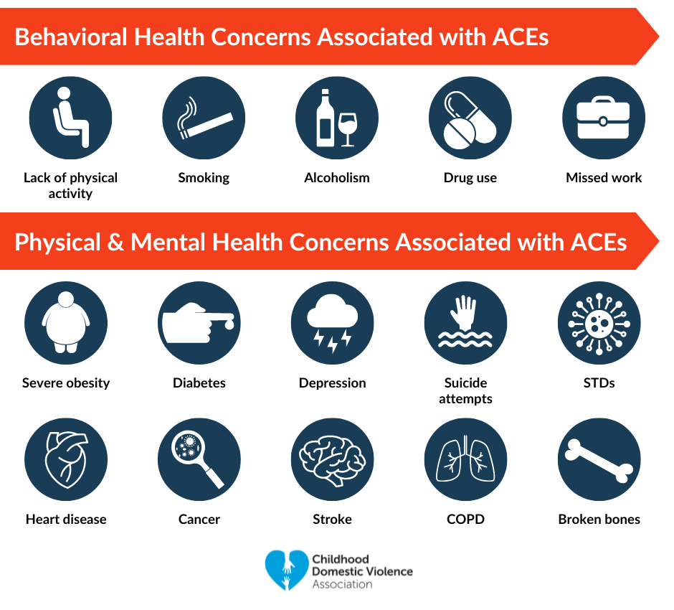

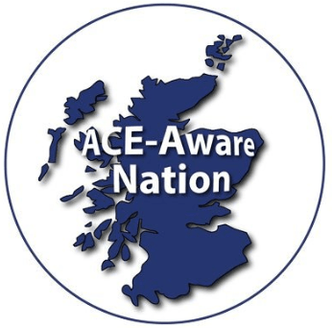

(Upstart, 2019)

Background
Boullier and Blair, (2018) acknowledged that a significant study conducted by the CDC-Kaiser in 1998 was the first to describe the connection between adverse childhood experiences (ACEs) and health outcomes. The results have sparked a surge in research on the effects of ACEs on behavioural patterns, life possibilities, and economic stability in addition to their effects on physical and mental health outcomes. Felitti, (2019) stated that new technologies were introduced in Kaiser Permanente's Department of Preventive Medicine in San Diego, California, for the treatment of obesity. This led to important paradoxical discoveries, which directly resulted in the ACE Study.
Stevens, (2019) acknowledged that according to the Blackburn & Darwen Study that was carried out in 2012, almost 50% of people in England have had at least one ACE, and 9% have had four or more. Public Health Wales (2023) identified from the first Welsh ACEs study carried out in 2016, that 47% of adults have experienced at least one ACE and 14% have experienced four or more ACEs.
Goldstein et al., (2020) stated that ACEs represent some of the most severe stressors and traumatic events that can happen to a child, and their sense of stability, safety, and development can be undermined by ACEs. Duffy et al, (2018) recognised that chronic interpersonal trauma experienced as a child, such as abuse on both a physical and psychological level, can change the neural circuitry underlying cognitive control and emotional processing related to determining reward and threat. Malave et al., (2022) support this and stated that complex neural circuits are forming in the prenatal and early postnatal periods of life, when the brain is most malleable. The adversity that affects these processes during critical developmental stages can have widespread, long-lasting effects on the maturation of neural circuits.
Pino et al., (2021) suggest that Adverse Childhood Experiences have been shown to influence an individual's sensitivity to the development of chronic diseases through a variety of processes; epigenetic modifications explain how preexisting risk factors may contribute to cause altered biological responses and chronic disease risk. Berens et al., (2017), agreed and suggested that results from physiological research conducted in the last few decades point to a potential underlying mechanism: the biological embedding of psychologically traumatic childhood experiences. Nist, (2016) defines biological embedding as early stress that has the ability to irreversibly change biological processes at critical developmental stages, a phenomenon that has an effect on long-term adult health outcomes.
Lozano et al (2012) suggest that ACE exposure can have a negative impact on physical health and raise the risk of chronic diseases. Kelly-Irving et al., (2013) agreed and suggested that previous studies have indicated that ACEs have been linked to premature death, risk behaviours, and other chronic diseases such as diabetes, chronic heart disease, and obesity. Chu et al, (2021) stated that obesity has become a public health concern due to its steady rise in prevalence over the last few decades. Jackson and Vaughn, (2019) suggest that it has generally been overlooked that there may be a link between psychological and physical abuse and the consumption of obesogenic foods during childhood, even with the abundance of research analysing the risk factors for obesity in children. Wiss and Brewerton., (2020) acknowledge that multiple studies have shown that people who have experienced childhood trauma may cause inadequate management of obesity and related chronic diseases during a child's first eighteen years of life. Gardner et al., (2019) support this and suggested that the likelihood of obesity in adolescence increases if an ACE occurs before the age of nine.
Javier et al., (2019) suggest that negative adverse childhood experiences raise the chance of a number of diseases and unhealthy habits, such as obesity, smoking, alcoholism, depression, cancer, and heart disease. Kivimäki et al., (2020) identified that a child's socioeconomic disadvantage is associated with an adult's higher risk of developing coronary heart disease. Wang et al., (2023) support this and state that negative childhood experiences increase the chance of coronary heart disease. Adebiyi et al., (2023) stated that studies have shown that ACEs have been linked to a number of heart conditions in children; in addition to causing cardiovascular disease in later life. Akasaki et al., (2021) analysed the Whitehall II cohort study and suggested that while there is some association between individual adverse childhood experiences and coronary heart disease, there is no discernible relationship between the number of adverse experiences and the disease. Kubera et al., (2022) argue that early life traumas play a critical influence on future health risks and suggest that an increased risk of either fatal or non-fatal coronary heart disease events was associated with a high level of overall childhood adversities but suggested that more research is needed.

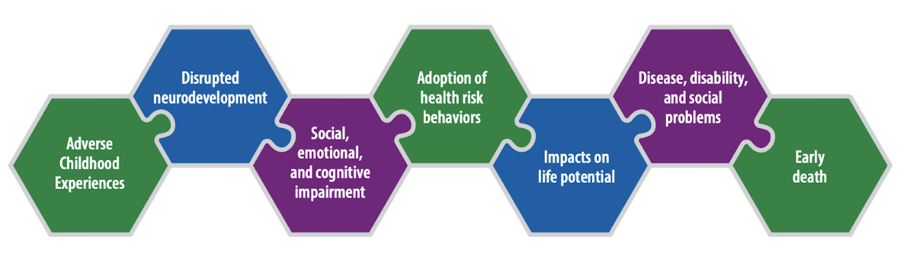

(www.communitycommons.org, n.d.)

Articles

Article 1
Wiss, D.A. and Brewerton, T.D. (2020). Adverse Childhood Experiences and Adult Obesity: A Systematic Review of Plausible Mechanisms and Meta-Analysis of Cross-Sectional Studies. Physiology & Behavior.

Methods
The authors used quantitative research methods, to clarify quantitative research gathers a variety of numerical data. It enables researchers to collect the data through basic to highly complex statistical analyses. The research includes techniques such as experiments, structured observations, and questionnaires (Albers, 2017). A systematic review was used, which is to provide a thorough summary of all the primary research that is currently available in answer to a particular research question. A systematic review is also referred to as secondary research (Clarke, 2011). A meta-analysis was used, to clarify a meta-analysis is a statistical combination of findings from two or more different studies (Haidich, 2010).

Article 2
Akasaki, M., Nicholas, O., Abell, J., Valencia-Hernández, C.A., Hardy, R. and Steptoe, A. (2021). Adverse childhood experiences and incident coronary heart disease: a counterfactual analysis in the Whitehall II prospective cohort study. American Journal of Preventive Cardiology.

Methods
The authors used quantitative research and studied a counterfactual analysis, for clarity counterfactual analysis allows researchers to find a link between interventions and outcomes. The impact is determined by contrasting the counterfactual results with those observed during the intervention to determine what would have happened to beneficiaries in the absence of the intervention (Mahoney and Barrenechea, 2017). The authors examined the White Hall II cohort study, cohort studies are a type of long-term study, that monitor research participants over a period of time (Barrett and Noble, 2019).

Themes

Article 1 The article showed that ACEs are linked to obesity. Five studies out of the 18 discussed possible pathways that could connect adverse childhood experiences to obesity. The initial ACE researchers suggested a direct biological mechanism in which recurrent stress raises glucocorticoids, which in turn causes an increase in intra-abdominal and other fat deposits.

Article 2 The article showed that coronary heart disease is linked to adverse childhood experiences. Over an average follow-up of 12.9 years, 509 cases of coronary heart disease were identified. In a multiply-adjusted model involving 14 adverse childhood experiences, parental unemployment exhibited the highest risk of coronary heart disease incidence but a dose-response effect was not noted. The authors estimated a 6.0% reduction in coronary heart disease in the absence of childhood adversities.

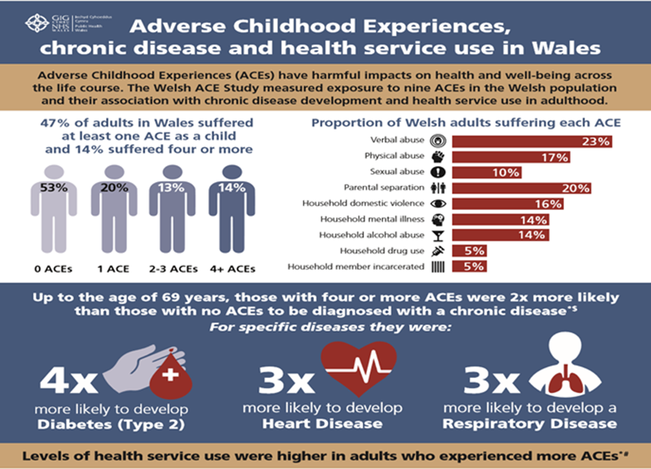

(www.futuregenerations.wales, n.d.)

Why is health promotion needed?
The goal of health promotion is to maintain a person’s health. Health promotion lowers the risk of chronic disease development and empowers people to engage in healthy behaviours. (www.ruralhealthinfo.org, n.d.). In contrast to health promotion, disease prevention focuses on particular efforts meant to lessen the onset and severity of chronic illnesses and other morbidities. The aim of disease prevention is to stop a disease from manifesting, this is known as primary prevention. Additionally, it addresses preventive medication therapy, congenital malformation prevention, and early disease detection. This is known as secondary prevention (WHO, 2022).
Centers for Disease Control and Prevention, (2021) recognise that adverse childhood experiences have a detrimental impact on a person’s mental and physical health, and believe that ACEs can be prevented, which will help reduce:
- Adult risk of diseases like coronary heart disease and obesity
- Help people cut back on dangerous habits like smoking and binge drinking
- Boost prospects for employment and education
- Ensure that ACEs are not handed down to future generations.
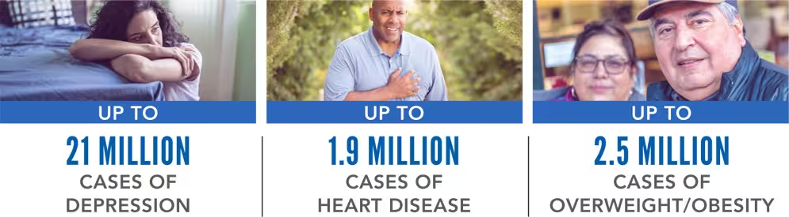
Numerous medical conditions could be decreased by ACE prevention

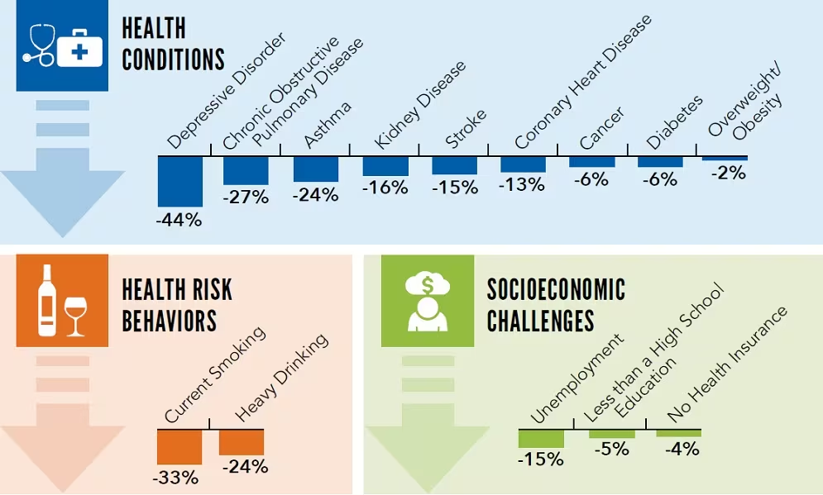
Potential decrease of negative outcomes as an adult

CDC (2021).
Conti et al., (2021) stated that the lifetime cost of non-fatal child abuse by a primary carer in the UK has been conservatively estimated to be £90 000 per victim. Hughes et al., (2020) acknowledge that adverse childhood experiences place a significant burden on society in Wales. Gardner et al., (2017) suggest that policies and practices that help prevent ACEs, foster resilience, and create trauma-informed services are required in order to lower the burden of disease and financial costs in the health and other sectors.
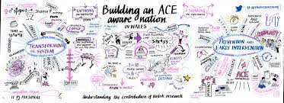
Grey et al., (2019) recognise that adversity exposure during childhood is a serious global public health concern. Mccoy et al., (2019) stated that in order to improve public health, the 2009 World Health Organisation (WHO) report gave priority to addressing ACEs and preventing child abuse. Lemma et al., (2019) acknowledge that while ACEs are becoming more widely known, they have not yet been treated as a public health issue in the United Kingdom. GOV.WALES, (n.d.) recognises that ACEs are a public health issue in Wales, and states that although there has been good progress in the development of ACE-aware public services, there is still more work that needs to be done to guarantee increased knowledge and comprehension of childhood adversity and actions that benefit children and parents, safeguard them from harm, and enhance outcomes.

(Ace Hub Wales., N.D.)
www.futuregenerations.wales, (n.d.) recognises that there has been a surge in activity since the first Public Health Wales reports on Adverse Childhood Experiences were released in 2015 and 2017 where these reports confirmed the prevalence of 'ACEs' in Wales and stated that organisations such as Early Help Hub, local authorities and the health sector have been trained to be trauma-informed and ACE aware. Ace Hub Wales, (2022) stated that Wales is now a leader in addressing, preventing, and mitigating ACEs thanks to the establishment of the ACE Hub Wales, which aims to support Welsh society in fostering an ACE-Aware Wales, it encourages knowledge exchange and idea-sharing, challenges established practices, and seeks to end the cycle of ACEs, the hub is funded by the Welsh Government and is a component of Public Health Wales World Health Organisation Collaborating Centre. Spratt and Kennedy, (2020) recognise the introduction of the Trauma-Informed Practice Framework that is presented in numerous organisations, programmes, and training providers. GOV.WALES, (n.d.) stated that the framework is offered to all people through specialised services, as well as the networks and communities that give those occurrences context and where the support services are operational and will provide a trauma-informed approach in Wales.

Conclusion

A growing number of studies and data have been conducted worldwide to look at the detrimental effects that adverse childhood experiences can have on a person’s health. The research sources have shown that adverse childhood experiences have been linked to obesity and coronary heart disease however some articles indicate that more research is needed to link High ACE scores with coronary heart disease. Studies have shown that introducing early intervention could save an estimated £ 90,000 per person throughout their lifetime, which would help take the pressure off public health services. The research has shown that if ACEs could be prevented then it would decrease chronic illness, and unhealthy habits and it could potentially boost job opportunities and education. Wales has recognised that ACEs are a public health concern and have set up the ACEs HUB to promote knowledge and safeguard children. The Welsh government has set up the trauma-informed practice framework that has been introduced into organisations in Wales to create more understanding and knowledge to help spread awareness in Wales.

ACE Hub Wales. (n.d.). What we do. [online] Available at: https://acehubwales.com/what-we-do/.[accessed 9 November 2023].
Adebiyi, E., Jariselle Pietri-Toro, Adeola Awujoola and Gwynn, L. (2023). Association of Adverse Childhood Experiences with Heart Conditions in Children: Insight from the 2019–2020 National Survey of Children’s Health. Children (Basel), [online] 10(3), pp.486–486.
Akasaki, M., Nicholas, O., Abell, J., Valencia-Hernández, C.A., Hardy, R. and Steptoe, A. (2021). Adverse childhood experiences and incident coronary heart disease: a counterfactual analysis in the Whitehall II prospective cohort study. American Journal of Preventive Cardiology, 7, p.100220.
Albers, M.J. (2017). Quantitative Data Analysis—In the Graduate Curriculum. Journal of Technical Writing and Communication, [online] 47(2), pp.215–233. doi:https://doi.org/10.1177/0047281617692067.
Barrett, D. and Noble, H. (2019). What are cohort studies? Evidence Based Nursing, [online] 22(4), pp.95–96. doi:https://doi.org/10.1136/ebnurs-2019-103183.
Bekesi, C. (2022). What are Adverse Childhood Experiences (ACEs)? [online] CDV. Available at: https://cdv.org/2022/12/what-are-adverse-childhood-experiences-aces/. [accessed 3 November 2023].
Berens, A.E., Jensen, S.K.G. and Nelson, C.A. (2017). Biological embedding of childhood adversity: from physiological mechanisms to clinical implications. BMC Medicine, [online] 15(1).
Boullier, M. and Blair, M. (2018). Adverse Childhood Experiences. Paediatrics and Child Health, [online] 28(3), pp.132–137. doi:https://doi.org/10.1016/j.paed.2017.12.008.
CDC (2021). Adverse Childhood Experiences (ACEs). [online] Centers for Disease Control and Prevention. Available at: https://www.cdc.gov/vitalsigns/aces/index.html. [Accessed 05 November 2023].
Centers for Disease Control and Prevention (2023). Preventing adverse childhood experiences. [online] www.cdc.gov. Available at: https://www.cdc.gov/violenceprevention/aces/fastfact.html. [Accessed 5 November 2023].
Chu, W.W. and Chu, N.-F. (2021). Adverse childhood experiences and development of obesity and diabetes in adulthood—A mini review. Obesity Research & Clinical Practice, 15(2).
Clarke, J. (2011). What Is a Systematic review? Evidence-Based Nursing, [online] 14(3), pp.64–64. doi:https://doi.org/10.1136/ebn.2011.0049.
Conti, G., Pizzo, E., Morris, S. and Melnychuk, M. (2021). The economic costs of child maltreatment in UK. Health Economics, 30 (12).
Di Lemma L.C.G., Davies A.R., Ford K., Hughes K., Homolova L., Gray B and Richardson G. (2019). Responding to Adverse Childhood Experiences: an evidence review of interventions to prevent and address adversity across the life course. Public Health Wales, Cardiff and Bangor University, Wrexham.
Duffy, K.A., McLaughlin, K.A. and Green, P.A. (2018). Early life adversity and health-risk behaviors: proposed psychological and neural mechanisms. Annals of the New York Academy of Sciences, 1428 (1), pp.151–169.
Felitti, V.J. (2019). Origins of the ACE Study. American Journal of Preventive Medicine, 56 (6), pp.787–789. doi:https://doi.org/10.1016/j.amepre.2019.02.011.
Gardner, F., Leijten, P., Mann, J., Landau, S., Harris, V., Beecham, J., Bonin, E.-M., Hutchings, J. and Scott, S. (2017). Could scale-up of parenting programmes improve child disruptive behaviour and reduce social inequalities? Using individual participant data meta-analysis to establish for whom programmes are effective and cost-effective. Public Health Research, 5 (10), pp.1–144.
Gardner, R., Feely A., Layte, R. et al. (2019) Adverse childhood experiences are associated with an increased risk of obesity in early adolescence: a population-based prospective cohort study. Pediatric Research 86, pp.522-528.
Goldstein, E., Topitzes, J., Miller-Cribbs, J. and Brown, R.L. (2020). Influence of race/ethnicity and income on the link between adverse childhood experiences and child flourishing. Pediatric Research.
GOV.WALES. (n.d.). Annex 1: Links between Community Focused Schools and other policies [HTML]. [online] Available at: https://www.gov.wales/annex-1-links-between-community-focused-schools-and-other-policies-html. [Accessed 7 November 2023].
Grey, H.R., Ford, K., Bellis, M.A., Lowey, H. and Wood, S. (2019). Associations between childhood deaths and adverse childhood experiences: An audit of data from a child death overview panel. Child Abuse & Neglect, 90, pp.22–31.
Haidich, A.B. (2010). Meta-analysis in medical research. Hippokratia, [online] 14(Suppl 1), pp.29–37. Available at: https://www.ncbi.nlm.nih.gov/pmc/articles/PMC3049418/. [Accessed .9 November 2023]
Hughes, K., Ford, K., Kadel, R., Sharp, C.A. and Bellis, M.A. (2020). Health and financial burden of adverse childhood experiences in England and Wales: a combined primary data study of five surveys. BMJ Open, 10 (6), p.e036374.
Jackson, D.B. and Vaughn, M.G. (2019). Obesogenic food consumption among young children: the role of maltreatment. Public Health Nutrition, 22 (10), pp.1840–1849
Javier, J.R., Hoffman, L.R. and Shah, S.I. (2019). Making the case for ACEs: adverse childhood experiences, obesity, and long-term health. Pediatric Research, 86 (4), pp.420–422.
Kelly-Irving, M., Lepage, B., Dedieu, D., Bartley, M., Blane, D., Grosclaude, P., Lang, T. and Delpierre, C. (2013). Adverse childhood experiences and premature all-cause mortality. European Journal of Epidemiology, [online] 28(9), pp.721–734. doi:https://doi.org/10.1007/s10654-013-9832-9.
Kivimäki, M., Batty, G.D., Pentti, J., Shipley, M.J., Sipilä, P.N., Nyberg, S.T., Suominen, S.B., Oksanen, T., Stenholm, S., Virtanen, M., Marmot, M.G., Singh-Manoux, A., Brunner, E.J., Lindbohm, J.V., Ferrie.
Kubera, B., Kohlmann, T. and Peters, A. (2022). Psychological stress, body shape and cardiovascular events: Results from the Whitehall II study. Comprehensive Psychoneuroendocrinology, 9, (1) p.100104.
Lozano R, Naghavi, M. Foreman, et al. (2012) Globa; and regional mortality from 235 causes of death for 20 age groups in 1990 and 2010: a systematic analysis for the Global Burden of Disease Study 2010, Lancet. 380((9859), pp.2095-2128
Mahoney, J. and Barrenechea, R. (2017). The logic of counterfactual analysis in case-study explanation. The British Journal of Sociology, 70 (1), pp.306–338. doi:https://doi.org/10.1111/1468-4446.12340.
Malave, L., van Dijk, M.T. and Anacker, C. (2022). Early life adversity shapes neural circuit function during sensitive postnatal developmental periods. Translational Psychiatry, 12 (1).
Mccoy, E., Harrison, R., Butler, N., Kinsella, K., Oyston, J., Timpson, H. and Quigg, Z. (2019). Evaluation of the Rock Pool Adverse Childhood Experiences (ACEs) Recovery Toolkit Programme Evaluation of the Rock Pool ACES Recovery Toolkit Programme Contributions.
Nist, M.D. (2016). Biological embedding: evaluation and analysis of an emerging concept for nursing scholarship. Journal of Advanced Nursing, 73 (2), pp.349–360.
Pino, O., Cadena, R.T. and Poli, D. (2022). A Comprehensive Review on Multifaceted Mechanisms Involved in the Development of Breast Cancer Following Adverse Childhood Experiences (ACEs). International Journal of Environmental Research and Public Health, 19 (19), p.12615. doi:https://doi.org/10.3390/ijerph191912615.
Public Health Wales (2020). Adverse Childhood Experiences - Public Health Wales. [online] Nhs.wales. Available at: https://phw.nhs.wales/topics/adverse-childhood-experiences/.

References
Scott, K. (2021) Adverse childhood experiences. InnovAiT: Education and inspiration for general practice, 14 (1), pp.6–11
Spratt, T. and Kennedy, M. (2020). Adverse Childhood Experiences: Developments in Trauma and Resilience Aware Services. The British Journal of Social Work, 51(3).
Stevens, A. (2019). Health Needs Assessment of Adverse Childhood Experiences in Bradford. [online] Available at: https://jsna.bradford.gov.uk/documents/Children%20and%20Young%20People/Adverse%20Childhood%20Experiences/Adverse%20Childhood%20Experiences%20-%202019.pdf. [Accessed 8 November 2023].
Upstart (2019). Adverse Childhood Experiences: more questions than answers? [online] Upstart. Available at: https://upstart.scot/adverse-childhood-experiences-more-questions-than-answers/ [Accessed 17 November 2023].
Wang, W., Liu, Y., Yang, Y. et al. (2023) Adverse childhood and adulthood experiences and risk of new-onset cardiovascular disease with consideration of social support: a prospective cohort study. BMC Med 21, 297.
WHO (2022). Health promotion and disease prevention through population-based interventions, including action to address social determinants and health inequity. [online] www.emro.who.int. Available at: https://www.emro.who.int/about-who/public-health-functions/health-promotion-disease-prevention.html. [Accessed 8 November 2023].
Wiss, D.A. and Brewerton, T.D. (2020). Adverse Childhood Experiences and Adult Obesity: A Systematic Review of Plausible Mechanisms and Meta-Analysis of Cross-Sectional Studies. Physiology & Behavior, 223, p.112964.
www.communitycommons.org. (n.d.). Adverse Childhood Experiences. [Accessed 8 November 2023].
www.futuregenerations.wales. (n.d.). #ACEsDecember Putting ACEs front and centre with the Well-being of Future Generations Act – The Future Generations Commissioner for Wales. [online] Available at: https://www.futuregenerations.wales/news/acesdecember-putting-aces-front-and-centre-with-the-well-being-of-future-generations-act/ [Accessed 5 November 2023].
www.futuregenerations.wales. (n.d.). Future Generations Framework – The Future Generations Commissioner for Wales. [online] Available at: https://www.futuregenerations.wales/resources_posts/future-generations-framework/ [Accessed 14 November 2023].
www.gov.wales. (2021). Review of Adverse Childhood Experiences (ACE) policy: report | GOV.WALES. [online] Available at: https://www.gov.wales/review-adverse-childhood-experiences-ace-policy-report [Accessed 14 November 2023].
www.ruralhealthinfo.org. (n.d.). Defining Health Promotion and Disease Prevention - RHIhub Toolkit. [online] Available at: https://www.ruralhealthinfo.org/toolkits/health-promotion/1/definition#:~:text=Health%20promotion%20and%20disease%20prevention%20programs%20focus%20on%20keeping%20people,chronic%20diseases%20and%20other%20morbidities. [Accessed 10 November 2023].
Zarse, E.M., Neff, M.R., Yoder, R., Hulvershorn, L., Chambers, J.E. and Chambers, R.A. (2019). The adverse childhood experiences questionnaire: Two decades of research on childhood trauma as a primary cause of adult mental illness, addiction, and medical diseases. Cogent Medicine, [online] 6(1).

