ACCB6017
Usability Engineering – Component 2 Technical Report
Full Interface & Testing

Name: Andreea Ruse
ID: 2108815

Module Tutor: Osman Elgawi


Table of Contents
Introduction 3
Usability Issues to be Addressed 3
Feedback Collection Process 7
Summary of Elicited Feedback 8
Future Data Collection and Utilisation 9
Conflicts and Resolutions in the Design Process 11
Reflective Summary: Usability vs User Experience 12
Conclusion 12
References 13

Introduction
his report presents the design and development of a mobile-based game interface inspired by The Traitors, adapted for the University of Wales Trinity Saint David (UWTSD). The game is designed as a social deduction experience where players take on different roles within a university environment, collaborating to achieve objectives while identifying hidden traitors among them. The primary aim of this project is to design an intuitive, engaging, and accessible mobile interface that supports gameplay while maintaining strong usability principles. Following the initial wireframing stage outlined in Assignment 1, this report details the progression to full-colour, high-fidelity storyboards, informed by user feedback and established principles of interaction design.
The report covers usability considerations, wireframe and storyboard development, feedback collection methods, and reflections on the balance between usability and user experience.

Usability Issues to be Addressed
The design addresses several key usability challenges. One of the main issues is learnability, as new users must quickly understand how the game works. To solve this, the interface uses simple layouts, clear labels, and progressive disclosure, where information is revealed step-by-step rather than all at once. Another important issue is visibility of system status. Players must always understand what phase of the game they are in (day or night). This is achieved through clear indicators such as timers and labels at the top of the screen.
Error prevention is also critical, especially during voting. The design includes confirmation pop-ups to prevent accidental actions. This aligns with usability principles that emphasise reducing user errors (Nielsen, 1994). Accessibility is addressed through high contrast design, readable text, and touch-friendly buttons, ensuring usability across different devices and user abilities.

Colour Scheme and Graphic Style
The initial wireframes were developed as low-fidelity designs to focus on layout, interaction flow, and usability before introducing visual styling. These wireframes were later transformed into a fully designed interface, as shown in the final prototype. The final design follows a modern mobile UI style, combining minimalism with a dark, cinematic theme that reflects the mystery and tension of the game.
A ‘dark mode’ aesthetic was chosen as the default to evoke the "darkly dramatic" nature of the game (The Traitors, n.d.). The colour palette is dominated by a deep navy blue, reflecting UWTSD's corporate colours whilst also symbolising night, mystery, and intellect (Hemphill, 1996).
Welcome Screen
The welcome screen presents the game title prominently, followed by two main options: “Create Game” and “Join Game”. The layout is simple and centred, ensuring that users immediately understand their choices. The use of large buttons improves usability and reduces the chance of input errors.
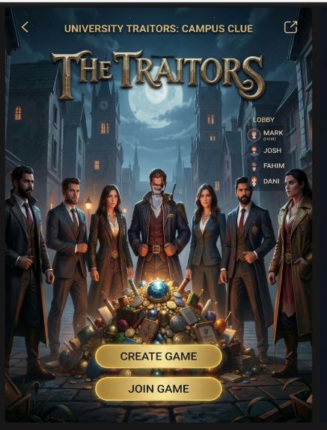
The lobby
Displays players who have joined the game which are our personas using avatar icons. The host is clearly identified, and a “Start Game” button is provided. This screen supports social interaction and ensures users are aware of who is participating.
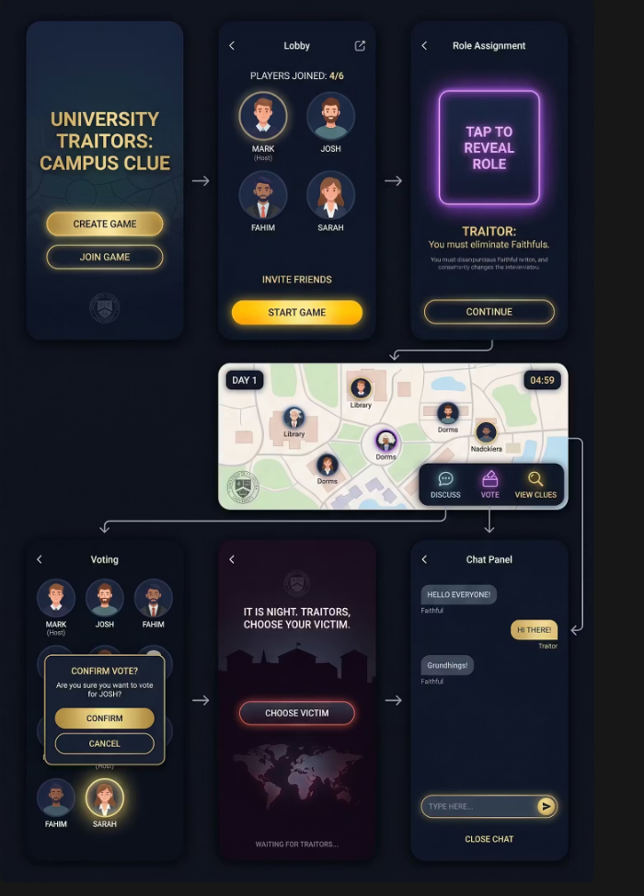

The role assignment screen
Includes a “Tap to Reveal Role” interaction, which adds both usability and engagement. This prevents accidental exposure of sensitive information while also making the experience more interactive.

Main Game Screen (Day Phase)
The main gameplay screen includes:
- A timer and phase indicator at the top
- A map showing player positions
- Action buttons such as “Discuss”, “Vote”, and “View Clues”
This layout ensures that information and actions are clearly separated. The placement of buttons at the bottom follows mobile usability guidelines, making them easy to reach. Also, as you can in the image above is the only one that is different because to use “day phase” you have to use in in landscape mode on the phone.
The clean layout and spacing improve readability and prevent visual clutter.

Voting Screen
The voting interface presents players in a structured grid format. Users can select a player and confirm their decision through a pop-up dialogue. This prevents mistakes and ensures clarity in decision-making.
Night Phase Screen
The night phase uses a darker theme to visually differentiate it from the day phase. Only relevant actions are shown, reducing confusion and guiding users through the gameplay. The Night Phase screen uses the darkest shades of the palette to create a sense of isolation and secrecy.
Chat Panel
The chat interface allows players to communicate during the game. Messages are clearly displayed, and the input field is positioned at the bottom for easy access. The design is simple and familiar, similar to modern messaging apps.

Navigation Flow
The user flow follows a logical sequence:
Welcome → Lobby → Role Assignment → Gameplay → Voting → Night Phase → Repeat
Arrows between screens illustrate how users move through the app. This structured flow ensures that users always understand where they are and what to do next.
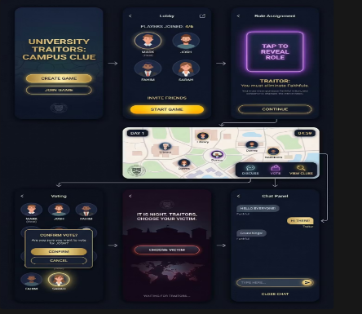

Feedback Collection Process
A robust feedback process is essential for validating design decisions and identifying unforeseen usability issues. For the high-fidelity storyboards, a mixed-methods approach was employed to capture both quantitative usability metrics and qualitative insights into the user's emotional journey.
Following the interactive session, participants were asked to complete the System Usability Scale (SUS) questionnaire. The SUS provides a “quick and dirty” but reliable score of perceived usability (Brooke, 1996). This quantitative measure served as a useful benchmark to complement the qualitative data from the think-aloud sessions.
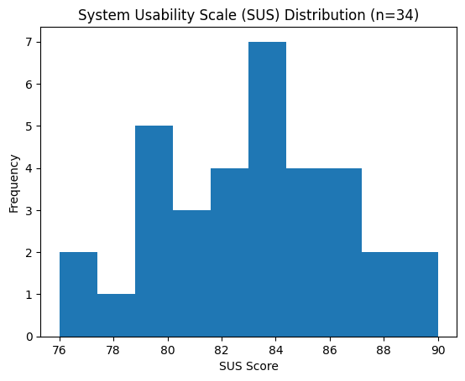
To ensure the feedback was representative, test subjects were recruited to match the four personas developed in the initial project phase:
Mark (44, Warehouse Supervisor): not very familiar with gaming conventions, values efficiency.
Josh (28, Autistic worker in warehouse): High aesthetic standards, very familiar with mobile gaming, values clarity and intuitive design.
Dani (24, Construction worker): Active on social media, enjoys collaborative experiences, values communication features.
Fahim (20, IT Student at UWTSD): Task-oriented, focuses on functionality, intolerant of bugs or confusing workflows.
Also, a survey was created using Google Forms was distributed after testing. The survey included questions about usability, navigation, and overall experience.
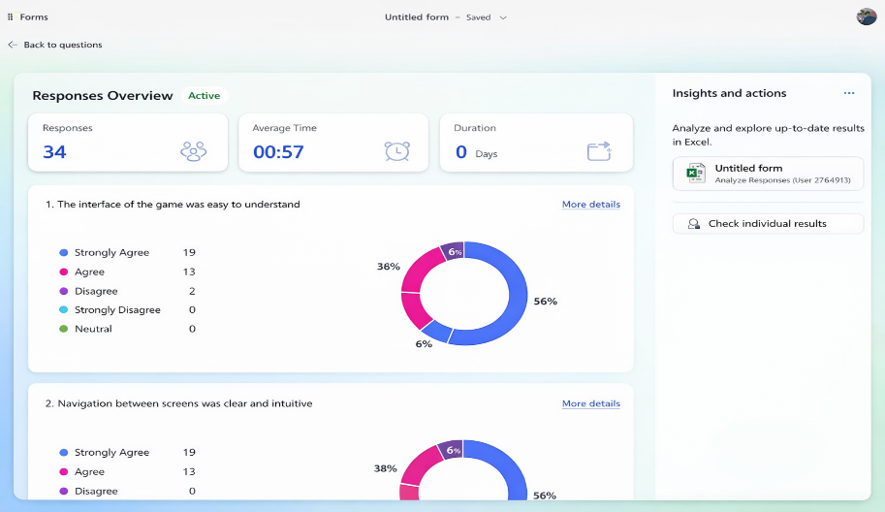
Results showed that users found the interface easy to use and visually engaging. The voting system and role reveal feature were particularly well received. However, some improvements were suggested, such as making the timer more visible and increasing spacing in the chat interface.

Summary of Elicited Feedback
Participants were asked to complete tasks such as joining a game, revealing their role, and voting. A think-aloud method was used to understand their thought processes. The session was recorded to analyse user behaviour in detail.
The primary method for feedback collection was the Think-Aloud Protocol. As described by Budiu (2018), this involves participants verbalising their thoughts, feelings, and frustrations as they interact with the prototype. This method was chosen because it provides direct insight into the user's cognitive processes and emotional reactions, which is crucial for a game predicated on atmosphere and social dynamics (Nielsen, 1994). Each session was moderated, and participants were guided through a set of predefined tasks, such as 'Join a game', 'Voting', and 'Choose a victim'.
Positive Feedback:
- Atmosphere and Theme: All participants, particularly the ‘Mark’ persona, praised the colour scheme and graphics. One commented, “It feels professional, like a proper UWTSD app, but also has that spooky, mysterious vibe. The balance is just right.” This validated the chosen aesthetic direction.
- Clarity of Core Loop: Dani and Fahim found the game’s core loop (Welcome → Lobby → Role Assignment → Gameplay → Voting → Night Phase) easy to understand. The visual flow from screen to screen was described as “logical” and “intuitive.”
- Impact of Reveals: The ‘Night Phase’ reveal screens were consistently highlighted as emotionally effective. A ‘Josh’ participant noted, “That moment when you see if they were a Traitor or not is really dramatic.”
Negative Feedback and Usability Issues:
- Onboarding: Several participants, especially the ‘Mark’ persona, felt the game needed a more robust tutorial. While a ‘How to Play’ screen existed, feedback suggested an interactive, guided first-round would be more effective for users unfamiliar with the social deduction genre. This was an unexpected oversight, as the design had assumed a level of genre familiarity.
- Chat Functionality: The ‘Josh’ personas found the text chat during the Chat Panel to be “a bit basic.” They suggested features like threaded replies or the ability to ‘tag’ other players in messages to make rapid, complex discussions easier to follow.
The emotional responses were largely as expected, with users reporting feelings of “suspicion,” “tension,” and “excitement” during key moments. The unexpected feedback regarding the need for a better tutorial demonstrates why testing with a range of personas is critical.

Future Data Collection and Utilisation
Once a working version of ‘Traitors’ is built and released, the design process does not end. It enters a new phase of continuous improvement, fuelled by data collected from a live user base. A comprehensive data collection strategy must be implemented to monitor gameplay, user behaviour, and player sentiment, ensuring the game remains balanced, engaging, and usable over time. This strategy must differentiate between automatically collected quantitative data and more deliberately solicited qualitative data.
Data to be Collected and Rationale
Quantitative Data (Usage Analytics): This data focuses on what users are doing and can be collected automatically and passively via an integrated analytics framework (e.g., Unity Analytics, Firebase). This data is vital for identifying large-scale trends and gameplay imbalances. Key metrics would include:
- Win/Loss Ratios: What is the percentage win rate for ‘Traitors’ versus ‘Faithfuls’? A significant imbalance (e.g., Traitors winning 80% of the time) would indicate that game mechanics, such as the number of Traitors or the difficulty of tasks, need rebalancing.
- Game Duration: Tracking the average length of a game can help determine if the pacing is correct. Games that are too short may lack depth, while those that are too long may lead to player fatigue.
- Feature Engagement: Which features are used most? Are players viewing profiles, using the accuse function, or interacting with the game log? Low engagement with a specific feature might suggest it is poorly designed, not useful, or not easily discovered.
- Player Drop-off Points: At what stage of the game do users most frequently quit? A high drop-off rate in the lobby suggests matchmaking issues, while drop-offs after a player is ‘murdered’ might indicate a need for a ‘spectator’ mode to keep them engaged.
Qualitative Data (Emotional and Experiential Feedback): This data focuses on why users behave as they do and how they feel. It generally requires active solicitation.
- In-Game Surveys: Short, non-intrusive pop-up questions after a game is completed (e.g., “On a scale of 1-5, how fair did this round feel?”).
- Open-Ended Feedback Forms: A dedicated, optional ‘Send Feedback’ button within the settings menu where users can report bugs, suggest features, or provide detailed comments.
- Community Forum Analysis: Establishing an official Discord server or subreddit for the game would create a space for players to discuss strategy, share experiences, and provide organic feedback. This can be a rich source of qualitative data on player sentiment and desired features.
All data collection must be transparent and compliant with GDPR. Users must be informed about what data is being collected via a clear privacy policy and given the option to opt out of non-essential tracking. As Lazar, Feng, and Hochheiser (2017) argue, ethical considerations are paramount in user research.
The difference between collecting usage data and emotional response data is fundamental. Usage data is objective and scalable, revealing patterns of behaviour. Emotional data is subjective and provides context, revealing the motivations and feelings behind that behaviour.
A Pure Usability Design
Had the app been designed purely from a usability viewpoint, focusing solely on efficiency, effectiveness, and learnability, its form would have been dictated by function alone. The colour scheme might have been a high-contrast, black-on-white design for maximum legibility, devoid of thematic nuance. The main screen might have presented players in a simple, sortable list rather than a ’round table’ circle, prioritising information density over social metaphor. The ‘Night Falls’ transition would have been instantaneous, moving the player to their next required action with zero delay to maximise efficiency. As Krug (2014) famously advocates, the guiding principle would be “Don’t Make Me Think.” While this approach would create a highly functional tool for playing the game, it would likely strip the experience of its core emotional appeal: the drama, tension, and atmosphere that define The Traitors. The app would be usable, but it would not be engaging.

Conflicts and Resolutions in the Design Process
Throughout the design process, several conflicts between usability and user experience arose, requiring careful compromise.
A key example was the design of the ‘Night Phase’ transition.
- Usability Goal: Rapidly and clearly present the user with their night-time action. Any delay is, from a pure efficiency standpoint, a usability flaw.
- User Experience Goal: Create a moment of tension and suspense. The transition should feel like a genuine descent into a secretive, dangerous part of the game.
- Conflict: An instant screen change serves usability but harms UX. A long, unskippable animation serves UX but would frustrate experienced players, violating the usability principle of user control and freedom (Nielsen, 2020).
- Resolution: I implemented a short, atmospheric animation that lasts approximately two seconds. Crucially, a ‘tap to skip’ function was included. This solution offers the best of both worlds: it establishes the mood for new or immersed players but provides a shortcut for those who prioritise speed, thereby respecting the user’s time and choice.
Another significant conflict emerged in the design of the player profiles.
- Usability Goal: Present critical game information (player name, status alive/dead) as clearly as possible. Extraneous information is clutter.
- User Experience Goal: Foster social deduction, bluffing, and attachment to one’s persona. The profiles should be a canvas for deception and character.
- Conflict: A purely usable profile would be spartan. A UX-focused profile could become overloaded with customisable but game-irrelevant details (avatars, mottos, ‘favourite campus coffee spot’), potentially hindering the primary task of identifying Traitors.
- Resolution: The goal of balancing usability and user experience was achieved by utilizing a progressive disclosure methodology throughout the design of the interface. To ensure that all users are able to clearly navigate both the lobby and main game play screens, only the most critical information (i.e., player name, avatar, role) is visible on each respective screen by default. Additional, non-essential information is available via expandable sections; for example, users may select from one of several UWTSD themed roles for the in-game identity. Although this selection does not add functionality to the game, it does enhance both socialization and immersion related to the game. Thus, the interface remains clean and free from extraneous clutter while still providing support for creative role-playing and player interaction.
The input of users was very influential in fine-tuning the design of the interface. Through storyboard testing, participants expressed frustration during the Night Phase screen due to the lack of controls, especially when they did not have an active role. The design of the Night Phase screen was therefore modified to provide the user with more explicit feedback regarding their status and the option to engage in a passive waiting state. User input confirmed that the addition of personalized features to user profiles was viewed as enhancing their engagement and ability to tell stories, rather than being considered clutter.

Reflective Summary: Usability vs User Experience
If the design had focused only on usability, the interface would likely be simpler but less engaging. For example, a purely functional design might use plain colours and minimal interaction.
However, this project aimed to balance usability with user experience. The dark theme, animations, and interactive elements create a more immersive experience while still maintaining clarity.
Some conflicts arose between usability and aesthetics. For example, dark themes can reduce readability, but this was solved by using high contrast elements.
The final design demonstrates that usability and user experience can work together when supported by user testing and iterative improvements.

Conclusion
This project successfully demonstrates the development of a user-centred mobile game interface inspired by The Traitors. By combining usability principles with engaging design, the final prototype provides a clear, intuitive, and enjoyable user experience.
The use of wireframes, storyboards, and user feedback ensured that the design was continuously improved and aligned with user needs. The results highlight the importance of testing and iteration in interface design.
Future improvements could include additional features, enhanced animations, and further usability testing with a larger group of users.

References
[1] Bangor, A., Kortum, P. T. and Miller, J. T. (2008) ‘An Empirical Evaluation of the System Usability Scale’, International Journal of Human-Computer Interaction, 24(6), pp. 574-594.
[2] Brooke, J. (1996) ‘SUS: A ‘Quick and Dirty’ Usability Scale’, in Jordan, P. W., Thomas, B., Weerdmeester, B. A., & McClelland, I. L. (eds.) Usability Evaluation in Industry. London: Taylor & Francis.
[3] Budiu, R. (2018) Think-Aloud: The #1 Usability Tool. Nielsen Norman Group. Available at: https://www.nngroup.com/articles/thinking-aloud/ (Accessed: 22 April 2026).
[4] Hemphill, C. S. (1996) ‘A note on adults’ color-emotion associations’, The Journal of genetic psychology, 157(3), pp. 275-280.
[5] Krug, S. (2014) Don’t Make Me Think, Revisited: A Common Sense Approach to Web Usability. 3rd edn. San Francisco, CA: New Riders.
[6] J. Lazar, J. H. Feng, and H. Hochheiser, Research Methods in Human-Computer Interaction, 2nd ed. Cambridge, MA, USA: Morgan Kaufmann, 2017.
[7] Lazar, J., Feng, J. H. and Hochheiser, H. (2017) Research Methods in Human-Computer Interaction. 2nd edn. Cambridge, MA: Morgan Kaufmann.
[8] Nielsen, J. (1994) Usability Engineering. San Diego, CA: Morgan Kaufmann.
[9] Nielsen, J. (2020) 10 Usability Heuristics for User Interface Design. Nielsen Norman Group. Available at: https://www.nngroup.com/articles/ten-usability-heuristics/ (Accessed: 22 April 2026).
[10] Norman, D. (2013) The Design of Everyday Things: Revised and Expanded Edition. New York: Basic Books.
[11] O’Connor, Z. (2011) ‘Colour, contrast and gestalt: The role of visual perception in user interface design for older adults’, in Proceedings of the 23rd Australian Computer-Human Interaction Conference, pp. 165-168.
[12] The Traitors. (n.d.) The Traitors Card Game. Available at: https://www.thetraitorscardgame.co.uk/ (Accessed: 22 April 2026)

