

Student name: Mariya Georgieva
Student ID: 1906952
Module name: Complementary Therapies
Module code: BMHP 5001
Lecturer name: Bianca Sanfilippo

Table of contents

1.Introduction…………………………………………………………….3
2. History…………………………………………………………………3
3.Uses……………………………………………………………………4
4.Efficacy…………………………………………………………………5
5.Contraindications………………………………………………………5
6.Effectiveness…………………………………………………………...6
7.Conclusion……………………………………………………………...6
8. References…………………………………………………………….6

1.Introduction
Herbal remedies are these with energetic substances made from plant parts, such as leaves, roots or plant life ,including most of the world’s normal redress for disorder.(NHS,2021)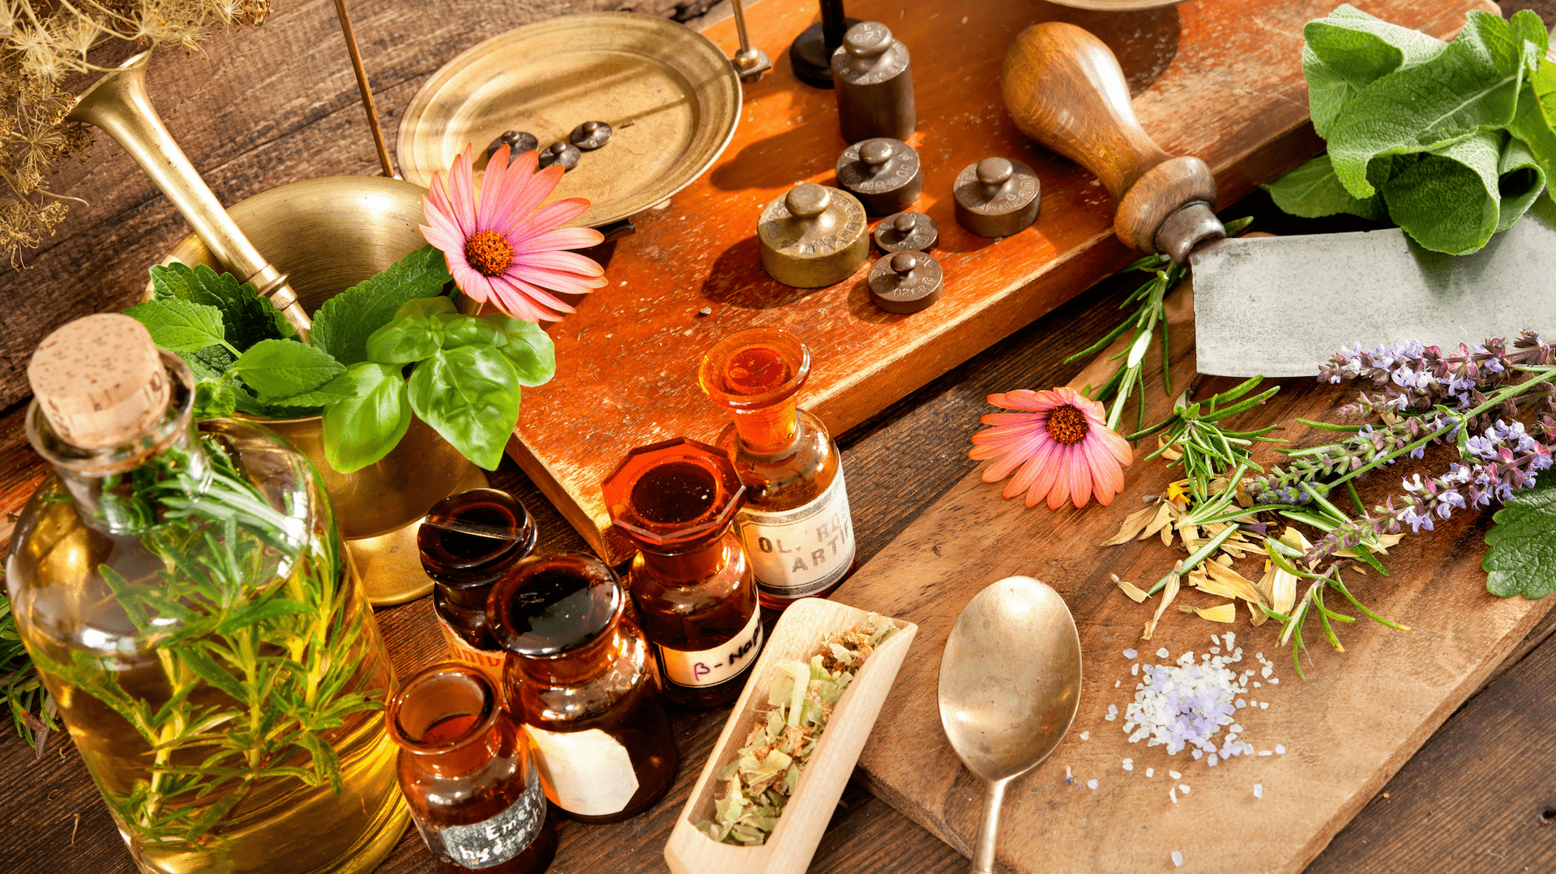
People use natural products to continue to be wholesome to deal with health conditions and illnesses. They are on hand in many forms, along with capsules, tea bags, tablets, liquids and powders.
Just like conventional medicines, natural drug treatments will have an affect on the physique and can be unsafe if no longer used successfully. They be used with the equal care and recognize as usual drugs..

2.History
Herbal medicine has existed for heaps of years ago. The oldest written evidence for the use of medical plant life for the practise of drugs was determined in the Sumerian clay clab structure Nagpur about 5000 years old.
The Chinese book on roots and grasses used to be written about 2500 before new generation.
As a an independent organism, the plants we use ibn herbalism have existed for a very long time-certainly much longer than we humans. Flowering plants have existed for about 125 million years, but even early primitive humans did not appear until about 5 million years ago. And, of course, plants have always been the staple food of human nutrition-our Paleolithic ancestors seem to have eaten many plants (Richards, 2009) and used them for medicinal purposes as well. Herbal medicine may have separated from traditional medicine , but its imagination has never disappeared. Many different types of natural movements persist to prosper, such as drug, customary posture or care choices. The use of herbs is now finding its way into traditional medicine as part of an integrated or practical drug movement, and herbs are often used by practitioners of osteopathy or naturopathic remedies.
And, of course there are herbs in our gardens and backyards, as well as in grocery store and pharmacy cabinets.

3.Uses
Herbal medicine aims to restore the body’s herbal balance so that it can heal itself.Herbs affect different parts of the body in different ways. Natural medication therapies for these chronic illnesses have been demonstrated in studies:
- Cardiovascular disorders are treated
- Pore and skin problems are addressed
- As a depressive therapy
- Arthritis management
- To treat a variety of ailments, including gynaecological issues
The following are some of the most commonly used herbs in herbal therapy, as well as their typical applications:
- Aloe vera gel is used to treat minor burns, rashes, and inflammations of the skin
- Bruises ,sprains, painful muscles, and joints are treated with arnica
- Chamomile-many studies have shown that ginger tea can help with indigestion, heartburn, and colic.
Echinacea is used to boots the immune system and help the body fight infection, formerly
• Dong quai (dang gui) -used for gynaecological complaints such as premenstrual tension, menopause symptoms and signs and period pain. Some research factor out that dong quai can decrease blood pressure.
• Garlic -used to minimize the danger of heart sickness through decreasing ranges of blood fat and cholesterol (a form of blood fat). The antibiotic and antiviral residences of garlic mean that it is additionally used to war colds, sinusitis and different respiratory infections.
• Ginger -many researches have proven ginger to be advisable in treating nausea, along with movement sickness and morning sickness.
• Ginkgo biloba- typically used to deal with poor blood circulation and tinnitus ( ringing in the ears)
• Ginseng- usually used to treat fatigue, for occasion at some point of recuperation from illness. It is additionally used to restriction blood stress and ldl cholesterol levels, alternatively overuse of ginseng has been related with raised blood pressure.
• Hypericum perforatum- normally recognized as St. Jhon’s Wort. It is moreover used for anxiousness and insomnia.

4.Efficacy

Although there are a number of differences between natural and conventional drug treatments, the efficacy of herbal remedy can be examined the usage of conventional testing methodology.
Although the public is often tricked into believing that all herbal remedies are inherently safe ,herbal drug treatments raise risks Ultimately, we want to recognize which herbal treatments do more harm than good for what condition. Due to the modern-day popularity of natural medicine, lookup in this place be intensified.

5. Contraindications

Herbs are regarded by many to be ‘’perfectly safe’’ due to the fact they are natural. While we accept as true with that natural medicines are safer than many drug treatments that originate from a laboratory, this is solely real if they are used appropriately. Inappropriate use of some herbs should be dangerous, this consists of combining them with prescription medicinal drug or using them to treat a serious sickness except the help of a professiona
Taking a herbal medicine may now not be appropriate for;
• People taking specific medicines
• People with serious fitness conditions, such as liver or kidney disease
• People who are going to have surgery
• Pregnant or breastfeeding women
• The elderly
• Children- as with all medicines, natural drug remedies need to be kept out of the sight and achieve of youngsters

6.Effectiveness
Herbal medicines tend to be greater fine for a long term, chronic illness the place current remedy is not so helpful. Conditions like PCOS ,arthritis and continual fatigue have a tendency to be higher treated with modifications in food regimen and the addition of herbs than with traditional medicine.

7.Conclusion
The long history of use of herbal medication products cross-culturally demonstrates their significance to consumers. Pharmacist -especially within neighbourhood and health center pharmacies-need to understand and accept the vast use of these products. Acceptance brings alongside with it vital duties to profession, to ensure that patients are using these products safely, and now not to detriment of their health
8.References
Herbal medicines - NHS (www.nhs.uk)
Pharmacogn Rev. 2012 Jan-Jun; 6(11): 1–5. [ online] Available at: http://www.ncbi.nlm.nih.gov. Historical review of medicinal plants’ usage (nih.gov) Accessed on 23/11/2021
Herbalism Through The Centuries .[ online] Available at: Herbal History (theherbalacademy.com) [Accessed on 24/11/2021]
Herbal Medicine And Medicinal Herbs [ online] Available online at: https://www.drweil.com/health-wellness/balanced-living/wellness-therapies/herbal-medicine Accessed on 24/11/2021
Edzard Ernst (2005 Aug.). [online] Fundam Clin Pharmacol
2005 Aug;19(4):405-9.
Available at: The efficacy of herbal medicine--an overview - PubMed (nih.gov)
[Accessed on 26/11/2021]
Woodland Herbs[online] Available at: Cautions & Contraindications | Woodland Herbs Blog
Accessed on 26/11/2021
Herbal medicines - NHS (www.nhs.uk) [online]
Accessed on 26/11/2021
Family Valley Homestead [online] Available at: https://piwakawakavalley.co.nz/benefits-of-herbal-medicine/#:~:text=Herbal
Accessed on 27/11/2021
The evidence for the effectiveness of herbal medicines [online]Available at: Benefit of herbal medicines | Medical Herbalists, Oakham (nikkihawkes.com)
Accessed on 27/11/2021

