BMPF7102 – Quantitative Research Methods
An analysis of European Social Survey 21-item value types in an organisational context

Nigel Evans
1813546
Submitted: January 6, 2021

An analysis of European Social Survey 21-item value types in an organisational context

Introduction
Organisations need to adapt and develop management practices that can respond quickly to changing global environments. The organisations that can continually innovate are supported by a culture of resilience (Teixeira and Werther, 2013). This point has been ever present through 2020 with the onset of COVID-19 and the implications it has brought to organisations as they adopt new practices to ensure business continuity. Khurana, et al. (2020) in their assessment of the pandemic slowing economic activities highlighted the need for organisations to be resilient and provide a pathway to change through governance in rebuilding both industries and societies. Achieving this objective is best reached through collaboration as employees are unified to a set of related and specific performance goals.
Our values underpin what is important in life and guide our beliefs and attitudes (Boer, Fischer and Hinshaw, 2013) and linking what is important to us and the organisation will be a key motivator for managing change (Gehman, Trevino and Garud, 2013). The proposition of this study examines an individual’s values and the association to collaboration in an organisational context. The literature review will examine our values as they have a significant bearing on the way we react to situations and provide insight to our beliefs and behaviour. Values define (Rokeach, 1973; Scheler, 1973; Schwartz, 1992; Hofstede, 1980) what is important to us and shape our lives, give meaning and provide the foundation to our beliefs. They influence our decisions, actions and behaviours.
As our life experience increases, we supplement our layers of learning which accrue over time and expand our ideals of how things ought to be and how one should interact with the world. If our values are aligned with our work, they support and provide motivation.

Literature Review
Our values are a fundamental aspect of cognition (Jones, et. al. 2016) and represent the deep-rooted inner beliefs that we hold. They are the red lines which we simply avoid crossing and if crossed, we become uncomfortable as they can cause conflict which Lencioni (2002) observed as deeply ingrained principles. These red lines or core values are shaped by life experiences and influence our beliefs, behaviour, skills and the environment to which we interact. Our environment, behaviour and capabilities are numerous, situation specific and are readily changed depending on the social interactions we have.
Researchers have explored values from several paradigms (Graves, 1970; Rokeach, 1973; Scheler, 1973; Schwartz, 1992; Hofstede, 1980; Quinn and Rohrbaugh, 1983) and developed meaning from multiple perspectives. Max Scheler (1874-1928), a German philosopher known for his work in phenomenology and ethics, set out a hierarchical theory of values and emotions (Cutting, 2016) and postulated an organised hierarchy of separate levels which contain agreeableness, vitality, mentality and holiness. For each lower or vital level, there are positive and negative examples of generic values and examined as if something is agreeable or disagreeable. Scheler considered the mental level to be known to someone of higher mind and could appreciate that something could be right or wrong in a moral sense as opposed to the lower level where it is correct or incorrect. Typically, at this higher level there is comprehension of culture awareness and an ability to perceive if things can be true or false which underpins the very possibility of philosophy and science (Cutting, 2016). At the fourth level, Scheler considered values to relate exclusively to those allied to the holy or unorthodox.
Graves (1970) considered that people and systems react and develop in response to external factors as he considered levels of psychological maturity. Graves theorised that nature is not a set thing and is emergent and continuously evolving as it is a dynamic open-ended system. Graves’ values system advanced the theory of Maslow’s hierarchy of needs where a person’s values evolve over time and in a reasonably predictable manner with some notable differences. The evolution is more subtle and there is no fixed level of self-actualisation that can be generalised; a person will repeatedly cycle through towards and away strategies during the self-actualisation journey and each level of maturity encapsulates the prior level rather than seemingly leave them behind. Value systems could be conceivably built from levels of self-actualisation, as systems and people develop further and thus embed organisational change at each level of self-actualisation. In other words, change will be embedded and not a short-lived initiative.
Fulton, Manfredo and Lipscomb (1996) postulated a framework for studying values towards wildlife and expressed values in different levels and depicted in Figure 1. The conceptual framework is an example of exploring the lower hierarchical levels defined by Scheler. Cognitive hierarchy is postulated to be built like an inverted pyramid with values setting the foundation. Held values reflect the ideals or red lines which we would avoid crossing and reflect the correct or incorrect generic values of how an individual would interact with the world. The held values are Ideological and exhibited in our modes of behaviour, our loyalty, our qualities and provide the basis for preference and judgements. Assigned values are shaped by the held values and express the relative importance of worth of an object to an individual or group for a given context. Assigned values are influenced by factors such as experience and perception and intrinsically focused on the interaction of the factors as they are born from comparative judgement. They are a better predictor of behaviour than a deeply held value.

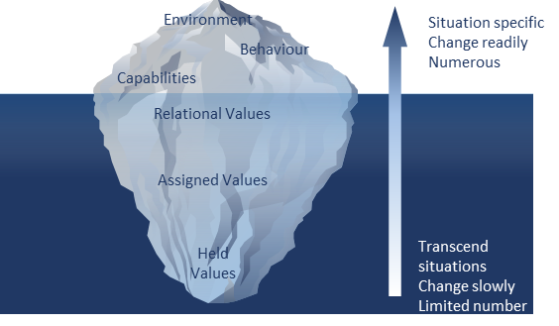
Figure 1. Cognitive hierarchy model and adapted from Fulton, Manfredo and Lipscomb (1996).
Relational values are context specific and expressed more openly, involve feelings and develop from a preference of the relationship between a subject and an object. These felt values are evolved from a personal understanding or experience, give relative importance, worth and/or significance something has for an individual and draw attention to the interaction between memory and emotion. A situation or object if made explicit from the relational values will draw out the assigned and held values when externalised.
The model provides an opportunity to go beyond the foundations of behaviour at a superficial level which can be influenced by the environment and prevailing skills or capabilities in a specific context or situation. It creates the opportunity to explore the more fundamental and slower moving aspects of cognition but is generic and does not consider the value types. Consideration also needs to be given to our experiences, as these accumulate over time and supplement our levels of learning which accrue over time and expand our ideals of how things ought to be and how we should interact with the world.
The concept of hierarchy of levels is not limited to cognitive theories. Bateson (2000) examined five levels to the learning process which at level 0 depicts repetitive behaviours and akin to being stuck in a rut. Learning at level I is gradual as it takes place by making corrections and adaptions through behavioural flexibility but remaining in the same system or mode of thinking. At level II, learning is discontinuous and is an instantaneous change and reflective of using the same processes, just a different mode of thinking. The next level is evolutionary change and where the behaviours are stretched beyond the boundaries of the current system or mode of thinking. It can be considered as out of box thinking and reflective of transition of role, brand or identity. At the highest level IV and akin to Scheler’s hierarchical holy value, learning is revolutionary and is not just a new mode of thinking, it is completely unchartered possibilities and reflective a new world / universe.
The psychological standpoint of our values transcending situations as they are very slow to change and that we generally have very few was developed through the works of Rokeach (1973). Rokeach proposed terminal (an individual’s goals that they would like to achieve over their lifetime) and instrumental (preferred behavioural modes) value classifications which consisted of 36 items that are ranked based on an individual’s relative importance. Through his research, he demonstrated links between the importance of values and diverse beliefs and behaviours (Hanel, Litzellachner and Maio, 2018) but fell short of developing a method to predict the linkage between different values and their associated beliefs and behaviour.
Schwartz (1992) built upon the works of Rokeach and explored an association between value types and their motivational dynamics which led to the postulation of 11 value types. Each value type considered a sub-set of two to nine values and ordered across two dimensions of openness versus conservation and self-transcendence versus self-enhancement but did not consider spirituality. Through continued research into value types, Schwartz has continued to document an association with his proposed structure of human values noting a trade-off exists between relevant, competing values which guide an individual’s beliefs and behaviours (Schwartz, 2012). Values therefore influence an individual’s response to a given situation by activating the deep-rooted inner belief.

Value Name | Basic Value Definition
Achievement | Personal success through demonstrating competence according to social standards
Power | Social status and prestige, control or dominance over people and resources
Benevolence | Preserving and enhancing of the welfare of those with whom one is in frequent personal contact
Universalism | Understanding, appreciation, tolerance and protection for the welfare of all people and for nature
Security | Safety, harmony, and stability of society, of relationships and of self
Tradition | Respect, commitment, and acceptance of the customs and ideas that traditional culture or religion provide the self
Conformity | Restraint of actions, inclinations, and impulses likely to upset or harm others and violate social expectations or norms
Self-Direction | Independent thought and action choosing, creating, exploring
Stimulation | Excitement, novelty, and challenge in life
Hedonism | Pleasure and sensuous gratification for oneself

Table 1. Schwartz (2012) Basic Value Types.

In Schwartz’s (2012) overview of basic values, the value types are reduced to 10 (Table 1). The theory postulates that the value types are defined by the motivation that underlies each value and considered to be universal as they are grounded in the biological, social and welfare needs of individuals. Schwartz also observes that some values compete against one another and as such it would be difficult to pursue personal achievement as this could typically conflict with benevolence values. However, substitute benevolence for power values and these would be complimentary. The pattern of congruence or conflict is summarised in Figure 2 as it illustrates the bi-polar nature of competing value types and assists to explore the inter-relationships of a higher order value continuum as openness to changes competes with conservatism and self-enhancement contrasts with self-transcendence.
Adopting a circular model, Schwartz is not only expressing a motivational continuum, but is also implying the basic value types can relate to several variables (beliefs, behaviour, age, gender, etc). The circular model is implicit in demonstrating that an individual’s behavioural response is drawn from any number of basic value combinations in reaction to a given circumstance or environment and demonstrate that values transcend situations and are organised into a value system. A typical system gives structure to the values and prioritises them to meet universally important biological and social needs. The dynamic relationship and trade-offs that take place between these universal value types cluster together to form a value orientation that guides behaviour. Conceptually, understanding how a pattern of value-based preferences is constructed will enable a greater understanding of how people prioritise values in changing environmental circumstances, behavioural situations or organisational change.

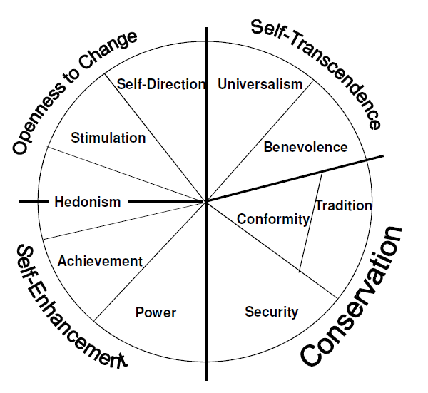

Figure 2. Schwartz (2012) Theoretical model of relations among motivational value types.

Through the 2012 revision to the model, Schwartz supported the concept of the motivational continuum by including 19 components by apportioning the now 10 basic value types into more narrowly defined values. In doing so, Cieiuch et al. (2014) noted that these values added significant worth and facilitate predicting various attitudes.
The data collection instrument is the Portrait Values Questionnaire (PVQ) and was developed (Schwartz, 2012) to measure the 10 basic values with respondents that emphasise abstract free-thinking. The PVQ includes 40 portraits of people to gender-match with the respondent and describes a person’s goals, aspirations, ideals and wishes to implicitly elicit importance of the value to the respondent. Each value described with in the PVQ consists of between 3 to 6 portraits to represent the breadth of the values. Through Schwartz’s development of the PVQ, this has been reduced to a 21-item version which is adopted by the European Social Survey (ESS). Schwartz (2012) observes that although the reliability is compromised by the reduction in items, repeated assessment of the instrument across cultures demonstrates validity.
The research herein utilises secondary data accessed from the ESS and explores the variables of age, gender, occupation, working tenure and duration in full-time education in relation to the basic value types. A test is conducted of the higher order values in relation to individuals whose occupations depict the business functions of a global manufacturing business, Control Techniques (CT) located in Newtown, Mid-Wales.

Research Methods
The secondary data is accessed from the European Social Survey (ESS Round 9, 2018) which was released June 15, 2020. The ESS was awarded European Research Infrastructure Consortium status in November 2013 by the European Commission and provides clear structure and governance as its researchers provide data collected from different national surveys. The ESS sets out a clear specification for the data collection process and outlines the tasks and responsibilities of the National Coordinators and the Survey Agency in conjunction with its ethics policy. The ESS aims to ensure that data collected is of a high quality and comparable across each participating country. The source questionnaire is constructed around a core module which is designed to capture changing attitudes and values across Europe and a rotating module that is selected from proposals presented for each survey round. The Questionnaire includes a supplemental questionnaire that is included within the core module and collects responses from the 21-item measures of human values by Professor Shalom Schwartz.
Samples are representative of all persons above the age of 15 that are resident in private households across 27 countries and regardless of nationality, citizenship or language. Participants in the survey are selected on random probability methods with each country submitting data from a minimum of 1500 participants or 800 in countries with a population of less than 2 million. Quota sampling or substitution of non-reporting households is not permitted. The data collected is from face to face interviews with adjudication from a National Coordinator to uphold the specification of data collection set out by the ESS and maintain standards of the interviewer behaviour. To maintain good quality data, the ESS sets a minimum target response of 70% where interviewers are trained to sufficiently secure a good level of cooperation. However, the ESS does recognise that there is a margin of error with the type of data collection methods used and provides a Survey Quality Predictor to predict the reliability and validity of the survey questions.
The survey data provided by the ESS reports 47,086 respondents with a mean age of 51.13 years (Median=52 and Standard Deviation (SD)= 18.63) with females accounting for 53.8% of the survey population. The data provides responses to 532 questions from 559 occupations which are represented across both genders. In the interests of this study, the survey has been reduced to focus on 10 countries that account for the European operational territories of CT with a further data reduction to focus on 80 occupations (Appendix I) that best represent CT’s core business activities. Occupations including Government, Healthcare, Education, Welfare and Service sectors are excluded. This change reduces the final survey data to 3,297 respondents and changes the gender demographic with female representation reduced to 38.7%. Whilst this does represent a significant change in gender and occupation demographic it does permit focus of the values of respondents that best represent the occupations at CT. If the values of each occupation were being considered then 21 occupations would further be reduced as there are <10 respondents, but as values are being considered for the working population, then no further data reduction is considered. The final sample (Table 2) is represented by the same age range from 16 to 90 years (Mean = 51.40, Median = 51 and SD= 16.48) with the mean age of males being 55.02 (Median=51, SD=58.13) compared to 50.86 (Median=51, SD=15.96) for females and includes a review of tenure and duration spent in full time education.
In order to assess the associations of age, a classification was adopted from Sweiry and Willits (2012) which defined 5 age groups of 16-24, 25-49, 50-64, 65-79 and 80+. The groups defined an additional variable which was created in SPSS-26 to provide data simplification and ease of assessment. Considering a univariate analysis, the demographics of the respondents (gender, age, country, tenure and time in full-time education) largely matched the statistical population except for Spain where the country population was under-represented (5%) compared to Germany (14%) and UK (14%).

Ethical considerations are maintained through the survey with anonymity of the respondent and interviewer. The survey uses semi-quantitative methodology as it uses a combination of scale data (numerical data with fixed intervals, for age, tenure and time in full time education), ordinal data (data that can be ranked as size of organisation and can be subjective) and nominal data (which describes categories and includes occupation and country). With this combination of data, the number of false negatives or false positives is reduced as it is considered as insensitive. Analysis of this nature lends itself well to a positivist epistemology (Crotty, 2015).
The 21-item values (Table 3) are measured through the PVQ (Schwartz, 2012) where respondents are required to read a statement relating to a fictitious person of the same age and gender as them and rate using a Likert scale. The scale is ranged from 1 (like me) to 6 (not like me at all) and includes options for refusal, don’t know and no answer. Analysis of the PVQ, Schwartz recommends calculating mean score for all 21 value items for each respondent and refers to the variable as MRAT. The centred items represent the basic value types (Schwartz, 2012) which had reliabilities between α = 0.664 (Achievement) and α = 0.694 (Universalism) using Cronbach’s alpha (Appendix II) and therefore recognises the reliability of the survey.
Item | Value
1 | Important to think new ideas and being creative
2 | Important to be rich, have money and expensive things
3 | Important that people are treated equally and have equal opportunities
4 | Important to show abilities and be admired
5 | Important to live in secure and safe surroundings
6 | Important to try new and different things in life
7 | Important to do what is told and follow rules
8 | Important to understand different people
9 | Important to be humble and modest, not draw attention
10 | Important to have a good time
11 | Important to make own decisions and be free
12 | Important to help people and care for others well-being
13 | Important to be successful and that people recognise achievements
14 | Important that government is strong and ensures safety
15 | Important to seek adventures and have an exciting life
16 | Important to behave properly
17 | Important to get respect from others
18 | Important to be loyal to friends and devote to people close
19 | Important to care for nature and environment
20 | Important to follow traditions and customs
21 | Important to seek fun and things that give pleasure

Table 3. Schwartz 21-item values
Data Analysis
The aim of the analysis is to statistically explore the associations of Schwartz’s 21-item values in relation to occupations relating to the business operations of CT. Data provided by the ESS is available in multiple formats (ESS Round 9, 2018). For the purposes of this analysis, SPSS-26 is used to explore the survey data and test the variable associations and it is assumed that a basic knowledge of the statistical package is held. The statistical assessments cleanse the data by excluding “refusal”, “don’t know”, “no answer“ responses and blank cells which were denoted by missing responses. It is also assumed that the data analysed constituted a normal distribution from the survey results.
In setting out a method to explore this, the analysis is conducted over 2 parts. Firstly, the associations between gender, age, length of service, time in education, highest level of education and occupation are examined to consider the notion that these variables can be generalised (Han, Kamber and Pei, 2011) rather than examining the association of each variable with the 21-item values. Part 2 explores the relationship of the 21-item values to consider conceptual higher-level values and the effect of valid responses are considered through Pairwise and Listwise deletion.
The steps adopted are outlined below.
Part 1.
- The data demographic of respondents age, time in full-time education and length of service is statistically explored through descriptive analysis (Table 4). The data table is constructed by using the Frequencies analysis and selecting mean, median and mode to review central tendency and standard deviation as a measure of data dispersion.
- The strength of these relationships is examined using a Pearson’s correlation (Table 5) and represented with a trend line on scatter diagrams (Figures 4 and 5).
- Acknowledging the sample size is reduced, an Independent T-test (Appendix III) examines the statistical significance of gender differences on length of service, and the correlation between the respondents age and length of service. Length of service is set as the test variable and gender selected as the grouping variable. [SPSS-26 requires the groups to be defined as 1 (male) and 2 (female) before running the analysis].
- Inferential and descriptive statistical techniques examine the structural variable associations of occupation to gender, highest level of education and respondents age.
  - Chi-square (Table 6) tests the null hypothesis that the gender and occupation variables are independent. [The test is selected through the crosstabs option from descriptive statistics with gender (row) and occupation (columns) variables selected. Chi-squared is selected as the statistical test and analysis compiled].
  - One-way ANOVA (Table 7) from the General Linear Model family of inferential statistical models examines the statistical difference between independent variables of occupation and highest level of education means. Occupation is set as the dependent variable and highest level of education considered as the test factor. Post-Hoc comparison using Tukey is not considered as some occupation groups have fewer than two cases. The descriptive option is selected and the results available in Appendix VII. It is noted that one-way ANOVA is an omnibus test statistic and as such cannot illustrate which groups are statistically significant.
  - Chi-square (Table 8) tests the null hypothesis of age and the occupational categorical variable. The process in 1.iv.a is repeated with age and occupation selected as row and column variables.
- To complete the analysis, tests of associations with gender, age, length of service and occupation a multivariate analysis of variance (MANOVA) is explored (Appendix IV). MANOVA (Table 9) is used to understand if there is an interaction between the independent variables and explores differences between age / length of service and gender/ occupation. Age and length of service are set as the dependent variables with gender and occupation being the fixed factors. Descriptive statistics is selected from the options menu and the test run.
Part 2.
- The respondents age and satisfaction with life is statistically explored with one-way ANOVA (Table 10). Age is set as the dependent variable with satisfaction of life being the factor. Post Hoc comparison with Tukey analysis is selected with a significance level set at the default 0.05 level before running the test. To reduce the number of data points on a mean plot (Figure 6), a new variable is created from the Transform function in SPSS-26 by creating 16-24, 25-49, 50-64, 65-79 and 80+ age categories (Sweiry and Willits, 2012).
- Non-parametric Associations are assessed through Kruskal-Wallis and Pairwise to explore how age differs to higher order values and occupation (Appendix VIII). An Independent Samples test of higher order values and age are set as the test fields and the group is set as the respondent’s occupation before using the default setup with SPSS-26.
- Multi-dimensional scaling (MDS) tests the association of the 21-item values and is performed with the PROXSCAL procedure using the default setup (Figure 8).
- To develop an understanding of the 21-item value associations, a Pearson’s coefficient is used. The 21-item values are grouped into the basic values (Table 11) defined by Schwartz (2012) with each group signifying the strongest correlations. Further examination of the data is conducted through Principal Component Analysis (PCA) to explore the strongest underlying factors. A basic assessment of the data is required to review the distribution plausibility and identify any outlying data. Frequency charts (Appendix VI) and descriptive statistics (Table 12) enable a cursory check of valid responses.
SPSS-26 enables a dimension reduction using a standard analysis with a scree plot (Figure 9), Varimax rotation (Table 14) and missing values excluded by Pairwise options are selected to create the total variance explained (Table 13). Using the rotated component matrix (Table 14), the corresponding Pearson correlations are sorted high to low for each corresponding component. The higher-order value variables are calculated from the means of the 21-item values present in the corresponding factors and summarised with descriptive statistics (Table 15).
- To explore the effect of managing missing data, the dimension reduction in step ix is repeated. The same default and options are selected with one important change and missing values by Listwise chosen. When the test is run, a revised scree plot (Figure 10) and total experience explained (Table 16) are output. The Pearson correlations represented within the Varimax rotation are sorted high to low in the respective extracted sums or underlying factors (Table 16). The corresponding underlying factors have higher-order values variables calculated from the 21-item value means and summarised with descriptive statistics (Table 18).

Results
The ESS values survey data is explored over two parts to firstly assess implications of validity and reliability by reducing the data to the focused countries and occupations before conducting exploratory factor analysis (EFA) of the 21-item values by examining the missing data through the more common techniques of Pairwise and Listwise (Peugh & Enders, 2004). The data assessed in Part 1, explores the descriptive statistics and associations of the respondents gender, age, length of service, duration in full-time education and occupation to develop a case for the data to be generalised to then explore the association of the respondents responses to the 21-item values. Part 2 considers EFA and assumes data is missing completely at random (MCAR). Processing the data through Pairwise considers all cases and uses an algorithm to impute missing data to minimise data loss. Further assessment through Listwise enables a focus on the respondents that have completed all 21-item values with data being removed to provide a complete case analysis. Although pairwise deletion maximises all data available, it also analyses the entire data population to compute the standard of errors which can lead to over or under estimation.
Part 1
- The first area explored is the tenure or length of service of the respondent and association with age and duration in full-time education (Table 4). For each variable, the mean, median and mode is calculated. The mean values indicate that average respondent was 51.40 years of age and has 31.27 years of service with 14.87 years in full time education. The median values indicate the midpoint of the data and with 51.0, 30.0 and 15.0 respectively, indicate an even distribution of the data as they are close to the mean values. However, the mode which indicates the value that occurs most often is a close match for age (49) and years of education (13) but is 20 for years of service which indicates the distribution range is high.
 |  | Gender | Age of respondent, calculated | Length of Service | Years of full-time education completed
N | Valid | 3297 | 3287 | 3115 | 3270
N | Missing | 0 | 10 | 182 | 27
Mean |  | 1.39 | 51.40 | 31.2726 | 14.87
Median |  | 1.00 | 51.00 | 30.0000 | 15.00
Mode |  | 1 | 49ª | 20.00 | 13
Std. Deviation |  | .487 | 16.475 | 17.52726 | 4.056
Variance |  | .237 | 271.434 | 307.205 | 16.448
Minimum |  | 1 | 16 | .00 | 0
Maximum |  | 2 | 90 | 80.00 | 50
Percentiles | 25 | 1.00 | 38.00 | 17.0000 | 12.00
Percentiles | 50 | 1.00 | 51.00 | 30.0000 | 15.00
Percentiles | 75 | 2.00 | 64.00 | 45.0000 | 18.00
- Multiple modes exist. The smallest value is shown

Table 4. Data demographic
- To examine which variables relate more strongly to age, a Pearson’s correlation is undertaken (Table 5). The strongest correlation exists (0.962) between age and length of service as this is closest to 1. Whereas the weakest correlation is between tenure and duration in full-time education (-0.288). It should be noted in both assessments that the number of respondents in each group is not identical, but the number of respondents remains over 3000.
 |  | Age of respondent, calculated | Years of full-time education completed | Length of Service
Age of respondent, calculated | Pearson Correlation | 1 | -.231** | .962**
Age of respondent, calculated | Sig. (2-tailed) |  | .000 | .000
Age of respondent, calculated | N | 3287 | 3260 | 3110
Years of full-time education completed | Pearson Correlation | -.231** | 1 | -.288**
Years of full-time education completed | Sig. (2-tailed) | .000 |  | .000
Years of full-time education completed | N | 3260 | 3270 | 3094
Length of Service | Pearson Correlation | .962** | -.288** | 1
Length of Service | Sig. (2-tailed) | .000 | .000
Length of Service | N | 3110 | 3094 | 3115
**. Correlation is significant at the 0.01 level (2-tailed).

Table 5. Pearson correlations of age, full-time education and tenure.

The scatter graph in Figure 4 illustrates the highest correlating variables with age being positively correlated to length of service and demonstrated by the trendline whilst the weakest correlation of tenure and years in full time education is represented in Figure 5. The slightly negative correlation could be anticipated as there are more educational opportunities today in comparison to older generations who were encouraged to earn a salary rather than study. However, the precise analysis would benefit from future research.

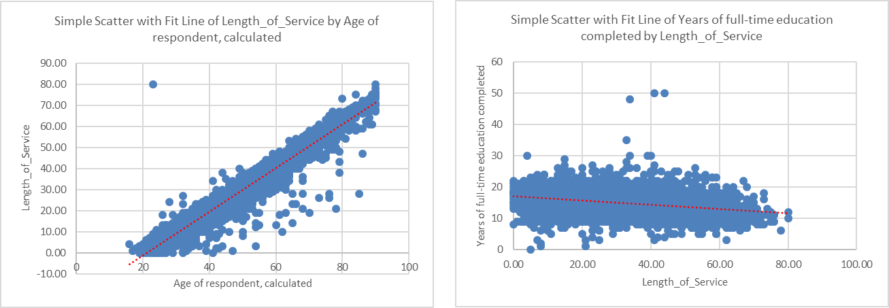
Figure 4. Age and tenure. Figure 5. Tenure and time in education.
- Recognising the shortened survey data has changed the gender demographic, the association of gender (two groups) and tenure (scale variable) is analysed using an Independent T-test to establish if there is a statistically significant difference (Appendix III). The mean length of service for males (31.7 years) is closely matched to females (30.60 years) and the null hypothesis was accepted as the p-value (0.84) is greater than 0.05, so there is no difference between gender and length of service. Completing this assessment is important as it negates the need to repeat the following analysis by gender as it can be generalised (Polit and Beck, 2010) that age is correlated to length of service regardless of gender.

  - Exploring the relationship of occupation to the respondents, an initial assessment is placed on investigating if there is a relationship between gender and occupation. The objective is to establish if there is a statistically significant difference between gender and the shortened list of 80 occupations. Testing the association between the categorical variables, a Chi-squared test is used (see Appendix V for breakdown of gender and occupation). Table 6 shows the null hypotheses, i.e. no difference between gender and occupation was rejected as the p-value is <0.05.
 | Value | df | Asymptotic Significance (2-sided)
Pearson Chi-Square | 794.455ª | 79 | .000
Likelihood Ratio | 879.238 | 79 | .000
Linear-by-Linear Association | 87.880 | 1 | .000
N of Valid Cases | 3297
a. 42 cells (26.3%) have expected count less than 5. The minimum expected count is .39.
Table 6. Chi-Squared test of gender and occupation.

  - Continuing the assessment of occupation of the respondents, an objective is set to consider the association of education and occupation. A one-way ANOVA is used (Table 7) where the null hypothesis is rejected as the p-value <0.05, indicating that there is a difference of highest level of education and occupation.
Occupation, ISCO08
 | Sum of Squares | df | Mean Square | F | Sig.
Between Groups | 1707812693 | 25 | 68312507.712 | 31.114 | .000
Within Groups | 7170794114 | 3266 | 2195589.135
Total | 8878606806 | 3291

Table 7. One-way ANOVA of highest level of education and occupation.

  - In this final assessment of occupation, the relationship between respondents age and occupation is explored. A Chi-squared test (Table 8) considers the categorical variables and the null hypotheses is rejected here too as the p-value is less than 0.05. Thus, indicating statistically that there is a difference between age and occupation.
 | Value | df | Asymptotic Significance (2-sided)
Pearson Chi-Square | 617.286ª | 316 | .000
Likelihood Ratio | 612.518 | 316 | .000
Linear-by-Linear Association | 7.268 | 1 | .007
N of Valid Cases | 3287
a. 243 cells (60.8%) have expected count less than 5. The minimum expected count is .04.

Table 8. Chi-Squared test of age and occupation.
- The MANOVA enables the data to be explored further and considers gender, respondent’s age, length of service and occupation. The descriptive statistics (Appendix IV) enables us to draw parallels between the variables, but the multivariate test statistic (Table 9) is used to test the statistical significance of the different effects of the independent variables. The p-value is <0.05 which means that there is a statistically significant interaction effect and the effect of the intervention on dependent variables is not the same for males and females.

Table 9. Wilk’s Lambda statistical significance of effects of independent variables.
Part 2
- The 21-item values are the primary area of analysis which explores the inter-relationship with the respondents. An initial assessment considers the association of the respondents age and how satisfied they are with life. In this instance the objective is to establish if there is a statistically significant difference between age (scale variable) and satisfaction (groups defined by a Likert scale). As there are more than two groups, a one-way ANOVA statistical test is used. The null hypothesis (no association between age and being satisfied with life) is rejected as the p-value is <0.5 and illustrated in Table 10. The alternate hypothesis, that there is a difference in age and the midpoints of how satisfied with life is accepted and illustrated in Figure 6. It is acknowledged that satisfaction with life reduces in the 50 to 64 category, but analysis of this is beyond the scope of this study.
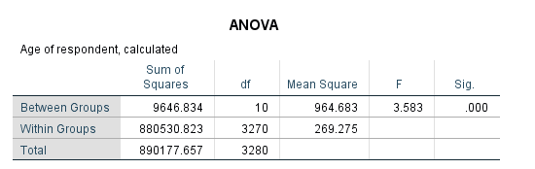
Table 10. One-Way ANOVA Age and satisfaction with life.
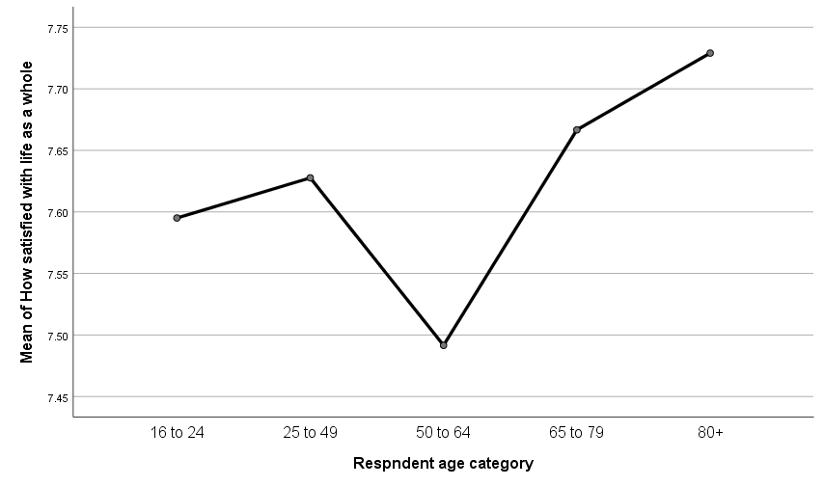
Figure 6. Age group satisfaction with life.

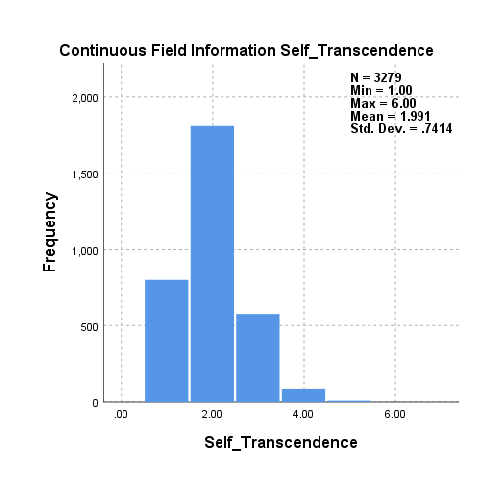
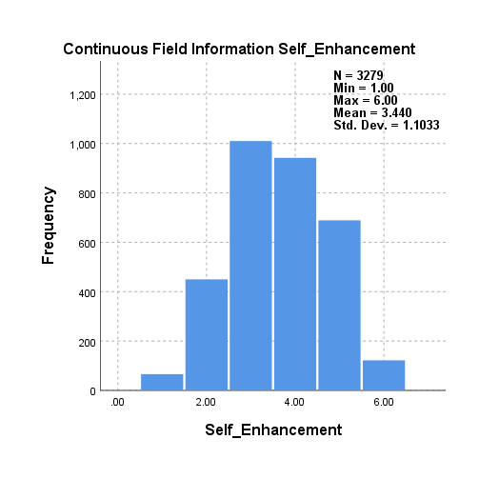
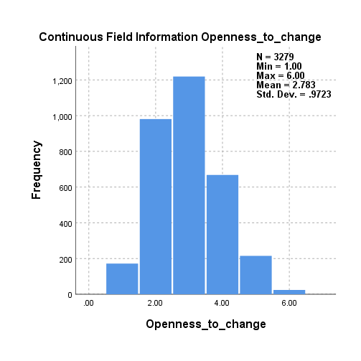
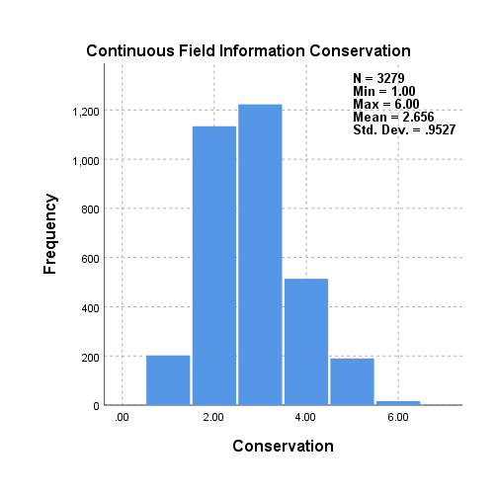
- To consider the median association of age on occupation and higher-order values (Schwartz, 2012), a Kruskal-Wallis non-parametric Tests is conducted (Appendix VIII). The null hypothesis is rejected in all cases as p-values are <0.05. The alternate hypothesis is accepted and there is an effect on age to occupation and higher-order value. Analysis of this is beyond current scope and may be considered with future research. Exploring the continuous field data (Figure 7) of higher-order values, the distributions of Conservation, Openness to change and self-transcendence have the normal curve peak to the left side which indicates it is positively skewed and reflects the values to be more-like respondents. Whereas, Self-Enhancement is marginally skewed to the right and indicates less-like the respondents.

Figure (7). Higher order values distribution
- Multidimensional Scaling (MDS) enables the 21-item values to be visually represented by their proximity to one another. Figure 8 illustrates similarities at the central point with a safe environment (ipstrgv) and helping people (iphppl) but the closest similarity is pleasure (impfun) and caring for nature/environment (impenv). Longer distances between the points indicate larger dissimilarities and this is demonstrated between wealth (imprich) and pleasure. (Figure 13 gives a complete listing of 21-item values and variable name).

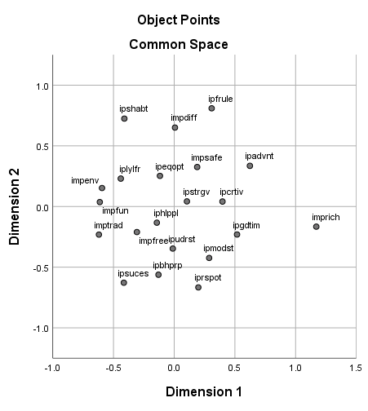
Figure 8. MDS 21-item values plot.

- Table 11 considers the Pearson’s coefficient for each of the 21-item values and grouped according to the underlying factors in Table 14. To explore this further and consider the association of the 21-item values for the focused population EFA is used. The objective of this statistical assessment is to identify the strongest correlations and identify underlying factors. There are several mathematical approaches to explore the underlying factors and SPSS-26 uses the most common of these with Principal Component Analysis (PCA). An initial assessment of the responses to the 21-item values (Appendix VI) indicates that the frequency distributions with corresponding bar charts are plausible with no outlying data. The descriptive statistics (Table 12) enables an assessment of the missing values and it is observed <5% of the respondents have missing values. SPSS-26 factor analysis is used with the standard analysis and missing data excluded with pairwise. Pairwise is often preferred as the method to manage missing data as the pairwise deletion attempts to use a correlation coefficient to take the data into account and therefore maximises all the data available.
Table 11. Pearson’s Coefficient of 21-item values.

Table 12. 21-item values descriptive statistics.

PCA extracts the 21 factors to assess the total variance which identified 4 factors with eigenvalues greater than 1 (Table 13) and illustrated with the Scree Plot (Figure 9). The remaining factors are considered to have low quality scores and are not assumed to represent real traits underlying the 21-item values.
Table 13. Total Variance Explained Pairwise deletion.

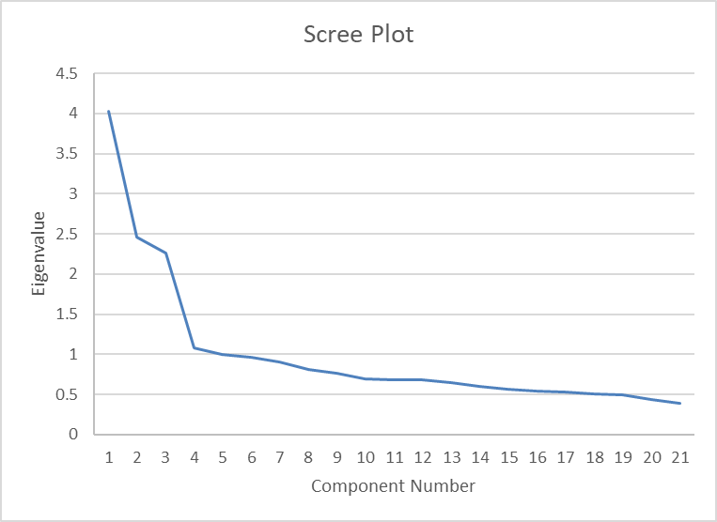
Figure 9. Scree Plot of 21-item values Pairwise deletion.
SPSS enables a rotated component matrix to be compiled and identifies which variables measure which factors. The factor represents what the variables have in common and for simplicity these have been grouped by colour (Table 14). Schwartz (2012) considered these factors to represent higher-order values corresponding to Conservation (5,14,9,20,7,16), Openness to change (1,11,6,15,10,21), self-enhancement (2,17,4,13) and self-transcendence (12,18,3,8,19). Whilst the results in this study replicate the higher order values presented by Schwartz, there are noticeable differences with value items 1 and 11 are arranged in the first factor with items 12,18,3,8 and 19 forming an expanded self-transcendence.
Table 14. Varimax rotation of variables measured by 4 underlying factors.

 | N | Minimum | Maximum | Mean | Std. Deviation
Conservation | 3279 | 1 | 6 | 2.66 | 0.95
Openness_to_change | 3279 | 1 | 6 | 2.78 | 0.97
Self_Enhancement | 3279 | 1 | 6 | 3.44 | 1.10
Self_Transcendence | 3279 | 1 | 6 | 1.99 | 0.74
Valid N (listwise) | 3279

Table 15. High Value descriptive statistics.

The mean values of the calculated higher values are illustrated with the descriptive statistics (Table 15) and show how the factors are interpreted. As the higher values are computed from their means they share the same 1 to 6 as the input variables. This identified that self-transcendence is the most like-me value from the respondents whereas self-enhancement is observed as the most unlike-me value and supports Schwartz’s theoretical model (Figure 2).
- Pairwise deletion uses the average sample size across the analysis and could produce standard errors that are underestimated or overestimated. Given that 3133 respondents gave complete responses a listwise deletion would remove the variability a coefficient correlation would add to the analysis. Repeating the factor analysis with the listwise deletion, PCA extracts the 21 factors to assess the total variance which now identifies 5 factors with eigenvalues greater than 1 which are illustrated on the Scree Plot below (Figure 10).
Table 16. Total Variance Explained Listwise deletion.

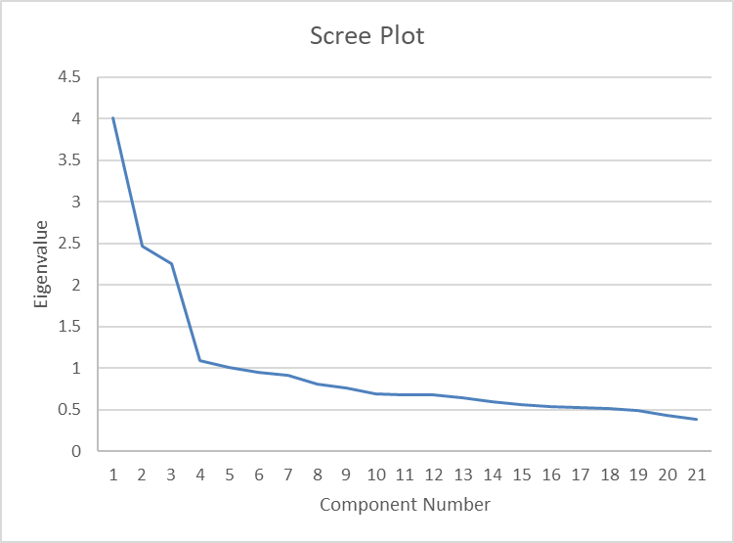 Figure 10. Scree Plot of 21-item values Listwise deletion.

Table 17. 21-Item value rotated component matrix.

Using the 5 underlying factors, revised means are computed with new variable labels annotated to explore correlation to Schwartz’s higher-order values and avoid potential confusion. The descriptive statistics (Table 18) shows how the factors are interpreted and enables a conclusion of a Leader value to be most unlike-me from the respondents whereas Empathetic is the most like-me value.

Table 18. Descriptive Statistic of higher values and emergent 5th higher value.

Discussion
The study sets out to explore variables of age, gender, occupation, working tenure and duration in full-time education in relation to the basic value types (Schwartz, 2012). Secondary data, accessed from ESS provides data from all 27 member European countries, although comprehensive does not expressly reflect the operational territories of CT or fully align to the organisation’s functions. Whilst reducing the sample data could introduce bias and increase the margin of error, the number of respondents assessed remained over 3000 and with Cronbach alpha scores above 0.6 reliability and repeatability is maintained. However, it is worth noting that Cronbach’s alpha results are sensitive to the number of items on a scale (Gray, 2018).
The limitations of Microsoft Excel to statistically examine the ESS with available statistical tests and management of missing data were overcome by migrating to SPSS-26. This enabled exploratory factor analysis to be considered with the data assessment and hypotheses associations. The respondents analysed limited the field of analysis to 10 predominant territories in Europe for CT and excluded the remaining 17 European countries or potentially the consideration of the global respondents reported through the World Values Survey. It is also noted that occupations relating to Government, Healthcare, Education, Welfare and Service sectors are excluded which may introduce bias as the random sample is no longer reflective of the entire population. Future research may benefit by replicating the analysis with these specific occupations to explore how the higher values may differ and if the emergent 5th component is also observed and considered across these occupations. The final limitation considered with this study is regarded to the data reporting and knowing which respondent is actively in employment, seeking employment, retired or not available for work may have some influence on the results.
Although not a focal point of this study, it is interesting to note from Figure 6, there is a positive trend that as the respondent increases with age, they become more satisfied with life. However, it is observed that there is a marked reduction in satisfaction with life between the ages of 50 and 64. Further research could benefit from exploring this demographic and the effect on the strongest components and higher-order values.
Schwartz’s theoretical model of relations among motivational value types (Figure 2) indicates that value types can be assessed among variables including age, gender, occupation, etc. Utilising the focused sample data, the age demographic remained broadly consistent with the original data, but the female demographic was observed to reduce by 15.1% to 38.7% of respondents. Although this change provides a dominant male gender in the respondents, it also reflects the current gender demographic within CT. Sample reliability is maintained when the change to gender demographic is considered as an independent T-test (appendix III) to assess association of gender and length of service showed no difference. Differences existed between gender and occupation (Table 6), duration in full time education and occupation (Table 7) and age and occupation (Table 8). The associations tested and confirmed with a multivariate test (Table 9) mirror the demographic within CT and the random data sample considered representative.
ESS aims to measure the 21-item values in a context-free manner. They are recorded from households and intended to capture respondents across all situations, cultures, etc. Schwartz identified 10 value types, which are organised into a value system. A typical system gives structure to the values and prioritises them to meet universally important biological and social needs. The dynamic relationship and trade-offs that take place between these universal value types cluster together to form a value orientation which guides behaviour. Conceptually, understanding how a pattern of value-based preferences is constructed will enable a greater understanding of how people prioritise values in different value systems. Detert, Schoeder and Mauriel (2000) considered a system to be of shared values defining what is important with norms defining appropriate attitudes and behaviours which is a notion supported with Schwartz’s basic values. Dilts (2003) explores this further by examining that we belong on average to 160 systems and it can be argued that the ESS does not capture the specificity of work-based values or how an individual’s values could adapt across occupations.
The focused set of respondents used in this study give the opportunity to explore the association of the 21-item values in a sub-group of occupations which reflect the business functions in a global organisation. Using pairwise to manage missing data, the results replicated 4 components from the exploratory factor analysis. However, item values 1 and 11 which form the Self-Direction basic value have transitioned to the Self-Transcendence higher-order value.

Figure 11. Schwartz (2012) Theoretical model of relations among motivational value types

To explore this further, it is necessary to understand the interaction from the value types. Schwartz conceptualised that the 21-item values formed a focus around personal values and values that shape behaviours in a social context. These are summarised in Figure 12 which draws in a third perspective to illustrate how values are ordered on organising principles of anxiety and self-protection.
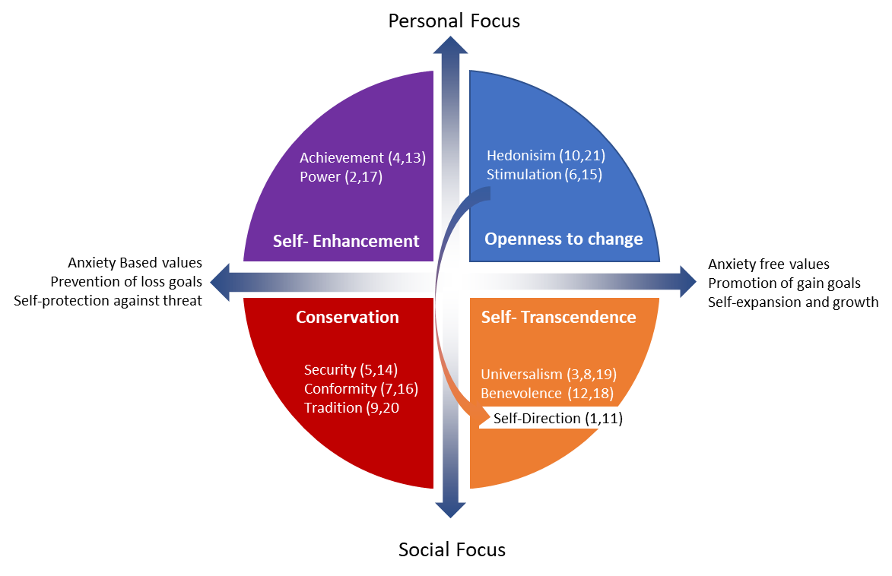
Figure 12. Adapted from Schwartz theoretical model of relation among motivational types.

Item values 1 and 11, have seemingly moved from one component variable to another (Table 14) and captured within the Self-Transcendence higher-order value. Given the reduced sample data is focused on business occupations representing industrial applications, it is conceivable that the Self-Direction basic value in a work-based context is mindful of the necessary organisational collaboration across teams, projects, occupations and cultures. This stresses the importance of the third perspective in the model to consider gain and growth, not as an individual, but as a team which supports the notion of shared values in a system.
Examining the respondent’s reply to the 21-item value Likert questions, >95% gave complete responses with no missing data. Given the missing data is no different than the complete cases, MCAR is considered as the missing data is purely a random subset of the data and won’t introduce bias in analysis based on complete cases. Future research may be benefited by considering the relationship between the propensity of missing values and the 21-item value responses.
Given the high level of responses a complete case analysis was examined using the listwise deletion. The results from the exploratory factor analysis (Table 17) indicate 5 factors which represents commonality over 5 variables. Considering the associated 21-item value questions these variables have notionally been considered as Leader, Explorer, Conformist, Empathetic and Courteous. To draw out the differences, the item values are summarised in Table 19.

Table 19. Value items transitioned with higher-order values.

Organisations consider creativity and decision-making key leadership characteristics (Korn Ferry, 2015) and therefore anticipatory with the focused occupations that Self-Direction transitions to a higher-order work-based value rather than a personal focus in the Schwartz model. Modesty, integrity and corporate social responsibility are important core values within an organisation and it is interesting that these have been drawn out of the sample data from the focused occupations. It is notionally feasible that these item-values are accentuated as they may be representative of held values that exist in an organisational context and remain in our subconscious.

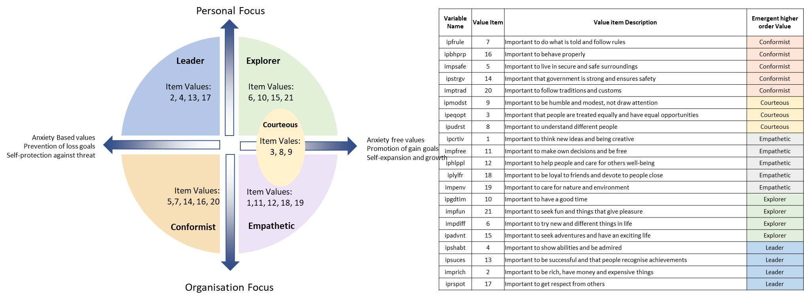
Figure 13.
EFA (Listwise) adaptation of Schwartz’s theoretical model of relation among motivational types.

The emergence of the fifth variable (Figure 13) straddles the boundary between personal and organisation focus. Organisations are goal focused which could explain how an achievement-based value transitions through a permeable higher-order value boundary. It is notional that a work-based value is materialising from within the survey data and recognising that collaboration is prevalent in a work-based context. Korn Ferry Institute (2015) recognises collaboration as leadership competence and in a work-based context, building relationships and working collaboratively with others to meet shared objectives implies courteousness as individuals participate with integrity in an open dialogue from a wide variety of contributors or stakeholders. With 51% of the respondents reporting that they are responsible for others, Appendix V illustrates a significant association between occupation and being responsible for others so it can be considered that occupation is not the main driver for courteousness as a potential work-based value.
Further research would benefit by conducting the analysis with organisations which are not goal focused and with the occupations excluded to test the emergent 5th variable and its respective associations. Analysis could test the association of the 21-item values to specific occupations which require greater or less collaboration in an organisational context. A notion that different professions draw out different core values and how these professions need to develop value changes would provide greater insight into Human Resource Management, Recruitment and Project Management.
Consiglio et al. (2017) report limited studies into work-based values and in their own assessment cross referenced Schwartz (1992) theory to postulate work-based values. Their study broadly reports similar values in a work-based context to the individual values reported through the 10 basic value types. It does not assess how work values influence an individual. Leuty and Jansen (2011) comment further in their research that there is no common construct to define work values and call for guidance in selecting a measure of work values with academics.
Spirituality is an aspect not considered by Schwartz (2012) in the value types as earlier research (Schwartz, 1992) postulated that spirituality did not demonstrate a consistent meaning across cultures. The focus was capturing an individual’s religion through the Benevolence and Tradition basic values types as opposed to considering the impact of a universal spirituality value. This hypothesis contrasts with Scheler’s hierarchy of values which considered values to relate exclusively to those allied to the holy or unorthodox. Further research to explore the associations of faith groups, voluntary organisation who do not have a goal focused culture may provide insight and test the emergent 5th variable and cultural awareness in organisations. Burnes and Jackson (2011) however, explored Graves’ Emergent Cyclical Levels of Existence Theory (ECLET) to proport a method for determining and aligning value systems. Graves’ theory considers a hierarchical relationship between eight core value systems and their motivation to move from one to another. The theory has further developed through the 1980’s to hypothesise a further 4 levels which exist beyond our level of consciousness and therefore could represent the universal spirituality-value that Schwartz omitted in the 2012 revision of the value types and is a component explored by Spinelli, Nelson-Becker and Ligossi (2019).
Understanding the values in play across an organisation can therefore play an important role in averting conflicts during change or potentially having the change derailed in its entirety. An organisation having studied the values at play would be able to assess the management strategies and plans that might impinge on the individuals and/or the organisation. Where misalignment is identified, then business leaders would be able to focus on these employees with specific communication that acknowledges and addresses the divergence and assures collaboration with key stakeholders.
The study enforces the need to consider how personal values would affect strategic decision making (Hambrick and Mason, 1984) as a project leader or manager’s filtering process of external factors could have a bearing on how information is perceived and interpreted (Arthur, Herdman and Yang, 2016). Equally, considering implications of Scheler’s hierarchy of values for mentality in an organisational context with a higher level of comprehension, could have a significant bearing of how a project is led if this value is absent from the leader.
As our held values change over long periods, it is conceivable that there is a spectrum of held values. Understanding the respective value system hierarchy may provide insight and understanding to delivering organisational change. Developing these theories further could have a significant bearing on how individuals transcend between value systems and advance academic research in this field. It would also provide greater understanding of how our values evolve and contribute to attitudes and behaviour and benefit HR, recruitment and team development. Our values become enriched through transformative change which is where the learning and the how to learn happen simultaneously. If value systems are transcended by individuals, then it is conceivable that as value systems overlap, a new system is created. If this process has an identifiable and unique relationship with its held value’s then further research in this field would benefit to develop a framework that seeks to comprehend and intuitively adjust cognitive behaviour through transcending the value systems and will be key to unlocking the success of comprehending cognitive change.

Summary
The study provides empirical support for the use of Schwartz’s value types and the reliability of the PVQ ensured assessment of the focused occupations is valid. Through empirical assessment using complete case analysis, an emergent 5th variable came from within the study to consider courteousness across stakeholders in an organisational context which indicates collaboration is inherent within our values. The literature review indicates an abundance of research from the 1970’s defining values, but there is limited on-going research to develop a deeper understanding of work-based values. This research gives rise to explore an emergent framework to postulate the association of values an individual may hold toward protecting the status quo during fundamental change as they may also assign these held values towards a specific place, process, group or object.
Future study would benefit by considering a pragmatic enquiry to test the association of what is valued, why and by whom and to intervene at more than one point in the value system and/or held value in association to work-based values. If our values are aligned to our work, they support and provide motivation. Exploring a business leader’s own set of values to deliver transformational change could cultivate the emergent 5th variable, courteousness, to draw on a critical mass of people into amending their own held and assigned values. Shared values would provide motivation and minimise a disconnect with diverging values that can cause conflict and stress through periods of change. The effect of individuals transcending value systems would advance the field of knowledge and develop cognitive change in an organisational context.

References
Arthur, J.B., Herdman, A.O. and Yang, J. (2016) ‘How top management HR beliefs and values affect high-performance work system adoption and implementation effectiveness’, Human Resource Management, 55(3), pp. 413-435.
Bateson, G. (2000) Steps to an ecology of mind. Chicago: The University of Chicago Press.
Boer, D., Fischer, R. and Hinshaw, P.S. (2013) ‘How and When Do Personal Values Guide Our Attitudes and Sociality? Explaining Cross-Cultural Variability in Attitude-Value Linkages’, Psychological bulletin, 139(5), pp. 1113-1147.
Cieciuch, J., Davidov, E., Vecchione, M. and Scwartz, S. H. (2014) ‘A Hierarchical Structure of Basic Values in a Third-Order Confirmatory Factor Analsysis’, Swiss Journal of Psychology, 73(3), pp. 177-182.
Consiglio, C., Cenciotti, R., Borgogni, L., Alessandri, A. and Schwartz, S.H. (2017) ‘The WVal: A New Measure of Work Values’, Journal of Career Assessment, 25(3), pp. 405-422.
Crotty, M. (2015) The Foundations of Social Research: Meaning and perspective in the research process. London: Sage.
Cutting, J. (2016) ‘Max Scheler’s theory of the hierarchy of values and emotions and its relevance to current psychopathology’, History of Psychiatry, 27(2), pp. 220-228.
Detert, J.R., Schoeder, R.G. and Mauriel, J.J. (2000) ‘A framework for linking culture and improvement initiatives in organizations’, Academy of Management Review, 25(4), pp. 850-863.
Dilts, R. (2003) From Coach to Awakener. California: Dilts Strategy Group.
ESS Round 9: European Social Survey Round 9 Data (2018). Data file edition 2.0. NSD - Norwegian Centre for Research Data, Norway. Available at: http://dx.doi.org/10.21338/NSD-ESS9-2018 (Accessed: 01 November, 2020).
Fulton, D. C., M. J. Manfredo, and J. Lipscomb. (1996) ‘Wildlife value orientations: a conceptual and measurement approach’, Human Dimension of Wildlife, 1(2), pp. 24-47.
Gehman, J. Trevino, L.K, and Garud, R. (2013) ‘Values work: A process study of the emergence and performance of organizational value practices’, Academy of Management Journal, 56(1), pp. 84-112.
Gray, D. E. (2018) Doing research in the real world. 4th edn. London : Sage.
Graves, C.W. (1970) ‘Levels of existence: an open systems theory of values’, Journal of Humanistic Psychology, 10(2), pp. 131–155.
Hambrick, D. C., & Mason, P. A. (1984) ‘Upper echelons: The organization as a reflection of its top managers’, Academy of Management Review, 9, pp. 193–206.
Han, J., Kamber, M. and Pei, J. (2011) Data Mining: Concepts and Techniques. 3rd ed. Waltham, MA. : Morgan Kaufman.
Hanel, P.H.P, Litzellachner, L.F. and Maio, G.R. (2018) ‘An Empirical Comparison of Human Values Models’, Frontiers in Psychology, 9, pp. 1-14.
Hofstede, G. (1980) Cultures Consequences: International Differences Work Related Values. Newbury Park: Sage Publications, Inc.
Jones, N. A., Shaw, S., Ross, H., Witt, K. and Pinner B. (2016) ‘The study of human values in understanding and managing social-ecological systems’. Ecology Society, 21(1). Available at: https://www.ecologyandsociety.org/vol21/iss1/art15/ (Accessed: 28 June, 2020).
Khurana, S., Haleem, A., Luthra, S., Huisingh and Mannan, B. (2020) ‘Now is the time to press the reset button: Helping India’s companies to become more resilient and effective in overcoming the impacts of COVID-19, climate changes and other crises’, Journal of Cleaner Production, 280, pp. 124466-124466.
Korn Ferry Institute. (2015) FYI for your improvement. London: Korn Ferry Institute.
Lencioni, P.M., (2002) ‘Making your values mean something’, Harvard Business Review, July, pp. 113-117.
Leuty, M.E. and Hansen, J.C. (2011) ‘Evidence of construct validity for work values’, Journal of Vocational Behaviour, 79(2), pp. 379-390.
Peugh, J.L. and Enders, C.K. (2004) ‘Missing data in educational research: A review of reporting practices and suggestions for improvement’, Review of Educational Research, 74, pp. 525-556.
Polit, D.E. and Beck, C.T. (2010) ‘Generalization in quantitative and qualitative research: Myths and strategies’, International Journal of Nursing Studies,47, pp. 1451-1458.
Quinn, R. E., and Rohrbaugh, J. (1983) ‘A spatial model of effectiveness criteria: Towards a competing values approach to organizational analysis’, Management Science, 29, pp. 363–377.
Rokeach, M. (1973) The Nature of Human Values. New York, NY: The Free Press.
Scheler, M. (1973) Formalism in ethics and non-formal ethics of values : a new attempt toward the foundation of an ethical personalism. 5th edn. Evanston : Northwestern University Press.
Schwartz, S. H (1992) ‘Universals in the content and structure of values: theoretical advances and empirical tests in 20 countries’, Advances in Experimental Social Psychology, 25. pp. 1-65.
Schwartz, S. H. (2012) ‘An Overview of the Schwartz Theory of Basic Values, Online Readings in Psychology and Culture’, 2(1). Available at: https://doi.org/10.9707/2307-0919.1116 Accessed: 13 July, 2020).
Spinelli, G., Nelson-Becker, H. and Ligossi, R. (2019) ‘Consumer Competence Strategies, Spirituality Inspired Core Values and Locus of Control: What Are ther Links?’, Sustainability, 11(4787), pp. 1-22.
Sweiry, D. and Willits, M. (2012) ‘Attitudes to age in Britain 2010/11’, In-House Research No 7, Department for Work and Pensions: Sheffield.
Teixeira, E. and Werthr, W.B. Jr. (2013) ‘Resilience: Continuous renewal of competitive advantages’, Business Horizons, 56(3), pp. 333-342.

Appendix I
Valid ESS Occupation Summary and comparison to focus occupations.
Occupation, ISCO08 | Raw Data |  |  | Shortened
Occupation, ISCO08 | Frequency | Percent | Valid Percent | Frequency | Percent | Valid Percent
Managers | 55 | 0.1 | 0.1 | 30 | 0.9 | 0.9
Chief executives, senior officials and legislators | 4 | 0 | 0 | 3 | 0.1 | 0.1
Managing directors and chief executives | 352 | 0.7 | 0.8 | 147 | 4.5 | 4.5
Administrative and commercial managers | 31 | 0.1 | 0.1 | 6 | 0.2 | 0.2
Business services and administration managers | 12 | 0 | 0 | 4 | 0.1 | 0.1
Finance managers | 107 | 0.2 | 0.3 | 67 | 2 | 2
Human resource managers | 97 | 0.2 | 0.2 | 52 | 1.6 | 1.6
Sales, marketing and development managers | 14 | 0 | 0 | 10 | 0.3 | 0.3
Sales and marketing managers | 227 | 0.5 | 0.5 | 108 | 3.3 | 3.3
Research and development managers | 61 | 0.1 | 0.1 | 26 | 0.8 | 0.8
Production and specialised services managers | 41 | 0.1 | 0.1 | 21 | 0.6 | 0.6
Manufacturing managers | 239 | 0.5 | 0.6 | 117 | 3.5 | 3.5
Supply, distribution and related managers | 182 | 0.4 | 0.4 | 74 | 2.2 | 2.2
Information and communications technology service managers | 70 | 0.1 | 0.2 | 36 | 1.1 | 1.1
Professionals | 23 | 0 | 0.1 | 15 | 0.5 | 0.5
Science and engineering professionals | 32 | 0.1 | 0.1 | 20 | 0.6 | 0.6
Engineering professionals (excluding electrotechnology) | 29 | 0.1 | 0.1 | 13 | 0.4 | 0.4
Industrial and production engineers | 97 | 0.2 | 0.2 | 39 | 1.2 | 1.2
Environmental engineers | 9 | 0 | 0 | 2 | 0.1 | 0.1
Mechanical engineers | 115 | 0.2 | 0.3 | 64 | 1.9 | 1.9
Engineering professionals not elsewhere classified | 135 | 0.3 | 0.3 | 86 | 2.6 | 2.6
Electrotechnology engineers | 5 | 0 | 0 | 3 | 0.1 | 0.1
Electrical engineers | 63 | 0.1 | 0.1 | 22 | 0.7 | 0.7
Electronics engineers | 38 | 0.1 | 0.1 | 14 | 0.4 | 0.4
Business and administration professionals | 50 | 0.1 | 0.1 | 2 | 0.1 | 0.1
Finance professionals | 12 | 0 | 0 | 9 | 0.3 | 0.3
Accountants | 481 | 1 | 1.1 | 146 | 4.4 | 4.4
Financial and investment advisers | 127 | 0.3 | 0.3 | 83 | 2.5 | 2.5
Financial analysts | 53 | 0.1 | 0.1 | 25 | 0.8 | 0.8
Management and organization analysts | 163 | 0.3 | 0.4 | 99 | 3 | 3
Personnel and careers professionals | 102 | 0.2 | 0.2 | 61 | 1.9 | 1.9
Training and staff development professionals | 38 | 0.1 | 0.1 | 27 | 0.8 | 0.8
Sales, marketing and public relations professionals | 11 | 0 | 0 | 5 | 0.2 | 0.2
Advertising and marketing professionals | 136 | 0.3 | 0.3 | 80 | 2.4 | 2.4
Public relations professionals | 56 | 0.1 | 0.1 | 25 | 0.8 | 0.8
Information and communications technology professionals | 19 | 0 | 0 | 15 | 0.5 | 0.5
Software and applications developers and analysts | 16 | 0 | 0 | 6 | 0.2 | 0.2
Systems analysts | 107 | 0.2 | 0.3 | 51 | 1.5 | 1.5
Software developers | 145 | 0.3 | 0.3 | 81 | 2.5 | 2.5
Web and multimedia developers | 21 | 0 | 0 | 4 | 0.1 | 0.1
Applications programmers | 63 | 0.1 | 0.1 | 39 | 1.2 | 1.2
Software and applications developers and analysts not elsewhere classified | 58 | 0.1 | 0.1 | 43 | 1.3 | 1.3
Database designers and administrators | 16 | 0 | 0 | 4 | 0.1 | 0.1
Systems administrators | 39 | 0.1 | 0.1 | 10 | 0.3 | 0.3
Computer network professionals | 9 | 0 | 0 | 2 | 0.1 | 0.1
Legal, social and cultural professionals | 17 | 0 | 0 | 15 | 0.5 | 0.5
Legal professionals | 10 | 0 | 0 | 1 | 0 | 0
Legal professionals not elsewhere classified | 85 | 0.2 | 0.2 | 37 | 1.1 | 1.1
Technicians and associate professionals | 27 | 0.1 | 0.1 | 24 | 0.7 | 0.7
Science and engineering associate professionals | 9 | 0 | 0 | 9 | 0.3 | 0.3
Electrical engineering technicians | 91 | 0.2 | 0.2 | 45 | 1.4 | 1.4
Electronics engineering technicians | 28 | 0.1 | 0.1 | 11 | 0.3 | 0.3
Mechanical engineering technicians | 110 | 0.2 | 0.3 | 42 | 1.3 | 1.3
Physical and engineering science technicians not elsewhere classified | 161 | 0.3 | 0.4 | 65 | 2 | 2
Manufacturing supervisors | 308 | 0.7 | 0.7 | 121 | 3.7 | 3.7
Business and administration associate professionals | 19 | 0 | 0 | 17 | 0.5 | 0.5
Financial and mathematical associate professionals | 18 | 0 | 0 | 14 | 0.4 | 0.4
Accounting associate professionals | 392 | 0.8 | 0.9 | 188 | 5.7 | 5.7
Statistical, mathematical and related associate professionals | 20 | 0 | 0 | 15 | 0.5 | 0.5
Commercial sales representatives | 316 | 0.7 | 0.7 | 149 | 4.5 | 4.5
Buyers | 119 | 0.3 | 0.3 | 51 | 1.5 | 1.5
Business services agents not elsewhere classified | 56 | 0.1 | 0.1 | 30 | 0.9 | 0.9
Office supervisors | 213 | 0.5 | 0.5 | 111 | 3.4 | 3.4
Legal secretaries | 53 | 0.1 | 0.1 | 35 | 1.1 | 1.1
Administrative and executive secretaries | 300 | 0.6 | 0.7 | 168 | 5.1 | 5.1
Information and communications technology operations and user support technicians | 18 | 0 | 0 | 6 | 0.2 | 0.2
Information and communications technology operations technicians | 37 | 0.1 | 0.1 | 15 | 0.5 | 0.5
Information and communications technology user support technicians | 77 | 0.2 | 0.2 | 42 | 1.3 | 1.3
Computer network and systems technicians | 29 | 0.1 | 0.1 | 19 | 0.6 | 0.6
Web technicians | 8 | 0 | 0 | 5 | 0.2 | 0.2
Broadcasting and audio-visual technicians | 16 | 0 | 0 | 7 | 0.2 | 0.2
Clerical support workers | 47 | 0.1 | 0.1 | 37 | 1.1 | 1.1
Customer services clerks | 15 | 0 | 0 | 7 | 0.2 | 0.2
Payroll clerks | 77 | 0.2 | 0.2 | 32 | 1 | 1
Service and sales workers | 60 | 0.1 | 0.1 | 9 | 0.3 | 0.3
Sales workers | 70 | 0.1 | 0.2 | 1 | 0 | 0
Electrical and electronic equipment assemblers | 118 | 0.3 | 0.3 | 35 | 1.1 | 1.1
Assemblers not elsewhere classified | 107 | 0.2 | 0.3 | 36 | 1.1 | 1.1
Manufacturing labourers | 27 | 0.1 | 0.1 | 5 | 0.2 | 0.2
Manufacturing labourers not elsewhere classified | 268 | 0.6 | 0.6 | 97 | 2.9 | 2.9
Total | 42381 | 90 | 100 | 3297 | 100 | 100

Appendix II
Cronbach’s Alpha reliability test on basic values.

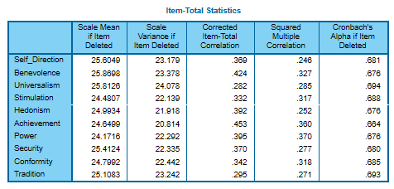

Appendix III
Independent T-test of gender and length of service.

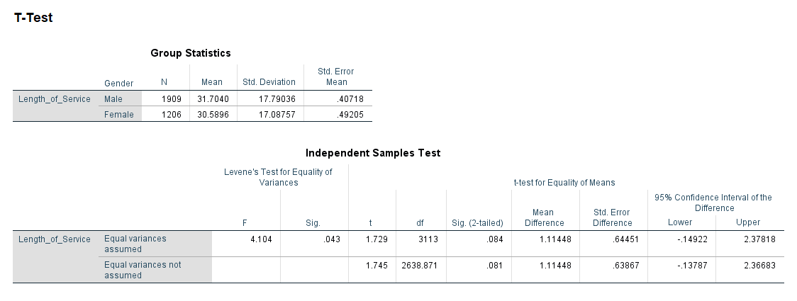

Appendix IV
MANOVA Descriptive Statistics, Occupation, Age and Length of service.

Appendix V
Occupation vs responsible for managing others.

Correlations
 |  | Occupation, ISCO08 | Responsible for supervising other employees
Occupation, ISCO08 | Pearson Correlation | 1 | .325**
Occupation, ISCO08 | Sig. (2-tailed) |  | .000
Occupation, ISCO08 | N | 3297 | 3290
Responsible for supervising other employees | Pearson Correlation | .325** | 1
Responsible for supervising other employees | Sig. (2-tailed) | .000
Responsible for supervising other employees | N | 3290 | 3290
**. Correlation is significant at the 0.01 level (2-tailed).

Appendix VI
21-item frequency distributions.

Appendix VII
One-Way ANOVA Occupation Statistical Descriptive.

Occupation, ISCO08
 | N | Mean | Std. Deviation | Std. Error | 95% Confidence Interval for Mean |  | Minimum | Maximum
 |  |  |  |  | Lower Bound | Upper Bound | Minimum | Maximum
Not completed ISCED level 1 | 3 | 7260.00 | 3583.613 | 2069.000 | -1642.19 | 16162.19 | 3122 | 9329
ISCED 1, completed primary education | 93 | 5293.46 | 3184.261 | 330.193 | 4637.67 | 5949.25 | 1120 | 9329
Vocational ISCED 2C < 2 years, no access ISCED 3 | 1 | 2514.00 | . | . | . | . | 2514 | 2514
General/pre-vocational ISCED 2A/2B, access ISCED 3 vocational | 33 | 3702.70 | 2377.279 | 413.831 | 2859.75 | 4545.64 | 1120 | 9329
General ISCED 2A, access ISCED 3A general/all 3 | 157 | 4388.97 | 2886.500 | 230.368 | 3933.93 | 4844.02 | 1120 | 9329
Vocational ISCED 2A/2B, access ISCED 3 vocational | 29 | 3970.69 | 2246.551 | 417.174 | 3116.15 | 4825.23 | 2149 | 9329
Vocational ISCED 3C < 2 years, no access ISCED 5 | 29 | 3212.66 | 1802.184 | 334.657 | 2527.14 | 3898.17 | 1120 | 9329
General ISCED 3 >=2 years, no access ISCED 5 | 7 | 2628.57 | 803.695 | 303.768 | 1885.28 | 3371.86 | 1221 | 3322
General ISCED 3A/3B, access ISCED 5B/lower tier 5A | 21 | 2782.33 | 1581.335 | 345.076 | 2062.52 | 3502.15 | 1120 | 8212
General ISCED 3A, access upper tier ISCED 5A/all 5 | 304 | 2974.43 | 1413.184 | 81.052 | 2814.93 | 3133.92 | 1100 | 9329
Vocational ISCED 3C >= 2 years, no access ISCED 5 | 180 | 3821.42 | 2346.097 | 174.868 | 3476.35 | 4166.48 | 1120 | 9329
Vocational ISCED 3A, access ISCED 5B/ lower tier 5A | 234 | 3026.44 | 1658.554 | 108.423 | 2812.83 | 3240.06 | 1000 | 9329
Vocational ISCED 3A, access upper tier ISCED 5A/all 5 | 224 | 2912.09 | 1297.802 | 86.713 | 2741.21 | 3082.97 | 1000 | 9329
General ISCED 4A/4B, access ISCED 5B/lower tier 5A | 5 | 2534.80 | 1103.940 | 493.697 | 1164.08 | 3905.52 | 1321 | 3343
General ISCED 4A, access upper tier ISCED 5A/all 5 | 3 | 3039.00 | 526.543 | 304.000 | 1730.99 | 4347.01 | 2431 | 3343
ISCED 4 programmes without access ISCED 5 | 49 | 3365.59 | 1674.246 | 239.178 | 2884.69 | 3846.49 | 1000 | 9329
Vocational ISCED 4A/4B, access ISCED 5B/lower tier 5A | 33 | 3188.61 | 1820.367 | 316.885 | 2543.13 | 3834.08 | 1120 | 9329
Vocational ISCED 4A, access upper tier ISCED 5A/all 5 | 99 | 2943.26 | 1591.391 | 159.941 | 2625.87 | 3260.66 | 1000 | 9329
ISCED 5A short, intermediate/academic/general tertiary below bachelor | 24 | 2660.50 | 685.973 | 140.024 | 2370.84 | 2950.16 | 1211 | 3513
ISCED 5B short, advanced vocational qualifications | 349 | 2529.91 | 1034.324 | 55.366 | 2421.01 | 2638.80 | 1000 | 9329
ISCED 5A medium, bachelor/equivalent from lower tier tertiary | 256 | 2471.77 | 786.776 | 49.173 | 2374.93 | 2568.61 | 1000 | 8219
ISCED 5A medium, bachelor/equivalent from upper/single tier tertiary | 300 | 2458.17 | 852.210 | 49.202 | 2361.34 | 2554.99 | 1000 | 9329
ISCED 5A long, master/equivalent from lower tier tertiary | 141 | 2209.03 | 674.177 | 56.776 | 2096.78 | 2321.28 | 1000 | 3512
ISCED 5A long, master/equivalent from upper/single tier tertiary | 633 | 2230.91 | 836.732 | 33.257 | 2165.61 | 2296.22 | 1000 | 9320
ISCED 6, doctoral degree | 66 | 2104.56 | 679.027 | 83.582 | 1937.64 | 2271.49 | 1000 | 3343
Other | 19 | 2915.47 | 1670.078 | 383.142 | 2110.52 | 3720.43 | 1211 | 8212
Total | 3292 | 2850.49 | 1642.512 | 28.627 | 2794.37 | 2906.62 | 1000 | 9329

Appendix VIII
Non-parametric Tests of Age, Occupation and High Order Values.

Hypothesis Test Summary
 | Null Hypothesis | Test | Sig. | Decision
1 | The distribution of Age of respondent, calculated is the same across categories of Occupation, ISCO08. | Independent-Samples Kruskal-Wallis Test | .000 | Reject the null hypothesis.
2 | The distribution of Conservation is the same across categories of Occupation, ISCO08. | Independent-Samples Kruskal-Wallis Test | .000 | Reject the null hypothesis.
3 | The distribution of Openness_to_change is the same across categories of Occupation, ISCO08. | Independent-Samples Kruskal-Wallis Test | .000 | Reject the null hypothesis.
4 | The distribution of Self_Enhancement is the same across categories of Occupation, ISCO08. | Independent-Samples Kruskal-Wallis Test | .000 | Reject the null hypothesis.
5 | The distribution of Self_Transcendence is the same across categories of Occupation, ISCO08. | Independent-Samples Kruskal-Wallis Test | .000 | Reject the null hypothesis.
Asymptotic significances are displayed. The significance level is .050.

