Assessment 1 The Global Business Environment
Module Code:LCCB4005 Lecturer: Dr Rexon Nting
(Individual Report)
Evaluative Report
Environmental Analysis of Automobile Industry
Tesla Plc

Stefan Vasilev Zamfirov
University of Wales Trinity Saint David, London Campus,
BA Business and Management, London, United Kingdom
2024063@student.uwtsd.ac.uk

Executive Summary
This report provides an overview of the challenges and factors which are associated with the global business expansion in the automobile industry. The selected business is Tesla Plc. Different business models have been used to analyse the impact of the external factors on the business activities. This report mainly discusses about the major factors which help in shaping the Global Business Environment. There are different forces which help in shaping the business environment of automobile industry in the global environment. International trade or global business provides a lot of scope to the company to expand its activities and to increase its existing customers
.

Table of Contents
Introduction 4
Major forces shaping the global business environment 5
Changes in the global business environment 6
Challenges of the internal and the external business environment 7
PESTEL Analysis 7
SWOT Analysis 9
Porter’s Five Force Model 9
Value Chain Analysis 10
Reasons for engaging in international trade 12
Competitive advantage concerning the core values of sustainability 13
Analysis of the Market 14
Conclusion 15
References 16

Introduction
Tesla PLC is an American Electric Vehicle company. It has its headquarter in UK. The company mainly focuses on producing automobile vehicles which helps in energy consumption. The company was founded in the year 1981 and is the private limited company (Baek, et al.,2020). The company mainly operates in the automobile industry. The activity of the company is conducted in more than 600 retail stores. Some of the areas in which Tesla PLC operates are East Asia, Europe, West Asia, North America and Oceania. This report mainly discusses about the major factors which help in shaping the Global Business Environment. The changes which take place in a Global Business Environment are analysed (Çitilci, and Akbalık, 2020). Some of the challenges while operating in the international environment are analysed with the help of PESTEL analysis and SWOT analysis.

Figure 1: Tesla Plc
Source: (Friesendorf, and Uedelhoven, 2021)

Major forces shaping the global business environment
There are different forces which help in shaping the business environment of automobile industry in the global environment.
1. This factor mainly comprises of labor supply, consumers demand, supply chain reliability, availability of raw materials, fluctuations in the government policies and worker’s expectations (Han, et al., 2021).
2. It is believed that, global business environment helps Tesla Plc to gain raw materials very easily. The main aim for expanding the business operations of the company in the international market is to acquire raw materials.
3. The supply of raw material from the international market has helped Tesla Plc to discharge its responsibilities effectively. T
4. The easy availability of labor contributes to the success of the business. The demand of the product of Tesla Plc in the international market is very high. This helps in the growth and expansion of the company (Zámborský, 2020).

Changes in the global business environment
Due to the rapid changes taking place in the economy, a lot of changes are observed in the global business environment of Tesla Plc.
1. Some of the changes are evident in the banking structure, changing technology, transformation of public sector to private sector, promoting energy consumption, use of sustainable energy and competitive advantage (Kim, et al.,2021).
2. All these changes have created a positive impact in the automobile industry. There are certain additional changes which are noticed such as hybridization, electrification downsizing and down speeding. This helps in making the best use of technology while manufacturing automobiles (Wu, et al.,2021).

Challenges of the internal and the external business environment

PESTEL Analysis
Political Factors: Tesla PLC has analysed the impact of the government on the business before conducting its activities in UK. Some of the political factors comprises of exit of UK from brexit and changes in the government regulations. The negative effect of the political factor was that the business activities of Tesla PLC has been reduced after exit of UK from brexit (Zulkifli, et al.,2020). Moreover, the changes in the government policies have helped the company to increase its revenue. There are a lot of opportunities which are provided by the government to promote electric automobiles. Political stability of UK has contributed to the growth of the company.
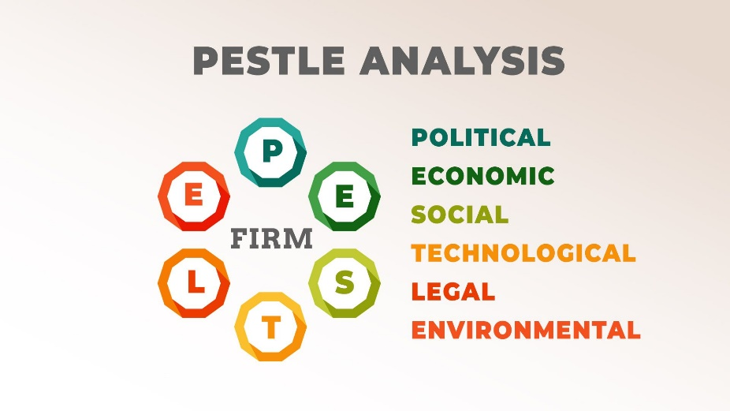
Figure 2: PESTEL Analysis
Source: (Baek, et al.,2020)
Economic Factors: Some of the economic factors comprises of GDP rate, market growth, fluctuations in the currencies, trade levels and employment rate. The negative impact of the economic factor was increase in the issues relating to economic stability. Whereas, on the other hand, some of the positive impact of the economic factor on Tesla PLC was decrease in the battery cost and cost of renewable energy due to the advent of covid-19 pandemic (Çitilci, and Akbalık, 2020).
Social Factors: There are certain social factors which are creating an impact on the workings of Tesla PLC. Some of the social factors are taste and preference of the customers, demographics, market trends, lifestyle and social culture. There is certain positive impact of social factors on the workings of Tesla PLC. This has led to the increase in the popularity of the products of the company and preference of the customers to choose the electric vehicles of Tesla. The negative impact is to deal with the changing demand of the customers (Friesendorf, and Uedelhoven, 2021).
Technological Factors: There are certain technological factors which creates an impact on the workings of Tesla PLC. Some of the latest technologies which are to be adapted by the company are Artificial Intelligence, Business Intelligence, Big Data Analytics, Machine Learning etc. The negative impact of the technological factor is increase in the amount of investment in technology. The positive impact of the technological factories increasing popularity of the company and enhances the business automation process.
Environmental Factors: Tesla PLC tries to comply with all the environmental regulations. Some of these regulations are Environmental Protection Act, Air Pollution Act, Sustainability Policies etc. The positive impact of the environment to factories to adapt with the climatic changes. These factors help the company to implement proper waste management programs and to expand its existing business activities (Han, et al., 2021).
Legal Factors: For conducting the business activities in UK, there are certain legal factors which are followed by Tesla PLC. These legal regulations include Consumer Protection Act, Health and Safety Act, Equality and Diversity Act, Human Rights etc. The positive impact of the legal factor is to expand the business activities in the international market and to encourage energy consumption regulations (Kim, et al.,2021).

SWOT Analysis
Strength: Tesla PLC uses the latest innovative technology for manufacturing electric cars. The growth and performance of the company in the competitive market is very high. The level of marketing and brand power is very high. The level of strategic partnership for conducting the business operations of the company is very impressive (KM, and KG, 2021). The company has a good brand reputation in the global market. Latest designs are used for the electric cars.
Weakness: There are a large number of manufacturing defects and problems in the electric vehicles of Tesla PLC. The financial performance of the company is weak for the last year. The production capacity of the company has been reduced. This acts as a weakness for the company.
Opportunities: There are a wide variety of growth and development opportunities in the international market (Stalevski, and Dobrosavljevi, 2020). Manufacturing of batteries in-house provides various cost benefit to Tesla Plc. A large number of government incentive opportunities are provided for expansion of the activities in the global market.
Threat: There exist a huge competition of automobiles in the global economy. The exit of UK from EU has created a reduction in the demand of the product of the company. There are a large number of substitute products which are available in the market.

Porter’s Five Force Model
Porter's Five Force Model helps in analysing the competitive position of Tesla PLC in the global environment (Radic, et al.,2020). This is a strategic management tool which helps the company in understanding the impact of external factors on the company and the competitive landscape of the automobile industry. The following assumptions have been obtained from the porter's five force model. These are listed as follows.
1. The level of competitive rivalry in the global market is high.
2. The power of the buyers to bargain is moderate (Stalevski, and Dobrosavljevi, 2020).
3. The suppliers to bargain in the market is moderate.
4. The threats associated with substitute products are medium.
5. The threats of new entrants in the automobile industry is low.

Value Chain Analysis
Support activities: The support activities comprise of inbound logistics, outbound logistics, services operations and marketing and sales.
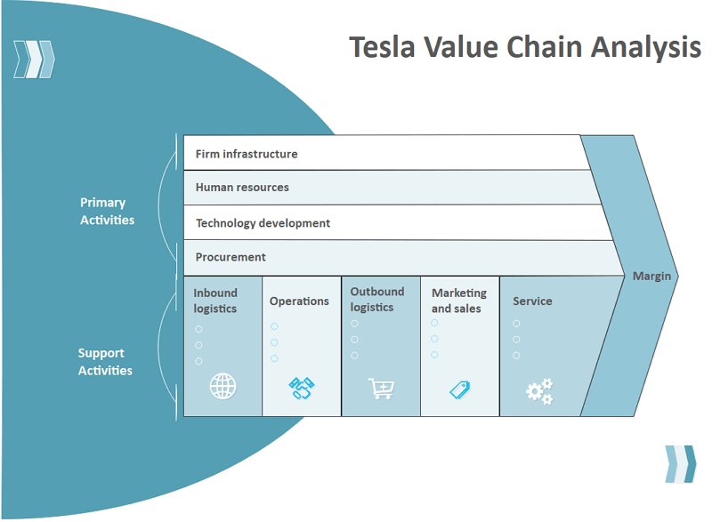
Figure 3: Value Chain Analysis of Tesla Plc
Source: (Morrison, 2020)
Primary Activities: The primary activities mainly include firm infrastructure, procurement, technology development and human resources. Infrastructure meaning comprises of legal matters, financial planning, strategic management and quality management. Talented workforce is appointed within the organisation. huge volume of finance is invested in research and development activities. Maintaining inventory and procuring inventory are the lifeline of Tesla is manufacturing process.

Reasons for engaging in international trade
Tesla Plc conduct its activities in the global environment. There are a large number of reasons due to which the company is emphasizing on international trade.
1. One of the most vital reason is to earn maximum profit. The company is involved in import and export activities in international trade. This increases the chances of sale of the automobiles in the international market (KM, and KG, 2021).
2. Moreover, cheap resources are available in the international market. This helps Tesla Plc to manufacture automobiles at a reduced cost. Reduction in the cost of production increases the profit margin for the company.
3. Conducting the activities in the international market helps in long-term survival of the company. International trade or global business provides a lot of scope to the company to expand its activities and to increase its existing customers.
4. Conducting activities in the international market helps to make the best use of technology and human resources (Kretschmar, 2020). Due to these reasons, Tesla Plc is engaging in international trade activities and global activities.

Competitive advantage concerning the core values of sustainability
Tesla PLC enjoys certain competitive advantages at the time of conducting its operations in the Global Business Environment.
1. These competitive advantages are in terms of good brand reputation, effective pricing strategy, highly skilled labor, unique geographical location and assets (Matovic, 2020).
2. These competitive advantage strategies have helped Tesla PLC to promote sustainability and to promote saving of energy.
3. Competitive advantage helps the company to gain more customers and to improve brand loyalty.
4. Competitive advantages help the company to distinguish itself from its competitors. These advantages contribute to the growth and development of the company in the automobile industry.
5. All the competitive advantages aim at providing sustainable value to the organisation. The main reason for competitive advantage is to provide maximum protection to the environment and to encourage the message of saving energy (Morrison, 2020).

Analysis of the Market
1. Micro-economic Foundation: The internal behavior of Tesla PLC in the automobile industry can be analysed with the help of microeconomics foundation. It is observed that, the reputation of the brand in the automobile industry is very high. The company is engaged in using the latest technologies for manufacturing electric vehicles (Radic, et al.,2020).
2. Macroeconomic Foundations: The legal procedures of Tesla PLC for conducting its automobile operations are included in the macroeconomic foundation. There are certain rules and regulations which are to be followed for conducting the operations in the international market.
3. Market structures and their influence on firm strategy: More than 60% of the market share in the automobile sector is under the control of Tesla PLC. The use of latest technology in the production activities contribute to the success of the company (Rao, 2021).
4. Changes in the long run: There are certain changes which are implemented by Tesla PLC for conducting its operations in the long run. These changes are implementation of modern business model, sustainable policies, robotics etc.
5. Changes in the short run: The short run changes which are taking place in Tesla PLC are change in the organisational culture (Stalevski, and Dobrosavljevi, 2020).
6. Characteristics of International economy: There are certain characteristics of conducting business in the international economy. These are growth opportunities, universal process, continuity, development opportunities, use of latest technology, easy availability of raw materials and cheap labor.

Conclusion
From this report, it can be concluded that, there are certain reasons behind conducting the business activities in the international market. Tesla PLC is able to increase its profit level and enhance its existing customer base after expanding its activities in the Global Business Environment. Different Business models have been used in order to analyse the international environment. These models are Porter's Diamond, Porters Five Force Model and Value Network Analysis. Proper market analysis has been provided for considering the microeconomic foundations and macroeconomic foundations. The international marketing strategy and market structure of Tesla PLC have been explained.

References
Baek, S., Mohanty, S.K. and Glambosky, M., (2020). COVID-19 and stock market volatility: An industry level analysis. Finance Research Letters, 37, p.101748.
Çitilci, T. and Akbalık, M., (2020). The Importance of PESTEL Analysis for Environmental Scanning Process. In Handbook of Research on Decision-Making Techniques in Financial Marketing (pp. 336-357). IGI Global.
Friesendorf, C. and Uedelhoven, L., (2021). Digital Transformation of Global Mobility Markets. In Mobility in Germany (pp. 1-9). Springer, Cham.
Han, K., Luo, J., Chen, J., Chen, B., Xu, L., Feng, Y., Tang, W. and Wang, Z.L., (2021). Self-powered ammonia synthesis under ambient conditions via N 2 discharge driven by Tesla turbine triboelectric nanogenerators. Microsystems & Nanoengineering, 7(1), pp.1-8.
Kim, S., Connerton, T.P. and Park, C., (2021). Exploring the impact of technological disruptions in the automotive retail: A futures studies and systems thinking approach based on causal layered analysis and causal loop diagram. Technological Forecasting and Social Change, 172, p.121024.
KM, K.R. and KG, N.K., (2021). Impact of Covid-19 Pandemic in the Automobile Industry: A Case Study. International Journal of Case Studies in Business, IT and Education (IJCSBE), 5(1), pp.36-49.
Kretschmar, D.K.M., (2020). A Synoptic View on Organizational Change Theories applied on Current Developments in the Automotive Industry. ACADEMIC JOURNAL, p.24.
Matovic, I.M., (2020). PESTEL Analysis of External Environment as a Success Factor of Startup Business. ConScienS, p.96.
Morrison, J., (2020). The Global Business Environment: Toward Sustainability?. Red Globe Press.
Radic, N., Radic, V. and Stevanovic, M., (2020). Economy Impact of the Coronavirus Pandemic on the Automobile Industry. Oditor, p.55.
Rao, S., (2021). International Business Environment. Himalaya Publishing House.
Stalevski, T. and Dobrosavljevi, A., (2020). CONTROL SYSTEM OF THE TESLA ACCELERATOR INSTALLATION.
Wu, X., Zhang, C. and Du, W., (2021), July. An analysis on the crisis of “chips shortage” in automobile industry——Based on the double influence of COVID-19 and trade friction. In Journal of Physics: Conference Series (Vol. 1971, No. 1, p. 012100). IOP Publishing.
Zámborský, P., (2020). A blueprint for succeeding despite uncertain global markets. Journal of Business Strategy.
Zulkifli, N.A., Yazid, M.F.M. and Shamsudin, M.F., (2020). How will the market players in the automotive industry strengthen their market positioning during the pandemic Covid-19 outbreak and recession. Journal of Postgraduate Current Business Research, 1(1).

