Programme: BA (Hons) Business Management
Module: Project Management
Module code: LCBB6006
Assignment Title: Component 1: Coursework: Essay
Project Plan for Launching an E-commerce Website for a Sustainable Clothing Brand in the UK
Student ID – 2125547
Student name: Nicoleta Carp
Table of Contents
1. Introduction 2
2. Project Aim, Objectives and Scope 3
3. Project Management Methodology 4
4. Project Outputs (Deliverables and Milestones) 6
5. Activities and Work Breakdown Structure (WBS) 8
6. Activities, Milestones and Project Timeline 9
7. Resource Planning and Allocation. 11
8. Management of Stakeholder Analysis and Communication. 12
9. Risk Management 14
10. Conclusion and Recommendations 16
References 17

1. Introduction
The UK retail sector has undergone a re-examination due to the swift development of e-commerce that has opened considerable possibilities to the sustainable fashion brands to connect with the environmentally-conscious consumer via online platforms. Online retail is a big part of overall retail sales, and the UK is one of the best e-commerce markets in Europe, and growing environmentally consciously increases the demand for ethically produced and sustainable clothing (Office for National Statistics, 2025; Statista, 2025). Meanwhile, the growing pressure on the fashion industry to reduce textile waste, carbon emissions and resource use, and more makes sustainable business models key to long-term competitiveness (WRAP, 2024; Ellen MacArthur Foundation, 2023). Therefore, the establishment of an online shopping platform is a business proposal as well as a sustainability program. To implement such a project within the agreed scope, budget, schedule and quality standards, project management is necessary to plan the delivery systematically, manage resources, involve stakeholders and control risks (PMI, 2021). This report prepares a detailed project plan based on the recognised project management tools and methodologies.
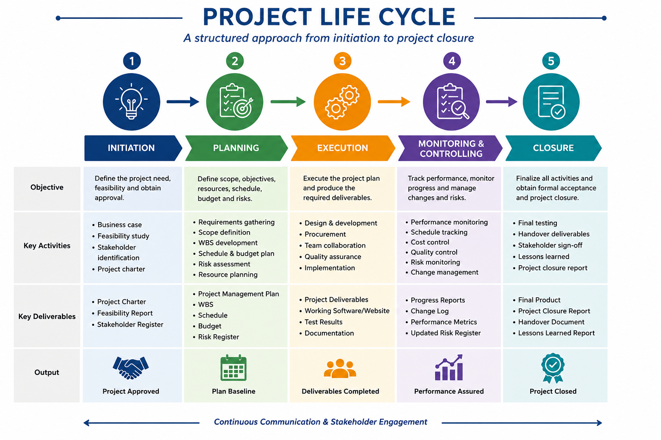
Figure 1: Project Life Cycle
Source: adapted from PMI (2021).

2. Project Aim, Objectives and Scope
The project will strive to establish and introduce a safe, convenient and sustainable online shop site to a UK based sustainable fashion brand in half a year and enhance the digital footprint, consumer experience and competitiveness at an equal balance of scope, time, cost and quality.
Objective | SMART Element
Develop a fully responsive e-commerce website within 24 weeks. | Specific, Measurable, Time-bound
Integrate secure payment gateways, inventory management and customer account functionality before project completion. | Specific, Achievable
Upload at least 300 sustainable clothing products before the website launch. | Measurable
Achieve 100% successful User Acceptance Testing (UAT) before deployment. | Measurable, Relevant
Launch the website within the approved project budget of £80,000 while meeting all agreed quality requirements. | Achievable, Relevant, Time-bound
Table 1: SMART objectives developed following the SMART framework (Doran, 1981).
In Scope | Out of Scope
Website planning and design | Physical retail store
UI/UX design | Mobile application
Website development | International expansion
Product catalogue | Marketplace integration
Shopping cart and checkout | Franchise development
Payment gateway | Clothing manufacturing
Inventory integration | International logistics
Customer registration | Long-term maintenance
Website testing | AI personalisation
SEO and website launch | Non-clothing expansion
Table 2: Scope Statement for the proposed e-commerce project.

3. Project Management Methodology
To plan, use resources effectively, communicate, and manage risks, it is necessary to choose a proper project management methodology. In the case of the proposed e-commerce site, a Hybrid Project Management style is the best choice due to its integration of a structured governance of Waterfall and a flexible approach of Agile (PMI, 2021). Waterfall helps to initiate the project, plan and implement it with the help of documentation and approvals, whereas Agile Scrum allows developing iteratively, receiving feedback repeatedly, and adapting quickly to the new customer needs (Kerzner, 2022; Schwaber and Sutherland, 2020). Therefore, the hybrid approach improves quality, stakeholder involvement and project success and retains control of scope, schedule and budget (Nicholas and Steyn, 2021).
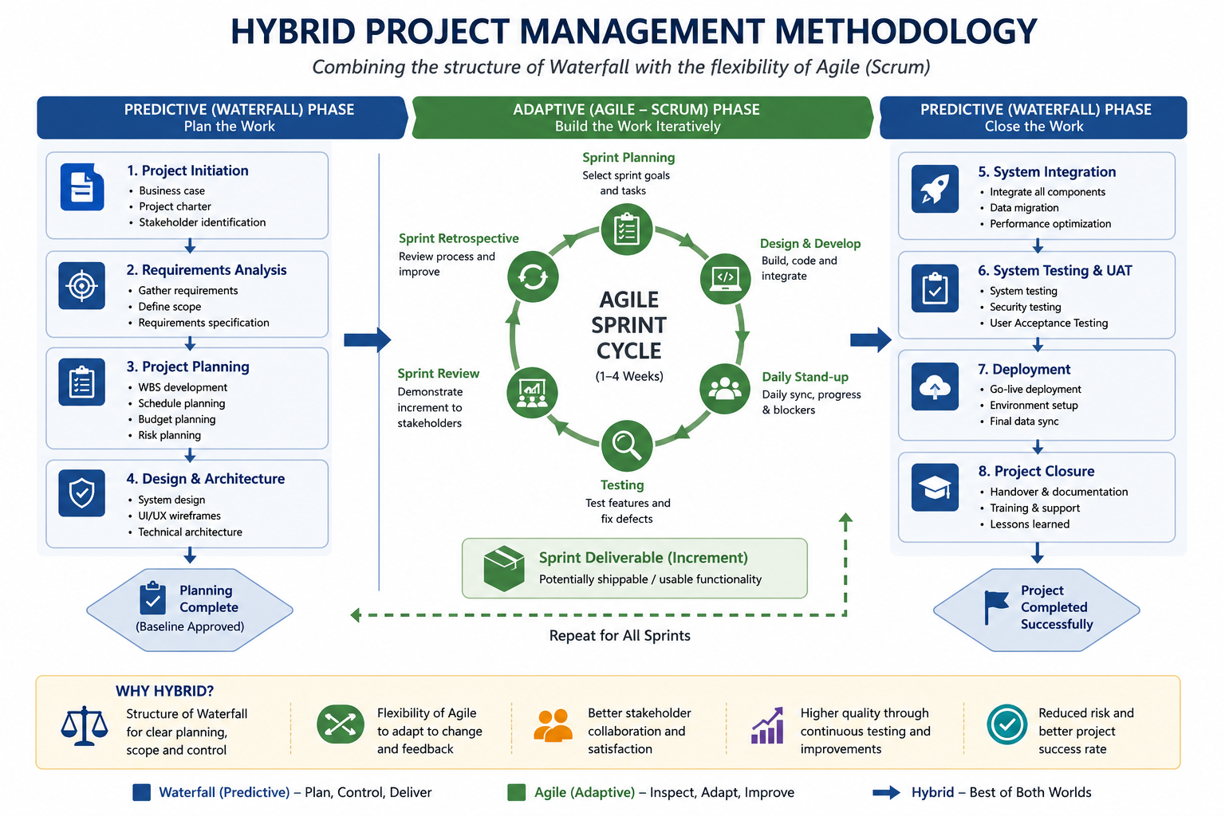
Figure 2: Hybrid project management methodology diagram
Source: Adapted from PMI (2021) and Schwaber and Sutherland (2020).
Criteria | Waterfall | Agile (Scrum) | Hybrid (Selected)
Planning | Comprehensive upfront planning | Incremental planning | Combination of both
Flexibility | Low | High | Moderate to High
Stakeholder Involvement | Limited after planning | Continuous | Continuous during development
Documentation | Extensive | Moderate | Balanced
Change Management | Difficult | Easy | Controlled flexibility
Risk Management | Risks identified early but difficult to adjust | Risks managed iteratively | Continuous monitoring with structured governance
Suitability for this Project | Moderate | High | Very High
Table 3: Comparison of Waterfall, Agile and Hybrid Methodologies

4. Project Outputs (Deliverables and Milestones)
Project deliverables are the quantifiable products realised in the duration of the project life cycle to realise the goals of the project. Project Management Institute (PMI, 2021) defines deliverables as distinct, verifiable products or services that cannot be approved without meeting predetermined acceptance standards. For the proposed e-commerce website project, deliverables are organised across each project phase, with associated milestones to ensure quality and effective decision-making. The use of this system of approach enhances the scope control, promotes quality assurance and minimises rework. Moreover, specific deliverables help track the performance and implement change, reduce scope creep, and lead to the successful deployment of the sustainable fashion e-commerce platform (Kerzner, 2022; Nicholas and Steyn, 2021).
Project Phase | Deliverable | Description | Acceptance Criteria | Milestone
Initiation | Project Charter | Formal project authorisation | Approved and signed by project sponsor | Project Approved
Planning | Project Management Plan | Scope, schedule, budget, quality and communication plans completed | Sponsor approval obtained | Planning Complete
Planning | Requirements Specification | Functional and non-functional requirements documented | Stakeholder approval received | Requirements Approved
Design | UI/UX Prototype | Wireframes and interface designs completed | Approved by client and users | Design Sign-off
Development | Front-end Website | Responsive customer interface developed | Passes functional testing | Front-end Complete
Development | Back-end System | Database, product management and business logic completed | Successfully integrated | Back-end Complete
Development | Payment Gateway Integration | Secure online payment functionality | Successful payment transactions tested | Payment Approved
Development | Inventory Management Integration | Stock management system integrated | Real-time inventory updates verified | Inventory Operational
Testing | Functional Testing Report | Website functionality validated | All critical defects resolved | Functional Testing Complete
Testing | Security Testing Report | Vulnerability and penetration testing completed | No critical security vulnerabilities identified | Security Approved
Testing | User Acceptance Testing (UAT) Report | End-user validation completed | Client formally accepts system | UAT Sign-off
Deployment | Live E-commerce Website | Website deployed to production server | Successfully accessible to users | Website Go-Live
Closure | User Training Manual | Operational guide for administrators | Client approval received | Training Complete
Closure | Project Closure Report | Final project evaluation and lessons learned documented | Sponsor approval received | Project Closed
Table 4: Project Deliverables Register developed following PMI (2021).
Milestone | Expected Completion
Project Approval | Week 1
Requirements Sign-off | Week 3
Website Design Approved | Week 6
Website Development Completed | Week 16
System Testing Completed | Week 20
User Acceptance Testing Approved | Week 22
Website Go-Live | Week 23
Project Closure | Week 24
Table 5: Major milestones for the proposed project.

5. Activities and Work Breakdown Structure (WBS)
Work Breakdown Structure (WBS) is a hierarchical breakdown of project scope to manageable work packages to plan, monitor and control (PMI, 2021). In this project of e-commerce site, eight phases structure activities and deliverables, enhance responsibility distribution, cost analysis, stakeholder communication and integrated scope, schedule, resource and quality management (Kerzner, 2022; PMI, 2021).
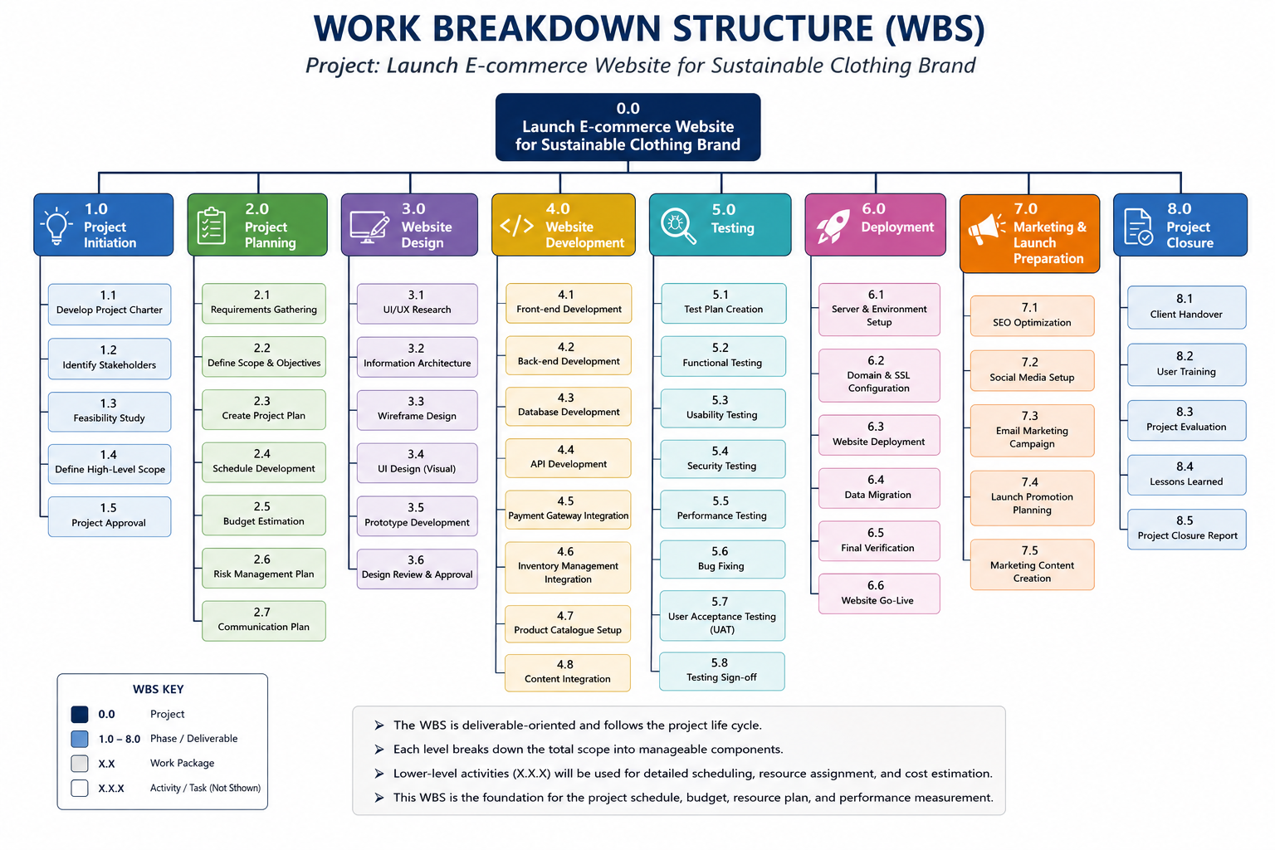

Figure 3: Work Breakdown Structure for the proposed project
Source: (adapted from PMI, 2021).

6. Activities, Milestones and Project Timeline
A realistic project schedule makes sure that the activities are done within the approved period of time with quality and effective resource utilisation. Project Management Institute (PMI, 2021) defines scheduling as sequencing tasks, estimating durations, determining dependencies and creating milestones to oversee the project successfully. The designed e-commerce site will be completed in a 24 week period with smooth flow between the implementation and launch phases. The main milestones, such as project approval, design sign-off, testing and web site launch, allow ongoing progress tracking and timely corrective measures, aid efficient schedule management and successful project delivery (Kerzner, 2022).
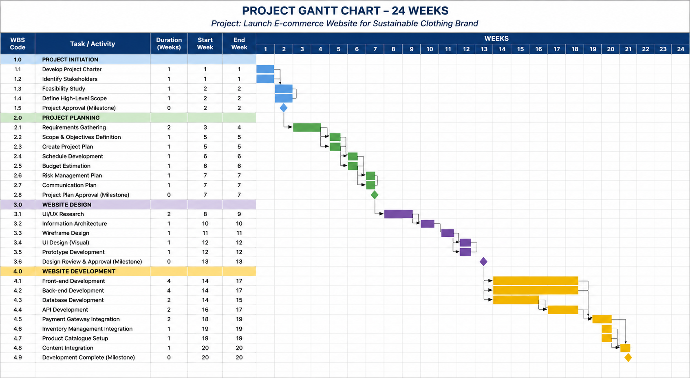
Figure 4: Gantt chart illustrating the proposed 24-week project schedule.
Source: (Self-developed)
Milestone | Target Week | Purpose
Project Approval | Week 1 | Formal project authorisation
Requirements Approved | Week 4 | Scope confirmed
Design Sign-off | Week 7 | Development authorised
Development Completed | Week 17 | Core website completed
Functional Testing Completed | Week 19 | System validated
UAT Approved | Week 21 | Client acceptance received
Website Go-Live | Week 23 | Public launch
Project Closure | Week 24 | Final handover and evaluation
Table 6: Major milestones and project control points.
Critical Path Method (CPM) determines the chain of activities which are dependent and thus determines the project completion time which is the minimum (Nicholas and Steyn, 2021). In this project, the critical path encompasses Project Charter, Requirements Gathering, Scope and Budget Planning, UI/UX Design, Prototype Development, Website Development, Database and Payment Integration, Functional Testing, Security Testing, User Acceptance Testing, Website Deployment and Project Closure. Any delays within these activities will have a direct impact on the schedule. Consequently, to reduce delays and ensure project performance, it is necessary to constantly monitor its progress, distribute resources, have a contingency plan, and formal change control (PMI, 2021; Kerzner, 2022).

7. Resource Planning and Allocation.
Resource planning is an activity that requires the identification, obtaining and distribution of the human, technological and financial resources that will be needed to effectively deliver the project. Proper utilisation of resources improves productivity, reduces conflicts and aids the project in being completed within the intended schedule and budget (PMI, 2021). The e-commerce project proposed needs well trained human resources and proper technological infrastructure to facilitate project activities effectively. Additionally, resource planning minimises risks in projects by levelling and smoothing workloads using resource levelling and smoothing. Combining resource planning with the Work Breakdown Structure (WBS) and project schedule is also beneficial in terms of cost estimation, capacity planning and the overall project governance (Kerzner, 2022).
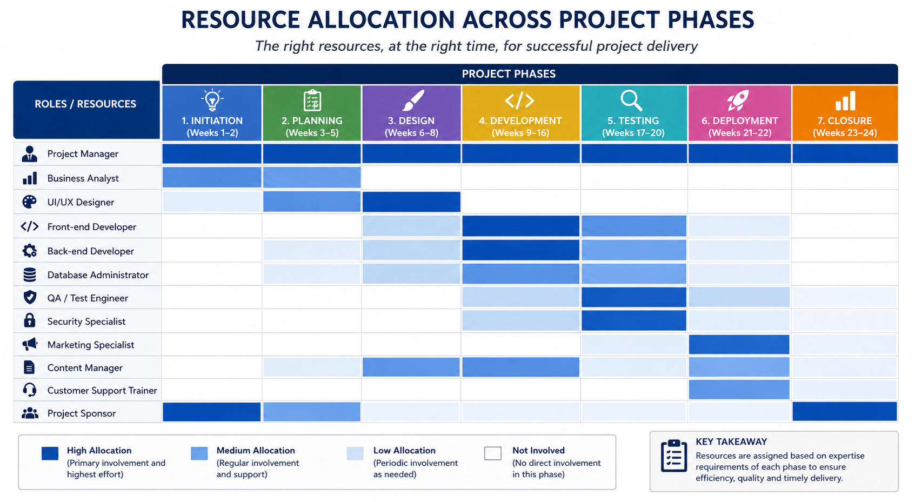
Figure 5: Allocation of key personnel across the project life cycle.
Source: (Self-developed)
Even though the quality of specialists increases when using specialist resources, overdependence on individual experts can lead to bottlenecks and riskier projects in the event that skilled employees are not available. Thus, organisational resilience and continuity in projects are enhanced by encouraging cross-functional co-operation and knowledge exchange (Nicholas and Steyn, 2021). In addition, resource levelling and resource smoothing allow to balance the workloads without postponing the project completion (PMI, 2021). Simultaneously running front end and back end development reduces delivery time and security testing must be done after functional testing to keep the rework to minimum and optimisation of resources as well as ensuring success in project delivery.

8. Management of Stakeholder Analysis and Communication.
Stakeholder management improves the success of projects by ranking the stakeholders based on their interest and influence. The Power–Interest Matrix helps to have effective communication, whereas the involvement of key decision-makers and customer engagement in UAT helps in governance, decision-making, and project outcomes (PMI, 2021; Freeman, 1984; Mendelow, 1991). .
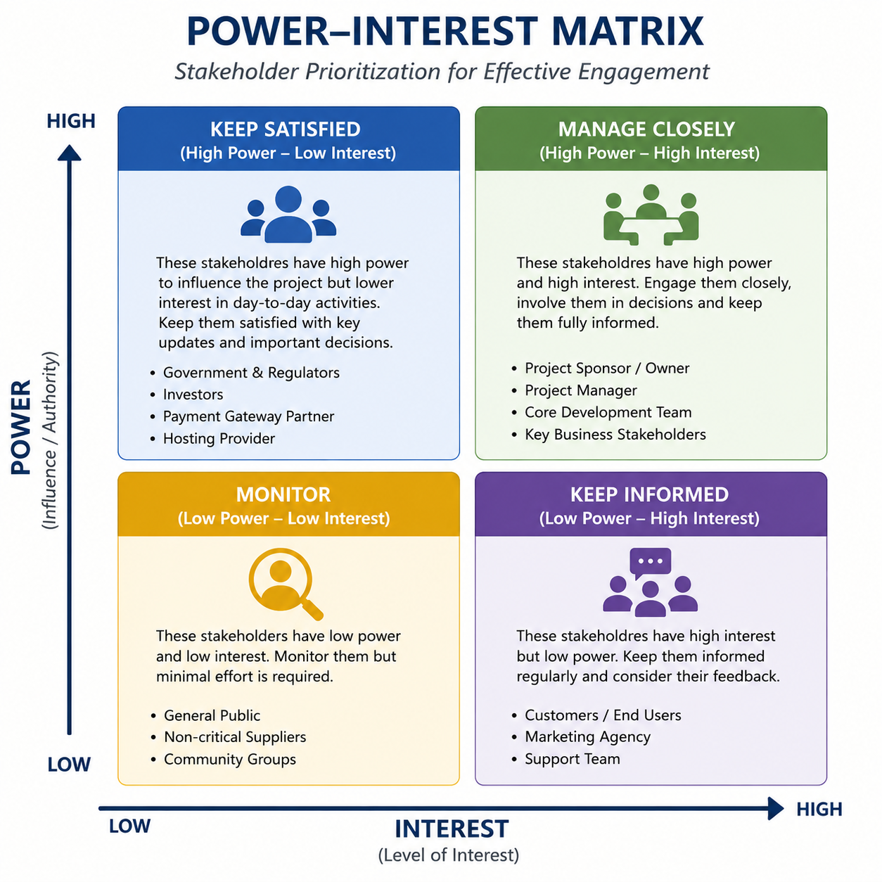
Figure 6: Stakeholder Power–Interest Matrix
Source: adapted from Mendelow (1991).
Stakeholder management and monitoring of expectations of the stakeholders in the project life cycle is more effective than communication in drawing stakeholders. Lack of engagement of key stakeholders can lead to slowed approvals, conflicting requirements and higher project risks (PMI, 2021). As an illustration, inadequate customer involvement in the interface design process can lead to expensive post-implementation changes. Similarly, a lack of good coordination with payment gateway providers or the hosting providers can postpone system integration. Thus, formal stakeholder communication improves transparency, facilitates quicker decision-making, minimises conflicts and increases the chances of successful project completion (Kerzner, 2022).

9. Risk Management
Risk management is an organised way of defining, evaluating and reacting to the unpredictable occurrences that can influence project targets. Risk management decreases the cause and effects of threats and enhances the resilience and success of projects (PMI, 2021). The proposed sustainable clothing e-commerce site will analyse risks by risk probability and risk impact with response strategies of avoidance, mitigation, transfer and acceptance. Effective governance, informed decision-making and constant monitoring by keeping a Risk Register can ensure timely corrective measures and enhance accountability throughout the project life cycle (Kerzner, 2022).
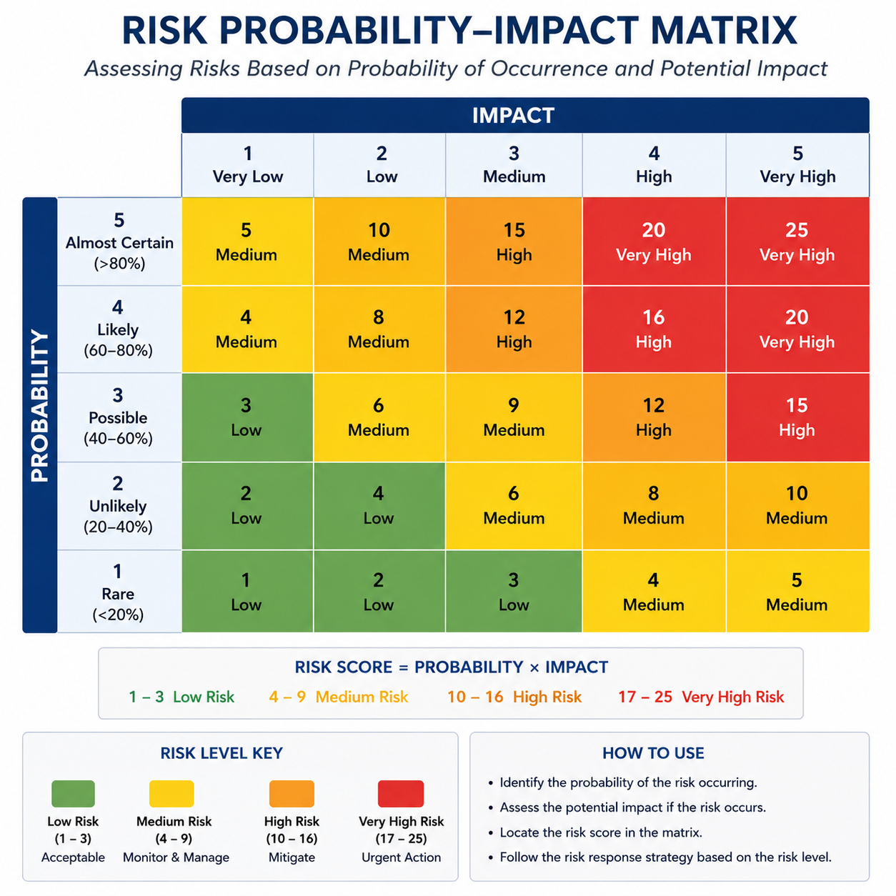
Figure 7: Probability–Impact Matrix
Source: adapted from PMI (2021).
Strategy | Application in the Project
Avoid | Prevent unnecessary scope changes through formal approval procedures.
Mitigate | Perform regular testing, progress reviews and quality assurance activities to reduce the likelihood of technical failures.
Transfer | Use third-party cloud hosting and secure payment providers to transfer operational and financial risks.
Accept | Accept low-impact risks while monitoring them through periodic project reviews and contingency planning.
Table 7: Risk response strategies.
The risk management strategy suggested encourages proactive management of the project by detecting risks at the planning phase and applying preventive actions to limit the schedule slips and cost overruns. Early security testing minimises cybersecurity risks, and formal change control can prevent scope creep, which is a frequent failure cause with software projects (Nicholas and Steyn, 2021). However, there are still uncertainties like technology breakdowns, regulatory reforms and supplier back-ups. As such, ongoing risk assessments, contingency planning and frequent updates to Risk Register enhance project resilience and increase the chances of achieving the timely, in-budget and to the necessary quality delivery of the site.

10. Conclusion and Recommendations
The proposed project plan provides a systematic model of opening an e-commerce store of a sustainable clothing brand in the UK utilising the principles and practices of project management. Effective planning, execution and control throughout the project lifecycle are supported by using the Work Breakdown Structure (WBS), project scheduling, milestone planning, resource allocation, stakeholder engagement and risk management (PMI, 2021). Moreover, a hybrid project management approach will use a combination of structured planning of the traditional methodology and the flexibility of Agile, allowing the project team to react appropriately to evolving requirements, and to continue controlling project scope, schedule and quality. Specifically stated deliverables, sound resource planning and a 24-week implementation plan have a tangible foundation on which project objectives can be met within budget and time limits. The organisational change control procedures, performance monitoring based on KPIs, UK GDPR and cybersecurity, constant stakeholder engagement, and continuous improvement with customer feedback and website analytics must be used to maximise the project success (PMI, 2021).

References
Doran, G.T. (1981) ‘There's a S.M.A.R.T. way to write management's goals and objectives’, Management Review, 70(11), pp. 35–36.
Ellen MacArthur Foundation (2023) Circular economy in fashion. Available at: https://www.ellenmacarthurfoundation.org (Accessed: 19 July 2026).
Freeman, R.E. (1984) Strategic Management: A Stakeholder Approach. Boston: Pitman.
Kerzner, H. (2022) Project Management: A Systems Approach to Planning, Scheduling, and Controlling. 13th edn. Hoboken, NJ: John Wiley & Sons.
Mendelow, A.L. (1991) ‘Stakeholder Mapping’, Proceedings of the 2nd International Conference on Information Systems. Cambridge, MA.
Nicholas, J.M. and Steyn, H. (2021) Project Management for Engineering, Business and Technology. 6th edn. New York: Routledge.
Office for National Statistics (ONS) (2025) Internet sales as a percentage of total retail sales. Newport: ONS. Available at: https://www.ons.gov.uk/businessindustryandtrade/retailindustry/timeseries/j4mc/drsi (Accessed: 17 July 2026).
Project Management Institute (PMI) (2021) A Guide to the Project Management Body of Knowledge (PMBOK® Guide). 7th edn. Newtown Square, PA: Project Management Institute.
Schwaber, K. and Sutherland, J. (2020) The Scrum Guide: The Definitive Guide to Scrum: The Rules of the Game. Scrum.org & Scrum Inc.
Statista (2025) Retail e-commerce revenue in the United Kingdom. Hamburg: Statista. Available at: https://www.statista.com/outlook/emo/ecommerce/united-kingdom/?srsltid=AfmBOop4IXsg1JTzbVdJqzNuKvapB2DADyLPgySoh738kzKcIuV_LUv1 (Accessed: 19 July 2026).
WRAP (2024) Textiles Market Situation Report. Banbury: WRAP. Available at: https://www.wrap.ngo/resources/report/textiles-market-situation-report-2024 (Accessed: 19 July 2026).

