

Assessment 1 – Reading Task Template
PART 1: Upload your photo of your A3 in-class notes here:
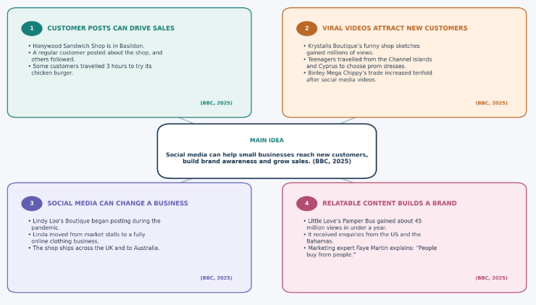

PART 2:
- What is the main idea of the whole text?
The main idea is that social media can help small companies reach more people, gain customers and boost sales. According to the article, a viral post or relatable video can sometimes affect a business's operations (BBC, 2025).
- What is one key point that supports the main idea and which specific example from the text shows this?
Firstly, customer posts can help advertise a business and generate additional sales. For instance, someone regularly wrote about the Honywood Sandwich Shop in Basildon and others later made a trip of three hours to experience its chicken burger (BBC, 2025).
- What is a different key point that supports the main idea and which specific example from the text shows this?
Another key point is that social media can change how a business operates. By building her own marketing techniques, Linda Hunter, who runs Lindy Loo's Boutique, turned her online presence into a reality during the pandemic and now runs a fully-fledged online fashion business, shipping throughout the UK and even to Australia (BBC, 2025).
- Which part of the text do you think is most important and why?
I believe the most critical element is marketing genius Faye Martin's point that “People buy from people.” It demonstrates that videos that are relatable and authentic are more likely to help customers feel connected to a business and learn about a brand than to feel like they are being marketed to (BBC, 2025).
Reflection:
- What did you find difficult in this task (including in-class components) and why was it difficult?
It was hard to select the most critical points since the article offers various case studies of companies using social media. I also had to make sure my two major points were distinct and not the same central idea.
- What helped you with this difficulty and how did it help you?
Using the mind map helped me to categorise the content in various themes and rereading the article helped to check the details. Using examples made it easier to understand without repeating the concepts (Honywood Sandwich Shop, Lindy Loo's Boutique).
Reference
BBC News (2025) If you post it, they will come: The businesses turning likes into livelihoods. Available at: https://www.bbc.co.uk/news/articles/cm2701py5npo (Accessed: 24 October 2026).

