Blow the candle on queerness: an analysis of Jesus Christ’s gender identity and sexuality, in relation to Christianity in contemporary queer art

Student Name: Iulia-Adina Hulea
Student Number: 2005277
Programme of Study: Fine Art: Studio, Site and Context (BA)
Module: ADAA6000 Independent Project
Supervisor: Alex Duncan
Word Count: 5012 (excluding title page, acknowledgements, table of contents, list of illustrations, summary of topic, author’s declaration, in-text chapter titles, in-text illustrations titles, appendix, works cited, and bibliography)

Submitted in partial fulfilment of the requirements for the degree of BA (Hons): Fine Art: Studio, Site and Context, University of Wales Trinity Saint David, Swansea (14th December 2022)

Acknowledgements

I want to express my deepest gratitude to my supervisor for his patience and understanding and, most importantly, for his input, which helped me in mapping a more polished thesis.
I am also thankful to my close friends, namely Ruxandra N., Paul P., and Wanda P., for their immense patience and enthusiasm whenever I rambled on about Jesus Christ’s metaphorical vagina.
Finally, I would want to dedicate this dissertation to my parents, whose confusion over the topic of my thesis was obvious, but never fruitless, as they bombarded me with questions that stimulated me.

Table of Contents

List of Illustrations 4

Introduction 6

Chapter I: The Sun of the Resurrection 8

Chapter II: Christ was a diligent mother 13

Chapter III: Queer hearts and queer swords 19

Conclusion 26

Appendix 27

Works Cited 29

Bibliography 30

List of Illustrations

Figure 1. da Caravaggio, M. M. (1601-2) The Incredulity of Saint Thomas [Oil on canvas]. Available at: https://en.wikipedia.org/wiki/The_Incredulity_of_Saint_Thomas_(Caravaggio) (Accessed: 14 November 2022) 5

Figure 2. Galli, G. (1630) Christ Displaying His Wounds [Oil on canvas]. Available at: https://artuk.org/discover/artworks/christ-displaying-his-wounds-129846 (Accessed: 16 November 2022) 5

Figure 3. Le Noir, J. (>1349) The Prayer Book of Bonne de Luxembourg, Duchess of Normandy [Tempera, grisaille, ink, and gold on vellum]. Available at: https://www.metmuseum.org/art/collection/search/471883 (Accessed: 20 November 2022) 8

Figure 4. Unknown, (1214-70) Bible moralisée, Codex 1179 [Manuscript book on parchment]. Available at: https://digital.onb.ac.at/RepViewer/viewer.faces?doc=DTL_5955097&order=1&view=SINGLE (Accessed: 21 November 2022) 9

Figure 5. Unknown, (1220-30) Bible moralisée de Vienne, Codex 2554 [Manuscript book on parchment]. Available at: https://www.facsimilefinder.com/facsimiles/bible-moralisee-facsimile (Accessed: 21 November 2022) 9

Figure 6. Le Noir, J. (>1349) The Prayer Book of Bonne de Luxembourg, Duchess of Normandy [Tempera, grisaille, ink, and gold on vellum]. Available at: https://www.metmuseum.org/art/collection/search/471883 (Accessed: 20 November 2022) 10

Figure 7. Unknown, Jesus Christ as Lady Wisdom. Available at: http://www.allanbevere.com/2016/02/the-question-of-christ-in-earliest_15.html 11

Figure 8. Unknown, Mary Magdalene’s Skull. [Gold]. Available at: https://commons.wikimedia.org/wiki/File:Mary_Magdalene%27s_skull.jpg (Accessed: 7 December 2022) 12

Figure 9. McQueen, A. (1996) Dante: Look 18. Available at: https://www.vogue.com/fashion-shows/fall-1996-ready-to-wear/alexander-mcqueen (Accessed: 8 December 2022) 13

Figure 10. McQueen, A. (1996) Dante: Look 71. Available at: https://www.vogue.com/fashion-shows/fall-1996-ready-to-wear/alexander-mcqueen (Accessed: 8 December 2022) 14

Figure 11. McQueen, A. (1996) Dante: Look 8. Available at: https://www.vogue.com/fashion-shows/fall-1996-ready-to-wear/alexander-mcqueen (Accessed: 8 December 2022) 14

Figure 12. McQueen, A. (1996) Dante: Look 1. Available at: https://www.vogue.com/fashion-shows/fall-1996-ready-to-wear/alexander-mcqueen (Accessed: 8 December 2022) 15

Figure 13. Commoy, P. and Blanchard, G. (1995) Sainte Marie Mac Killop (Kylie Minogue) [Mixed media]. Available at: https://www.artsy.net/artwork/pierre-et-gilles-sainte-marie-mac-killop-kylie-minogue (Accessed: 9 December 2022) 15

Figure 14. Boskovich, J. (1997) Untitled (Fireplace Screen) [Iron place screen, fireplace tools, vinyl text]. Available at: https://www.davidlewisgallery.com/exhibitions/john-boskovich (Accessed: 10 December 2022) 16

Author’s Declaration: I declare that all the material debated in this thesis is my own work.

Introduction

Christianity has always existed as a polarised notion, generating solace as it does turmoil, and its opulent aesthetics and principles of love continue to elicit wonder within the contemporary world.
This thesis examines religiously prohibited notions and connects them to contemporary views of queerness and religion in order to illustrate and establish their durability as interrelated ideologies. The relationship between Christianity’s set of values and concepts like sexuality, fetishism, and queerness may appear limited or non-existent at first glance, but deeper research reveals that this is not the case. Despite its archaic principles, the Holy Bible contains a significant amount of circumstances in which the exact sexual orientation and gender identity of Jesus Christ can be questioned. By refusing to acknowledge this fact, the humanity he so much fought for is completely denied; “The more that Jesus the Christ was Hellenised, ontologised, spiritualised, depoliticised and ecclesialised, the more the human person, Jesus, was neutered” (Goss, 1993, p. 64)
The first chapter discusses the fetishistic and hedonistic approaches of two Renaissance artists regarding the sexualisation of Jesus Christ and the symbolism of his yonic wound in relation to the act of penetration through a non-genital opening, with references to Judith Butler, James Elkins, Sianne Ngai, and others.
The second chapter focuses on demonstrating Christ’s connection to womanhood and non-binarity through an analysis of several pieces of Medieval media, including illustrations from Books of Prayer and icons. Writers such as Karma Lochrie, Marguerite d’Oingt, and Mark D. Jordan are mentioned.
The last chapter incorporates the ideas presented in the previous chapters into contemporary equivalents, presenting three diverse works of art made with religion in mind by queer artists as focal points. The motivation for the creation of queer and religious art is briefly debated. In this chapter, the emphasis is on Luce Irigaray’s theories.
As a queer, Christian-Orthodox person, I used to assume that to be an ideal Christian, I needed to immerse myself in abstinence and repentance, and have a continual urge to place myself above others – to demonstrate to God, in his voyeuristic presence, that I am frightened of his wrath. As a result, religious trauma, Christian symbolism, and the opposing idea of occultism all have a strong impact on my practice. As the foundation for my thesis proposal essay from last year, what I address in my physical work expanded into an exploration of Christ’s multifaceted life. This exploration sparked a variety of concepts that I wanted to explore further, many of which turned into the primary points of my thesis.
Before I begin, I want to clarify that the subject of my thesis was not chosen to generate shock, but rather to provide a safe environment for people to ask questions about divinity that they might not feel necessary to ask every day. “I’ve often thought of a female Christ,” Eileen Myles wrote in her novel “Cool for You” (2000, p. 25), and this particular quote prompted comprehensive research that will assist in asking more questions regarding the church’s need for oppression.

Chapter I: The Sun of the Resurrection

And after eight days again his disciples were within, and Thomas with them. Jesus cometh […]. Then he saith to Thomas: Put in thy finger hither, and see my hands; and bring hither thy hand, and put it into my side; and be not faithless, but believing.
(John, 20:26-27)
The Resurrection of Jesus Christ is an intriguing story set within the scriptures of the Christian Holy Bible, so the subject of this story became a prevalent theme present throughout the Bible’s visual depictions and intertwined with the history of art. Developed from the Scripture, inside this allegory of rebirth, was the new motif of inserting one’s finger into Christ’s side wound. The contrast between this motif – a carnally motivated gesture – and Divine Love is a key idea to investigate in this first chapter.
Divine Love is preached within Christianity and it claims that God is love and that this love is warm and endless, albeit conditional. Divine Love was founded on principles that correspond with the Biblical ideal of purity, it therefore cannot be associated with concepts that contradict this purity, such as sexuality and fetish, which defy the expectation that a person should not partake in sexual activities. Throughout history, the idealised Christian portrays themself as “sexually virtuous and their enemies as sexually degenerate. [so] a ‘Christian’ became someone who exhibits sexual self-mastery” (Knust, 2006, p. 10).
The Bible tells us that Jesus was sent to Earth by God as his representative and son, thereby living as an embodiment of Divine Love itself, although his existence defies its principles. The yonic shape of the wound that remained on his side piqued the interest of artists, allowing them to approach the issue in a way that correlates with the contemporary definition of erotic fetishism (defined as a sexual fixation with either non-living things or non-genital bodily parts). This made it simpler to deny the actuality of Christ’s sexuality while sexualizing his body; he still represents an epitome of domineering masculinity, but the way he is seen by others is contingent on how they perceive his body as it exists within space. Judith Butler (2004, p. 21) argues that our bodies are never truly ours because of their public existence, which also applies in the case of Christ:
The body implies mortality, vulnerability, agency: the skin and the flesh expose us to the gaze of others but also to touch and to violence. […] the very bodies for which we struggle are not quite ever only our own. The body has its invariably public dimension; constituted as a social phenomenon in the public sphere, my body is and is not mine.
The fascination with the wounds of Christ may also stem from the need to fulfil the abnormal curiosity of how the insides of a person would feel in the context of either sexual or non-sexual penetration through a non-genital opening, a curiosity that is difficult to attain because of the disgust it induces, even though this disgust “both includes and attacks the very opposition between itself and desire” (Ngai, 2005, p. 335). Therefore, the recurring action of putting one’s finger into Jesus’s open wound can be defined as an antithesis to the characteristics of Divine Love, since it is imbued with religious and erotic fetishism, thus encouraging a sexualised experience.
This specific motif is either present or hinted at throughout religious artworks spanning from Renaissance to Baroque, including pieces such as Verrocchio’s “Christ and St. Thomas” (1467-83), Titian’s “The Entombment” (1526), Caravaggio’s “The Incredulity of Saint Thomas” (1601-2) and Galli’s “Christ Displaying His Wounds” (1630), of which the last two we will be looking at in detail within the context of the rejection of Divine Love’s sexual purity.

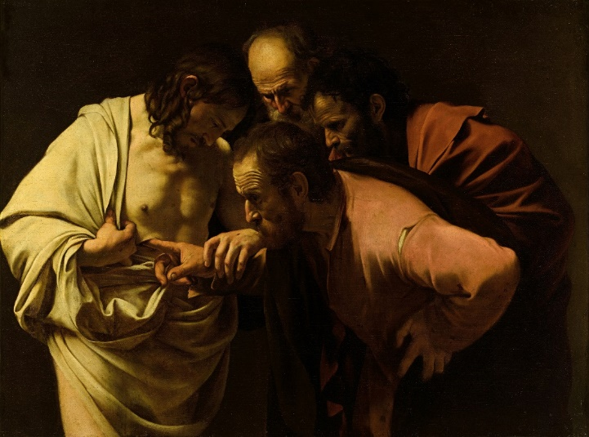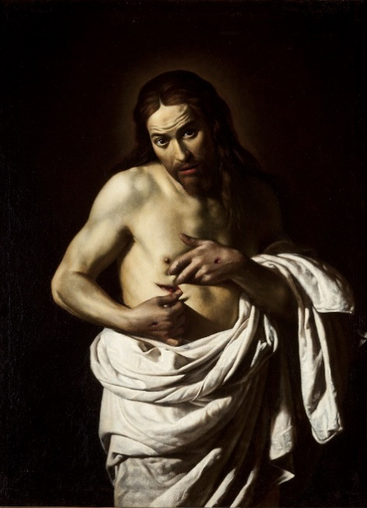
Figure 1. The Incredulity of Saint Thomas Figure 2. Christ Displaying His Wounds
In Figure 1 and Figure 2, Caravaggio and Galli take inspiration from a story told in the Gospel of John in which Thomas the Apostle doubted Christ’s resurrection until he saw – and felt – his wounds. Both paint intimate works of art, a certain tension permeating their surfaces.
Figure 1 depicts Jesus and the Apostles gathered together, but he and Thomas are closer to the viewer’s eyes. The light streams into the painting from the left, casting a warm sheen on Jesus’s skin. The absence of divine symbols, such as nimbuses, is significant because it emphasises equality in God’s eyes while not negating Christ’s corporeality. Caravaggio’s attention to detail contributes to the appearance of a distinction between the divine and the non-divine: the burial shroud of Jesus is a virginal, untainted white, while the Apostles wear colourful, tattered clothes. Dirt is visible on Thomas’s fingernails, pushing further the idea of contamination of Christ’s body.
Caravaggio’s depiction of the wound and Thomas’s probing finger is particularly explicit: Thomas inserts a finger deep inside the cut, unlike many earlier Italian versions of the subject in which this contact is less invasive.
(Benay, 2014, p. 61)
Jesus’s distress – caused by Thomas’s touch or its circumstance – is palpable as he tries to pry his finger away after guiding it in. This scene has a forbidden, intrinsically unnatural quality to it, which is underlined by the fact that, rather than just having Thomas be the witness to his examination, we also have Peter and John sitting behind him, acting more as voyeurs than participants. Thomas (in the words of Barbara Kruger (1981)) constructed an intricate ritual that allowed him to touch the skin of another man and sexualised Jesus’s body in the process.
By comparison, Figure 2 is equally intense. The light source is invisible on the pitch-black background, giving Christ’s skin an ethereal glow and creating a nimbus behind his head. The shadows beneath his wide, dark gaze and the redness of his lips, the same nuance as the red of his wounds, are also details that constructed an idealised, divine quality; Galli encourages the viewing of Christ only as a divine entity, imposing a difference between him and the viewer.
The resurrected body of Jesus is not just Jesus’ body back again. Despite the testimony of the wounds, it is a different body. It is, for example, a body that can live while being unnaturally opened.
(Alcoff, 2011, p. 53)
Galli’s Jesus looks more surprised than uncomfortable and, unlike Caravaggio’s representation, there is no actual penetration of the wound. He is holding a piece of his robe aside, spreading his wound with both hands, his expression on the verge of confrontational. The flesh parts willingly while his fingers press hard into it, creating more space for the hand of another person to reach towards it, to touch. Even though there is indeed no touch by a third party, the action of Christ can still be linked to the prohibited, intrinsically unnatural characteristic mentioned earlier because it was not self-motivated.
Both paintings are “hungry paintings” (Elkins, 2001, p. 156), effectively drawing you into their atmosphere. However, what represents the biggest contrast between Caravaggio’s and Galli’s approaches of the same Biblical story is the way the viewer is integrated into the visual story itself. In Figure 1, the viewer is a simple witness to a scene that is beneath their power to affect, put in a voyeuristic position of distanced looking. Whereas in Figure 2, the viewer is brought into the scene, directly engaging Christ in the role of doubting Thomas, with Christ challenging their scepticism.
The implication that one of Jesus’s mortal wounds is similar to a genital organ that symbolises both life and sexuality is what sets apart these artworks depicting the tale of Thomas’s incredulity from others that are also based on Biblical scenes, thus proving their rejection of Divine Love through the sexualisation of Christ’s body. The sexual motif can be categorised as homoeroticism, with the implication that two males are erotically vulnerable with each other. However, unlike sexual penetration, the gesture of touching and inserting one’s finger into Jesus’s side wound, no matter how intimate and erotic, cannot bring pleasure, a characteristic that further adds to the rejection of Divine Love because it does not preach mutual love and respect between the participating individuals.
Jesus Christ had his own body as proof of existence, whereas God existed through him and other beings. It can be concluded that this corporeality in itself was a motivator for the curiosity of the artists that took inspiration from Christianity and its aesthetics, since it would be easier to imagine him as a body first and divinity second. The sexualisation of the body of Christ brought with itself the freedom of seeing him as a human – with flaws and desires – and created a sizeable ground for the reinterpretation of Christ’s exact sexuality and gender placement in the order of the world.

Chapter II: Christ Was a Diligent Mother

And you, Jesus, are you not also a mother? […] Truly, Lord, you are a mother; for both they who are in labour and they who are brought forth are accepted by you. […] Mother, know again your dead son, both by the sign of your cross and the voice of his confession.
(Anselm, 1973, pp. 152-6)
A surprising idea that came out of Medieval media, dating from the 1100s to the 1400s, is Jesus Christ as an embodiment of the two genders – masculine and feminine – and even as a combination of the two or neither, effectively falling into the non-binary and gender nonconforming spectrums.
The Holy Bible has instances of Jesus identifying with feminine beings. In the New Testament, for example, he cried over Jerusalem and compared himself to a mother hen gathering her chicks (Luke, 13:34). There are also accounts that he connected with Lady Wisdom (Hagia Sophia), speaking through her when people criticised his actions (Luke, 7:35). Paul (1:24) also refers to Jesus as “the wisdom of God”, and all these passages suggest that people recognised and cherished Jesus’s connection to womanhood, not only the one to manhood and divinity. Therefore, Christ rejected the gender binary by embracing traits from both genders into his body. According to Judith Butler (1990, p. 9), gender and sex are separate constructs; it is possible to reject gender binarity just by existing:
The presumption of a binary gender system implicitly retains the belief in a mimetic relation of gender to sex whereby gender mirrors sex or is otherwise restricted by it. When the constructed status of gender is theorized as radically independent of sex, gender itself becomes a free-floating artifice, with the consequence that man and masculine might just as easily signify a female body as a male one, and woman and feminine a male body as easily as a female one.
Many unconventional depictions of Christ’s side wound can be found in Medieval art and Medieval prayer books – Books of Hours – as shown in Figure 3. We may presume that Renaissance and Baroque painters were influenced by such work before developing their perspectives on the meaning of Christ’s yonic wound. The differences in these painters’ perspectives are fascinating: for Renaissance and Baroque artists, Christ’s side wound symbolised a dubious, carnal curiosity, whereas, for Medieval artists, it was an object of devotion and a source of Divine Love.
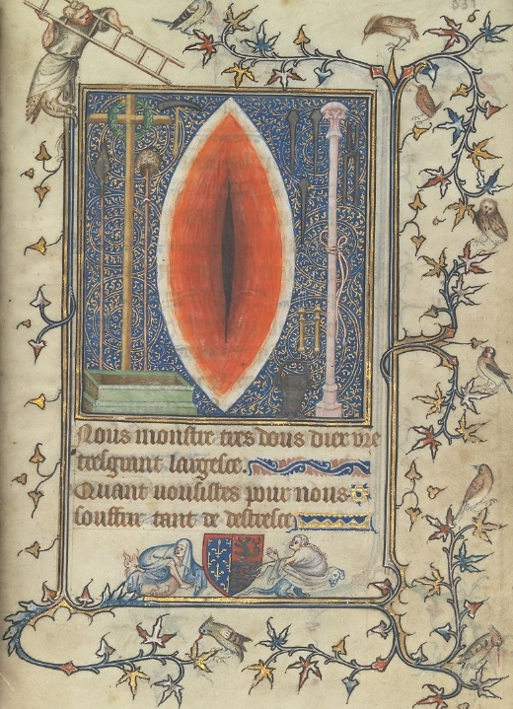
Figure 3. Miniature of Christ’s Side Wound and Instruments of the Passion

Often shown as a separate entity from Christ’s body, the wound itself was viewed as sacred even when disembodied. The mandorla shape is an instant signifier of sacredness and divinity; this also explains why the wound, which is vulvic in shape, is always positioned within it, even though it is oriented vertically. Simultaneously, the biblical context emphasises Christ’s humanity, because he bled and suffered during the Passions through this wound.
The author of this particular illustration (Figure 3) focused on viscerally evoking emotions, with the single wound serving as the only proof of Christ’s Passions. Only by fragmenting the object of suffering and depicting it as separate from the body of Christ, the viewers were able to comprehend the true anguish of his corporeality because the focus shifts to the carnality and goreness of the slit in a manner comparable to relics. The wound of Christ becomes a representation of him in his purest form as well, as a being brought into the world by the force of the Virgin Mary’s womb and Divine Love.
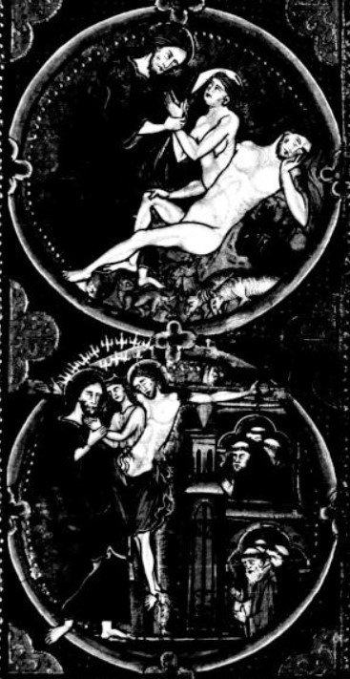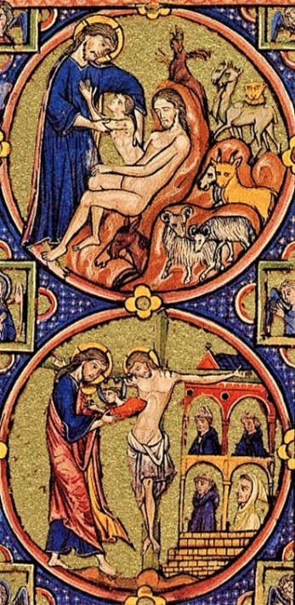
Figure 4. Codex 1179 Figure 5. Codex 2554

Feminine symbolism was frequently attributed to Christ from the wish to make him accessible to both sexes, and this represents one, if not the most, distinguishing feature of medieval devoutness.
Medieval authors do not seem to have drawn as sharp a line as we do between sexual responses and affective responses or between male and female. Throughout the Middle Ages, authors found it far easier than we seem to find it to apply characteristics stereotyped as male or female to the opposite sex.
(Bynum, 1982, p. 162)
Christ’s side wound was analogised for a vagina or a lactating breast because all three of these body parts can emit clear or white secretions and blood. The placement of the wound is close to the physical location an uterus would reside in, so Medievalists saw these aspects as an indication that Christ could fulfil the role of a mother, encouraging his non-binarity and gender nonconformity. For example, he was illustrated giving birth in various works, as can be observed in Figures 4 and 5. These Codexes show the Church’s birth through Jesus’s vagina and attest to his fertility, further feminising his body by incorporating the context of labour, menstruation, and bleeding while giving birth. Even medieval religious figures compared his Passions’ anguish to a woman’s pain after childbirth. Marguerite d’Oingt (1286, p. 33), a thirteenth-century French Carthusian nun, wrote:
Are you not my mother more than my mother? […] you, my sweet and lovely Lord, were in pain for me not just one day, but you were in labor for more than thirty years. […] But when the time approached where you had to give birth, the labor was such that your holy sweat was like drops of blood which poured out of your body and onto the ground.
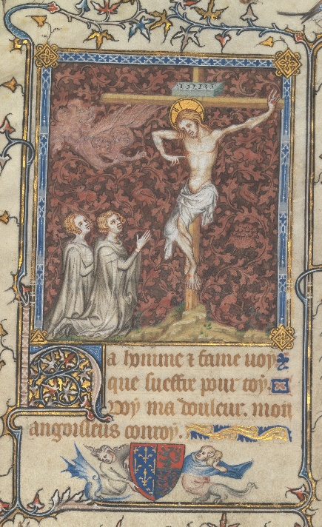
Figure 6. Detail of a miniature of the Crucifixion of Christ, with him displaying his side wound

There is also the ceremony of the Christian Eucharist, in which wine and bread, representing the blood and body of Christ, are consecrated and then consumed. Late Medieval painters associated the act of ingesting these figurative parts of Jesus’s body with his side wound as well, regarding the fleshy opening as a “fountain of eternal life” (McKinion, 2004) from which they may drink and revitalise themselves – Figure 6. It is another action that acknowledges his non-binarity and gender nonconformity; similar to a fetus developing in a mother’s womb, we are encouraged to feed off of his blood and body in order to feel revitalised and powerful, even growing to be more devout. Then, like the Church, we are born as a result of his love.
In “Feminism, Sexuality, and the Return of Religion” (2011, p. 48), Mark D. Jordan states that “Jesus, who must be the phallus, cannot have a penis – and if he once did, he may not have used it for reproduction or for deliberate pleasure”, which is congruent with how he is portrayed in most Christian art. Jordan, on the other hand, dismissed the likelihood of Jesus’s vagina existing in the form of his mortal wound. Though the reproduction aspect itself is more visual and spiritual than factual, there is no denying the fact that Christ was regarded as a sexual being even by archaic standards – because birth would be impossible without the involvement of a third party in the form of an intimate act – and also as a being who could emphatically relate to both sexes on both a spiritual and physical level.
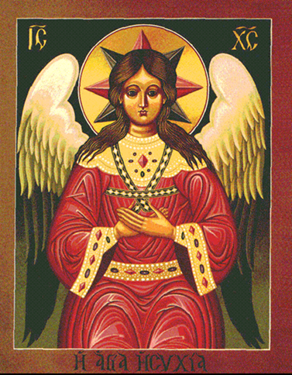
Figure 7. Jesus Christ as Lady Wisdom

Casting the context of the side wound aside, portrayals of Christ in religious art with both masculine and feminine features are exceedingly rare, though not entirely non-existent. Figure 7, which depicts Jesus as a personification of Lady Wisdom, is an intriguing example. The characters “IC XC” indicate and confirm that this is Jesus Christ. His features are considerably more feminine, placing him on the androgynous spectrum and “emphasising [his] humanity, physical access to the sacred, and the deployment of social roles to define [his] relationship to the mystic as mother, husband, lover, and child” (Lochrie, 1997, p. 187). Christ’s distinctive, blood-red robe is draped over his body, while his hair falls softly on his shoulders. His gaze is fixed on the viewer, but he is neither hostile nor uneasy, but rather inviting and understanding. He wants the viewer to ponder his existence, how feminine and masculine attributes coexist in one body, and finally admit that differentiating holy beings by gender is ludicrous, given all of the unfathomable marvels that have occurred thanks to him.
Finally, the possibility of a non-binary or gender-nonconforming Jesus Christ should not be dismissed. Rather than considering him to be an epitome of masculinity or even going as far as to argue he was, in reality, a woman – as in the debate over the proper gendered pronoun for God –, we can see Christ as an ethereal being who lived outside the imposed gendered existence. This is the first indication of his humanity: he unabashedly rejected the cultural standards of his day, and even ours, while preaching acceptance.

Chapter III: Queer Hearts and Queer Swords

If we keep on speaking the same language together, we are going to reproduce the same history. […] Listen: all round us, men and women sound just the same. The same discussions, the same arguments, the same scenes. The same attractions and separations. The same difficulties, the same impossibility of making connections. The same… Same… Always the same.
(Irigaray, 1985, p. 205)
Most contemporary and religious observers regard queerness and Christianity as diametrically opposing concepts that should never mix. The irony of this scenario was discussed in the previous two chapters, but it is crucial to note that LGBTQ+ people have never stopped creating works based on the distinctive aesthetics of Christianity.
Opulence is the term that springs to mind first when thinking of Christianity. In this context, the average individual perceives queerness to be dramatic. This establishes a common ground between two seemingly contrasting subjects because both are extravagant, camp, and maximalist. According to Britni de la Cretaz (2021), “maximalism also feels inherently queer in that it is entirely extra”, a fact that can be observed in contemporary queer artist’s work, which coincides with their urge to be bold to distinguish themselves from heterosexual societal norms. Maximalism also manifests in the way relics are displayed in cathedrals (i.e. the proclaimed skull of Mary Magdalene, Figure 8), albeit this cannot be termed maximalism in the broad sense, but rather the conventional Christian aesthetic.

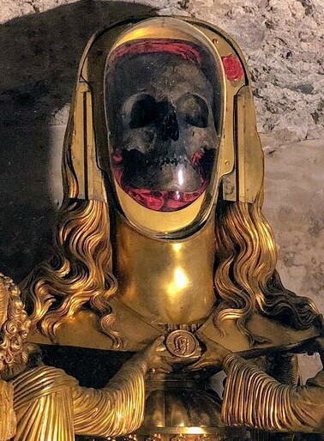
Figure 8. Close-up of the Skull of Mary Magdalene in Vézelay Abbey, France

Conversely, labelling queer art solely as camp and maximalist would be incorrect. Some artists feel it necessary to reject those characteristics particularly because of their association with religious art, preferring a more practical, minimalist approach. This demonstrates how varied queer art can be.
Christian people were never completely silent about their beliefs; they believe “there is no simple and straightforward way to liberate […] sexuality from religion” (Alcoff, 2011, p. 9). For instance, in various media produced decades ago with Christian principles in mind, queerness was always shown as sexual deviance. As a result, queer individuals began physically and artistically challenging the notions that separated them from society. The need to confront the apparatus that supports their oppression stems from an urge to understand the inner workings of their beings, to find acceptance in the face of the religious idea of eternal damnation.
From Giovanni Bellini’s “Christ Blessing” (1465), which, when viewed through a contemporary lens, can be seen as a depiction of Jesus Christ with a post-chest masculinisation surgery wound, to Elisabeth Ohlson Wallin’s “Sermon on the Mount” (1998), which portrays Jesus amongst leather-clad queer people, to Ethel Cain’s album “Preacher’s Daughter” (2022) that deals with religious guilt, queerness can be found in diversified media throughout centuries. This underlying queerness is not always visible; sometimes it is difficult to discern for the untrained eye.
We will be looking at three distinct examples of queer and religious art to understand and underline the appeal of using Christian symbolism while recognising elements that refer to queerness.
Alexander McQueen’s “Dante” (1996) is a collection that forged a link between high fashion, queerness, and Christianity. “[His] shows were often fashion’s equivalent of a psychological thriller – dark, intense and twisted.” (Ahmed, 2018). The designer was openly gay and enamoured with Christian aesthetics, religion being a recurring theme in his work.
The narrative of McQueen’s 1996 collection, as shown in Figures 9, 10, 11, and 12, was inspired by Dante Alighieri’s “Divine Comedy” (1321), illustrating the soul’s journey towards God and the phases one must undergo to obtain redemption. He had a remarkable eye for distinguishing between the motifs of holiness and sin, yet simultaneously merging the two into garments that conveyed a tale about humankind. The fashion show itself was held in Christ Church in London, United Kingdom, reinforcing the concept of iconography and religious symbolism through the once-sanctified site.
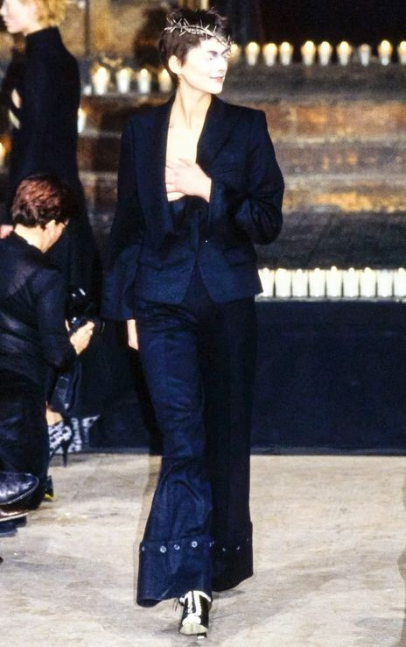
Figure 9. Runway photo, Look 18 Figure 10. Runway photo, Look 71

Figure 9 shows a mask with a crucified Jesus detail and Figure 10 shows a crown of thorns, both alluding to Christ’s Passions. The crown of thorns is made out of silver, which references the betrayal of Judas as well. The models wear immaculate, sharp-cut attire – an allusion to bodily purity. However, they are only meant to appear pure because of the spotless clothes they wear; reinterpreting the symbolism provided, it can be concluded that the models were meant to represent nuns on their way to divine redemption, given how a minority of holy women suffered greatly on their path to becoming saints.
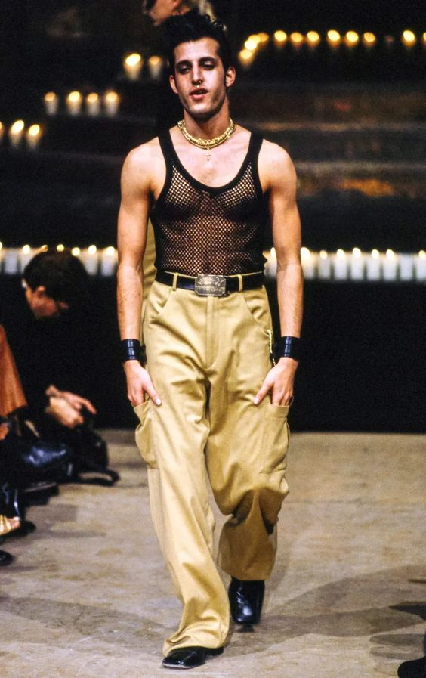
Figure 11. Runway photo, Look 8 Figure 12. Runway photo, Look 1

Figures 11 and 12 have the models in the roles of the deviants, the unholy. Despite being created to mimic the purity and crispness of Figure 10, the attire in Figure 11 has an atypical silhouette, with the lilac detail of the suit in the shape of a devil tail and the headpiece indicating towards rejection of Christian tradition and acceptance of the occult. Figure 11’s outfit is based on 1980s homosexual bar culture, with a mesh top and cuffs similar to those seen in standard fetish stores as the centrepiece, but what ties the ensemble together is the large, gold cross necklace, which is a mockery of the divine.
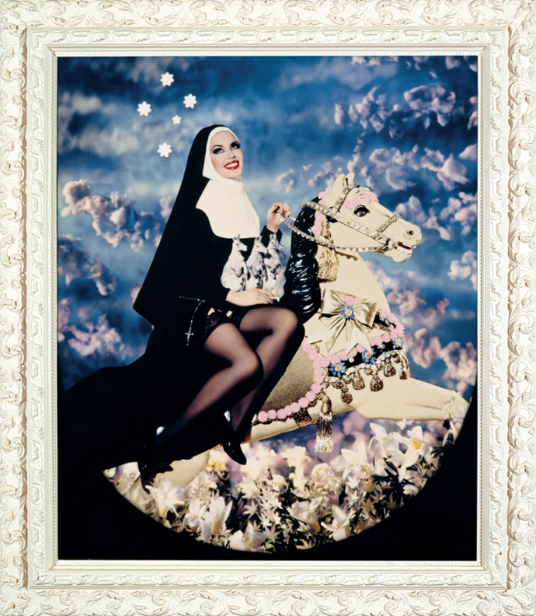
Figure 13. Sainte Marie Mac Killop (Kylie Minogue)

The eclecticism and religious symbolism evident in the works of the French creative and romantic duo Pierre et Gilles are characteristics that are difficult to overlook. Inside their campy cosmos represented by provocative compositions, brilliant colours, and sugary, false innocence, the viewer becomes a part of a dream that is also a form of divination.
They are inspired by historical and contemporary societal themes, their works also being “marked by icons” (Baconsky, 2020). What distinguishes them from, for example, the dismantled pair of Marina Abramović and Ulay is the playfulness with which they treat each subject, thus adding a layer of eeriness to every work as a result of this specific approach.
The iconographic inspiration is evident in Figure 13. The Virgin Mother, portrayed by singer and LGBTQ+ icon Kylie Minogue, is carefree and sensuous, but also discreetly sapphic given the juxtaposition of the nun habit with the black, sheer tights. In contrast to traditional depictions of Mary, in which she either smiles modestly or weeps for the world’s woes, Pierre et Giles’ reimagining of Mary smiles as she rides on a golden carousel horse, indifferent to heavenly judgement. Contradicting Irigaray’s (1985, p. 203) reasoning that “[a woman’s] nature has always been defined by men”, she is no longer bound by religious conventions or the expectation of nurturing a child, allowing her to indulge in carnal desires and thus making her seem more human than divine.
The lily, which represents purity and innocence and is linked to the Virgin Mary, can be seen filling the area behind the figure, hinting at her innocence and the fact that she is not used to human customs. The work as a whole is picturesque and additionally suggests the exaltation of the self to Heaven through its cloudy but gloomy background.
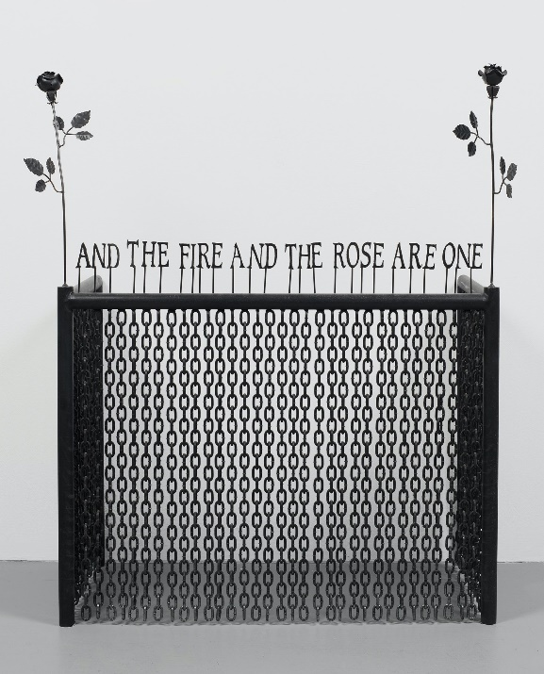
Figure 14. Untitled (Fireplace Screen)

Late artist John Boskovich had a fascinating relationship with queerness and religion, generating a cult following throughout the past two decades and after his death. Oftentimes creating bold and ironic installations or self-affirmations pasted over highly intimate photos, his way of reinterpreting these two concepts can be considered striking as much as it can be considered relatable.
Boskovich’s “Untitled (Fireplace Screen)” (1997) – Figure 14 is one of his most thoughtful installations. Made out of an iron fireplace screen, remodelled fireplace utensils, and vinyl lettering, the piece resembles an impractical mortcage. The monochrome material, paired with the even number of roses – which are only offered at funerals in certain cultures since they are thought to bring bad luck – resembles a burial site. The piece, similar to McQueen’s “Dante” (1996), has a direct correlation to the notion of the afterlife, and the minimalist design allows the viewer to question what precisely they are supposed to be mourning.
Through its metaphoric phrasing, the lettering above the fireplace screen, “AND THE FIRE AND THE ROSE ARE ONE”, establishes a clear connection to sin and queerness. Normally, a rose with its thorns intact is associated with Jesus Christ’s five deadly wounds, so Boskovich’s flowers have been bared of their thorns to support the piece’s vinyl text. Fire and the thornless rose are intrinsically opposed in religious symbolism; fire denotes eternal damnation, while the rose represents Heaven. The three components, merged by the same material into an installation, create the abstract portrait of a queer person condemned to live with the guilt of their frowned-upon existence. Boskovich’s words indicate that wherever one may end up in the afterlife, they will confront the same amount of misery – forever aware of “a certain presence, an immediacy, or even a nameless pushing” (Elkins, 2001, p. 143).
The LGBTQ+ community always carried with it the pressure of conforming to an exclusionist, sexually insecure society, so it is reasonable to believe that religious queer art is revolutionary. Creating art based on the rejection or acceptance of such a heavy subject as religion and the LGBTQ+ experience should not be ignored. By drawing inspiration from their emotional pain, queer people educated the privileged individual whilst still supporting their search for identity.

Conclusion

Throughout history, a considerable amount of artists explored Christian symbols and sacred figures in their works. While some of them did it in accordance with archaic values, others, like Caravaggio, opted to move this exploration towards the uncomfortable aspects of religion – the ones that are connected with human, carnal desires. When you are a male, there is an inherent queerness in the act of painting the semi-naked body of a man in such a vulnerable position. Of course, this queerness continues to Medieval art, but for a completely different cause, one that relates Jesus to femininity while essentially negating his masculinity. The Holy Bible, although occasionally including queer subtexts, also provides a good number of points of view on gender and sexuality, depending on the particular issue one is looking for.
In conclusion, by considering the numerous and varied media present in this body of work, and analysing the ideas that they bring forward, we can state that Christianity and queerness are more interconnected than the ordinary person believes. It is absurd to enforce the same rules of existence in the 21st century as it was done in A.D. 1, and this research represents not only evidence regarding my topic of work, but it also fosters a more current, open-minded vision of Christianity.
Everything falls into the need for love and acceptance and, as Jesus said, “This is my commandment, that you love one another, as I have loved you” (John, 15:12).

Appendix

This is a transcript of an interview I conducted with Father Dulceata, a retired priest from my home country, which helped me reconsider some of my thesis writing. My questions will be boldened, while his answers will be in normal text.

I just started writing my thesis, which deals with the way Jesus Christ is portrayed in art and other media throughout history. I am especially interested in how different religious depictions are compared to artistic ones. To break the ice, I wanted to ask you if you are familiarised with any artistic depictions of Christ rather than the Byzantine icons we are so used to seeing. Also, if you could give me an example you enjoy, that would be great.
I admit that I am not that familiarised with many paintings, but I am aware of Caravaggio’s ”The Entombment of Christ”. One of the churchgoers showed it to me years ago and I still remember it, surprisingly. It was a beautiful painting.
And how do you feel about it? Not in the sense of how it is made, but rather its spiritual value and accuracy.
I would say it is amazingly made, and it conveyed the exact sadness that occurred on that unfortunate day. Jesus was said to have smelled sweet, like flowers and honey, after his death. People wanted to be close to him no matter the circumstances. You can see Nicodemus touching his wound, right there, which is inaccurate, but it makes me wonder why the artist chose to paint them like this.
On the topic of Christ’s side wound, is there any confirmation that Thomas the Apostle put his finger inside it?
No. Jesus said to him: Bring your finger further and feel my hands, then put your finger into my side and do not be faithless but believing, but it was never established that he touched his crucifixion wounds; Thomas believed him out of shock. Jesus had an imposing presence – he was tall, straight, and determined, and he never lost these traits, even in death. I imagine that him being there, confronting whoever doubted him, was enough to confirm his resurrection.
Interesting. Do you think Jesus was an imposing person?
Yes, I am sure of that, or else he would not have convinced so many people of his holiness, but he was also a pacifist, a soft-hearted person. He is always portrayed standing tall and serious in paintings, as opposed to how he actually was; I always liked to joke that painters forgot to tell him to say ”cheese”.
I am sure you are aware of some medieval portrayals of Jesus – if not, I have some ready to show you. How would you explain these representations?
Oh, these are quite strange indeed, but not that uncommon. The Church came to exist from the blood and water that flowed out of Jesus’s wound, after all, so I am not surprised that some religious painters created these images. If you are curious about what blood and water mean, blood represents redemption and water stands for sharing life. Now that I have said these things, I think these painters might have given Jesus some of Saint Mary’s attributes – see the cream-coloured cloth he is dressed in? Saint Mary was known to wear that specific colour. Also, the mandorla shape is commonly used to signify her apparitions, and I can see that it is also used for Jesus’s wound here.
Do you reckon people saw Christ as a feminine figure, given these medieval works? Not necessarily in the literal way, but more like someone that could understand women more than the average man.
I believe Jesus understood everything and everyone. It would not be wrong to think he understood women more than the average man, as you have said, but he was not a man; he was a divine being, and even though he existed in the body of a man, his love and understanding were not of this world.
I have heard different points of view about how Jesus should be regarded as; some say he was a traditionalist that always conformed to the norms, others say he was free-spirited and big-hearted. What is your take on these opinions?
This is a hard question. I, on one hand, believe that he followed some traditions specific to that period. At the same time, Jesus broke two of the most important norms: he did not resolve to violence and preached peace, and he never married. In a way, he was a bit of both of those things. He was not an oppressor, that is for sure.
Finally, what would you tell a person that struggles with accepting God’s love and their religious identity?
The heart is at its strongest when you let yourself feel Divine Love. Let it exist within you, because it is infinite, and that way you will never have to beg for redemption.

Works Cited

Ahmed, O. (2018) The Era-Defining Alexander McQueen Show That Took Fashion to Church. Available at: https://www.anothermag.com/fashion-beauty/10818/the-era-defining-alexander-mcqueen-show-which-took-fashion-to-church (Accessed 7 December 2022).
Alcoff, L. M. et al (2011) Feminism, Sexuality, and the Return of Religion. Bloomington: Indiana University Press.
Anselm (1973) Prayers and Meditations of St. Anselm. Revisited edn. London: Penguin Classics.
Baconsky, I. (2020) “The word ‘kitsch’ doesn’t mean anything anymore”: Pierre et Gilles reinvent camp for the metamodernist age. Available at: https://www.sleek-mag.com/article/pierre-et-gilles (Accessed 7 December 2022).
Benay, E. E. (2014) Caravaggio: Reflections and Refractions. Surrey: Ashgate Publishing Limited.
Butler, J. (1990). Gender Trouble: Feminism and the Subversion of Identity. London: Routledge.
Butler, J. (2004). Undoing Gender. New York: Routledge.
Bynum, C. W. (1982) Jesus as Mother: Studies in the Spirituality of the High Middle Ages. London: University of California Press.
de la Cretaz, B. (2021) My Gender is Maximalism. Available at: https://www.autostraddle.com/my-gender-is-maximalism (Accessed 28 November 2022).
d'Oingt, M. (1286) Pagina Meditationum.
Elkins, J. (2001) Pictures and Tears. London: Routledge.
Goss, R. (1993) Jesus Acted Up: A Gay and Lesbian Manifesto. Reprint ed. New York: HarperCollins.
Irigaray, L. (1985) This Sex Which Is Not One. New York: Cornell University Press.
Knust, J. W. (2006) Abandoned to Lust: Sexual Slander and Ancient Christianity. New York: Columbia University Press.
Kruger, B. (1981) Untitled (You Construct Intricate Rituals). [Art] (Museum of Fine Arts Boston).
Lochrie, K. et al (1997) Constructing Medieval Sexuality. Minneapolis: University of Minnesota Press.
McKinion, S. A. (2004) Ancient Christian Commentary on Scripture: Isaiah 1-39. Westmont: InterVarsity Press.
Myles, E. (2000) Cool for You: A Novel. New York: Soft Skull Press.
Ngai, S. (2005) Ugly Feelings. London: Harvard University Press.
The Holy Bible: Douay-Rheims Version (1609, 1582), France: English College at Rheims and Douay

Bibliography

Adly, G. S. (2006) The Last Days of Judas Iscariot. London: Faber & Faber.
Ahmed, S. (2014) Wilful Subjects. London: Duke University Press.
Bataille, G. (1962) Death and Sensuality: a Study of Eroticism and the Taboo. Poland: Publications Development Corporation.
Caruth, C. (1996) Unclaimed Experience: Trauma, Narrative, and History. London: The Johns Hopkins University Press.
Davies, B. (2006) The Reality of God and the Problem of Evil. Croydon: Cpi Anthony Rowe Ltd.
Irigaray, L. (1993) An Ethics of Sexual Difference. New York: Cornell University Press.
Kotrosits, M. (2015) Rethinking Early Christian Identity: Affect, Violence, and Belonging. Philadelphia: Fortress Press.
Kripal, J. J. (2017) Secret Body: Erotic and Esoteric Currents in the History of Religions. Chicago: The University of Chicago Press.
Lochrie, K. (1994) Margery Kempe and Translations of the Flesh. Philadelphia: University of Pennsylvania Press.
Machacek, D. W. and Wilcox, M. M. (2003) Sexuality and the World’s Religions. Santa Barbara: ABC-CLIO.
Morny, J. (2006) Divine Love: Luce Irigaray, women, gender and religion. Manchester: Manchester University Press.
Moslener, S. (2015) Virgin Nation: Sexual Purity and American Adolescence. New York: Oxford University Press.
Priest (1994) Directed by Antonia Bird. [Drama film] BBC Films, Polygram Filmed Entertainment.
Sontag, S. (1969) Styles of Radical Will. New York: Picador USA.
Soskice, J. M. (2007) The Kindness of God: Metaphor, Gender, and Religious Language. New York: Oxford University Press.
Westengard, L. (2019) Gothic Queer Culture: Marginalised Communities and the Ghosts of Insidious Trauma. Lincoln: University of Nebraska Press.

