Marketing Plan
Introduction
In this report, the researcher will produce a marketing plan for a 3 day itinerary for a family with children visiting Swansea. The itinerary will include accommodation and leisure attractions and activities that will appeal to the family. It will be discussed on how the researcher plans on marketing the itinerary in order for it to be persuasive and successful for the chosen market segment.

Executive Summary
The purpose of this report is to create an itinerary for the researchers chosen market segment, families with children to visit Swansea. The main activities and attractions in Swansea will be discussed and why they are key features for the chosen market segment to visit. The report will include internal and external research, a SWOT and PEST analysis, and analysis of key segment market, marketing objectives and the marketing mix. Recommendations will also be made on how tourism numbers can increase and improve in Swansea.

Destination
Swansea is a city, also a county located on the South Wales coast and is the second largest City in Wales It is mostly well-known for being home to the centre of education, where there is Swansea University, University if Wales Trinity Saint David and Gower College Swansea, with a total of over 20,000 students. According to Swansea Council, its most recent figure of Swansea’s population from 2016 is 244,500 and is the second highest population out of the 22 Welsh local authorities, which represents 8% of Wales’ population, which is 3,113,200. Swansea is a popular city in Wales for its leisure. Many events take place there and a number of activities, including both indoor and outdoor, children’s play sessions and many youth clubs. One of its main attractions is the Grand Theatre where a number of performances take place, it is also popular for its activeness with many active centres for both adults and children, swimming, sport development and memberships. The Brangwyn is one of the most popular halls where a number of events, conferences and weddings take place. Swansea is well-known for its culture, the Glynn Vivian being one, where there are many art galleries and exhibitions, as well as the many castles and parks. Swansea holds many of its stunning beaches due to its location on the coast. The most famous beaches are the Gower, which is an Area of Outstanding Natural Beauty, Rhossili Bay, Mumbles and Caswell Bay.
Situation Analysis
Swansea is currently in a good place with its tourism numbers, although there are a number of strengths and weaknesses of the City. One of its strengths is that there is currently a good mix of activities available to suit different types of guests’ wants and needs. Whether the guests are visiting for historic and culture or to just simply relax and spend time with their family, Swansea has it all to offer. Another strength is that Swansea has the most stunning coastline, with a number of beaches for visitors to explore, including the Gower, which is an Area of Outstanding Natural Beauty. One of Swansea’s major weaknesses is the weather. Wales is known to not have the best weather therefore this could put visitors off to visit Swansea. An opportunity that is provided is that tourism helps to generate money into the local community to help improve and better the area, therefore tourism is a great opportunity for Swansea. A threat for tourism in Swansea could be the infrastructure. According to an article from Wales Online written by Sue Hall, Swansea needs a vision to benefit the country and address the concerns of the future generations. She states that if the infrastructure is improved, it will benefit not only the local community, but also the local people and small businesses as well.
There are a number of issues that are affecting Swansea, the main political impact being Brexit. Due to Brexit, tourism in Swansea may decrease as the cost of everyday life is increasing, therefore visitors may feel that it is too expensive to visit Swansea when they could visit somewhere ‘better’ for the same price. An economic impact that may be affecting Swansea is that Swansea City Council is in debt. This can affect Swansea greatly, as they are not able to provide funding to the community which would be beneficial and bring more tourists into Swansea. Another economic impact is the Tidal Lagoon. Millions of pounds have been spent in trying to make the Tidal Lagoon successful, even though it has been unsuccessful. This may have caused an economic impact on Swansea as funding has been put into a project that has been unsuccessful where as it could have been funded into Swansea to improve it and making it more appealing to tourists. A social impact is that more jobs are provided for the locals in Swansea when new restaurants and attractions open, which is beneficial for the local community. A technological impact is that technology has been made so easy, that guests are able to have an easy online booking process when booking a trip or a visit, which has been a great impact on Swansea.
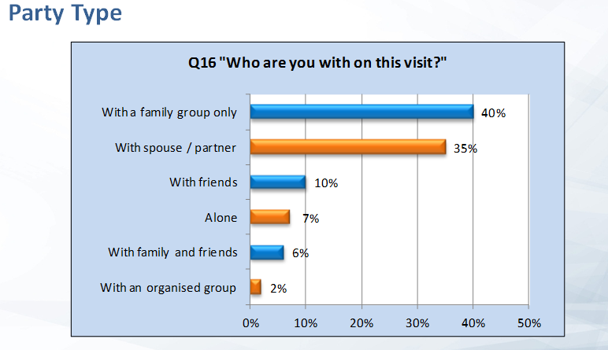
Analysis of Key Segment Market – statistics of families
Swansea is a very popular destination for families travelling with children, and according to Swansea Council, 40% of guests travelling to Swansea are in fact families travelling with children, as it is showed in the graph below.

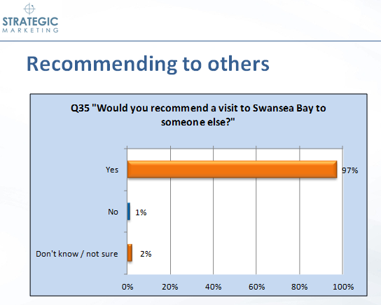
This clarifies that Swansea is most definitely an appropriate destination for families travelling with children to visit and that it is the most popular category all together of any type of group travelling to Swansea. In the graph below, it also shows that 97% of guests that visited Swansea Bay would recommend it to someone else.

Marketing Objectives
The researcher has decided that the most appropriate and best way to market their product for their market segment to visit Swansea is to produce leaflets and posters. These will include the main points that will bring guests in to Swansea. The researcher has decided that they can hand out leaflets around different cities and counties around the United Kingdom, promoting their product so that they are able to bring in customers from the whole of the UK, to experience a fun-filled experience in the UK, This has been decided as it is the most sufficient way to be able to target their market segment specifically and will not be at an expensive cost to produce. Another marketing material that the researcher feels may be useful is social media. This will be done via a Facebook page including key information about Swansea including the most popular attractions and facilities, statistics and customer feedback and many photographs of the city to persuade guests that Swansea is a great city to visit. Due to social media being a big part of most people’s lives, it could be one of the key marketing materials to use to promote the product. A website could also be produced with similar/extra information and details for customers to look at. The researcher felt that materials such as newspapers would not be appropriate to target their specific market as they would not be able to promote and target families with children specifically and therefore would not be as successful as leaflets and social media.

Marketing Mix
The researcher has produced an itinerary for families with children to visit Swansea. The itinerary includes a range of activities and historic places to visit throughout their stay, to suit all types of families’ wants and needs. Restaurants and places to eat have also been included so that the families do not need to worry about where to eat out during their stay.
For the first day, the researcher ensured that the itinerary was not too full or busy, as the guests may have been travelling a while to reach their destination and they may feel tired. A visit to the National Waterfront Museum was included as it has interactive technology that tells the story of the industry and the innovation of Wales, which is interesting for guests who are not from the area. A visit to Parc Tawe was also included so that the family can relax and spend time together whilst having fun at the cinema and playing bowling.
As the itinerary is for 3 days, the researcher made the second day to be quite full and busy, to ensure that the guests can experience the most popular attractions that Swansea has to offer. During the second day, Rhossili Bay and Mumbles beach have been included as a trip to Swansea should include what it is most famous for, which is its stunning coastline. Some visitors that visit Swansea may not live near a coastline therefore the researcher feels that they would appreciate the experience of visiting Swansea’s beaches. A visit to the Oystermouth Castle has been included as it is a Norman Stone Castle and also a 12th century landmark. The Oystermouth Castle has a stunning view of Swansea Bay that visitors do not want to miss. The researcher included to watch a show at the Swansea Grand Theatre as there are a wide range of shows and exhibitions that the visitors can enjoy during their trip. The researcher chose the Harvester for the families to eat at as it is a suitable family restaurant, and quite often have deals and offers on, which will be appropriate for the families.
As the third day is the day of the families departure, the researcher ensured that the day would not be too busy for them, but also that they would get to experience that last of Swansea’s most popular attractions. The researcher chose for the families to visit LC2 as it includes many facilities for all of the family to enjoy such as the swimming pool and water slides, the surf machine, a climbing wall, an indoor play area and a sports hall. The Swansea Museum has also been included for the last day as it provides a visitor experience for the family to enjoy and it is also is a real focus for the city’s future. Singleton Park has been included in the last day of the itinerary so that the guests can have a relaxing walk around with the botanical gardens, a play area, crazy golf and a lake. The researcher thought that it would be appropriate for the families to go shopping, so that they can take some good home and also because it is good for the local community as it will generate money back into the community. The researcher chose Pizza Hut for the families to eat at before they depart; as it is a family-friendly restaurant and also they will be ready for the journey home.
The marketing mix is essential when selling a product as it is important that the right product is being sold at the right place, at the right time, at the right price, with the right promotion. All of these have to work together in order for a product to be sold; otherwise it will most definitely be unsuccessful.
Summary
In summary, Swansea is currently successful with its tourism rates, especially for families with children. This could potentially change if the problems such as the Tidal Lagoon are not resolved. A recommendation would be that Swansea Council should carefully take into consideration where and what they are funding their money on. Swansea Council could also promote more tourism in the area by advertising holiday get a ways for families with children to increase their tourism rates even higher.

Appendices
 | Itinerary
Day 1 | - Arrive at Tankey Lake Livery - Buttercup Cottage located in the Gower, a 4* accommodation suitable for a family with children.  - Visit National Waterfront Museum and then Frankie and Benny’s for lunch.  - Visit Parc Tawe to watch a film at the cinema, followed by a game of bowling. Dinner included at the tenpin bowling premises.  - Arrive back at the cottage.
Day 2 | - Breakfast in the cottage.  - Visit Rhossili Bay.  - Visit Oystermouth Castle.  - Lunch at Verdi’s restaurant.  - Stop at Mumbles beach/visit mumbles pier and arcade.  - Watch a show at the Swansea Grand Theatre  - Dinner at the Harvester in Morfa.  - Return back to the cottage.
Day 3 | - Breakfast in the cottage  - Visit LC2 to use the pool/slide facilities and the surf machine.  - Visit Swansea Museum  - Lunch at the 360 Cafe.  - Visit Singleton Park  - Dinner at Pizza Hut.  - Shopping in Swansea City and the Quadrant.  - Depart to return home.

SWOT
Strength | Weakness
- Mix of Activities  - History and Culture  - Stunning Coastline | - Weather/Climate
Opportunity | Threat
- Bringing more money into the community | - Infrastructure

PEST
Political | Economic
- Brexit | - Tidal Lagoon  - Swansea City Council in Debt
Social | Technological
- Providing more jobs | - Booking Process

References
Swansea Council, (2017). ‘Population’, [Online]. Available: https://www.swansea.gov.uk/population, Accessed Date – 2018, March, 12].

Swansea Council, (2018). ‘About Swansea’, [Online]. Available: https://www.swansea.gov.uk/keyfacts, [Accessed Date – 2018, March, 12].

Swansea Council, (2018). ‘Leisure’, [Online], Available: ‘(https://www.swansea.gov.uk/leisure, [Accessed Date – 2018, March, 12].

Lydall, A and Nesbitt, L, (2015). ‘Swansea Visitor Survey’, Available: https://www.swansea.gov.uk/article/6406/Tourism-research-and-statistics, [Accessed Date – 2018, March, 9].

Cottages.com, ‘Tankey Lake Livery – Buttercup Cottage’, [Online], Available: http://www.cottages.com/cottages/tankey-lake-livery-buttercup-cottage-jam, [Accessed Date – 2018, March, 23].

Hall, S. Wales Online, (2017), ‘Wales needs an infrastructure vision for future generations’, [Online], Available: https://www.walesonline.co.uk/special-features/wales-needs-infrastructure-vision-future-12470993, [Accessed Date – 2018, March, 9].

Kelsey, C. Wales Online, (2018), ‘Lagoon delay causes concern over jobs’, [Online], Available: https://www.walesonline.co.uk/business/business-news/liam-fox-refuses-meet-austrian-14365519, [Accessed Date – 2018, March, 23].

