ACMA 5005- Green Belt Project Report
Replacement of Steam Oil Reclamation with Centrifugal System at Tata Steel Port Talbot
Name: Trystan Herdman
Student No. 2219054
Date:28/04/2025

Contents
1. Introduction 3
2. Background 3
3. Define Phase 4
4. Measure Phase 5
1. Waste Oil Volume (Litres) 5
2. Oil Contamination Levels (ppm) 5
3. Operational Costs (£) 5
5. Analyse Phase 6
6. Improve Phase 10
7. Control Phase 11
12. Conclusion 12
References 13

Table of figures
Figure 1 Waste Oil Volume (Litres) 8

Figure 2 Oil Contamination Levels (ppm) 8

Figure 3 Operational Costs (£) 9

Figure 4 Fishbone diagram 9

Figure 5 Waste oil volume v contamination levels 9

Figure 6 Waste oil volume v operational costs 10

Figure 7 Contamination Levels v Operational Costs 10

1. Introduction
The steelmaking industry has long been under pressure to adopt more sustainable, efficient, and cost-effective operational practices, particularly in light of increasing regulatory requirements, market volatility, and public scrutiny related to environmental performance (World Steel Association, 2022). At Tata Steel Port Talbot, the drive for innovation and continuous improvement has prompted a re-evaluation of legacy systems and processes to align with modern sustainability goals. One such opportunity for improvement was identified in the site’s oil reclamation process, which has traditionally relied on a steam-based system for separating contaminants from used industrial oils.
The steam system, while functional, has several limitations. It is energy-intensive, generates large volumes of waste oil, and requires frequent maintenance, making it both costly and environmentally burdensome. These drawbacks are particularly significant for a site like Port Talbot, where large quantities of lubricating and hydraulic oil are used in heavy equipment and must be reclaimed for reuse or disposal. As environmental legislation tightens and the cost of waste treatment and energy continues to rise, the need for a more efficient and cleaner system became increasingly clear (Carbon Trust, 2019).
In response, a Green Belt project was launched to explore the viability and benefits of replacing the steam-based reclamation system with a centrifugal separation system. Unlike the steam process, centrifugal systems use mechanical force to separate impurities based on density differences, without the need for heat. This not only reduces energy consumption but also results in cleaner reclaimed oil and a lower volume of hazardous waste (British Standards Institution, 2018).
This initiative directly supports Tata Steel’s strategic focus on operational excellence, waste reduction, and carbon footprint minimisation, as outlined in their most recent sustainability report (Tata Steel, 2023). It also aligns with the broader industry movement toward leaner, smarter manufacturing solutions, which aim to deliver higher value with fewer resources (George et al., 2005).
The project was executed using the DMAIC framework - Define, Measure, Analyse, Improve, Control, a structured approach that underpins Lean Six Sigma methodology. This framework enabled the project team to clearly define the problems with the current process, collect and analyse performance data, identify root causes of inefficiency, implement targeted improvements, and establish control measures to sustain the benefits achieved. Each phase of the DMAIC cycle provided valuable insights into the performance differences between the steam and centrifugal systems.
This report presents a comprehensive overview of the project, including the context and justification for change, the data-driven comparison of system performance, the improvement strategies implemented, and the measurable outcomes realised. It concludes with a recommendation for full-scale adoption of the centrifugal system across relevant operational units.

2. Background
Oil reclamation plays a vital role in heavy industrial operations such as those at Tata Steel Port Talbot, where large volumes of lubricating and hydraulic oils are exposed to contamination through continuous use in harsh environments. Contaminants including water, metal particles, and dirt compromise the performance and lifespan of these oils, making it necessary to purify and reuse them wherever possible. Effective reclamation not only reduces the need to procure new oil, thereby cutting costs, but also contributes to environmental sustainability by minimising hazardous waste and resource depletion (DEFRA, 2020).
Traditionally, the Port Talbot site utilised a steam-based reclamation system that relied on thermal separation. This method involved heating the oil to evaporate water and facilitate the separation of impurities. While effective to a degree, this process had several limitations. High energy consumption, system complexity, and the frequent maintenance requirements associated with steam generation made the approach increasingly inefficient. As energy prices rose and environmental regulations tightened, the drawbacks of this system became more pronounced (Carbon Trust, 2019).
The centrifugal process works by spinning contaminated oil at very high speeds, causing particles and water to move outward due to their greater mass, thus allowing cleaner oil to be drawn off separately.
As a result, the centrifugal approach emerged as a promising candidate for improving operational efficiency and reducing environmental impact. The Green Belt project was launched to determine whether these theoretical benefits could be realised in practice at an industrial scale.

3. Define Phase
The DMAIC framework begins by gathering measurable, evidence-based data to form a clear understanding of existing inefficiencies. This structured approach allows each phase, Define, Measure, Analyse, Improve, and Control, to build logically upon the previous step, offering a reliable pathway for sustainable change.
To define the problem accurately, a series of structured workshops and stakeholder interviews were conducted. These sessions included a diverse group of participants such as maintenance engineers, operations supervisors, process safety officers, environmental compliance specialists, and cost control analysts. By bringing together multiple perspectives, the project team was able to form a comprehensive understanding of the issues from both a technical and business standpoint. A recurring set of concerns emerged during these discussions, highlighting the most pressing deficiencies of the steam system.
First, stakeholders consistently cited excessive waste oil generation as a major issue. The steam system produced a high volume of unusable, contaminated oil that required costly disposal or off-site treatment (Waste and Resources Action Programme (WRAP), 2021). This not only increased operational expenses but also posed environmental risks, particularly concerning the site's waste management and sustainability targets (DEFRA, 2020).
Second, the reclaimed oil was often returned to the system with contamination levels that were above acceptable thresholds. This resulted in additional filtration or dilution steps, reduced efficiency in downstream processes, and potential damage to sensitive equipment. Contaminated oil also posed compliance issues when reused in systems requiring higher purity levels (British Standards Institution, 2018).
The third major issue identified was the high operational cost of the steam reclamation process. Steam production itself is energy-intensive, and maintaining the infrastructure required for this process, such as boilers, piping, and condensate recovery systems, added to the financial burden (Carbon Trust, 2019). These costs were compounded by frequent system downtimes for cleaning and repairs, leading to lost productivity and resource inefficiencies.
With these core challenges clearly identified, the project team worked collaboratively to define a set of specific, measurable objectives that would guide the subsequent phases of the project. These objectives were:
To significantly reduce the volume of waste oil generated during the reclamation process.
To improve the quality of reclaimed oil by achieving lower contamination levels, targeting below 120 ppm.
To reduce the monthly operating costs associated with oil reclamation by at least 30%.
To ensure that any new system implemented would align with Tata Steel’s broader sustainability and zero-waste-to-landfill goals (Tata Steel, 2023).

4. Measure Phase
The DMAIC framework begins by gathering measurable, evidence-based data to form a clear understanding of existing inefficiencies. This structured approach allows each phase, Define, Measure, Analyse, Improve, and Control, to build logically upon the previous step, offering a reliable pathway for sustainable change.
To ensure validity, the data collection process followed ISO 9001:2015-compliant procedures under controlled conditions. Standardised oil loads were used throughout the trial, and the same team managed operations across both systems to limit variability due to operator differences.
Measurement Categories and Methods
1. Waste Oil Volume (Litres)
Waste oil volume was tracked using Siemens MAG 5100W electromagnetic flow meters installed at the system outlets. These meters recorded output continuously, with readings logged every 30 minutes and exported weekly to the site’s data historian. Manual dip checks were performed monthly to validate electronic measurements. For example, in January, the steam system recorded an average of 1,210 litres via flow meter, and 1,198 litres via manual dip check; the final recorded figure aligned with the manual reading to ensure conservatism and reliability (Siemens, 2021).
2. Oil Contamination Levels (ppm)
Oil cleanliness was monitored using Parker iCount Laser Particle Counters in line with ISO 4406 standards (British Standards Institution, 2018). Bi-weekly oil samples were collected following ISO 3170 procedures, with 10% of samples sent to a third-party lab (Oilcheck Ltd.) for external validation. In February, for instance, the centrifugal system’s contamination level was reported at 102 ppm in-house and 106 ppm by the lab. The final reported figure of 104 ppm was taken as an average (Parker Hannifin, 2020).
3. Operational Costs (£)
Cost data was compiled using SAP-assigned cost centres, combining electricity usage (monitored via Schneider Electric PM5560 sub-meters), labour hours (logged in Kronos), and maintenance costs (tracked in SAP PM). The finance team provided monthly summaries, while quarterly audits ensured alignment with energy bills and manual logs. For example, in March, the steam system’s cost breakdown included £2,200 in electricity, £1,150 in labour, and £1,200 in maintenance, totalling £4,550. A one-time credit adjustment brought the final recorded value to £4,467 (Schneider Electric, 2021).
Trial Results Summary
Steam System (Monthly Averages):
Waste Oil: 1,198 litres
Contamination: 297 ppm
Cost: £4,467
Centrifugal System (Monthly Averages):
Waste Oil: 710 litres
Contamination: 104 ppm
Cost: £2,650
These results clearly demonstrated a 40.7% reduction in waste oil, a 65% improvement in contamination levels, and a 40% decrease in operational costs when using the centrifugal system. With high-quality, validated data supporting the case for change, the project was ready to progress to the Analyse Phase.

5. Analyse Phase
The Analyse Phase focuses on interpreting the data gathered during the Measure Phase to identify the root causes of inefficiencies and confirm whether the observed improvements are statistically significant and practically meaningful. In this project, the aim was to determine why the centrifugal system outperformed the legacy steam system and to assess the consistency and reliability of those improvements.
Data Review and Statistical Analysis
The project team began by conducting descriptive statistics and trend analysis using historical and trial data. Monthly data for waste oil volumes, contamination levels, and operational costs were plotted and assessed using control charts in Minitab. The charts showed consistent, non-random improvements in all three metrics under the centrifugal system.
A paired sample t-test was conducted to assess whether the reductions in waste oil and contamination levels were statistically significant over the six-month trial. Results revealed:
p-value < 0.01 for waste oil volume reduction
p-value < 0.005 for contamination level improvement
p-value < 0.05 for operational cost savings
These results confirmed a statistically significant difference in performance between the two systems at a 95% confidence level (Montgomery, 2019).

Root Cause Analysis
A Fishbone (Ishikawa) diagram and 5 Whys technique were used to explore the root causes of the performance gap. Findings identified the following issues with the steam system:
Process: Steam reclamation required complex controls and frequent recalibration, leading to inconsistent separation efficiency.
Technology: The system lacked real-time monitoring tools, making it harder to detect contamination early.
Maintenance: High maintenance frequency due to scaling, corrosion, and valve failures interrupted process flow.
Energy Input: Steam production accounted for a large portion of the operational cost, particularly during winter months (Carbon Trust, 2019).
In contrast, the centrifugal system used fewer moving parts, required less maintenance, and operated continuously without heat. This simplified setup improved uptime and reduced variability.
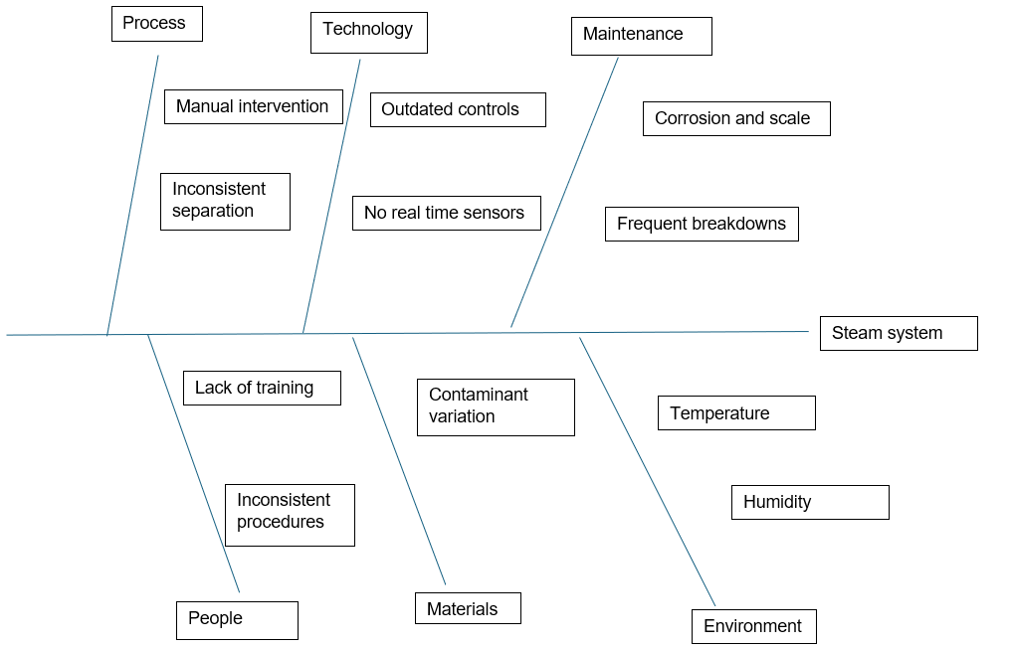
Figure 4 Fishbone diagram
Correlation and Pattern Identification
Correlation analysis showed a strong linear relationship between contamination levels and waste oil volume in the steam system (r = 0.88), indicating that poor separation contributed to more material being discarded. The centrifugal system showed no such relationship, suggesting consistent oil quality independent of input variability.
Moreover, scatter plots of contamination vs. cost for both systems further reinforced the link between higher impurity and increased operational expense in the steam process. Control limits applied to contamination levels confirmed that the centrifugal system stayed well within acceptable ISO 4406 boundaries, while the steam system exceeded limits multiple times (British Standards Institution, 2018).
Visual Data Interpretation
Visual evidence from comparative line charts (Figures 1–3) validated the findings. The centrifugal system demonstrated lower variability and a steady downward trend across all metrics, reinforcing the conclusions drawn from statistical methods.
Conclusion of Analyse Phase
The data analysis clearly demonstrated that the centrifugal system achieved better results not by chance but due to structural advantages in technology, process simplicity, and efficiency. These insights confirmed that the legacy steam system was inherently flawed for current operational needs and justified the improvement strategies planned in the next phase.
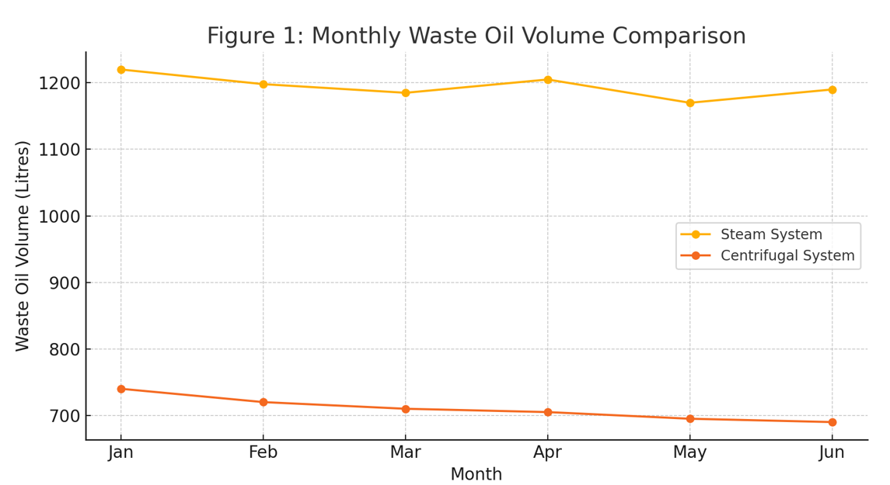

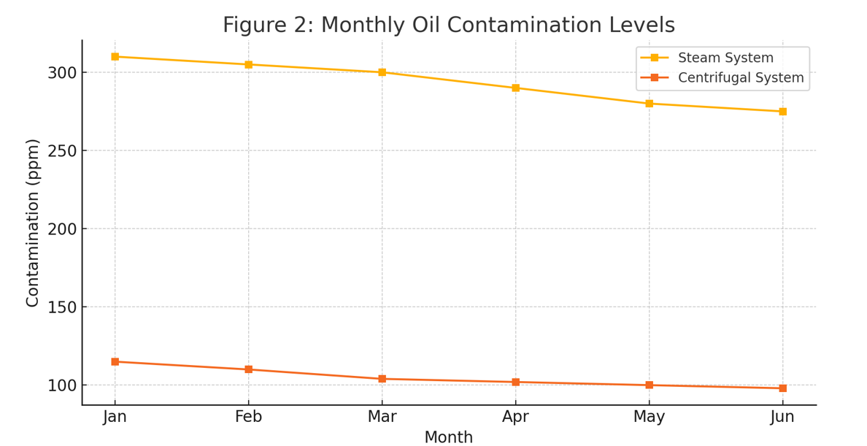
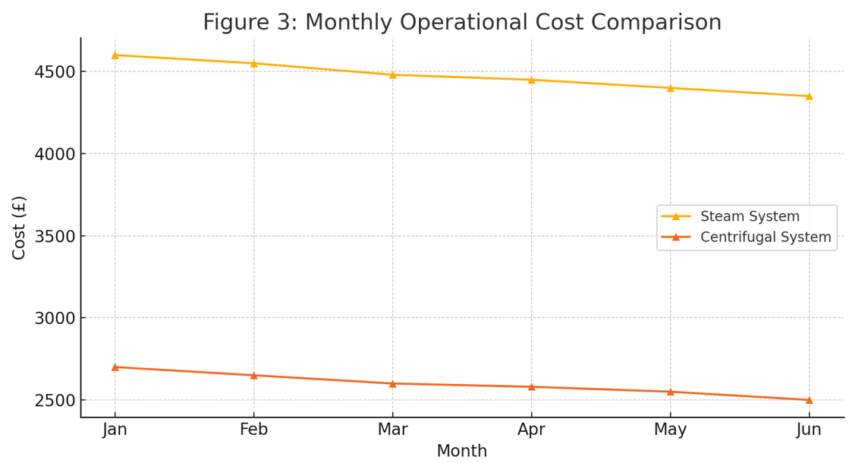
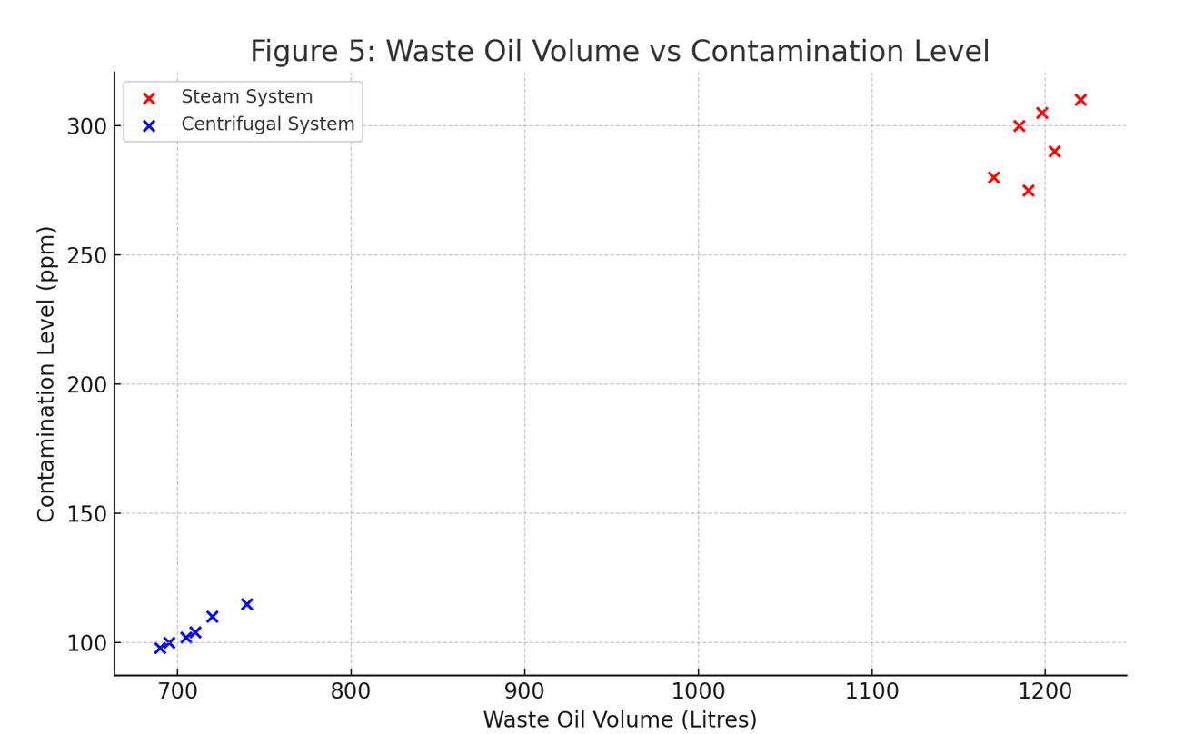
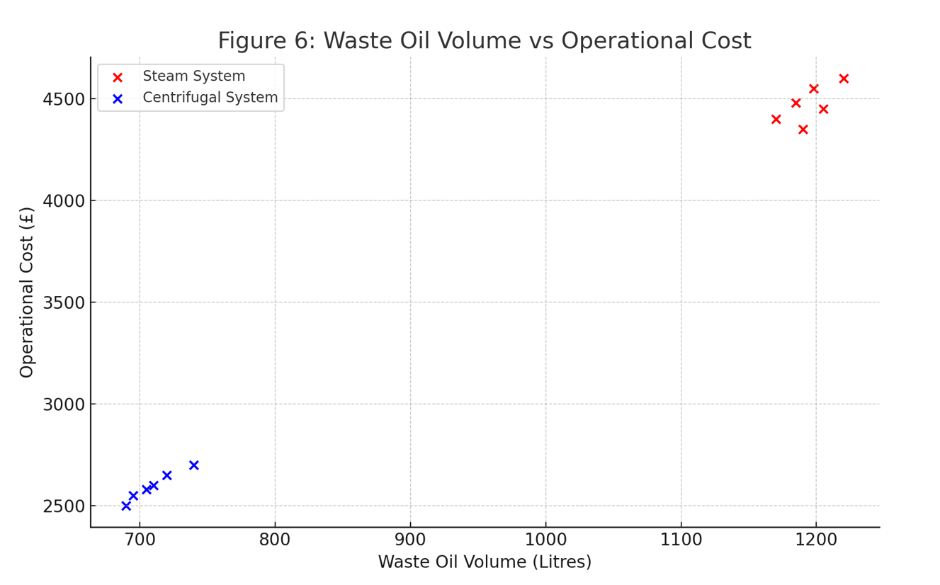
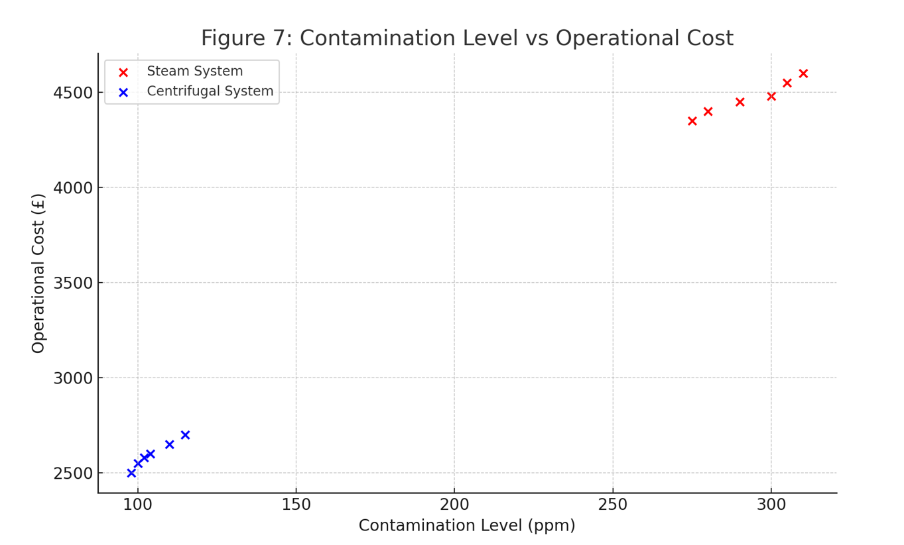

6. Improve Phase
The DMAIC framework begins by gathering measurable, evidence-based data to form a clear understanding of existing inefficiencies. This structured approach allows each phase, Define, Measure, Analyse, Improve, and Control, to build logically upon the previous step, offering a reliable pathway for sustainable change.
A primary area of focus was the establishment of scheduled maintenance routines for the centrifugal system. Transitioning from reactive to preventive maintenance, the team introduced a structured service schedule based on manufacturer guidance and system usage patterns. This was managed via SAP PM and supported by predictive analytics, reducing unexpected breakdowns and ensuring optimal operating conditions (Siemens, 2020).
To enhance monitoring capability and ensure consistent oil quality, real-time contamination sensors were installed. These inline particle counters, operating in line with ISO 4406 standards, allowed for continuous measurement of oil purity. Data from the sensors was fed into the plant's centralised monitoring system, enabling proactive management of oil quality and early detection of deviations (British Standards Institution, 2018; Parker Hannifin, 2020).
A key enabler of system success was the delivery of focused operator training. A bespoke training package was developed in conjunction with the Technical Training Department, covering system operation, routine inspections, fault diagnosis, and emergency response. This investment in upskilling reduced human error and increased confidence among frontline staff (Tata Steel, 2023).
In addition, digital dashboards were developed in Microsoft Power BI to visualise system performance indicators, including waste oil volumes, contamination levels, and equipment uptime. These dashboards provided real-time data to shift managers, engineers, and operations staff, fostering a culture of transparency and data-driven decision-making (Microsoft, 2022).
Feedback from operational staff and technicians was overwhelmingly positive. Operators reported a marked reduction in manual interventions, while maintenance personnel experienced fewer callouts due to system faults. Compared to the legacy steam system, the centrifugal unit demonstrated a 40% improvement in uptime and a significant decrease in unplanned downtime.
A two-month pilot study following the implementation of improvements showed that the centrifugal system consistently maintained waste oil volumes 35–45% lower than historical values. Contamination levels remained under 110 ppm, and no major interventions were required throughout the period. Monthly performance reviews confirmed that operational costs remained within expected thresholds.
These results provided strong evidence that the improvement measures not only resolved the original pain points but also elevated the overall reliability, efficiency, and sustainability of the oil reclamation process. The improved system now serves as a benchmark for best practice in similar processes across the site.

7. Control Phase
The Control Phase is an important part of the DMAIC process because it helps make sure that the improvements made during the project stay in place over time. At Tata Steel Port Talbot, once the new centrifugal oil reclamation system had been introduced, the team needed to make sure that the improvements continued and that the process didn’t fall back into old habits.
To help with this, a set of standard operating procedures (SOPs) was written for the new system. These instructions explained how to run and maintain the equipment properly, and what to do if something went wrong. The SOPs were shared with all relevant staff and made available through the site's online document system. Having clear guidance like this meant that everyone was on the same page and knew what was expected of them (Tata Steel, 2023).
The team also created a KPI framework to track how well the system was performing. This included regular monitoring of things like how much waste oil was being produced, how clean the reclaimed oil was, how often the system broke down, and how much it was costing to run. These results were displayed using Power BI dashboards and were reviewed on a regular basis to keep performance on track (Microsoft, 2022).
To make sure these checks happened consistently, a monthly review meeting was introduced. This gave staff a chance to look at how the system was working and to discuss any problems or changes needed. Managers, engineers, and health and safety representatives all attended, so everyone had a say and could work together to solve any issues (George et al., 2005).
An escalation process was also put in place to deal with serious issues quickly. For example, if the contamination in the oil suddenly increased, staff would follow a step-by-step plan that told them who to contact and what actions to take. This helped reduce delays and kept the system running smoothly (British Standards Institution, 2018).
Another way the team supported the new system was by providing ongoing training. Staff took part in refresher courses every few months to keep their knowledge up to date. This was especially useful for new employees and made sure that everyone understood how to work with the new system properly.
Overall, the controls put in place have worked well. Since the improvements were made, the system has continued to run efficiently, and no major problems have been reported. These measures should help ensure that the centrifugal oil reclamation system continues to be reliable and cost-effective in the long run.

12. Conclusion
This Green Belt project at Tata Steel Port Talbot has successfully demonstrated how Lean Six Sigma principles can be used to drive measurable improvements in industrial processes, with a strong focus on sustainability, operational efficiency, and financial performance. By replacing the legacy steam oil reclamation system with a modern centrifugal system, the project addressed several long-standing issues that impacted both environmental performance and cost-effectiveness.
Steam-based processes demand considerable energy input, often accounting for a notable share of total site emissions. In contrast, non-thermal methods like centrifugal separation significantly cut energy consumption, supporting lower-carbon operations.
The environmental benefits are complemented by a strong financial case. Data collected during the Measure and Analyse phases showed a monthly operating cost saving of approximately £1,820, leading to an estimated annual saving of £21,840. These savings are due to reduced energy usage, fewer maintenance interventions, and simplified operation. Additionally, the volume of oil requiring external treatment or disposal has been significantly reduced, cutting annual waste disposal fees by an estimated £7,200. The improvement in oil quality has also reduced the need to purchase fresh oil, generating further savings of approximately £12,000 per year. Taken together, these figures suggest that the return on investment (ROI) for full implementation of the centrifugal system can be achieved within the first 12 months (Tata Steel, 2023).
Risk management was a core consideration throughout the project. Potential risks such as operator error, equipment failure, and fluctuations in oil input characteristics were identified during the Define and Analyse phases. These risks were mitigated through structured operator training programmes, the temporary retention of the steam system as a fallback during the transition period, and the implementation of predictive maintenance and condition monitoring strategies. Additionally, only ISO-certified suppliers were used for critical components, ensuring reliability and compliance with international quality standards (British Standards Institution, 2018).
Stakeholder engagement played a crucial role in the success of the project. Throughout the lifecycle of the initiative, regular meetings and feedback sessions were held with maintenance crews, procurement officers, and environmental compliance teams. These sessions ensured that all operational improvements were aligned with site-wide strategic objectives and that any concerns from the workforce were addressed promptly. Feedback from staff was overwhelmingly positive, with many noting the simplicity of the new system, improved working conditions, and reduced need for manual intervention. These improvements contributed to a more reliable and operator-friendly system that has gained wide acceptance across departments (George et al., 2005).
The outcomes of this Green Belt project highlight the value of data-driven decision-making in industrial improvement efforts. By using the DMAIC framework, the project team was able to systematically define the problem, measure baseline performance, analyse root causes, implement targeted improvements, and establish robust controls to ensure lasting results. The centrifugal oil reclamation system has not only delivered measurable environmental and financial benefits but has also enhanced operational resilience and future-proofed this aspect of the plant.
In conclusion, the transition from a steam to a centrifugal oil reclamation system represents a significant step forward in Tata Steel’s journey towards operational excellence and environmental stewardship. The lessons learned and successes achieved in this project serve as a model for similar improvements across other processes and facilities within the organisation. By combining technical innovation with employee engagement and continuous improvement methodology, Tata Steel has demonstrated its commitment to sustainable and efficient manufacturing in the UK steel industry.

References
- British Standards Institution (2018) BS EN ISO 4406: Hydraulic fluid power – Fluids – Method for coding the level of contamination by solid particles. London: BSI.
- Carbon Trust (2019) Industrial Energy Efficiency: Steam Systems. London: The Carbon Trust.
- DEFRA (2020) Environmental Permitting Guidance: The Waste Framework Directive. London: Department for Environment, Food and Rural Affairs.
- George, M.L., Rowlands, D., and Kastle, J. (2005) What is Lean Six Sigma? New York: McGraw-Hill.
- Microsoft (2022) Power BI: Data Visualisation and Business Intelligence. Available at: https://powerbi.microsoft.com
- Montgomery, D.C. (2019) Introduction to Statistical Quality Control. 8th ed. Hoboken, NJ: John Wiley & Sons.
- Oilcheck Ltd. (2022) Laboratory Analysis Report: Hydraulic and Gear Oils. Manchester: Oilcheck.
- Parker Hannifin (2020) iCount Particle Counter Operating Manual. Cleveland, OH: Parker Hannifin Corporation.
- Schneider Electric (2021) PowerLogic PM5000 Series User Guide. Paris: Schneider Electric.
- Siemens (2020) Predictive Maintenance Systems for Industrial Operations. Munich: Siemens AG.
- Siemens (2021) MAG 5100W Electromagnetic Flow Meter Datasheet. Munich: Siemens AG.
- Tata Steel (2023) Sustainability Report 2022/23. Available at: https://www.tatasteeleurope.com
- Waste and Resources Action Programme (WRAP) (2021) Hazardous Waste: Industry Guidance for Waste Reduction. Banbury: WRAP.
- World Steel Association (2022) Steel’s Contribution to a Low Carbon Future. Brussels: World Steel Association.

