

Module: Marketing Management
Module code: LCMB7024

Assessment component 2: Marketing Strategies Portfolio

Student Name: Andrey Nieche

Table of Contents
Element 1: Brand Extension Poster Presentation 3
Element 2: Develop a Segmentation, Targeting, Differentiation, and Positioning (STDP) Analysis 4
Market Segmentation 4
Targeting Strategy 5
Differentiation Strategy 6
Positioning Strategy 6
Element 3: Marketing Mix (7Ps) Analysis: Dyson AirSphere 7
Product 7
Price 7
Place 8
Promotion 8
People 9
Process 9
Physical Evidence 10
Element 4: Reflection 10
Reference 13
Appendix 16

Element 1: Brand Extension Poster Presentation
Poster Title: Dyson AirSphere – Redefining Smart Air & Living
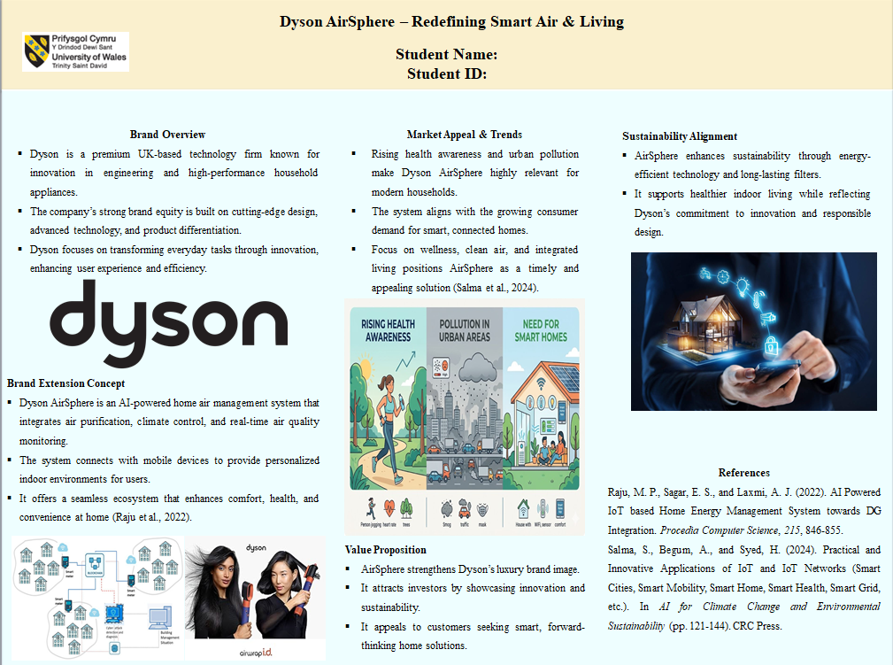
Brand Overview
Dyson is a luxury technology company that is based in the United Kingdom and is reputed to be innovative and excels in engineering and high-performance household appliances. It has a great brand equity that is based on its new design, high technology, and transforming lives.
Brand Extension Concept
Dyson AirSphere is an intelligent AI-powered home air management system, which combines air purification, climate and real-time air quality monitoring all in a single, seamlessly integrated ecosystem. It links with mobile devices to offer personal indoor environments(Raju et al., 2022).
Market Appeal & Trends
This extension is very relevant due to rising health awareness, pollution in urban areas and the need for smart homes(Salma et al., 2024). The focus on wellness, clean air, and connected living is also becoming a core value to consumers, making AirSphere an opportune and willing solution.
Sustainability Alignment
AirSphere promotes sustainability by means of energy-saving technology, long-term filters, and minimising environmental damage. It is also healthier to live indoors, and it also does not diverge from the fact that Dyson is an innovation-driven and responsible design company.
Value Proposition
AirSphere fortifies the luxury brand of Dyson as well as appeals to investors and customers with innovative, sustainable, and visionary smart living.

Element 2: Develop a Segmentation, Targeting, Differentiation, and Positioning (STDP) Analysis

Market Segmentation
The multidimensional segmentation strategy would be used and would include the use of the following variables: geographic, demographic, psychographic, and behavioural variables. The geographical area of the target audience is the densely populated urban areas of the United Kingdom. The significant cities such as London, Manchester, and Birmingham are characterized by very high indoor pollution factors. In this kind of urban environment, there is also an increased adoption of smart home technologies (Mogaji, 2025). They provide desirable opportunities for integrating interested air management systems.
In terms of demographics, the segment is made up of well-to-do professionals between the ages of 30 and fifty years. These are the people who are most likely to have a stable career, and the amount of disposable income is relatively high. A large percentage of them are in two-income families, and that has led to a sharp rise in their purchasing power. The level of education will also translate into informed and quality-based consumption behaviour. Consequently, they put a lot of emphasis on performance, durability and technology sophistication at the time of acquiring goods(Agustian et al., 2025).
Psychographically, the segment is a representation of health-conscious, environment-conscious, and innovative consumers. These people are highly interested in individual well-being and indoor environmental quality. Their motivation is optimisation of lifestyle and not necessarily the functional benefits of the product. Also, they portray good congruence with high-end brands that endorse technological perfection and sustainability. They have attitudes that are receptive to new technologies that help in increasing the living experiences of people.
In terms of behaviour, the segment has high brand loyalty to products of high-performance technology(Nilplengsang, 2024). Product innovation, reliability, and brand reputation are important product aspects that determine purchase decisions. There is a relatively low price sensitivity in consumers in this segment in the case of value demonstrated. They also interact with intelligent systems and devices that are linked to apps in their homes. Their trends of usage suggest their preference in terms of integrated, convenient and easy-to-use technological solutions.

Targeting Strategy
Dyson has adopted target marketing in an urban up-end segment that is well-specified. The major target population will be professionals who are being exposed to indoor air pollution more. These consumers actively want to have high-impact solutions that are convenient, healthy, and high-performance(Heo and Lee, 2025). Their lifestyles require effective, flawless, and smart technological assistance in the household settings.
The segment has a high propensity to invest in innovative and high-quality products. Long-term value is more preferred in their decision-making processes as opposed to short-term saving of money. Besides, they are very receptive to the brands that have a message of scientific credibility and engineering prowess(Kumar, 2023). The reputation of Dyson thus offers a great competitive edge among this target market.

Differentiation Strategy
Dyson AirSphere is one of the products that have excelled in terms of choice on technology integration, good product designs and superior performance. It offers a complete air management system in contrast to conventional air purifiers. The operating system combines purification, climatic control, and real-time observation and implementation on a single functional platform. The holistic approach simultaneously considers multiple needs of consumers and is much higher in opinion(Rosol, 2025).
In addition to this, the proprietary technology that Dyson has been able to establish in engineering is a sort of performance competitive advantage over other players. Air quality can be controlled by means of modern filtration technology and intelligent sensors. The smart home technologies can also be used with the current product, which makes its use more comfortable. In addition, its luxury and innovative brand is already confirmed by the inimitable language of design used by Dyson.
Sustainability has also played a major role as a differentiating factor in the competitive arena. Project et al. (2009) propose to use energy-efficient operations to develop an environmentally friendly operation, and long-life span philtres serve to insignificantly reduce the cost of operation. This is in line with the consumer needs that increase the desire to possess technological solutions that are environmentally friendly. This leads to bringing in differentiation through both functional performance and ethical value propositions.

Positioning Strategy
Dyson AirSphere has a brand position of an upscale, technology-driven brand of smart indoor air control. The brand is dedicated to high-level engineering, innovation, and the performance outcomes which are scientifically proven(Berlian, 2022). It is a powerful brand reinforcement position statement that Dyson has already acquired in the upper-end technological market.
Value proposal is based on improvement of health, comfort and conditions of living in general. It reports the change of the clean air work to a sophisticated environmental control system. This will allow Dyson to occupy a niche position in the smart home and wellness market.
Besides, the differentiation targets consumers who would desire to acquire symbolic and practical value from products(Jain et al., 2022). The fact that it is only through ownership that one displays not only the advanced technological level, but also the sophistication of the lifestyle and the awareness of the environment, is the best thing about it. This is why Dyson AirSphere develops a differentiated and aspirational strong market.

Element 3: Marketing Mix (7Ps) Analysis: Dyson AirSphere

Product
Dyson AirSphere is a technology-intensive, high-involvement product in the smart home. It combines purification of air, climate and smart monitoring into a single unit. This hybrid functionality does not simply offer quality product features but adds a wealth of user experience to it. The product provides both the practical use and the symbolic worth relating to the high-quality technology ownership(Kusdiana and Yulita, 2024).
The design of the product is based on the engineering of Dyson to be highly performing, durable, and precise in the management of air quality. Personalised environmental control, depending on the user's behavioural patterns, is made possible with the inclusion of AI-driven features. Also, the continuity of connections with the smart home complements the convenience and usefulness for consumers. It is also a symbol of the aesthetic of Dyson that also contributes to the consistency in its brand collection.
Also, the corresponding alignment of the product and brand underlines the credibility of the extension. It would ensure that a new proposition would not water down the existing brand equity and positioning. Thus, product strategy helps to maintain brand development and competitive differentiation over a long period of time.

Price
Dyson uses a premium pricing strategy, which indicates the superior technological features and style excellence of the product. AirSphere is priced higher than traditional air purification devices. Such a pricing strategy sends the message of high quality, innovation and exclusivity to the target market(Nguyen et al., 2025).
The market niche comprises high-income earners and low price elasticity. These consumers have a greater emphasis on the long-term value, performance of the product, and brand image than on the short-term considerations of affordability. As such, high pricing helps the brand positioning of Dyson as a luxury, innovation-related brand.
Nonetheless, the prices should be explained by the real and perceived value brought to consumers(Subrahmanyam and Arif, 2022). Dyson does this by ensuring high performance, energy saving, and a long lifespan of the product. Also, the hybrid system lowers the necessity of several independent devices, which contributes to value creation. Thus, pricing will be aligned with differentiation strategy and brand positioning goals.

Place
Distribution strategy deals with a selective channel which ensures control of brand experience and perception. Dyson AirSphere will be sold in retail outlets and high-end retail store networks, which include direct-to-consumer channels. Controlled environments of product demonstration and interaction can be acted out in official Dyson stores and websites(Hasan et al., 2023).
This will create uniformity in brand communication and improve the quality of customer experience. Also, collaboration with premium retailers provides the opportunity to reach specific customer groups without losing brand positions. Minimal distribution approach supports exclusivity and value perception among customers.
The online channels are important as they are effective in targeting digitally savvy, urban consumers. The e-commerce platforms facilitate individualised communication, information gathering, and product marketing. Moreover, the direct channels enable Dyson to have better working customer relationships with its customers. The distribution approach promotes brand consistency and strategic expansion goals.

Promotion
The promotional policy focuses on technological advancement, health improvements, and the enhancement of lifestyle, but does not focus on price-based incentives. Traditionally, Dyson opts to promote the performance of the products and their engineering excellence through their marketing campaigns(Widiyanto and Yulihapsari, 2023). Such a practise corresponds to an appealing promotional instrument that strengthens premium brand positioning.
Online marketing targets are at the centre stage of communicating with the target market effectively. Online video content, social media platforms and targeted advertisements increase brand visibility and involvement. Product demonstrations also aid in effectively passing on the complex technological features of products to consumers(Diana and Rifandi, 2026).
Also, narration about clean air, health, and sustainability enhances emotional bonding with the audience. Celebrity partnerships and celebrity recommendations also promote credibility and trust in the product. This combined promotion mix will be consistent with the brand identity and strategic goals of Dyson.

People
The people component focuses on the contributions of employees and customer contacts in providing brand value. Dyson invests a significant amount of money in employee training to ensure comprehensive product knowledge and technical skills(Nirawati and Hasoloan, 2024). This will allow the employees to interact effectively concerning the benefits of the products and facilitate the decision-making process of customers.
Customer service is important so that customer satisfaction is ensured and brand loyalty is created. When the perceived riskiness of high-end purchases is raised by good quality after-sales services, then the perceived riskiness would be higher. In addition, the seasoned staff strives to offer a greater in-store and online experience.
The communication between the consumers and brand reps affects the overall perception of the commodity. Thus, investment in talented people is in line with excellence and innovation, as Dyson values these two. This aspect assists in the retention of customers as well as the brand equity that is developed in the long run.

Process
Process element is the system and procedures by which the product is experienced and delivered. Dyson guarantees a smooth buying experience in both the online and offline markets. Customization is achieved through the incorporation of digital platforms to enable effective browsing, buying, and customer support services(Asiah et al., 2022).
The setup and installation procedures are packaged to be appropriate and easy to learn for users. The interface of its products allows mobile applications and smart systems to monitor and control them easily. Further, frequent software upgrades improve features and keep the products relevant over time.
Maintenance and change of filters and replacing them are examples of efficient service processes that help in customer satisfaction. All these processes minimize friction and increase perceived product reliability(Mecca et al., 2025). Promoted premium positioning and user experience are therefore facilitated by well-designed processes.

Physical Evidence
Physical evidence consists of physical objects that strengthen the credibility and quality of the brand. The design, package, and presentation of Dyson AirSphere portray the image as a high-quality and technologically advanced product. The futuristic and minimalist design affirms futility and accuracy in engineering(Christianti and Hasanah, 2025).
The physical outlets, such as Dyson stores, are built to display products attractively and educatively to the customers. The interactive displays will enable the customers to have a feel of how to use the products before making any buying decisions. This increases confidence and decreases uncertainty in buying high-value products.
Secondly, there exist digital interfaces such as mobile applications that are included in the entire brand experience. Intuitive design is easy to operate with, and it creates a touch of advanced technology. A combination of all of these tangible and intangible aspects helps in reinforcing the brand name and positioning of Dyson.

Element 4: Reflection
The evolution of the Dyson AirSphere brand extension put theoretical selling principles into practise. It was a life and thinking project extension to align with the personality of the brand of Dyson (Tan and Salo, 2023). Initial interpretation of concepts like brand equity and positioning to the actual product was not painless, but it contributed towards an even better definition of brand development and alignment of strategies. It was an abstract to real world process of connecting the abstract to product design, target markets and brand communication.
The project managed to demonstrate why a balance between innovation and consistency is necessary. The item in question must have been luxurious and high-tech and must meet the requirements of the relevant target audience, according to Dyson (Eddine and Fared, 2024). This necessitated a sharp focus on product features, functionality and value perception. It had to be so that the present image of Dyson could be preserved, so that it would be credible and acceptable. Thus it enhanced the critical thinking, particularly in pursuing the right market opportunities rather than merely adhering to the generic ideas. I was also more rigorous in the assessment of the concept to fit the brand. Segmentation and targeting analysis reinforced my knowledge of consumer behaviour and strategies that need to be adopted to reach particular groups.
The presentation poster enhanced my visualisation and communication abilities. I was forced to express complicated information in a simple, short, and organised manner(Abos et al., 2024). This meant focusing on important messages and logically structuring content to take the audience through the idea. I understood how to create something that would be memorable to the audience and convey value in a very minimal amount of time to the investors and customers alike. It also helped me get better at simplifying detailed analysis in a way that does not compromise the meaning. The practise of providing the presentation boosted my confidence and skills in communicating ideas in a professional, strong, and convincing manner within a limited time.
The personal and professional growth was facilitated in the project. I also developed my analytical skills because I would relate theory to practice and test hypotheses with real market situations(Tusquellas et al., 2025). I also managed to work on my market trend analysis and to rationalize the decisions made. Consumer perception and purchase decision-making are other areas that I was more aware of thanks to branding. It is completing multiple tasks on time, which strengthened my time management and organisational ability, as I had to be able to arrange the research, development of the ideas, and making of the presentation without any issues.
Future work can be improved in certain aspects. I should take more time to read about successful and unsuccessful brand extensions before coming up with final ideas. This would enable wider consideration of opportunities and risks and enable better-informed decisions. My other objective is to learn how to better tell stories visually so that the future presentation could be more captivating and memorable(Aw and Agnihotri, 2024). Enhanced use of data and evidence in substantiation of claims would also enhance the quality of my tasks.
In general, the project gave a good understanding of what strategic marketing and brand management are. It helped to enhance my skills in implementing theory in real life and gave me more confidence in my skills being used in the real world.

Reference
Abos, R. M., Taffe, S., Connory, J., Karunasena, G. G., and Pearson, D. (2024). Reducing food waste through persuasive communication design: how data visualisation principles reinforce behaviour change social marketing messages. Journal of Social Marketing, 14(3-4), 398-431.
Agustian, A. M., Bakhri, S., and Faozi, M. M. (2025). STP Analysis (Segmenting, Targeting, Positioning) and SWOT Analysis in Digital Marketing Strategies Infacing Business Competition at BT Batik Trusmi Cirebon.Journal on Islamic Economics, Finance and Banking [Z-CONOMICS], 1(2).
Asiah, S. N., Soe'oed, R., and Sjamsir, H. (2022, December).The implementation of 7Ps education marketing mix in early childhood education institution. In Educational Studies: Conference Series (Vol. 2, No. 2, pp. 233-244).
Aw, E. C. X., and Agnihotri, R. (2024). Influencer marketing research: review and future research agenda. Journal of Marketing Theory and Practice, 32(4), 435-448.
Berlian, M. (2022). Analysis Of Segmenting, Targeting And Positioning Strategies On Consumer Purchase Decisions In The Digital Era. International Journal of Economics, Business and Accounting Research (IJEBAR), 6(4).
Christianti, G. A., and Hasanah, N. (2025).The influence of marketing mix on customer satisfaction, trust, and loyalty.JurnalIlmiahManajemenKesatuan, 13(6), 4249-4260.
Diana, E., and Rifandi, A. (2026).Sustaining Competitiveness: Promotional Mix Strategies in High-Performing Primary Schools Facing Demographic Shift.At Turots: JurnalPendidikan Islam, 242-255.
Eddine, B. A. S., and Fared, M. A. (2024).Enterprise Strategy to Sustain Continuous Innovation and Product Quality Consistency in a Saturated Market.Bulletin of Science, Technology and Society, 3(3), 55-61.
Hasan, M., Ahmad, M. I. S., Kamaruddin, C. A., and Tahir, T. (2023). 7P Marketing Mix in Processed Farm Products by Urban Farming Businesses. International Journal of Social Science and Business, 7(3), 645-658.
Heo, H., and Lee, S. (2025). Consumer information-seeking and cross-media campaigns: An interactive marketing perspective on multi-platform strategies and attitudes toward innovative products. Journal of Theoretical and Applied Electronic Commerce Research, 20(2), 68.
Jain, R., Jain, S., and Jain, S. (2022). Analyzing and exploring the effectiveness of each element of 7Ps of marketing mix. International Journal of All Research Education and Scientific Methods (IJARESM), 10(1), 2455-6211.
Kumar, S. (2023). Red ocean strategy: a literature review. International Journal of Economics and Business Administration (IJEBA), 11(4), 91-100.
Kusdiana, Y., and Yulita, R. (2024). The Role of marketing mix (7P) Strategy Towards Customer Satisfaction. INVEST: JurnalInovasiBisnisdanAkuntansi, 5(1), 9-16.
Mecca, A. M., Nursanty, O. E., and Yuhelmis, Y. (2025).The Effect of 7p (Product, Price, Place, Promotion People, Process, Physical Evidence) Marketing Mix and Patient Satisfaction on Outpatient Retention with the Role of Electronic Word of Mouth (E-WOM) Mediation at BundaMargonda Hospital in 2025.International Journal of Health and Pharmaceutical (IJHP), 5(4), 1025-1035.
Mogaji, E. (2025). Market Segmentation, Targeting, and Positioning. In Strategic Marketing Management: Principles and Practice (pp. 103-133). Cham: Springer Nature Switzerland.
Nguyen, K. M., Dinh, L. T. K., Ngo, T. T., Phan, T. T. T., Nguyen, P. D. H., Tran, H. P. M., and Nguyen, N. T. (2025). The impact of 7Ps green marketing mix on customer commitment and willingness to pay a premium price: Evidence from Vietnam. Journal of Promotion management, 31(4), 578-619.
Nilplengsang, Yongyoot, and SumamanPankham."Beyond stp marketing strategy for online service businesses."Revista de Gestão Social e Ambiental 18, no. 6 (2024): 1-26.
Nirawati, I., and Hasoloan, J. (2024).The Effect of Marketing Mix ‘7P (Product, Price, Place, Promotion, People, Process, and Physical Evidence) on Customer Loyalty of NasiJamblang Bu Nur Cirebon.Greenation International Journal of Economics and Accounting, 2(1), 30-36.
Raju, M. P., Sagar, E. S., andLaxmi, A. J. (2022). AI Powered IoT based Home Energy Management System towards DG Integration. Procedia Computer Science, 215, 846-855.
Rosol, C. (2025). Flows of air, flows of electrons.The Anthropocene Review, 20530196251336250.
Salma, S., Begum, A., and Syed, H. (2024).Practical and Innovative Applications of IoT and IoT Networks (Smart Cities, Smart Mobility, Smart Home, Smart Health, Smart Grid, etc.).In AI for Climate Change and Environmental Sustainability (pp. 121-144).CRC Press.
Subrahmanyam, S., and Arif, S. A. F. (2022).PREMIUM PRICING STRATEGY AND CUSTOMER RETENTION-AN ANALYSIS.International Journal of Early Childhood Special Education, 14(3).
Tan, T. M., and Salo, J. (2023). Ethical marketing in the blockchain-based sharing economy: Theoretical integration and guiding insights. Journal of Business Ethics, 183(4), 1113-1140.
Tusquellas, N., Santiago, R., and Palau, R. (2025). Professional development analytics: A smart model for Industry 5.0. Applied Sciences, 15(4), 2057.
Widiyanto, P., and Yulihapsari, I. U. (2023). Using Social Media Promotions and Mixed Marketing Methods: Analysis Increasing the Interest of Transportation Jaklingko Passengers. East Asian Journal of Multidisciplinary Research, 2(4), 1437-1448.

Appendix

